Frame sketcher
© 2012 Marilen Corciovei len@len.ro
http://www.len.ro/tools/frameSketcher/

The real bicycle
Everything starts with the bicycle:

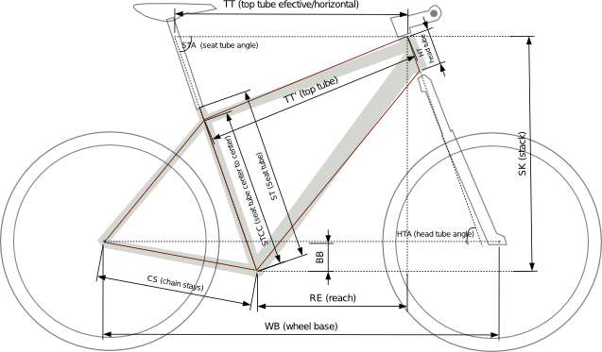

Based on the above, real, bicycle, one can then create a theoretical bicycle based on the following measurements: Wheel size (WS), Bottom bracket offset (BB), Chain stay length (CS), Seat tube (ST), ST center-center (STCC), Seat tube angle (STA), Wheel base (WB), Head tube (HT), Head tube angle (HTA). These measurements are the ones usually provided as the bicycle geometry. Depending on the manufacturer, sometimes either the Reach (RE) and Stack (SK) or the Top tube horizontal (TT) and Top tube sloped (TT’) are provided. The meaning of the above measurements should be obvious from the image above, if not, a good place to start is on wikipedia.

The model

Some things are ignored in the process, such as the frame tubes width, their shapes or their position on the head tube.

It should be possible however, within the theoretical model above, to calculate and sketch frames with an informative degree of accuracy.

Drawing the model frame

The coordinates of the points P₁ - P₇ are:

Calculations
Different manufacturers provide different values. Either the Reach (RE) and Stack (SK) or the Top tube horizontal (TT) and Top tube (TT') are sometimes provided.

Calculate the Standover height (SH)

