**Kidney**

Power function

FIT with power function if smoking cessation is 0.

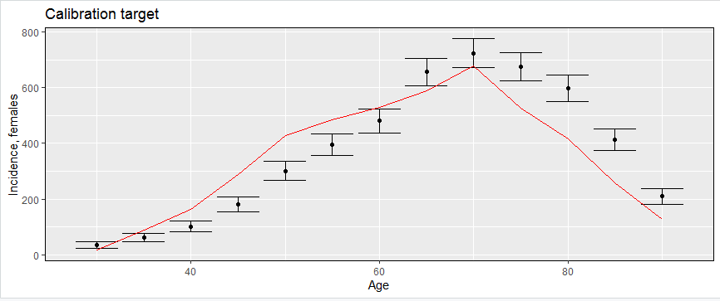

Power function with smoking cessation

Kidney doesn’t validate to mortality, assuming that staging is wrong (more early cancers are expected to fit mortality data)

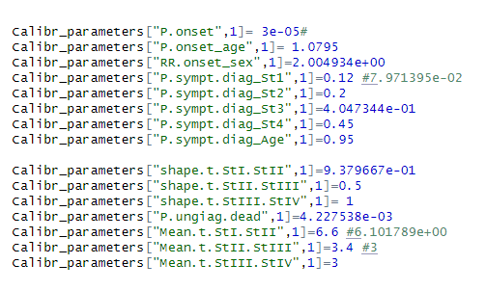

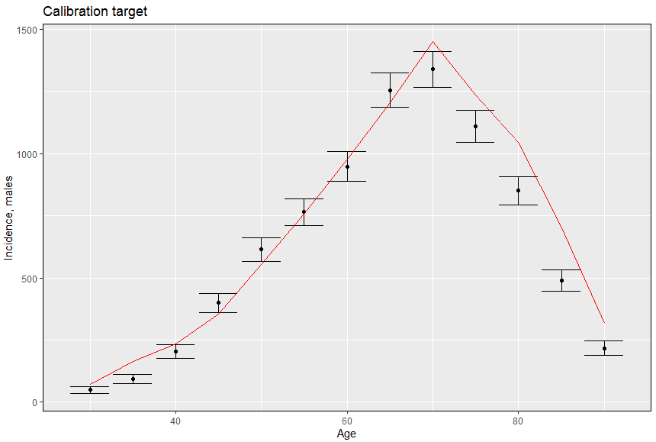

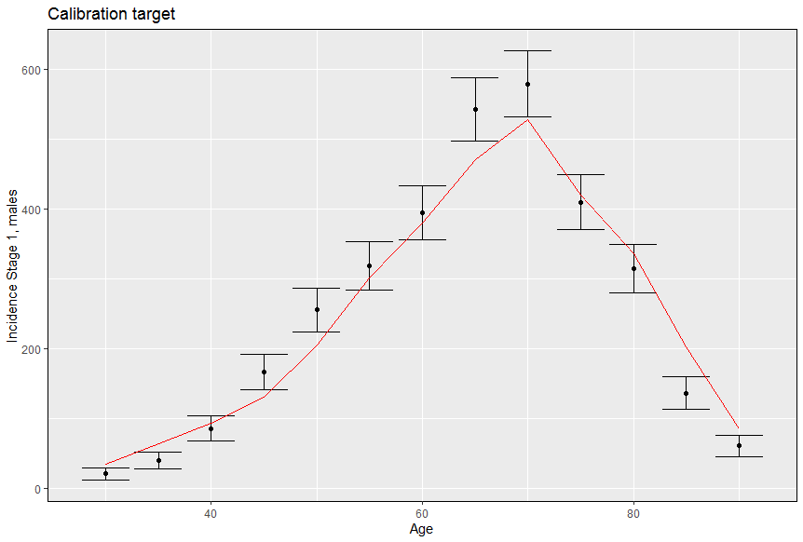

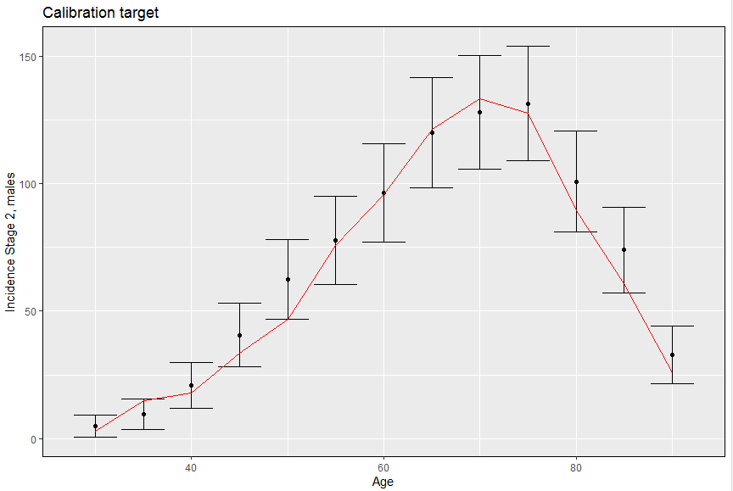

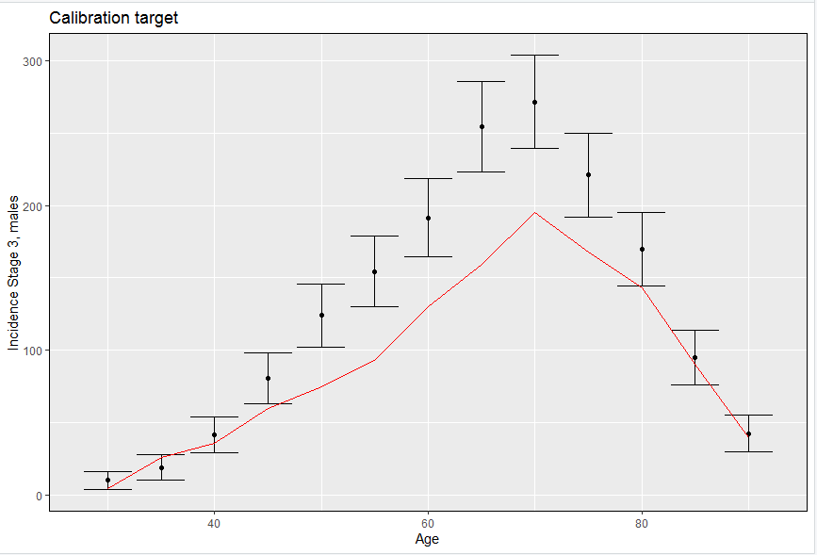 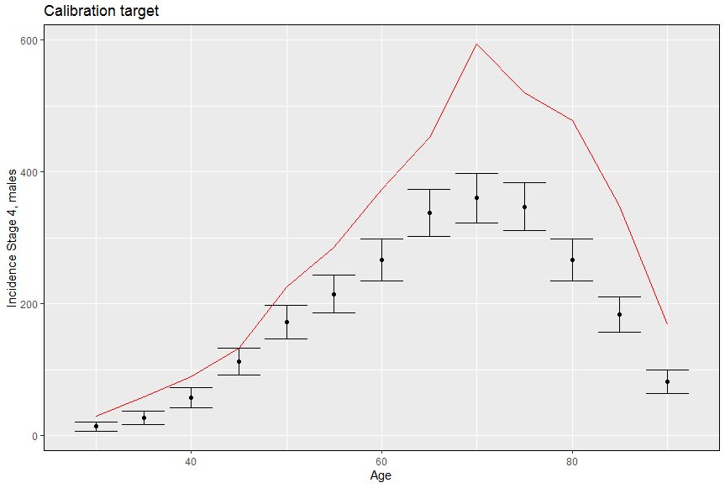

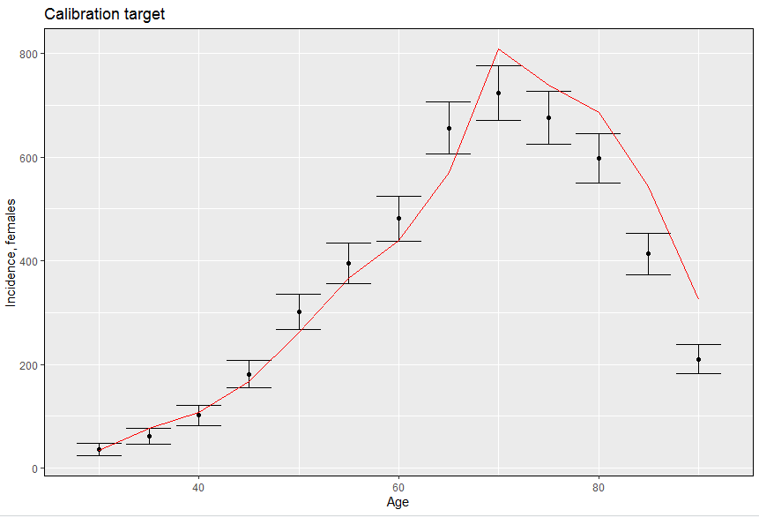 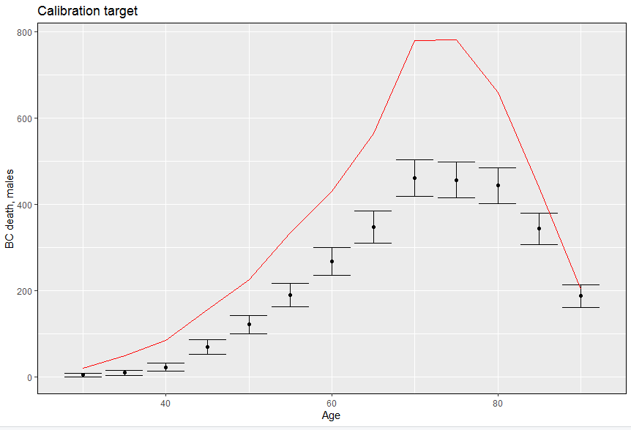 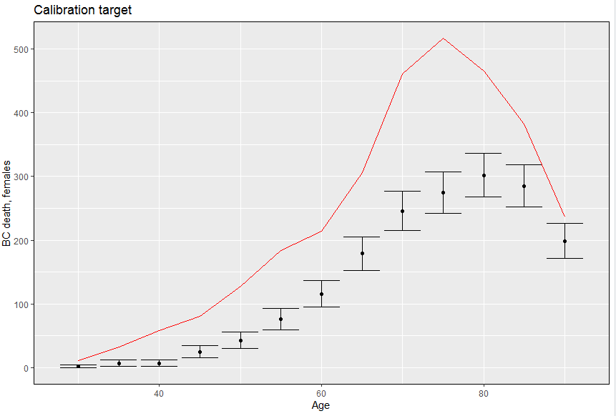

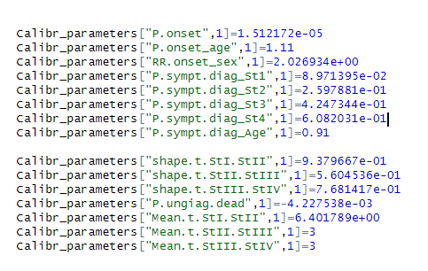

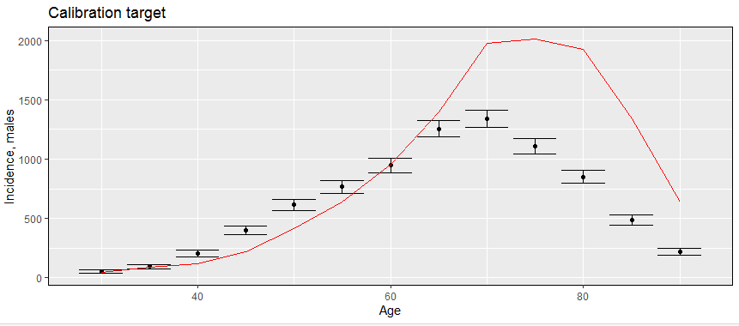

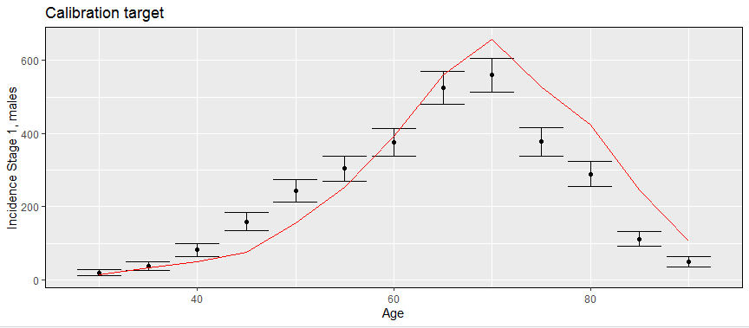

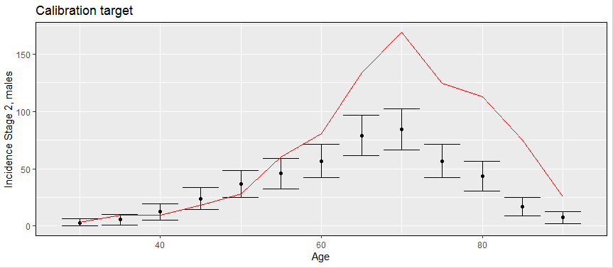

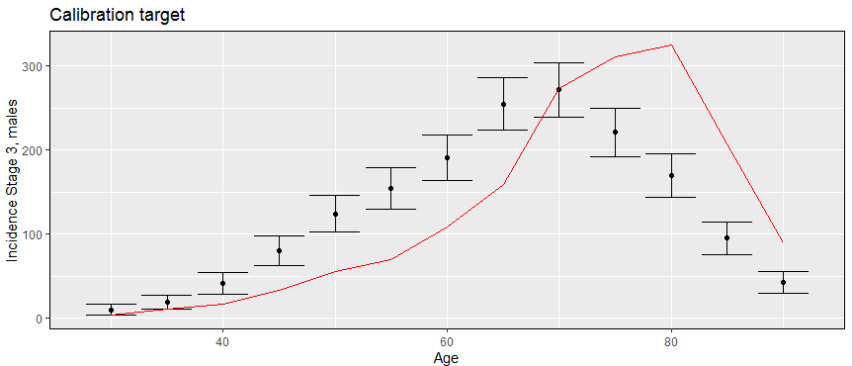

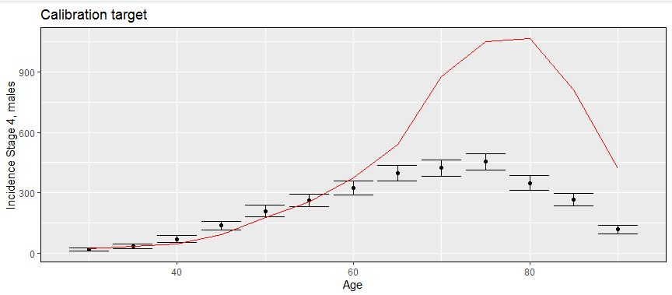

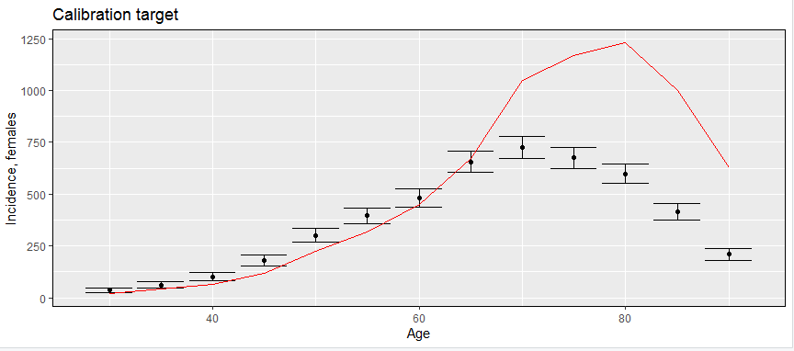

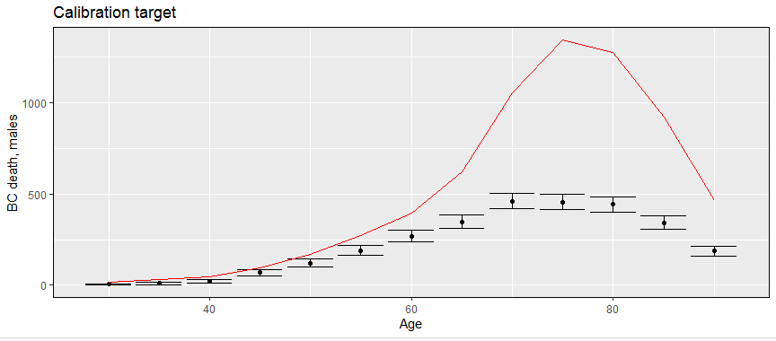

**BLADDER**

**Calibr_parameters["P.onset",1]=5.5E-06**

**Calibr_parameters["P.onset_low.risk",1]= 0.6376**

**Calibr_parameters["P.onset_age",1]=1.138**

**Calibr_parameters["RR.onset_sex",1]=3.64**

**Calibr_parameters["P.sympt.diag_LGBC",1]=0.171**

**Calibr_parameters["P.sympt.diag_St1",1]=0.15**

**Calibr_parameters["P.sympt.diag_St2",1]=0.25**

**Calibr_parameters["P.sympt.diag_St3",1]=0.3**

**Calibr_parameters["P.sympt.diag_St4",1]=0.34**

**Calibr_parameters["P.sympt.diag_Age",1]= 0.91**

**Calibr_parameters["shape.t.StI.StII",1]=1**

**Calibr_parameters["shape.t.StII.StIII",1]= 1**

**Calibr_parameters["shape.t.StIII.StIV",1]= 1**

**Calibr_parameters["P.LGtoHGBC",1]= 2.555e-03**

**Calibr_parameters["P.ungiag.dead",1]=-0.0051**

**Calibr_parameters["Mean.t.StI.StII",1]= 4.9**

**Calibr_parameters["Mean.t.StII.StIII",1]=4.2**

**Calibr_parameters["Mean.t.StIII.StIV",1]=4**

