

Министерство образования и молодежной политики Свердловской области

ГАПОУ СО «Екатеринбургский колледж транспортного строительства»

Отчёт по учебной практике

УП 01.01

Выполнила:Оберюхтина Елена

Группа: ПР-31

Преподаватель: Мирошниченко Г.В.

2023

**Задание:**Используя Recyclwiev и fragment (навигацию по фрагментам),

создать приложение:«Список дел за период (с расшифровкой)»

**Входные данные:**

dateEditText:пользователь вводит данные о дате дела

amountEditText:пользователь вводит данные о название дела

spinnerImportance:пользователь выбирает важность дела

**Листинг программы:**

ExpenseItem:

data class ExpenseItem (  
 val date: String,  
 val amount: String,  
 )

Fragment1:

package com.example.zd1_2  
  
import android.content.Context  
import android.os.Bundle  
import android.support.v4.app.Fragment  
import android.support.v7.widget.LinearLayoutManager  
import android.support.v7.widget.RecyclerView  
import android.view.LayoutInflater  
import android.view.View  
import android.view.ViewGroup  
import android.widget.Button  
import android.widget.EditText  
import android.widget.Toast  
import androidx.navigation.fragment.NavHostFragment  
import com.google.gson.Gson  
import com.google.gson.reflect.TypeToken  
  
// *TODO: Rename parameter arguments, choose names that match*// the fragment initialization parameters, e.g. ARG_ITEM_NUMBER  
private const val *ARG_PARAM1* = "param1"  
private const val *ARG_PARAM2* = "param2"  
  
*/**  
 * A simple [Fragment] subclass.  
 * Use the [Fragment1.newInstance] factory method to  
 * create an instance of this fragment.  
 */*class Fragment1 : Fragment() {  
 // *TODO: Rename and change types of parameters* private var param1: String? = null  
 private var param2: String? = null  
  
 override fun onCreate(savedInstanceState: Bundle?) {  
 super.onCreate(savedInstanceState)  
 *arguments*?.*let* **{** param1 = **it**.getString(*ARG_PARAM1*)  
 param2 = **it**.getString(*ARG_PARAM2*)  
 **}** }  
 private lateinit var dateEditText: EditText  
 private lateinit var amountEditText: EditText  
 private lateinit var addButton: Button  
 private lateinit var recyclerView: RecyclerView  
  
 private val tasks = *mutableListOf*<ExpenseItem>()  
 private lateinit var taskAdapter:TaskAdapter  
  
 override fun onCreateView(  
 inflater: LayoutInflater, container: ViewGroup?,  
 savedInstanceState: Bundle?  
 ): View? {  
 val binding = inflater.inflate(R.layout.*fragment_1*, container, false)  
 dateEditText = binding.findViewById(R.id.*editTextDate*)  
 amountEditText = binding.findViewById(R.id.*editTextTask*)  
 addButton = binding.findViewById(R.id.*buttonAddTask*)  
 recyclerView = binding.findViewById(R.id.*listView*)  
  
 loadExpenseList()  
 taskAdapter = TaskAdapter(tasks, this)  
 recyclerView.*adapter* = taskAdapter  
 recyclerView.*layoutManager* = LinearLayoutManager(*activity*)  
  
 addButton.setOnClickListener **{** addExpense()  
 **}** return binding  
 }  
 fun onExpenseItemClick(expenseItem: ExpenseItem) {  
 // Обработка нажатия на элемент списка  
 val bundle = Bundle()  
 bundle.putString("date", expenseItem.date)  
 bundle.putString("amount", expenseItem.amount)  
  
 val navController = NavHostFragment.findNavController(this)  
 navController.navigate(R.id.*action_fragment1_to_fragment2*, bundle)  
 }  
 private fun addExpense() {  
 val date = dateEditText.*text*.toString()  
 val amount = amountEditText.*text*.toString()  
  
 if (date.*isNotEmpty*() && amount != null) {  
 val expenseItem = ExpenseItem(date, amount)  
 tasks.add(expenseItem)  
 saveExpenseList()  
 taskAdapter.notifyDataSetChanged()  
  
 // Очищаем поля ввода  
 dateEditText.*text*.clear()  
 amountEditText.*text*.clear()  
 } else {  
 Toast.makeText(*activity*, "Введите корректные данные", Toast.*LENGTH_SHORT*).show()  
 }  
  
 loadExpenseList()  
 }  
  
 private fun saveExpenseList() {  
 val gson = Gson()  
 val json = gson.toJson(tasks)  
  
 val preferences = *activity*?.getPreferences(Context.*MODE_PRIVATE*)  
 preferences?.edit()?.putString("expenseList", json)?.apply()  
 }  
 private fun loadExpenseList() {  
 val preferences = *activity*?.getPreferences(Context.*MODE_PRIVATE*)  
 val json = preferences?.getString("expenseList", "")  
 val type = object : TypeToken<List<ExpenseItem>>() {}.*type* tasks.clear()  
 tasks.addAll(Gson().fromJson(json, type) ?: *emptyList*())  
  
 // Убедимся, что адаптер и RecyclerView не null перед обновлением  
 if (::taskAdapter.*isInitialized* && recyclerView.*adapter* != null) {  
 taskAdapter.notifyDataSetChanged()  
 }  
 }  
 companion object {  
  
 */**  
 * Use this factory method to create a new instance of  
 * this fragment using the provided parameters.  
 *  
 \** ***@param*** *param1 Parameter 1.  
 \** ***@param*** *param2 Parameter 2.  
 \** ***@return*** *A new instance of fragment Fragment1.  
 */* // *TODO: Rename and change types and number of parameters* @JvmStatic  
 fun newInstance(param1: String, param2: String) =  
 Fragment1().*apply* **{** *arguments* = Bundle().*apply* **{** putString(*ARG_PARAM1*, param1)  
 putString(*ARG_PARAM2*, param2)  
 **}  
 }** }  
}

Fragment2:

package com.example.zd1_2  
  
import android.content.Context  
import android.os.Bundle  
import android.support.v4.app.Fragment  
import android.support.v7.widget.LinearLayoutManager  
import android.support.v7.widget.RecyclerView  
import android.view.LayoutInflater  
import android.view.View  
import android.view.ViewGroup  
import android.widget.Button  
import android.widget.EditText  
import android.widget.Spinner  
import android.widget.TextView  
import android.widget.Toast  
import androidx.navigation.fragment.NavHostFragment  
import com.google.gson.Gson  
import com.google.gson.reflect.TypeToken  
import android.widget.ArrayAdapter  
  
// *TODO: Rename parameter arguments, choose names that match*// the fragment initialization parameters, e.g. ARG_ITEM_NUMBER  
private const val *ARG_PARAM1* = "param1"  
private const val *ARG_PARAM2* = "param2"  
  
*/**  
 * A simple [Fragment] subclass.  
 * Use the [Fragment2.newInstance] factory method to  
 * create an instance of this fragment.  
 */*class Fragment2 : Fragment() {  
 // *TODO: Rename and change types of parameters* private var param1: String? = null  
 private var param2: String? = null  
  
 override fun onCreate(savedInstanceState: Bundle?) {  
 super.onCreate(savedInstanceState)  
 *arguments*?.*let* **{** param1 = **it**.getString(*ARG_PARAM1*)  
 param2 = **it**.getString(*ARG_PARAM2*)  
 **}** }  
 private lateinit var textAllTxt: TextView  
 private lateinit var spinnerImportance: Spinner  
 private lateinit var amountEditText: EditText  
 private lateinit var addButton: Button  
 private lateinit var recyclerView:RecyclerView  
 private val tasks = *mutableListOf*<ExpenseItem>()  
 private lateinit var taskAdapter: TaskAdapterTwo  
 override fun onCreateView(  
 inflater: LayoutInflater, container: ViewGroup?,  
 savedInstanceState: Bundle?  
 ): View? {  
 // Inflate the layout for this fragment  
  
 val binding = inflater.inflate(R.layout.*fragment_2*, container, false)  
  
 textAllTxt = binding.findViewById(R.id.*textView*)  
  
  
 val date = *arguments*?.getString("date", "") ?: ""  
 val amount = *arguments*?.getString("amount", "") ?: ""  
 textAllTxt.*text* = "Дата: "+ date + "\nНазвание:" + "$amount"  
  
 spinnerImportance = binding.findViewById(R.id.*spinnerImportance*)  
 amountEditText = binding.findViewById(R.id.*editTextAmount*)  
 addButton = binding.findViewById(R.id.*buttonSave*)  
 recyclerView = binding.findViewById(R.id.*listView*)  
 val adapter = ArrayAdapter.createFromResource(  
 requireContext(),  
 R.array.*importance_options*,  
 android.R.layout.*simple_spinner_item* )  
  
 adapter.setDropDownViewResource(android.R.layout.*simple_spinner_dropdown_item*)  
 spinnerImportance.*adapter* = adapter  
 loadExpenseList()  
  
 taskAdapter = TaskAdapterTwo(tasks)  
 recyclerView.*adapter* = taskAdapter  
 recyclerView.*layoutManager* = LinearLayoutManager(*activity*)  
  
 addButton.setOnClickListener **{** addExpense()  
 **}** return binding  
 }  
 fun onExpenseItemClick(expenseItem: ExpenseItem) {  
 // Обработка нажатия на элемент списка  
 val bundle = Bundle()  
 bundle.putString("date", expenseItem.date)  
 bundle.putString("amount", expenseItem.amount)  
  
 val navController = NavHostFragment.findNavController(this)  
 navController.navigate(R.id.*action_fragment1_to_fragment2*, bundle)  
 }  
 private fun addExpense() {  
 val date = spinnerImportance.*selectedItem*.toString()  
 val amount = amountEditText.*text*.toString()  
  
 if (date.*isNotEmpty*() && amount != null) {  
 val expenseItem = ExpenseItem(date, amount)  
 tasks.add(expenseItem)  
 saveExpenseList()  
 taskAdapter.notifyDataSetChanged()  
  
 // Очищаем поля ввода  
  
 amountEditText.*text*.clear()  
 } else {  
 Toast.makeText(*activity*, "Введите корректные данные", Toast.*LENGTH_SHORT*).show()  
 }  
 }  
  
 private fun saveExpenseList() {  
 val gson = Gson()  
 val json = gson.toJson(tasks)  
  
 val preferences = *activity*?.getPreferences(Context.*MODE_PRIVATE*)  
 preferences?.edit()?.putString("expenseList1", json)?.apply()  
 }  
  
 private fun loadExpenseList() {  
 val preferences = *activity*?.getPreferences(Context.*MODE_PRIVATE*)  
 val json = preferences?.getString("expenseList1", "")  
 val type = object : TypeToken<List<ExpenseItem>>() {}.*type* tasks.clear()  
 tasks.addAll(Gson().fromJson(json, type) ?: *emptyList*())  
 }  
 companion object {  
  
 */**  
 * Use this factory method to create a new instance of  
 * this fragment using the provided parameters.  
 *  
 \** ***@param*** *param1 Parameter 1.  
 \** ***@param*** *param2 Parameter 2.  
 \** ***@return*** *A new instance of fragment Fragment2.  
 */* // *TODO: Rename and change types and number of parameters* @JvmStatic  
 fun newInstance(param1: String, param2: String) =  
 Fragment2().*apply* **{** *arguments* = Bundle().*apply* **{** putString(*ARG_PARAM1*, param1)  
 putString(*ARG_PARAM2*, param2)  
 **}  
 }** }  
}

MainActivity:

package com.example.zd1_2  
  
import android.support.v7.app.AppCompatActivity  
import android.os.Bundle  
import android.support.design.widget.NavigationView  
import androidx.navigation.fragment.NavHostFragment  
import androidx.navigation.ui.setupWithNavController  
  
class MainActivity : AppCompatActivity() {  
  
 override fun onCreate(savedInstanceState: Bundle?) {  
 super.onCreate(savedInstanceState)  
 setContentView(R.layout.*activity_main*)  
 val host:NavHostFragment=*supportFragmentManager* .findFragmentById(R.id.*navFragment*)as NavHostFragment? ?:return  
 val navController=host.*navController* val sideBar=findViewById<NavigationView>(R.id.*nav_view*)  
 sideBar?.*setupWithNavController*(navController)  
  
 }  
  
  
}

TaskAdapter:

package com.example.zd1_2  
  
import android.support.v7.widget.RecyclerView  
import android.view.LayoutInflater  
import android.view.View  
import android.view.ViewGroup  
  
import android.widget.TextView  
  
class TaskAdapter(private val expenseList: List<ExpenseItem>,  
 private val clickListener: Fragment1  
) :  
 RecyclerView.Adapter<TaskAdapter.ExpenseViewHolder>() {  
  
 override fun onCreateViewHolder(parent: ViewGroup, viewType: Int): ExpenseViewHolder {  
 val view =  
 LayoutInflater.from(parent.*context*).inflate(R.layout.*list_item_task*, parent, false)  
 return ExpenseViewHolder(view)  
 }  
  
 override fun onBindViewHolder(holder: ExpenseViewHolder, position: Int) {  
 val expense = expenseList[position]  
 holder.bind(expense)  
  
 // Обработка нажатия на элемент списка  
 holder.itemView.setOnClickListener **{** clickListener.onExpenseItemClick(expense)  
 **}** }  
  
 override fun getItemCount(): Int {  
 return expenseList.size  
 }  
  
 class ExpenseViewHolder(itemView: View) : RecyclerView.ViewHolder(itemView) {  
 private val dateTextView: TextView = itemView.findViewById(R.id.*dateTextView*)  
 private val amountTextView: TextView = itemView.findViewById(R.id.*descriptionTextView*)  
  
 fun bind(expense: ExpenseItem) {  
 dateTextView.*text* = expense.date.toString()  
 amountTextView.*text* = expense.amount.toString()  
 }  
 }  
}

TaskAdapterTwo:

package com.example.zd1_2  
  
import android.support.v7.widget.RecyclerView  
import android.view.LayoutInflater  
import android.view.View  
import android.view.ViewGroup  
import android.widget.TextView  
  
class TaskAdapterTwo (private val expenseList: List<ExpenseItem>) :  
 RecyclerView.Adapter<TaskAdapterTwo.ExpenseViewHolder>() {  
  
 override fun onCreateViewHolder(parent: ViewGroup, viewType: Int): ExpenseViewHolder {  
 val view =  
 LayoutInflater.from(parent.*context*).inflate(R.layout.*list_item_task*, parent, false)  
 return ExpenseViewHolder(view)  
 }  
  
 override fun onBindViewHolder(holder: ExpenseViewHolder, position: Int) {  
 val expense = expenseList[position]  
 holder.bind(expense)  
 }  
  
 override fun getItemCount(): Int {  
 return expenseList.size  
 }  
  
 class ExpenseViewHolder(itemView: View) : RecyclerView.ViewHolder(itemView) {  
 private val dateTextView: TextView = itemView.findViewById(R.id.*dateTextView*)  
 private val amountTextView: TextView = itemView.findViewById(R.id.*descriptionTextView*)  
  
 fun bind(expense: ExpenseItem) {  
 dateTextView.*text* = expense.date.toString()  
 amountTextView.*text* = expense.amount.toString()  
 }  
 }  
}

activity_main:

<?xml version="1.0" encoding="utf-8"?>  
<android.support.v4.widget.DrawerLayout xmlns:android="http://schemas.android.com/apk/res/android"  
 xmlns:app="http://schemas.android.com/apk/res-auto"  
 android:id="@+id/drawer_layout"  
 android:layout_width="match_parent"  
 android:layout_height="match_parent"  
 android:fitsSystemWindows="true">  
 <LinearLayout  
 android:layout_width="match_parent"  
 android:layout_height="match_parent"  
 android:orientation="vertical">  
 <android.support.v7.widget.Toolbar  
 android:id="@+id/toolbar2"  
 android:layout_width="match_parent"  
 android:layout_height="wrap_content"  
 android:background="?attr/colorPrimary"  
 android:minHeight="?attr/actionBarSize"  
 android:theme="?attr/actionBarTheme" />  
 <fragment  
 android:name="androidx.navigation.fragment.NavHostFragment"  
 android:layout_width="match_parent"  
 android:layout_height="match_parent"  
 app:navGraph="@navigation/routes"  
 app:defaultNavHost="true"  
 android:id="@+id/navFragment"/>  
 </LinearLayout>  
  
  
 <android.support.design.widget.NavigationView  
 android:id="@+id/nav_view"  
 android:layout_width="wrap_content"  
 android:layout_height="match_parent"  
 android:layout_gravity="start"  
 android:fitsSystemWindows="true"  
 app:menu="@menu/drawer_menu"/>  
  
  
  
  
</android.support.v4.widget.DrawerLayout>

fragment_1:

<?xml version="1.0" encoding="utf-8"?>  
<LinearLayout xmlns:android="http://schemas.android.com/apk/res/android"  
 xmlns:tools="http://schemas.android.com/tools"  
 android:layout_width="match_parent"  
 android:layout_height="match_parent"  
 tools:context=".Fragment1"  
 android:orientation="vertical"  
 android:background="@color/purple_200">  
 <LinearLayout  
  
 android:id="@+id/inputLayout"  
 android:layout_width="match_parent"  
 android:layout_height="wrap_content"  
 android:orientation="vertical"  
 android:padding="16dp">  
 <TextView  
 android:layout_width="wrap_content"  
 android:layout_height="wrap_content"  
 android:text="Список дел"  
 android:textSize="20dp"/>  
 <EditText  
 android:id="@+id/editTextTask"  
 android:layout_width="match_parent"  
 android:layout_height="wrap_content"  
 android:hint="Введите название дело" />  
 <EditText  
 android:id="@+id/editTextDate"  
 android:layout_width="match_parent"  
 android:layout_height="wrap_content"  
 android:hint="Введите дату"  
 android:inputType="none"  
 android:onClick="showDatePickerDialog" />  
  
 <Button  
 android:id="@+id/buttonAddTask"  
 android:layout_width="match_parent"  
 android:layout_height="wrap_content"  
 android:text="Добавить дело"  
 android:background="@drawable/button"/>  
 </LinearLayout>  
  
 <android.support.v7.widget.RecyclerView  
 android:onClick="perehodTwo"  
 android:layout_marginTop="1dp"  
 android:id="@+id/listView"  
 android:layout_width="match_parent"  
 android:layout_height="wrap_content"  
 android:divider="@android:color/darker_gray"  
 android:dividerHeight="1dp"  
 android:paddingTop="10dp"  
 android:paddingBottom="10dp"  
 />  
  
  
  
</LinearLayout>

fragment_2:

<?xml version="1.0" encoding="utf-8"?>  
<LinearLayout xmlns:android="http://schemas.android.com/apk/res/android"  
 xmlns:tools="http://schemas.android.com/tools"  
 android:layout_width="match_parent"  
 android:layout_height="match_parent"  
 tools:context=".Fragment2"  
 android:orientation="vertical"  
 android:background="@color/purple_200">  
  
 <!-- *TODO: Update blank fragment layout* -->  
 <TextView  
 android:id="@+id/textView"  
 android:layout_width="wrap_content"  
 android:layout_height="wrap_content"  
 android:text="Cписок дел"/>  
 <Spinner  
 android:id="@+id/spinnerImportance"  
 android:layout_width="match_parent"  
 android:layout_height="wrap_content"  
 android:entries="@array/importance_options"/>  
  
 <EditText  
 android:id="@+id/editTextAmount"  
 android:layout_width="match_parent"  
 android:layout_height="wrap_content"  
 android:hint="Дополнительно"  
 android:textSize="25dp"  
 tools:layout_editor_absoluteX="-16dp"  
 tools:layout_editor_absoluteY="200dp" />  
  
  
 <android.support.v7.widget.RecyclerView  
 android:onClick="perehodTwo"  
 android:layout_marginTop="1dp"  
 android:id="@+id/listView"  
 android:layout_width="match_parent"  
 android:layout_height="300dp"  
 android:divider="@android:color/darker_gray"  
 android:dividerHeight="1dp"  
 android:paddingTop="10dp"  
 android:paddingBottom="10dp"/>  
 <Button  
 android:id="@+id/buttonSave"  
 android:layout_width="match_parent"  
 android:layout_height="wrap_content"  
 android:text="Сохранить"  
  
 />  
</LinearLayout>

list_item_task:

<?xml version="1.0" encoding="utf-8"?>  
<LinearLayout  
 xmlns:android="http://schemas.android.com/apk/res/android"  
 xmlns:app="http://schemas.android.com/apk/res-auto"  
 android:layout_width="match_parent"  
 android:layout_height="wrap_content"  
 android:orientation="horizontal">  
  
 <TextView  
 android:id="@+id/descriptionTextView"  
 android:layout_width="250dp"  
 android:layout_height="wrap_content"  
 android:textSize="20dp"  
 />  
  
 <TextView  
 android:id="@+id/dateTextView"  
 android:layout_width="150dp"  
 android:layout_height="wrap_content"  
 android:textSize="20dp"  
 />  
  
</LinearLayout>

Strings:

<resources>  
 <string name="app_name">zd1_2</string>  
 <!-- *TODO: Remove or change this placeholder text* -->  
 <string name="hello_blank_fragment">Hello blank fragment</string>  
 <string-array name="importance_options">  
 <item>Важен</item>  
 <item>Второстепенное</item>  
 </string-array>  
</resources>

Библиотеки:

dependencies **{** implementation 'com.google.code.gson:gson:2.9.0'  
 //noinspection GradleCompatible  
 implementation 'com.android.support:appcompat-v7:28.0.0'  
 implementation 'com.android.support.constraint:constraint-layout:2.0.4'  
 testImplementation 'junit:junit:4.13.2'  
 androidTestImplementation 'com.android.support.test:runner:1.0.2'  
 androidTestImplementation 'com.android.support.test.espresso:espresso-core:3.0.2'  
 def nav_version = "1.0.0"  
 implementation "android.arch.navigation:navigation-fragment-ktx:$nav_version"  
 implementation "android.arch.navigation:navigation-ui-ktx:$nav_version"  
 //noinspection GradleCompatible  
 implementation 'com.android.support:design:28.0.0'  
**}**

**Проверки:**

Проверка на пустоту:

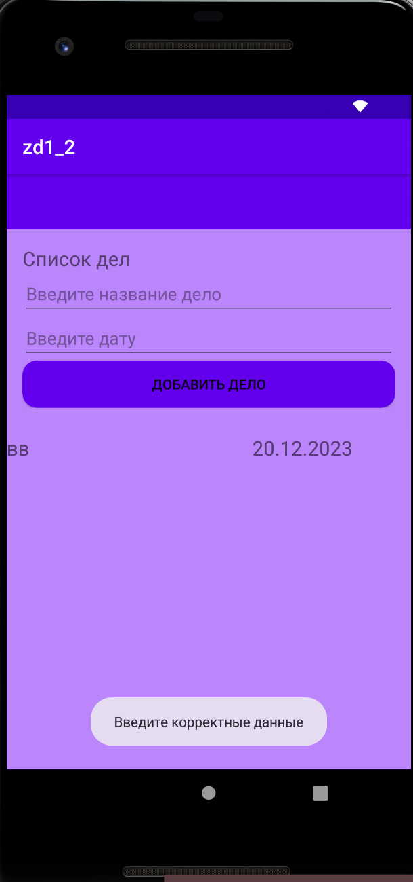

**Экраны:**

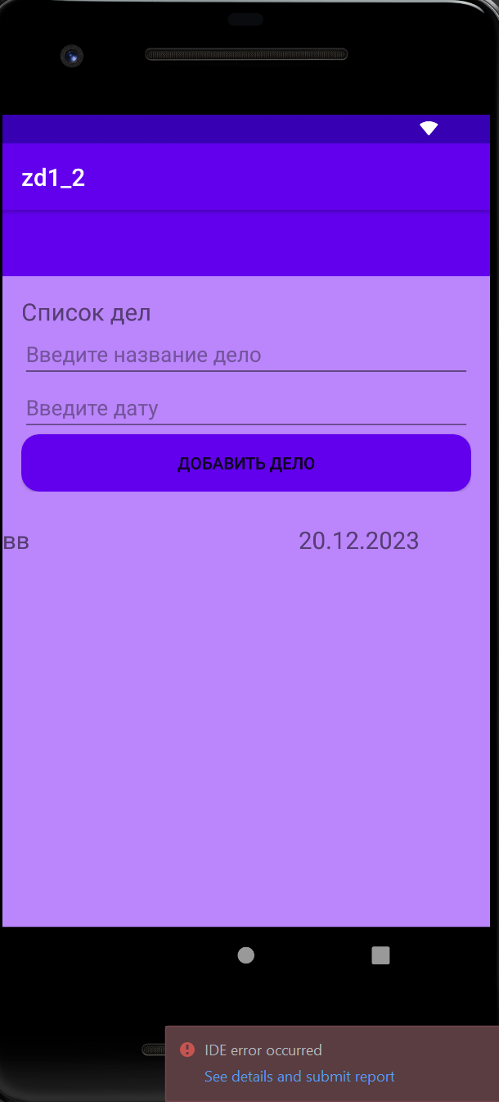

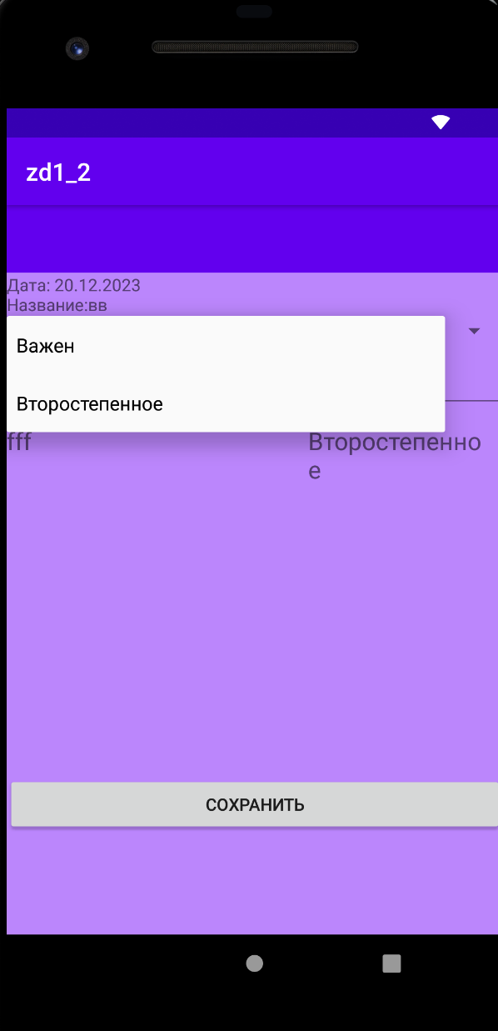

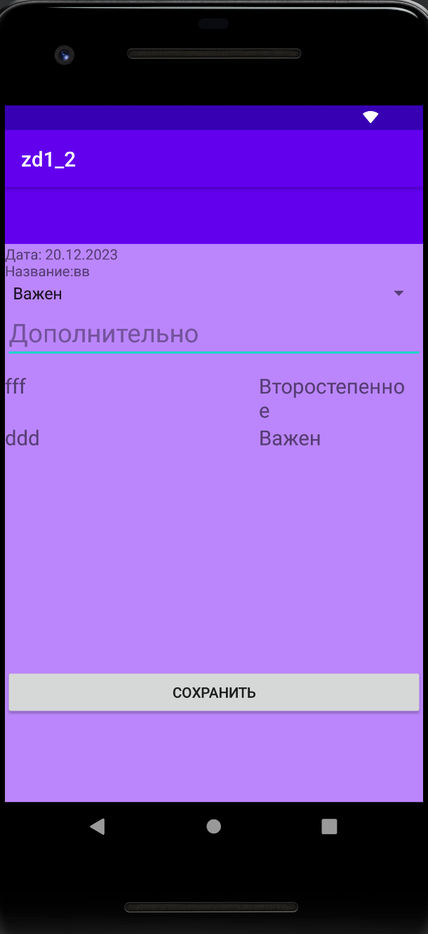

## **Вывод:** Научилась работать с фрагментами и навигацией.