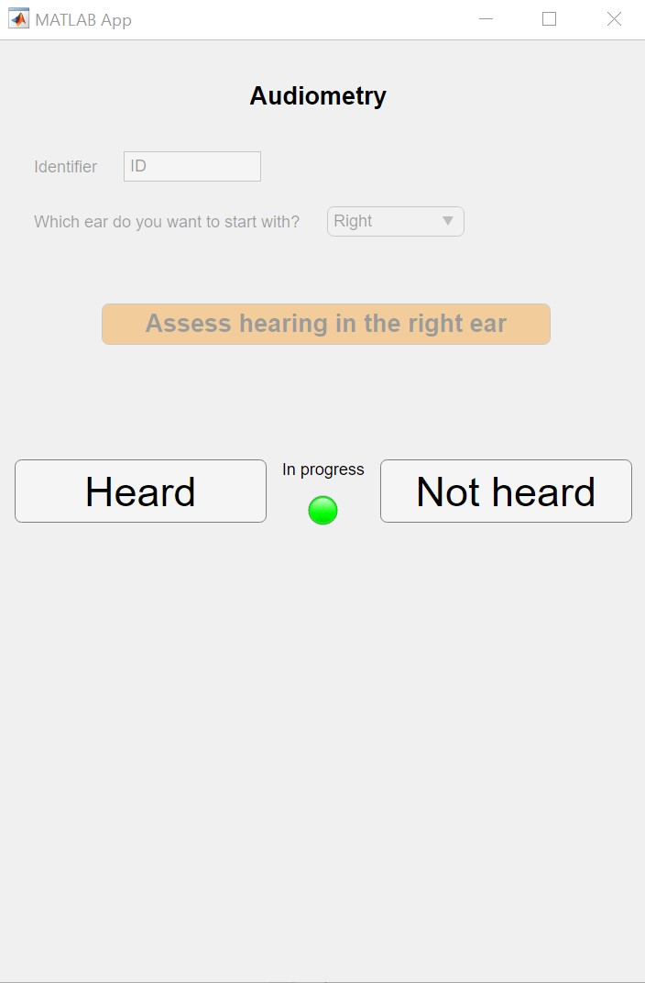

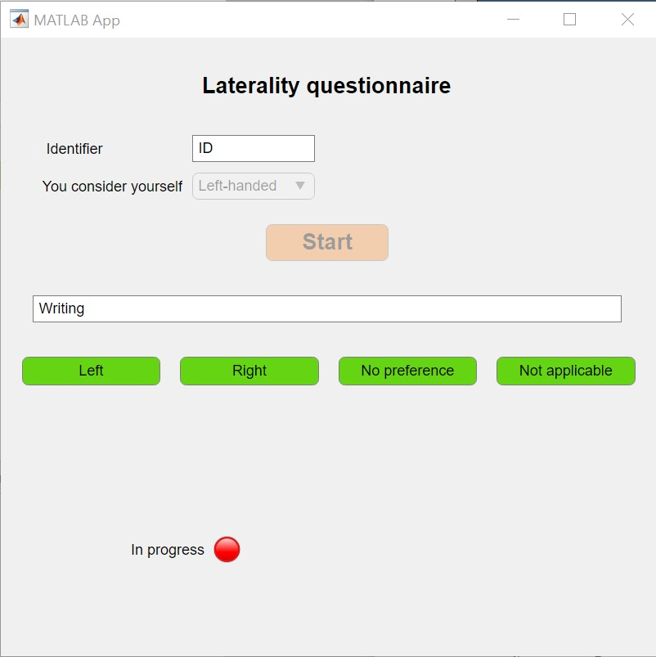

* Writing
* Throwing
* Using a comb
* Opening a box (holding the lid)
* Dealing cards (card being dealt)
* Holding a bottle
* Holding a glass
* Putting the key in the lock
* Playing ball
* Pointing precisely (to a place, for example)
* Using a remote control
* Stapling sheets of paper (hand holding the stapler)

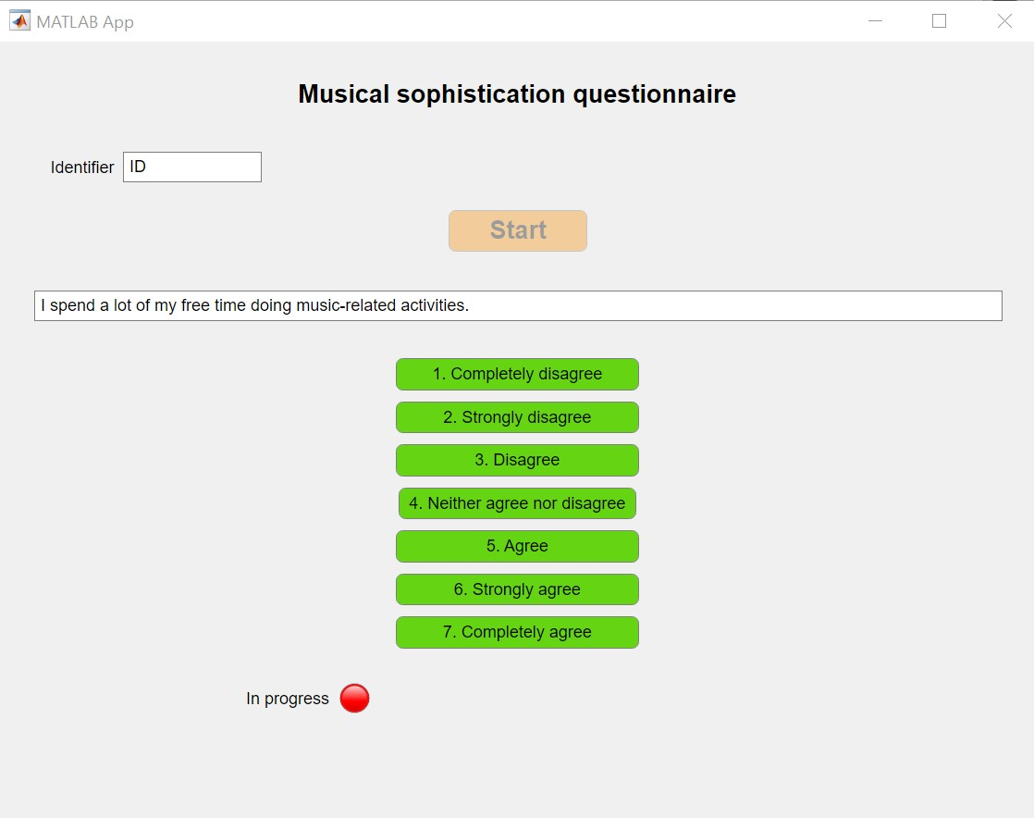

* I spend a lot of my free time doing music-related activities.
* I enjoy writing about music, for example on blogs and forums.
* If somebody starts singing a song I don’t know, I can usually join in.
* I am able to hit the right notes when I sing along with a recording.
* I can compare and discuss differences between two performances or versions of the same piece of music.
* I have never been complimented for my talents as a musical performer.
* I often read or search the internet for things related to music.
* I am not able to sing in harmony when somebody is singing a familiar tune.
* I am able to identify what is special about a given musical piece.
* When I sing, I have no idea whether I’m in tune or not.
* Music is king of an addiction for me – I couldn’t live without it.
* I don’t like singing in public because I’m afraid that I would sing wrong notes.
* I would not consider myself a musician.
* After hearing a new song two or three times, I can usually sing it by myself.
* I engaged in regular, daily practice of a musical instrument (including voice) for 0 / 1 / 2 / 3 / 4-5 / 6-9 / 10 or more years.
* At the peak of my interest, I practiced 0 / 0.5 / 1 / 1.5 / 2 / 3-4 / 5 or more hours per day on my primary instrument.
* I can play 0 / 1 / 2 / 3 / 4 / 5 / 6 or more musical instruments.

