Created by Sam Tokheim

16April2013

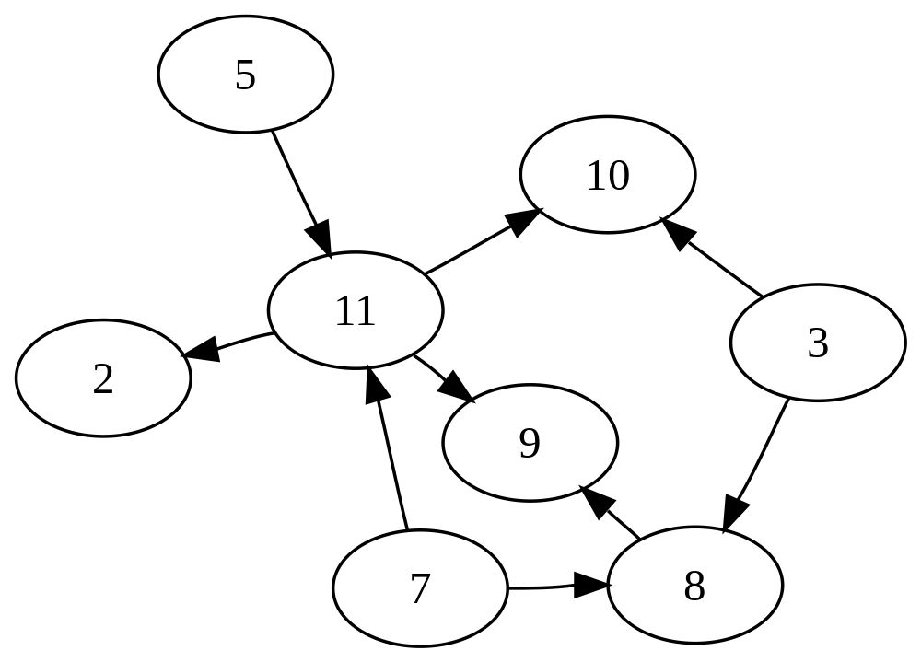

1.

#2 3 5 7 8 9 1011

[

[0 0 0 0 0 0 0 0]

[0 0 0 0 1 0 1 0]

[0 0 0 0 0 0 0 1]

[0 0 0 0 1 0 0 1]

[0 0 0 0 0 1 0 0]

[0 0 0 0 0 0 0 0]

[0 0 0 0 0 0 0 0]

[1 0 0 0 0 1 1 0]

]

{2:[]}

{3:[8,10]}

{5:[11]}

{7:[8,11]}

{8:[9]}

{9:[]}

{10:[]}

{11:[2,9,10]}

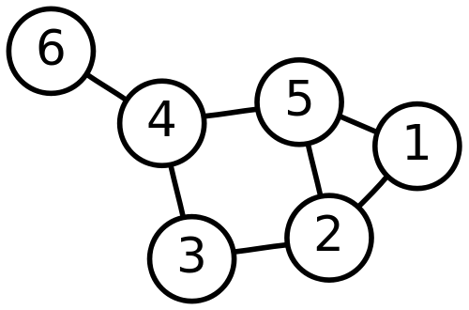

2.

1 2 3 4 5 6

[

[0 1 0 0 1 0]

[1 0 1 0 1 0]

[0 1 0 1 0 0]

[0 0 1 0 1 1]

[1 1 0 1 0 0]

[0 0 0 1 0 0]

]

{1:[2,5]}

{2:[1,3,5]}

{3:[2,4]}

{4:[3,5,6]}

{5:[1,2,4]}

{6:[4]}