**HOMEWORK #1**

**TASK #1**

1. git download

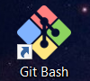

2. creating new repository



3. cloning repo to pc







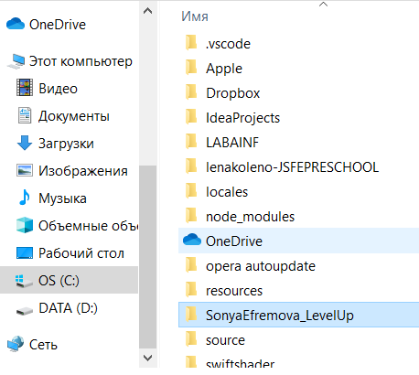

4. creating txt file in local repo with text: “# SonyaEfremova_LevelUp”



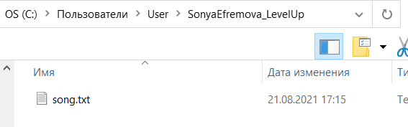

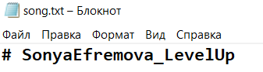

5. writing a piece of fav song in file song.txt

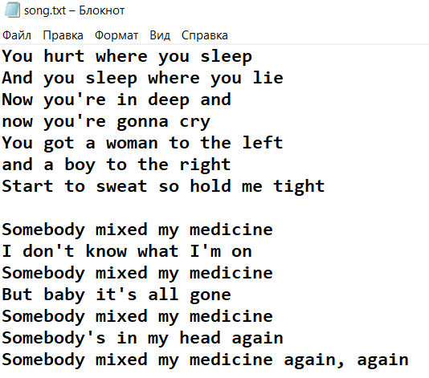

6. initialized empty git repo

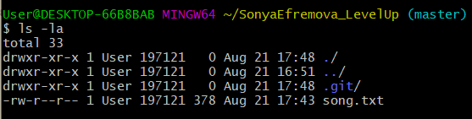

7. 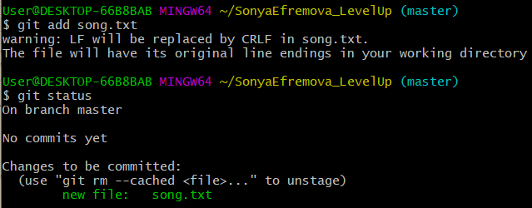

8. do a commit

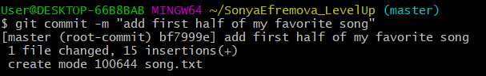

9. upload file to server

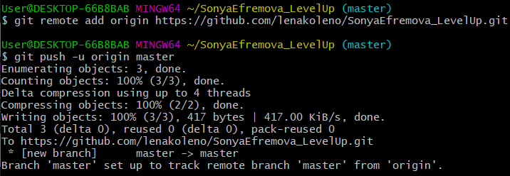

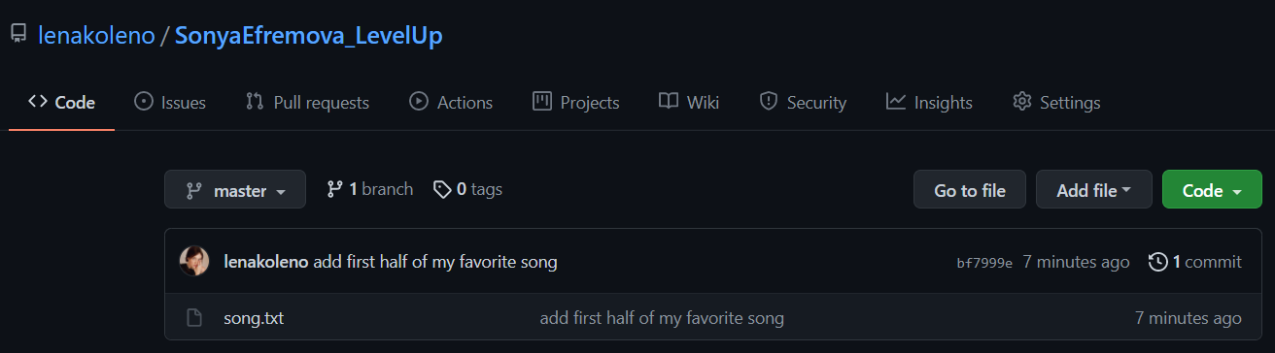

10. create new commit from github

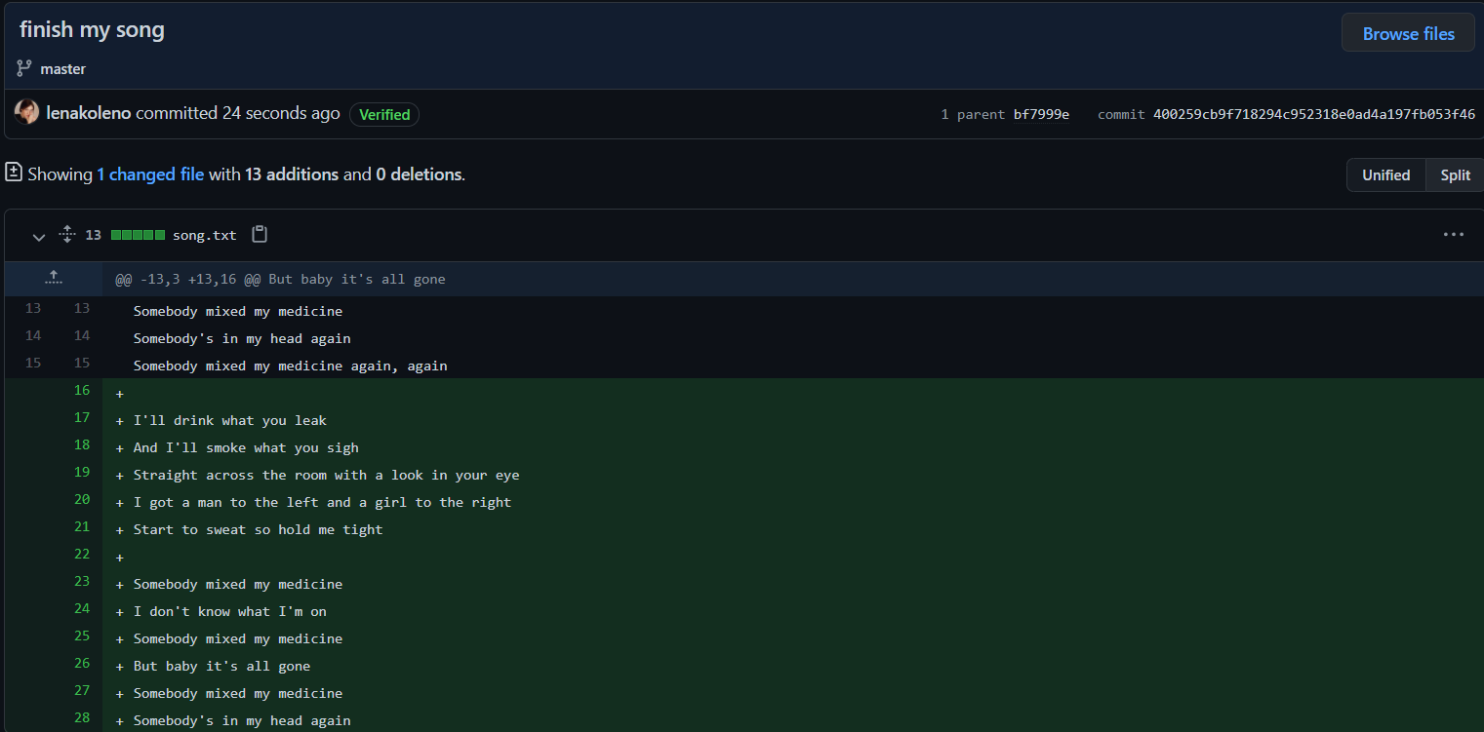

11. update the local version of a repository from a remote

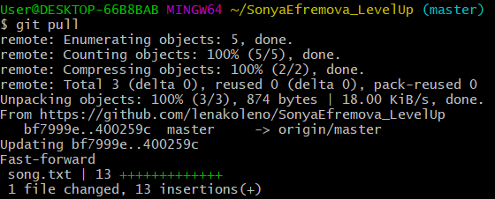

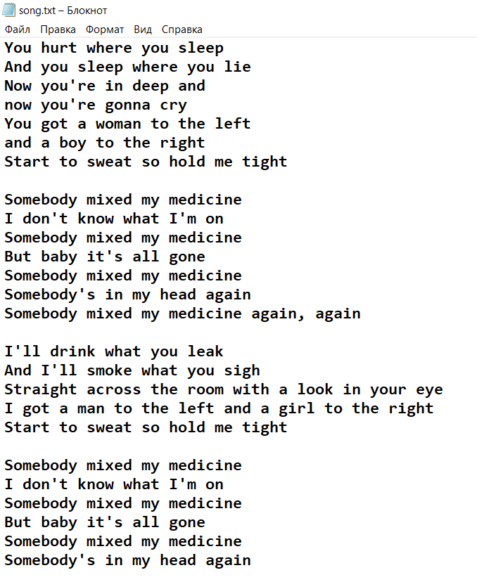

**TASK #2**

1. creating new branch

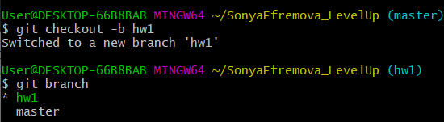

2. creating two new commits

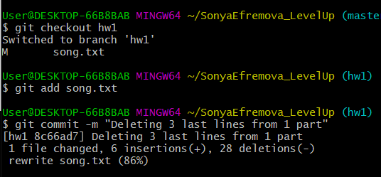

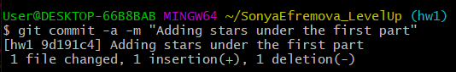

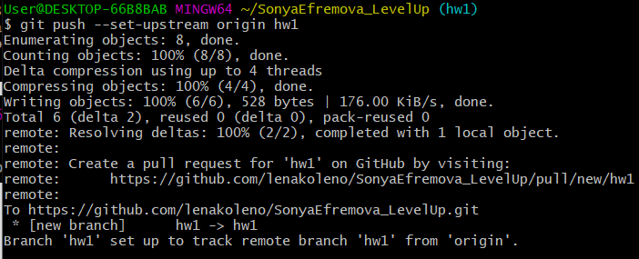

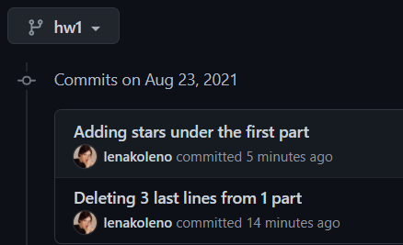

3. merge

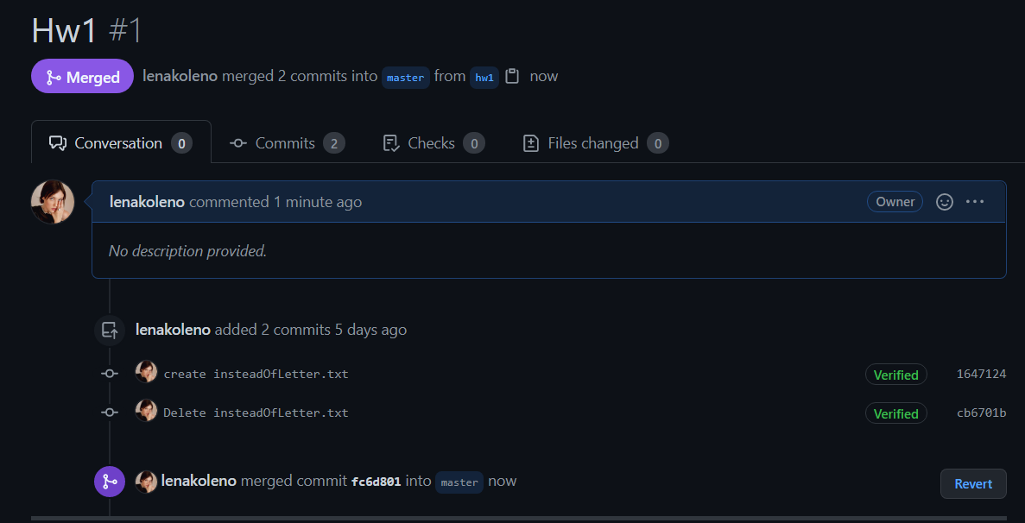

4. creating file with text in branch hw1

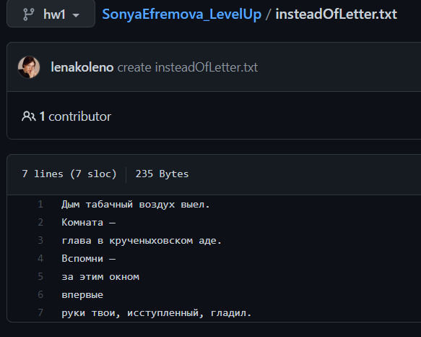

5. creating same file with another text in branch master

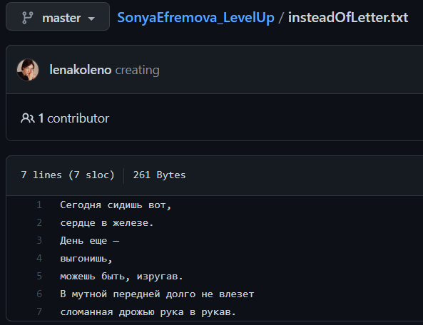

6. creating a conflict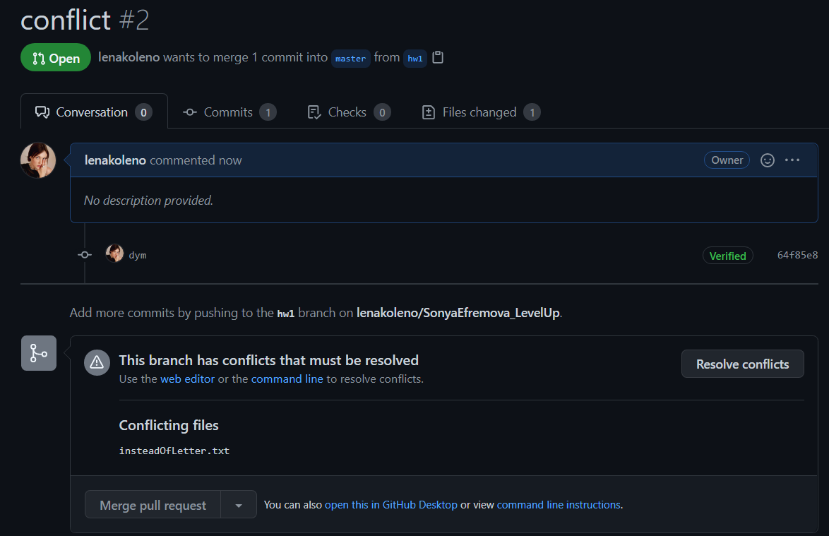

6. resolving conflict

