|  |
| --- |
|  |
| The Documentation |
| Vending Machine Website |
|  |
| **Nguyen Ngoc Tan Thuong** |
| **5/13/2018** |

1. Pages
   1. Page Tree

Home  
 01 - Login  
 02 - Forgot_Password_Screen  
 03 - Dashboard  
 04 - Machine Details  
 05 - CTID Management  
 06 - Customer Management  
 07 - User Management  
 08 - Transaction

* 1. Home
  2. 01 - Login
     1. User Interface

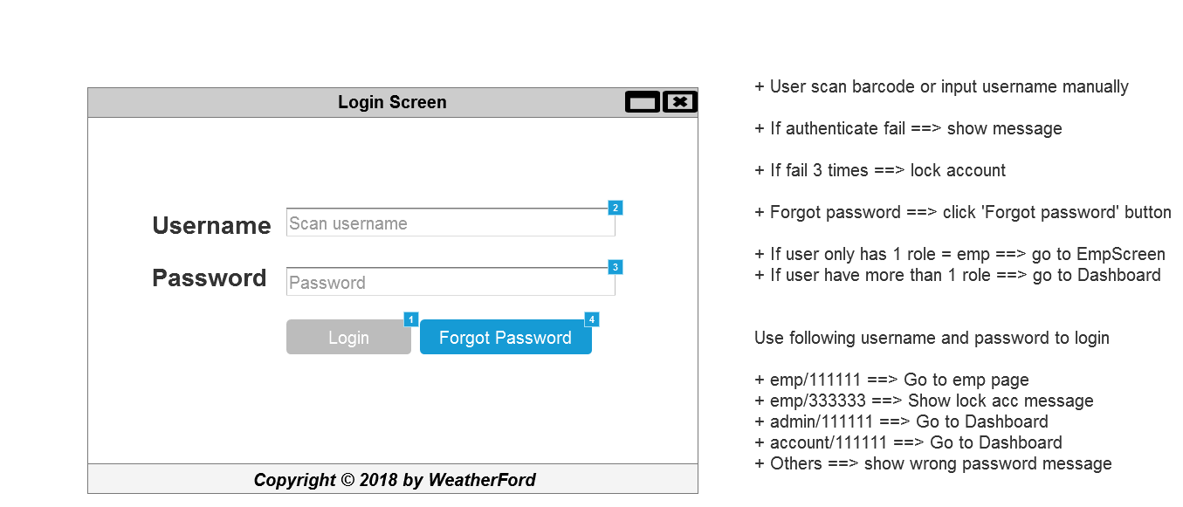

* + 1. Widget Table

|  |  |  |
| --- | --- | --- |
| Footnote | Name | Interactions |
| 1 | LoginButton | OnClick:  Case 5:  Open 03 - Dashboard in Current Window |
| 2 | UserName | OnTextChange:  Case 1  (If text on This does not equal """" and length of value of widget Password is greater than or equals "6"):  Set value of UserName equal to text on UserName  Enable LoginButton OnLostFocus:  Case 1  (If text on UserName equals ""):  Set text on Hint Username equal to "Username can not be blank"  Show Hint Username  Case 2  (Else If text on UserName does not equal ""):  Hide Hint Username |
| 3 | Password | OnTextChange:  Case 1  (If length of value of widget This is greater than or equals "6" and text on UserName does not equal """"):  Enable LoginButton OnLostFocus:  Case 1  (If length of value of widget Password is less than "6"):  Set text on Hint Pass equal to "Pwd length must greater than 6 chars"  Show Hint Pass  Case 2  (Else If text on Password does not equal ""):  Hide Hint Pass |
| 4 | ForgotPass | OnClick:  Case 1:  Open 02 - Forgot_Password_Screen in Current Window |

* 1. 02 - Forgot_Password_Screen
     1. User Interface

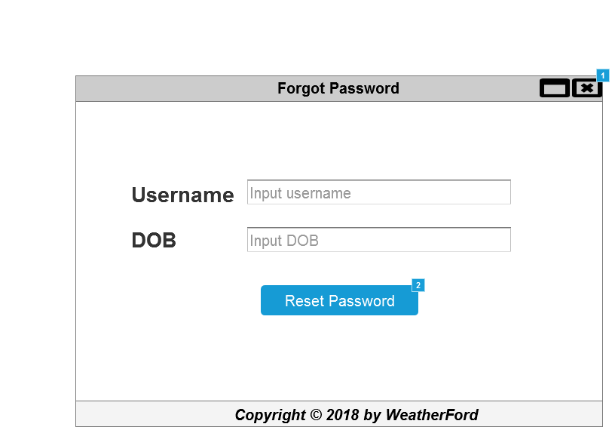

* + 1. Widget Table

|  |  |  |
| --- | --- | --- |
| Footnote | Name | Interactions |
| 1 |  | OnShow:  Case 1  (If text on UserName equals ""):  Disable Reset pass button |
| 2 | Reset pass button | OnClick:  Case 1:  Open 01 - Login in Current Window |

* 1. 03 - Dashboard
     1. User Interface

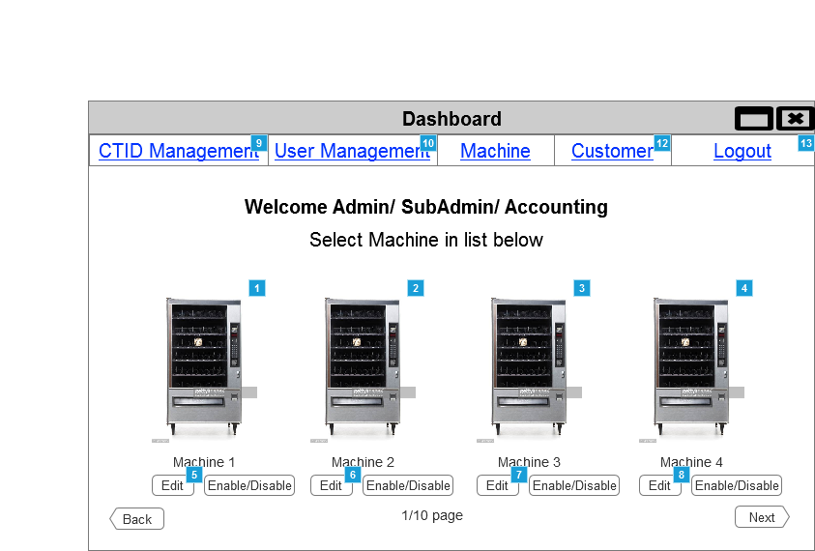

Menu Object

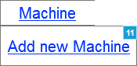

* + 1. Widget Table

|  |  |
| --- | --- |
| Footnote | Interactions |
| 1 | OnClick:  Case 1:  Open 04 - Machine Details in Current Window |
| 2 | OnClick:  Case 1:  Open 04 - Machine Details in Current Window |
| 3 | OnClick:  Case 1:  Open 04 - Machine Details in Current Window |
| 4 | OnClick:  Case 1:  Open 04 - Machine Details in Current Window |
| 5 | OnClick:  Case 1:  Open 04 - Machine Details in Current Window |
| 6 | OnClick:  Case 1:  Open 04 - Machine Details in Current Window |
| 7 | OnClick:  Case 1:  Open 04 - Machine Details in Current Window |
| 8 | OnClick:  Case 1:  Open 04 - Machine Details in Current Window |
| 9 | OnClick:  Case 1:  Open 05 - CTID Management in Current Window |
| 10 | OnClick:  Case 1:  Open 07 - User Management in Current Window |
| 11 | OnClick:  Case 1:  Open 04 - Machine Details in Current Window |
| 12 | OnClick:  Case 1:  Open 06 - Customer Management in Current Window |
| 13 | OnClick:  Case 1:  Open 01 - Login in Current Window |

* 1. 04 - Machine Details

OnPageLoad:  
 Case 1  
 (If value of UserName contains "acc"):  
 Enable/Disable Widget  
 Set value of Function equal to ""  
 Case 2  
 (Else If value of UserName contains "admin"):  
 Enable/Disable Widget  
 Case 3  
 (Else If True):  
 Enable/Disable Widget

* + 1. User Interface

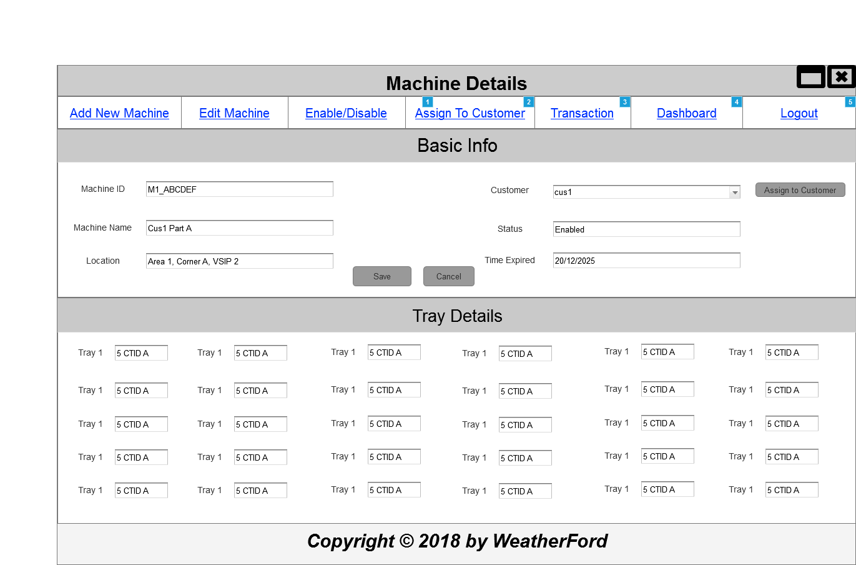

* + 1. Widget Table

|  |  |  |
| --- | --- | --- |
| Footnote | Name | Interactions |
| 1 |  | OnClick:  Case 1:  Open 01 - Login in Current Window |
| 2 |  | OnClick:  Case 1:  Set Focus on Widget |
| 3 |  | OnClick:  Case 1:  Open 08 - Transaction in Current Window |
| 4 |  | OnClick:  Case 1:  Open 03 - Dashboard in Current Window |
| 5 |  | OnClick:  Case 1:  Open 01 - Login in Current Window |

* 1. 05 - CTID Management
     1. User Interface

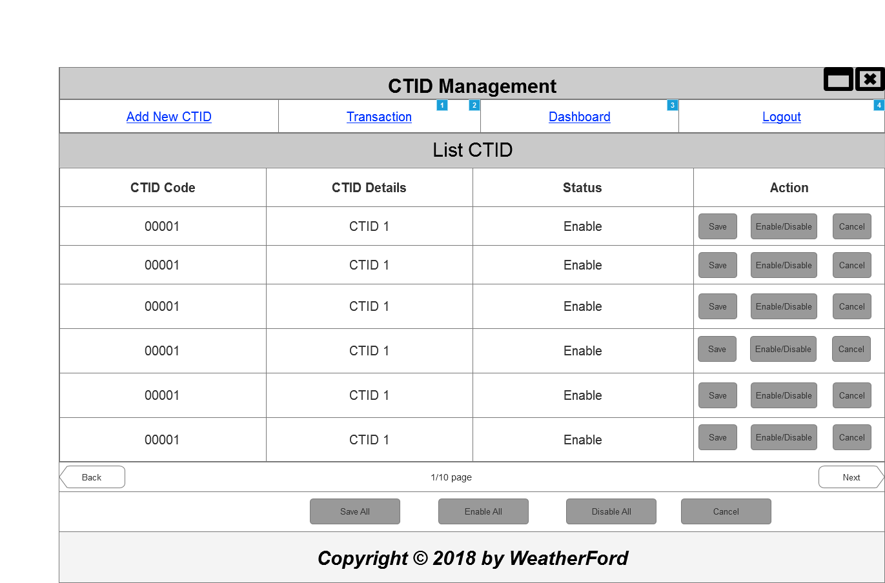

* + 1. Widget Table

|  |  |  |
| --- | --- | --- |
| Footnote | Name | Interactions |
| 1 |  | OnClick:  Case 1:  Open 01 - Login in Current Window |
| 2 |  | OnClick:  Case 1:  Open 08 - Transaction in Current Window |
| 3 |  | OnClick:  Case 1:  Open 03 - Dashboard in Current Window |
| 4 |  | OnClick:  Case 1:  Open 01 - Login in Current Window |

* 1. 06 - Customer Management
     1. User Interface

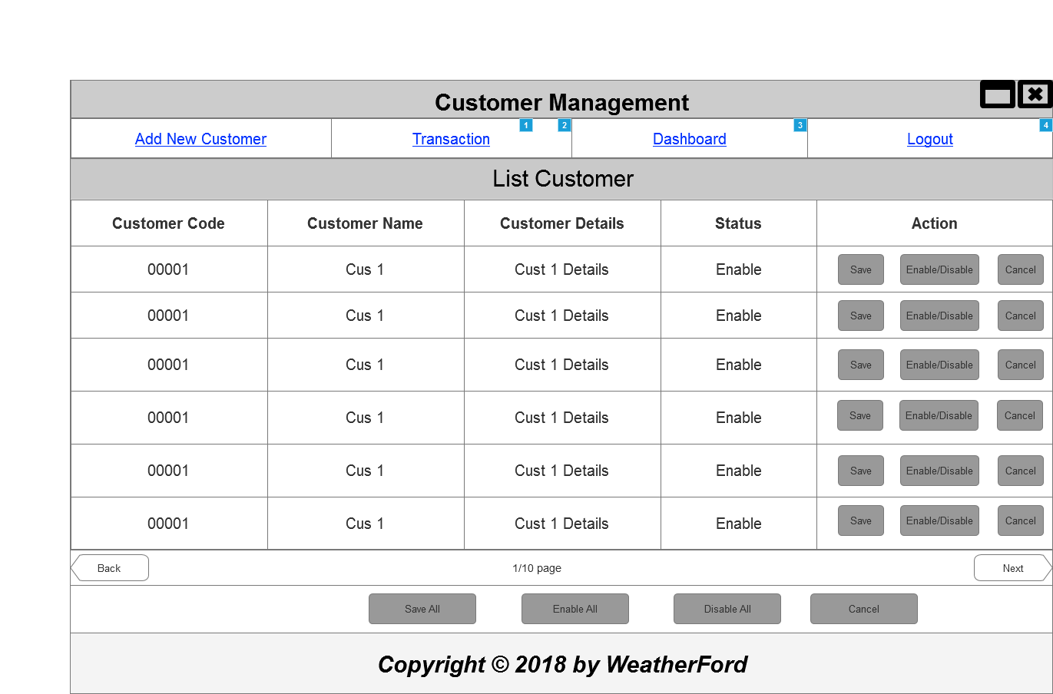

* + 1. Widget Table

|  |  |  |
| --- | --- | --- |
| Footnote | Name | Interactions |
| 1 |  | OnClick:  Case 1:  Open 01 - Login in Current Window |
| 2 |  | OnClick:  Case 1:  Open 08 - Transaction in Current Window |
| 3 |  | OnClick:  Case 1:  Open 03 - Dashboard in Current Window |
| 4 |  | OnClick:  Case 1:  Open 01 - Login in Current Window |

* 1. 07 - User Management
     1. User Interface

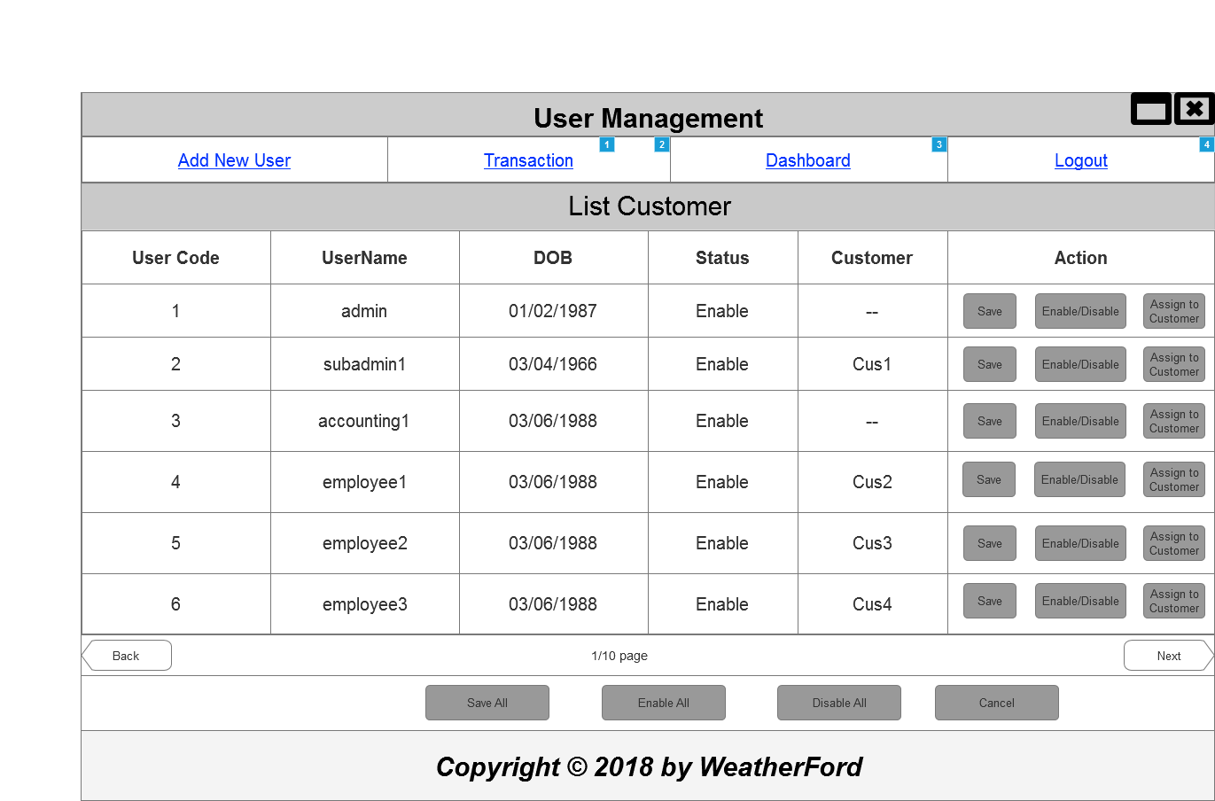

* + 1. Widget Table

|  |  |  |
| --- | --- | --- |
| Footnote | Name | Interactions |
| 1 |  | OnClick:  Case 1:  Open 01 - Login in Current Window |
| 2 |  | OnClick:  Case 1:  Open 08 - Transaction in Current Window |
| 3 |  | OnClick:  Case 1:  Open 03 - Dashboard in Current Window |
| 4 |  | OnClick:  Case 1:  Open 01 - Login in Current Window |

* 1. 08 - Transaction

OnPageLoad:  
 Case 1  
 (If value of UserName contains "acc"):  
 Enable/Disable Widget  
 Set value of Function equal to ""  
 Case 2  
 (Else If value of UserName contains "admin"):  
 Enable/Disable Widget  
 Case 3  
 (Else If True):  
 Enable/Disable Widget

* + 1. User Interface

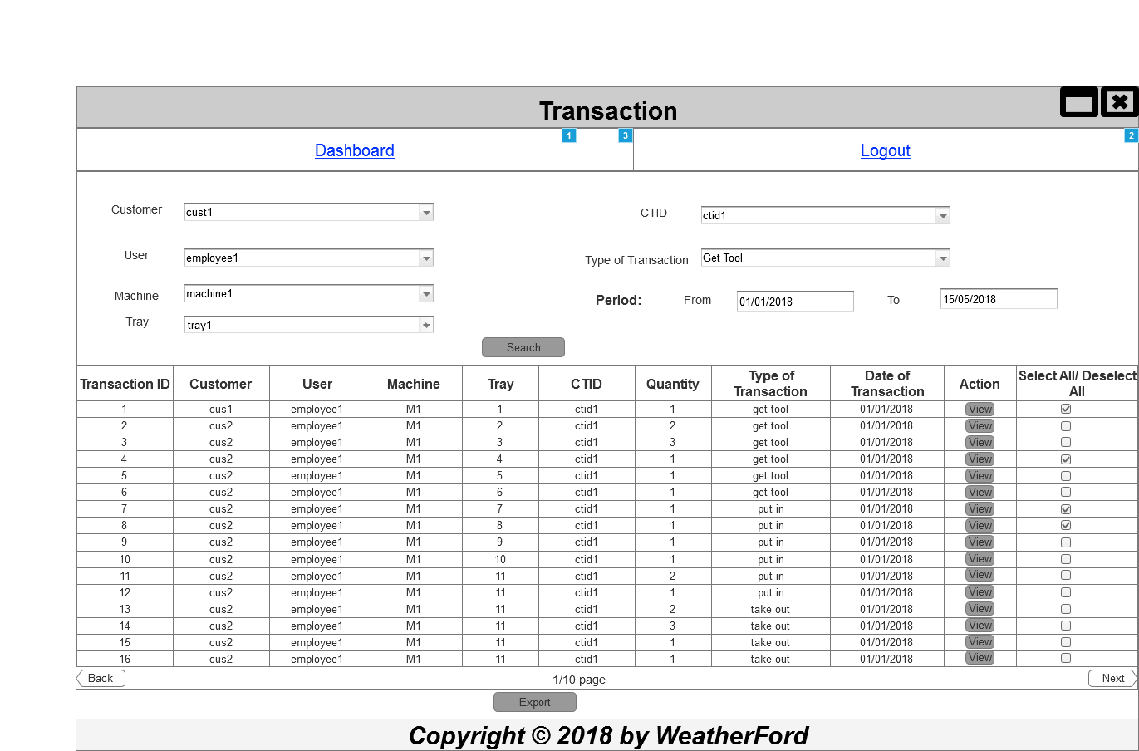

* + 1. Widget Table

|  |  |  |
| --- | --- | --- |
| Footnote | Name | Interactions |
| 1 |  | OnClick:  Case 1:  Open 01 - Login in Current Window |
| 2 |  | OnClick:  Case 1:  Open 01 - Login in Current Window |
| 3 |  | OnClick:  Case 1:  Open 03 - Dashboard in Current Window |