**Final Project Semester 1**

**Requirements document**



**Organization: ג’בארין אבו רפיק**

**Project name: BuildTech**

1. **Introduction**

**1.1 Information Sources:**

In order to collect all the data needed to understand the Organization and its environment we did an interview with ‘Rafeek’ he’s a contractor and the owner of a building repair company. The interview based in merging between Bottom-up and Top-down techniques. The questions we asked were semi structured which means we determined some of the questions before the interview, and the rest came out during the interview.

We also collected some of the documents needed beginning with a call to the manager for getting a project bid until the project is done.

**1.2 Purpose:**

We want to implement a system that manages the workflow for an independent contractor who has a company with 3 managers, 9 employees and secretary. There’s a need for a system in this business field.

We find a lot of problems after the interview with the contractor:

* He uses excel for saving all the data of his business like employees, cars, projects data…
* He misses the date of his insurance and test of the cars and trucks he has, and also he wants to manage who is holding each car in the working field and who can .
* In order to know when each payment was received and by who, he needs to check with the secretary and check his bank account to know and this is a serious problem for him.
* Each project is divided to little missions and Each part will receive a percentage payment, so in order to know the profit from the whole project he need to calculate the expenses form the revenue.

The system will analysis and include the following data:

1. The contractor has many cars, trucks, drag trucks and mini gragger, and there’s a drivers for each one has insurance, test and renew license.
2. Updating the owner about the project flow, by showing the manager the current development for each project.
3. All data saved securely, by defining all the entities in the system, there attributes and there relations.
4. Updating the owner about all payments needed, soon payments, customers payments for each stage in the project. (workers revenue)
5. Managing the Material Storage by Updating the Owner about current Material quantity and if there is any need to Order new quantity from the providers.

**All requirements will be detailed later.**

**1.2 Customers:**

* customers find us by:
  + Friends of friends. ? (network of connections)
  + Architect.
  + Construction inspector.
* customers also can contact the organization in the order of starting a:
  + private projects - house, gardens and any private site projects.
  + Public projects - such as Doorments, schools, medical centers and more…

**1.3 Market Survey**

After a deep searching and exploring for systems that manages a Huge construction projects, No system was founded that matches the Owner and the Business requirements. That's why the need was born for Operation a Management System for the Organization.

**Projects:**

projects divided by 3 types:

1. Renovation projects.
2. Building projects.
3. Maintenance and Repair of Older Buildings.

Each project has 3 or more stages. These stages depend on each specific project and its requirements.

**2. User research:**

**2.1 System Main users:**

The App is basically for the use of the Owner Rafeek, secretary, Team Manager.

**2.2 USE CASES**

1. For starting a new project.
2. For vehicles’ management.
3. For management of checks.

**3. Users Story**

1. As an administrator, I need a system to manage my business; the employees, the cars we own, the revenues, the expenses and the suppliers that I work with. I need a database beside the system to hold all the data up to date.

I need to be able to generate reports immediately and easily.

I want to get alerts whenever an assurance of a car is close to finish, also I want to know all the details about the cars’ maintenance.

I want it to be clear to me about each project how much the incomes, outcomes and the net profit.

1. As a secretary I need from the system to add to my work, in other words to be easier to deal with more than the excel, to save me time, for example in calculating the workers’ salaries, production of weekly or monthly reports.
2. As a team leader, I need to enter into the system the employees who work under me on the site on a daily basis, also to enter for each worker how many additional hours he worked(if he did).
3. **Persona**

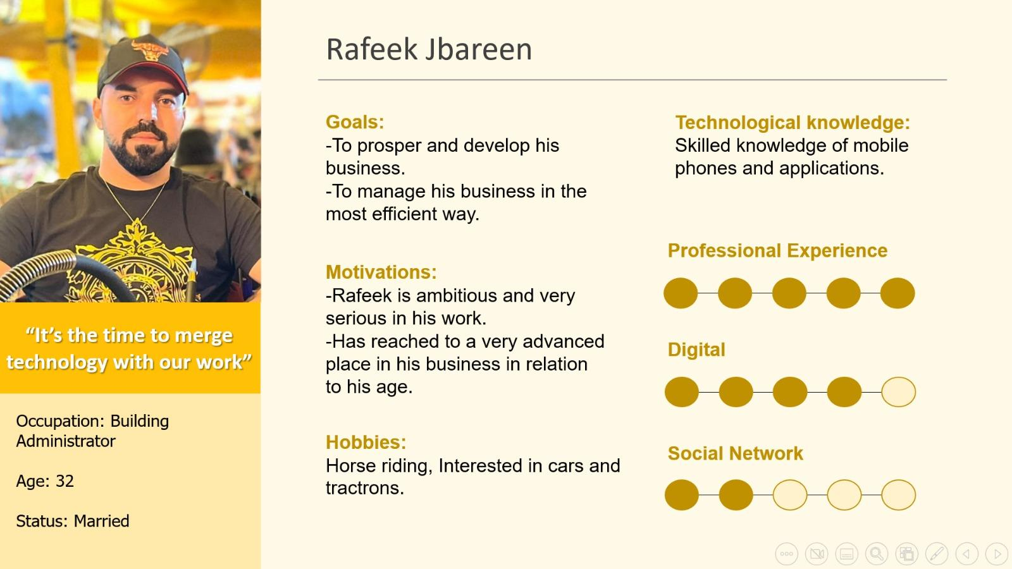

**ERD:**

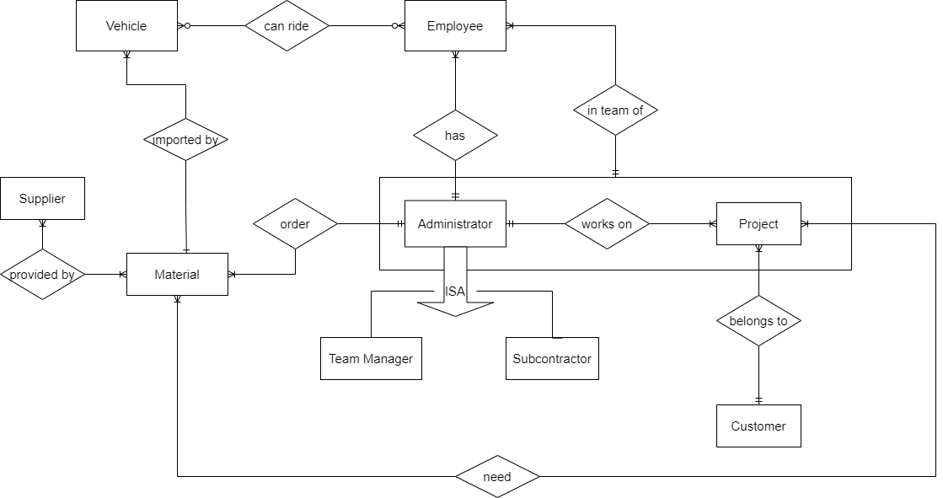

**Business Process Modeling Notation-BPMN**

**There are 4 essential process in our organization:**

1. The process of offering a price quote to the customer until it is approved.

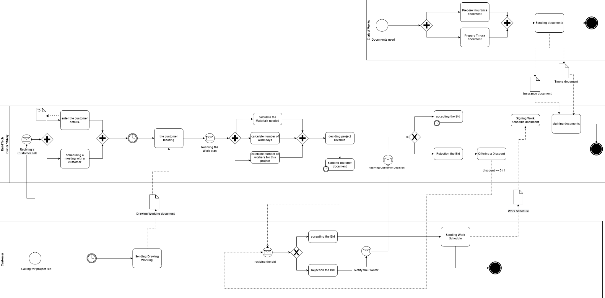

1. The process of starting a construction\repair project until it’s completed.

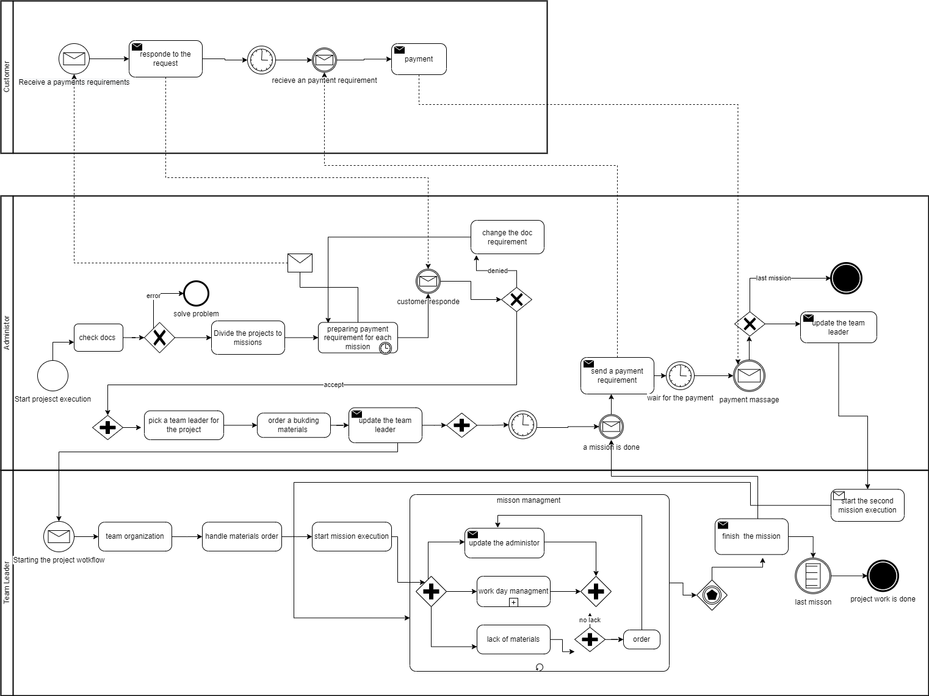

1. The process of a daily workflow in the working field.

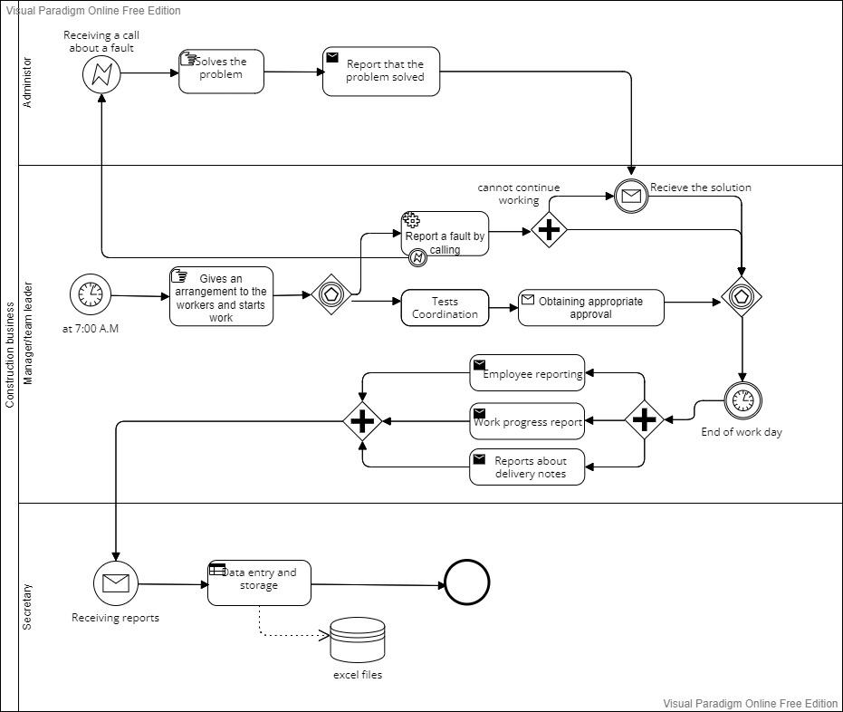

**Use Case Diagram**

1. **For vehicles’ management.**

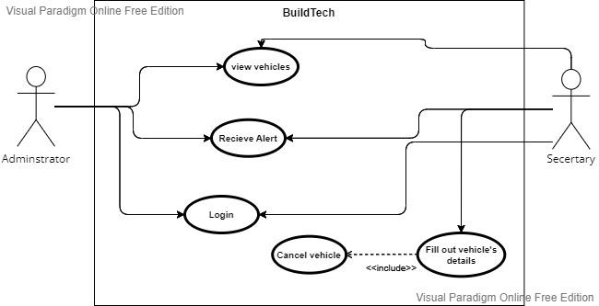

1. **New Project process use case**

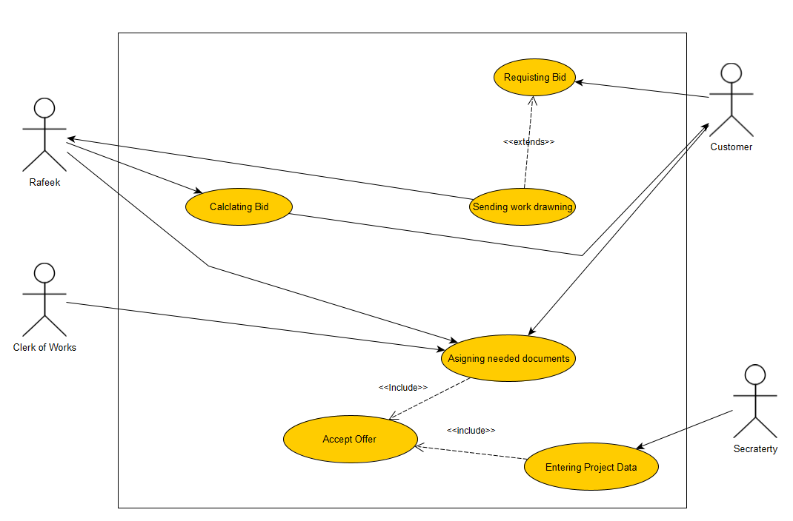

1. **For management of checks.**

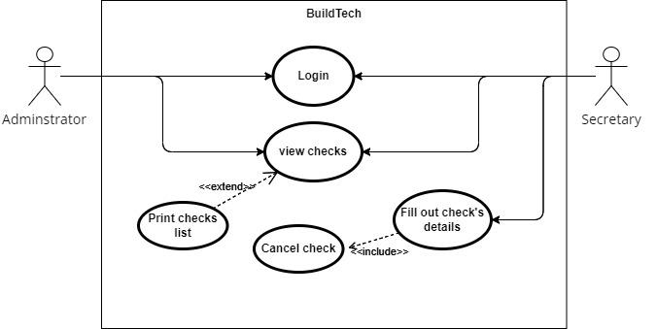

**3. System functional and nonfunctional Requirements**

**3.1 functional Requirements**

| **Requirements** | **Type** |
| --- | --- |
| While adding a new worker, customer System will check if the’re already saved in the system. | O |
| System will allow adding new customers, workers and projects. | O |
| The system has to save all workers data | D |
| System save all the projects data | D |
| System saves shift data | D |
| System saves all Customers data | D |
| Projects will have a status filed for its current stage. | D |
| System saves all the suppliers data | D |
| System saves all the Materials | D |
| System will allow entering the payments details | D, O |
| System will calculate the Income vs the expenses | O |
| System will allow entering the Documents needed for the each project | D |
| System saves all the purchase data | D |
| User can search any project by search field | O |
| User can search any project site by a map | O |
| The system will update and send a message when the vehicle's test/insurance is over. | Q |
| System will calculate the project revenue through the building process. | O |
| System will allow managing the weekly shifts for the workers. | O |
| System will allow uploading PDF files. | O |
| System allow updating or editing projects, workers, supplier, customers and material data, | O,D |

**3.2 Nonfunctional Requirements**

| **Requirements** | **Type** |
| --- | --- |
| Manager can login the System only with username and password. | Q |
| Manager / Secretary can access the system via computer. | H |
| Internet connection is needed to access the system. | H |
| At the start of the month System will apply to the manager Income vs the expenses reports | M |
| The implementation of the system will be via the internet - Web application. | H |
| Every day Managers will update the quantity of the material they used for the project process. | M |

**Gantt Chart**

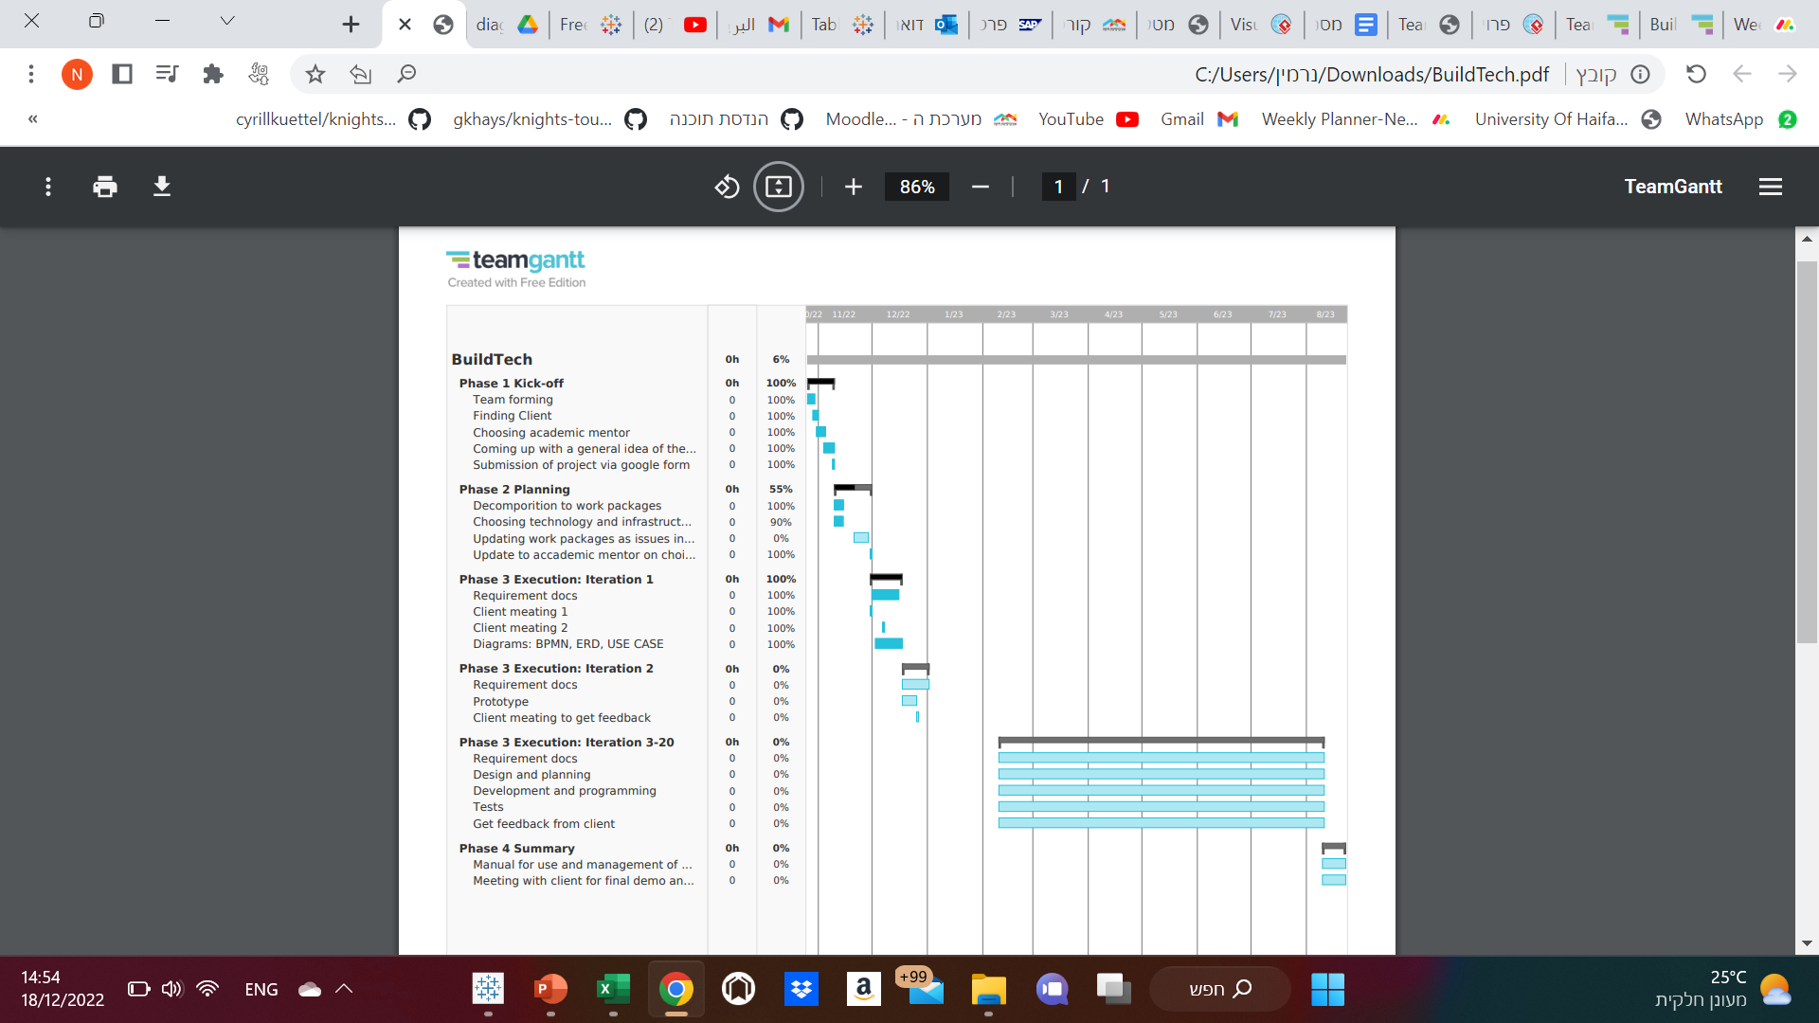

**Requirements**

* database = SQL server.

| New Project Form (screen) (Nermin) |  |
| --- | --- |
| 1. Designing the screen. |  |
| 1. Mark required fields on step 1 (all the fields are required). |  |
| 1. Add fields as step 1 on the form. |  |
| 1. The fields on step 1 will be: address as String, starting date as Date, finishing date as Date, Client as Object from list. |  |
| 1. Each project will have a serial number that will be uniq for it. |  |
| 1. The address field will be complex from: city, street number, house number. |  |
| 1. Checking inserting dates. |  |
| 1. Adding new project. |  |
| 1. Catching the inserting data (save temporarily- not on the database until the form is finishing). |  |
| 1. Clear data on the form. |  |
| 1. Client coordination for the project through an impressive selection (from a list). |  |
| 1. The project will be added after the offer is approved. |  |
| 1. Able coordination of more than one client to the project. |  |
| 1. Continue to step 2 in filling out the “new project form” after filling all the required fields on step 1. |  |
| 1. On step 2 in the form will be tow options of each kind of project: Private or Public project. |  |
| 1. For the private project will be fields: With/out swimming pool as Boolean, With/out basement as Boolean, With/out parking as Boolean, Floors number as Integer. |  |
| 1. For the public project will be fields: Floors number as Integer. |  |
| 1. Mark required fields on step 2 (all the fields are required). |  |
| 1. Checking the inserting data on step 2. |  |
| 1. Catching the inserting data (without saving on the database until finishing the whole form). |  |
| 1. Moving from step 2 on the form to step 3. |  |
| 1. Step 3 on the form will be the last step. |  |
| 1. Step 3 will contain labels to attach documents. |  |
| 1. The documents that will be attached by the user are: Quotation document, Consideration document, Contract document, Work plans document, Other. |  |
| 1. Will be an option to add other documents with inserting it’s name. |  |
| 1. The required documents will be: Quotation and Contract, the other documents will be optional. |  |
| 1. Checking if the required fields have been attached. |  |
| 1. Attaching documents will be as pdf only. |  |
| 1. Saving the whole data from the current and the previous steps on the database. |  |
| 1. Option on each step to back to the previous step and edit the inserting data. |  |
| 1. Catching the new data after editing. |  |
|  |  |