**Final Project Semester 1**

**Requirements document**



**Organization: ג’בארין אבו רפיק**

**Project name: BuildTech**

* **System Requirements:**

| **Requirement** | **Number** |
| --- | --- |
| The system will allow to users to login with Email and password. | 1 |
| In a case that the user forget his password, system will allow password reset to the specific user. | 2 |
| Password should be more than 6 characters, must include numbers, small and capital letters. | 3 |
| In a case that one of the fields are empty (Email or Password) the system will not allow a login. and alerts the user. | 4 |
| in a case that the password doesn't match the Email system will alert the user. | 5 |
| in a case that the Email isn't correct (not found in the system) system will alert the user for that or to sign up! | 6 |
| The maximum attempts to connect is 5 times. other system will send alert to the manager for that. | 7 |
| The maximum attempts to connect is 5 times. otherwise Email will be blocked for 5 minutes.. | 8 |
| 3 buttons will appear in the login view - login, signup, reset password. | 9 |
| system will allow signing-up. | 10 |
| while the signing-up system will save userID, username, password, email and job description. | 11 |
| Job description is a combo box filled by enums values. (Manager, Secretary) | 12 |
| All fields are Required. | 13 |
| in a case that the user does not fill all the fields system will alert to that. | 14 |
| Password should be more than 6 characters, must include numbers, small and capital letters. | 15 |
| Password will be entered twice for the Confirming password. | 16 |
| system will not allow seeing the password while typing it. | 17 |
| system will check the password strength. | 18 |
| if the password strength appears in red, system, will ask the user to re-enter a new password. | 19 |
| if the password strength appears in yellow, system will alert the user for that. | 20 |
| if the password strength appears in green, system will accept the password entered. | 21 |
| after sign up system will checks the ID validations (numbers only + 9 numbers), if its not correct system will alert the user. | 22 |
| in the singing-up view 2 buttons will appear: clear, signup. | 23 |
| clear button will reset all the fields to null (empty text and empty combo box selection). | 24 |
| while pressing on the sign-up button with all fields filled system will send the manager a validation message. | 25 |
| while signing-up successfully the system will add a new user. | 26 |
| the main menu screen is the landing page after logging in. | 27 |
| the username that logged in will appear at the left top side of the main menu. | 28 |
| the main menu will be separated to a 3 main sectors. | 29 |
| projects sector:   * in this sector will appear the total number of the projects. * a list of the current projects in process. * a click on one of the projects will opens the selected project page. | 30 |
| reminder / notifications sector:   * the notifications will appear as a list of tasks to do. * user can ‘check” the specific task if he done with it. * notifications:   + Payment deadline is approaching.   + Vehicle tests deadline is approaching.   + Vehicle Insurance deadline is approaching.   + Checking deadline is approaching.   + Materials ending soon (not enough) | 31 |
| finance sector:  system will calculate the Income vs the expenses   * describing the total income and expenses will be shown in a graph. * pie chart will be synchronized with the graph, for a specific projects or aspect. | 32 |
| the project sector will be displayed on the top half of the main menu. | 33 |
| in the main menu will be appear on the right side a nav bar, including: Bid Offer, Project, Add, Edit, Finance, Material Storage, Report on shift, Reports and setting. | 34 |
| the main menu will allow the user to log out from the system. | 35 |
| the system will show the project name. (at the top) | 36 |
| the system will show the project manager name. | 37 |
| system will show the location of the project area. | 38 |
| Payments deadline is approaching. | 39 |
| system will calculate the Income vs the expenses for the specific project | 40 |
| the workers will appear as a list of workers in this project | 41 |
| the system will show the flow of the project work, done stages, to do stages in an appropriate chart. | 42 |
| system shows the all attached document for this project | 43 |
| all Demand for Payments and there’s Payment Receipt will be attached to the project | 44 |
| the system will show the start day of the project | 45 |
| system will show the working drawing. | 46 |
| system will calculate the expected finish date | 47 |
| The system will allow just the administrator and the secretariat to add a new vehicle. | 50 |
| For each new vehicle it will be stored vehicleNum, manufactureYear, model, vehicletype, gasType testEndDate and insuranceEndDate. | 51 |
| The vehicle types will be stored as enum type in the system. | 52 |
| The system will display the vehicle types to the user. | 53 |
| The user can fill the fields. | 54 |
| All fields are Required. | 55 |
| If the user does not fill all the fields, the system will display a warning message to the user. | 56 |
| If the vehicle number is wrong the system will display a warning message. | 57 |
| The system will check if the manufacturer date is valid, otherwise it will display an alert. | 58 |
| The system will check the validation of the test end date and insurance end date, otherwise it will display an alert. | 59 |
| User can import and export PDF information documents about the vehicle: insuranceDoc, testDoc and others docs. | 60 |
| Fields can be cleared. | 61 |
| When adding the vehicle the system will check if it’s already in the db. | 62 |
| If the vehicle is already in db, it will display a warning message. | 63 |
| The system will send an alert message two weeks before the test and the insurance dates of the vehicles will end. | 64 |
| The vehicle data can be edited. | 65 |
| The system will allow just the administrator and the secretariat to add a new employee. | 66 |
| For each new employee it will be stored id, name, family, birthDate, gender, address, phoneNum, startDate, endDate, rule and email. | 67 |
| The employee’s roles will be stored as enum type in the system. | 68 |
| The system will display the roles to the user. | 69 |
| The user can fill the fields. | 70 |
| Fields can be cleared. | 71 |
| All fields are Required except email field. | 72 |
| If the user does not fill all(except email) the fields, the system will display a warning message. | 73 |
| The system will check the validation of the id, email, startDate and endDate fields, and by that it will alert a warning/success message to the user. | 74 |
| When adding the new employee the system will check if it’s already in the db by its id. | 75 |
| If the employee is already in db, it will display a warning message. | 76 |
| The employee data can be edited. | 77 |
| User can import and export PDF information documents about the employee as employee Id or other docs. | 78 |
| The system will allow just the administrator and the secretariat to add a new customer. | 79 |
| For each new customer it will be stored id or Bn.number, fullName, gender, address, phoneNum, anotherPhoneNum, and email. | 80 |
| The user can fill the fields. | 81 |
| Fields can be cleared. | 82 |
| All fields are required except gender and anotherPhoneNum fields. | 83 |
| If the user does not fill all the required fields, the system will display a warning message. | 84 |
| User can import and export PDF information documents about the customer. | 85 |
| The system will check the validation of the id, phones and email fields and by that it will alert a warning/success message to the user. | 86 |
| When adding the customer the system will check if it’s already in the db by it’s id. | 87 |
| If the customer is already in db, it will display a warning message. | 88 |
| The customer data can be edited. | 89 |
| The system will allow just the administrator and the secretariat to add a new supplier. | 90 |
| For each new supplier it will be stored id or Bn.number, fullName, email, address, phoneNum and phoneNum2. | 91 |
| The user can fill the fields. | 92 |
| Fields can be cleared. | 93 |
| All fields are Required except email and the phoneNum2 fields. | 94 |
| If the user does not fill all required fields, the system will display a warning message. | 95 |
| The system will check the validation of the id, email, phoneNum fields, and by that it will alert a warning/success message to the user. | 96 |
| When adding the new supplier the system will check if it’s already in the db by its id. | 97 |
| If the supplier is already in db, it will display a warning message. | 98 |
| The supplier data can be edited. | 99 |
| User can import and export PDF information documents about the supplier, as supplier Id or other docs. | 100 |
| The system will allow just the administrator and the secretariat to add new material. | 100 |
| For each new material it will be stored materiaName, price, quantity, metrics and supplier. | 101 |
| The user can fill the fields. | 102 |
| Fields can be cleared. | 103 |
| All fields are Required except supplier field. | 104 |
| If the user does not fill all required fields, the system will display a warning message. | 105 |
| The system will check the validation of chosen supplier, if it’s in the db. | 106 |
| When adding the new material the system will check if it’s already in the db by its id. | 107 |
| If the material is already in db, it will display a warning message. | 108 |
| User can import and export PDF information documents about the material, as material quantity or price. | 109 |
| The secretariat is allowed to edit the material quantity. | 110 |
| The system will allow the administrator and the secretariat to edit the db information. | 111 |
| Designing the screen. | 112 |
| Mark required fields on step 1 (all the fields are required). | 113 |
| Add fields as step 1 on the form. | 114 |
| The fields on step 1 will be: address as String, starting date as Date, finishing date as Date, Client as Object from list. | 115 |
| Each project will have a serial number that will be uniq for it. | 116 |
| The address field will be complex from: city, street number, house number. | 117 |
| Checking inserting dates. | 118 |
| Adding new project. | 119 |
| Catching the inserting data (save temporarily- not on the database until the form is finishing). | 120 |
| Clear data on the form. | 121 |
| Client coordination for the project through an impressive selection (from a list). | 122 |
| The project will be added after the offer is approved. | 123 |
| Able coordination of more than one client to the project. | 124 |
| Continue to step 2 in filling out the “new project form” after filling all the required fields on step 1. | 125 |
| On step 2 in the form will be tow options of each kind of project: Private or Public project. (ComboBox) | 126 |
| For the private project there will be fields: With/out swimming pool as Boolean, With/out basement as Boolean, With/out parking as Boolean, Floors number as Integer, space as double, Development cups as Integer. | 127 |
| For the public project there will be fields: Floors’ number as Integer, Rooms’ number as Integer, space as double, Development cups as Integer. | 128 |
| Mark required fields on step 2 (all the fields are required). | 129 |
| Checking the inserting data on step 2. | 130 |
| Catching the inserting data (without saving on the database until finishing the whole form). | 131 |
| Moving from step 2 on the form to step 3. | 132 |
| Step 3 on the form will be the last step. | 133 |
| Step 3 will contain labels to attach documents. | 134 |
| The documents that will be attached by the user are: Quotation document, Consideration document, Contract document, Work plans document, Other. | 135 |
| Will be an option to add other documents with inserting its name. | 136 |
| The required documents will be: Quotation and Contract, the other documents will be optional. | 137 |
| Checking if the required fields have been attached. | 138 |
| Attaching documents will be as pdf only. | 139 |
| Saving the whole data from the current and the previous steps on the database. | 140 |
| Option on each step to back to the previous step and edit the inserting data. | 142 |
| Catching the new data after editing. | 143 |
| Continue to step 4 (the last step) on filling the form, which will be choosing the stages. | 144 |
| Retrieving the steps from enum to a list. | 145 |
| Choosing a project. | 146 |
| Can search the project by address and client’s name. | 147 |
| Adding the choosing steps with the inserting percent to the chosen project. | 148 |
| Calculating the percent of the steps and showing them on the screen. | 149 |
| Mark the percent’s field as required. | 150 |
| Can add another step by clicking on a “+” button. | 151 |
| Calculating the percentages and ensuring the total is 100%, in other cases show a warning. | 152 |
| Retrieving the active workers from the database. | 153 |
| Can search workers by its name. | 154 |
| For each worker will be added “additional hours” and “?”. | 155 |
| If a worker was chosen before (on the same date) a warning will appear. | 156 |
| Can edit the shift. | 157 |
| The Bid will be a type of calculator. | 158 |
| The user can calculate multiple outcomes. | 159 |
| For each material there will be an option to choose type. | 160 |
| For each type there will be a saved price per unit. | 161 |
| The user will be able to enter the quantity and to get the outcome by pressing the “calculate button”. | 162 |
| For each material there will be an input field for the quantity and a button to calculate. | 163 |
| The materials that will be calculated: Iron, Concrete, Block, Plaster, Electrical power, Plumbing, Colors work and Sealing. | 164 |
| The material units: Block, Plaster, Colors work and Sealing measured in meters. Electrical power and Plumbing measured in points. Iron measured in tons. Concrete measured in cups. | 165 |
| The user will be able to choose the employee. | 166 |
| After choosing the employee the user can press on the “show” button to see his balance. | 167 |
| The balance will be up to date. | 168 |
| The balance will be calculated by ((calculating his days and hours of work) + (Promotional)) + (the payments he received). | 169 |
| (calculating his days and hours of work) = data updated when the secretary enters his shift. | 170 |
| (the payments he received) = data updated when the secretary enters a payment that he got. | 172 |
| (Promotional) = data updated when the secretary enters a promotional he deserve. | 173 |
| An input field will be intended for insertion of a payment for the chosen employee. | 174 |
| The payment will be saved to the employee with the date of insertion. | 175 |
| An input field will be intended for insertion of a refund for the chosen employee. | 176 |
| The refund will be saved to the employee with the date of insertion. | 177 |
| For updating each of the payment and refund will be a button to confirm the action. | 178 |
| The amounts will be on shekels. | 179 |
| On the reports will be a relevant report of the employees salaries. | 180 |
| On the reports will be for each employee | 181 |
| The database on the system will be SQL Server. | 182 |
| Any manually entered field can be updated. | 183 |
| After calculating the materials the user can get the total cost. | 184 |
| The user can import the quotation after calculating. | 185 |
| Showing Graphs on the landing page. | 186 |
| Saving for each project exceptions. | 187 |

* **Users Story:**

1. **Rafeek Jbareen- The Administrator**

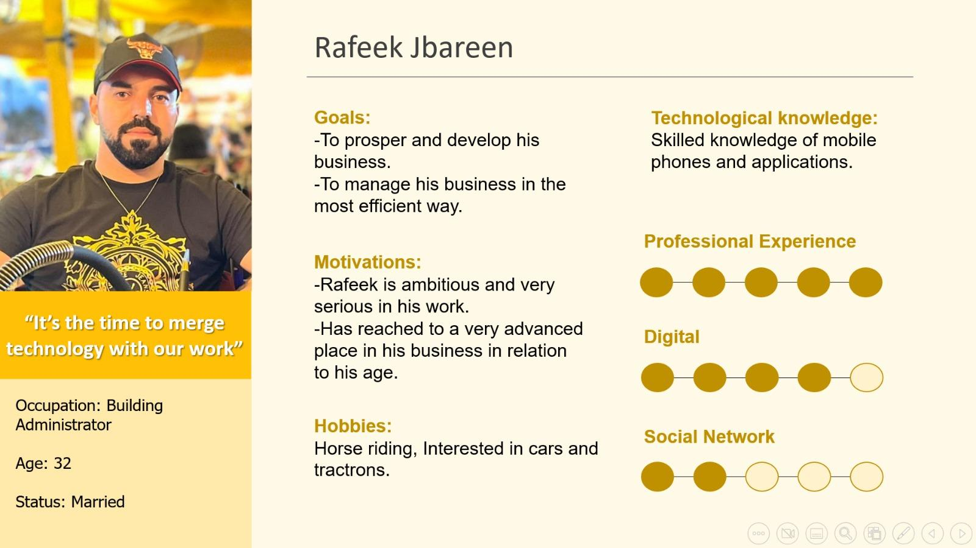

1- As an administrator, I need a system to manage my business; the employees, the cars we own, the revenues, the expenses and the suppliers that I work with. I need a database beside the system to hold all the data up to date.

I need to be able to generate reports immediately and easily.

I want to get alerts whenever an assurance of a car is close to finish, also I want to know all the details about the cars’ maintenance.

I want it to be clear to me about each project how much the incomes, outcomes and the net profit. When I want to start a new project I want all of its data to be documented and recorded on the system. In my job I have two types of projects; public and private. When saving a new project on the system I want to know for each project if it's private or public. In other words, I want to be able to do filtration. I also want to save the documents such as the bid document and the agreement doc…

It will be awesome if the system proves to me a program that helps me on doing the quotation. I want the data of the customers and my suppliers to be recorded on the system, to make it easy for me to get their contact information for example. On every project, I want to be updated on which step we are standing on and what percent of the work is done.

We have a lot of materials in our warehouses, and we use it a lot, until this moment there’s no documentation for the amount of each material, and most of the time I know that a material is going to be out of stock.

Also as a manager I want to be able to securely log in to the system so that all the information can be accessed by me and some choosing information can be accessed by the secretary under my permission.

2- Each day I want to be able to add the employees that had worked today, I need to add in which project they worked with which team leader and the number of working hours in the shift.

When we get a new customer I need to add all the information about him in the system and save it. After the agreement between the administrator and the current customer I create a new project with the information about the customer’s requirement and financial projects requirements.

For each project there are a lot of vehicles in each workspace, so I need to add and save their data, and make sure to update the dates when vehicles get tests and treatments.

I want to calculate the workers’ salaries in the shortest time and the easiest ways.

As a secretary I need from the system to add to my work, in other words to be easier to deal with more than the excel, to save me time, for example in calculating the workers’ salaries, production of weekly or monthly reports.

I want to be able to see and change all the customers, projects, employees, vehicles, suppliers and the materials data.

Module 1 :

* Choosing the programming language and the framework.
* Choosing the Design Pattern.
* Design the views: Login, SignUp, Add Employee, Add Customer, Add Material, Add Project, Add Employee’s Shift.
* Essential classes implementation code: Employee, Customer, Material, Project, Shift, Vehicle, Supplier, Account, Steps Enum.
* Tests the code.
* Get feedback.
* Meet & Plan.

Module 2:

* Design the views:Update Employee, Update Customer, Update Material, Update Project, Update Employee’s Shift.
* Creating the logics: LogIn, SignUp, Add Employee, Add Customer, Add Material, Add Project, Add Employee’s Shift, Update Employee, Update Customer, Update Material, Update Project, Update Employee’s Shift.
* Connecting to dataBase.
* Tests the code.
* Get feedback.
* Meet & Plan.

Module 3:

* Design the views: MainMenu, Quotation, Employee balance, Alerts.
* Completing and Implementation for all the functionality of the system.
* Creating Graphs.
* Tests the code.
* Get feedback.
* Meet & Plan.