SignLink: A Smart Sign Language Translation Framework Using EMG Signal Processing, Machine Learning & Mobile Application

Sombatla Truc Deydeepya Lakshmi
(25195661/1)

CMP6200/DIG6200 Individual Undergraduate Project 2025-2026
B.Sc. (Honors) Computer Science
Submitted by June 2026

A thesis submitted to Birmingham City University in partial fulfilment of the requirements of the degree of Bachelor of Science.

Abstract
This dissertation presents the design, development and evaluation of SignLink, an intelligent sign language translation system that integrates wearable Electromyography (EMG) sensing technology, machine learning-based gesture recognition and a mobile application platform. The final objective of this initiative is to translate hand gestures into understandable text and speech in real time, thereby facilitating more effective communication between sign language users and non-sign language users.
The proposed system combines EMG signal acquisition through a low-cost wearable alternative manually built and tested to commercial EMG devices (such as the Myo Armband), artificial intelligence-driven gesture classification and a dedicated Android application to provide an accessible communication solution. The mobile application serves as the primary interface of the system, offering features such as text-to-speech, real-time translation, communication assistance and local data management. To enable accurate gesture recognition, the machine learning model was trained and evaluated using electromyographic signal data, allowing the system to identify and classify sign language gestures for translation into meaningful outputs.
To establish a reliable baseline, we first validated the machine learning component of this study using an example, publicly available electromyography dataset of ASL fingerspelling collected via a Myo Armband. This approach provides a reliable benchmark for assessing the effectiveness of the proposed artificial intelligence framework while demonstrating the potential capabilities of the intended wearable hardware platform currently under development.
The findings of this study highlight the potential of integrating wearable sensing technologies, mobile computing and artificial intelligence to improve communication accessibility for individuals with hearing and speech impairments. Furthermore, the project contributes a scalable framework for sign language translation that combines intelligent gesture recognition with mobile application technologies. Future work includes expanding the supported gesture vocabulary from individual alphabet gestures to complete words and phrases, refining the wearable sensing platform, collecting a dedicated EMG dataset and implementing more advanced machine learning models to improve recognition accuracy and real-time translation performance.

Acknowledgement
I would like to express my sincere gratitude to all those who have contributed to the successful completion of this dissertation and the SignLink project. First and foremost, I would like to thank my supervisor, Dr. Vi Chi Thanh, for his guidance, support and valuable feedback throughout this research. His advice and encouragement were instrumental in shaping the direction and development of this project.
I would also like to express my sincere thanks to Mr. Nguyen Huu Nghia for his guidance and assistance with the hardware development of the project. His insights and technical advice regarding the design and implementation of the wearable EMG sensing platform were greatly appreciated and contributed significantly to the progress of this work. I would also like to extend my sincere appreciation to my friend Satwik for his valuable advice and insights regarding the machine learning aspects of this project. His guidance on data preparation, training approaches and model development provided useful perspectives that helped shape the artificial intelligence component of SignLink.
My heartfelt gratitude goes to my friends and volunteers who generously dedicated their time to participating in usability and user experience testing. Their valuable feedback, suggestions and observations provided important perspectives that helped improve the overall quality, usability and functionality of the SignLink application. I would also like to thank my friend Andrew for his constant encouragement and support throughout the development of this project. His positivity and motivation were greatly appreciated during challenging stages of the research and implementation process.
Finally, I am especially grateful to my family for their unwavering support, patience and encouragement throughout my project. Their belief in my abilities and their constant motivation has been a source of strength during both the challenges and achievements encountered throughout this journey. To all those who contributed, whether directly or indirectly, I extend my sincere appreciation and gratitude.

Table of Contents

Abstract 2
Acknowledgement 3
Glossary 6
List of Figures 6
List of Tables 7
List of Code Snippets 7
1.0 Introduction 8
1.1 Problem Statement 8
1.2 Scope 9
1.3 Significance 9
1.4 Project Aim and Objectives 9
1.4.1 Project Aim 9
1.4.2 Project Objectives 10
2.0 Review of Existing Knowledge 12
2.1 Sign Language and Sign Language Translation Technologies 12
2.1.1 Vision-Based Translation Systems 13
2.1.2 Sensor-Based Translation Systems 13
2.2 Electromyography (EMG) for Gesture Recognition 14
2.3 Machine Learning for Sign Language Recognition 15
2.4 Research Gap 16
3.0 Method and Implementation 17
3.1 UI/UX Design and User Testing 17
3.1.1 Evaluation Framework and Participants 19
3.1.2 Data Collection Methods 21
3.2 Mobile Application Development 21
3.3 Wearable Hardware Development 25
3.4 Machine Learning Development 30
3.4.1 Dataset Identification 30
3.4.2 Data Cleaning and Preprocessing 30
3.4.3 Exploratory Data Analysis 31
3.4.4 Feature Selection and Engineering 31
3.4.5 Splitting of Data into Training and Testing 32
3.4.6 Training the model 32
3.5 Final UI and UX App Testing 32
4.0 Evaluation 33
4.1 UI/UX Prototype Evaluation 33
4.1.1 Quantitative Results 33
4.1.2 Qualitative Results (Think Aloud & Interviews) 34
4.2 Machine Learning Model Evaluation 34
4.3 Final UI/UX Prototype Evaluation 36
4.3.1 Quantitative Results 36
4.3.2 Qualitative Results (Think Aloud & Interviews) 37
4.4 Final Application Evaluation 37
5.0 Conclusions 38
5.1 Limitations 38
5.2 Future Work 39
6.0 References 40
7.0 Appendix 43
7.1 Appendices of UI/UX Design Section 43
7.1.1 Gantt Chart 43
7.1.2 Low Fidelity Diagrams 44
7.1.3 High Fidelity Diagrams 46
7.1.4 Testing Consent Forms 51
7.1.5 Results from Form 56
7.2 App Screens 66
7.3 Model Training Code 71
7.4 Appendices of Final UI/UX Design Section 75
7.4.1 Testing Consent Forms 75
7.4.2 Results from Form 91

Glossary
AI | Artificial Intelligence
ML | Machine Learning
EMG | Electromyography
sEMG | Surface Electromyography
IMU | Inertial Measurement Units
ASL | American Sign Language
UI | User Interface
UX | User Experience

List of Figures
Figure 1: Vision-Based vs. Sensor-Based Approaches 13
Figure 2: Hand Muscles (Retrieved from Backyard Brains: Signal Classification Experiment) 14
Figure 3: Example Electrode Placement for EMG Acquisition (Same source as figure 2) 15
Figure 4: Gantt Chart 17
Figure 5: Hierarchical Task Analysis 19
Figure 6: Screens set 1 22
Figure 7: Screens set 2 23
Figure 8: Screens set 3 24
Figure 9: Screens set 4 25
Figure 10: Setup of V1 26
Figure 11: V1 Signal 26
Figure 12: V1 Rough Code 27
Figure 13: Setup of V2 28
Figure 14: Code and Signal 28
Figure 15: V2 In Real Life 29
Figure 16: Setup of V3 30
Figure 17: Performance Metrics VS Seed Number 35
Figure 18: Average Metrics of all Seeds 36

List of Tables
Table 1: MoSCoW 18
Table 2: Participant Data of Pre-Testing 20
Table 3: Participant Data of Final Testing 20
Table 4: SUS Score (first test) 34
Table 5: SUS Score (final test) 37

List of Code Snippets
Code 1: Control Random Forest Classifier (with no feature selection) 71
Code 2: Random Forest Classifier (on selected features) 71
Code 3: Control Hyper-parameter Tuning & CV Testing (to make sure model was accurate on all folds and not just one specific instance) 72
Code 4: Final Tuning (run on different random states to make sure accuracy is consistent throughout) 74

1.0 Introduction
Communication is a basic human right that is crucial for social inclusion. In this regard, the United Nations Convention on the Rights of Persons with Disabilities acknowledges sign languages as valid forms of communication and highlights the importance of accessible communication (United Nations, 2006). Despite the progress in technology, significant obstacles remain between sign language users and individuals who do not understand sign language. To address this communication divide, automated sign language translation has become an important area of research, utilizing recent advancements in artificial intelligence, wearable sensing, and mobile computing to transform gestures into real-time text and speech outputs.
The following section presents the problem statement, project scope, significance, aims and objectives that form the foundation of the SignLink project.

1.1 Problem Statement
According to the World Health Organization, more than 1.5 billion individuals worldwide suffer from hearing loss, with 430 million needing rehabilitation services (WHO, 2026). Although sign language serves as the main mode of communication for many, the reliance on human interpreters is frequently obstructed by high costs and limited availability. This results in a continuous communication gap, compelling those who are deaf or hard-of-hearing to confront daily obstacles in educational, professional, and healthcare settings.
To address the environmental and lighting constraints associated with conventional vision-based translation systems (Abdullahi & Chamnongthai, 2022), this project presents SignLink: an advanced translation system that employs wearable electromyography (EMG) sensing alongside machine learning (ML) to effectively monitor muscle activity during hand gestures. By combining this effective sensing technique with a supportive Android application, SignLink translates identified sign gestures into immediate text and speech outputs, thereby closing the communication divide with a practical and accessible solution.

1.2 Scope
The scope of this project encompasses the design, development and evaluation of SignLink and that includes the development of a ML-based gesture recognition framework, the implementation of a mobile application for communication assistance and the investigation of a wearable EMG sensing platform intended to support real-time gesture acquisition.
Due to limitations in time and resources, the machine learning model was trained and assessed using a publicly available Myo Armband EMG dataset for American Sign Language (ASL) fingerspelling alphabet gestures instead of the custom wearable prototype. Features like continuous recognition, real-time implementation on custom hardware, multilingual capabilities, and comprehensive user studies are beyond the current scope and are planned for future development.

1.3 Significance
The significance of this project lies in its potential to improve communication accessibility for individuals with hearing and speech impairments hence contributing to the field of assistive technology through the integration of ML, wearable sensing technologies and mobile computing. It also aligns with the United Nations Sustainable Development Goal 10 (Reduced Inequalities) by supporting accessibility and technological inclusion (United Nations, 2015).

1.4 Project Aim and Objectives
The following aim and objectives define the intended outcomes of the project and provide a structured framework for its design, development and evaluation.

1.4.1 Project Aim
The aim of this project is to design, develop and evaluate SignLink, an intelligent sign language translation system that utilizes ML and EMG-based gesture recognition to translate sign language gestures into text and speech through an Android mobile application, thereby improving communication accessibility between sign language users and non-sign language users.

1.4.2 Project Objectives

Objective 1: Research and Requirements Analysis
- Specific: Investigate sign language translation systems, wearable sensing technologies, ML techniques and accessibility requirements relevant to assistive communication systems.
- Measurable: Produce a comprehensive literature review and define the functional and non-functional requirements of SignLink.
- Achievable: Utilize academic journals, conference papers and existing research studies to gather information and requirements.
- Relevant: Provides the theoretical and technical foundation necessary for the design and development of the proposed system.
- Time-bound: To be completed during the initial research and planning phase of the project.

Objective 2: User Interface Design and User Experience Validation
- Specific: Design UI prototypes and conduct usability testing with peers and volunteers to evaluate the accessibility, usability and effectiveness of the proposed application design.
- Measurable: Collect user feedback through surveys and observations and implement design improvements based on the results.
- Achievable: Utilize wireframes, mock-ups and interactive prototypes developed using standard UI/UX design principles.
- Relevant: Ensures the application is user-friendly and suitable for its intended audience before development begins.
- Time-bound: To be completed before the implementation phase of the mobile application.

Objective 3: Mobile Application Development
- Specific: Develop an Android mobile application capable of displaying translated sign language gestures as text and speech outputs.
- Measurable: Implement and test core functionalities including communication assistance and local data management.
- Achievable: Utilize Kotlin and Android Studio to develop and deploy the application.
- Relevant: Provides the primary platform through which users interact with the SignLink system.
- Time-bound: To be completed during the system implementation phase.

Objective 4: Wearable Hardware Development
- Specific: Design, develop and evaluate multiple iterations of a low-cost wearable EMG sensing prototype using commercially available components.
- Measurable: Produce and assess successive hardware revisions based on signal acquisition capability, usability and design improvements.
- Achievable: Utilize EMG sensors, microcontrollers, inertial sensing modules and battery-powered circuitry.
- Relevant: Supports the long-term objective of developing an affordable alternative to commercial EMG sensing devices.
- Time-bound: To be conducted throughout the hardware development phase of the project.

Objective 5: Machine Learning Model Development
- Specific: Develop and evaluate an ML model capable of classifying ASL fingerspelling alphabet gestures using EMG signal data.
- Measurable: Evaluate model performance using accuracy, precision, recall, F1-score and confusion matrix analysis.
- Achievable: Utilize a publicly available Myo Armband dataset for model training, validation and testing.
- Relevant: Provides the core gesture recognition functionality required for sign language translation.
- Time-bound: To be completed following dataset preparation and prior to final system evaluation.

Objective 6: System Testing and Evaluation
- Specific: Evaluate the developed mobile application, machine learning model and hardware prototype components to determine their functionality, usability and feasibility.
- Measurable: Assess application usability through user feedback, evaluate ML performance using classification metrics and analyze the effectiveness of the hardware prototypes through iterative testing.
- Achievable: Utilize testing procedures, usability surveys and machine learning evaluation metrics.
- Relevant: Ensures that the developed components meet the project requirements and identifies areas for future improvement and integration.
- Time-bound: To be completed during the final phase of the project.

2.0 Review of Existing Knowledge
As technology has progressed from initial configurations to contemporary portable solutions, the domain has broadened to encompass human-computer interaction, biomedical signal processing, and mobile computing. To provide context for these advancements, this chapter examines the associated literature.

2.1 Sign Language and Sign Language Translation Technologies
Sign language is a complete, grammatically complex, and natural visual-spatial language that enables communication through a synchronized combination of manual indicators such as hand gestures, wrist orientations and non-manual signals such as facial expressions, lip movements and torso postures (Emmorey, 2002; Ambavane et al., 2020). It serves as the primary means of communication for many hard-of-hearing and mute individuals worldwide. However, communication difficulties often arise when interacting with people who do not understand sign language, creating barriers in education, healthcare, employment and everyday social interactions (United Nations, 2006).
To alleviate these systemic inequities, contemporary human-computer interaction research has focused heavily on the engineering of automated sign language recognition and sign language translation systems. In the literature, these recognition mechanisms are broadly segmented into two primary architectural paradigms: vision-based systems and sensor-based systems (Papatsimouli et al., 2022).

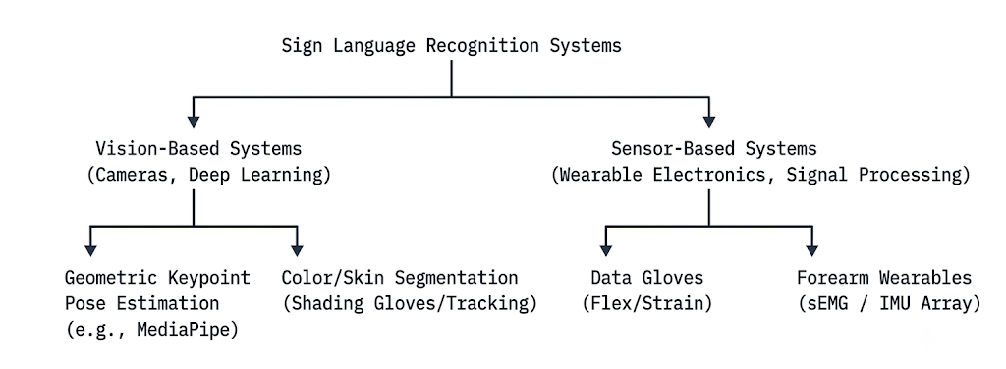
Figure 1: Vision-Based vs. Sensor-Based Approaches

2.1.1 Vision-Based Translation Systems
Vision-based architectures tend to utilize optical sensors, such as standard webcams, RGB cameras, or depth sensors, combined with computer vision and deep learning pipelines to capture and classify gestures. These systems offer distinct operational flexibility, as they natively allow for the extraction of non-manual linguistic features, including facial expressions, head tilts, and lip-reading cues (Shukor et al., 2015; Akmeliawati et al., 2007)
However, despite the advancements in deep convolutional networks, these systems are fundamentally bounded by the camera’s field of view (FoV), rendering them highly sensitive to spatial geometry, background environmental noise, and variable lighting conditions (Papatsimouli et al., 2022).

2.1.2 Sensor-Based Translation Systems
In contrast, sensor-based architectures utilize wearables placed directly on the hand or forearm to capture real-time kinematics and spatial orientation. These systems leverage diverse hardware matrix including IMUs for velocity tracking, flex sensors for finger articulation, and Time-of-Flight (ToF) or tactile sensors for surface contact. Since data collection occurs entirely onboard, they generate lightweight numeric data streams immune to external lighting and environmental noise.
To classify these signals, modern frameworks leverage deep learning; Convolutional Neural Networks (CNNs) extract spatial patterns from multi-channel data, while Recurrent Neural Networks (RNNs) with Long Short-Term Memory (LSTM) blocks map the temporal variations of continuous gestures (Maharjan et al., 2024).

2.2 Electromyography (EMG) for Gesture Recognition
Electromyography (EMG) measures the electrical activity produced by skeletal muscles during contraction. Surface electromyography (sEMG) captures these signals non-invasively via skin-surface electrodes. The collected signals provide valuable information regarding muscle activation patterns and movement intentions, making EMG a widely used technology in rehabilitation, prosthetics, human-computer interaction and gesture recognition systems (Chowdhury et al., 2013).
For sign language translation, sEMG sensors are typically placed around the forearm to detect the distinct muscle contractions generated by specific hand and finger movements. Unlike vision-based systems, sEMG is immune to lighting variations, background noise, and hand occlusions. To optimize signal acquisition, electrodes must align precisely with the underlying musculature responsible for digit articulation.
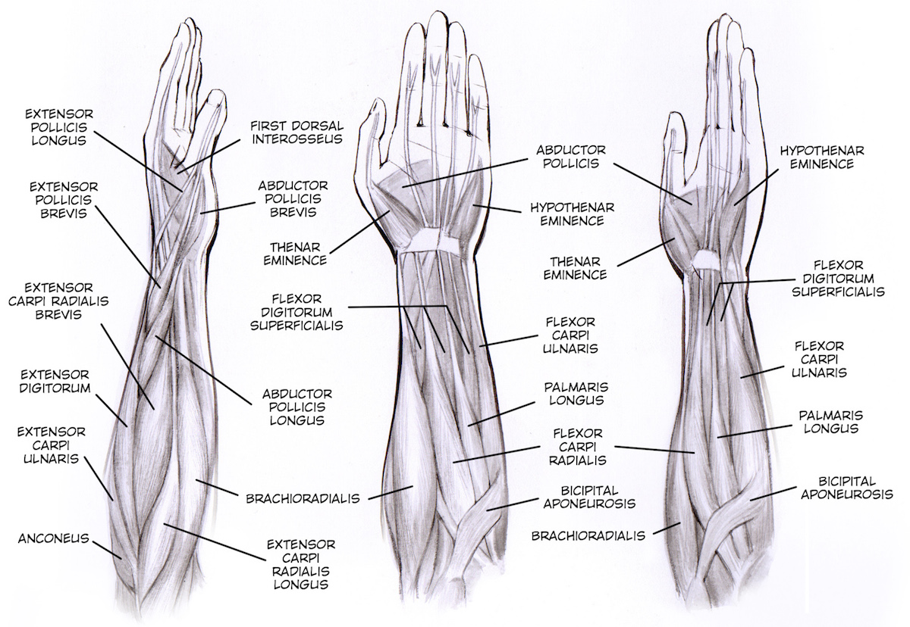
Figures 2 and 3 illustrate the anatomical layout of these primary forearm muscle groups to demonstrate a multi-channel electrode placement strategy designed to isolate individual finger movements alongside a dedicated ground reference node.

Figure 2: Hand Muscles (Retrieved from Backyard Brains: Signal Classification Experiment)
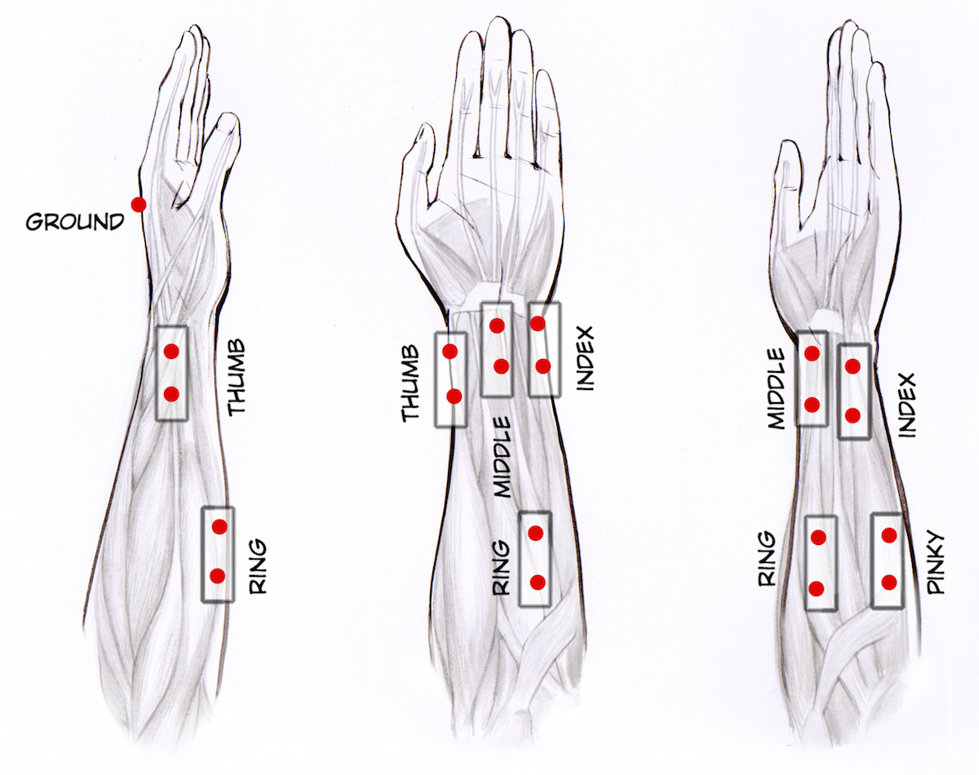
Figure 3: Example Electrode Placement for EMG Acquisition (Same source as figure 2)
The Myo Armband is a benchmark consumer-grade wearable featuring 8 surface Electromyography sensor channels and an integrated 9-axis Inertial Measurement Unit to simultaneously monitor muscle activity and spatial kinetics. Although discontinued, it continues to be a reference point in the literature on human-computer interaction due to its durable design, demonstrated classification effectiveness, and the extensive accessibility of high-quality, open-source gesture datasets, which provide essential baselines for contemporary research.

2.3 Machine Learning for Sign Language Recognition
Machine learning plays a crucial role in EMG-based gesture recognition by
transforming raw muscle signals into gesture classifications through a series of
processes including data collection, preprocessing, feature extraction, model training, and evaluation.

The algorithms frequently employed in this domain encompass Support Vector Machines (SVM), Random Forests, Artificial/Convolutional Neural Networks (ANNs/CNNs), and Gradient Boosting techniques, all of which have shown significant efficacy on EMG datasets (Chowdhury et al., 2013).
Among these algorithms, Random Forest stands out as one of the most prevalent baseline models utilized in gesture recognition studies. Research conducted by Shakeel et al. (2020)(MAST) and Paudyal et al. (2017)(DyFav) has compared custom algorithms against Random Forest baselines, yielding accuracies of 93% compared to 81.4% and 95.36% against 80.47%, respectively. The capability of Random Forest to manage structured numerical data, as well as its resilience to noise and inherent variations in EMG signals, makes it particularly effective for gesture recognition tasks. Consequently, a Random Forest classifier was chosen for the SignLink project and was trained using a publicly accessible Myo Armband EMG dataset that includes American Sign Language (ASL) fingerspelling gestures.

2.4 Research Gap
The current literature reveals a significant disconnect between high-accuracy laboratory models and practical, real-world utility. While camera-based translation systems offer linguistic flexibility, they remain fundamentally restricted by environmental lighting and background clutter. Conversely, sensor-based alternatives are heavily reliant on either expensive clinical equipment or discontinued consumer hardware like the Myo Armband. Furthermore, existing research focuses predominantly on maximizing offline machine learning accuracy on desktop computers, largely neglecting the integration challenges of deploying these models onto mobile devices.
This leaves a clear gap for an affordable, environment-immune system optimized for daily use and SignLink intends to address it with the system proposed.

3.0 Method and Implementation
The development of this project followed a structured and iterative chronological framework encompassing user-centred design planning, mobile application development, hardware research and design, and machine learning model training. The following sections describe each stage of the development process in detail, and the Gantt chart below provides an idea of the timeframe and time segregation.
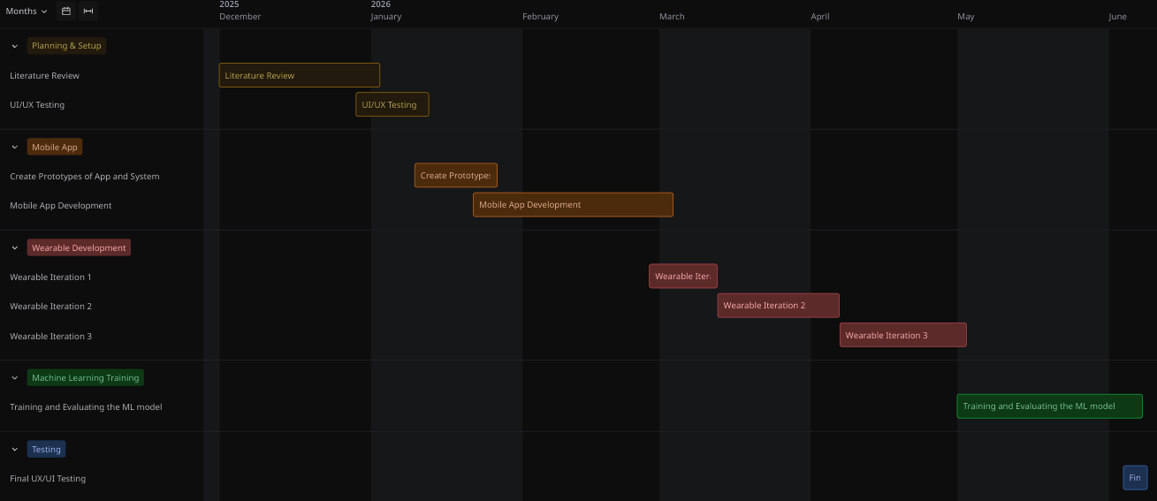
Figure 4: Gantt Chart

3.1 UI/UX Design and User Testing
The design of the SignLink mobile application was guided by a user-centered approach following Nielsen’s Heuristics, with the primary objective of creating an accessible and intuitive communication platform for sign language users. Prior to implementation, the application's functionality and interface requirements were identified based on findings from the literature review, project objectives and anticipated user needs.
To prioritize development efforts, the MoSCoW prioritization technique was utilized to classify system features according to their importance as seen below. This approach enabled the identification of essential functionality required for the initial implementation while also establishing a roadmap for future enhancements.
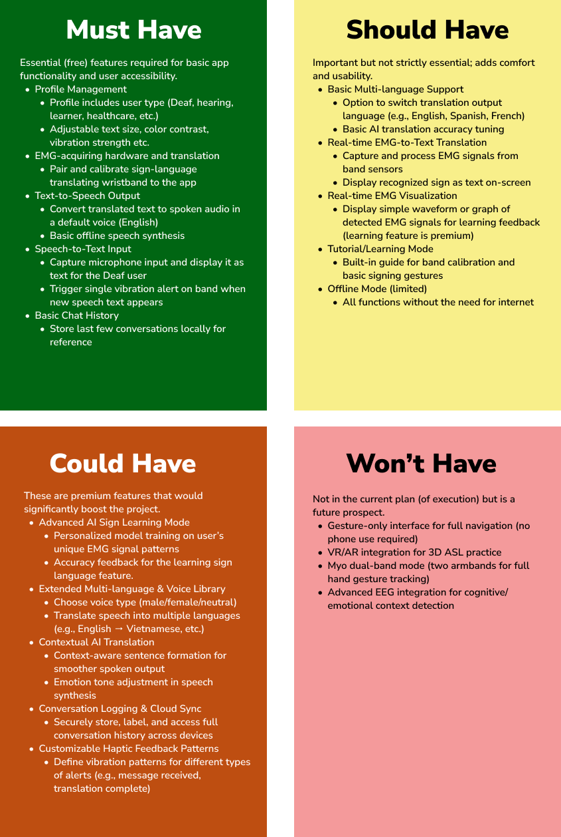
Table 1: MoSCoW
Following feature prioritization, user flows and interface layouts were designed to visualize how users would interact with the system. A Hierarchical Task Analysis (HTA) was developed to model the primary user journey. Due to the size and complexity of the complete HTA diagram, a high-resolution version is available in the project repository: https://github.com/codingsanji/Honors_signLink/blob/main/
designs/UI_UX/Prototypes/HTA.png
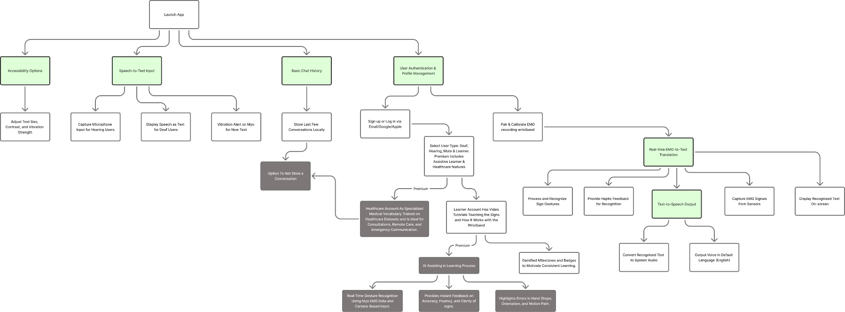
Figure 5: Hierarchical Task Analysis
Following the development of the HTA, a series of low-fidelity and high-fidelity prototypes were created to progressively refine the application's navigation flow, functionality and visual design.

3.1.1 Evaluation Framework and Participants
Both testing phases utilized a hybrid structure combining on-site in-person sessions (focusing on ergonomics, hand gestures, and physical environment interaction) and remote online sessions (focusing on navigation clarity and remote comprehension). Before each session, participants were briefed on system objectives and informed that evaluations targeted interface design rather than hardware sensor accuracy.
- Phase 1 (Initial Usability Testing): Conducted between December 29 and January 12 with 5 participants (3 in-person at the UIT Library, 2 remote via Google Meet using a Figma prototype) to evaluate initial navigation flow, Bluetooth pairing, and sensor calibration.
- Phase 2 (Final UI/UX App Testing): Conducted between June 5 and June 6 with 15 participants (9 in-person, 6 remote via video conferencing downloading the actual app on their phones) to evaluate the final refined iteration.
A diverse cohort of 20 total participants was recruited. To preserve privacy, precise identities are excluded; signed consent forms are available in the Appendix. The Phase 1 demographic baseline is outlined below:
Participant | Age Group | Type of User | Sign Language Familiarity
1 | 18-24 | Hearing user (non-signer) | Not familiar at all
2 | 18-24 | Sign Language Learner | Basic Knowledge
3 | 18-24 | Hearing user (non-signer) | Not familiar at all
4 | 18-24 | Sign Language Learner | Not familiar at all
5 | 25-34 | Hearing user (non-signer) | Not familiar at all
Table 2: Participant Data of Pre-Testing
The Phase 2 demographic baseline is outlined below:
Participant | Age Group | Type of User | Sign Language Familiarity
1 | 18-24 | Hearing user (non-signer) | Not familiar at all
2 | 18-24 | Sign Language Learner | Not familiar at all
3 | 25-34 | Hearing user (non-signer) | Not familiar at all
4 | 18-24 | Hearing user (non-signer) | Not familiar at all
5 | 18-24 | Hearing user (non-signer) | Not familiar at all
6 | 18-24 | Sign Language Learner | Basic Knowledge
7 | 55-64 | Hearing user (non-signer) | Not familiar at all
8 | 13-18 | Sign Language Learner | Not familiar at all
9 | 55-64 | Hearing user (non-signer) | Not familiar at all
10 | 25-34 | Hearing user (non-signer) | Basic Knowledge
11 | 18-24 | Hearing user (non-signer) | Not familiar at all
12 | 18-24 | Hearing user (non-signer) | Not familiar at all
13 | 35-44 | Hearing user (non-signer) | Not familiar at all
14 | 18-24 | Sign Language Learner | Basic Knowledge
15 | 35-44 | Hearing user (non-signer) | Not familiar at all
Table 3: Participant Data of Final Testing

3.1.2 Data Collection Methods
The evaluation incorporated a blend of qualitative and quantitative data collection methods:
- Think Aloud Method (Qualitative): Participants verbalized their thoughts and intentions while interacting with the interface, revealing whether the simulated Bluetooth pairing and sensor calibration workflows were intuitive.
- System Usability Scale (Quantitative): Following the tasks, users completed a standard 10-item System Usability Scale (SUS) questionnaire via Google Forms. This numerical metric provided a baseline to determine if the interface cleared the industry-average usability threshold score of 68.
- Semi-Structured Interviews (Qualitative): Each session concluded with an open-ended interview to probe deeper into observed usability "pain points," which was especially vital for gathering feedback from remote users navigating the framework without a physical device.

Due to the size of the raw prototype assets, detailed testing transcripts, participant feedback matrices, and granular evaluation results, all comprehensive supporting materials are included in the appendices.
3.2 Mobile Application Development
The SignLink mobile application, developed in Kotlin within Android Studio, serves as the primary interface for the translation system providing an accessible, modular platform designed to support communication assistance, hardware connectivity, and seamless model integration. In this section, the screens attached will be in “light” mode with “small” text font. The screens in other modes will be attached in section 7.2 of the appendix corner.
The workflow begins with the Welcome Screen, introducing users to the platform, followed by the User Type Selection Screen, where individuals identify their profile (e.g., Deaf user, hearing user, or learner). Following profile selection, users proceed to the Device Pairing Screen to establish communication between the application and the wearable EMG sensing device via Bluetooth Low Energy (BLE), as illustrated below.
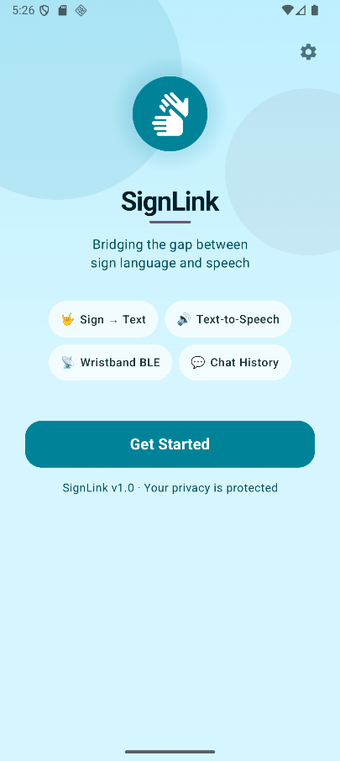 | 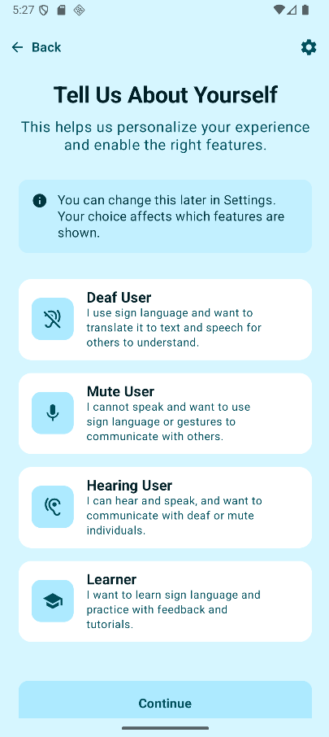 | 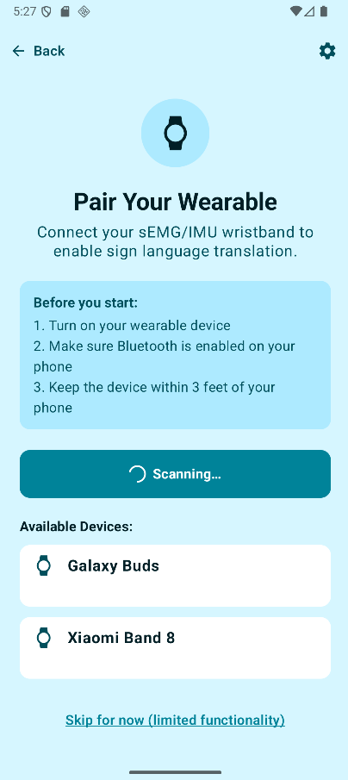
Figure 6: Screens set 1
Once a connection is established, users are guided to the Calibration Screen to prepare the wearable device for signal acquisition and future gesture recognition. This calibration workflow ensures more reliable sensor readings to improve the overall translation process. Upon successful calibration, users are directed to the Home Screen, which serves as the central navigation hub for all application features.
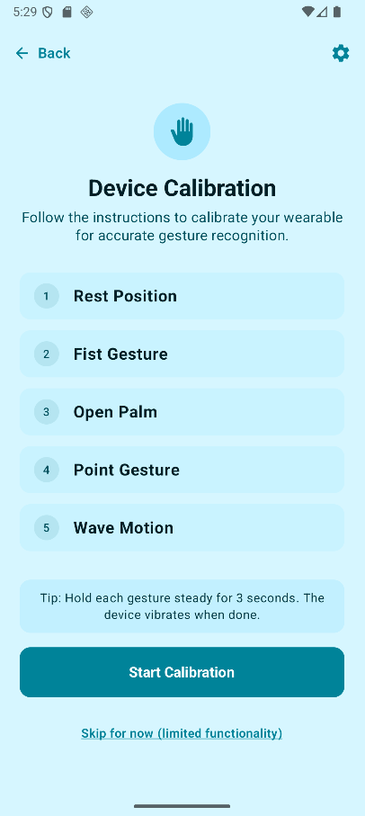 | 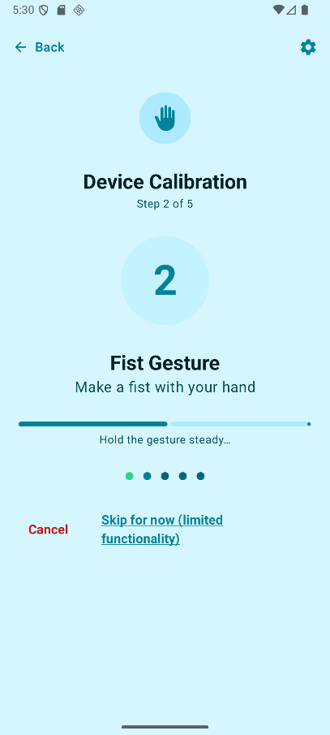 | 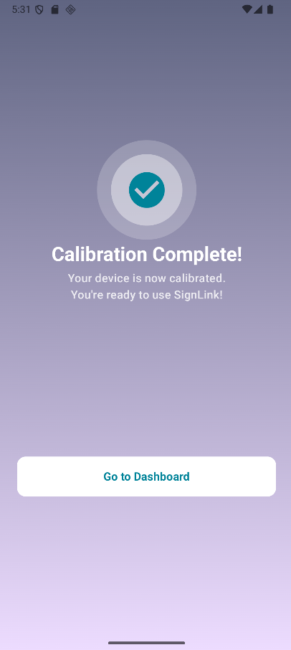
Figure 7: Screens set 2
The Home Screen provides access to the application's core communication modules: the Translation Screen, Speech-to-Text Screen, and Text-to-Speech Screen. The Translation module displays sign language outputs generated from recognized EMG gestures, while the Speech-to-Text and Text-to-Speech modules enable two-way communication between sign language and non-sign language users. Together, these components form the system's primary communication assistance functionality.
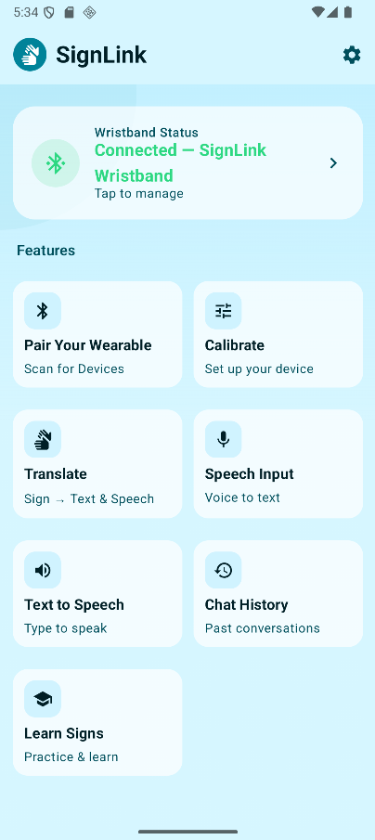 | 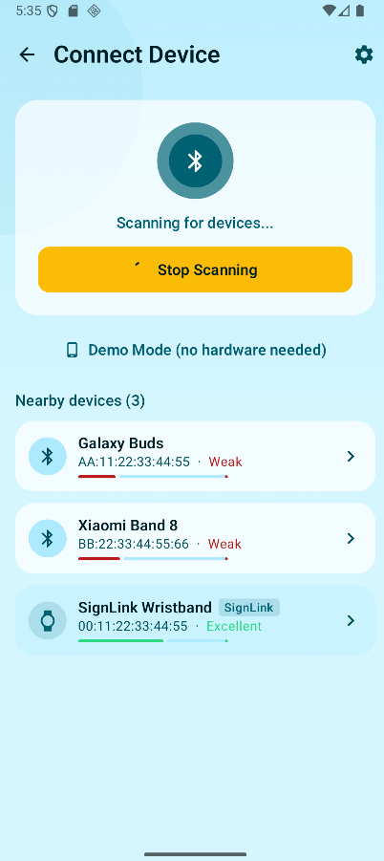 | 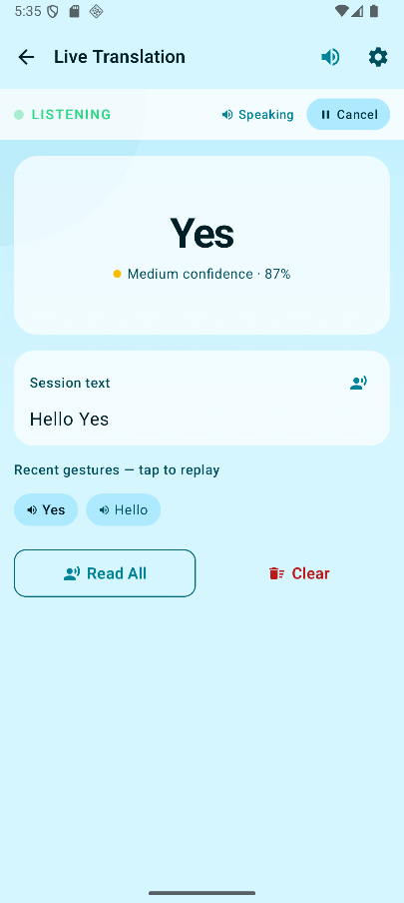
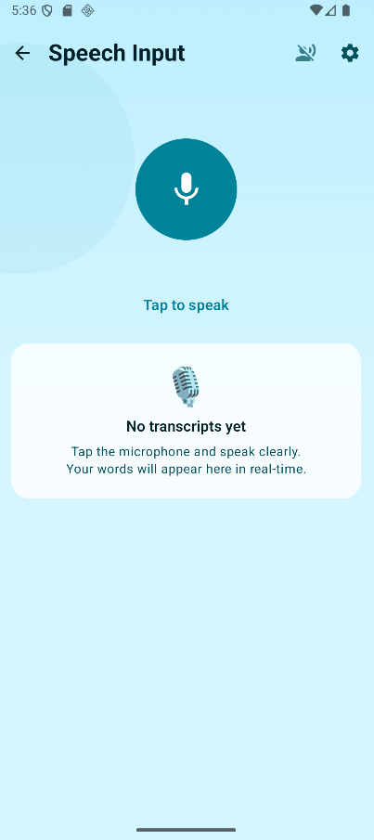 | 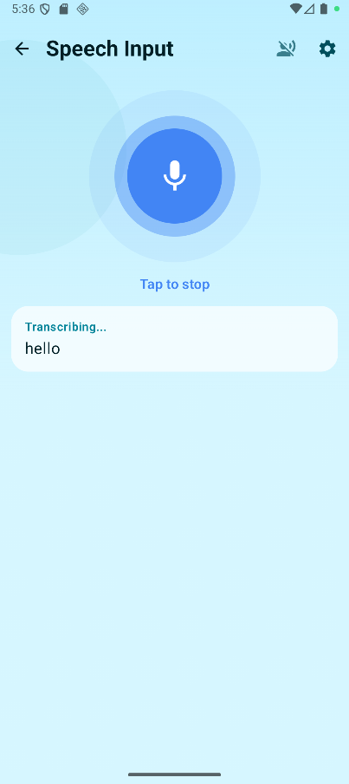 | 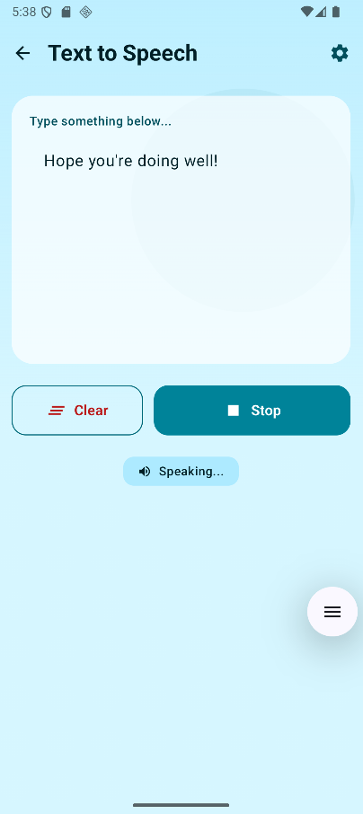
Figure 8: Screens set 3
Additional features include a Chat History Screen for reviewing previous conversations, a Learning Screen for future educational content and sign language practice, and a Settings Screen for accessibility and application configurations. These supporting modules were included to improve usability and enhance the overall user experience.
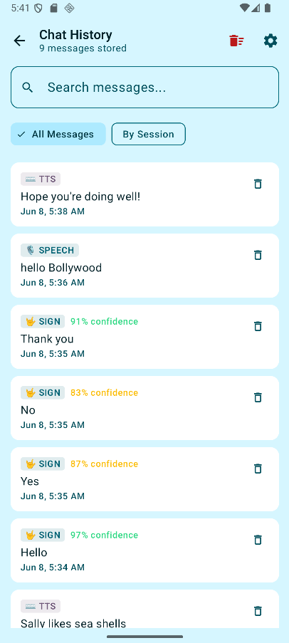 | 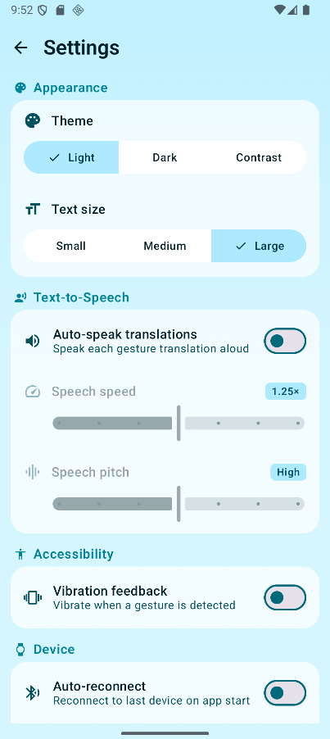 | 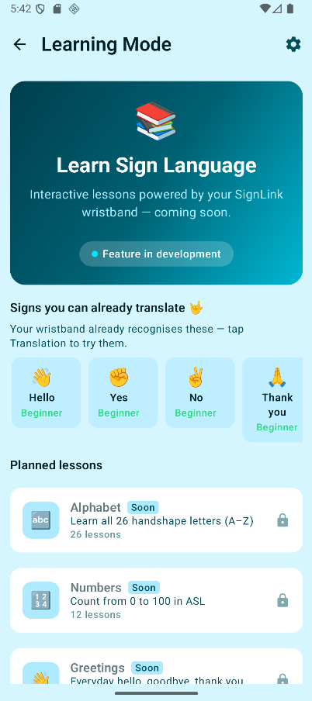
Figure 9: Screens set 4

3.3 Wearable Hardware Development
The SignLink wearable device was created to explore the potential of a cost-effective substitute for commercial EMG devices like the Myo Armband. Its aim was to record muscle activity produced during sign language gestures and relay the signals for processing within a mobile application. The hardware experienced three significant design revisions.
Version 1 (V1) featured a single EMG sensor linked to an Arduino Uno and was utilized to examine EMG signal acquisition, electrode positioning, and sensor functionality. However, this design was restricted to a single sensing channel and was insufficient in capturing the intricate muscle activity associated with sign language gestures.
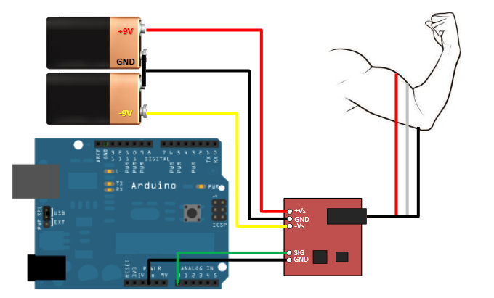
Figure 10: Setup of V1
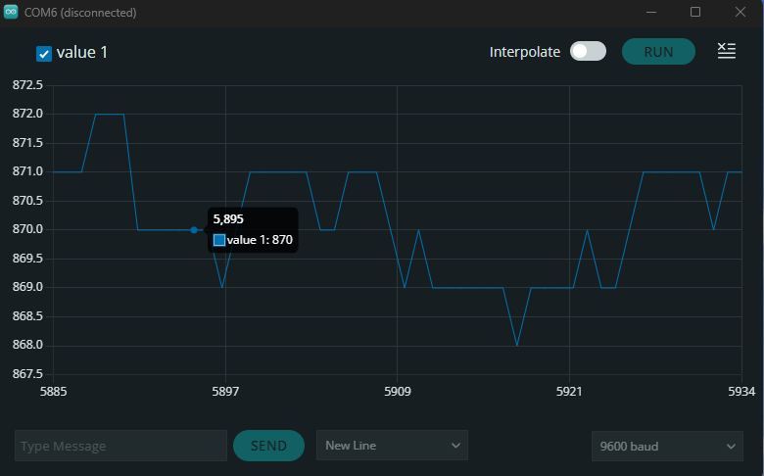
Figure 11: V1 Signal
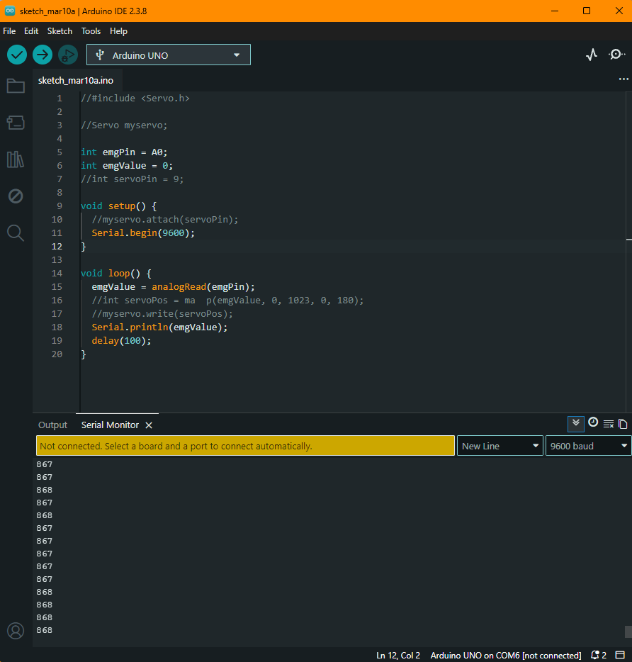
Figure 12: V1 Rough Code
To overcome this limitation, Version 2 (V2) enhanced the system by incorporating four EMG sensors connected to an Arduino Nano V3. Although this modification improved muscle coverage, the prototype faced issues with unstable signal acquisition due to loose jumper-wire connections. As a result, the design was modified, and soldered connections were implemented to enhance reliability.
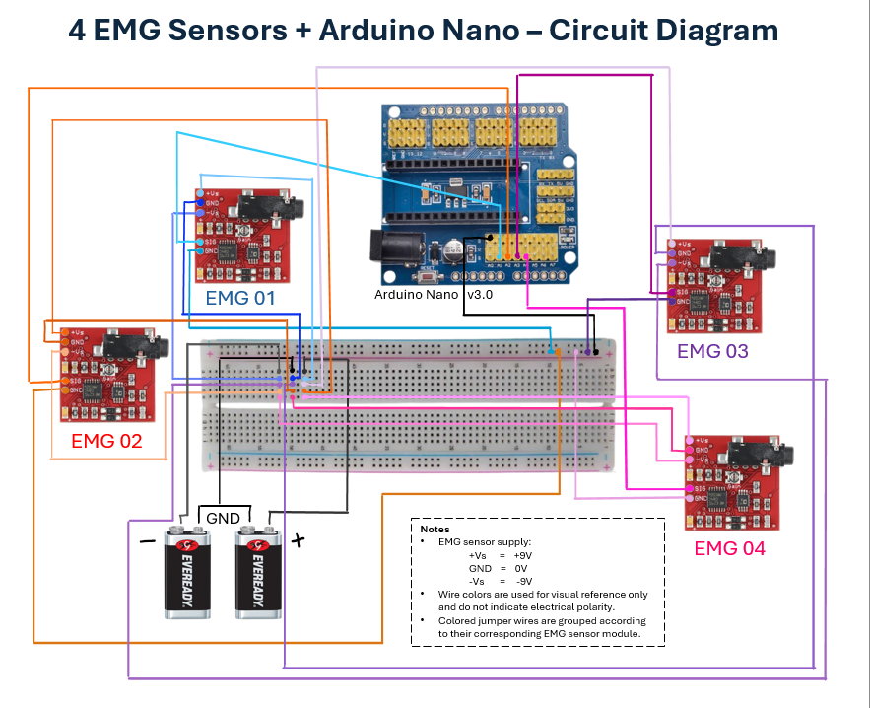
Figure 13: Setup of V2
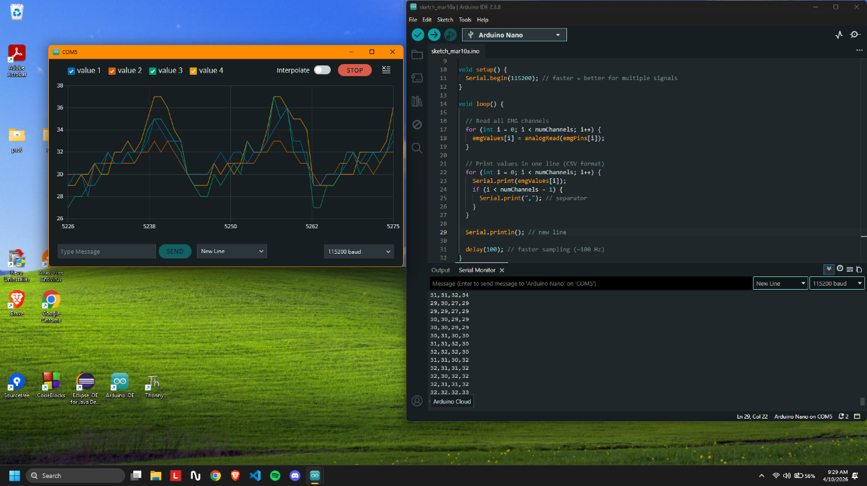
Figure 14: Code and Signal
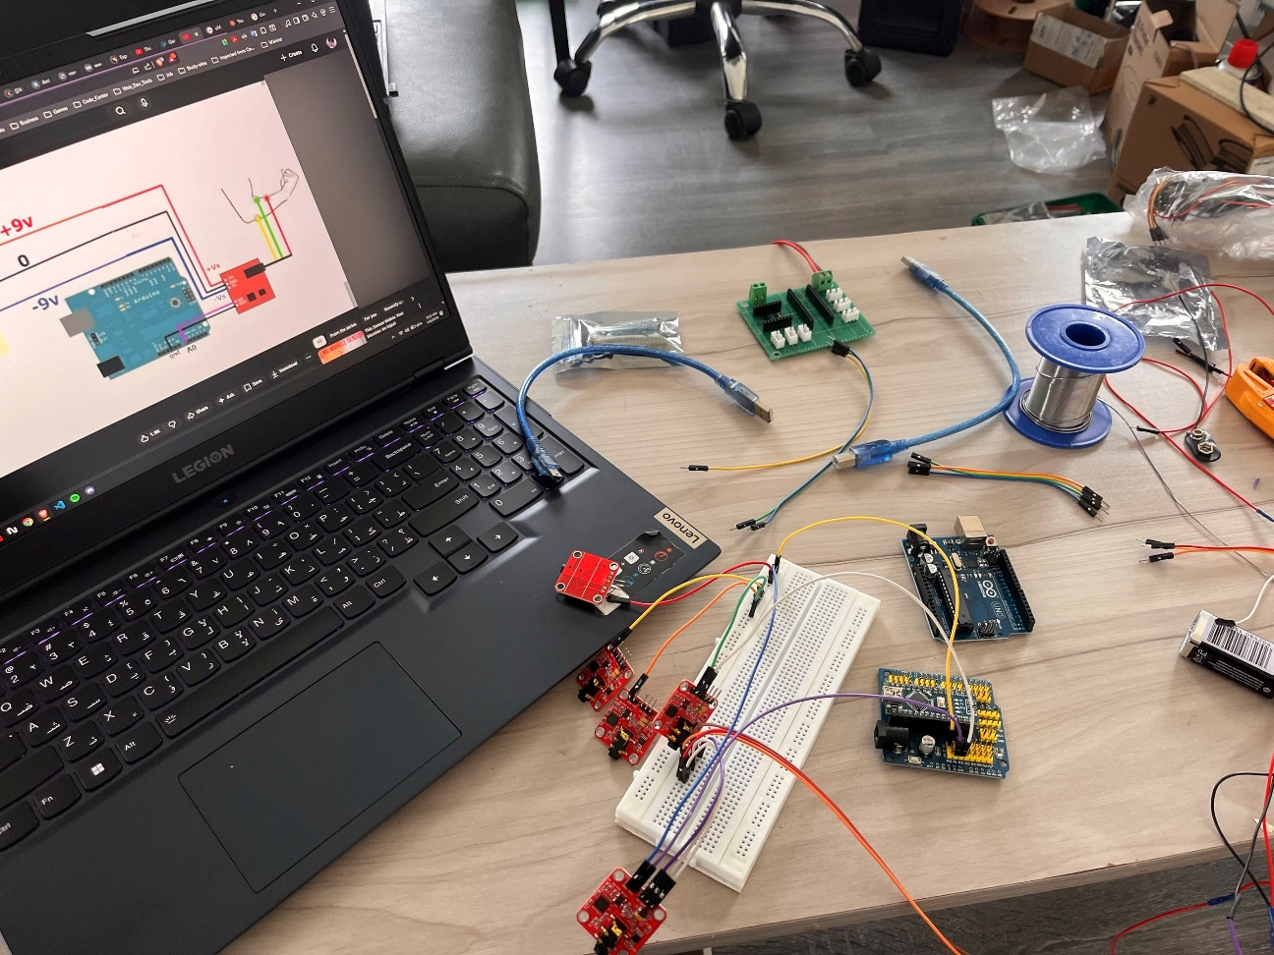
Figure 15: V2 In Real Life

Version 3 (V3) marked the most recent prototype and was still undergoing testing during this study. While it could accommodate four EMG sensors, only three were utilized to ensure circuit stability while validating the hardware architecture.
Despite the successful acquisition of EMG signals, obstacles such as signal noise, sensitivity to electrode placement, and the absence of a sufficiently large, labelled dataset hindered the custom hardware's application in training machine learning models.

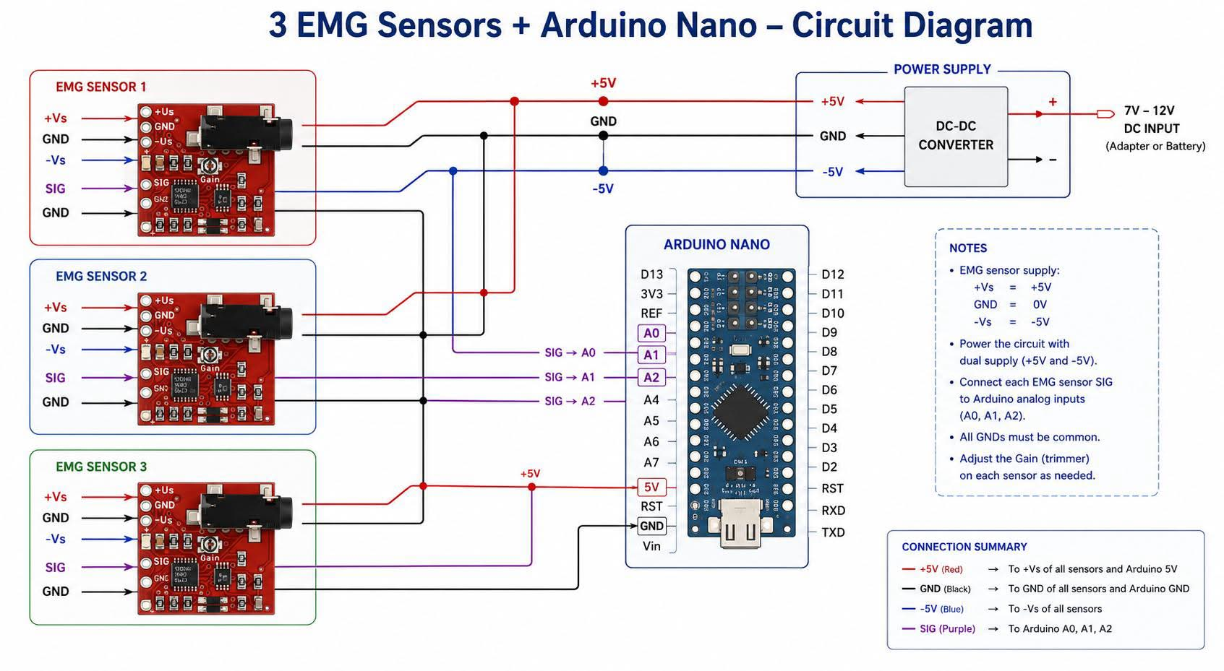
Figure 16: Setup of V3

Consequently, a publicly accessible Myo Armband ASL dataset was employed to train and assess the recognition framework under controlled conditions. Thus, the hardware functioned as a proof-of-concept platform and lays the groundwork for future endeavours focused on enhanced signal conditioning, wireless communication, and real-time integration with the SignLink application.
3.4 Machine Learning Development

3.4.1 Dataset Identification
A dataset released by the Arizona State University (American Sign Language (ASL) Fingerspelling dataset for Myo Sensor) was used to build and train the machine learning model. This dataset comprised of EMG and IMU sensor values from a Myo armband taken from 9 users for 5 secs for each letter of the ASL alphabet. The first 8 columns contain data for the 8 EMG pods/electrodes, the next 3 are for Accelerometer, the next 3 are for Gyroscope and the final 3 are for Orientation (Roll, Pitch and Yaw).

3.4.2 Data Cleaning and Preprocessing
The dataset was checked for duplicates, null/missing values and out of range values (the sensors in the Myo armband have specific ranges). The above issues were handled accordingly while making sure the label balance was preserved. Zeroing of the EMG sensor values was done as explained by Paudyal et al., 2017 to account for different starting positions and rest-level activations. It was found to be very fruitful since before zeroing and testing the limitation of the model, the accuracy turned out to be significantly low.

3.4.3 Exploratory Data Analysis
To understand the data on a deeper level, research papers using the dataset were studied and information gained from those papers were used to build and develop the model (Paudyal et al.,2017; Paudyal et al., 2016).

3.4.4 Feature Selection and Engineering
The methodology for feature engineering was influenced by the works of Shakeel et al. (2020) and Paudyal et al. (2017), both of which utilized comparable preprocessing methods. Initially, five statistical features - maximum, minimum, mean, standard deviation, and total energy were derived from each of the 17 parent features, culminating in a total of 85 engineered features.
In order to maintain temporal information, each 5-second recording was subsequently partitioned into five equal segments, and the same features were extracted from each segment, thereby elevating the feature count to 510.
When a baseline Random Forest classifier was tested on both the non-segmented and segmented datasets, the accuracies recorded were 73.3% and 75.0%, respectively, suggesting that segmentation enhanced performance. Subsequently, feature selection was conducted to further optimize the model.
Although dimensionality reduction techniques such as PCA have been investigated in prior research, they were deemed unnecessary due to the Random Forest's intrinsic capability to assess feature importance through metrics like Gini impurity and information gain. A baseline Random Forest model trained on all 510 features yielded an accuracy of 75.00%. By employing SelectFromModel to retain only the most significant half of the features, accuracy was improved to 77.97%, thereby illustrating the advantages of feature selection.

3.4.5 Splitting of Data into Training and Testing
The first iteration of the train-test split started with Leave-One-Group-Out (LOGO) cross-validation, a common approach for sensor-based applications. However, accuracies remained low at approximately 20–25% per fold. This was expected because the model was trained on data from a subset of users and tested on a completely unseen user. Due to natural variations in muscle activity, arm size and armband placement, EMG signals differ significantly between individuals, making inter-user generalisation difficult.
A stratified 80–20 train-test split was therefore adopted, ensuring class balance while allowing data from every user to appear in both the training and testing sets. Under this approach, model accuracy increased to 75%, indicating that the model could successfully learn user-specific EMG patterns and recognise gestures from previously unseen samples of the same users.
These findings suggest that the model performs best as an intra-user classifier rather than an inter-user classifier. Consequently, the SignLink application incorporates a calibration phase, allowing the model to learn the EMG characteristics of a specific user before performing gesture recognition.
3.4.6 Training the model
A Random Forest Classifier was used with control parameters to ensure minimal overfitting. Even though overfitting is to be expected to an extent due to the smaller dataset. The code snippets are attached in the appendix section 7.3.
3.5 Final UI and UX App Testing
A final UI/UX testing phase was conducted between June 5 and June 6 to evaluate the refined iteration of the application interface. To ensure comprehensive feedback across diverse environments, a total of 15 participants were evaluated using a hybrid testing structure:
- In-Person Testing: Nine sessions were conducted on-site in a physical environment, allowing for direct observation of real-world usability, ergonomic comfort, and immediate user interaction with the application flow.
- Remote Testing: Six sessions were conducted online via video conferencing, where participants were guided on how to download and run the app on their phones to assess navigation clarity and remote user comprehension.
Before commencing each session, participants were briefed on the system's objectives. Similar to earlier testing phase, the evaluation focused strictly on the final application interface logic, visual layout consistency, and accessibility features. Qualitative feedback via the Think-Aloud method and quantitative metrics were gathered to validate the final design enhancements.

4.0 Evaluation
This chapter evaluates the effectiveness of SignLink through three stages of assessment: prototype usability testing, machine learning model evaluation and final application testing. The objective was to assess the usability, functionality and technical feasibility of the proposed system.

4.1 UI/UX Prototype Evaluation

4.1.1 Quantitative Results

Task Performance and Design Metrics (1–5 Likert Scale)
Initial Clarity: App purpose clarity scored 4.8/5.0, with 100% confidence regarding home screen navigation.
Navigation Success: Locating the Bluetooth pairing menu scored 4.4/5.0 (P4 noted a slight delay in button discovery).
Calibration Logic: Comprehension of gesture instructions ("Fist" and "Wave") scored 4.8/5.0.
Accessibility and Readability: Visual contrast and text size scored 4.6/5.0, with 80% validating the accessibility-first design.

System Usability Scale (SUS)
The application achieved an average SUS score of 89.0, placing it in the Excellent (Grade A) bracket. A minor friction point was identified by P4, whose lower score (72.5) stemmed from discomfort with the simulated calibration process.
Participant | SUS Score Calculation | SUS Score | Grade | Adjective Rating
P1 | (18+16)*2.5 = 34*2.5 | 85.0 | A | Excellent
P2 | (18+20)*2.5 = 38*2.5 | 95.0 | A+ | Best Imaginable
P3 | (18+19)*2.5 = 37*2.5 | 92.5 | A+ | Best Imaginable
P4 | (14+15)*2.5 = 29*2.5 | 72.5 | B | Good
P5 | (20+20)*2.5= 40*2.5 | 100.0 | A+ | Best Imaginable
Avg |  | 89.0 | A | Excellent
Table 4: SUS Score (first test)

4.1.2 Qualitative Results (Think Aloud & Interviews)

Think-Aloud Observations
Device Calibration: Interactions were generally positive (P2: "Easy to use and quite intuitive"). However, P4 found the wizard-driven setup somewhat abstract without the physical weight of the hardware band present.
Translation Mode: Navigation was fluid and confident. P5 noted that the interface layout was "visually clear and uncluttered" with zero points of navigation confusion.

4.2 Machine Learning Model Evaluation
Among all baseline models, the Random Forest that was trained on the 255 selected features (segmented data with feature selection) demonstrated the highest performance, achieving an accuracy of 77.97% prior to hyperparameter optimization and cross-validation.
Following the tuning process utilizing RandomizedSearchCV in conjunction with Stratified K-Fold cross-validation, the average cross-validation score was around 77%, whereas the final test accuracy rose to 83.9%. Considering the relatively small dataset and the unexpectedly elevated test accuracy, the experiment was replicated across various train-test random states to assess robustness.
Throughout all splits, the RF1, RF2, and cross-validation scores exhibited a degree of stability, while the optimized Random Forest consistently attained the highest accuracies, albeit with increased variability among test sets. This variability is likely attributable to the limited dataset size, where alterations in the train-test partition can considerably influence test difficulty, coupled with the model's capacity to leverage advantageous training partitions post hyperparameter optimization.
No indications of train-test leakage were detected, as feature selection, model training, and hyperparameter optimization were conducted solely on the training data. The consistency of the cross-validation scores across multiple random states further corroborates the dependability of the evaluation process.
The final hyperparameter-tuned model achieved an average accuracy of 84.67% ± 2.80% across 17 random states. This performance is within the range reported for Random Forest-based approaches by Paudyal et al. (2017) and Shakeel et al. (2020), although direct comparisons should be interpreted cautiously due to potential differences in experimental methodology.
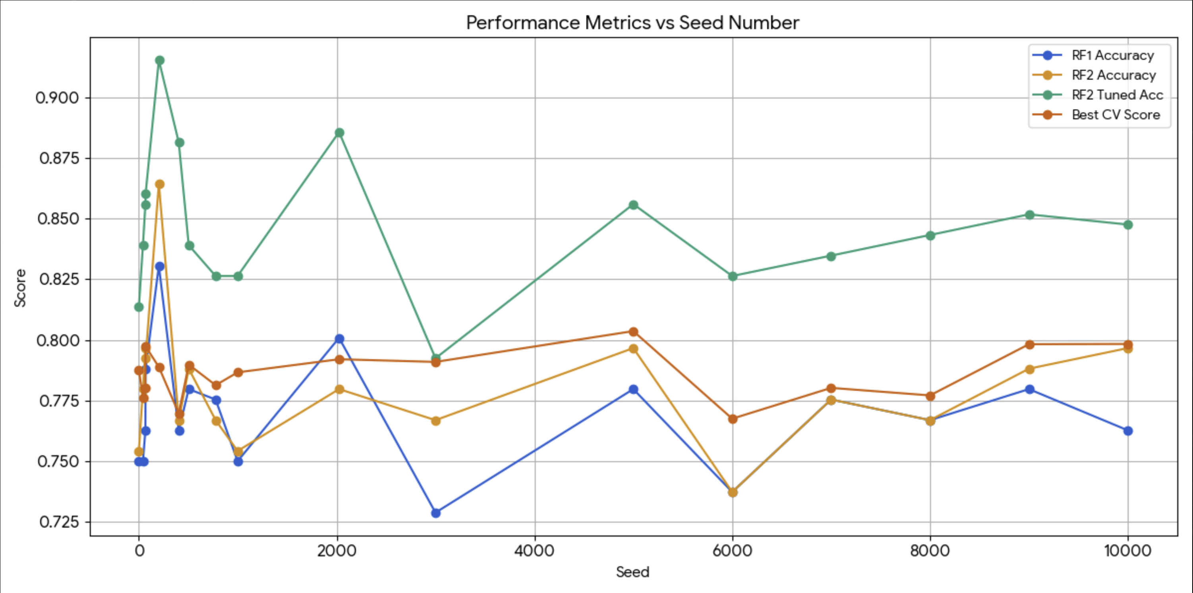
Figure 17: Performance Metrics VS Seed Number
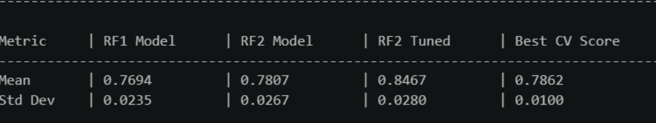Figure 18: Average Metrics of all Seeds

4.3 Final UI/UX Prototype Evaluation

4.3.1 Quantitative Results

Task Performance and Design Metrics (1–5 Likert Scale)
Initial Clarity: App purpose clarity scored 5.0/5.0, with 100% confidence regarding home screen navigation.
Navigation Success: Locating the Bluetooth pairing menu scored 4.8/5.0 (P4 noted a slight delay in button discovery).
Calibration Logic: Comprehension of calibration gestures ("Fist" and "Wave") scored 4.7/5.0.
Accessibility and Readability: Visual contrast and text size scored 4.9/5.0, while the translated text readability scored 5.0/5.0.

System Usability Scale (SUS)
The application achieved an average SUS score of 96.8, placing it in the Best Imaginable (Grade A+) bracket. Here is a table calculating all the SUS scores based on the Google Form data.
Participant | SUS Score Calculation | SUS Score | Grade | Adjective Rating
P1 | 39*2.5 | 97.5 | A+ | Best Imaginable
P2 | 38*2.5 | 95.0 | A+ | Best Imaginable
P3 | 39*2.5 | 97.5 | A+ | Best Imaginable
P4 | 39*2.5 | 97.5 | A+ | Best Imaginable
P5 | 38*2.5 | 95.0 | A+ | Best Imaginable
P6 | 40*2.5 | 100.0 | A+ | Best Imaginable
P7 | 38*2.5 | 95.0 | A+ | Best Imaginable
P8 | 38*2.5 | 95.0 | A+ | Best Imaginable
P9 | 38*2.5 | 95.0 | A+ | Best Imaginable
P10 | 40*2.5 | 100.0 | A+ | Best Imaginable
P11 | 38*2.5 | 95.0 | A+ | Best Imaginable
P12 | 40*2.5 | 100.0 | A+ | Best Imaginable
P13 | 39*2.5 | 97.5 | A+ | Best Imaginable
P14 | 39*2.5 | 97.5 | A+ | Best Imaginable
P15 | 38*2.5 | 95.0 | A+ | Best Imaginable
Avg |  | 96.8 | A+ | Best Imaginable
Table 5: SUS Score (final test)

4.3.2 Qualitative Results (Think Aloud & Interviews)

Think-Aloud Observations
Device Calibration: Interactions were generally positive but despite many finding the app still usable without the hardware, they thought it’d be better to have it.
Translation Mode: Navigation was fluid and confident.

4.4 Final Application Evaluation
The final application successfully implemented the core features identified during requirements analysis, including communication assistance, accessibility-focused design and support for future EMG integration. Combined with the machine learning results presented in Section 4.2, the project demonstrates the feasibility of an EMG-based sign language translation framework. While real-time integration with the custom hardware remains future work, the project achieved its primary objectives and provides a strong foundation for further development.

5.0 Conclusions
This project presented the design, development and evaluation of SignLink, an intelligent sign language translation system that combines wearable electromyography (EMG) sensing, machine learning and mobile application technologies. The project successfully demonstrated the feasibility of using EMG signals and machine learning techniques for sign language gesture recognition while also providing a functional mobile application capable of supporting communication between sign language users and non-sign language users.
The developed system incorporated a user-centred design approach, resulting in a mobile application that was evaluated positively during usability testing. Furthermore, the machine learning model achieved promising gesture classification performance using a publicly available Myo Armband dataset, demonstrating the potential of EMG-based sign language recognition. Although full integration between the wearable hardware, machine learning model and mobile application was not achieved within the project timeframe, the results provide a strong foundation for future development.
Overall, the findings suggest that wearable sensing technologies, artificial intelligence and mobile computing can be effectively combined to create accessible assistive communication solutions that help reduce communication barriers for individuals with hearing and speech impairments.

5.1 Limitations
Several limitations were encountered during the development of this project. The most significant limitation was the inability to collect a large-scale custom EMG dataset using the wearable prototype. As a result, the machine learning model was trained and evaluated using a publicly available Myo Armband dataset rather than data collected from the custom hardware platform.
Additionally, the wearable hardware prototype remained under development throughout the project and therefore was not sufficiently stable for extensive real-time testing and machine learning integration. Consequently, the complete end-to-end translation pipeline could not be fully validated using the custom hardware.
This model also performs best for intra-user predictions as compared to inter-user predictions and hence a calibration system was implemented in the Application to make the App work best for a specific user.
The current implementation also focuses on recognizing individual American Sign Language (ASL) fingerspelling alphabet gestures rather than continuous words, sentences or conversational sign language. This limits the practical communication capabilities of the current system.
Finally, usability testing was conducted on a relatively small sample of participants due time and resource constraints. While the results provided valuable feedback, larger-scale testing would provide a more comprehensive evaluation of system usability and accessibility.

5.2 Future Work
Future development of SignLink should focus on completing and refining the wearable EMG sensing platform to enable reliable real-time data acquisition and direct integration with the mobile application. Collecting a dedicated EMG dataset from the custom hardware would also allow the machine learning model to be trained and evaluated using project-specific data.
Further improvements could include expanding gesture recognition beyond ASL fingerspelling alphabets to support words, phrases and continuous sign language translation. The integration of the trained machine learning model directly into the Android application would also enable real-time translation functionality.
An additional feature that could be explored is video-to-translation functionality, where users can upload or capture videos of sign language gestures using a smartphone camera. Computer vision and deep learning techniques could then be used to recognise signs directly from video input and convert them into text or speech. This would provide an alternative translation method for users who do not have access to the wearable device and would increase the accessibility and versatility of the SignLink platform.
Additional future enhancements may include multilingual translation support, cloud-based data synchronization, improved accessibility features and larger-scale user testing involving Deaf and Hard of Hearing participants. These developments would further improve the practicality, accuracy and accessibility of the SignLink platform while supporting wider real-world adoption.

6.0 References
- Abdullahi, S.B. and Chamnongthai, K., 2022. American Sign Language Words Recognition Using Spatio-Temporal Prosodic and Angle Features: A Sequential Learning Approach. IEEE Access, 10, pp.15911–15923. Available at: https://ieeexplore.ieee.org/document/9702061 [Accessed 5 November 2025].
- United Nations, 2006. Convention on the Rights of Persons with Disabilities. New York: United Nations. Available at: https://www.un.org/development/desa/disabilities/convention-on-the-rights-of-persons-with-disabilities.html [Accessed 20 May 2026].
- United Nations, 2015. Transforming our World: The 2030 Agenda for Sustainable Development. New York: United Nations. Available at: https://sdgs.un.org/2030agenda [Accessed 20 May 2026].
- World Health Organization, 2026. Deafness and Hearing Loss. Available at: https://www.who.int/news-room/fact-sheets/detail/deafness-and-hearing-loss [Accessed 20 May 2026].
- Papatsimouli, M., Kollias, K.F., Lazaridis, L., Maraslidis, G.S., Fragulis, G.F., Sarigiannidis, P. and Fragulis, G.F., 2022. Real Time Sign Language Translation Systems: A review study. In: 2022 11th International Conference on Modern Circuits and Systems Technologies (MOCAST). Bremen, Germany, 8-10 June 2022. New York: IEEE, pp. 1–4. doi:10.1109/MOCAST54814.2022.9837666. Available at: https://www.researchgate.net/publication/362331604_Real_Time_Sign_Language_Translation_Systems_A_review_study [Accessed 28 May 2026].
- Ambavane, P., Karjavkar, R., Pathare, H., Relekar, S., Alte, B. and Sharma, N.K., 2020. A novel communication system for deaf and dumb people using gesture. ITM Web of Conferences, 32, p. 02003. doi:10.1051/itmconf/20203202003. Available at: https://www.researchgate.net/publication/343284260_A_Novel_Communication_System_For_Deaf_And_Dumb_People_using_gesture [Accessed 25 May 2026].
- Emmorey, K., 2002. Language, cognition, and the brain: Insights from sign language research. Mahwah, NJ: Lawrence Erlbaum Associates. Available at: https://staibabussalamsula.ac.id/wp-content/uploads/2024/03/LANGUAGE-COGNITION-THE-BRAIN-staibabussalamsula.ac_.id_.pdf [Accessed 28 May 2026].
- Maharjan, S., Shrestha, S. and Fernando, S., 2024. Sign language detection and translation using smart glove. In: International Conference on Computer Networking, Security & Data Analytics. Springer, Singapore, pp. 419–431. doi:10.1007/978-981-97-3591-4_41. Available at: https://repository.londonmet.ac.uk/9015/1/Sign%20Language%20Detection%20and%20Translation%20using%20Smart%20Glove.pdf [Accessed 28 May 2026].
- Shukor, A.Z., Miskon, M.F., Jamaluddin, M.H., Ali@Ibrahim, F.b., Asyraf, M.F. and Bahar, M.B.b., 2015. A new data glove approach for Malaysian sign language detection. Procedia Computer Science, 76, pp.60–67. Available at: https://www.sciencedirect.com/science/article/pii/S1877050915037771 [Accessed 28 May 2026].
- Akmeliawati, R., Ooi, M.P.L. and Kuang, Y.C., 2007. Real-time Malaysian sign language translation using colour segmentation and neural network. In: 2007 IEEE Instrumentation & Measurement Technology Conference IMTC 2007. Warsaw, Poland, 1-3 May 2007. New York: IEEE, pp.1–6. Available at: http://ieeexplore.ieee.org/document/4258110/ [Accessed 28 May 2026].
- Shakeel, Z.M., So, S., Lingga, P. and Jeong, J.P., 2020. MAST: Myo Armband Sign-Language Translator for Human Hand Activity Classification. In: 2020 International Conference on Information and Communication Technology Convergence (ICTC). ICTC 2020. October 2020. DOI: 10.1109/ICTC49870.2020.9289153.Available at: https://iotlab.skku.edu/publications/international-conference/MAST-ICTC2020.pdf [Accessed: 30 May 2026].
- Paudyal, P., Lee, J., Banerjee, A. and Sandeep, K.S. (2017) DyFAV: Dynamic Feature Selection and Voting for Real-time Recognition of Fingerspelled Alphabet using Wearables. In: Proceedings of the 22nd International Conference on Intelligent User Interfaces. New York, NY: ACM. Available at: https://doi.org/10.1145/3025171.3025216 [Accessed: 30 May 2026].
- Paudyal, P., Banerjee, A. and Sandeep, K.S. (2016) SCEPTRE: a Pervasive, Non-Invasive, and Programmable Gesture Recognition Technology. In: Proceedings of the ACM Intelligent User Interfaces Conference (IUI 2016). New York, NY: ACM. Available at: https://doi.org/10.1145/2856767.2856794 [Accessed: 30 May 2026].
- Chowdhury, R.H., Reaz, M.B.I., Ali, M.A.B.M., Bakar, A.A.A., Chellappan, K. and Chang, T.G. (2013) 'Surface Electromyography Signal Processing and Classification Techniques', Sensors, 13(9), pp. 12431–12466. doi: 10.3390/s130912431. Available at: https://pmc.ncbi.nlm.nih.gov/articles/PMC3821366/ [Accessed: 22 May 2026].
- Chen, T. and Guestrin, C., 2016. XGBoost: A Scalable Tree Boosting System. Proceedings of the 22nd ACM SIGKDD International Conference on Knowledge Discovery and Data Mining, pp.785–794. Available at: https://dl.acm.org/doi/10.1145/2939672.2939785 [Accessed: 22 May 2026].
- World Health Organization, 2022. Global Report on Health Equity for Persons with Disabilities. Geneva: World Health Organization. Available at: https://www.who.int/publications/i/item/9789240063600 [Accessed 23 May 2026].
- Zhang, R., Hong, Y., Dong, H., Yang, X., Zhang, H. and Dang, L. 2025. Advances in electromyography armbands for gesture recognition and multimodal fusion. iScience, 29(1), p. 114517. doi: 10.1016/j.isci.2025.114517. Available at: https://www.sciencedirect.com/science/article/pii/S2589004225027786 [Accessed: 22 May 2026].

7.0 Appendix

7.1 Appendices of UI/UX Design Section

7.1.1 Gantt Chart

7.1.2 Low Fidelity Diagrams
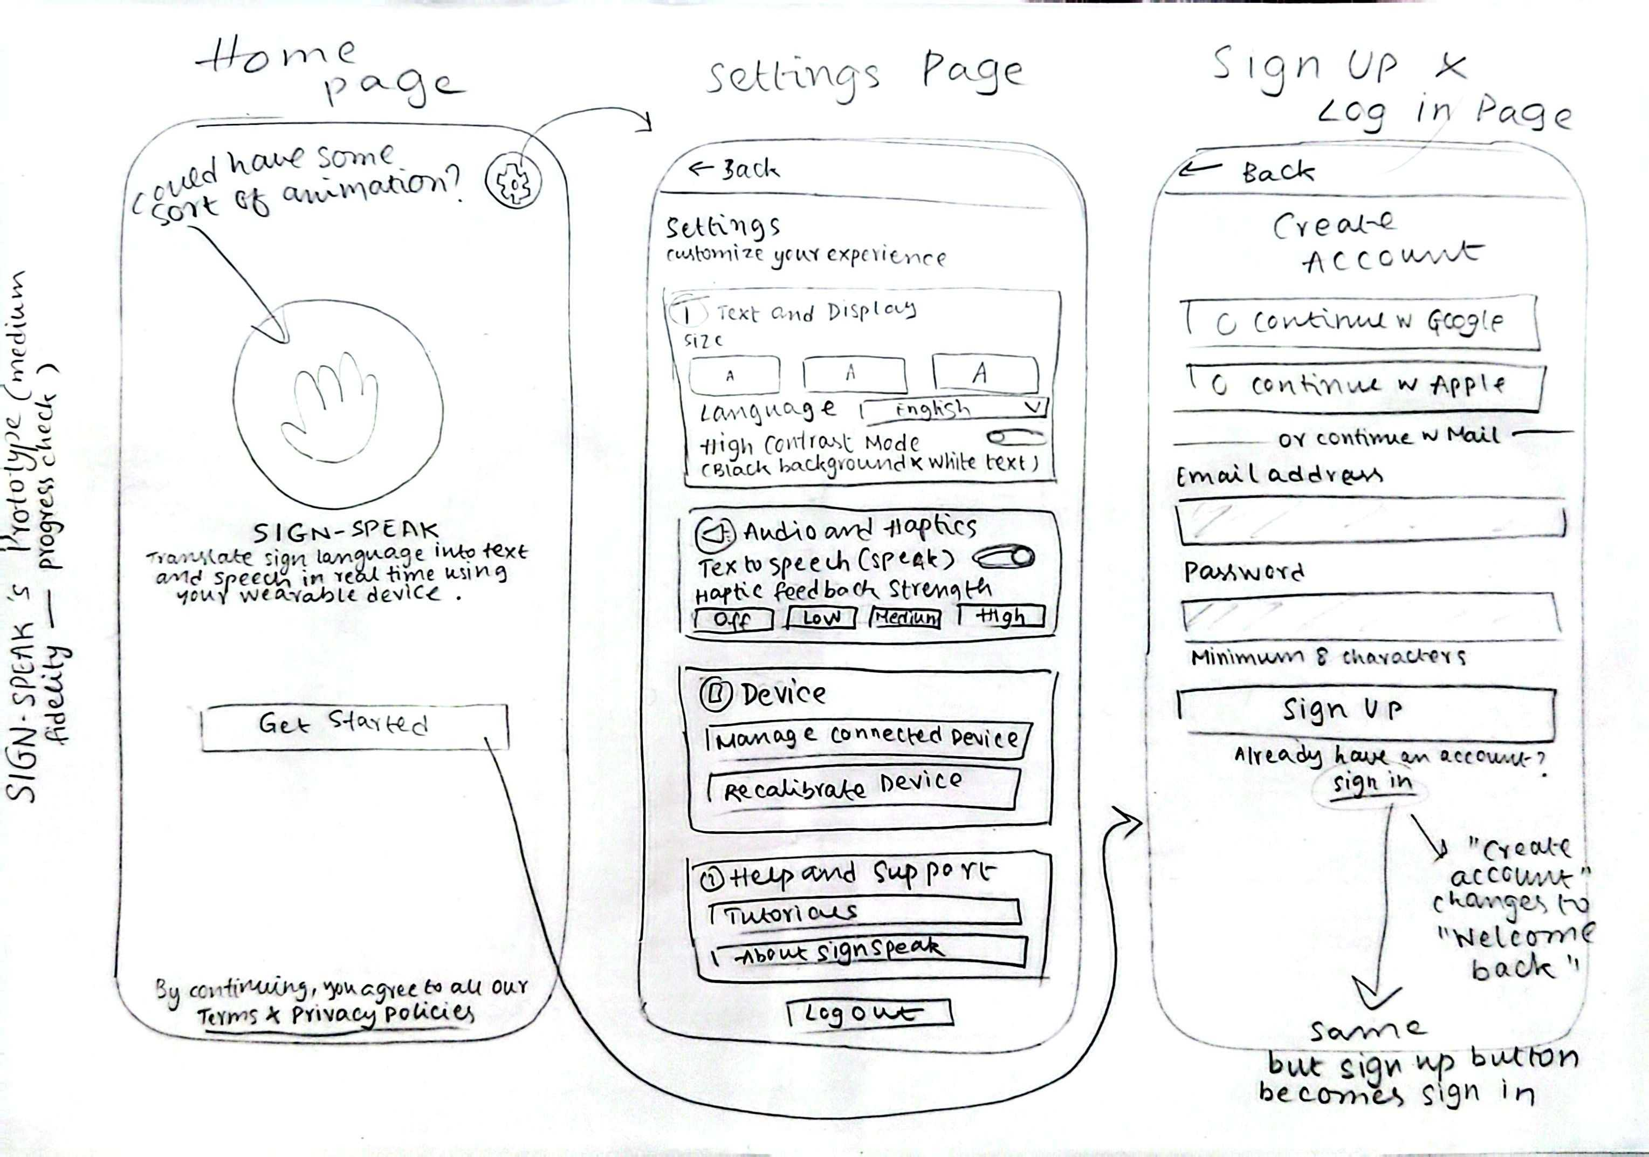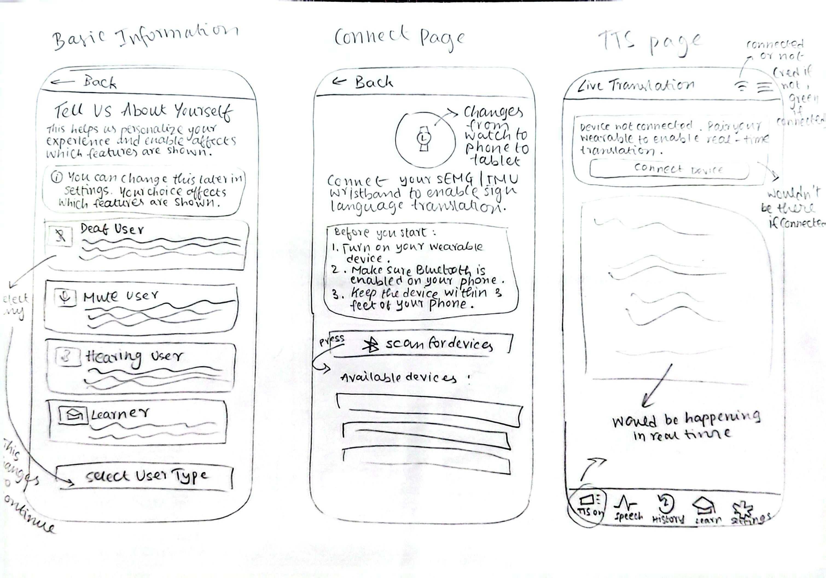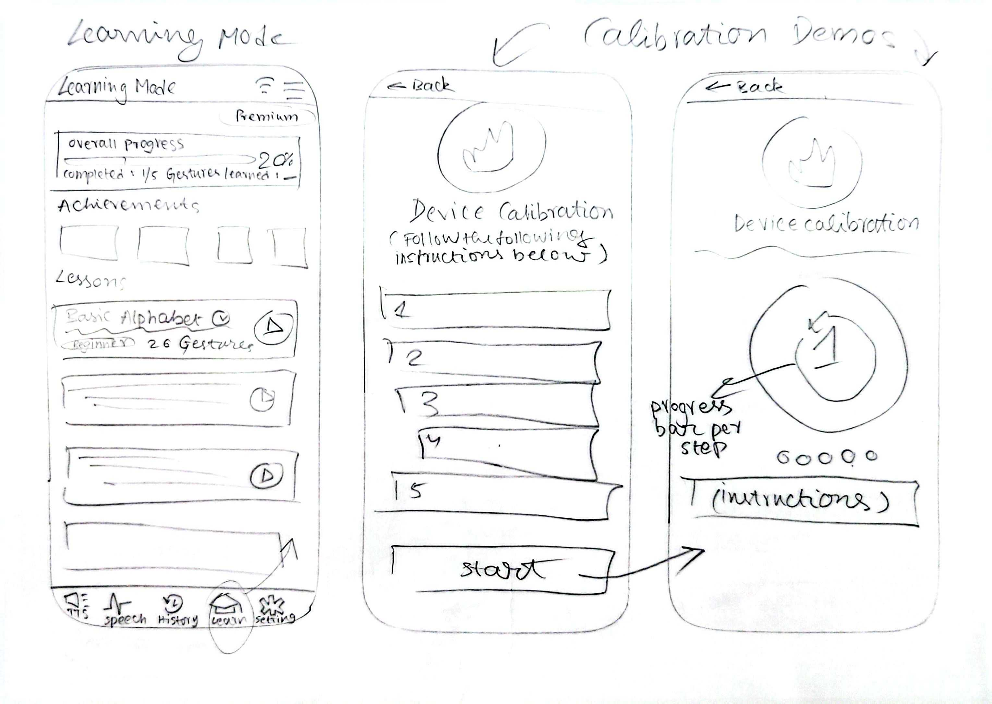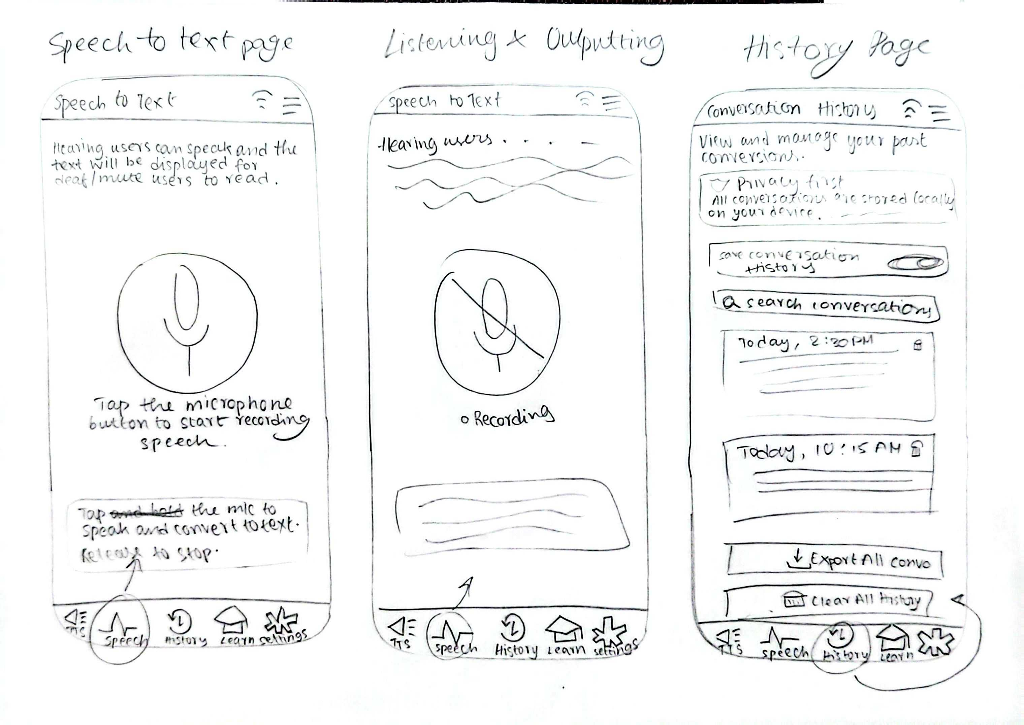

7.1.3 High Fidelity Diagrams
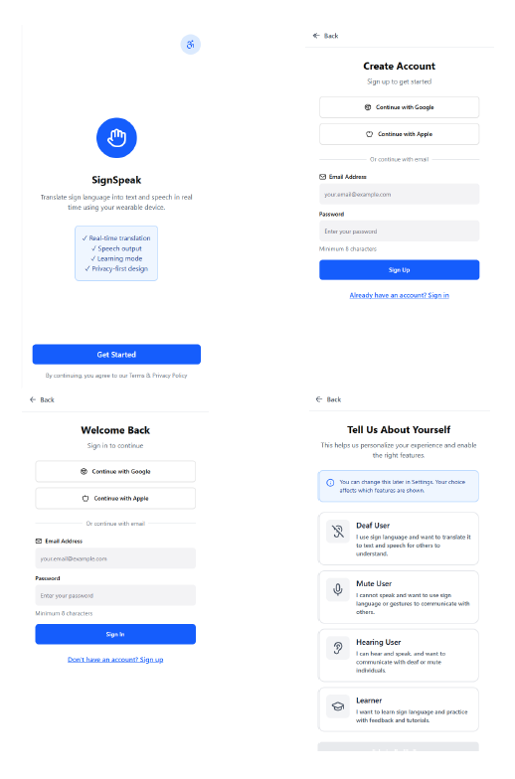
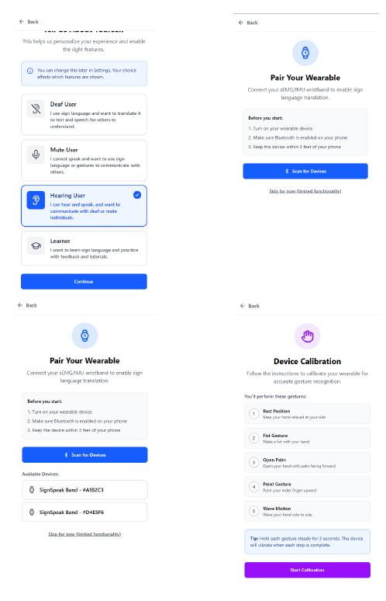
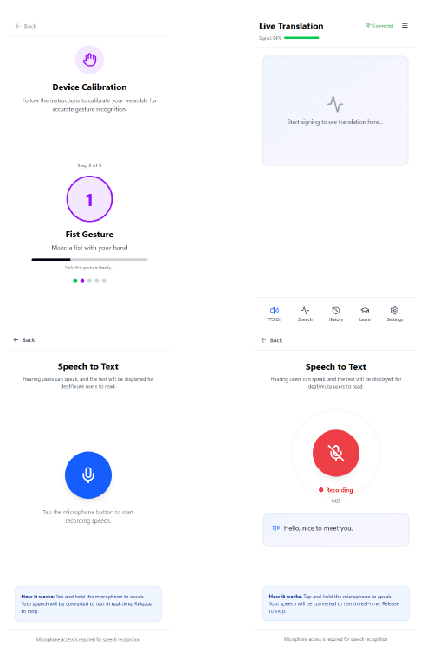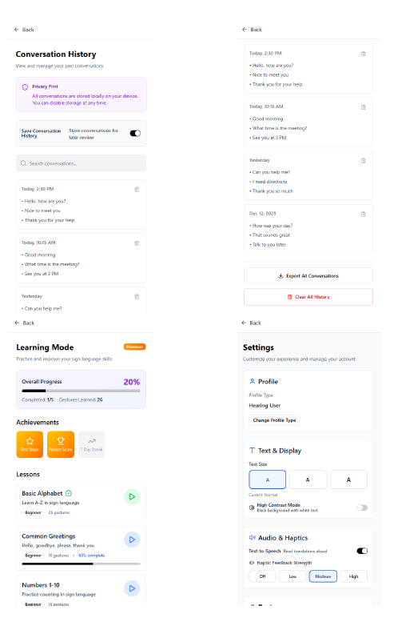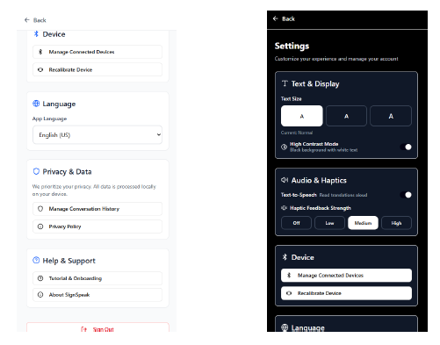

7.1.4 Testing Consent Forms
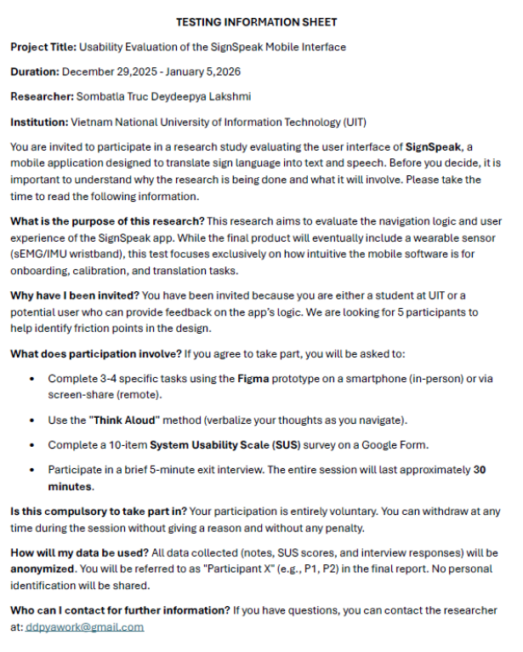
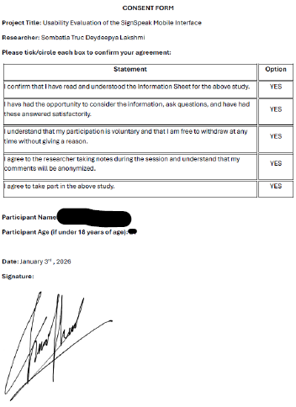
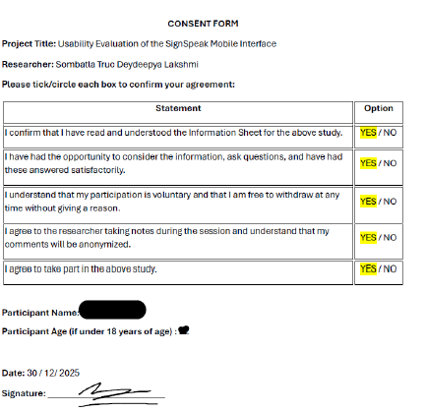
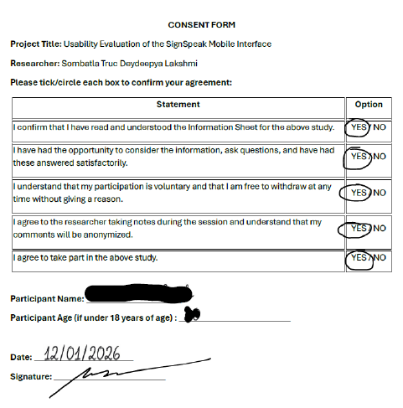
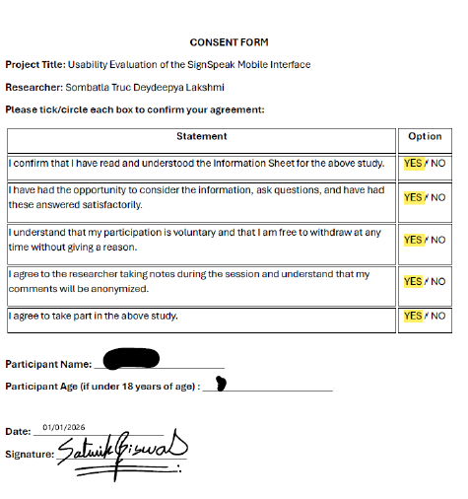
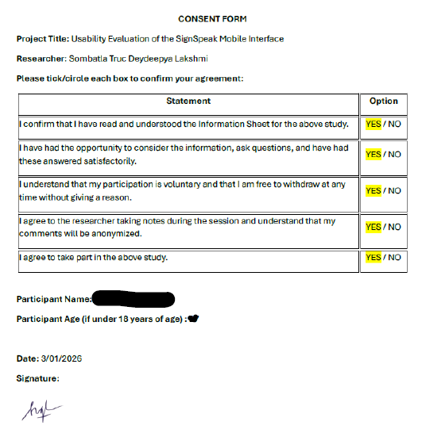

7.1.5 Results from Form
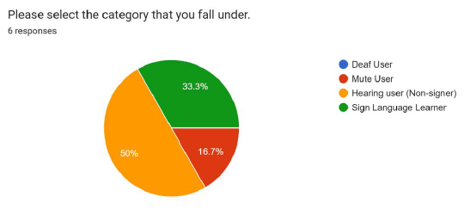
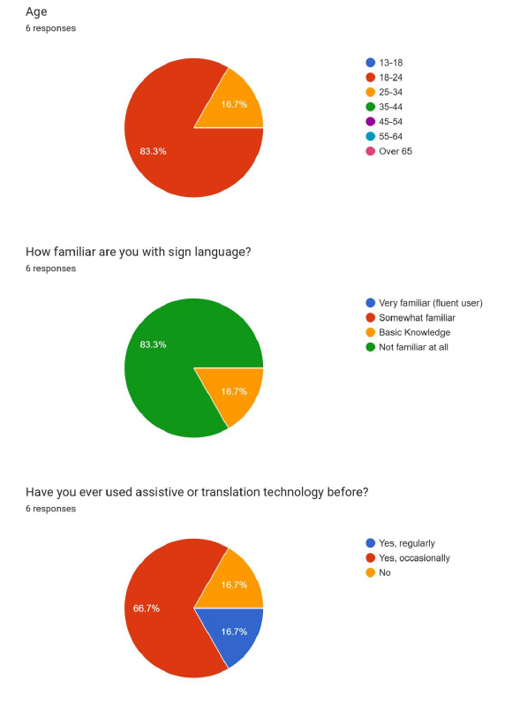
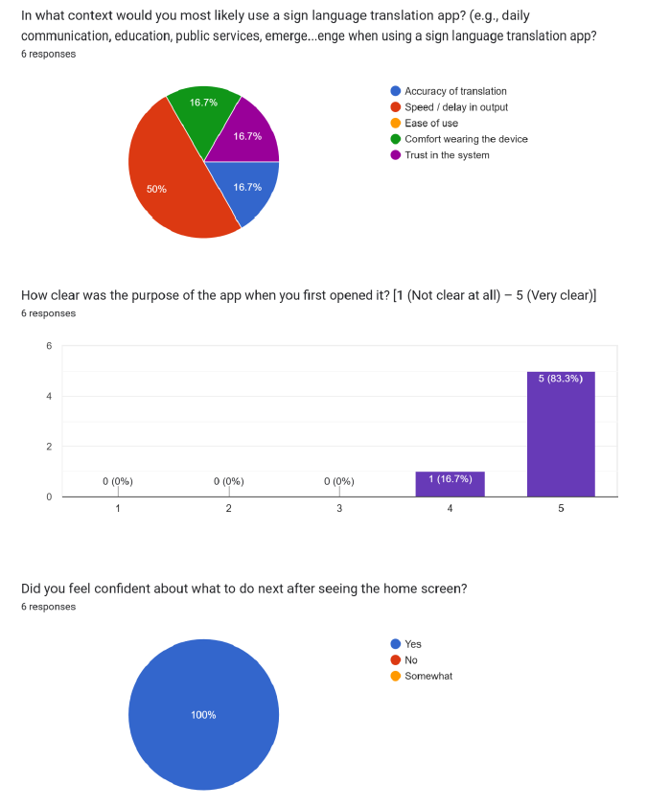
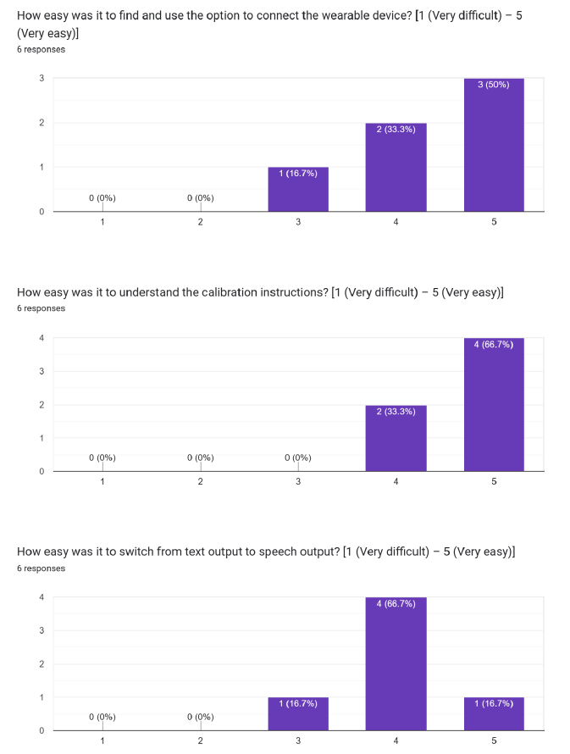
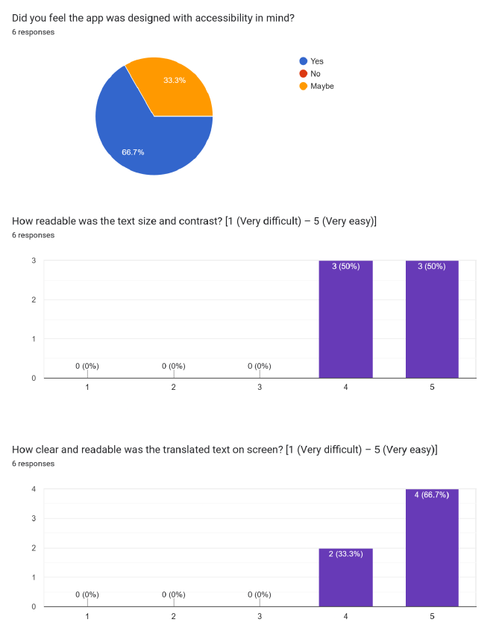
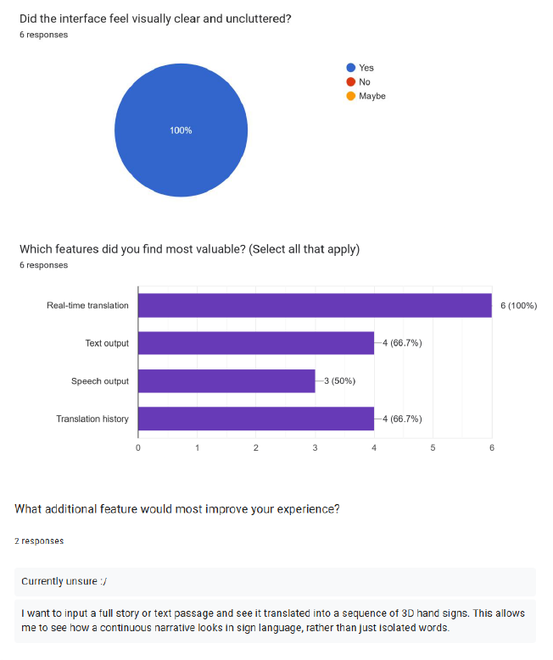
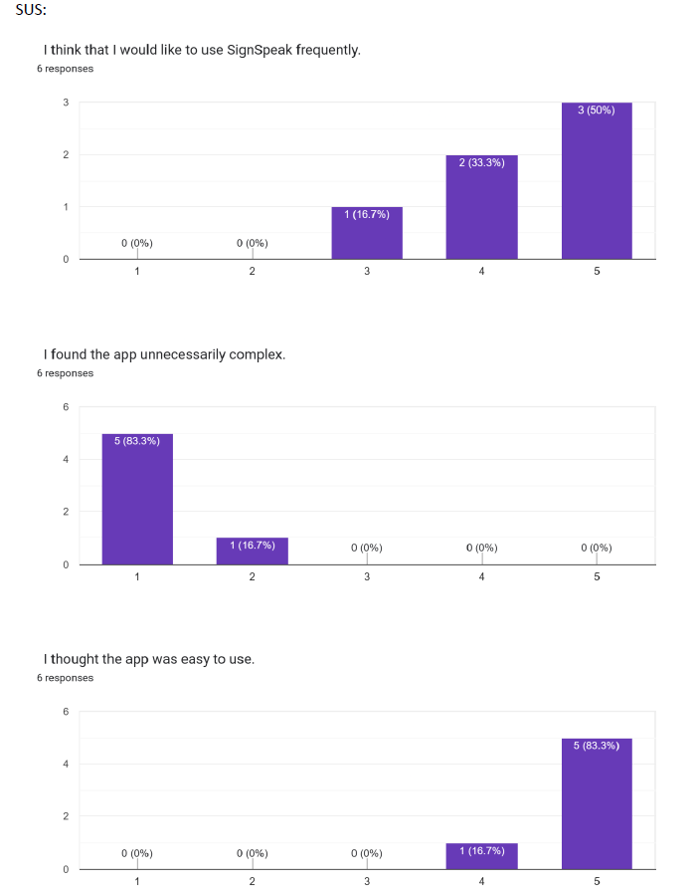
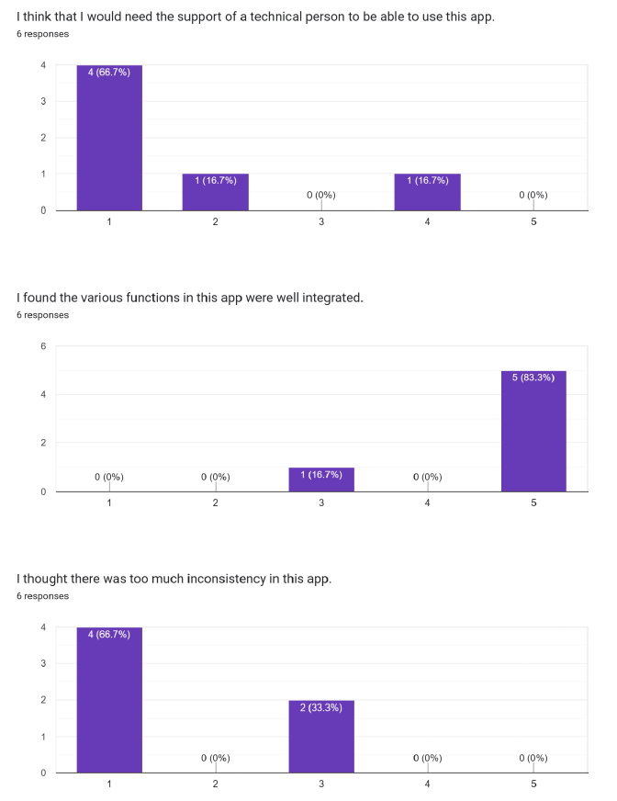
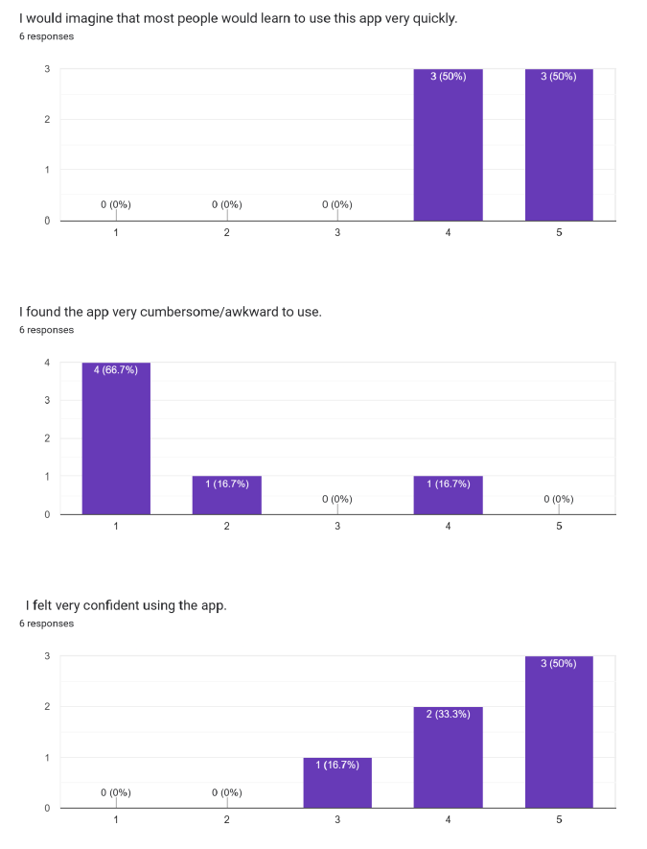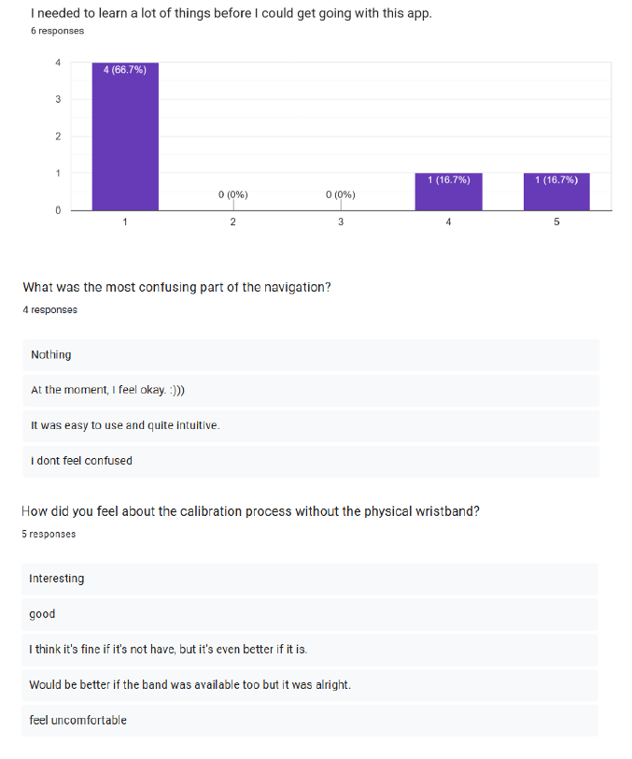

7.2 App Screens
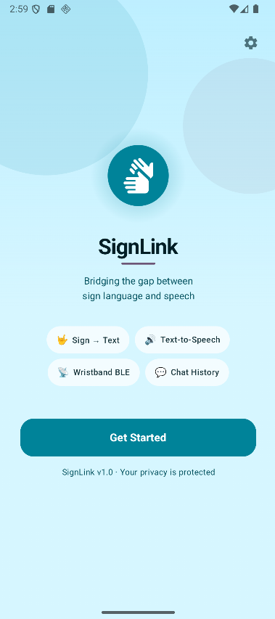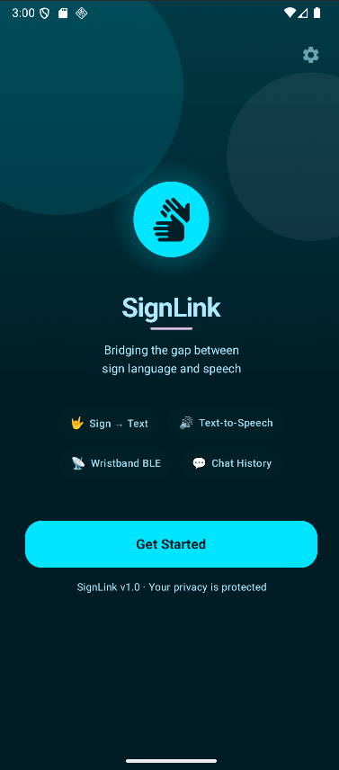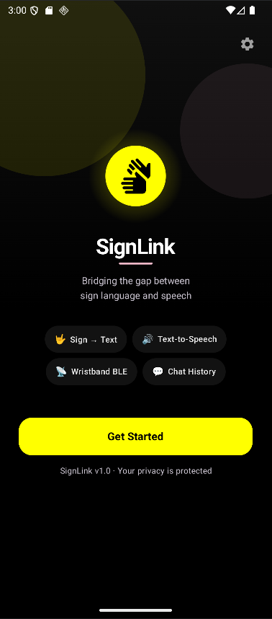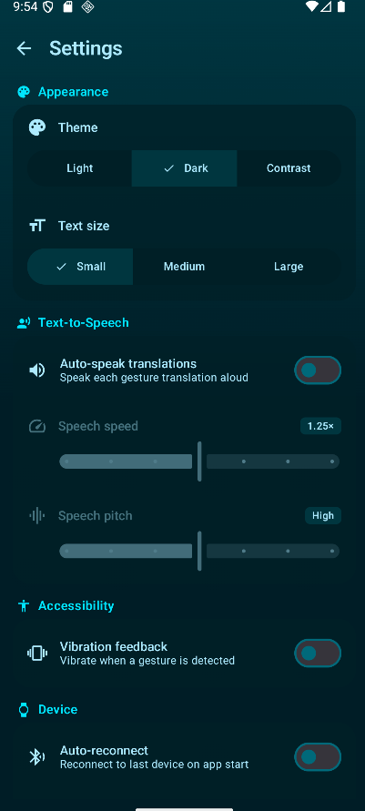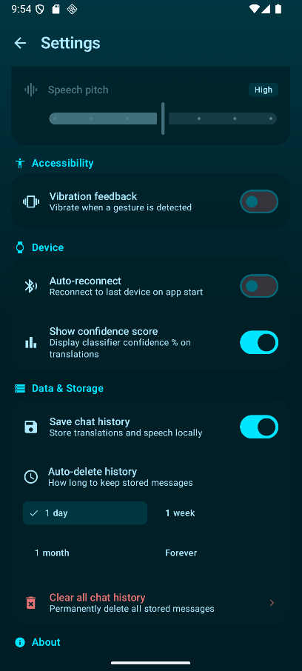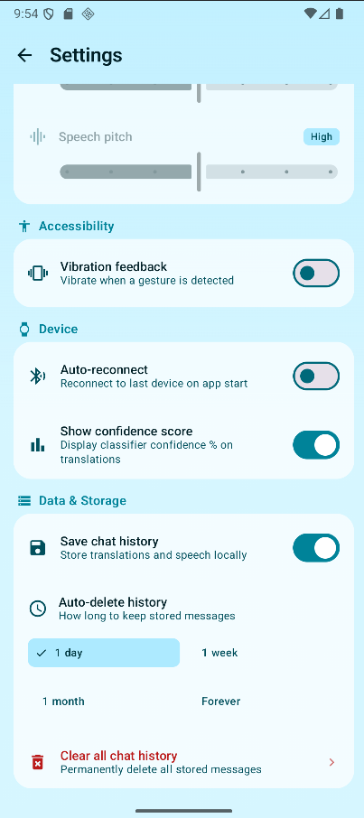
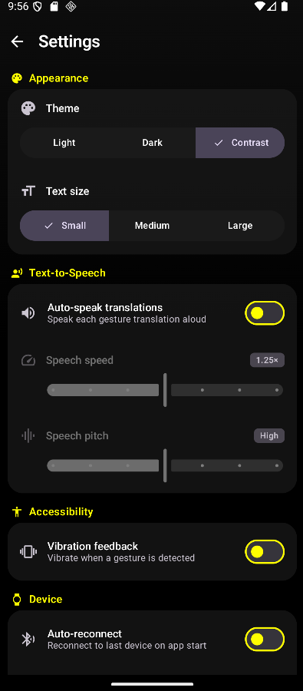 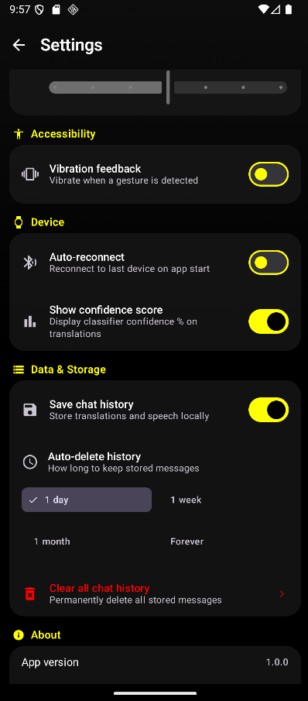 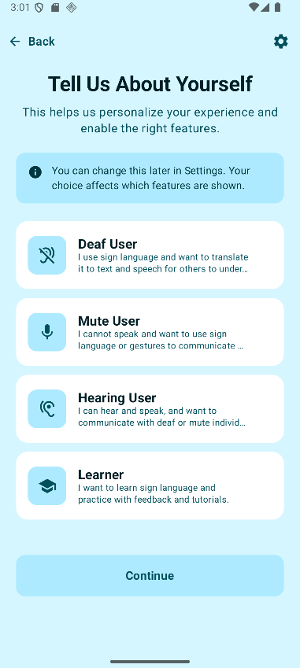 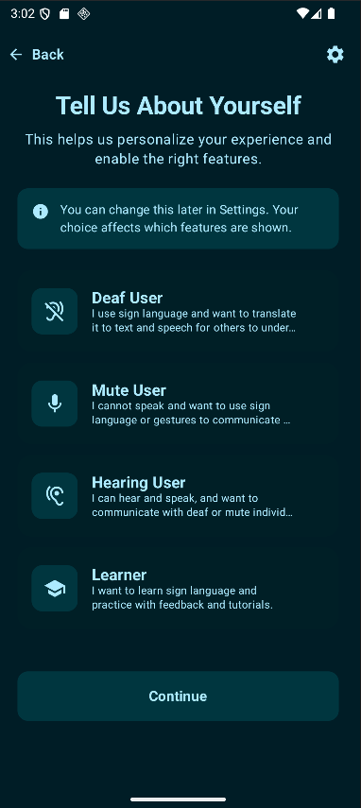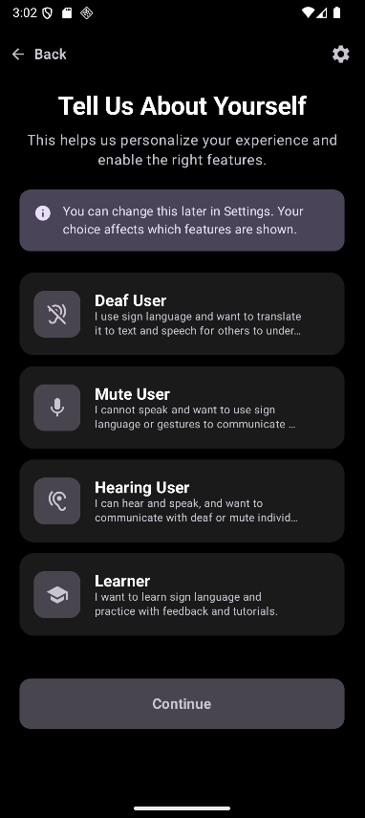 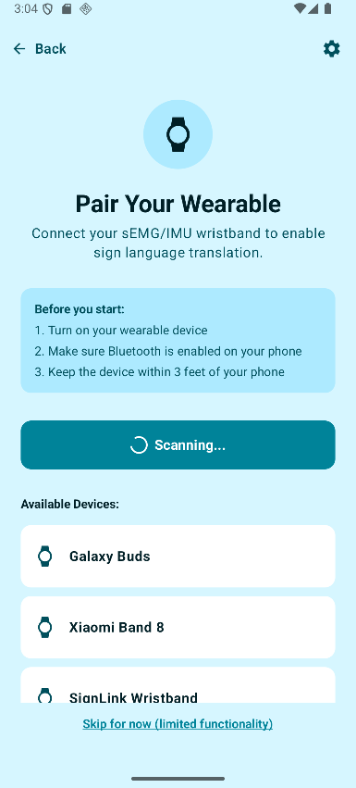 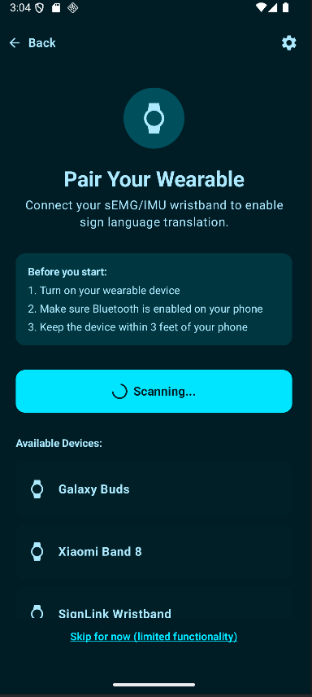 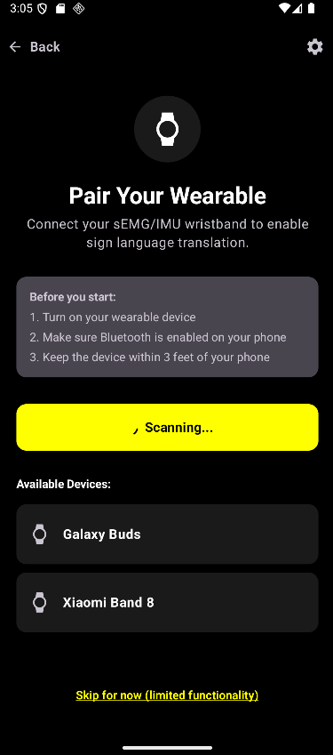 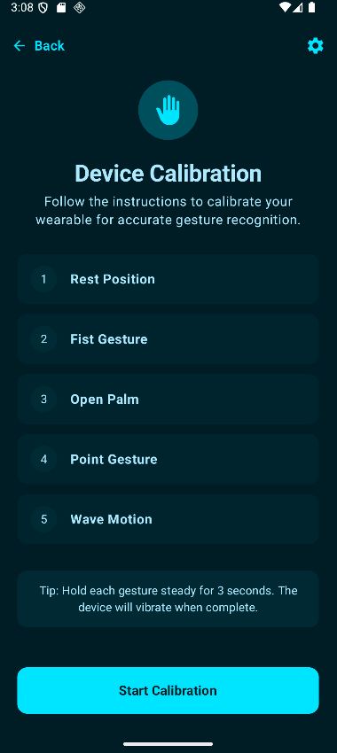 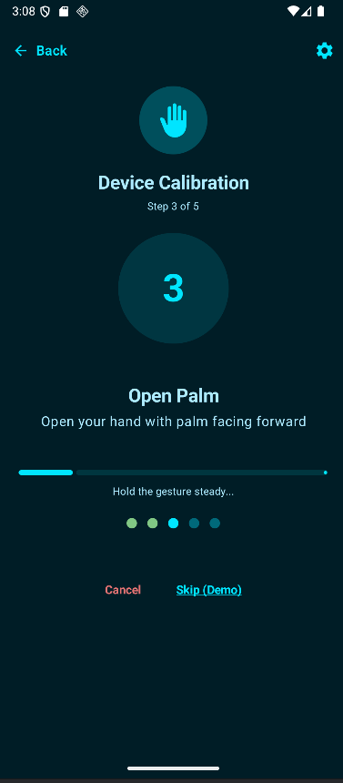 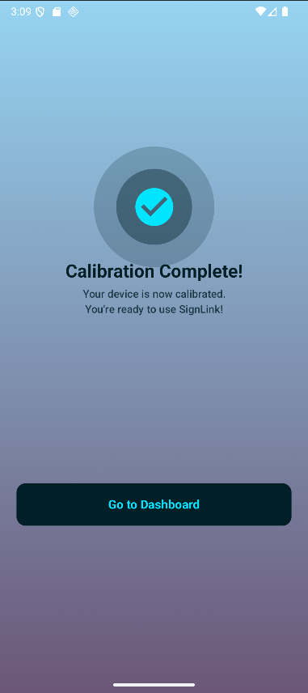 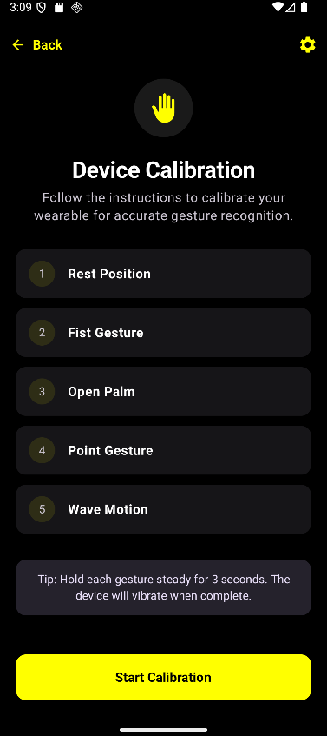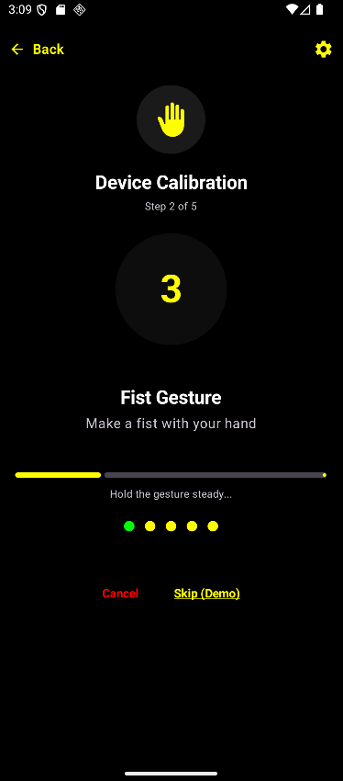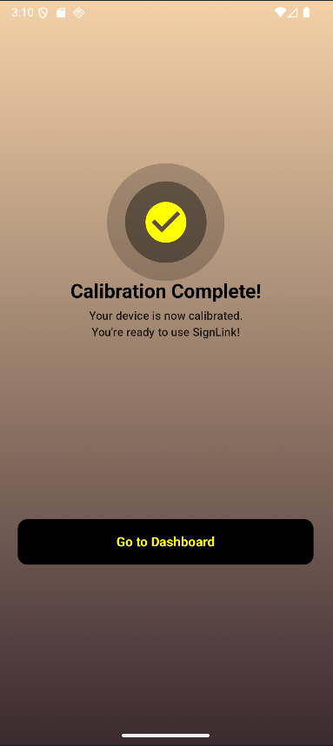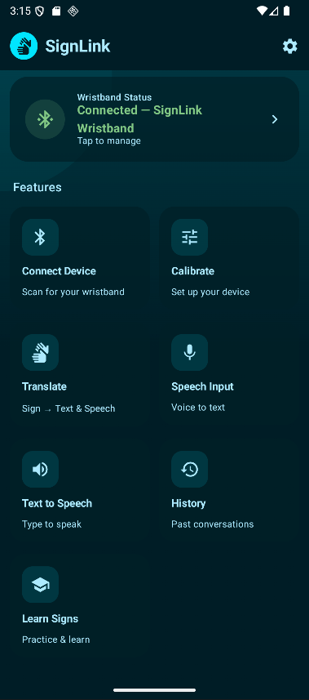 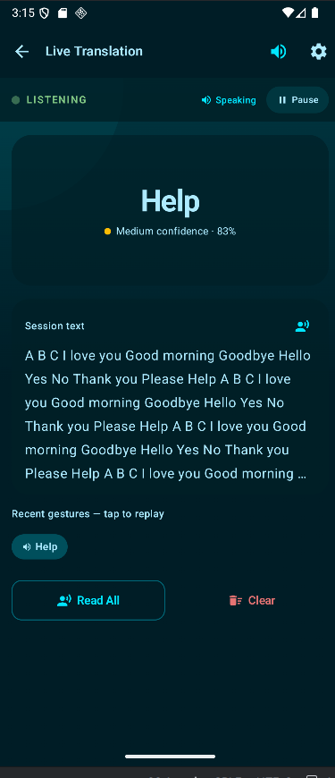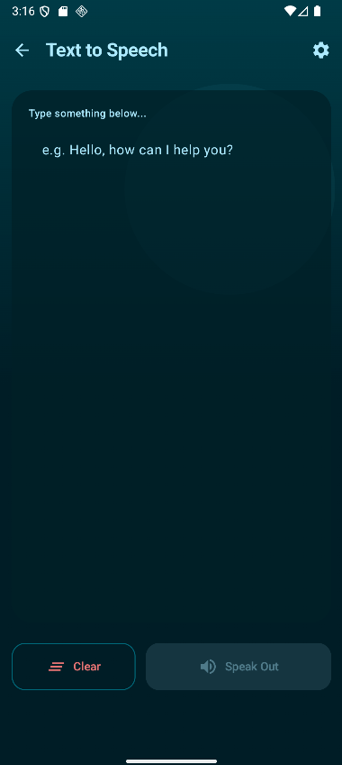 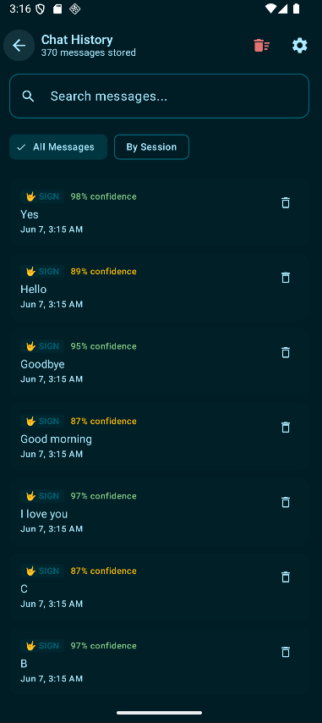 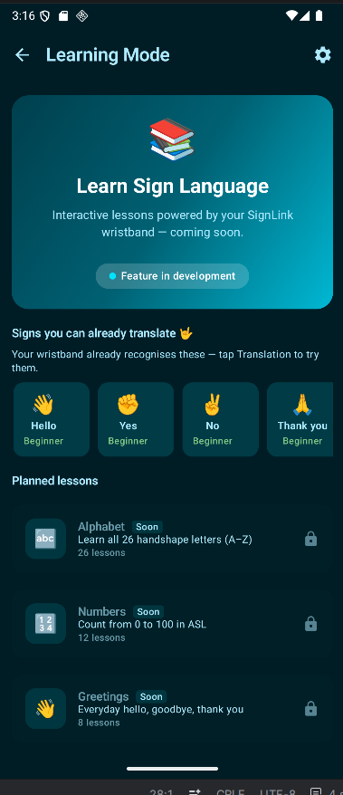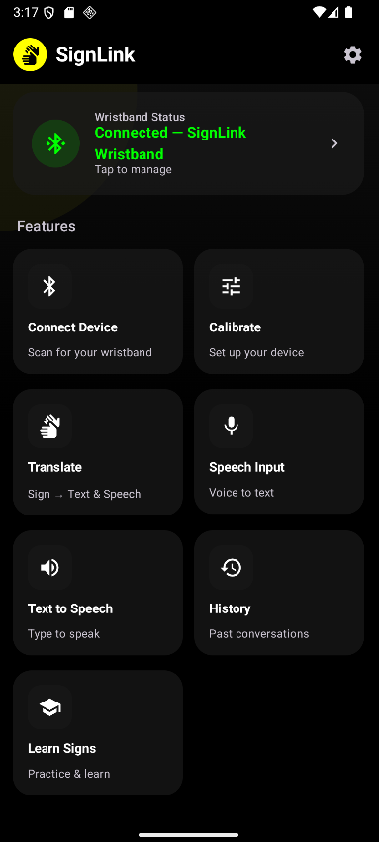 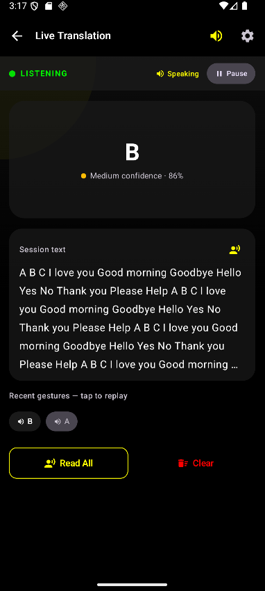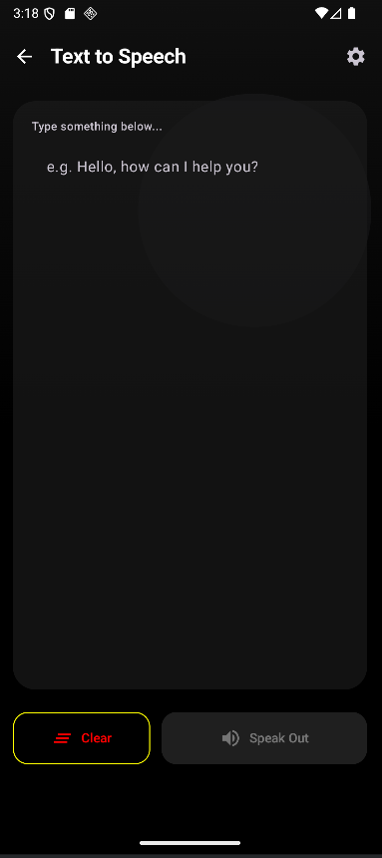 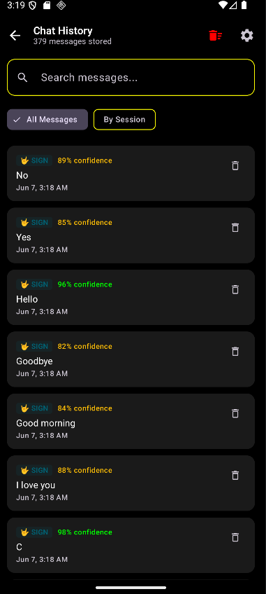 and many more…

7.3 Model Training Code
1. rf = RandomForestClassifier(
2. random_state=42,
3. n_estimators=1000,
4. criterion="gini",
5. max_depth=None,
6. min_samples_split=5,
7. min_samples_leaf=2,
8. max_features="sqrt",
9. bootstrap=True,
10. n_jobs=-1
11. )
12.
13. rf.fit(X_train, y_train)
14.
Code 1: Control Random Forest Classifier (with no feature selection)
1. rf2 = RandomForestClassifier(
2. random_state=42,
3. n_estimators=1000,
4. criterion="gini",
5. max_depth=None,
6. min_samples_split=5,
7. min_samples_leaf=2,
8. max_features="sqrt",
9. bootstrap=True,
10. n_jobs=-1
11. )
12. selector = SelectFromModel(
13. rf,
14. threshold='median',
15. prefit=True
16. )
17. X_train_sel = selector.transform(X_train)
18. X_test_sel = selector.transform(X_test)
19.
20. rf2.fit(X_train_sel, y_train)
21.
Code 2: Random Forest Classifier (on selected features)
1. param_distributions = {
2. 'n_estimators': [300,500,800,1000,1500],
3. 'criterion': ['gini','entropy'],
4. 'max_depth': [None,20,30,40],
5. 'min_samples_split': [2,3,5,8,10],
6. 'min_samples_leaf': [1,2,3,5],
7. 'max_features': ['sqrt','log2']
8. }
9.
10. cv = StratifiedKFold(
11. n_splits=5,
12. shuffle=True,
13. random_state=42
14. )
15.
16. # Initialize the RandomizedSearchCV object
17. # We use the rf2 model as the estimator
18. random_search = RandomizedSearchCV(
19. estimator=rf2,
20. param_distributions=param_distributions,
21. n_iter=100,
22. cv=cv,
23. n_jobs=-1,
24. verbose=2,
25. random_state=42,
26. scoring='accuracy'
27. )
28.
29. # Fit the random search to the data
30. print("Starting Randomized Search for optimal hyperparameters...")
31. random_search.fit(X_train_sel, y_train)
32. print("Randomized Search complete.")
33.
34. # Print the best parameters and the best score
35. print(f"Best parameters found: {random_search.best_params_}")
36. print(f"Best cross-validation accuracy: {random_search.best_score_:.4f}")
37.
38. # You can access the best model directly
39. best_rf2_model_random = random_search.best_estimator_
40.
41. # Evaluate the best model on the test set
42. best_preds_random = best_rf2_model_random.predict(X_test_sel)
43. best_acc_random = accuracy_score(y_test, best_preds_random)
44. print(f"Test accuracy with best parameters from Randomized Search: {best_acc_random:.4f}")
45.
Code 3: Control Hyper-parameter Tuning & CV Testing (to make sure model was accurate on all folds and not just one specific instance)
1. seeds = [
2. 1,
3. 42,
4. 67,
5. 69,
6. 203,
7. 404,
8. 505,
9. 777,
10. 999,
11. 2025,
12. 3000,
13. 5000,
14. 6000,
15. 7000,
16. 8000,
17. 9000,
18. 10000,
19. ]
20.
21. # Define the parameter distributions to sample from for RandomizedSearch
22. param_distributions = {
23. "n_estimators": [300, 500, 800, 1000, 1500],
24. "criterion": ["gini", "entropy"],
25. "max_depth": [None, 20, 30, 40],
26. "min_samples_split": [2, 3, 5, 8, 10],
27. "min_samples_leaf": [1, 2, 3, 5],
28. "max_features": ["sqrt", "log2"],
29. }
30.
31. # Lists to store accuracies for final statistics
32. rf1_accuracies = []
33. rf2_accuracies = []
34. rf2_tuned_accuracies = []
35. cv_scores = []
36.
37. print("Running iterations over seeds...\n")
38. print(
39. f"{'Seed':<8} | {'RF1 Accuracy':<14} | {'RF2 Accuracy':<14} | {'RF2 Tuned Acc':<14} | {'Best CV Score':<14}"
40. )
41. print("-" * 82)
42.
43. for seed in seeds:
44. # 1. Train/Test Split (Only changing this random_state)
45. X_train, X_test, y_train, y_test = train_test_split(
46. X, y, test_size=0.2, stratify=y, random_state=seed
47. )
48.
49. # 2. First Random Forest Model
50. rf = RandomForestClassifier(
51. random_state=42,
52. n_estimators=1000,
53. criterion="gini",
54. max_depth=None,
55. min_samples_split=5,
56. min_samples_leaf=2,
57. max_features="sqrt",
58. bootstrap=True,
59. n_jobs=-1,
60. )
61.
62. rf.fit(X_train, y_train)
63. preds = rf.predict(X_test)
64. acc = accuracy_score(y_test, preds)
65. rf1_accuracies.append(acc)
66.
67. # 3. Feature Selection & Second Random Forest Model
68. rf2 = RandomForestClassifier(
69. random_state=42,
70. n_estimators=1000,
71. criterion="gini",
72. max_depth=None,
73. min_samples_split=5,
74. min_samples_leaf=2,
75. max_features="sqrt",
76. bootstrap=True,
77. n_jobs=-1,
78. )
79.
80. selector = SelectFromModel(rf, threshold="median", prefit=True)
81. X_train_sel = selector.transform(X_train)
82. X_test_sel = selector.transform(X_test)
83.
84. rf2.fit(X_train_sel, y_train)
85. preds2 = rf2.predict(X_test_sel)
86. acc2 = accuracy_score(y_test, preds2)
87. rf2_accuracies.append(acc2)
88.
89. # 4. Hyperparameter Tuning on RF2 via RandomizedSearchCV
90. cv = StratifiedKFold(n_splits=5, shuffle=True, random_state=42)
91.
92. random_search = RandomizedSearchCV(
93. estimator=rf2,
94. param_distributions=param_distributions,
95. n_iter=100,
96. cv=cv,
97. n_jobs=-1,
98. verbose=0, # Turned verbose down to 0 to keep the loop table readable
99. random_state=42,
100. scoring="accuracy",
101. )
102.
103. random_search.fit(X_train_sel, y_train)
104.
105. # Evaluate the best randomized search model on the test set
106. best_rf2_model_random = random_search.best_estimator_
107. best_preds_random = best_rf2_model_random.predict(X_test_sel)
108. best_acc_random = accuracy_score(y_test, best_preds_random)
109. rf2_tuned_accuracies.append(best_acc_random)
110. best_cv_score = random_search.best_score_
111. cv_scores.append(best_cv_score)
112.
113. # Print individual results for the current seed
114. print(f"{seed:<8} | {acc:<14.4f} | {acc2:<14.4f} | {best_acc_random:<14.4f} | {best_cv_score:<14.4f}")
115.
116. print("-" * 82)
117.
118. # 5. Calculate and display Mean and Standard Deviation
119. print(
120. f"\n{'Metric':<10} | {'RF1 Model':<14} | {'RF2 Model':<14} | {'RF2 Tuned':<14} | {'Best CV Score':<14}"
121. )
122. print("-" * 82)
123. print(
124. f"{'Mean':<10} | {np.mean(rf1_accuracies):<14.4f} | {np.mean(rf2_accuracies):<14.4f} | {np.mean(rf2_tuned_accuracies):<14.4f} | {np.mean(cv_scores):<14.4f}"
125. )
126. print(
127. f"{'Std Dev':<10} | {np.std(rf1_accuracies):<14.4f} | {np.std(rf2_accuracies):<14.4f} | {np.std(rf2_tuned_accuracies):<14.4f} | {np.std(cv_scores):<14.4f}"
128. )
129
Code 4: Final Tuning (run on different random states to make sure accuracy is consistent throughout)

7.4 Appendices of Final UI/UX Design Section

7.4.1 Testing Consent Forms
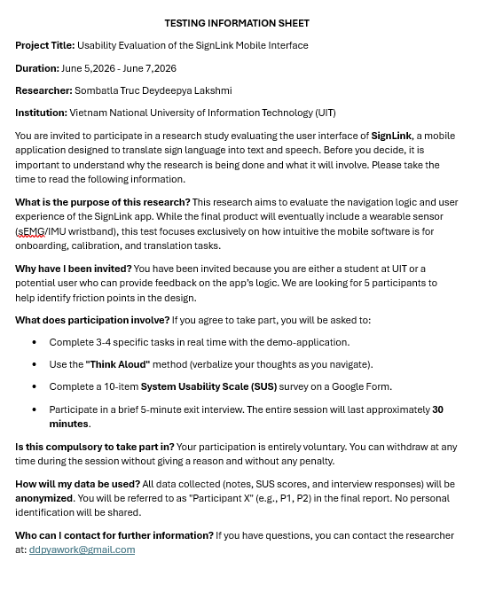
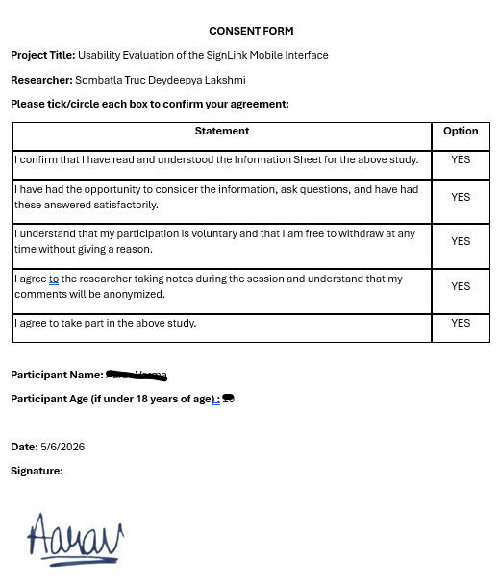
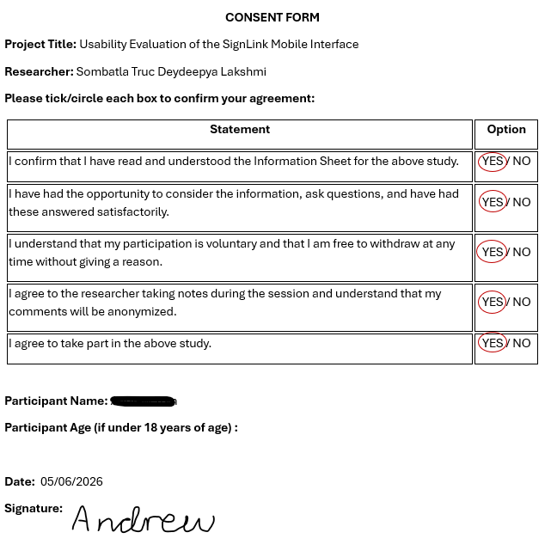
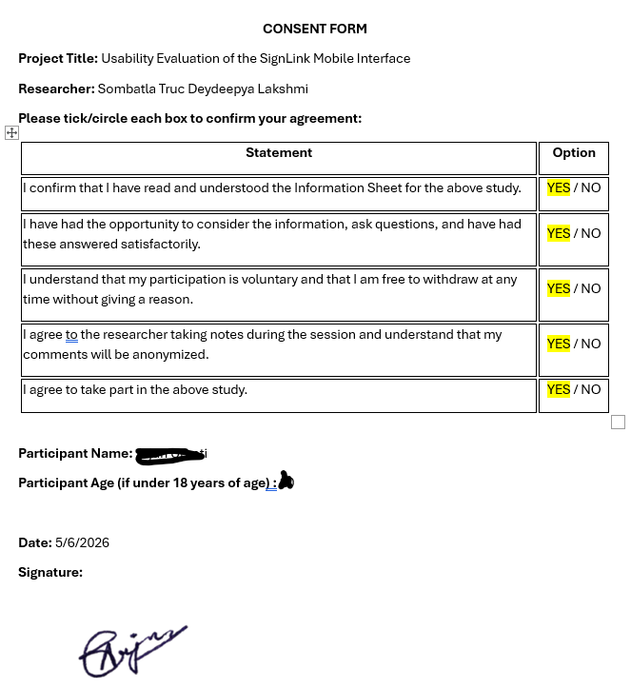
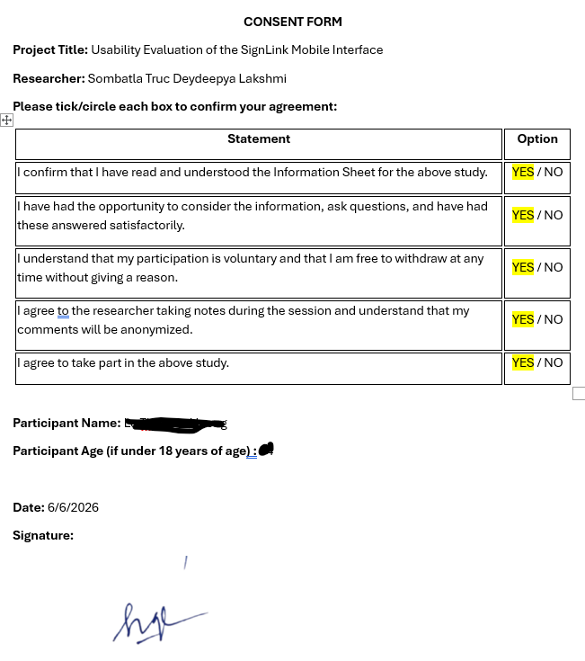
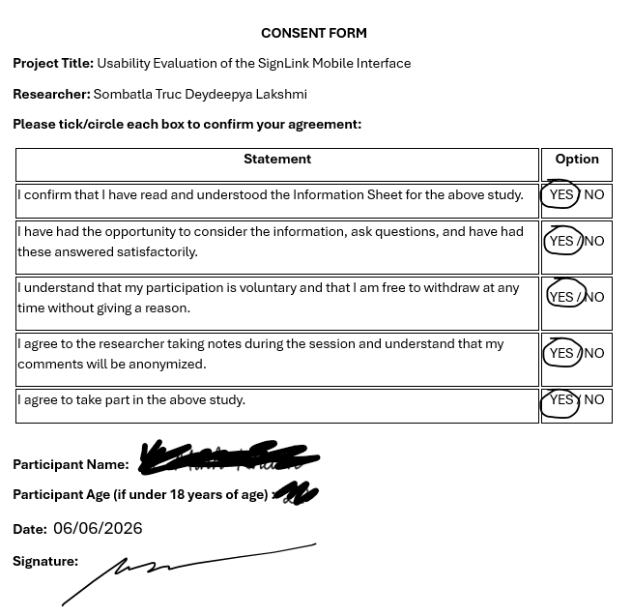
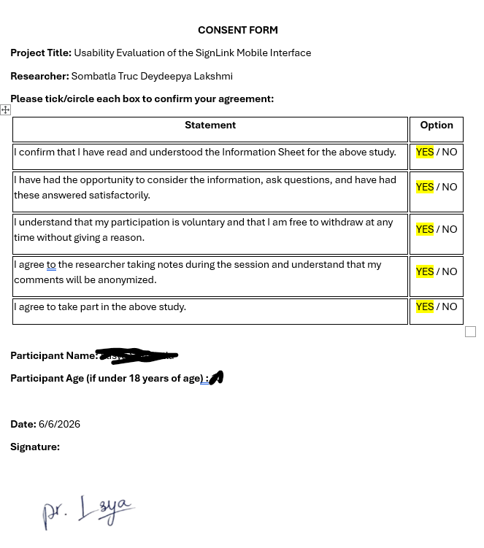
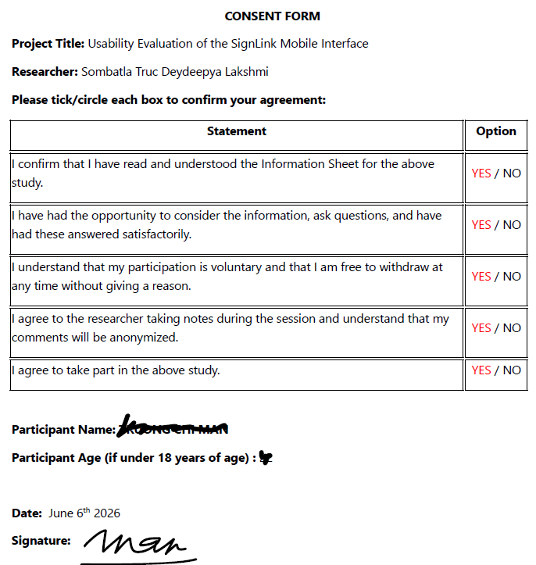
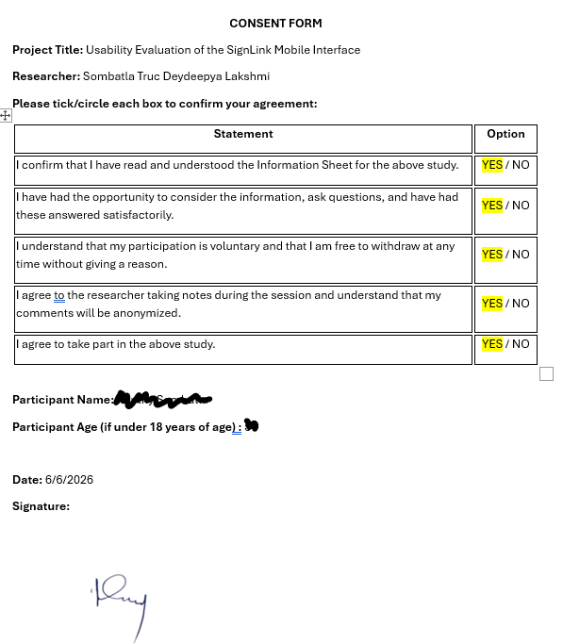
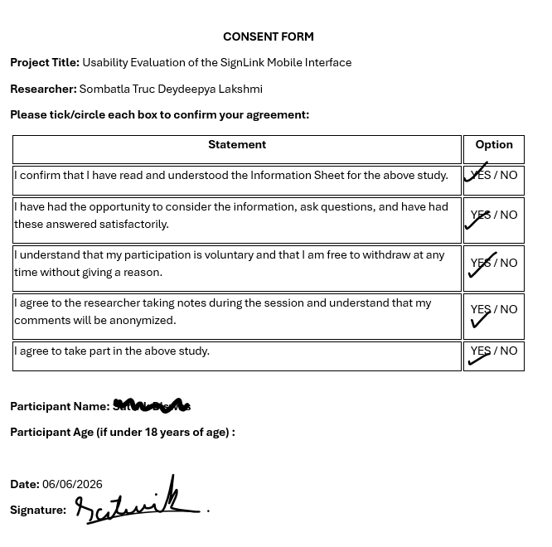
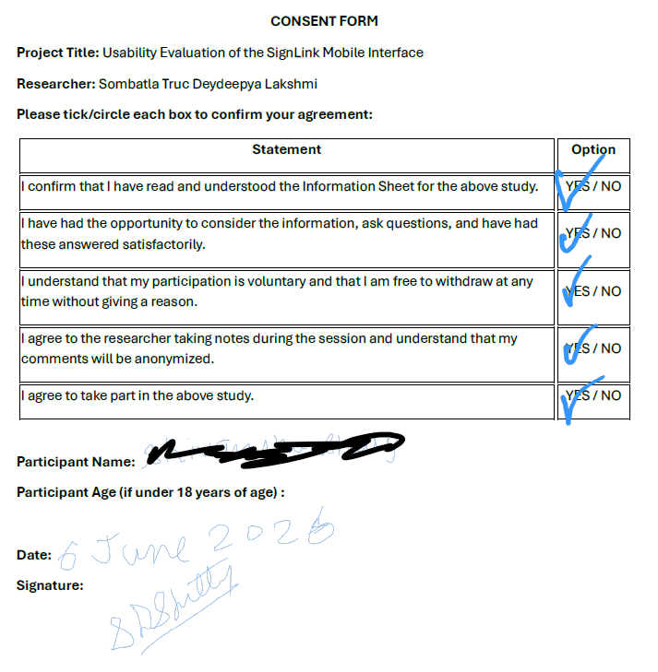
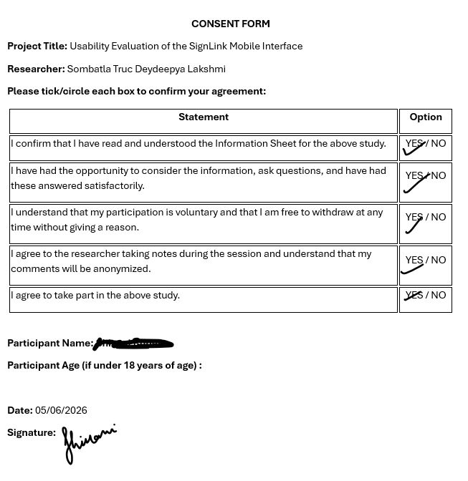
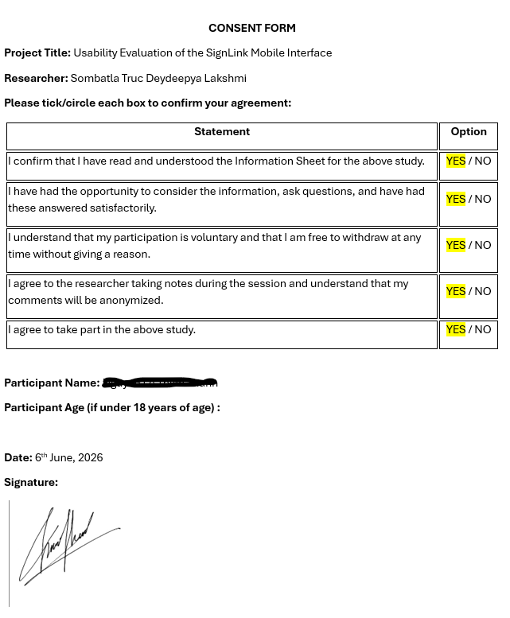
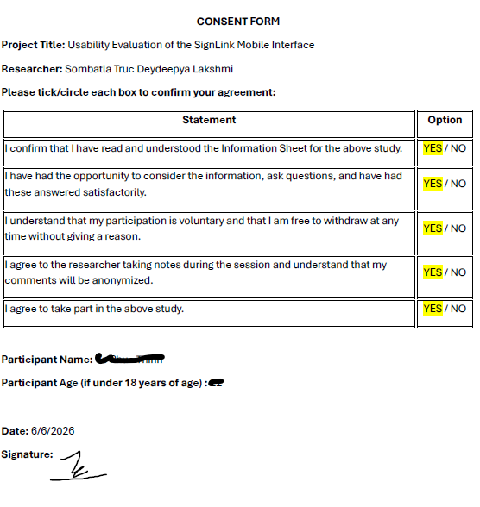
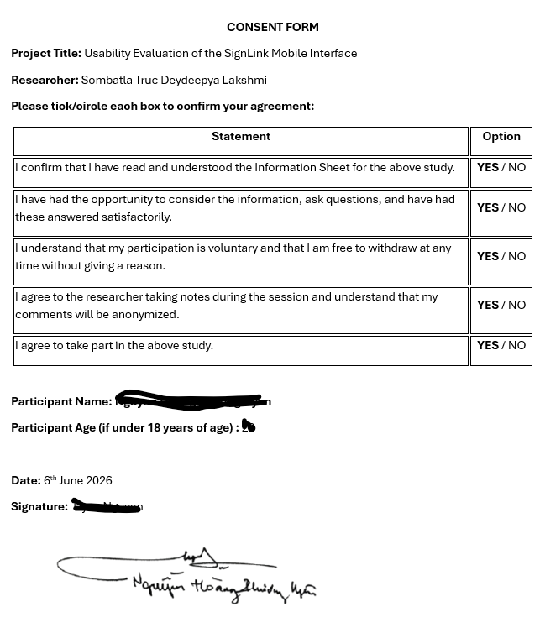
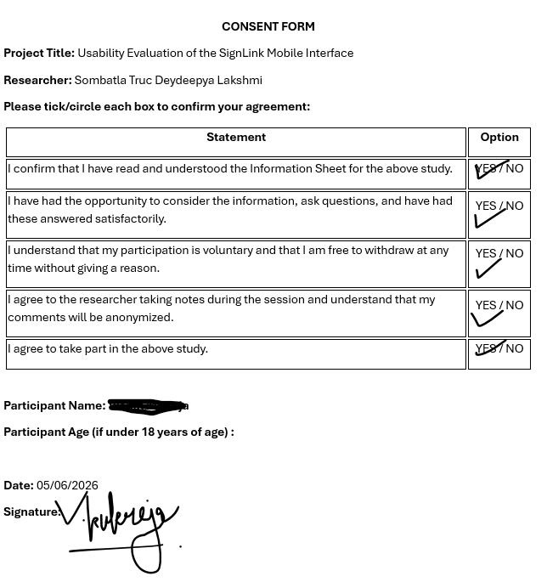

7.4.2 Results from Form
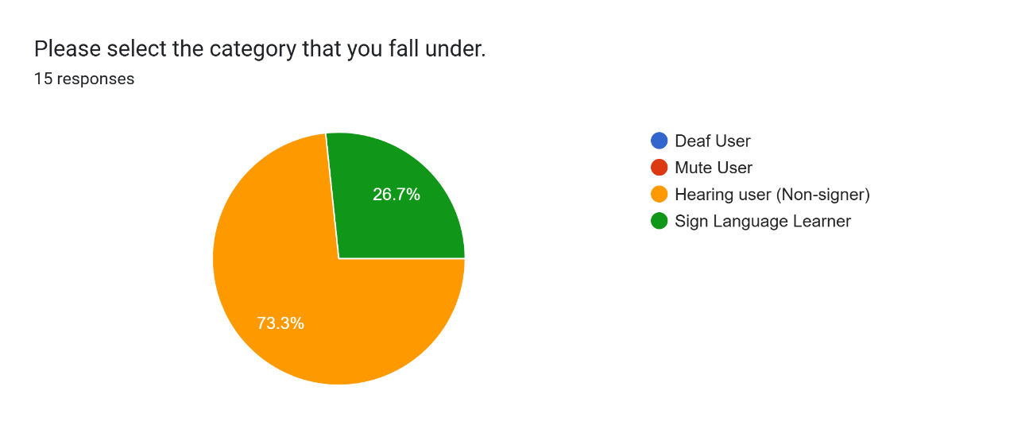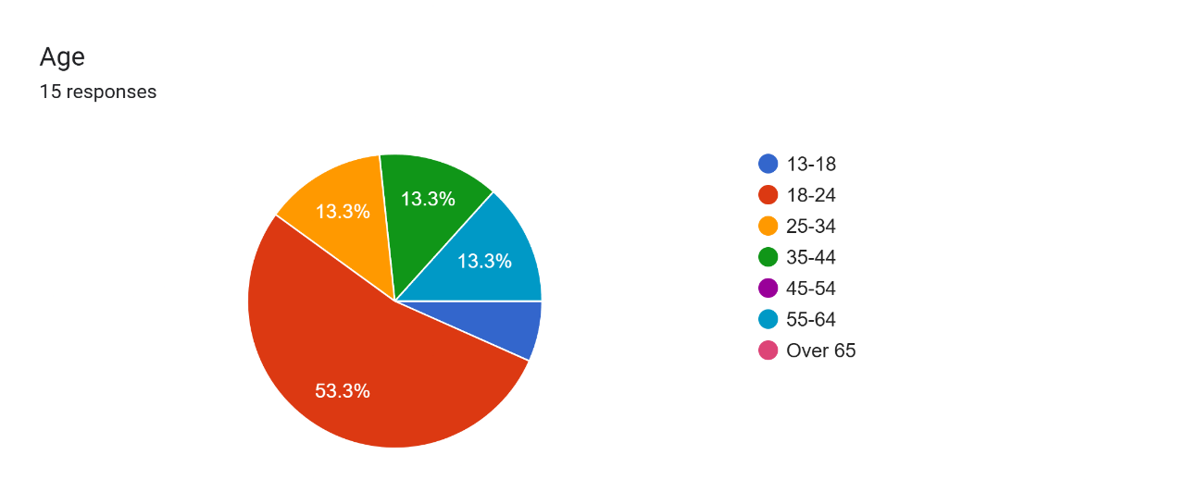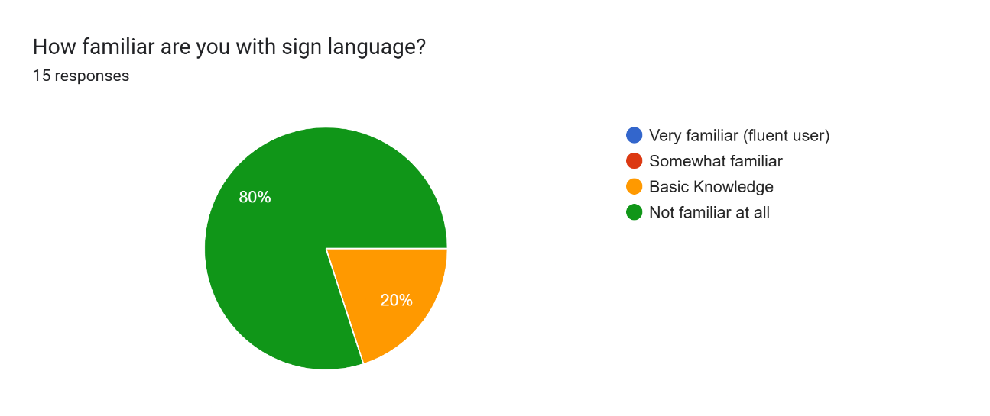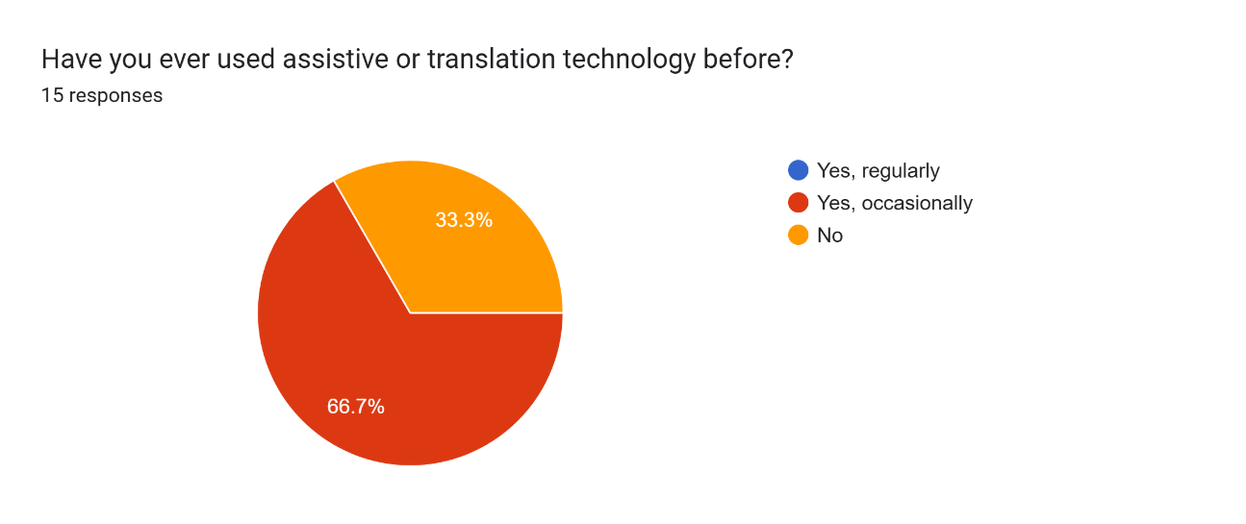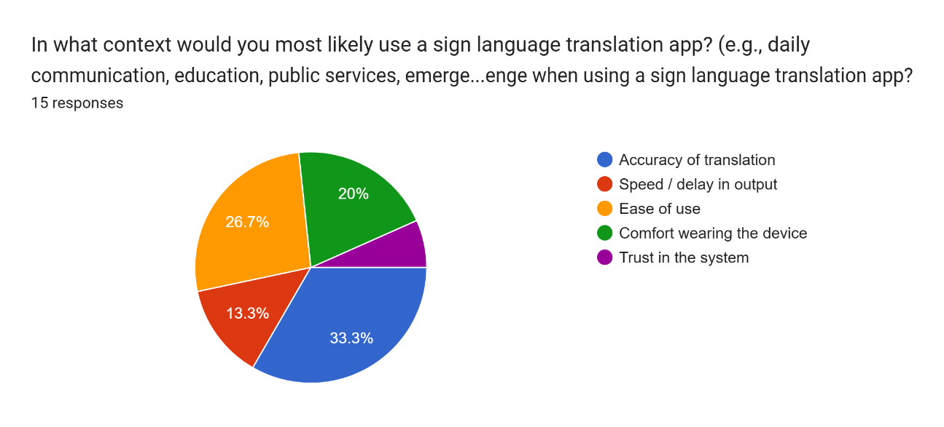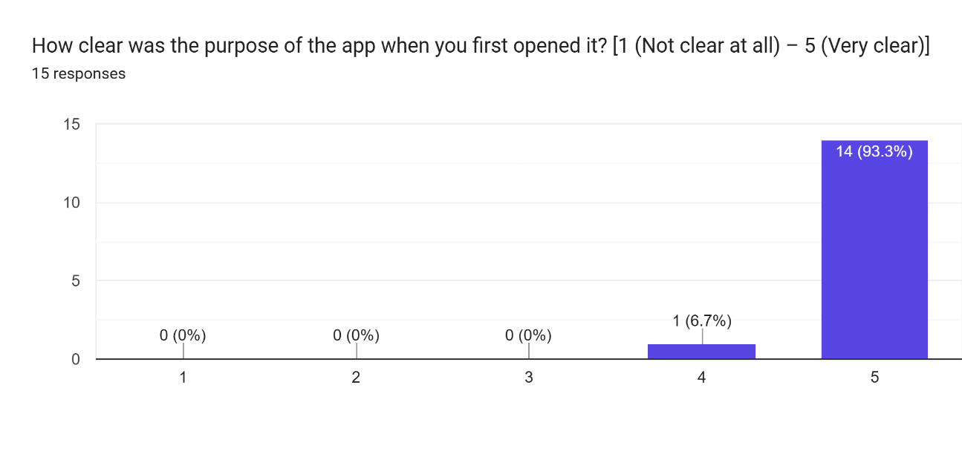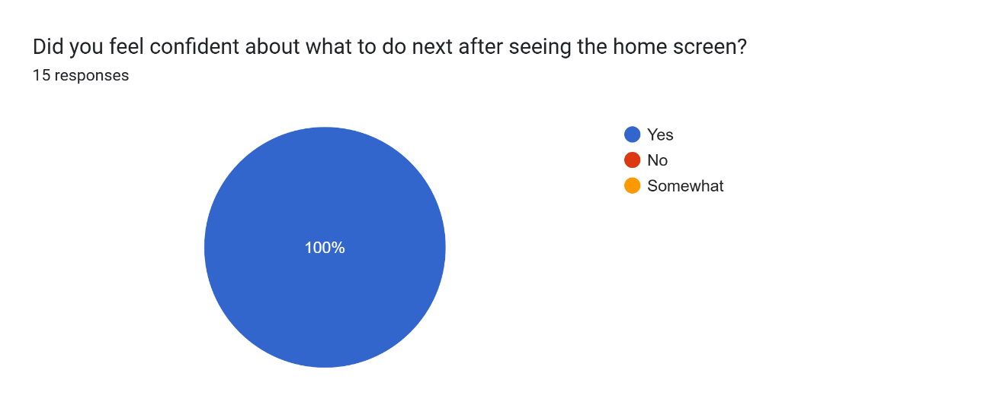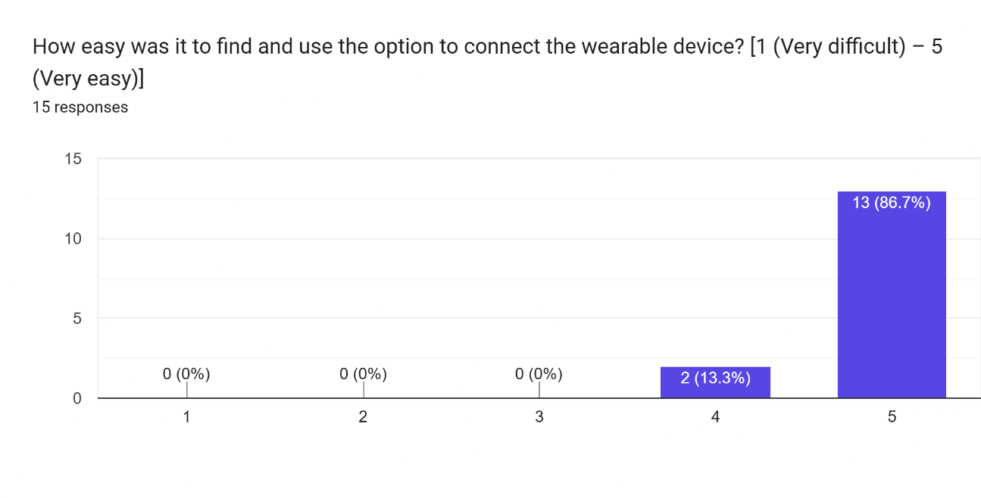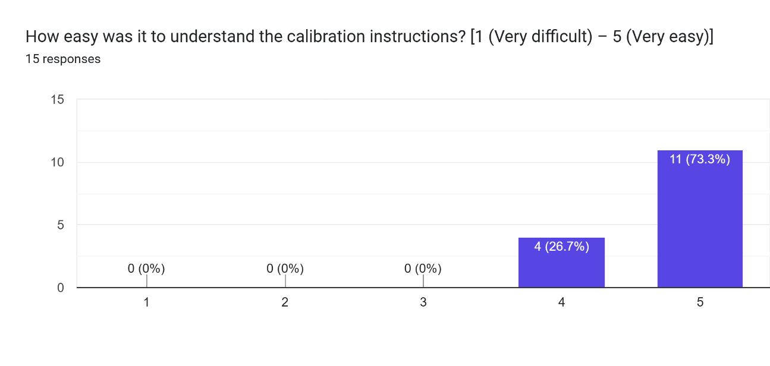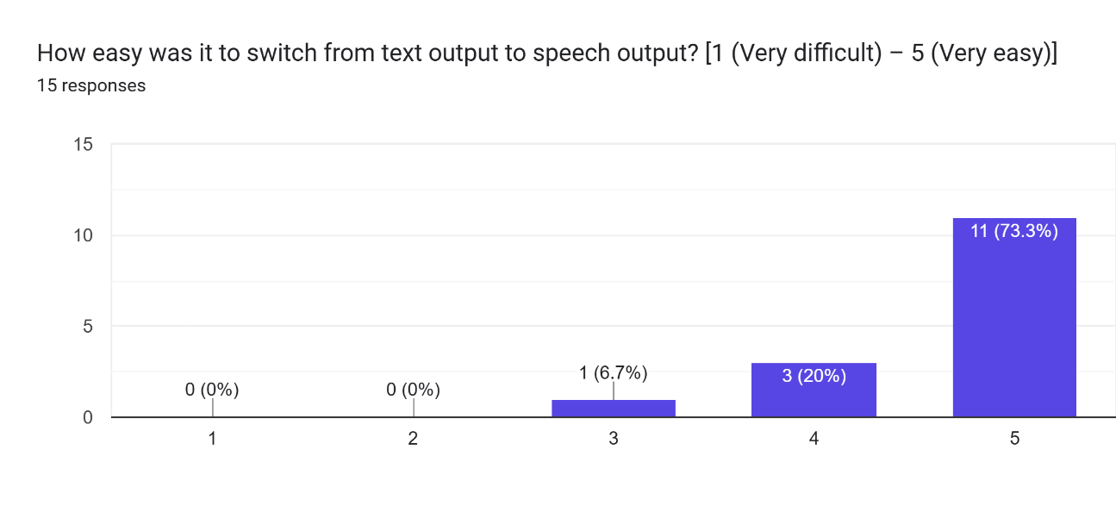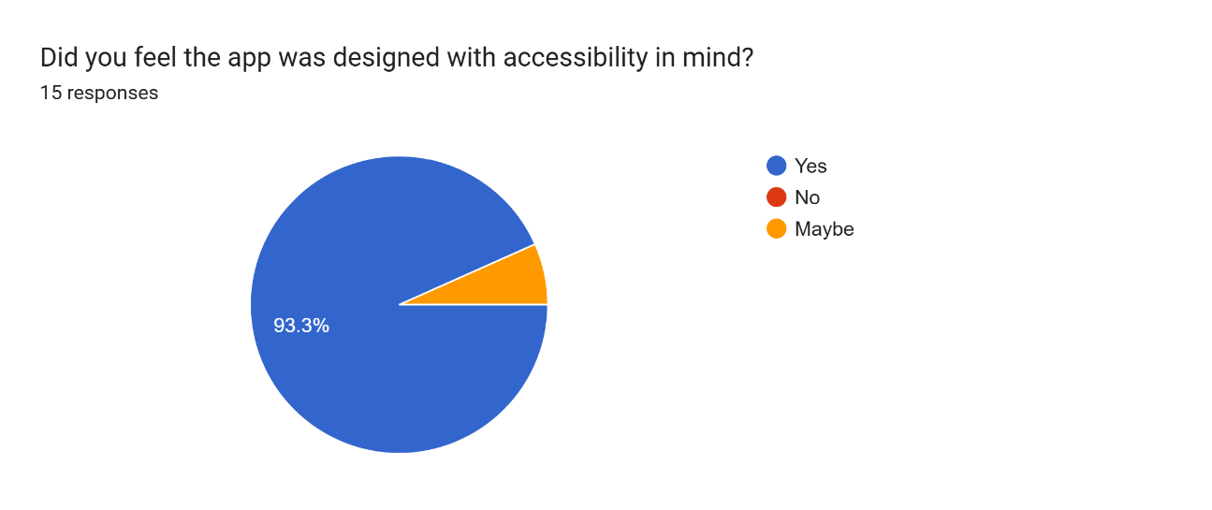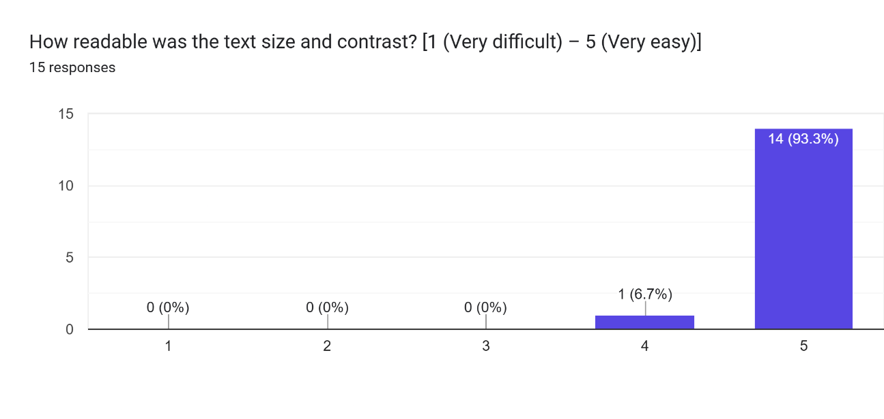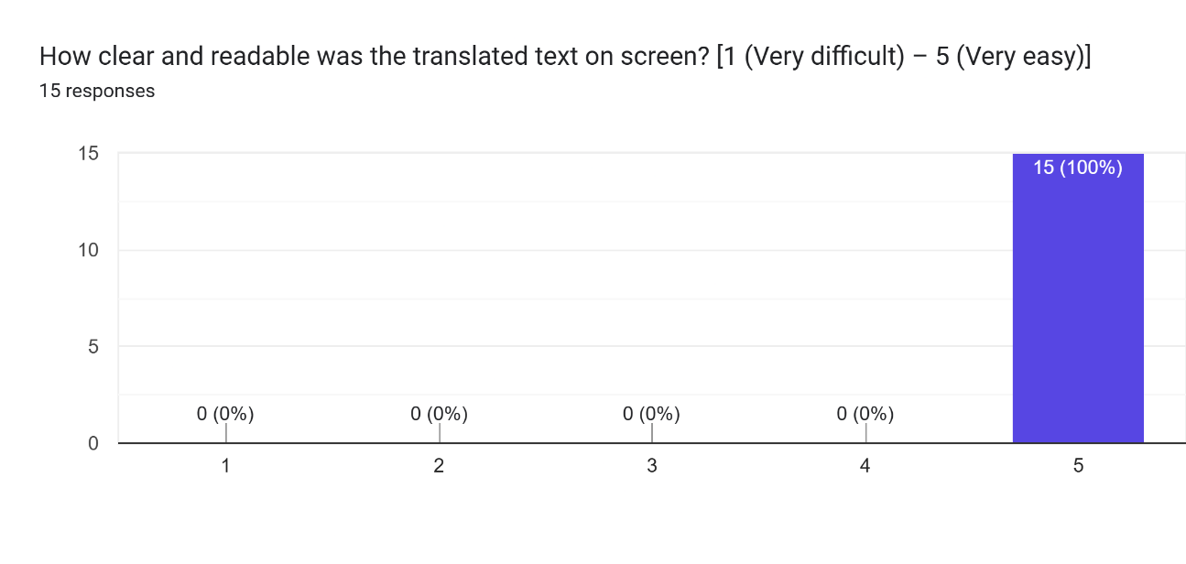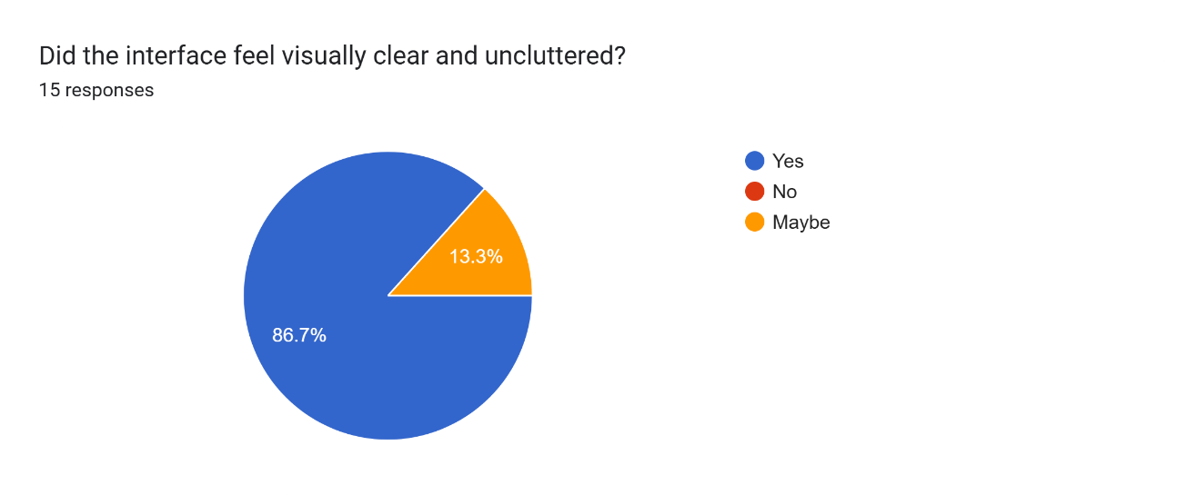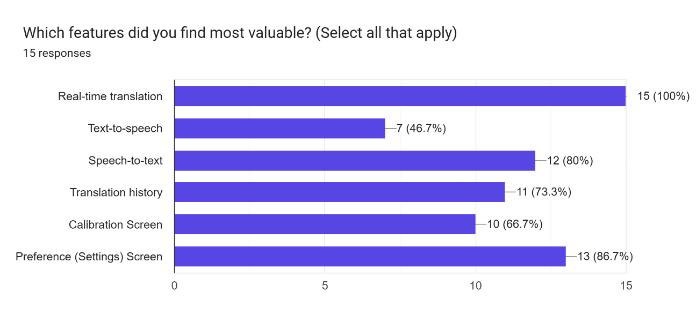
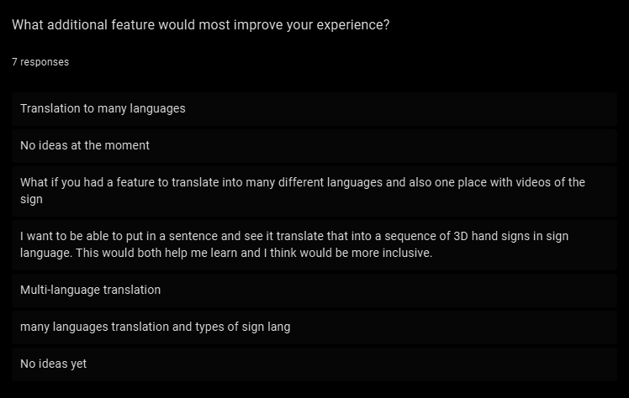
- SUS


