BUSINESS CASE
Checkpoint.

Who decides what, and when?
Checkpoint AI: An AI-supported readmission-risk and follow-up process for Lakeside Health Network, with human decision rights built in
Challenge focus area: Focus Area 2, AI and the Future of Work
Case: Mapping the Human Decision Points, Lakeside General and Riverside Specialist Hospital merger
Prepared by: Pod Nova
Prototype: https://lenavon.github.io/10alytics-Hackathon---Checkpoint-/
Event: 10Alytics Q3 Students Hackathon 2026

Contents
# | Section | Purpose
1 | Executive summary | The recommendation in brief
2 | Strategic context and case for change | Why act now, and on what problem
3 | Options analysis | Alternatives considered and why one is recommended
4 | Recommended solution | The TO-BE process and the human-AI decision model
5 | Stakeholder analysis and governance | Who is affected, and who decides what
6 | Benefits realisation | What improves, for whom, and how it is measured
7 | Cost estimate | Illustrative one-time and ongoing costs
8 | Financial summary | Illustrative payback and return
9 | Risk assessment | Key risks and mitigations
10 | Implementation roadmap | Phased delivery plan
11 | Success criteria and KPIs | How we will know it worked
12 | Assumptions, constraints and dependencies
13 | Recommendation and next steps
A to E | Appendices | BRD, use cases, traceability matrix, change-impact detail, glossary

1. Executive summary
Lakeside General and Riverside Specialist have merged into Lakeside Health Network and want to use AI to predict which patients are likely to be readmitted within 30 days of discharge, so nurses can prioritise follow-up. The two hospitals run different systems and discharge processes, patients may hold different identifiers at each site, and no one has yet decided who owns a decision once an AI tool is introduced.
The business problem: without a defined decision model, an AI readmission tool risks being built on unreliable, unmatched data, making recommendations no one is accountable for, and losing the trust of the nurses who are meant to act on it.
Recommended option: Introduce the AI readmission-risk tool with a redesigned workflow and four mandatory human-in-the-loop checkpoints (Option C, Section 3), rather than a manual-only fix (Option B) or full automation (Option D).

Case summary
Dimension | Summary
Problem | Two merged hospitals, inconsistent processes, duplicate patient identities, no decision-rights model for AI
Recommended solution | AI-scored, human-approved discharge follow-up workflow with 4 checkpoints (HC1 to HC4) and a 3-level automation policy
Illustrative one-time cost | CAD 1.09 million (Section 7)
Illustrative annual net benefit | CAD 1.18 million per year after ongoing costs (Section 8)
Illustrative payback | Under 12 months (Section 8)
Primary risk | Automation bias and low nurse trust; mitigated by mandatory review, explainability and override rights
Timeframe | 28 weeks to supervised go-live, then phased scale-up (Section 10)

2. Strategic context and case for change

2.1 Business problem
The NOVA Analysts will analyse the existing discharge and follow-up process, design the future AI-enabled process, and define the requirements needed to build and implement it safely. Left unresolved, the issues below compound each other: inconsistent data undermines the model, an undefined decision model erodes accountability, and low trust means the tool sits unused even if it is technically accurate.
Issue | Root cause | Consequence if unaddressed
Different processes and systems across the two hospitals | Independent legacy workflows and record systems | Inconsistent model inputs; unequal care standards
Duplicate patient records and different patient IDs | Site-specific identifiers, no network-wide link | Scores built on partial history; patient safety risk
Unclear ownership of decisions after AI implementation | No decision-rights model exists | Diffused accountability; unsafe automation creep
Uncertainty over which AI decisions can be automated | No risk-based automation criteria | Either over-automation of clinical calls, or no automation benefit realised at all
No defined human-review points | Tool not yet designed into the workflow | Harmful AI outputs reach patients unchecked
Risk that staff do not trust the system | Opaque scores, no accountability, no feedback loop | Tool is ignored; investment produces no benefit

2.2 Current state (AS-IS)
Full AS-IS swimlane is provided in Section 4 alongside the TO-BE design, so the change is visible side by side. In brief: discharge documentation, patient identity and follow-up prioritisation are all handled separately by each hospital today, with no shared risk view and no closed feedback loop from readmissions back into practice (see Section 4.1 for the full pain-point list).

2.3 Strategic alignment
Alignment | How this case supports it
Focus Area 2: AI and the Future of Work | Redesigns three jobs (follow-up nurse, Health Records steward, ward staff) around a defined human-AI decision split, not around replacing staff
SDG 3, Good Health and Well-Being | Better-targeted follow-up for patients most likely to be readmitted
SDG 10, Reduced Inequalities | One network identity and process so care does not depend on which hospital holds the record
SDG 17, Partnerships for the Goals | Structured, governed data sharing between two merged institutions
Lakeside's own objectives (BO-1 to BO-5, Appendix A) | Improve follow-up targeting, unify patient records, assign clear decision ownership, use AI safely, and support staff adoption

3. Options analysis
Four options were considered against four criteria: patient safety and trust, cost to deliver, speed to benefit, and fit with the brief's requirement for defined human oversight.
Option | Description | Pros | Cons | Recommended?
A. Do nothing | Continue with manual, judgement-based follow-up prioritisation at both sites | No cost or disruption | High-risk patients continue to be missed; the merger's process gaps persist; no answer to the brief's challenge | No
B. Harmonise process only, no AI | Standardise discharge and identity processes across both sites; keep prioritisation manual | Lower cost; fixes some data problems; low technical risk | Does not use AI to target follow-up; misses the case's core ask and its benefit case | No
C.Checkpoint AI: AI-supported, human-in-the-loop (recommended) | AI scores and tiers readmission risk; humans confirm identity, review low-confidence cases, approve or override every tier, and govern the model monthly | Targets follow-up effort where it matters; keeps accountability with clinicians; builds trust through transparency and override rights; matches the brief exactly | Requires investment in data quality, integration, training and governance | Yes
D. Full automation of prioritisation and scheduling | AI assigns tiers and books follow-up with no routine human review | Lowest ongoing staff effort | No safeguard against data errors or model drift; brief explicitly requires human-review points; highest patient-safety and trust risk | No

3.1 Why Option C
- It is the only option that both uses AI to target follow-up and satisfies the brief's requirement for defined human-review points.
- It keeps clinical accountability with named people (Section 5), which Option D removes and Option B never provides for an AI-driven service.
- Its costs are proportionate to the benefit case (Sections 7 and 8), unlike Option D's undifferentiated automation risk.
- It is deliverable in phases (Section 10), so early learning from a shadow pilot reduces risk before wider rollout.

4. Recommended solution

4.1 AS-IS process (current state, for comparison)
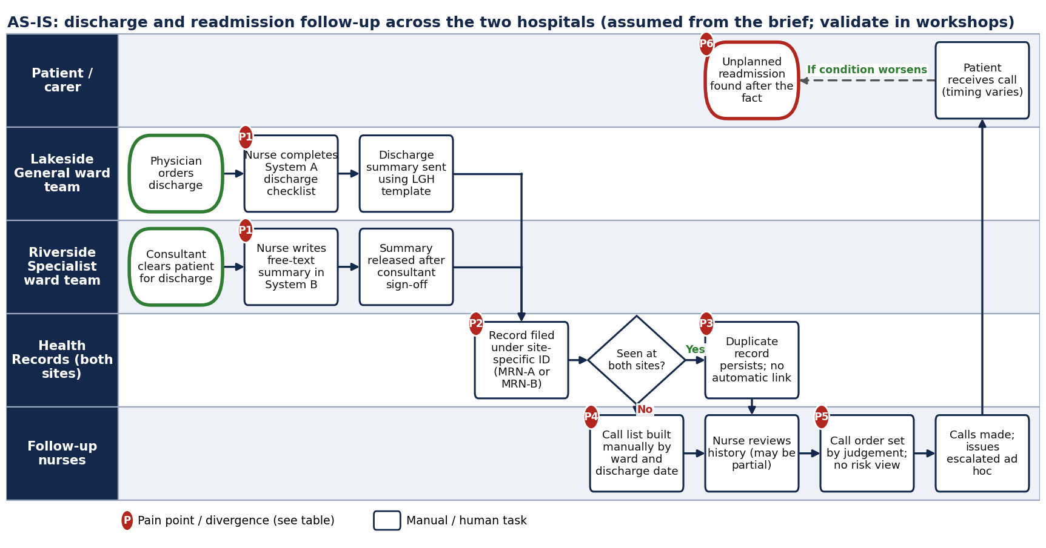
Figure 1. AS-IS swimlane: discharge and readmission follow-up across Lakeside General and Riverside Specialist (assumed from the brief; validate in workshops).

4.2 Pain points driving the recommendation
Ref | Where | What diverges or fails | Consequence for an AI tool
P1 | Discharge documentation | System A structured checklist versus System B free-text summary | Model inputs are inconsistent and partly unstructured across sites
P2 | Patient identity | Site-specific IDs (MRN-A, MRN-B) | One patient can appear as two people
P3 | Duplicate records | No automatic linkage when a patient used both hospitals | Score built on partial history is unreliable, and can understate risk
P4 | Follow-up list | Built manually from ward lists by date | Effort spent on assembly, not on patients
P5 | Prioritisation | Call order by individual judgement, no shared risk view | Inconsistent care; high-risk patients may wait
P6 | Outcome detection | Readmissions found after the fact | No feedback to improve prioritisation

4.3 TO-BE process (recommended design)
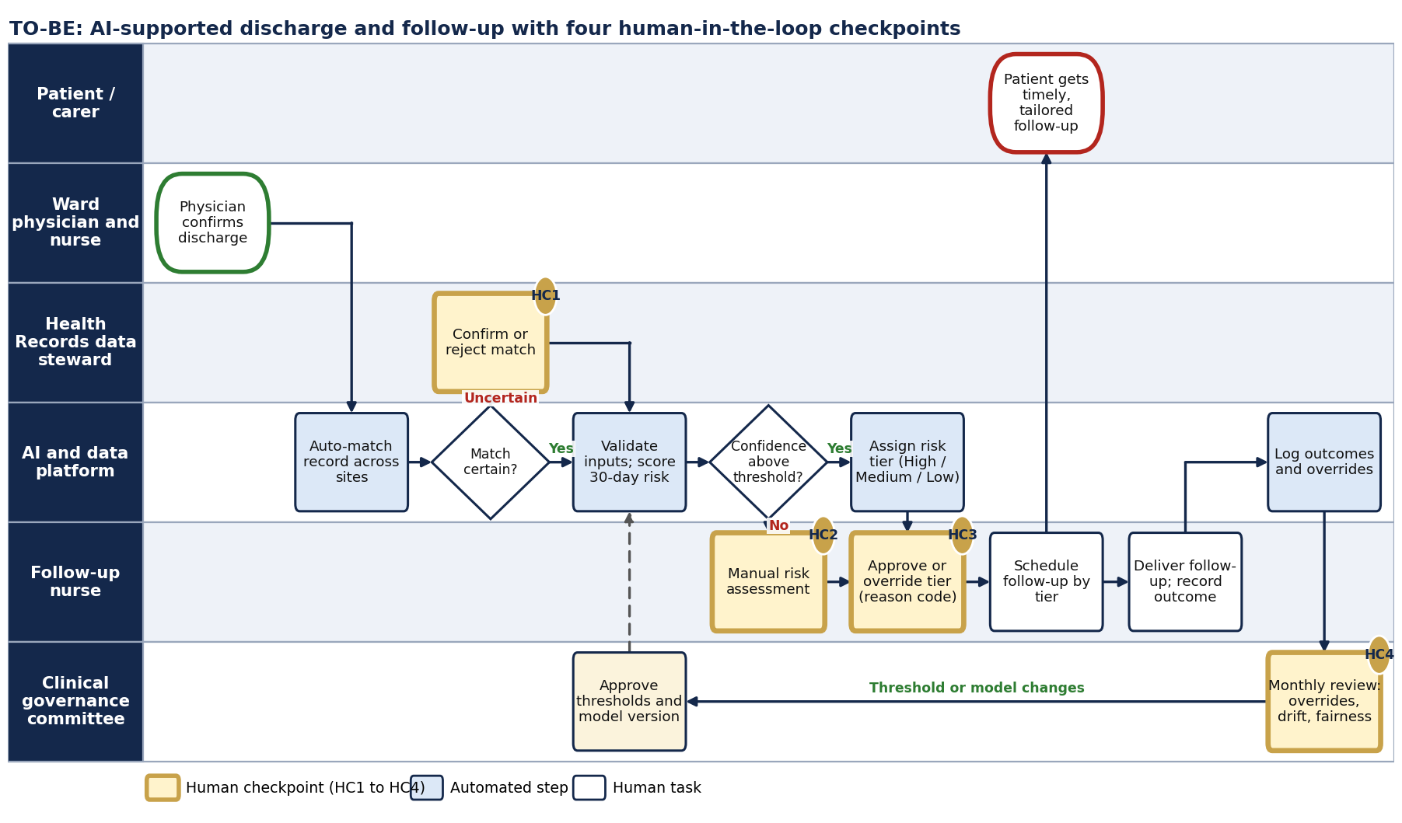
Figure 2. TO-BE swimlane: AI-supported workflow with four human-in-the-loop checkpoints (HC1 to HC4).

4.4 Human-in-the-loop checkpoints
Checkpoint | Trigger | Human role | Allowed actions | Why a human
HC1 Identity match | Match rules return an uncertain match | Health Records data steward | Confirm, reject or request more information; merges are reversible | Wrong merge mixes two patients' histories
HC2 Low-confidence case | Data incomplete or model confidence below threshold | Follow-up nurse | Complete manual risk assessment and set tier | AI should not guess when evidence is thin
HC3 Tier review | Every tier assigned (High approval mandatory; others reviewable) | Follow-up nurse | Approve, or override up or down with a reason code | Clinical accountability stays with a person
HC4 Governance review | Monthly, and on any safety event | Clinical governance committee | Adjust thresholds, retrain, pause the tool | Oversight of drift, fairness and safety

Design principles
AI narrows, humans own. Uncertainty escalates. Every override is a signal for HC4. Downtime never blocks care.

4.5 Human-AI decision framework (governance model)
The brief asks for clear documentation of which decisions AI can make independently and which require human judgement. We use a three-level policy, applied decision by decision.
Level | Meaning | Applies when
A Automate | System acts; result is logged and reversible | Rule-based or statistical, no direct effect on a patient's care, easy to reverse, validated
B AI recommends, human approves | System proposes; a named person must confirm before anything happens | Affects care priorities or patient records, and errors are correctable
C Human decides | A person decides; AI may show information but not choose | Clinical action, lowering care intensity, or any change to how the AI itself works

# | Decision | Level | Accountable role | Rationale
D1 | Check required inputs are present before scoring | A | Clinical informatics lead | Deterministic rule; failure routes to HC2, so nothing is hidden
D2 | Link records on an exact multi-identifier match | A | Health Records | Deterministic, reversible and logged
D3 | Link records on a probable (not exact) match | B | Health Records data steward | A wrong merge mixes two patients' histories (HC1)
D4 | Calculate the risk score and its main drivers | A | Clinical informatics lead | Analytical output only; does not itself trigger care
D5 | Assign a tier when data is complete and confidence is above threshold | B | Follow-up nurse | AI proposes; nurse approves High and can override any tier (HC3)
D6 | Assign a tier when data is incomplete or confidence is low | C | Follow-up nurse | AI must not guess when evidence is thin (HC2)
D7 | Set follow-up intensity for High-tier patients | B | Follow-up nurse | Affects workload and patient care; needs a person's agreement
D8 | Reduce follow-up below standard care | C | Follow-up nurse | Never automatic; the risk of harm is asymmetric
D9 | Clinical action: medication change, physician escalation, readmission | C | Treating physician | Clinical judgement; the tool does not touch these decisions
D10 | Change thresholds, retrain or release a model version | C | Clinical governance committee | Changes the behaviour of the whole system (HC4)

5. Stakeholder analysis and governance

5.1 Stakeholder register
Stakeholder | Interest and concern | Influence | Engagement approach
Board of Directors (sponsor) | Safer transitions of care; nurse adoption; accountability | High | Sponsor; approves scope and requirements; monthly steering
Clinical governance committee | Patient safety, fairness, model oversight | High | Owns thresholds and model release; receives monthly dashboard
Clinical informatics / AI lead | Model validity, integration, technical feasibility | High | Co-design; owns model performance monitoring
Follow-up nurses | Workload, trust in scores, autonomy to override | Medium | Primary users; co-design worklist; super-user network
Ward nurses and physicians | Consistent discharge steps; no extra documentation burden | Medium | Workshops on the harmonised discharge standard
Discharge coordinators | Clear handoff to follow-up; timing of summaries | Medium | Process walkthroughs; pilot feedback
Health Records team | Duplicate clean-up workload; role change; job security | Medium | Early involvement; role redesign; training (Appendix D)
IT and integration | Two systems to connect; downtime; security | Medium | Technical design authority; integration plan
Privacy officer | Lawful use of health data; minimum necessary access | High | Privacy impact assessment before pilot
Patients and carers | Timely follow-up; transparency; fair treatment | Low (formal) | Plain-language notice; feedback channel; patient advisory input
Health authority / regulator | Compliance; reporting of readmission indicators | High | Inform; align reporting definitions
Finance and operations | Readmission cost; capacity for follow-up calls | Medium | Benefits tracking; staffing model

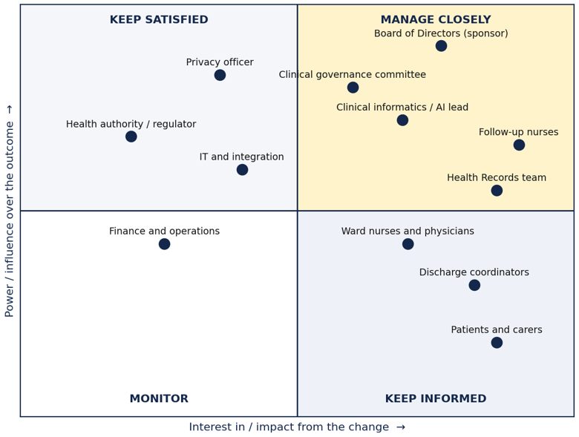
Figure 3. Stakeholder power and interest (positions are analyst judgement, to be validated with the sponsor).

5.2 RACI matrix
R = Responsible (does the work), A = Accountable (one owner who signs off), C = Consulted, I = Informed. Every activity has exactly one accountable role.
Activity | Board of DIrectors | Clinical informatics / AI lead | Ward nurse / physician | Follow-up nurse | Health Records | IT / integration | Privacy officer | Governance committee | Business analyst
Harmonise the discharge standard across both sites | A | C | R | C | C | I | I | C | R
Resolve duplicate records and unify patient ID | I | C | I | I | A/R | R | C | I | C
Set risk thresholds and tier definitions | C | R | C | C | I | I | C | A | C
Generate risk score at discharge (system function) | I | A | I | I | I | R | I | I | I
Review, approve or override the risk tier | I | I | C | A/R | I | I | I | I | I
Schedule and deliver follow-up | I | I | I | A/R | C | I | I | I | I
Monitor accuracy, drift and fairness | I | R | I | C | C | R | C | A | C
Privacy and security impact assessment | I | C | I | I | C | C | A/R | I | C
Training and transition support | A | C | C | C | C | I | I | I | R
Requirements sign-off | A | R | C | C | C | C | C | C | R

6. Benefits realisation
All figures in this and the following two sections are illustrative order-of-magnitude estimates, built to show the shape of the business case. They are clearly marked and would be replaced with Lakeside's own data (readmission volumes, cost per readmission, staff time studies) before an investment decision.

6.1 Tangible benefits (illustrative)
Benefit | How it arises | Illustrative annual value | Linked objective
Avoided readmission costs | Earlier, better-targeted follow-up reduces 30-day readmissions among High-tier patients | CAD 1,200,000 | BO-1
Nurse time saved building call lists | Prioritised worklist replaces manual list assembly (est. 30 min/day per nurse across the follow-up team) | CAD 140,000 | BO-1, BO-5
Health Records rework avoided | Fewer duplicate-record corrections once identity is resolved up front | CAD 60,000 | BO-2
Total illustrative tangible benefit |  | CAD 1,400,000

6.2 Intangible benefits
- Clearer accountability for AI-influenced decisions, reducing clinical and reputational risk.
- Higher nurse trust and confidence in the tool, through visible reasoning and override rights.
- A stronger evidence base for future AI initiatives across the merged network.
- A defined career path for Health Records staff moving into data stewardship.

6.3 Benefit ownership
The Board of Directors is accountable for realising the readmission-avoidance benefit; the follow-up nurse lead owns the time-saving benefit; the Health Records lead owns the rework-avoidance benefit. All three report progress to the governance committee alongside the KPIs in Section 11.

7. Cost estimate
Costs are presented as rough order-of-magnitude (ROM) estimates in Canadian dollars, for the purpose of comparing options and sizing the investment. They should be refined with IT, vendor and HR input before funding approval.

7.1 One-time implementation costs (illustrative)
Cost item | Illustrative estimate (CAD)
Patient identity resolution and data clean-up (Health Records, Section 10 Phase 1) | 180,000
AI model development, validation and integration | 420,000
Workflow and interface build (prioritised worklist, steward queue) | 260,000
Change management and training (all affected roles) | 140,000
Governance set-up and compliance (privacy impact assessment, security review) | 90,000
Total one-time cost (illustrative) | 1,090,000

7.2 Ongoing annual costs (illustrative)
Cost item | Illustrative estimate (CAD per year)
Hosting, model monitoring and re-training | 95,000
Support and maintenance | 120,000
Governance committee time and audit | 60,000
Total ongoing cost (illustrative, per year) | 275,000

8. Financial summary
This is a simple, illustrative view to support the option decision. It is not a full net-present-value analysis and does not assume a discount rate; Lakeside finance would need to apply one for a funding submission.
Year | Illustrative benefit (CAD) | Illustrative cost (CAD) | Illustrative net (CAD) | Cumulative (CAD)
Year 1 | 1,400,000 | 1,090,000 + 275,000 = 1,365,000 | 35,000 | 35,000
Year 2 | 1,400,000 | 275,000 | 1,125,000 | 1,160,000
Year 3 | 1,400,000 | 275,000 | 1,125,000 | 2,285,000

Illustrative measure | Value
Payback period | Approximately 11 to 12 months from go-live
3-year cumulative net benefit | CAD 2,285,000
Simple 3-year return on the one-time investment | Approximately 210%

Reading this financial case
The readmission-avoidance figure is the most sensitive assumption and the most important to validate first (actual readmission volumes, cost per readmission, and a realistic reduction rate from a shadow pilot).
Even if the readmission benefit is materially lower than illustrated, the efficiency and rework-avoidance benefits alone materially offset the ongoing cost, which supports proceeding to a shadow pilot before a full funding commitment.

9. Risk assessment
Risk | Likelihood | Impact | Mitigation | Owner
Duplicate or wrongly merged records produce a misleading score | Medium | High | HC1, reversible merges, data clean-up (Section 10), match-rate monitoring | Health Records
Over-reliance on the score (automation bias) | Medium | High | HC3 requires review; show confidence and drivers; training on judgement | Board of Directors
Nurses distrust the tool and ignore it | Medium | High | Plain-language drivers, override with reasons, co-design, shadow pilot | Follow-up nurse lead
Model performs unevenly across patient groups | Medium | High | Subgroup monitoring; governance review (HC4) | Governance committee
Privacy breach or unlawful data use | Low | High | Privacy impact assessment; minimum-necessary access; audit | Privacy officer
Model drift after go-live | Medium | Medium | Calibration tracking; version control and rollback | Clinical informatics
Integration delays across two systems | High | Medium | Phase by ward; manual fallback; early technical design | IT
Change fatigue after the merger | High | Medium | Sequenced change; visible sponsor; super-users | Board of Directors
Illustrative benefit estimates overstate the real case | Medium | Medium | Validate readmission and time-saving assumptions in the shadow pilot before wider funding | Business analyst

10. Implementation roadmap
Phase | Timing (illustrative) | Key activities | Exit criterion
0 Prepare | Weeks 1 to 4 | Impact validation workshops; baseline duplicate rate; privacy impact assessment | Baseline and role design agreed
1 Clean up and train | Weeks 5 to 12 | Reconcile priority duplicates; role-based training; sandbox practice | Duplicate rate at agreed level; training complete
2 Shadow pilot | Weeks 13 to 20 | Steward queue live; AI scores produced but not acted on; compare to actual outcomes | Shadow report accepted by governance; benefit assumptions validated
3 Supervised go-live | Weeks 21 to 28 | One ward per site; super-user support; full checkpoint model live | Go decision at governance review
4 Scale and embed | Week 29 onward | Extend by ward; move to steady-state monitoring and KPIs | Steady-state queue age and KPIs within agreed limits

11. Success criteria and KPIs
Targets are set only after the Phase 0 baseline. Values shown as illustrative are placeholders, not results.

Measure | Type | Illustrative target | Review cycle | Source
High-tier patients contacted within 2 working days of discharge | Process | ≥90% of High-tier patients | Monthly from Phase 2 | Worklist data
30-day readmission rate, High-tier patients | Outcome | ≥15% relative reduction vs. Phase 0 baseline, within 6 months of go-live | Quarterly | Outcome records
Override rate against AI-proposed tier | Trust | Between 10% and 20% of tiers overridden; any single reason code above 10% of overrides triggers review | Monthly at HC4 | Audit log
Duplicate patient record rate | Data quality | From an illustrative 8% baseline to under 2%, within 90 days of Phase 1 | Monthly during Phase 1, then quarterly | Health Records
Time to prepare the follow-up list | Efficiency | From ~30 minutes/day per nurse to under 5 minutes/day | At pilot go-live (Phase 3) | Time study
Nurse trust and usability score | Adoption | ≥80% of follow-up nurses score the tool 4/5 or higher (post-pilot survey) | End of Phase 2 shadow pilot | Survey
Subgroup performance gap (age, sex, site) | Fairness | Model accuracy varies by no more than 5 percentage points across subgroups | Monthly at HC4 | Dashboard
Realised benefit vs. the CAD 1.4M illustrative annual case | Financial | Tracked variance within ±20% of the illustrative figure | Quarterly | Finance

12. Assumptions, constraints and dependencies

Assumptions
- The AS-IS process is assumed from the brief and will be validated in workshops with both sites.
- A validated readmission-risk model is available or can be built; model development itself is technically out of scope of this business case's BA work.
- A data-sharing arrangement between the two sites already exists post-merger.
- Applicable health-privacy legislation is identified by Lakeside's privacy officer; this document does not assume a specific jurisdiction.
- All costs, benefits and timings are illustrative and will be recalibrated with Lakeside data before funding approval.

Constraints
- Delivery must not disrupt live discharge activity at either site.
- Solution must comply with Lakeside's existing security and privacy policies.
- Training capacity is limited during the post-merger transition period.

Dependencies
- Executive sponsorship from the Board of Directors
- IT capacity to integrate the two legacy record systems.
- Availability of Health Records staff for the clean-up phase (Section 10, Phase 1).

13. Recommendation and next steps
We recommend proceeding with Option C: Checkpoint AI An AI-supported readmission-risk and follow-up workflow, delivered through the phased roadmap in Section 10, starting with the Phase 0 preparation and baseline work.

Immediate next steps
- Secure Board of Directors sponsorship and confirm the governance committee's terms of reference.
- Commission the Phase 0 baseline (duplicate rate, current follow-up timing, readmission rate) to replace the illustrative figures in Sections 6 to 8.
- Begin the privacy impact assessment in parallel, so it does not delay the shadow pilot.
- Approve the requirements package in Appendix A as the basis for solution design.

Appendix A. Business Requirements Document

A.1 Purpose and scope
This BRD defines what Lakeside Health Network needs from an AI-supported 30-day readmission-risk process and the changes to work around it. In scope: patient identity across the two sites, risk scoring at discharge, tiering, the follow-up worklist, human review, monitoring and transition. Out of scope: the design of the predictive model itself, changes to clinical treatment pathways, and patient-facing apps.

A.2 Business objectives
ID | Objective
BO-1 | Improve follow-up of patients at highest risk of 30-day readmission
BO-2 | Establish one trusted view of each patient across both hospitals
BO-3 | Give every decision in discharge and follow-up a clear owner and defined human review
BO-4 | Use AI safely, fairly and lawfully, with transparency and audit
BO-5 | Enable staff to adopt the tool with confidence

Priorities use MoSCoW (Must, Should). Each requirement carries a business objective, traced fully in Appendix C.

A.3 Business requirements
ID | Requirement | Priority | Objective
BR-01 | A single harmonised discharge and follow-up process applies at both sites | Must | BO-3
BR-02 | Follow-up effort is prioritised toward patients with the highest predicted 30-day readmission risk | Must | BO-1
BR-03 | Every AI-influenced decision has one named accountable role | Must | BO-3
BR-04 | The solution complies with applicable health-privacy law and Lakeside policy | Must | BO-4
BR-05 | A baseline and success measures are agreed before go-live | Should | BO-1

A.4 Stakeholder requirements
ID | Requirement | Priority | Objective
SR-01 | Nurses see the main reasons behind each score in plain language | Must | BO-5
SR-02 | Nurses can override any tier inside the worklist, with a reason code | Must | BO-3
SR-03 | Health Records has a work queue for uncertain matches, with merge and reject tools | Must | BO-2
SR-04 | The governance committee receives a monthly report on overrides, performance and fairness | Must | BO-4
SR-05 | Patients are told that AI supports follow-up prioritisation and that a person makes the decision | Should | BO-4

A.5 Functional requirements
ID | Requirement | Priority | Objective
FR-01 | Link patient records across both sites under a network-wide patient identifier | Must | BO-2
FR-02 | Auto-link only on deterministic match rules; route probable matches to the steward queue | Must | BO-2
FR-03 | Every merge is reversible and audit-logged | Must | BO-2
FR-04 | Check required inputs before scoring; if missing, show 'insufficient data' instead of a score | Must | BO-4
FR-05 | Generate the 30-day readmission risk score when discharge is ordered and refresh at discharge | Must | BO-1
FR-06 | Display the top contributing factors and a confidence indicator with each score | Must | BO-4
FR-07 | Assign High, Medium or Low tier using governance-approved thresholds | Must | BO-1
FR-08 | Route low-confidence or incomplete cases to manual nurse assessment | Must | BO-4
FR-09 | Present a prioritised follow-up worklist to follow-up nurses | Must | BO-1
FR-10 | Require approve or override at HC3; overrides need a reason code | Must | BO-3
FR-11 | Never lower follow-up below standard care without a recorded human decision | Must | BO-3
FR-12 | Record follow-up outcomes and readmission events to close the feedback loop | Should | BO-1
FR-13 | Log every score, tier, view, override and approval with user, time and model version | Must | BO-4
FR-14 | Provide a governance dashboard: tier mix, overrides, calibration and subgroup results | Should | BO-4

A.6 Non-functional requirements
ID | Requirement | Priority | Objective
NFR-01 | Role-based access, encryption in transit and at rest, and minimum necessary data | Must | BO-4
NFR-02 | Logs are tamper-evident and kept per Lakeside retention policy | Must | BO-4
NFR-03 | Score available within a proposed 60 seconds of a discharge order (illustrative) | Should | BO-5
NFR-04 | Tool downtime never blocks discharge; a manual fallback exists (proposed availability 99.5% in clinical hours, illustrative) | Must | BO-5
NFR-05 | Explanations are understandable to a non-technical nurse | Must | BO-5
NFR-06 | Performance is monitored across subgroups (for example age, sex, site); disparities beyond an agreed limit trigger review | Must | BO-4
NFR-07 | Match rate and data completeness are monitored and reported | Should | BO-2
NFR-08 | Approve or override takes no more than three clicks inside the existing worklist (proposed) | Should | BO-5
NFR-09 | Model versions are controlled: validated before release, with rollback | Must | BO-4

A.7 Transition requirements
ID | Requirement | Priority | Objective
TR-01 | Reconcile and clean legacy duplicate records before go-live | Must | BO-2
TR-02 | Role-based training for follow-up nurses, Health Records, ward staff and coordinators | Must | BO-5
TR-03 | Run a shadow-mode pilot at both sites: scores produced but not acted on, then compared to outcomes | Must | BO-4
TR-04 | Phased rollout: one ward per site first, then wider | Should | BO-5
TR-05 | Redefine Health Records roles toward data stewardship | Must | BO-2
TR-06 | Support model: super-users, help channel and feedback route | Should | BO-5
TR-07 | Documented manual contingency procedures | Must | BO-5
TR-08 | Monitor adoption, overrides, safety and outcomes after go-live | Must | BO-5

A.8 Business Requirements Protocol

A.8.1 Unreliable Output Controls
· Restrict AI functions to approved data and validated use cases.
· Do not allow fabricated patient facts to be treated as evidence.
· Display relevant source/context information for material inputs.
· Flag outputs that conflict with source data or validation rules.
· Require human review before defined clinical action.
· Log material AI outputs and review outcomes.

A.8.2 Conflict Resolution
· Identity conflict → stop processing and route to Health Records.
· Clinical-data conflict → flag discrepancy and require clinician review.
· AI recommendation conflicts with professional judgement → human judgement prevails; record override where required.
· AI/system unavailable → use approved fallback workflow.

A.8.3 Compliance Checking
· Validate role-based access before displaying patient information.
· Include privacy/security controls in acceptance testing.
· Maintain an auditable record of material AI-assisted decisions.
· Assign clear ownership for AI monitoring and escalation.

Appendix B. Detailed use cases

UC-01 Prioritise follow-up for a discharged patient
Field | Detail
Primary actor | Follow-up nurse
Supporting actors | Ward physician; AI and data platform; Health Records data steward (only if identity is uncertain)
Trigger | Physician confirms a discharge order
Preconditions | Patient has an admission record at either site  Network patient ID is linked, or HC1 has been resolved  Nurse has role-based access to the worklist
Main flow | 1. Physician confirms the discharge order.  2. Platform checks the network record; the match is certain (FR-01, FR-02).  3. Platform validates inputs and generates the 30-day risk score with top drivers and confidence (FR-04 to FR-06).  4. Platform proposes a tier from the approved thresholds (FR-07).  5. Patient appears in the follow-up worklist, ordered by tier (FR-09).  6. Nurse opens the patient and reads the drivers and confidence.  7. Nurse approves the tier at HC3 (FR-10).  8. Nurse schedules follow-up by tier.  9. Nurse delivers the follow-up and records the outcome (FR-12).  10. Platform logs every step (FR-13).
Alternate flows | A1 Insufficient data (step 3): platform shows 'insufficient data'; case goes to HC2; nurse assesses manually.  A2 Low confidence (step 4): routed to HC2, same handling as A1.  A3 Nurse disagrees (step 7): nurse overrides the tier and selects a reason code; the override is logged for HC4.  A4 Tool unavailable: discharge proceeds on the manual process; missed patients are scored when service returns.  A5 Uncertain match (step 2): follow UC-02; if discharge is imminent, the nurse uses manual assessment (HC2).
Exceptions | E1 Nurse attempts to reduce follow-up below standard care without a recorded decision: system blocks the action.  E2 Scoring service times out: treated as A4.
Postconditions | Follow-up tier and owner recorded; audit trail complete; outcome captured for the feedback loop
Requirements | BR-02, BR-03, SR-01, SR-02, SR-05, FR-04 to FR-13, NFR-01 to NFR-05, NFR-08, TR-03, TR-07

UC-02 Resolve a possible duplicate patient record
Field | Detail
Primary actor | Health Records data steward
Supporting actors | AI and data platform; follow-up nurse (informed of outcome)
Trigger | Match rules return an uncertain match at discharge or during clean-up
Preconditions | Records from both sites are readable by the platform  Steward has role-based access to the queue
Main flow | 1. Platform flags the probable duplicate and places it in the steward queue with the matching evidence (FR-02, SR-03).  2. Steward opens the pair and compares identifiers, dates of birth, contact details, encounters and the match rationale.  3. Steward verifies with the ward or the patient's contacts if needed.  4. Steward confirms the match at HC1.  5. Platform links the records under one network ID and keeps the original site IDs (FR-01, FR-03).  6. Platform re-scores the patient if a follow-up decision is pending.  7. Platform logs the action with steward, time and rationale (FR-13).
Alternate flows | A1 Steward rejects: records stay separate and are marked 'reviewed, not a duplicate'.  A2 Not enough evidence: steward requests more information; ward uses manual assessment meanwhile.  A3 Error found later: steward unmerges; platform restores both records and re-scores.  A4 Time-critical discharge: follow-up nurse proceeds with manual assessment (HC2) while the case is worked.
Exceptions | E1 Clinical data conflicts (for example differing allergy records): escalate to the clinical safety officer before linking.
Postconditions | The patient has one verified network identity, or a documented decision to keep records separate; audit trail complete
Requirements | BR-03, BR-04, SR-03, FR-01 to FR-03, FR-13, NFR-01, NFR-07, TR-01, TR-05

Appendix C. Requirements Traceability Matrix
Each requirement traces upward to a business objective and downward to a process step, a use case and a verification method. Process steps refer to Figure 2 (W1 discharge order; S1 to S4 automated steps; HC1 to HC4 checkpoints; F1 and F2 follow-up).
Req | Objective | Process step | Use case | Verification
BR-01 | BO-3 | Whole flow | UC-01 | Process walkthrough signed off at both sites
BR-02 | BO-1 | S3, F1 | UC-01 | Pilot: share of High-tier patients contacted within the agreed window
BR-03 | BO-3 | HC1 to HC4 | UC-01, UC-02 | RACI and decision table approved by sponsor
BR-04 | BO-4 | All | UC-01, UC-02 | Privacy impact assessment approved before pilot
BR-05 | BO-1 | HC4 | n/a | Baseline report accepted by governance
SR-01 | BO-5 | S2, HC3 | UC-01 | Usability test with follow-up nurses
SR-02 | BO-3 | HC3 | UC-01 | Functional test; audit log check
SR-03 | BO-2 | HC1 | UC-02 | Functional test with seeded duplicates
SR-04 | BO-4 | HC4 | n/a | Report produced and reviewed during pilot
SR-05 | BO-4 | F2 | UC-01 | Patient notice reviewed by privacy officer
FR-01 | BO-2 | S1 | UC-02 | Match test on a known duplicate set
FR-02 | BO-2 | S1, HC1 | UC-02 | Rule test cases (exact versus probable)
FR-03 | BO-2 | HC1 | UC-02 | Unmerge test; log inspection
FR-04 | BO-4 | S2 | UC-01 | Test with incomplete records
FR-05 | BO-1 | S2 | UC-01 | Timing and refresh test
FR-06 | BO-4 | S2 | UC-01 | Display test; nurse comprehension check
FR-07 | BO-1 | S3 | UC-01 | Threshold configuration test
FR-08 | BO-4 | HC2 | UC-01 | Routing test at boundary values
FR-09 | BO-1 | F1 | UC-01 | Worklist ordering test
FR-10 | BO-3 | HC3 | UC-01 | Workflow test; step cannot be skipped
FR-11 | BO-3 | HC3 | UC-01 | Negative test: no automatic downgrade
FR-12 | BO-1 | S4 | UC-01 | Data flow test
FR-13 | BO-4 | All | UC-01, UC-02 | Audit trail review
FR-14 | BO-4 | HC4 | n/a | Dashboard acceptance test
NFR-01 | BO-4 | All | UC-01, UC-02 | Security review and access tests
NFR-02 | BO-4 | S4 | UC-01 | Audit test
NFR-03 | BO-5 | S2 | UC-01 | Performance test
NFR-04 | BO-5 | W1 | UC-01 | Failover drill
NFR-05 | BO-5 | HC3 | UC-01 | Usability test
NFR-06 | BO-4 | HC4 | n/a | Subgroup report
NFR-07 | BO-2 | S1, S2 | UC-02 | Data quality report
NFR-08 | BO-5 | HC3 | UC-01 | Usability timing test
NFR-09 | BO-4 | HC4 | n/a | Release checklist
TR-01 | BO-2 | HC1 | UC-02 | Duplicate rate before versus after
TR-02 | BO-5 | n/a | n/a | Training completion and competency check
TR-03 | BO-4 | S2 | UC-01 | Shadow-mode report
TR-04 | BO-5 | n/a | n/a | Go or no-go review per phase
TR-05 | BO-2 | HC1 | UC-02 | Approved role descriptions
TR-06 | BO-5 | n/a | n/a | Support log review
TR-07 | BO-5 | W1 | UC-01 | Contingency drill

C.1 Coverage check by objective
Objective | Requirements | IDs
BO-1 | 6 | BR-02, BR-05, FR-05, FR-07, FR-09, FR-12
BO-2 | 7 | SR-03, FR-01, FR-02, FR-03, NFR-07, TR-01, TR-05
BO-3 | 5 | BR-01, BR-03, SR-02, FR-10, FR-11
BO-4 | 13 | BR-04, SR-04, SR-05, FR-04, FR-06, FR-08, FR-13, FR-14, NFR-01, NFR-02, NFR-06, NFR-09, TR-03
BO-5 | 9 | SR-01, NFR-03, NFR-04, NFR-05, NFR-08, TR-02, TR-04, TR-06, TR-07
Every objective is covered by at least one Must requirement, and every requirement traces to an objective.

Appendix D. Change impact and transition assessment: Health Records team
The Health Records team is affected more than any other group, because the tool only works if patient identity is right. The work does not disappear; it moves from filing and retrieval to identity stewardship.

D.1 Impact by area
Area | Today | Future | Impact | Mitigation
Core purpose | Register, file and retrieve; correct records on request | Steward the network patient identity; decide uncertain matches (HC1) | High | Redesigned role description, career path (TR-05)
Workload profile | Steady, mostly reactive | One-off clean-up backlog, then queue-based work | High (temporary) | Time-boxed clean-up with temporary capacity (TR-01)
Tools | Two site-specific record systems | One steward queue with side-by-side evidence view | Medium | Sandbox practice and hands-on training (TR-02)
Decision rights | Case-by-case corrections | Written authority to confirm, reject and unmerge, with escalation | Medium | RACI and decision table; escalation path agreed
Performance measures | Volume of records processed | Queue age, match accuracy, unmerge rate | Medium | Co-design measures with the team
Job security concern | Not applicable | Possible fear that automation replaces the team | High (perception) | Sponsor message that the tool creates stewardship work; team involved in design

D.2 Adoption plan (ADKAR)
Element | For the Health Records team
Awareness | Sponsor explains why identity accuracy underpins safe AI use
Desire | Team helps design the steward queue; stewardship recognised as a skilled role
Knowledge | Training on matching evidence, decision authority, reason codes and escalation
Ability | Sandbox practice, super-user coaching, realistic workload during clean-up
Reinforcement | Queue metrics shared with the team; monthly feedback into HC4

Appendix E. Glossary
Term | Meaning
BRD | Business Requirements Document
HC1 to HC4 | Human-in-the-loop checkpoints defined in Section 4
MRN | Medical record number (site-specific patient identifier)
RACI | Responsible, Accountable, Consulted, Informed
ROM | Rough order of magnitude (a preliminary cost estimate)
Shadow mode | Tool produces scores that staff can see for evaluation but no one acts on them
Tier | High, Medium or Low readmission-risk category assigned from governance-approved thresholds

Appendix F. Tools and AI assistance
This submission was developed with the assistance of Claude (Anthropic), an AI assistant, which supported drafting of documentation, diagram generation, and prototype code. All problem framing, requirements decisions, process design, and business judgement reflect the work of the Pod Nova team.
Citation (APA 7th): Anthropic. (2026). Claude (Sonnet 5) [Large language model]. https://claude.ai

