Supplementary Table S1
Soil management history of the ten farm counties included in this study.

Farm county | Soil order | Cash crop in 2019 | Years of cover crop use | Cash crop sequence  2019--2015¹ | SH management treatments  2016/2017---2021/2022² | Years without soil disturbance | Grazing component 2019--2015³ | Organic amendment 2019--2015
Greeley | Entisols and Alfisols | Soy | 0 | Soy/Mze/Soy/Mze/Soy + rye | no CC | 10 | Y _ _N N | N _ _ _ _
Greeley |  | Soy | 4 | Soy + CC/Mze + CC/Soy + CC/Mze + CC/Soy + rye | CC mixture (5) | 10 | Y _ _N N | N _ _ _ _
Howard |  | Soy | 0 | Soy/Mze/Soy/Mze + Rye | no CC | 0 | N _ _ _ | N _ _ _
Howard | Mollisols | Soy | 0 | Soy/Mze/Soy/Mze + Rye | no CC | 3 | N _ _ _ | N _ _ _
Howard |  | Soy | 3 | Soy + CC/Mze + CC/Soy + CC/Mze + rye | CC mixture (10) | 3 | N _ _ _ | N _ _ _
Merrick |  | Soy | 0 | Soy/Mze/Mze/Mze/Mze | no CC | 0 | N _ _ _ _ | N _ _ _ _
Merrick | Entisols and Mollisols | Soy | 3 | Soy + CC/Mze + CC/Mze + CC/Mze/Mze | interseeding CC (11) | 0 | N _ _ _ _ | N _ _ _ _
Merrick |  | Soy | 3 | Soy + CC/Mze + CC/Mze + CC/Mze/Mze | postharvest CC (8) | 0 | N _ _ _ _ | N _ _ _ _
Colfax | Mollisols | Soy | 0 | Soy/Mze/Soy/Mze/Soy | no CC | 20 | N _ _ _ _ | N N Y N N
Colfax |  | Soy | 3 | Soy + CC/Mze + CC/Soy + CC/Mze/Soy | CC mixture (9) | 20 | N _ _ _ _ | N N Y N N
Otoe | Mollisols | Triticale | 8 | Oats, Sorghum sudan, German millet + CC/Soy + triticale/ Mze + CC/ Soy + CC/ Mze + CC | singlespecies CC (1) | 10 | N _ _ _ _ | N Y N N N
Otoe |  | Triticale | 8 | Oats, Sorghum sudan, German millet + CC/Soy + triticale/ Mze + CC/ Soy + CC/ Mze + CC | multispecies CC (6) | 10 | N _ _ _ _ | N Y N N N
Nemaha | Mollisols and  Entisols | Mze | 4 | Mze + CC/Wht + CC/Soy + CC/Mze + CC/Wht + CC | winter hardy CC (2) | 30 | Y Y N Y Y | N _ _ _ _
Nemaha |  | Mze | 4 | Mze + CC/Wht + CC/Soy + CC/Mze + CC/Wht + CC | winter terminated CC (2) | 30 | Y Y N Y Y | N _ _ _ _
Nemaha |  | Soy | 4 | Soy + CC/ Mze + CC/Wht + CC/Soy + CC/Mze + CC | winter hardy CC (2) | 30 | N Y Y N Y | N _ _ _ _
Nemaha |  | Soy | 4 | Soy + CC/ Mze + CC/Wht + CC/Soy + CC/Mze + CC | winter terminated CC (2) | 30 | N Y Y N Y | N _ _ _ _
Nemaha |  | Wht | 4 | Wht + CC/Soy + CC/Mze + CC/Wht + CC/Soy + CC | winter hardy CC (2) | 30 | Y N Y Y N | N N Y N N
Nemaha |  | Wht | 4 | Wht + CC/Soy + CC/Mze + CC/Wht + CC/Soy + CC | winter terminated CC (2) | 30 | Y N Y Y N | N N Y N N
Knox | Mollisols | Millet, oats, triticale | 6 | Warm season CC/Wht + CC/Field pea + CC/Mze + CC/ | grazed CC mixture (12) | 11 | Y _ _ _ _ | N _ _ _ _
Knox |  | millet, oats, triticale | 6 | Warm season CC/Wht + CC/Field pea + CC/Mze + CC/ | ungrazed CC mixture (12) | 11 | N _ _ _ _ | N _ _ _ _
Dodge | Alfisols and Mollisols | Soy | 3 | Soy + CC/Mze + CC/Soy + CC/Mze/Soy | intermittent CC (3) | 6 | N _ _ _ _ | N _ _ _ _
Dodge |  | Soy | 3 | Soy + CC/Smal grain + CC/Soy + CC/Mze/Soy | continuous CC (3) | 6 | N _ _ _ _ | N _ _ _ _
Dodge |  | Mze | 3 | Mze + CC/Soy + CC/Mze + CC/Soy/Mze | intermittent CC (1) | 6 | Y N Y N Y | N _ _ _ _
Dodge |  | Wht | 3 | Smal grain + CC/Soy + CC/Mze + CC/Soy/Mze | continuous CC (8) | 6 | Y N Y N Y | N _ _ _ _
Stanton | Mollisols | Mze | 12 | Mze + CC/Wht + CC/Soy + CC/Mze/ Soy + rye | CC rye (1) | 20 | N _ _ _ _ | N _ _ _ _
Stanton |  | Mze | 12 | Mze + CC/Wht + CC/Soy + CC/Mze/ Soy + rye | CC mixture (4) | 20 | N _ _ _ _ | N _ _ _ _
Seward | Entisols, Molisols and Alfisols | Soy | 5 | Soybeans/Oats Hay/Oats Hay/Oats Hay/Oats Hay | grazed CC (9) | 5 | Y _ _ _ _ | N _ _ _ _
Seward |  | Soy | 5 | Soybeans/Oats Hay/Oats Hay/Oats Hay/Oats Hay | ungrazed CC (9) | 5 | N _ _ _ _ | N _ _ _ _
Seward |  | cover crop | 5 | Soybeans/Oats Hay/Oats Hay/Oats Hay/Oats Hay | high diversity CC (6) | 5 | Y _ _ _ _ | N _ _ _ _
Seward |  | cover crop | 5 | Soybeans/Oats Hay/Oats Hay/Oats Hay/Oats Hay | low diversity CC (3) | 5 | Y _ _ _ _ | N _ _ _ _
¹Crop abbreviations: Mze – maize, Wht – wheat, Soy – soybean, CC – cover crop
²Number in parenthesis indicates number of species in mixture
³Y=yes, N=no

Supplementary Table S2
Details of area, number of contrasting management practice, replication, average plot size and individual soil composite sample of the ten fields included in this study.

County | Field area (ha) | Number of treatments (contrasting management practices) | Number of treatment replication | Average plot size  (width x length) | Number of individual soil composite samples | Late-Fall sampling date
Greeley | 32 | 2 | 6 | 74m x 412 m | 16 | October 22, 2019
Howard | 39 | 3 | 7 | 52 m x 573 m | 14 | October 23, 2019
Merrick | 26 | 3 | 6 | 24 m x 670 m | 18 | October 29, 2019
Colfax | 27 | 2 | 6 | 40 m x 623 m | 12 | November 5, 2019
Otoe | 41 | 2 | 4 | 161 m x 353 m | 10 | October 30, 2019
Nemaha | 8 | 6 | 4 | 9 m x 301 m | 24 | October 24, 2019
Knox | 30 | 2 | 4 | 71 m x 72 m | 8 | November 8, 2019
Dodge | 32 | 4 | 4 | 48 m x 392 m | 16 | November 6, 2019
Stanton | 21 | 2 | 5 | 56 m x 376 m | 14 | November 15, 2019
Seward | 11 | 4 | 4 | 37 m x 127 m | 16 | October 24, 2019

Supplementary Table S3
Descriptive statistics for the 21 measured variables collected in 2019 and included in the multivariate analysis with means and standard deviation (SE) for 0-5 cm soil depth across ten farm counties included in this study.

Soil health indicators | Soil management index¹
 | CDI |  | CCU |  | YWSD |  | OAI |  | CL
 | 0.1 - 0.44 | 0.45 - 1 | 0 - 0.49 | 0.5 - 1 | 0 - 0.5 | 0.5 - 1 | 0 - 0.1 | 0.1 - 0.2 | 0 - 0.5 | 0.5 - 1
NRCS²
Infiltration (mm/hour⁻¹) | 149.6 (340.6) | 217.0 (632.3) | 82.3 (149.9) | 499.0 (586.5) | 143.0 (278.5) | 230.0 (449.7) | 197.7 (381.7) | 73.1 (115.7) | 204.2 (408.6) | 120.1 (205.4)
Soil porosity (%) | 53.90 (5.10) | 54.98 (5.01) | 53.50 (5.13) | 56.97 (3.78) | 54.31 (5.53) | 54.22 (4.10) | 53.95 (5.33) | 55.51 (3.67) | 55.9 (4.16) | 51.75 (5.32)
Soil temperature (°C) | 6.32 (2.80) | 4.74 (2.54) | 6.56 (2.58) | 3.31 (2.39) | 5.42 (2.55) | 6.40 (3.15) | 5.54 (2.94) | 6.62 (2.11) | 4.68 (2.34) | 7.40 (2.68)
Volumetric water content (%) | 25.85 (5.40) | 26.45 (6.19) | 25.39 (5.91) | 28.23 (4.11) | 24.38 (5.98) | 29.06 (3.42) | 25.76 (6.21) | 27.06 (2.65) | 25.89 (5.20) | 26.28 (6.41)
Bulk density (g cm⁻³) | 1.201 (0.135) | 1.178 (0.138) | 1.215 (0.139) | 1.119 (0.098) | 1.195 (0.150) | 1.190 (0.106) | 1.203 (0.144) | 1.157 (0.095) | 1.555 (0.121) | 1.254 (0.139)
HSHT³
Water Extr. Org. N (ppm) | 12.32 (3.50) | 11.43 (3.54) | 11.32 (2.87) | 14.08 (4.52) | 12.42 (3.19) | 11.27 (3.95) | 12.16 (2.92) | 11.37 (5.09) | 12.51(3.50) | 10.78 (3.33)
Water Extr. Org. C (ppm) | 151.3 (40.2) | 145.2 (39.1) | 148.4 (36.8) | 151.0 (48.2) | 157.2 (41.1) | 135.4 (33.60) | 149.7 (36.2) | 146.4 (50.6) | 152.4 (40.6) | 140.9 (37.0)
Water Extr. Total N (ppm) | 22.02 (8.43) | 20.33 (5.10) | 19.23 (4.51) | 28.58 (10.09) | 21.41 (4.75) | 21.32 (10.32) | 22.01 (7.43) | 19.07 (6.77) | 23.57 (7.55) | 16.67 (4.11)
Organic matter (% LOI) | 3.68 (0.69) | 3.56 (0.91) | 3.47 (0.76) | 4.15 (0.59) | 3.61 (0.89) | 3.67 (0.55) | 3.54 (0.83) | 3.95 (0.48) | 3.59 (0.84) | 3.73 (0.61)
24-h soil respiration (ppm CO₂) | 49.29 (21.12) | 50.42 (25.26) | 44.49 (19.65) | 67.79 (23.76) | 80.76 (23.11) | 47.92 (22.18) | 47.11 (22.32) | 58.37 (22.29) | 51.33 (24.74) | 46.16 (17.31)
Inorganic N (ppm) | 10.80 (5.75) | 11.71 (4.39) | 10.0 (4.07) | 14.70 (6.78) | 11.15 (4.11) | 11.13 (6.76) | 11.75 (5.72) | 9.08 (2.34) | 12.73 (5.47) | 7.49 (1.96)
Inorganic P (ppm) | 16.04 (16.03) | 16.18 (9.70) | 13.41 (9.92) | 25.89 (13.32) | 14.99 (10.86) | 17.96 (13.25) | 14.35 (11.26) | 21.93 (12.10) | 19.33 (12.42) | 8.87 (6.11)
Organic P (ppm) | 3.93 (1.63) | 4.67 (1.41) | 4.17 (1.67) | 4.36 (1.22) | 4.54 (1.53) | 3.62 (1.52) | 4.14 (1.65) | 4.46 (1.33) | 4.79 (1.43) | 2.87 (1.02)
Aluminum (ppm) | 205.8 (37.2) | 212.1 (52.1) | 208.2 (42.3) | 208.40 (47.8) | 210.6 (44.0) | 204.1 (42.5) | 203.1 (42.2) | 225.4 (43.6) | 218.8 (41.1) | 185.4 (39.7)
Calcium (ppm) | 486.0 (90.4) | 445.70 (86.23) | 471.1 (91.1) | 472.32 (90.29) | 457.8 (94.3) | 491.0 (81.2) | 454.9 (90.1) | 531.5 (63.2) | 444.5 (89.9) | 524.6 (66.0)
Sodium (ppm) | 16.51 (3.62) | 18.77 (3.02) | 17.49 (2.97) | 16.72 (4.79) | 19.2 (3.1) | 14.65 (3.0) | 17.33 (3.40) | 17.33 (3.59) | 18.11 (3.72) | 15.46 (1.54)
Manganese (ppm) | 5.37 (3.40) | 4.14 (1.58) | 5.0 (3.0) | 4.57 (2.55) | 3.71 (1.77) | 6.96 (3.31) | 5.10 (2.90) | 4.21 (2.79) | 4.01 (1.97) | 7.10 (3.59)
Magnesium (ppm) | 104.9 (30.0) | 107.2 (35.4) | 97.1 (25.6) | 135.7 (34.5) | 112.3 (35.1) | 95.14 (23.0) | 102.8 (30.4) | 115.8 (35.6) | 109.4 (34.0) | 97.4 (25.5)
Sulfur (ppm) | 6.88 (7.70) | 10.44 (9.79) | 8.36 (9.78) | 7.92 (4.11) | 6.83 (3.85) | 10.68 (13.12) | 5.93 (3.73) | 16.70 (14.60) | 9.78 (9.68) | 4.82 (4.51)
Potassium (ppm) | 92.0 (42.7) | 109.5 (47.2) | 101.2 (48.42) | 89.7 (30.4) | 104.2 (51.8) | 89.4 (29.6) | 102.8 (47.9) | 85.0 (29.1) | 105.8 (46.7) | 82.6 (37.2)
Soil health score | 9.26 (2.66) | 9.12 (2.96) | 8.58 (2.63) | 11.20 (3.08) | 9.49 (2.88) | 8.72 (2.55) | 8.98 (2.57) | 9.97 (3.27) | 9.48 (3.05) | 8.58 (1.91)
Number of observations | 98 | 50 | 116 | 32 | 98 | 50 | 118 | 30 | 92 | 56
¹CDI, CCU, YWSD, OAI, CL are the crop diversity index, years of cover crop use, years without soil disturbance, organic amendment index, and crop and livestock integration.
²Soil health indicators included in assessment protocol used by NRCS on conservation programs administered on privately managed lands.
³Soil health indicators included in the Haney soil health test (HSHT).

Supplementary Table S4
Variance inflation factor analysis obtained from regression models shown in Table 2.
Soil health indicators |  | Soil management index¹
 | Intercept | CDI | CCU | YWSD | OAI | CL
NRCS² |  | Variance inflation rate
Infiltration (mm/hour⁻¹) | 0.000 | 1.364 | 1.526 | 2.256 | 1.383 | 1.567
Soil porosity (%) | 0.000 | 1.310 | 1.488 | 2.172 | 1.406 | 1.595
Soil temperature (°C) | 0.000 | 1.263 | 1.546 | 2.023 | 1.444 | 1.638
Volumetric water content (%) | 0.000 | 1.340 | 1.665 | 2.483 | 1.481 | 1.895
Bulk density (g cm⁻³) | 0.000 | 1.315 | 1.523 | 2.216 | 1.423 | 1.602
HSHT
Water Extr. Org. N (ppm) | 0.000 | 1.299 | 1.599 | 2.777 | 1.830 | 1.5177
Water Extr. Org. C (ppm) | 0.000 | 1.337 | 1.417 | 2.393 | 1.405 | 1.640
Water Extr. Total N (ppm) | 0.000 | 1.360 | 1.385 | 2.369 | 1.407 | 1.670
Organic matter (% LOI) | 0.000 | 1.346 | 1.404 | 2.346 | 1.377 | 1.670
24-h soil respiration (ppm CO₂) | 0.000 | 1.352 | 1.337 | 2.379 | 1.393 | 1.686
Inorganic N (ppm) | 0.000 | 1.349 | 1.406 | 2.391 | 1.382 | 1.677
Inorganic P (ppm) | 0.000 | 1.338 | 1.353 | 2.321 | 1.392 | 1.650
Organic P (ppm) | 0.000 | 1.367 | 1.371 | 2.175 | 1.377 | 1.643
Potassium (ppm) | 0.000 | 1.343 | 1.398 | 2.276 | 1.393 | 1.645
Calcium (ppm) | 0.000 | 1.397 | 1.380 | 2.698 | 1.505 | 1.865
Aluminum (ppm) | 0.000 | 1.375 | 1.425 | 2.222 | 1.365 | 1.707
Sodium (ppm) | 0.000 | 1.255 | 1.533 | 2.588 | 1.507 | 1.678
Manganese (ppm) | 0.000 | 1.339 | 1.414 | 2.302 | 1.386 | 1.602
Magnesium (ppm) | 0.000 | 1.344 | 1.388 | 2.450 | 1.397 | 1.701
Sulfur (ppm) | 0.000 | 1.224 | 1.404 | 2.420 | 1.307 | 1.705
Soil health score | 0.000 | 1.339 | 1.355 | 2.368 | 1.400 | 1.676
¹CDI, CCU, YWSD, OAI, CL are the crop diversity index, years of cover crop use, years without soil disturbance, organic amendment index, and crop and livestock integration.
²Soil health indicators included in assessment protocol used by NRCS on conservation programs administered on privately managed lands.
³Soil health indicators included in the Haney soil health test (HSHT).

Supplementary Table S5
Condition index analysis obtained from regression models shown in Table 2.
Soil health indicators |  | Soil management index¹
 | Intercept | CDI | CCU | YWSD | OAI | CL
NRCS² | Condition Index
Infiltration (mm/hour⁻¹) | 1.0000 | 2.1723 | 2.4459 | 3.4967 | 5.2701 | 7.0569
Soil porosity (%) | 1.0000 | 2.1863 | 2.5005 | 3.4577 | 5.3934 | 7.0702
Soil temperature (°C) | 1.0000 | 2.1842 | 2.4948 | 3.3910 | 6.0470 | 7.0874
Volumetric water content (%) | 1.0000 | 2.2003 | 2.4967 | 3.5100 | 5.4311 | 7.3537
Bulk density (g cm⁻³) | 1.0000 | 2.1735 | 2.4837 | 3.4495 | 5.3798 | 7.0032
HSHT
Water Extr. Org. N (ppm) | 1.0000 | 2.1055 | 2.3860 | 3.3306 | 5.3929 | 7.1059
Water Extr. Org. C (ppm) | 1.0000 | 2.1888 | 2.3943 | 3.3741 | 5.2791 | 7.2722
Water Extr. Total N (ppm) | 1.0000 | 2.2005 | 2.4287 | 3.5010 | 5.2825 | 7.3520
Organic matter (% LOI) | 1.0000 | 2.1964 | 2.4247 | 3.4158 | 5.2747 | 7.3189
24-h soil respiration (ppm CO₂) | 1.0000 | 2.1986 | 2.4179 | 3.526 | 5.1837 | 7.2696
Inorganic N (ppm) | 1.0000 | 2.1934 | 2.4049 | 3.4068 | 5.2769 | 7.3475
Inorganic P (ppm) | 1.0000 | 2.2154 | 2.3997 | 3.6905 | 5.3100 | 7.3065
Organic P (ppm) | 1.0000 | 2.1671 | 2.5002 | 3.6267 | 5.1598 | 7.1503
Potassium (ppm) | 1.0000 | 2.1403 | 2.4334 | 3.3859 | 5.3219 | 7.2949
Calcium (ppm) | 1.0000 | 2.2457 | 2.417 | 3.6593 | 5.4577 | 7.8128
Aluminum (ppm) | 1.0000 | 2.0930 | 2.4585 | 3.3841 | 5.0280 | 6.9939
Sodium (ppm) | 1.0000 | 2.1963 | 2.3332 | 3.2649 | 5.6064 | 7.3540
Manganese (ppm) | 1.0000 | 2.1688 | 2.4072 | 3.3512 | 5.2002 | 7.2133
Magnesium (ppm) | 1.0000 | 2.2055 | 2.3921 | 3.4309 | 5.2680 | 7.4086
Sulfur (ppm) | 1.0000 | 2.2169 | 2.3421 | 3.4236 | 5.6548 | 7.2133
Soil health score | 1.0000 | 2.1951 | 2.4282 | 3.4549 | 5.2839 | 7.2659
¹CDI, CCU, YWSD, OAI, CL are the crop diversity index, years of cover crop use, years without soil disturbance, organic amendment index, and crop and livestock integration.
²Soil health indicators included in assessment protocol used by NRCS on conservation programs administered on privately managed lands.
³Soil health indicators included in the Haney soil health test (HSHT).

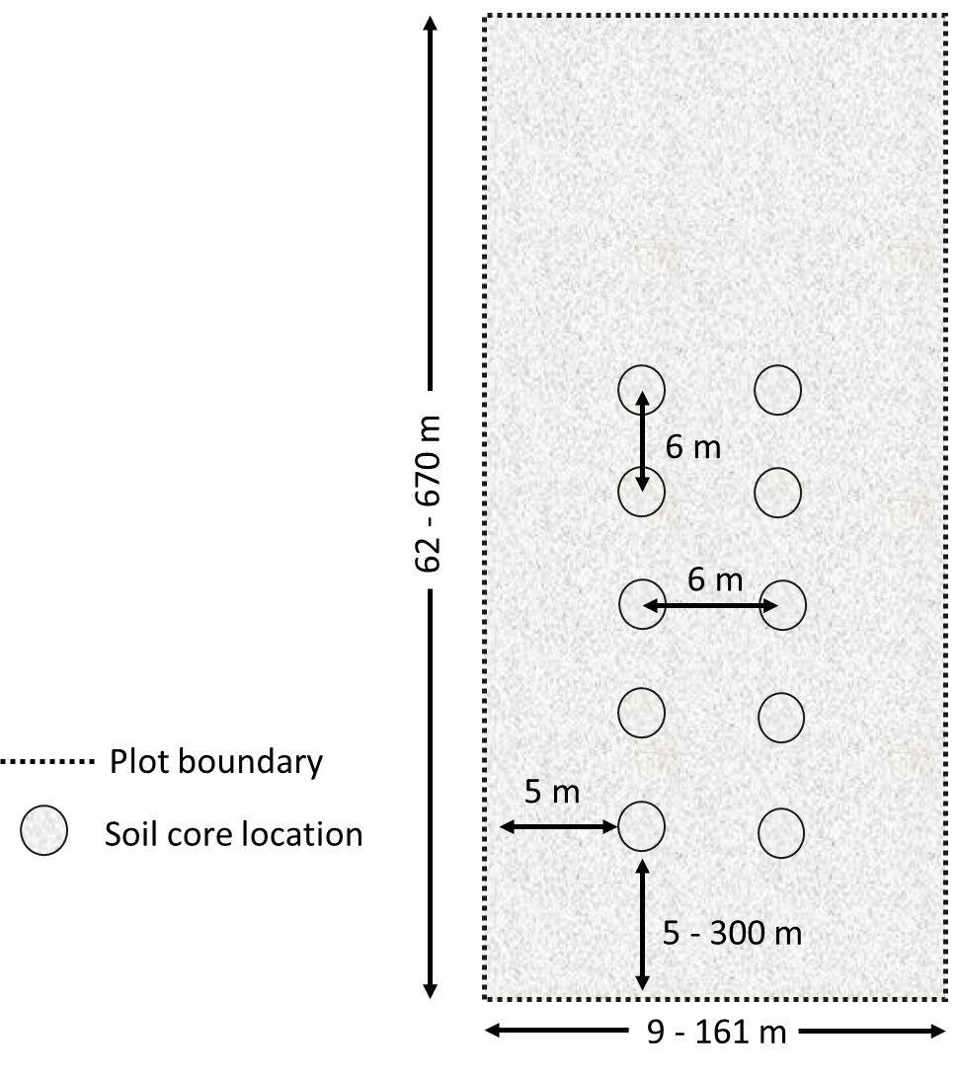
Supplementary Figure S1. Layout showing the 6 m × 24 m area within each plot used for field measurements and soil sampling along with distance in between each measurement point and from the plot boundaries (not to scale).

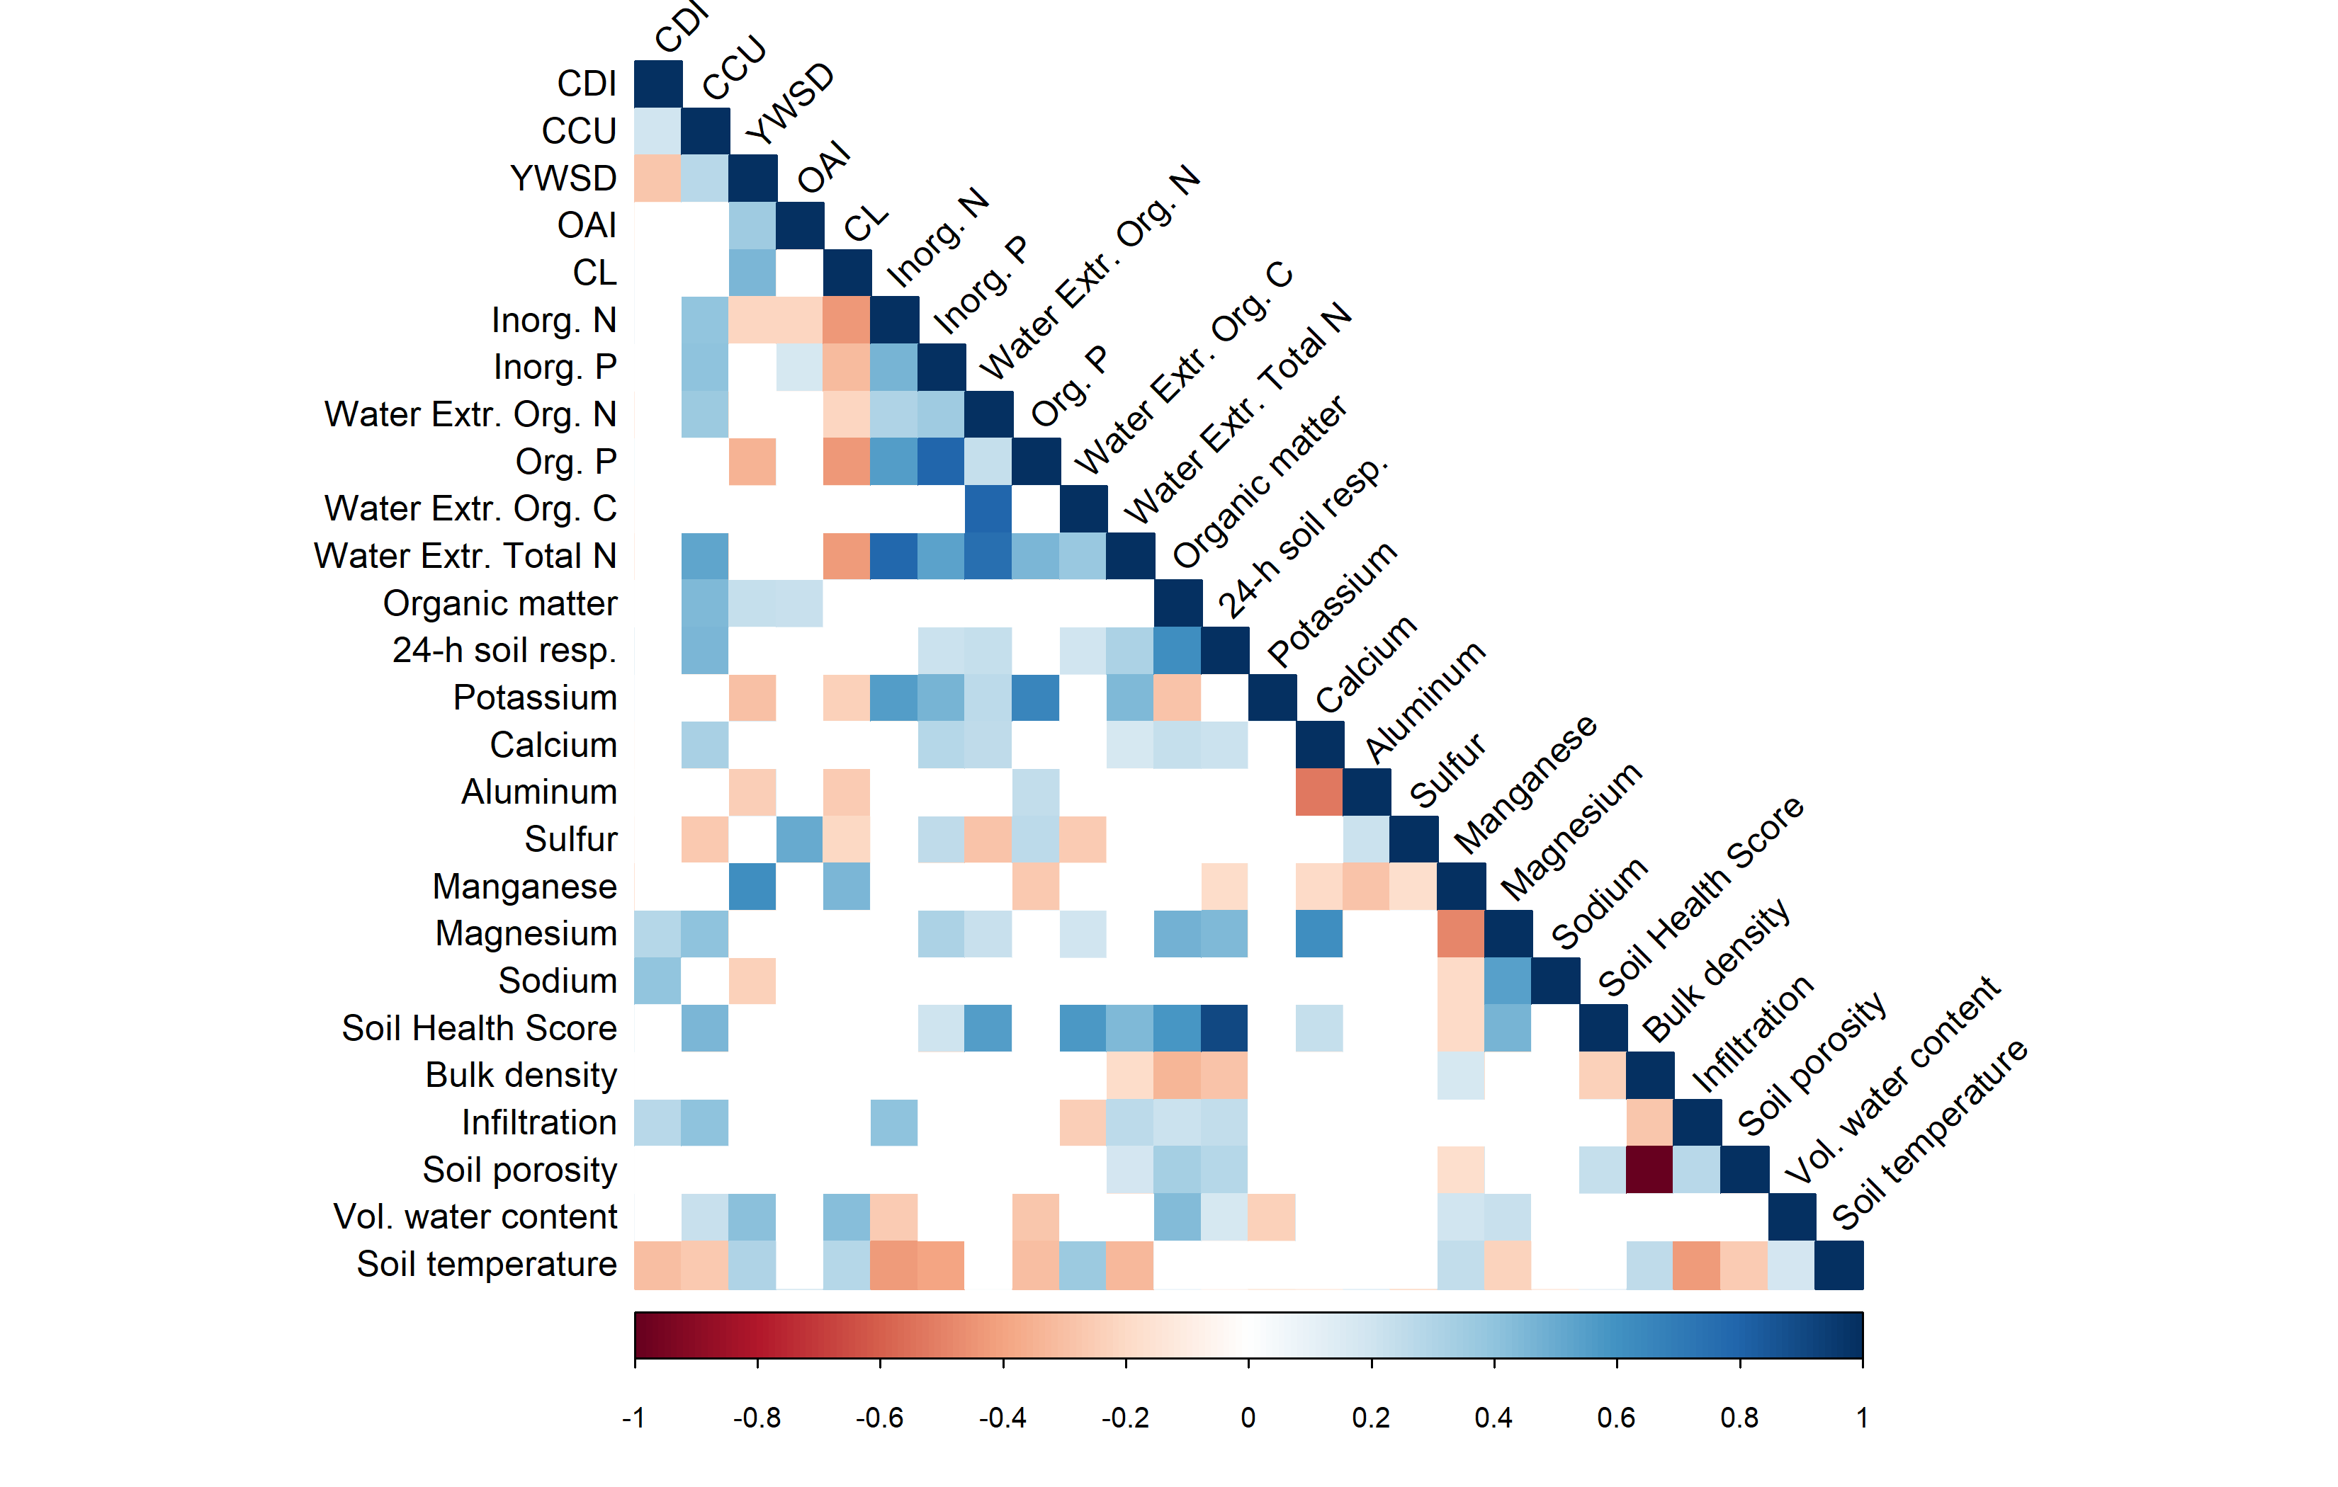
Supplementary Figure S2. Pearson correlation analysis between soil properties used for PCA and multiple linear regression. Correlations with p-value > 0.05 are considered as insignificant and were left blank. CDI, CCU, YWSD, OAI, CL are the crop diversity index, years of cover crop use, years without soil disturbance, organic amendment index, and crop and livestock integration.

Supplementary Table S6
Principal component analysis of 5 soil management indexes and 21 soil health indicators for 0-15 cm soil depth with eigenvalues and proportion of variability explained for the first two components (PC). Component correlation score are shown in percentage; highest loading in each component are bolded.
 | PC1 | PC2
Eigenvalue | 5.36 | 3.68
Proportion | 20.62 | 14.14
 | Component correlation score⁴
Soil management index¹
CDI | 15% | -3%
CCU | 38% | -28%
YWSD | -11% | -25%
OAI | 2% | -8%
CL | -10% | -11%
NRCS²
Infiltration (mm/hour⁻¹) | 11% | -2%
Soil porosity (%) | 11% | -3%
Soil temperature (°C) | -4% | -3%
Volumetric water content (%) | -2% | -10%
Bulk density (g cm⁻³) | -23% | 6%
HSHT³
Water Extr. Org. N (ppm) | 44% | -4%
Water Extr. Org. C (ppm) | 12% | -8%
Water Extr. Total N (ppm) | 20% | 6%
Organic matter (% LOI) | 6% | -11%
24-h soil respiration (ppm CO₂) | 5% | -4%
Inorganic N (ppm) | 7% | 6%
Inorganic P (ppm) | 2% | 0%
Organic P (ppm) | 31% | 29%
Potassium (ppm) | 36% | 58%
Calcium (ppm) | 22% | -26%
Aluminum (ppm) | 3% | 5%
Sodium (ppm) | 0% | 0%
Manganese (ppm) | -8% | -2%
Magnesium (ppm) | 6% | -6%
Sulfur (ppm) | 1% | 4%
Soil health score | 48% | -42%
¹CDI, CCU, YWSD, OAI, CL are the crop diversity index, years of cover crop use, years without soil disturbance, organic amendment index, and crop and livestock integration.
²Soil health indicators included in assessment protocol used by NRCS on conservation programs administered on privately managed lands.
³Soil health indicators included in the Haney soil health test (HSHT).
⁴ Correlations between the variables (soil management indexes and physical, chemical and biological properties) and the PC loadings (e.g., eigenvalues).

