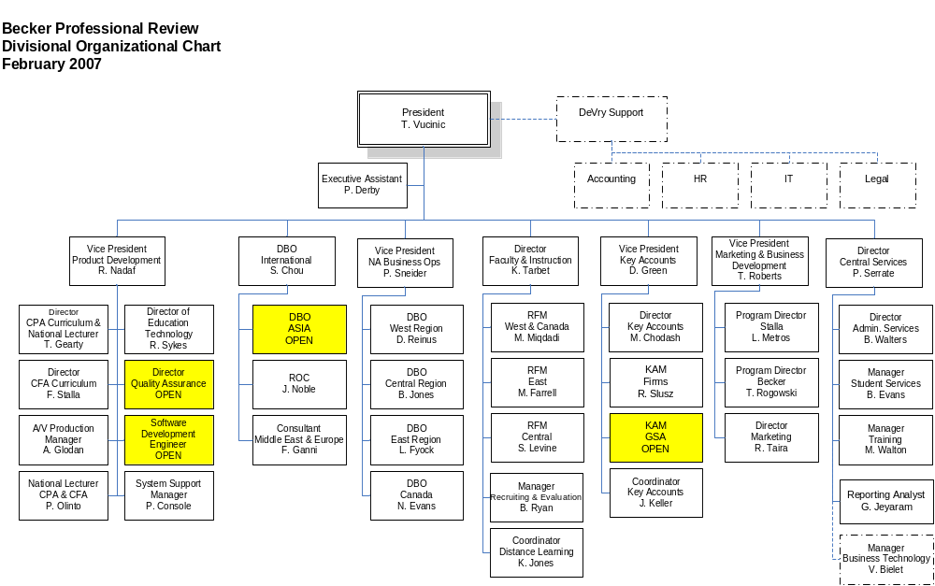

Glossary of Acronyms

CF – Classroom Facilitator
CR – Campus Representative
DBO – Director of Business Operations
HR – Human Resources
IT – Information Technology
KAM – Key Accounts Manager
LCF – Lead Classroom Facilitator
LF – Lead Faculty
MC – Marketing Coordinator
RFM – Regional Faculty Manager
RM – Regional Manager
RMM – Regional Marketing Manager
ROC – Regional Operations Coordinator

