**Python语言程序设计基础课程实验报告（七）**

**学号：** 117060400113 **姓名**： 曹晓静

**班级：** 17应用统计一班  **指导老师：** 林卫中

**一、实验名称**： 计算机程序设计

**二、实验要求：**

**1、了解并掌握函数及代码复用**

**2、掌握datetime库的使用**

**3、掌握函数定义语法，使用函数进行模块化设计**

**4、掌握递归函数定义和使用方法**

**三、实验题目：**

**1、ex5-1 反转字符串**

**2、ex5-2 输出斐波拉契数列的前n项**

**3、ex5-3 汉诺塔案例**

**4、ex5-4 七段数码管**

**四、算法实现：**

**1、法一**

**def reverse(s):**

**if s == “”:**

**return s**

**else:**

**return s[-1] + reverse(s[0:-1])**

**str = input(“please enter a string:”)**

**print(reverse(str))**

**法二**

**def reverse(s)**

**n = len(s)**

**if n == 1:**

**return s**

**else:**

**return reverse(s[n//2:]) + reverse(s[0:n//2])**

**str = input(“please enter a string:”)**

**print(reverse(str))**

**2、**

**def fib(n):**

**if n < 0:**

**print(“Error”)**

**elif n == 0:**

**return 0**

**elif n == 1:**

**return 1**

**else:**

**return fib(n-1) + fib(n-2)**

**n = int(input(“请输入一个整数：”))**

**for i in range(1, n+1):**

**print(fib(i), end=”, ”)**

**3、法一**

**def hanoi(a, b, c, n):**

**if n == 1:**

**print(a + ‘🡪’ + c)**

**else:**

**hanoi(a, c, b, n-1)**

**hanoi(a, b, c, 1)**

**hanoi(b, a, c, n-1)**

**hanoi(‘a’, ‘b’, ‘c’, 3)**

**法二**

**def hanoi(a, b, c, p):**

**if n == 1:**

**print(“圆盘{}:{}🡪{}”.format(p[0], a, c))**

**else:**

**hanoi(a, c, b, p[0:-1])**

**hanoi(a, b, c, [p[-1]])**

**hanoi(b, a, c, p[0:-1])**

**p = range(1, 5)**

**hanoi(‘a’, ‘b’, ‘c’, p)**

**4、**

**import turtle, datetime，random**

**def drawGap(): #绘制数码管间隔**

**turtle.penup()**

**turtle.fd(5)**

**def drawLine(draw): #绘制单段数码管**

**drawGap()**

**turtle.colormode(255)**

**r = random.randint(0, 255)**

**g = random.randint(0, 255)**

**b = random.randint(0, 255)**

**turtle.pencolor((r, g, b))**

**turtle.pendown() if draw else turtle.penup()**

**turtle.fd(40)**

**drawGap()**

**turtle.right(90)**

**def drawDigit(d): #根据数字绘制七段数码管**

**drawLine(True) if d in [2, 3, 4, 5, 6, 8, 9] else drawLine(False)**

**drawLine(True) if d in [0, 1, 3, 4, 5, 6, 7, 8, 9] else drawLine(False)**

**drawLine(True) if d in [0, 2, 3, 5, 6, 8, 9] else drawLine(False)**

**drawLine(True) if d in [0, 2, 6, 8] else drawLine(False)**

**turtle.left(90)**

**drawLine(True) if d in [0, 4, 5, 6, 8, 9] else drawLine(False)**

**drawLine(True) if d in [0, 2, 3, 5, 6, 7, 8, 9] else drawLine(False)**

**drawLine(True) if d in [0, 1, 2, 3, 4, 7, 8, 9] else drawLine(False)**

**turtle.left(180)**

**turtle.penup()**

**turtle.fd(20)**

**def drawStr(str):**

**r = random.randint(0, 255)**

**g = random.randint(0, 255)**

**b = random.randint(0, 255)**

**turtle.pencolor((r, g, b))**

**turtle.write(str,font=("Arial", 18, "normal"))**

**turtle.fd(40)**

**def drawDate(date):**

**turtle.pencolor('red')**

**for i in date:**

**if i == '-':**

**drawStr(‘年’)**

**elif i == '=':**

**drawStr(‘月’)**

**elif i == '+':**

**drawStr(‘日’)**

**else:**

**drawDigit(eval(i))**

**def main():**

**turtle.setup(800, 350, 200, 200)**

**turtle.penup()**

**turtle.fd(-350)**

**turtle.pensize(5)**

**drawDate(datetime.datetime.now().strftime('%Y-%m=%d+'))**

**turtle.hideturtle()**

**main()**

**五、实验结果：**

**1、ex5-1**

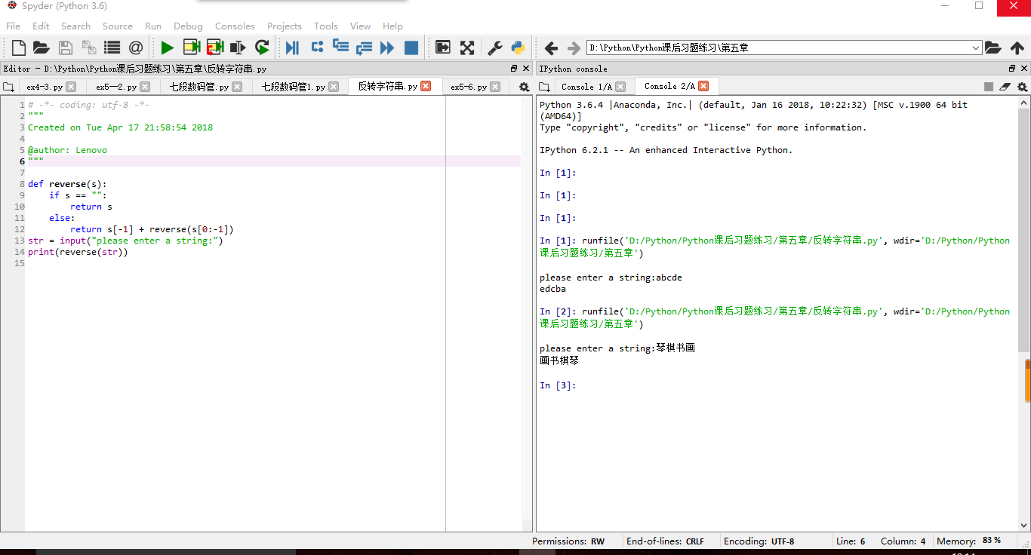

**2、ex5-2**

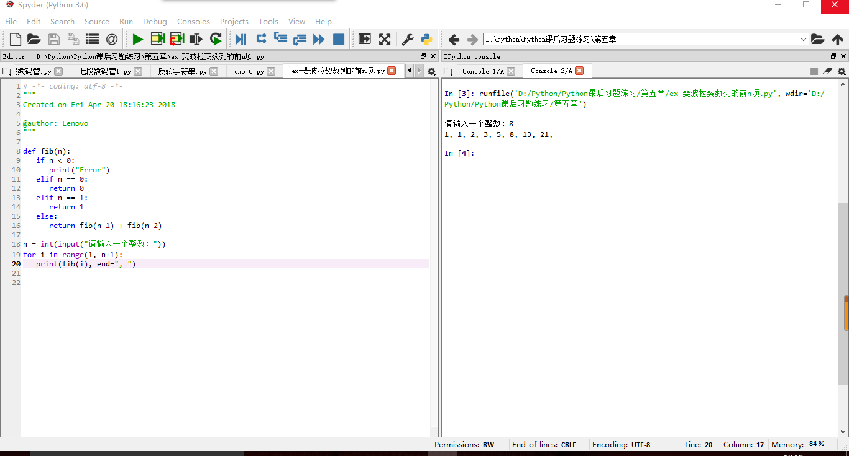

**3、ex5-3**

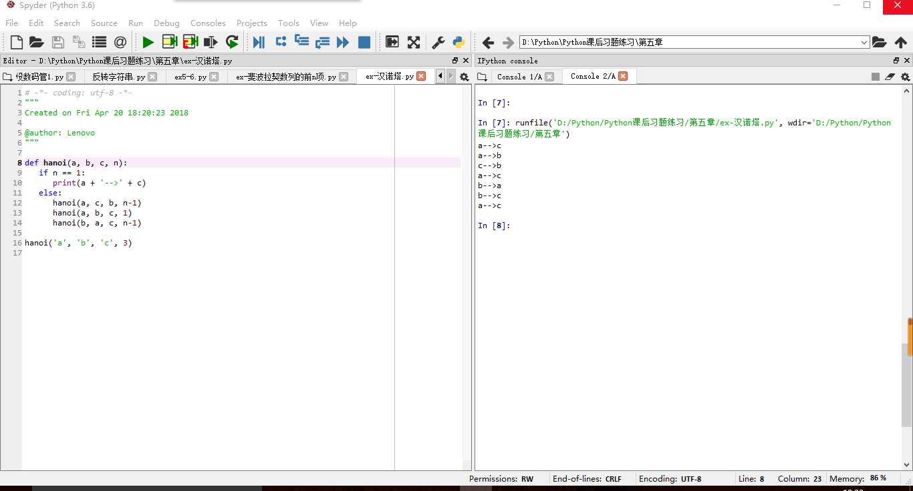

**4、ex5-4**

