**Python语言程序设计基础实验报告（十一）**

**学号：** 117060400113 **姓名**： 曹晓静

**班级：** 17应用统计一班  **指导老师：** 林卫中

**一、实验名称**： 计算机程序设计

**二、实验要求：**

**1、熟悉并掌握numpy库和matplotlib.pyplot**

**三、实验题目：**

**1、解方程**

**2、手绘图**

**3、方波绘制**

**4、圆的绘制**

**四、算法实现：**

**1、**

**#解方程**

**import numpy as np**

**from numpy.linalg import inv**

**A = np.array([[1,0.5,5], [2.3,2,3], [4,1,1.7]])**

**b = np.array([[1,2,3]])**

**x = np.matmul(inv(A),np.transpose(b))**

**print(x)**

**2、**

**#handdraw**

**from PIL import Image**

**import numpy as np**

**vec_el = np.pi/2.2**

**vec_az = np.pi/4.**

**depth = 10.**

**im = Image.open('basketball.jpg').convert('L')**

**a = np.asarray(im).astype('float')**

**grad = np.gradient(a)**

**grad_x, grad_y = grad**

**grad_x = grad_x*depth/100.**

**grad_y = grad_y*depth/100.**

**dx = np.cos(vec_el)*np.cos(vec_az)**

**dy = np.cos(vec_el)*np.sin(vec_az)**

**dz = np.sin(vec_el)**

**A = np.sqrt(grad_x**2 + grad_y**2 + 1.)**

**uni_x = grad_x/A**

**uni_y = grad_y/A**

**uni_z = 1./A**

**a2 = 255*(dx*uni_x + dy*uni_y + dz*uni_z)**

**a2 = a2.clip(0,255)**

**im2 = Image.fromarray(a2.astype('uint8'))**

**im2.save('basketballHD.jpg')**

**im2.show()**

**3、**

**#ex9-1 方波绘制**

**import numpy as np**

**import matplotlib.pyplot as plt**

**t = np.linspace(0, 2*np.pi, 2000)**

**N = 100**

**k = 1**

**y = np.zeros((t.shape[0],))**

**while k <= N:**

**y = y + (4*np.sin((2*k-1)*t))/((2*k-1)*np.pi)**

**k = k + 1**

**plt.plot(t,y)**

**plt.show()**

**4、**

**#circleDraw**

**import numpy as np**

**import matplotlib.pyplot as plt**

**x = np.linspace(-1,1,1000)**

**y = np.linspace(-1,1,1000)**

**px = []**

**py = []**

**for xx in x:**

**for yy in y:**

**if np.abs(xx**2 + yy**2 - 1) <= 1e-3:**

**px.append(xx)**

**py.append(yy)**

**plt.scatter(px,py)**

**plt.axis('equal')**

**plt.show()**

**#circleDraw**

**import numpy as np**

**import matplotlib.pyplot as plt**

**t = np.linspace(0,2*np.pi,100)**

**x = np.sin(t)**

**y = np.cos(t)**

**plt.plot(x,y)**

**plt.axis('equal')**

**plt.show()**

**#circleDraw**

**import numpy as np**

**import matplotlib.pyplot as plt**

**x = np.linspace(-1,1,100)**

**y = np.sqrt(1-x**2)**

**z = -y**

**plt.plot(x,y,'r')**

**plt.plot(x,z,'r')**

**plt.axis('equal')**

**plt.show()**

**五、实验结果：**

**1、**

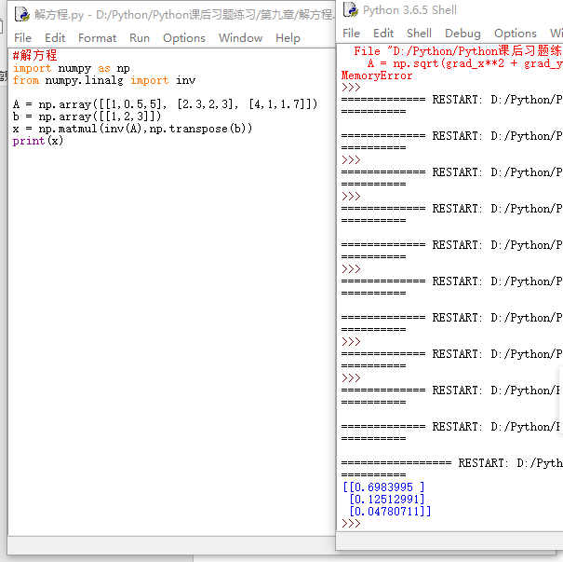

**2、**





**3、**

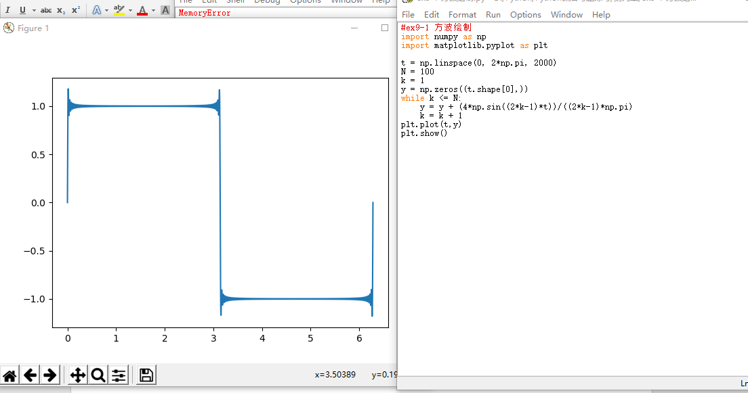

**4、**

