**Python语言程序设计基础实验报告（十二）**

**学号：** 117060400113 **姓名**： 曹晓静

**班级：** 17应用统计一班  **指导老师：** 林卫中

**一、实验名称**： 计算机程序设计

**二、实验题目：**

**1、掌握运用爬虫技术，爬取中国大学排名、世界大学排名。**

**2、爬取并下载明星图片**

**四、算法实现：**

**1、**

import requests

from bs4 import BeautifulSoup

allUniv = []

def getHTMLText(url):

try:

r = requests.get(url, timeout=30)

r.raise_for_status()

r.encoding = 'utf-8'

return r.text

except:

return ""

def fillUnivList(soup):

data = soup.find_all('tr')

for tr in data:

ltd = tr.find_all('td')

if len(ltd)==0:

continue

singleUniv = []

for td in ltd:

singleUniv.append(td.string)

allUniv.append(singleUniv)

def printUnivList(province):

print("{:<2}{:<10}{:<6}{:<4}{:^10}".format("排名","学校名称","省市","总分","培养规模"))

for u in allUniv:

if province in u[2]:

print("{:<2}{:<10}{:<6}{:<4}{:<10}".format(u[0],u[1],u[2],u[3],u[6]))

def main(p):

url = 'http://www.zuihaodaxue.cn/zuihaodaxuepaiming2016.html'

html = getHTMLText(url)

soup = BeautifulSoup(html, "html.parser")

fillUnivList(soup)

printUnivList(p)

main("江西")

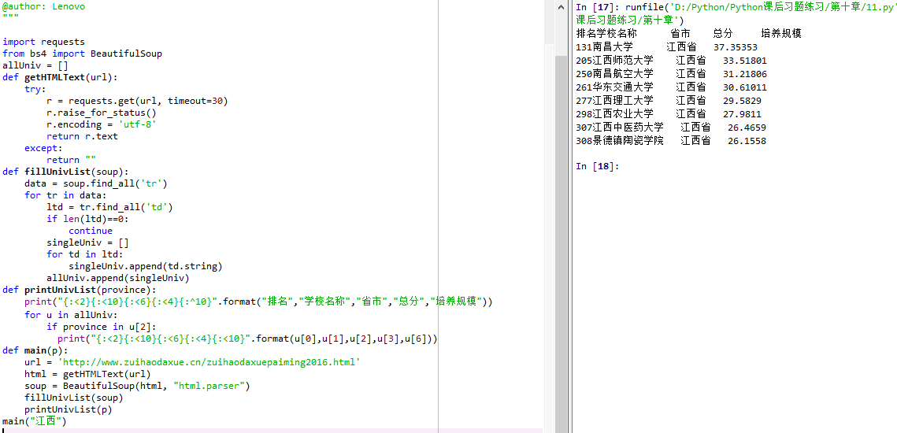

**2、**

import requestsfrom bs4 import BeautifulSoupallUniv = []def getHTMLText(url): try: r = requests.get(url, timeout=30) r.raise_for_status() r.encoding = 'utf-8' return r.text except: return ""def fillUnivList(soup): data = soup.find_all('tr') for tr in data: ltd = tr.find_all('td') if len(ltd)==0: continue singleUniv = [] for td in ltd: singleUniv.append(td.string) allUniv.append(singleUniv)def printUnivList(province): print("{:<2}{:<10}{:<6}{:<4}{:^10}".format("排名","学校名称","省市","总分","培养规模")) for u in allUniv: if province in u[2]: print("{:<2}{:<10}{:<6}{:<4}{:<10}".format(u[0],u[1],u[2],u[3],u[6]))def main(p): url = 'http://www.zuihaodaxue.cn/zuihaodaxuepaiming2016.html' html = getHTMLText(url) soup = BeautifulSoup(html, "html.parser") fillUnivList(soup) printUnivList(p)main("山东")

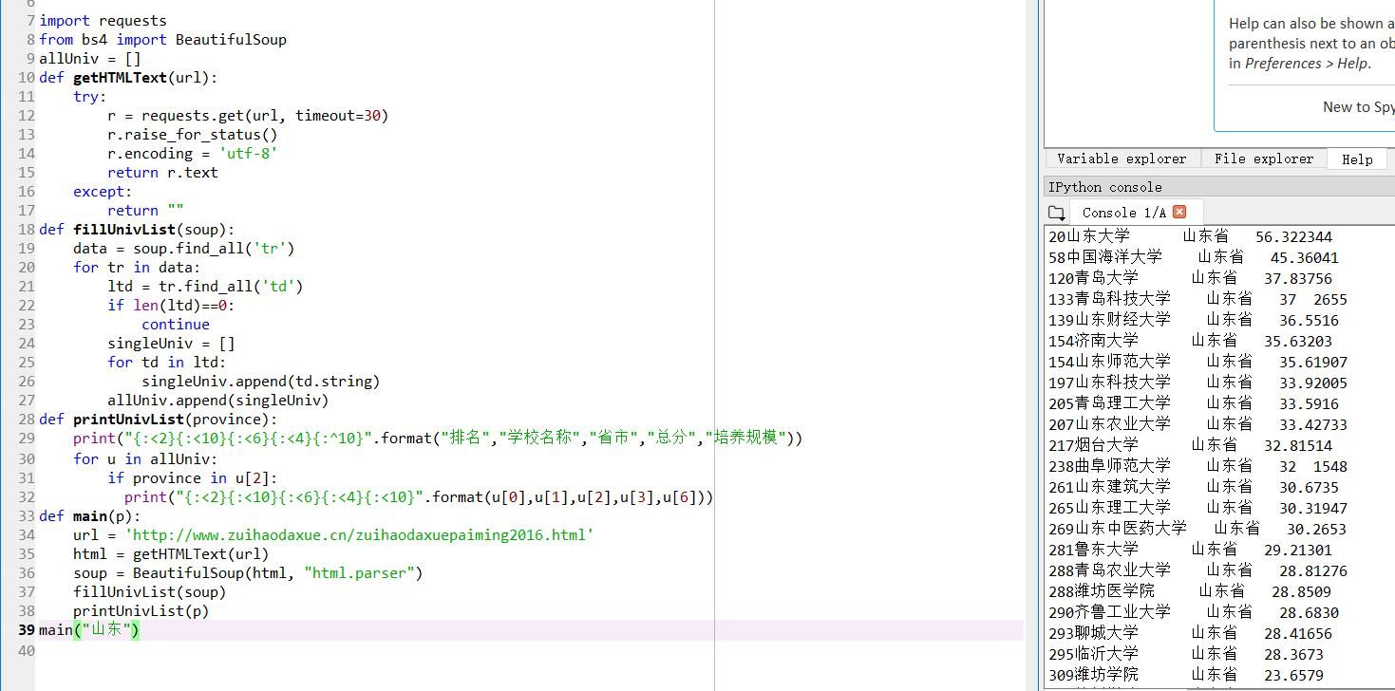

3.

import requestsfrom bs4 import BeautifulSoupallUniv = []def getHTMLText(url): try: r = requests.get(url, timeout=30) r.raise_for_status() r.encoding = 'utf-8' return r.text except: return ""def fillUnivList(soup): data = soup.find_all('tr') for tr in data: ltd = tr.find_all('td') if len(ltd)==0: continue singleUniv = [] for td in ltd: singleUniv.append(td.string) allUniv.append(singleUniv)def printUnivList(province): print("{:<2}{:<10}{:<6}{:<4}{:^10}".format("排名","学校名称","省市","总分","培养规模")) for u in allUniv: if float(u[3])>50: print("{:<2}{:<10}{:<6}{:<4}{:<10}".format(u[0],u[1],u[2],u[3],u[6]))def main(p): url = 'http://www.zuihaodaxue.cn/zuihaodaxuepaiming2016.html' html = getHTMLText(url) soup = BeautifulSoup(html, "html.parser") fillUnivList(soup) printUnivList(p)main("山东")

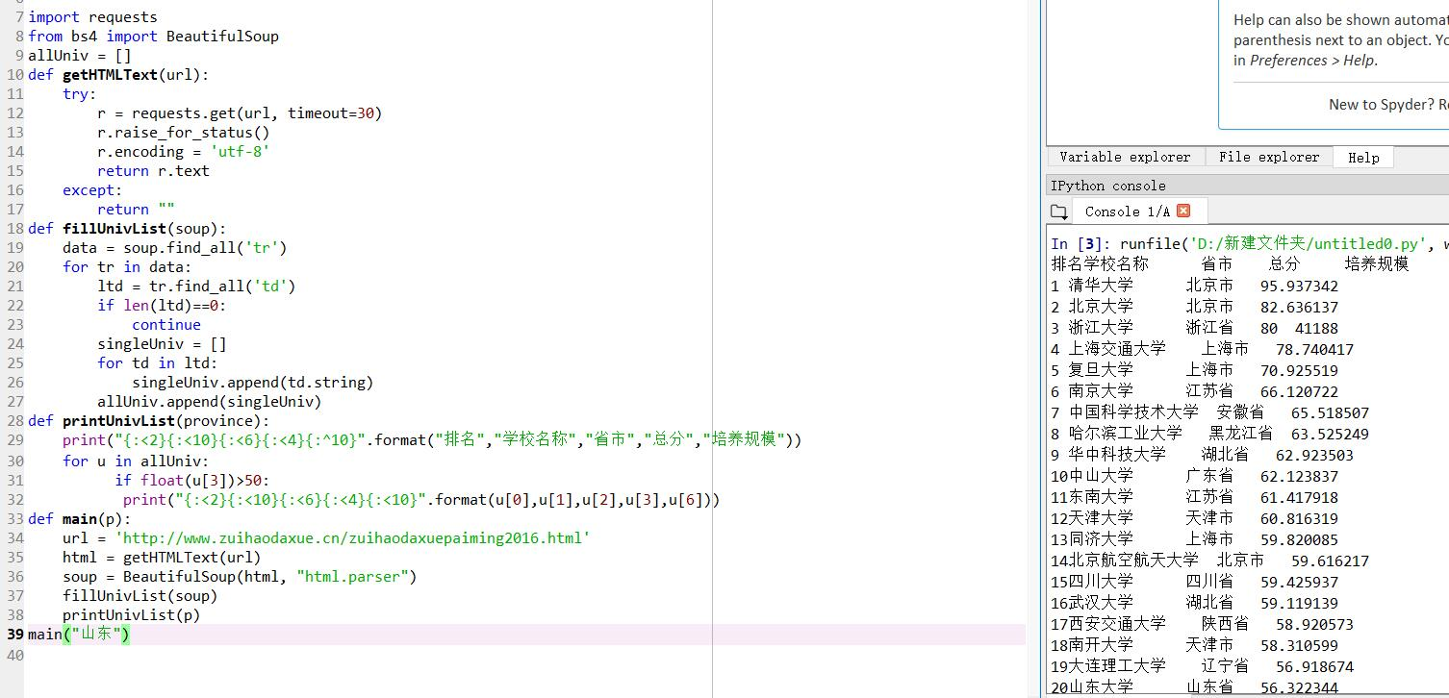

4.

import requestsimport refrom bs4 import BeautifulSoupallUniv=[]def getHTMLText(url): send_headers = { "User-Agent": "Mozilla/5.0 (Windows NT 10.0; Win64; x64) AppleWebKit/537.36 (KHTML, like Gecko) Chrome/61.0.3163.100 Safari/537.36", "Connection": "keep-alive", "Accept": "text/html,application/xhtml+xml,application/xml;q=0.9,image/webp,image/apng,*/*;q=0.8", "Accept-Language": "zh-CN,zh;q=0.8"} try: r = requests.get(url, headers=send_headers) r.raise_for_status() print(r.status_code) r.encoding = 'utf-8' return r.text except: return ""def fillUnivList(soup): data = soup.find_all('div',{'class':re.compile('shadow-dark')}) for div in data: singleUniv = [] #排名 div1 = div.find('div',{'style':'margin-left: 2.5rem;'}) rank = div1.get_text().strip() #学校名称 singleUniv.append(rank.split(' ')[0]) div2 = div.find('h3') #City singleUniv.append(div2.get_text().strip()) address = div.find('div',{'class':re.compile('block-normal')}) singleUniv.append(address.string) lstrong = div.find_all('strong') singleUniv.append(lstrong[0].string)#学费 singleUniv.append(lstrong[1].string)#培养规模 allUniv.append(singleUniv)def printUnivList(): print("{:<6}{:<20}{:<10}{:<10}{:<10}".format("排名","学校名称","City","学费","培养规模")) for u in allUniv: print("{:<6}{:<20}{:<10}{:<10}{:<10}".format(u[0],u[1],u[2],u[3],u[4]))def main(): url = 'https://www.usnews.com/best-colleges/rankings/national-universities' html = getHTMLText(url) soup = BeautifulSoup(html,'html.parser') fillUnivList(soup) printUnivList()main()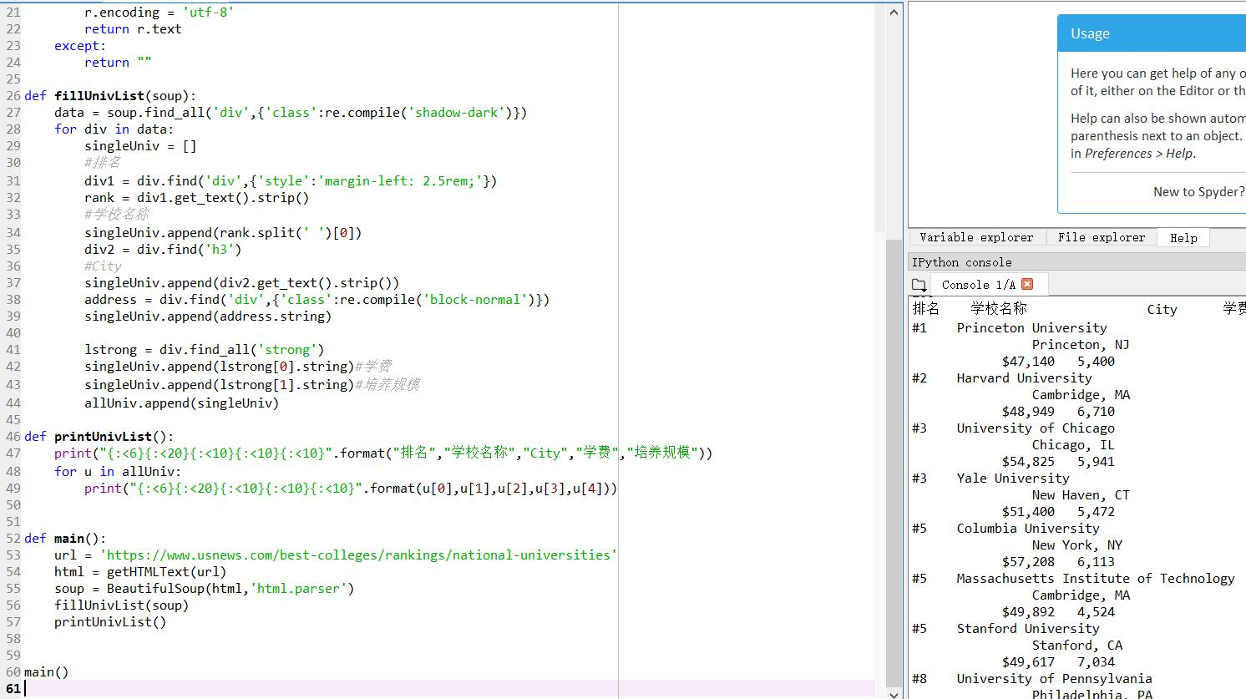

5.

import requests

import re

def getHTMLText(url,coding='gbk'):

try:

r = requests.get(url,timeout=30)

print(r)

r.raise_for_status()

r.encoding = coding

return r.text

except:

return ""

def downloadImageFile(imgUrl, destUrl, fname=''):

local_filename = imgUrl.split('/')[-1]

print('Download Image File={}'.format(local_filename))

try:

r = requests.get(imgUrl, stream=True)

r.raise_for_status()

if len(fname) == 0:

fname = local_filename

print('fname={}'.format(fname))

with open(destUrl + "/" + fname, 'wb') as f:

for chunk in r.iter_content(chunk_size=1024):

if chunk:

f.write(chunk)

f.flush()

f.close()

return r.status_code

except:

return r.status_code

def getImg(html):

imgre = re.compile('"objURL":"(.*?)"')

imglist = re.findall(imgre,html)

return imglist

def download(urls,path):

index = 1

for url in urls:

print("Download Image from page:{}".format(url))

status = downloadImageFile(url,path,str(index)+".jpg")

try:

if str(status)[0] == '4':

print("未下载成功{}".format(url))

continue

except Exception as e:

print("未下载成功{}".format(url))

index += 1

page = 'https://image.baidu.com/search/index?tn=baiduimage&word=李易峰'

html= getHTMLText(page,'utf-8')

download(getImg(html),'d:\\python\\pic')

