PERSONAL DATA
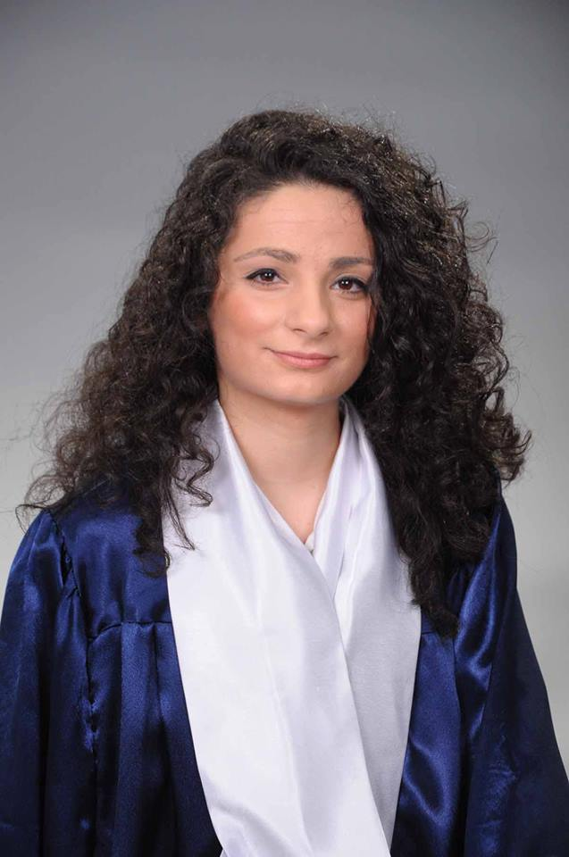

Date of birth: | 11.06.1992
: | 075/872/562
: | Skopje
e-mail: | lencepetkovska992@gmail.com

Personal Skills
- creative, team player, responsible, loyal, dedication, devoted to work, persistence, attentive, fundamental
EDUCATION
Graduate at the Faculty of Computer Science and Engineering(FINKI).
TRAINING
- Seven years English course at FILOS
- course for PHP I-level at Semos Education
- course PHP II-level at Semos Education

languages
- English: Very good.

programming languages
- PHP, Laravel Framework, HTML, CSS, MySQL, JavaScript, JQuery, Bootstrap, Less, Sass, AngularJS

COMPUTER SKILLS
- Solid knowledge of MS office: word, excel ,power point.

PROJECTS
- Web app for discussion of pharmaceutical drugs (Laravel 5)
- Web app for law office.(Laravel 5 - Graduate Thesis)

