#2 Coupon Codes – The ability to have a “Coupon Code” that can be used for free attendance to events

Introduce the following screen for staff users to set up a “coupon code” for a particular event.

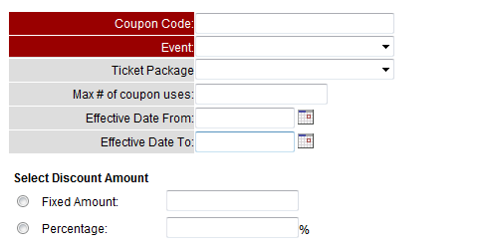
Couple Code is a text box that allows any alphanumeric characters. Event is a drop down field that lists all future events (i.e. event start time >= today’s date) as well as a choice called “All Events”. After the event gets selected, the ticket prices corresponding to the event will be rendered under the Ticket Package drop down. If a ticket package is selected, the coupon code will only be applied to that particular ticket package; if ticket package is blank, the coupon code applies to the entire event registration.

Max # of coupon uses is the optional field that indicates the limit number of uses per coupon code. If it’s left blank, the code can be used unlimited times. Date From and Date To are in MM/dd/yyyy format. They are optional and will be validated to make sure they are in valid format if populated.

Upon the submission of the form, the user will be directed to a “coupon code” listing page. It lists the event name and the applicable coupon code, the start and end time if applicable. Staff user can also edit and delete existing couple codes here. A confirm window will popup when the Delete link is clicked.

Action Event Ticket Coupon Code Effective Date Discount # of uses
Edit | Delete Event A Ticket XYZ 123ABC 04/30/2010 – 05/30/2010 $10 off 50

After this coupon code is set up, NEON will add a coupon code field to the following screen:

- Public Event registration page (Page 1)
- Event registration page (Page 1) after constituent login
- Back end event registration page (page 1)

If the coupon code matches, the discount will be automatically applied to the registration. The coupon code discount, including the coupon code and discount dollar amount will show up on the event registration report as two separate output columns.

#5 Group Membership for Households and Organizations

Each household or organization membership needs to be defined in NEON first. On the screen where a membership is defined, NEON will add a checkbox flag to indicate if this membership is a group membership. For group membership, we’ll need to collect the main membership due, extra fee for each additional member and max # of additional members allowed (optional)

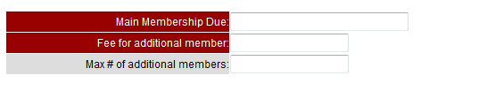

The following pages will be impacted:

- Front end Public Access page:
When Household or Organization membership is selected, NEON will ask for more information for each additional member, such as First Name, Last Name, title, company and address information. Based on the membership fee defined above, NEON will calculate the total and create each member a separate account. Each account will be enrolled in the household or organization membership. For household membership registration, we’ll add a checkbox to indicate the head of the household. For organization membership, the additional members will be treated as the employees of the organization. When membership fee is paid successfully, NEON will send out acknowledgement email to each member.

- Front end Constituent Login Page:
- When a household or organization membership is selected, we will support the same flow as describe above.
- When people view their membership history, they can add additional member to their household or organization membership if the current household or organization membership is current and valid. Only people who log in as the head of the household or the organization can add more members. The system will calculate the total and create each additional member a separate account.

- Back End changes:
When registering a household or organization membership, NEON will add a screen to collect additional members’ information. Internally we’ll implement the same logic as we did above – create each additional member a separate account and calculate the total based on the fee structure.

#6 Adding “Attendees” from the event registrations to the database. We’ll develop an easy process to convert previously entered attendees into NEON accounts.
When creating or modifying an event, we will add a checkbox to indicate if the attendees will be created as individual accounts for registrations on this particular event. If the checkbox is marked, event attendees will be added to NEON as individual accounts. This process will apply to both front end and back end of NEON. If the name of an attendee matches to the registrant name, no account will be created for this attendee. The event registration information will show up on each attendee’s account detail page as well as the registrant record.
Note: when an existing email is used for an attendee, NEON will NOT create a new account. We’ll copy the latest contact information to update the contact information on the existing account.

Develop a database script to convert existing event attendees to individual accounts.

