Proposal Analysis Report

*for the implementation of*

**Big Computer Corp Town Planner ©**

*in Tiny Town LGA*

*(REPORT BY CTO)*



Tiny Town LGA

**Table of Contents**

**Introduction** 3

**Information Systems Review of BCC Proposal** 4

Information Systems Diagrammatic Representation 4

Ethical Issues 6

Safety 6

Security 6

Privacy 6

Reliability of Data 6

Social Issues 6

Ergonomics 6

Economic 6

Personal 6

Survey Results 7

Recommendations 9

**Library System Database Prototype** 10

Table Information 10

Book Information Table – “Book” 10

Members Information Table – “Member” 11

Borrowings Information Table – “Borrow” 12

Database Relationships 13

Forms 14

Members Form 14

Books Form 15

Borrowing Form 16

Queries 17

Summary of All Books Query 17

Overdue Books Query 18

Summary of All Books Report 19

Mail Merge 20

Template Document 20

Example Merged Document 21

# **Introduction**

Mention of the “Software” refers to the “Big Computer Corp Town Planner© Software Package”.

*This report assumes that the resident data is held by the council on an existing internal database. Therefore, concerns about data mining relate to a possible man-in-the-middle attack whereby the Town Planner severs relaying the information to users would store or send that information on to an un-authorised party.*

This report evaluates and makes a judgement on the implementation of the Software in the context of Tiny Town LGA.

The contents of this report include a library database system prototype as well as a final decision as to whether the software shall be implemented.

The database prototype is used to demonstrate to local residents how a local library system could look like as a part of the Town Planner Software Package. It allows users to get to know how such a system would work and familiarise themselves with the various aspects of the system.

The full list of the contents of this report are on the previous page.

# **Information Systems Review of BCC Proposal**

### Information Systems Diagrammatic Representation

|  |  |  |  |  |  |
| --- | --- | --- | --- | --- | --- |
| **Environment** | | Tiny Town LGA | | | |
| **Users** | | Tiny Town residents, Tiny Town library, Council employees | | | |
| **Purpose** | | 1. To provide access for residents of Tiny Town to view: rate notices, development applications, minutes from council meetings. 2. To allow residents to view (2.1 & 2.2) and update (2.3 & 2.4) personal details. 3. To allow council employees to send residents emails regarding overdue notices or upcoming events. 4. To allow residents to see library book lists, borrowed books, return dates, overdue books and any fines they may have accrued. | | | |
| **Information Processes** | | | | | |
|  | Process | | Participants | Data / Information | Information Tech |
| 1.1 | The Town Planner server retrieves information such as relevant rate notices, development applications (personal / local area) and video/audio from council meetings from an internal network council database using the resident ID number.  **(Storage/Retrieval, Transmitting/Receiving)** | | Resident (initiates the process) | Resident ID, resident details, rate notice slips, development application documents, video or audio from council meetings. | Internal council database system, Town Planner computer server, Network infrastructure |
| 1.2 | Transmit the information from 1.1 and then display the information to the resident’s Town Planner software package or web browser in a human readable format.  **(Analysing, Transmitting, Displaying)** | |  | Resident details, rate notice slips, development application documents, video or audio from council meetings. | PC, Browser, Town Planner computer server, Network infrastructure |
| 2.1 | The Town Planner server retrieves relevant personal details from the internal council database system.  **(Storage/Retrieval, Transmitting/Receiving)** | | Resident (initiates the process) | Resident ID, Resident details | Internal council database system, Town Planner computer server, Network infrastructure |
| 2.2 | Transmit the information from 2.1 and then display the information to the resident’s Town Planner software package or web browser in a human readable format.  **(Analysing, Transmitting/Receiving, Displaying)** | |  | Resident details | PC, Browser, Town Planner computer server, Network infrastructure |
| *2.3* | If the user updates the information displayed in 2.2, then send the new details to the Town Planner server.  **(Analysing, Transmitting, Displaying)** | | Resident (initiates the process) | Resident ID, Resident details | PC, Browser, Town Planner computer server, Network infrastructure |
| *2.4* | If the process in 2.3 occurred, update the records using the Resident ID with resident details data inside the council database system to be current with the residents updated details.  **(Storage/Retrieval, Transmitting/Receiving)** | |  | Resident ID, Resident Details | Internal council database system, Town Planner computer server, Network infrastructure |
| 3.1  OR | A council employee logs onto the software and creates an email to be sent. This is then submitted to the Town Planner computer server. (goes to 3.2)  **(Collecting, Transmitting/Receiving)** | | Council employee | Council department name, Message content, Recipient(s)’ details, | Town Planner computer server, Town Planner software, Network infrastructure, PC |
| 3.1 | Using the current date, the Town Planner computer server checks the internal council database for overdue notices or events and sends mail merged documents to 3.2.  **(Collecting, Analysing, Storage/Retrieval, Transmitting/Receiving, Processing)** | |  | Recipient(s)’ details, Current date | Town Planner computer server,  Internal council database system,  Network infrastructure |
| 3.2 | The Town Planner server receives the documents/messages from 3.1 and then sends emails to all recipient(s)’ email addresses.  **(Transmitting/Receiving, Displaying)** | |  | Council department name, Email message content, Recipient(s)’ details, | Town Planner computer server, |
| 4.1 | Retrieve a list of all available books from the library database, any borrowed books and their return date, overdue books and any fines that have been accrued by the resident.  **(Analysing, Storage/Retrieval, Transmitting/Receiving, Processing, Displaying)** | | Resident | Resident ID, Resident details, Book list, Overdue books and fines, return dates, Borrowed books list. | Library database, PC, Network infrastructure |

### Ethical Issues

### Safety

The Software poses no direct issues of residents’ personal safety, which provides a positive point. However, in the event of a data breach the personal details of residents would be vulnerable and therefore be exploited by those with malicious intent.

### Security

The security of the Software requires that only authorised personnel should have access to the fundamental system. Care should be taken in the authentication of any person entering the system, that they receive the correct permissions for their accounts. An effective security model would give residents a sense of trust in the system. However, should it be compromised then it will be harder to regain the trust so it is vital to ensure security is right the first time.

### Privacy

The privacy of resident data is a key issue which must be addressed in light of the Cambridge Analytica and Facebook incident. We must know for sure that data is being dealt with properly and that no bad practises should cause harm to users of the information system. The issue here is that only those authorised to view this data may view it.

### Reliability of Data

The reliability of the data in the system is improved through the use of the Software. It enables residents to more easily keep details up to date and means that council will not have to chase up people in regards to outdated information held in council records.

### Social Issues

### Ergonomics

The deign of the Software should take into consideration all users who use the software, this includes: students, adults and seniors. A good user interface design should be easily adjustable to suit individuals needs and disabilities such as colour blindness, blindness, deafness, vision impairment. These can be implemented through screen readers, closed caption transcripts, greyscale modes, and scalable interfaces that can zoom to enlarge text. If an accessible interface is provided, residents will feel that their needs have been met and will feel more comfortable using the system. Should a poor interface be provided, it will likely not be used and discarded as unreadable.

### Economic

The economic issues associated with the software can be dealt with by means of information brochures available online and at the council free of charge. This will provide the equivalent of a free training course for residents. To make certain that the system is understood, several information days could be held to demonstrate (especially to seniors) how to use the system visually. These days can also act as question and feedback sessions for other issues relating to the Software. There are also likely to be positive economic impacts on Tiny Town LGA. For example, people who live and work rurally will have more time at their location as they won’t need to make the journey into town to sort out matters will the council such as rates, and updating personal details.

### Personal

The use of the Software will enable more time for residents who live in rural areas. There be no need to allocate travel time for trips to and from the city to sort out council issues. This will enable residents to spend more time with family and increase the overall happiness and wellbeing of member of the Tiny Town community.

### Survey Results

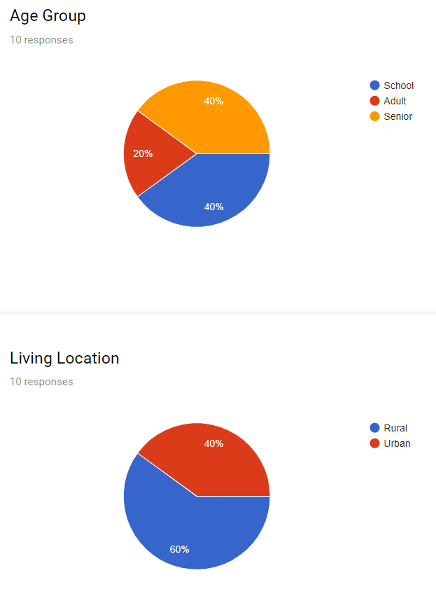***Survey conducted by BCC***

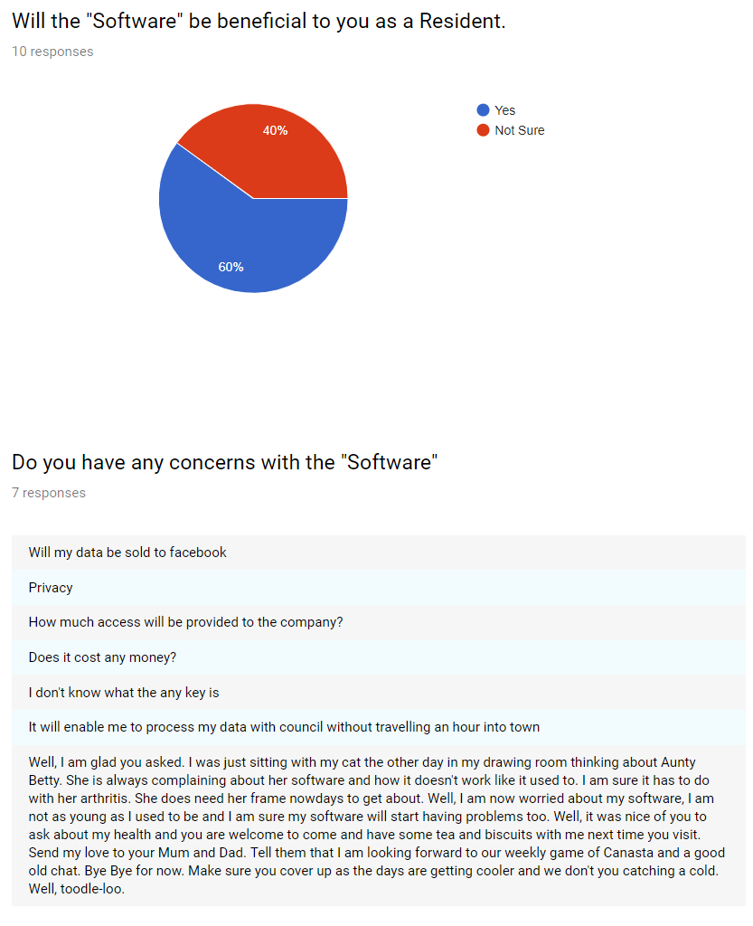

### Recommendations

As the CTO of Tiny Town LGA, I believe that in its current state, the proposal for Tiny Town LGA to implement the Big Computer Town Planner © software is inappropriate at this time unless certain questions regarding its implementation can be answered.

It is important that we learn from previous mistakes made in the Software Development Industry regarding privacy and the security of user’s data and information. Therefore, the process of retrieving the data from council’s internal database system exposes a vulnerability should an error occur in the Software. A prime example of data misuse is in the case of Cambridge Analytica and Facebook. Facebook was on selling the data of its users to advertising firms without users knowing explicitly.

The highlighted social and ethical issues prove to be too big of a security concern without the certainty of how they will be handled by the Software. Should an issue occur relating to system security, is not only resident trust that may be lost but there is also potential for harm to the individual if information such as unpaid rates ends up in the wrong hands.

From the survey results provided by Big Computer Corp, it is noticeable that the amount of people who think the software is beneficial is also matched by those who live in rural areas. This proves that the personal and economic benefits of the system would provide a positive impact on the community provided the system if safe. The fewer adults who answered the survey may relate to the time the survey was conducted. It is possible that adults were still at work in the afternoon or that many adults are indifferent to the system as accessing council directly is not an issue if they live close to the city. It is also interesting to note that the previously raised issues of security, privacy and data mining appear in the survey results. This shows that there is a genuine concern for the Software’s implementation and its procedures in dealing with data. *It is also interesting to note the possible existence of a time-travelling Grandmother.*

So, my final recommendation is the following:

**The implementation of the Town Planner Software Package *will not* go ahead at this point in time as the security, privacy and safety of the users of the system cannot be guaranteed at this time.**

# **Library System Database Prototype**

## Table Information

### Book Information Table – “Book”

|  |  |  |  |  |  |  |
| --- | --- | --- | --- | --- | --- | --- |
|  | Field Name | Data Type | Length | Format | Description | Example |
| **PK** | bookID | Number | Int |  | Uniquely identifies each book that the library currently owns. | 7 |
|  | title | Text | 100 |  | A text field containing the title of the book. | Dracula |
|  | author | Text | 100 |  | A text field containing the author who originally wrote the book. | Bram Stoker |
|  | datePublished | Date |  | dd/mm/yyyy | A date field containing the date of the book’s specific publication. (Not the original publication). | 01/01/1982 |
|  | genre | Text | 50 |  | A text field containing the most relevant genre that relates to the book. | Gothic |

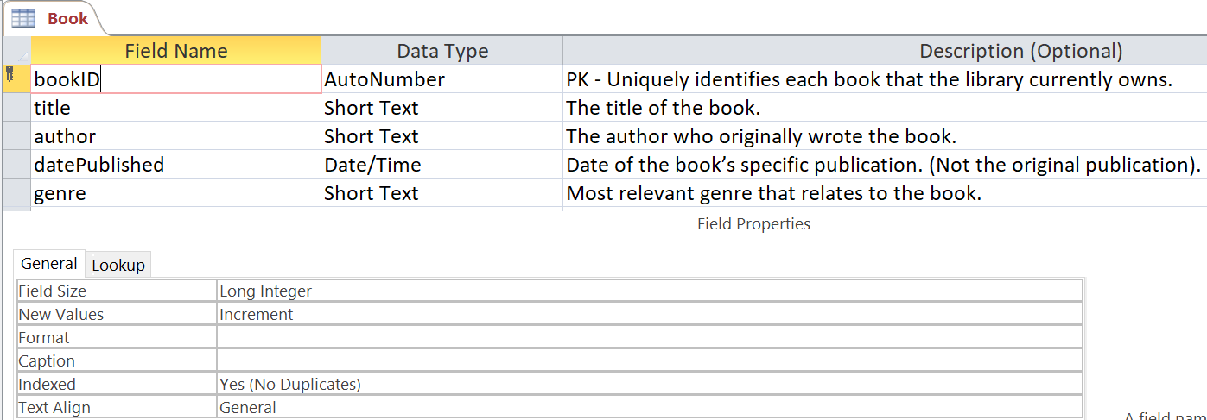

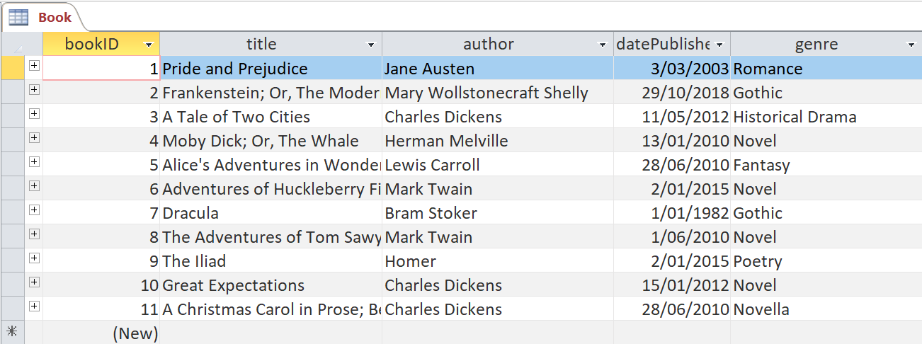

### Members Information Table – “Member”

|  |  |  |  |  |  |  |
| --- | --- | --- | --- | --- | --- | --- |
|  | Field Name | Data Type | Length | Format | Description | Example |
| **PK** | memberID | Number | Int |  | Uniquely identifies each member of the library system. | 9 |
|  | firstName | Text | 100 |  | A text field containing the first name of the library member. | Keenan |
|  | lastName | Text | 100 |  | A text field containing the last name of the library member. | Smith |
|  | streetAddress | Text | 100 |  | A text field containing the street address of the library member. | 17 Prime Lane |
|  | town | Text | 100 |  | A text field containing the suburb/town/locality name of where the member lives. | Chatswood |
|  | state | Text | 3 |  | A text field containing the letter code for the state where the member lives. | NSW |
|  | postcode | Text | 4 |  | A text field containing the four-digit postcode where the member lives. | 2029 |
|  | dateOfBirth | Date |  | dd/mm/yyyy | A date field containing the date of birth of the library member. | 09/05/2004 |

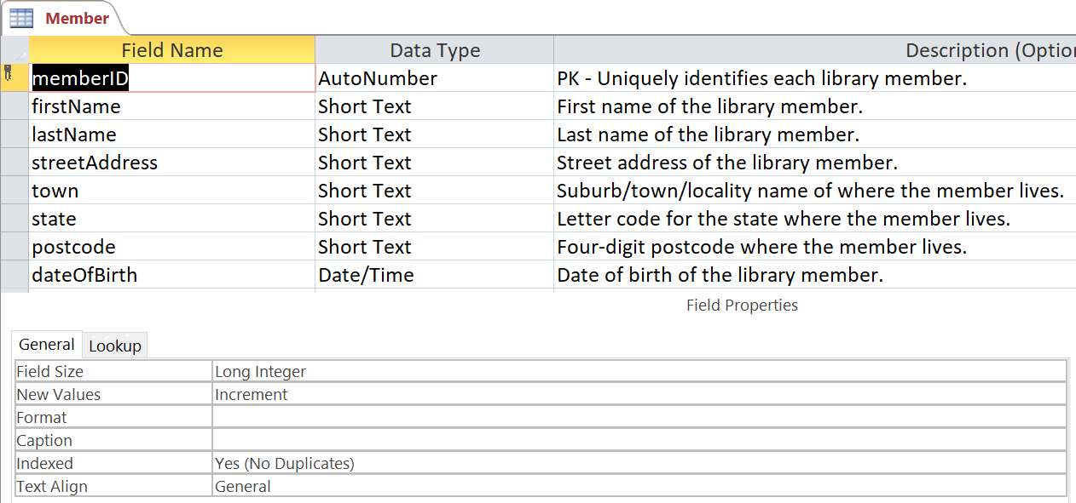

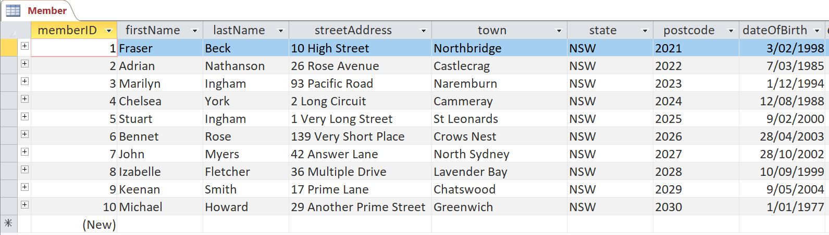

* Postcodes are not actual. Postcodes only serve as demonstration.

### Borrowings Information Table – “Borrow”

|  |  |  |  |  |  |  |
| --- | --- | --- | --- | --- | --- | --- |
|  | Field Name | Data Type | Length | Format | Description | Example |
| **PK** | borrowID | Number | Int |  | Uniquely identifies each time a book has been borrowed. | 9 |
| **FK** | memberID | Number | Int |  | Uniquely identifies the member which took out this borrowing. | 6 |
| **FK** | bookID | Number | Int |  | Uniquely identifies the book which was borrowed. | 9 |
|  | dateBorrowed | Date |  | dd/mm/yyyy | A date field containing the date when the book was borrowed. | 31/01/2019 |
|  | dateDue | Date |  | dd/mm/yyyy | A date field containing the date when the book is due back. | 21/01/2021 |
|  | dateReturned | Date |  | dd/mm/yyyy | A date field. If the book was returned then this will contain a date, otherwise this is null. |  |

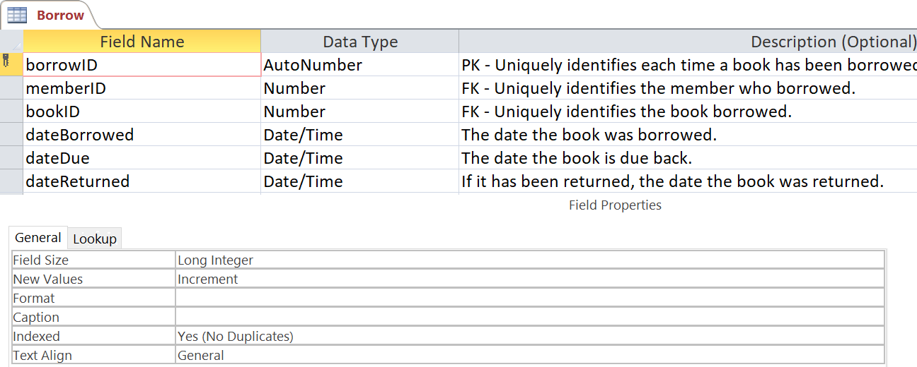

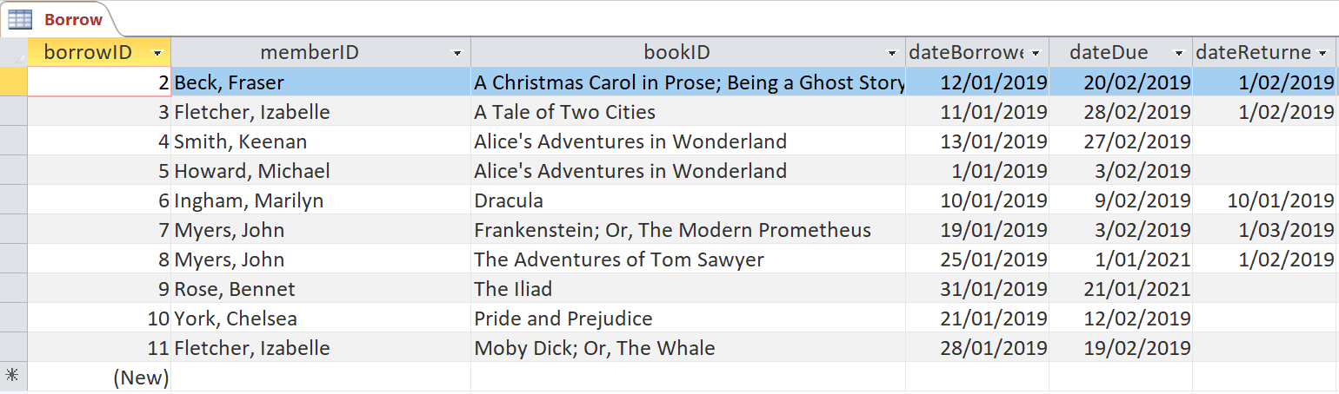

### Database Relationships

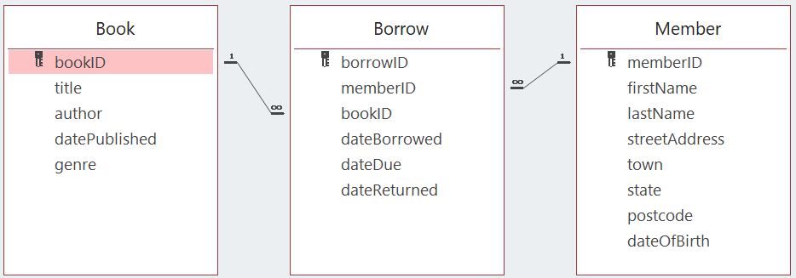

## Forms

### Members Form

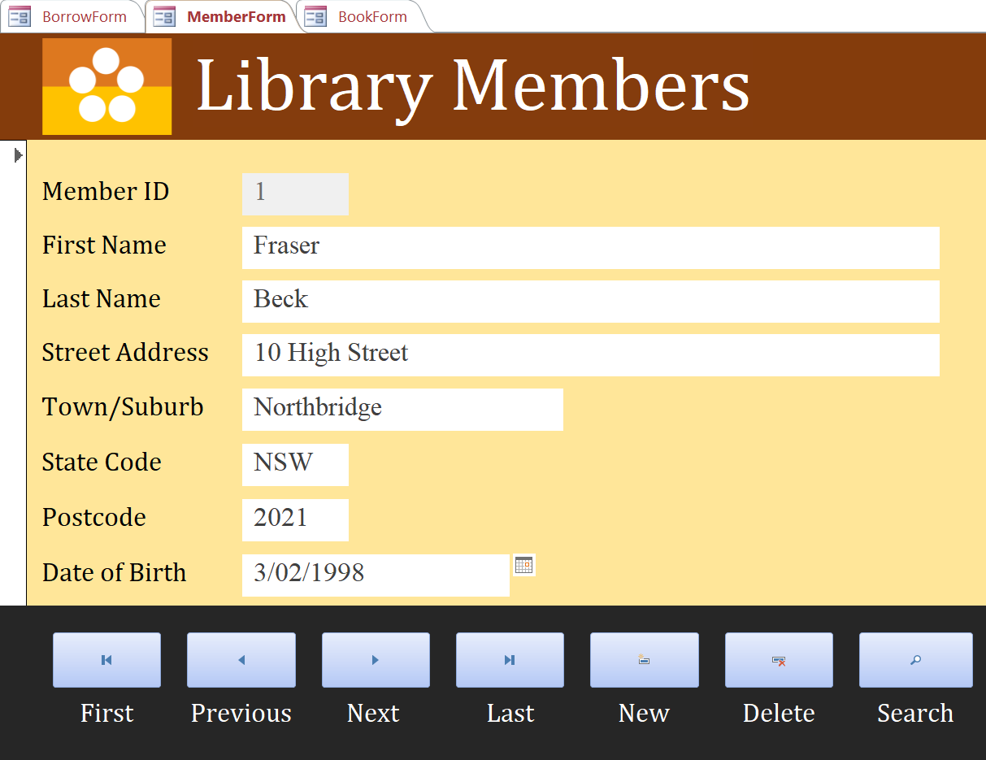

### Books Form

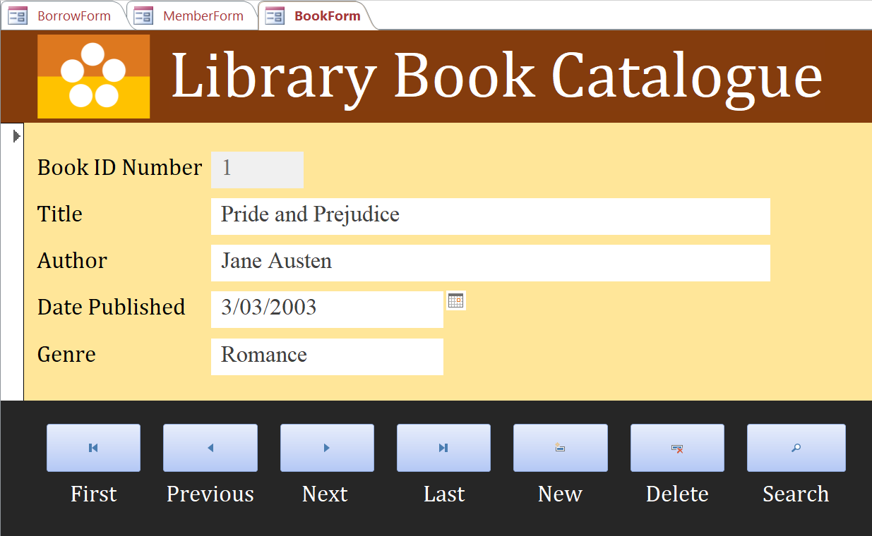

### Borrowing Form

## Queries

### Summary of All Books Query

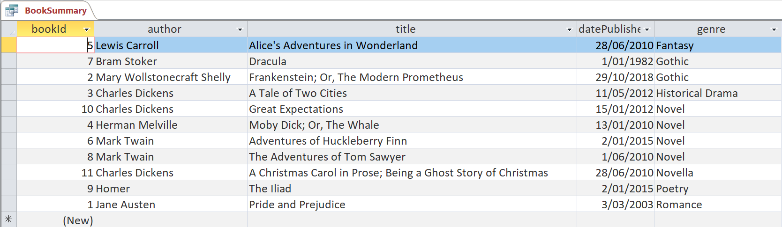

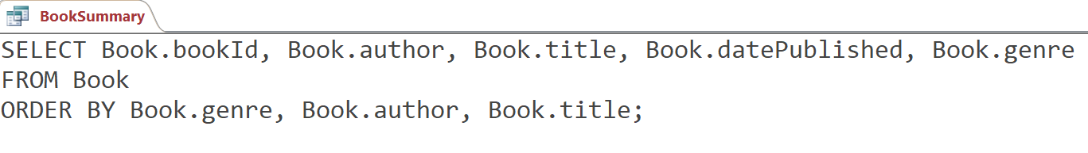

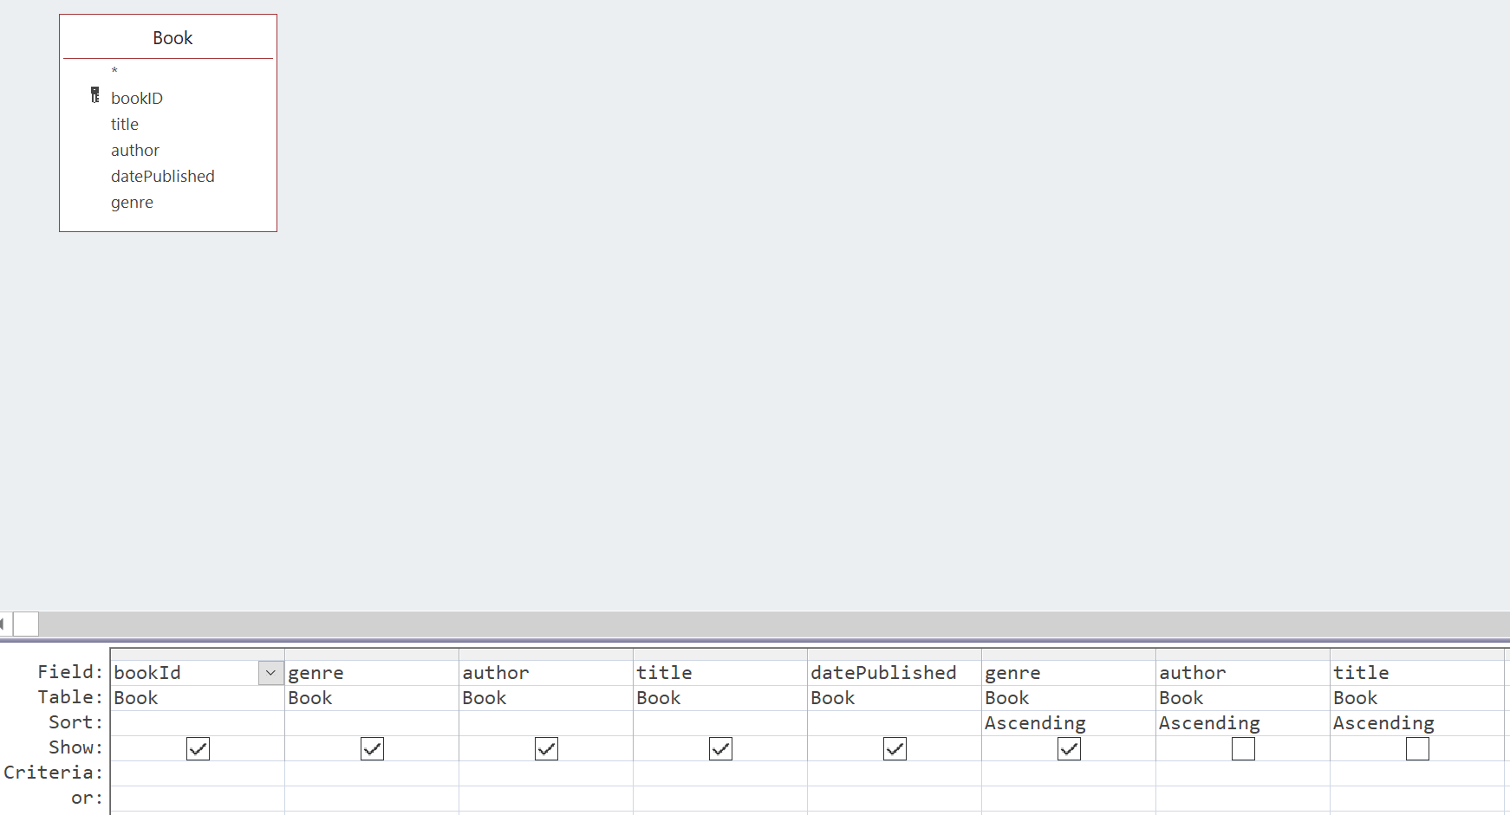

### Overdue Books Query

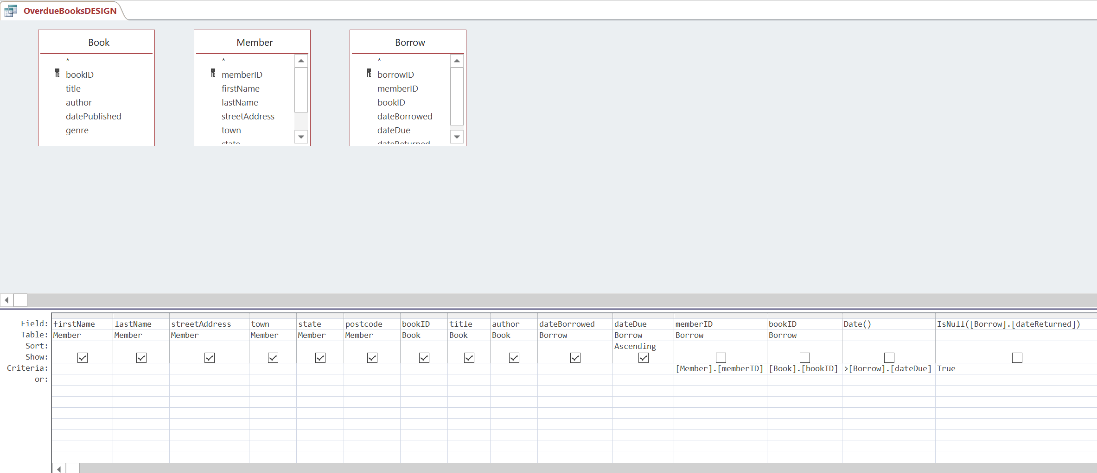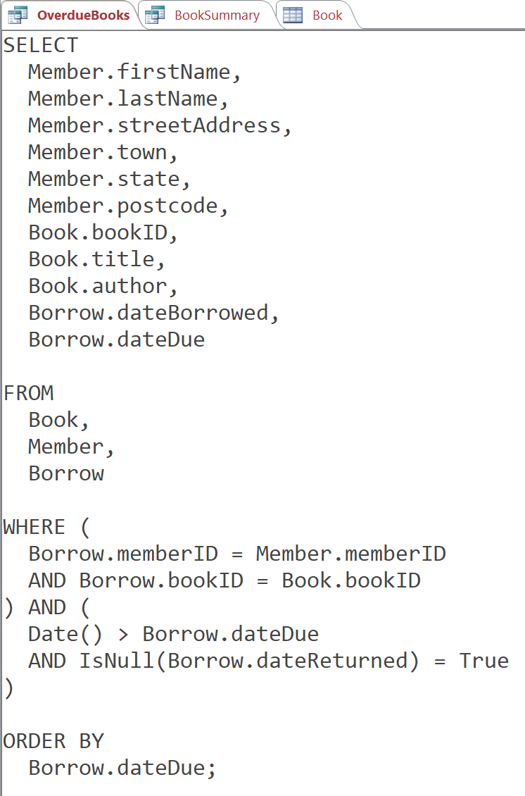

## Summary of All Books Report

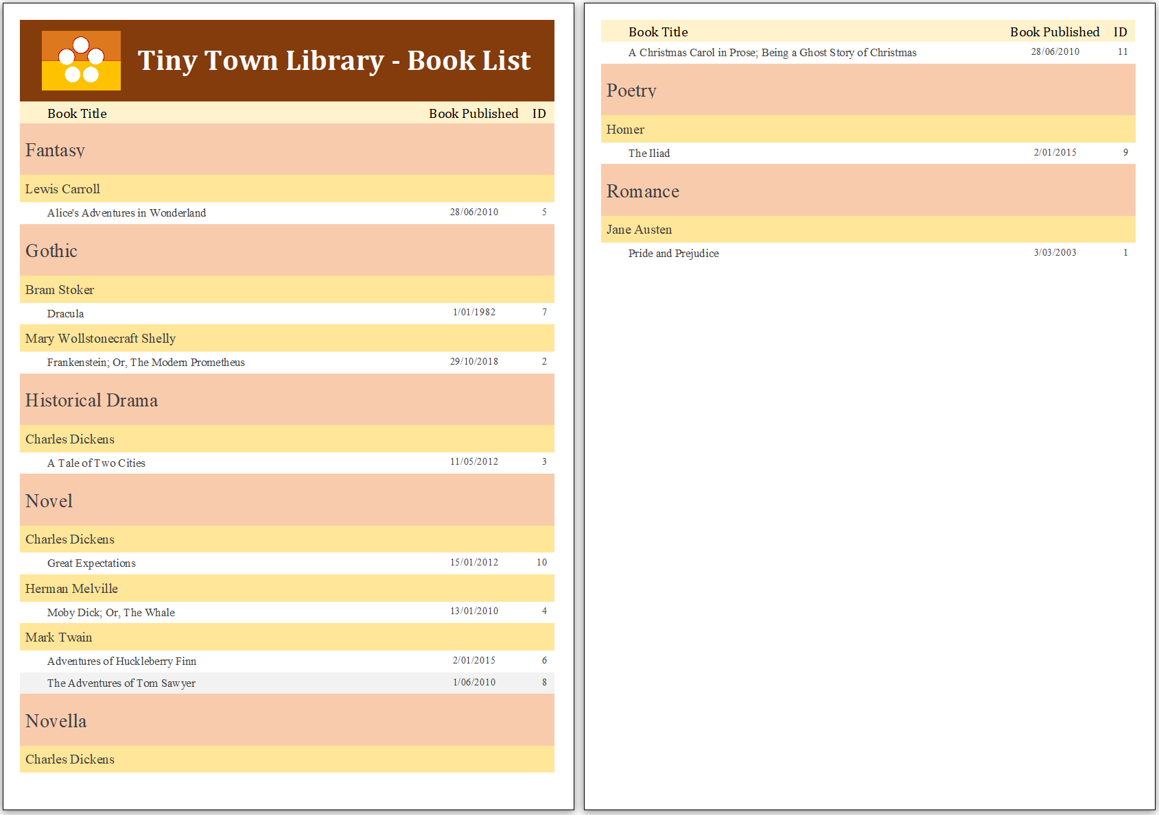

## Mail Merge

### Template Document

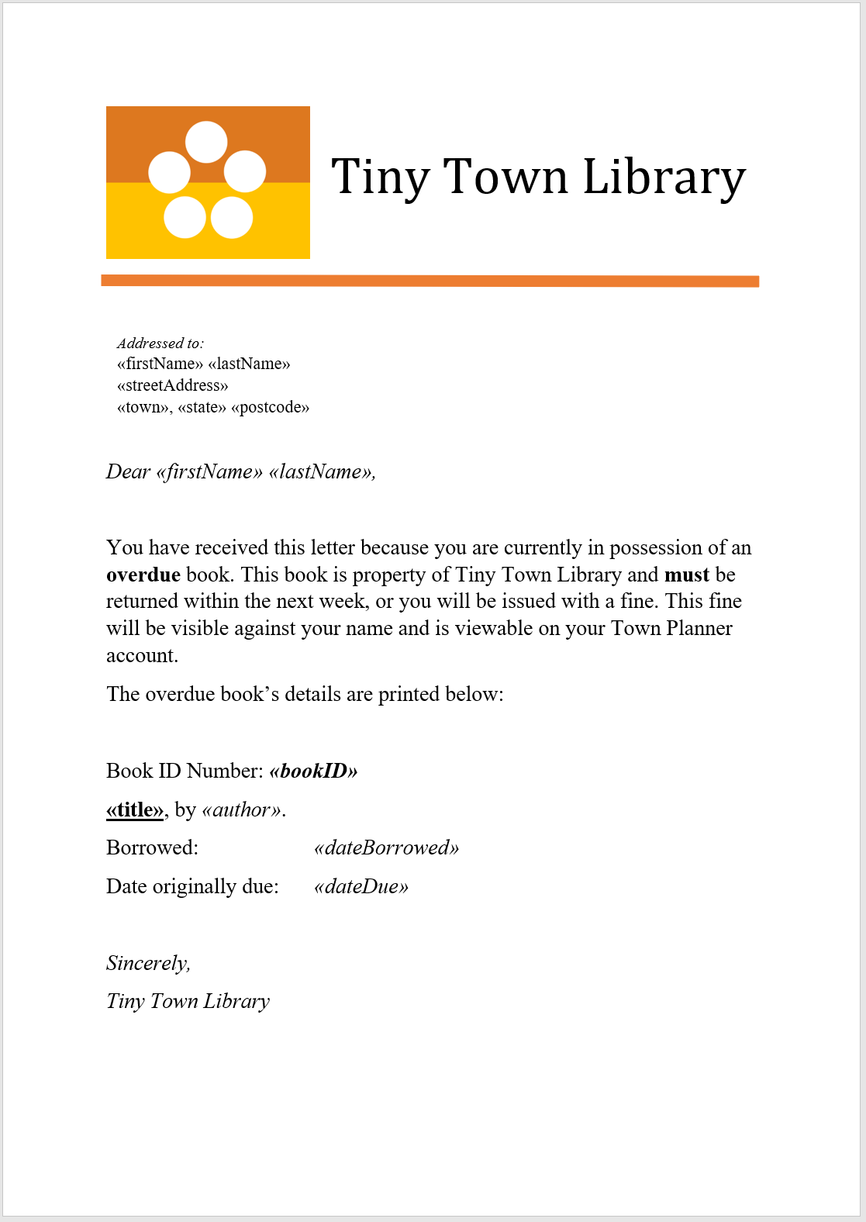

### Example Merged Document

