RESEARCH SUMMARY
A Reproducible Study of Catastrophic Forgetting in Class-Incremental Learning on CIFAR-100
Baselines, Replay-Buffer Ablation, and Multi-Seed Validation
Purpose: Research discussion at NTU CCDS
Setting: Single-head class-incremental learning
Status: Reproducible baseline and multi-seed ablation complete
KEY RESULT Replay is the strongest tested baseline, and increasing memory from 1,000 to 5,000 examples raises three-seed mean final accuracy from 12.14% to 26.79% while reducing forgetting from 60.56% to 42.63%.

Abstract
Continual-learning systems must acquire new knowledge without erasing what they learned earlier. This project studies catastrophic forgetting in a strict single-head class-incremental setting: CIFAR-100 is divided into ten sequential tasks, while a ResNet-18 always predicts over all 100 classes without receiving task identity at test time. I implemented and compared Naive Fine-Tuning, Experience Replay, and Online Elastic Weight Consolidation (EWC), retaining complete accuracy matrices and using deterministic CUDA execution for fair comparisons. At seed 42, Replay with a 2,000-example memory reached 17.96% final average accuracy, compared with 6.64% for Naive and 6.37% for Online EWC. Across seeds 0, 1, and 42, mean final accuracy increased from 12.14% at buffer 1,000 to 26.79% at buffer 5,000. The results identify replay capacity as a robust determinant of performance in this configuration while exposing persistent forgetting and an unresolved accuracy-memory trade-off.

1. Research question and contribution
Research question: How does replay-buffer capacity affect catastrophic forgetting in single-head class-incremental image classification?
- A deterministic ten-task CIFAR-100 benchmark with full post-task evaluation.
- Comparable Naive, reservoir-sampling Replay, and Online EWC implementations.
- A controlled buffer-size ablation with three-seed uncertainty estimates.
- Explicit retention of failed or invalid experiments instead of selective reporting.

2. Experimental setup
Component | Configuration
Dataset and stream | CIFAR-100; ten tasks; ten randomly ordered classes per task
Evaluation | One shared 100-class head; no task identity at test time
Backbone | ResNet-18 adapted for 32x32 images
Optimization | 10 epochs/task; SGD; LR 0.1; momentum 0.9; weight decay 5e-4
Batch policy | Current-task batch 128; replay batch 64
Replay | Fixed-capacity reservoir sampling
EWC | Online diagonal Fisher; lambda 10; decay 0.9
Reproducibility | Fixed class order per seed; deterministic CUDA algorithms

Let A[k,j] denote accuracy on task j after training task k. Average Accuracy is the mean of A[k,j] over learned tasks. Average Forgetting is the mean, over previous tasks, of the best historical accuracy minus current accuracy. Every run stores the accuracy matrix, complete configuration, training history, checkpoint, and summary metrics.

3. Results

3.1 Baseline comparison
Method, seed 42 | Final accuracy | Final forgetting | Time
Naive Fine-Tuning | 6.64% | 59.32% | 11.3 min
Replay, buffer 2,000 | 17.96% | 54.90% | 14.0 min
Online EWC, lambda 10 | 6.37% | 57.46% | 12.1 min

Naive Fine-Tuning exhibits near-complete forgetting: Task 1 falls from 54.4% immediately after it is learned to 0% after Task 2. Replay retains 40.9% on Task 1 after Task 2 and finishes at roughly 2.7 times the final average accuracy of Naive. Online EWC is stable at lambda 10 but provides no meaningful improvement in this configuration; this is a setting-specific result, not a general claim that EWC is ineffective.

3.2 Replay capacity and multi-seed validation
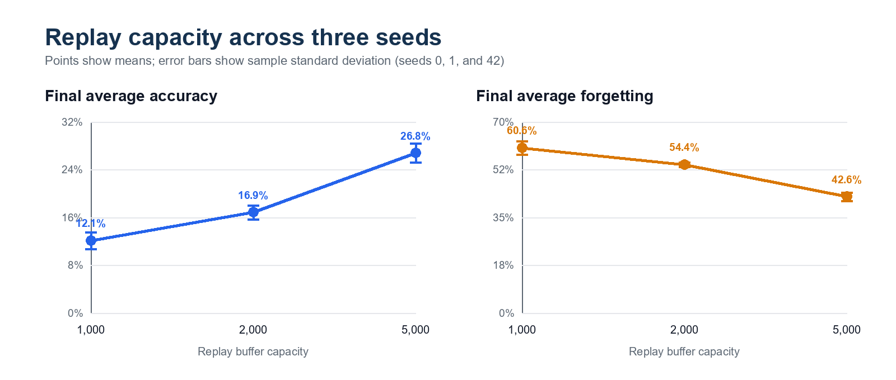
Figure 1. Replay-capacity results across seeds 0, 1, and 42.
Buffer | Final accuracy, mean ± sample std | Final forgetting, mean ± sample std
1,000 | 12.14% ± 1.40% | 60.56% ± 2.47%
2,000 | 16.85% ± 1.18% | 54.36% ± 0.81%
5,000 | 26.79% ± 1.56% | 42.63% ± 1.51%

The final accuracies for buffers 1,000 / 2,000 / 5,000 are 11.39 / 15.62 / 25.05% for seed 0, 13.75 / 16.98 / 28.07% for seed 1, and 11.28 / 17.96 / 27.26% for seed 42. Every seed preserves the same capacity ordering. This is stronger than a single best run, but three seeds remain insufficient for precise population-level claims or formal significance testing.
INTERPRETATION Larger memory consistently improves both retention and final accuracy, with no visible saturation by 5,000 examples. The gain therefore remains useful but must be weighed against storage and replay cost.

4. Failure analysis
The first nominal comparison was rejected because GPU nondeterminism caused Naive and Replay to diverge on Task 1 even though the replay buffer was empty. Deterministic algorithms were then enabled, after which the trajectories matched as expected. A separate EWC run with lambda 1,000 diverged at Task 5 and produced non-finite loss; the run was rejected, and training now fails immediately on non-finite values.

5. Limitations and next question
- The full Naive/Replay/EWC method comparison is still seed-42 only.
- The buffer stores already augmented float32 tensors, so replayed images do not receive fresh stochastic augmentation.
- Hyperparameters were not selected with a separate validation stream.
- Three seeds estimate variability but do not establish statistical significance.
The next method-level experiment fixes the buffer at 2,000 examples and compares the current uniform replay baseline with one curriculum- or importance-aware sampling rule. This isolates whether which examples are replayed changes retention and positive transfer beyond merely storing more data, motivated by work on replay curricula and dynamic continual data selection. The comparison will keep the seeds, replay batch size, and total training budget paired. DER++ remains a useful secondary baseline, and a complementary systems experiment will compare float32 tensor memory with compact uint8 source-image storage and fresh replay-time augmentation.

6. Reproducibility
- Entrypoints: train.py, plot_results.py, and run_replay_ablation.py.
- Artifacts: results.json, accuracy_matrix.csv, checkpoint.pt, and SVG plots for every formal run.
- Validation: eight automated tests covering task construction, metrics, Replay, EWC, ablation matching, statistics, and SVG output.
- Environment: PyTorch/CUDA runs in the validated ece488_clip Conda environment; deterministic mode is enabled by default.

References
- A. Krizhevsky. Learning Multiple Layers of Features from Tiny Images. Technical report, 2009.
- K. He, X. Zhang, S. Ren, and J. Sun. Deep Residual Learning for Image Recognition. CVPR, 2016.
- J. Kirkpatrick et al. Overcoming Catastrophic Forgetting in Neural Networks. PNAS, 2017.
- J. S. Vitter. Random Sampling with a Reservoir. ACM Transactions on Mathematical Software, 1985.
- A. Chaudhry et al. Riemannian Walk for Incremental Learning: Understanding Forgetting and Intransigence. ECCV, 2018.
- R. J. Tee and M. Zhang. Integrating Curricula with Replays: Its Effects on Continual Learning. AAAI Symposium Series, 2023.
- A. Maharana et al. Adapt-infinity: Scalable Continual Multimodal Instruction Tuning via Dynamic Data Selection. ICLR, 2025.

