原有的记录重放技术对pio读操作的记录方式是直接记录读取的数据，改进后的记录方式是记录对应数据在虚拟镜像中的真实物理扇区号

但是，根据实验分析，原有的记录重放技术记录的pio数据绝大部分只有1个字节的长度，

也有这样的情况的

port:1297, direction:0, size:1, count:4

port:1297, direction:0, size:1, count:64

port:1297, direction:0, size:1, count:64

port:1297, direction:0, size:1, count:1024

但是读取的内容也不是从磁盘扇区中读取的，因此log中直接记录读取到的数据

512字节长度的才是真正意义上读取的完整数据，如读取的/boot/文件夹下的某个文件，但是其中也有一些长度为512字节的记录数据并不是从磁盘扇区中读取的，因此现在的策略是，只把长度=512字节,且从磁盘中读取的数据记录方式变为记录对应的磁盘扇区号，其他的还是直接记录读取的数据

目前记录扇区号的情况大概是

port:496, direction:0, size:4, count:128

port:496, direction:0, size:2, count:256

port:368, direction:0, size:4, count:128

port:368, direction:0, size:2, count:256

假设现在每次都只读一个扇区的数据，后期要是实验数据有变再修改

记录重放机器上/home/zhangyy/qrow/qemu-kvm/copy文件下保存的是经过下述修改的代码

现在进行相关测试，实现上述改进

Qemu：

Qemu-kvm.c

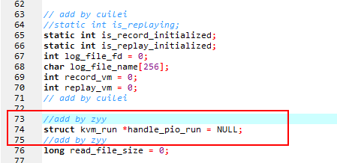

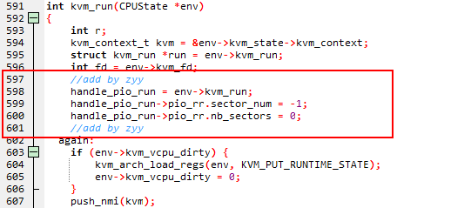

Kvm/include/linux/kvm.h

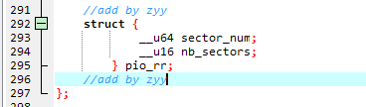

hw/ide/core.c

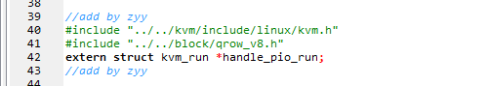

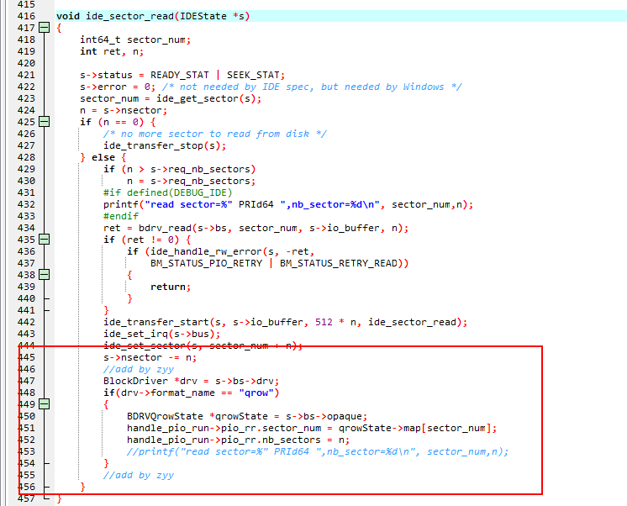

也可以在ide_data_readw里面进行上图类似操作，但是这样的话，会重复执行256遍，会不会影响效率

Kvm:

Include/linux/kvm.h

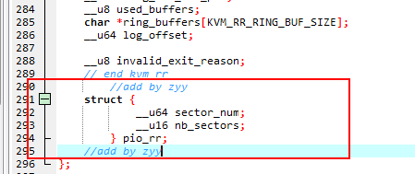

include/asm/kvm_rr.h

include/asm-x86/kvm_rr.h

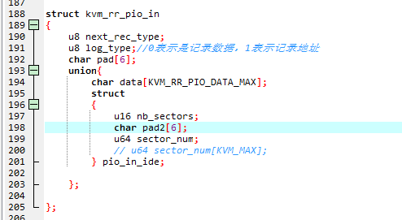

*/X86.c

//add by zyy

int kvm_rr_pio_handle(struct kvm_vcpu *vcpu, struct kvm_run *kvm_run)

{

//pio_rr_log.count = vcpu->arch.pio.count;

//pio_rr_log.port = vcpu->arch.pio.port;

//pio_rr_log.size = vcpu->arch.pio.size;

if(vcpu->is_recording)

{

if((vcpu->arch.pio.count * vcpu->arch.pio.size) > KVM_RR_PIO_DATA_MAX)

{

kvm_debug("error...\n");

vcpu->is_recording = 0;

return 0;

}

if(vcpu->log_offset == -1 && vcpu->is_recording)

{

struct kvm_rr_hdr hdr_log;

hdr_log.next_rec_type = 0;

// recording just started , write file header first

write_log(KVM_RR_HEADER, vcpu, sizeof(struct kvm_rr_hdr), &hdr_log);

}

struct kvm_rr_pio_in pio_rr_log;

pio_rr_log.next_rec_type = 0;

if(vcpu->run->pio_rr.sector_num >= 0 && vcpu->run->pio_rr.nb_sectors >= 1 && (vcpu->arch.pio.count * vcpu->arch.pio.size == 512))

{

pio_rr_log.log_type = LOG_TYPE_ADDR;

pio_rr_log.pio_in_ide.sector_num = vcpu->run->pio_rr.sector_num;

pio_rr_log.pio_in_ide.nb_sectors = vcpu->run->pio_rr.nb_sectors;

//zyy

vcpu->run->pio_rr.sector_num = -1;

vcpu->run->pio_rr.nb_sectors = 0;

//zyy

write_log(KVM_RR_PIO_IN,vcpu,\

(sizeof(pio_rr_log.pio_in_ide) + 8), \

(void *)&pio_rr_log);

}

else

{

pio_rr_log.log_type = LOG_TYPE_DATA;

memcpy(pio_rr_log.data,vcpu->arch.pio_data, \

vcpu->arch.pio.count * vcpu->arch.pio.size);

kvm_debug_log("LOG_IOIN %lu:%llu,%llx,%llx:port %d data %x count %d %d",\

vcpu->num_recs,vcpu->rr_ts.br_count,vcpu->rr_ts.rcx,vcpu->rr_ts.rip,vcpu->arch.pio.port,\

*(int *)(vcpu->arch.pio_data),vcpu->arch.pio.count,sizeof(struct kvm_rr_pio_in));

write_log(KVM_RR_PIO_IN,vcpu,\

(vcpu->arch.pio.count * vcpu->arch.pio.size + 8), \

(void *)&pio_rr_log);

}

// reset counter to zero .. next event is relative

// from here

vcpu->rr_ts.br_count = 0;

// record pending pkts

kvm_rr_rec_reqs(vcpu);

}// end of recording

else if(vcpu->is_replaying)

{

struct kvm_rr_pio_in *pio_rr_log = NULL;

int ret;

ret = read_log(vcpu);

//kvm_err("%d \n", ret);

if(ret <= 0 || ret != KVM_RR_PIO_IN)

{

// disable replaying , undefined behavior

kvm_err("is out of sync %d expecting KVM_RR_PIO_IN,\

got %d\n", ret != KVM_RR_PIO_IN, ret);

vcpu_disable_rply(vcpu);

return 0;

}

else

{

// just copy the input data from log file

pio_rr_log = get_log_data_ptr(vcpu);

}

if(!pio_rr_log)

{

// disable replaying , undefined behavior

kvm_err("couldn't get data ptr\n");

vcpu_disable_rply(vcpu);

return 0;

}

else

{

vcpu->next_rec_type = pio_rr_log->next_rec_type;

u8 log_type = pio_rr_log->log_type;

if(log_type == LOG_TYPE_DATA)

{

// copy to the place where user space would have

// copied

memcpy(vcpu->arch.pio_data, pio_rr_log->data, \

vcpu->arch.pio.count * vcpu->arch.pio.size);

kvm_debug_log("RPLY_PIO %lu:%llu,%llx,%llx:port %d data %x count %d",\

vcpu->num_recs,vcpu->rr_ts.br_count,vcpu->rr_ts.rcx,vcpu->rr_ts.rip,vcpu->arch.pio.port,\

*(int *)(vcpu->arch.pio_data),vcpu->arch.pio.count);

vcpu->rr_ts.br_count = 0;

kvm_rr_rply_reqs(vcpu);

return 1;

}

else

{

vcpu->run->pio_rr.sector_num = pio_rr_log->pio_in_ide.sector_num;

vcpu->run->pio_rr.nb_sectors = pio_rr_log->pio_in_ide.nb_sectors;

//接下来需要退出到qemu层读取数据。。。。

/* 下面两行代码也不造要不要，怎样处理了

vcpu->rr_ts.br_count = 0;

kvm_rr_rply_reqs(vcpu);

*/

return -1;

}

}

}// end of replay

return 1;//没有记录重放

}

static int emulator_pio_in_emulated(int size, unsigned short port, void *val,

unsigned int count, struct kvm_vcpu *vcpu)

{

// kvm rr

struct kvm *kvm_run;

// data coming from user space

// end kvm rr

if (vcpu->arch.pio.count)

goto data_avail;

trace_kvm_pio(0, port, size, count);

//回放的时候，是直接跳到了data avail执行么?不需要再跳到qemu处理了吧，后期需要验证一下

vcpu->arch.pio.port = port;

vcpu->arch.pio.in = 1;

vcpu->arch.pio.count = count;

vcpu->arch.pio.size = size;

if (!kernel_pio(vcpu, vcpu->arch.pio_data))

{

data_avail:

// kvm rr

// record the data which is presented by kernel instead of

// user space

kvm_run = vcpu->run;

int ret = kvm_rr_pio_handle(vcpu,kvm_run);

if (ret == 1)

{

memcpy(val, vcpu->arch.pio_data, size * count);

vcpu->arch.pio.count = 0;

return 1;

}

else

{

if (ret == -1)

{

//要去qemu拿数据了。。。

}

else

{

}

//证明 kvm_rr_pio_handle()出错了。。。。没看到原代码做出任何应对措施

}

// end kvm rr

}

vcpu->run->exit_reason = KVM_EXIT_IO;

vcpu->run->io.direction = KVM_EXIT_IO_IN;

vcpu->run->io.size = size;

vcpu->run->io.data_offset = KVM_PIO_PAGE_OFFSET * PAGE_SIZE;

vcpu->run->io.count = count;

vcpu->run->io.port = port;

return 0;

}

//add by zyy

问题1：

安装同一个centos的操作系统

qcow2格式安装完后，镜像大小为705M

raw格式安装完后，镜像大小为695M

qrow 格式安装完后，镜像大小为1376 M 比前两种格式大太多太多了。。。。。

执行下面的命令后，镜像大小增加了2M

./x86_64-softmmu/qemu-system-x86_64 -hda /home/zhangyy/qrow/vm/centos-qrow-2.img -vnc :2

问题2：

记录pio_in ide对应的512字节的扇区号而不是数据的话，回放的时候需要去qemu层处理，相对比较麻烦。。。。

问题3：

Qrow现在还是太慢了，安装系统，启动虚拟机等，都需要太久太久时间了