1. qapi-types.c

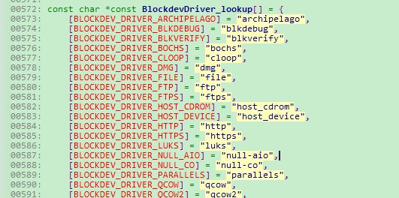

添加了一行代码

[BLOCKDEV_DRIVER_QROW] = "qrow",

1. qapi-types.h

添加了一行代码

BLOCKDEV_DRIVER_QROW = 29

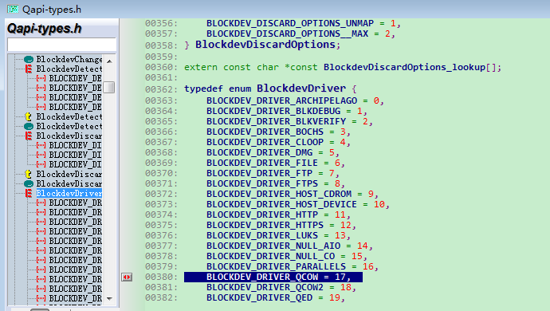

下面要改么？？？

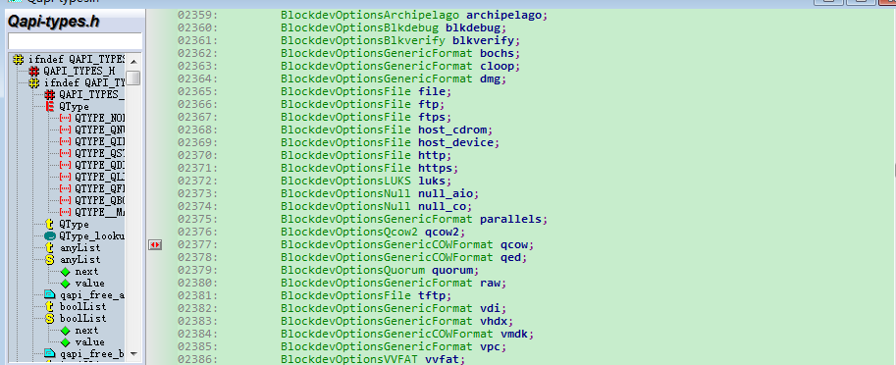

1. qapi-visit.c

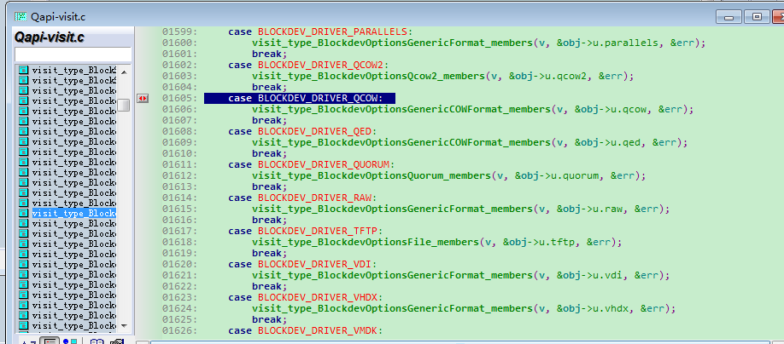

添加了

case BLOCKDEV_DRIVER_QCOW:

visit_type_BlockdevOptionsGenericCOWFormat_members(v, &obj->u.qrow, &err);

break;

1. qmp-introspect.c

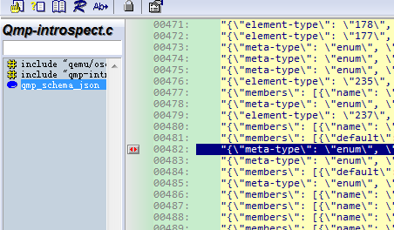

添加了qrow