Personalized Federated Learning with Graph Neural Networks and Kolmogorov–Arnold Networks for Cross-Domain Molecular Reorganization Energy Prediction
Can Leng¹, Author Two¹

Abstract
Molecular reorganization energy (λ) is a critical descriptor governing charge-transfer rates in organic semiconductors, yet its accurate prediction remains challenging due to the fragmentation of relevant data across institutions with heterogeneous chemical domains and privacy constraints.
Small specialized laboratories, such as those studying thermally activated delayed fluorescence (TADF) emitters, often possess fewer than 50 molecules—a regime in which isolated local models fail catastrophically (R² < 0).
Existing federated learning approaches for molecular property prediction have not addressed the compounded challenges of chemical domain shift, heterogeneous target quantities (λ_cation vs. λ_hole vs. λ_triplet), and the absence of three-dimensional conformational information.
This work presents FedPer-KAN, a personalized federated learning framework that combines a shared graph encoder—either the 2D Graph Isomorphism Network (GIN) [Xu et al., 2019] or the 3D continuous-filter SchNet [Schütt et al., 2018]—with client-private Kolmogorov–Arnold Network (KAN) [Liu et al., 2024] regression heads under the FedPer [Arivazhagan et al., 2019]+FedBN [Li et al., 2021] aggregation strategy.
The framework is evaluated across four heterogeneous clients: Client A (6,020 non-aromatic molecules, λ_cation), Client B (9,190 aromatic molecules, λ_cation), Client C (5,876 conjugated organic semiconductors, λ_hole), and Client D (53 TADF molecules, λ_hole / λ_triplet).
Federated collaboration raises the large-client R² from 0.52 (local GIN+MLP) to 0.85 (federated GIN+KAN), with the KAN head outperforming MLP by 30.7% in R².
For the data-scarce Client D, R² improves from -0.68 (local) to +0.03 (federated 2D GIN) and +0.18 (federated 3D SchNet).
Systematic ablation studies and per-molecule error analysis reveal a fundamental information bottleneck in 2D graph representations for conformationally flexible TADF molecules: GIN prediction errors correlate with the number of rotatable bonds (r = 0.30, p = 0.028), whereas SchNet errors do not (p = 0.256), confirming that explicit 3D coordinate encoding is essential for capturing the torsional degrees of freedom that govern λ.
These findings establish that personalized federated learning, when coupled with physically faithful 3D representations, provides a principled solution to both data fragmentation and domain heterogeneity in molecular property prediction.
Keywords: federated learning; reorganization energy; graph neural network; Kolmogorov–Arnold network; TADF; molecular property prediction

1. Introduction

Reorganization energy: importance and prediction challenges
Molecular reorganization energy (λ) is the central parameter in Marcus theory of electron transfer [Marcus, 1993], quantifying the energetic cost of nuclear rearrangement accompanying a charge-transfer event.
In organic semiconductors, λ directly governs the hopping rate k_ET ∝ exp(-λ / 4k_BT) and therefore controls carrier mobility in organic field-effect transistors [Coropceanu et al., 2007], exciton dissociation efficiency in organic photovoltaics, and—critically for next-generation displays—the reverse intersystem crossing (rISC) rate in thermally activated delayed fluorescence (TADF) emitters [Uoyama et al., 2012].
A low λ promotes rapid charge transport and efficient rISC, making λ a primary design target for high-performance organic electronic materials.
Computing λ from first principles requires two separate geometry optimizations at the density functional theory (DFT) level—one for the neutral state and one for the charged (cation, anion, or excited) state—followed by evaluation of single-point energies at the cross geometries [Nelsen et al., 1987].
For molecules with more than 30 heavy atoms, this four-point procedure costs 10–100 CPU-hours per molecule, making large-scale screening prohibitively expensive.
Machine learning (ML) models offer a compelling alternative: graph neural networks (GNNs) trained on DFT-computed λ values can predict reorganization energies in milliseconds.
Recent work by Atahan-Evrenk and Atalay [Atahan-Evrenk and Atalay, 2019] demonstrated random-forest regression on molecular fingerprints for 5,876 conjugated semiconductors, while Li and Tabor [Li and Tabor, 2023] achieved R² > 0.9 using 3D SchNet [Schütt et al., 2018] trained on approximately 50,000 molecules.
However, these successes rely on large, centralized datasets curated within a single laboratory—a luxury unavailable to most research groups.
While ML methods offer a promising path forward, their effectiveness depends critically on data availability—a condition that is rarely met in practice.

The data silo problem
In practice, molecular λ data are fragmented across institutions.
Large-scale computational databases (e.g., QM9 derivatives) contain tens of thousands of small organic molecules, but the chemical space they cover rarely overlaps with the complex donor–acceptor architectures studied in specialized TADF laboratories.
These specialized labs often possess fewer than 100 molecules with DFT-quality λ values, a regime in which local model training fails catastrophically: our experiments show that training a GIN+KAN model on 53 TADF molecules yields R² = -0.68 (Table 1, E5).
Meanwhile, intellectual property concerns and privacy regulations prevent the direct pooling of proprietary molecular data across institutions.
Federated learning (FL) [McMahan et al., 2017] offers a principled solution to this dilemma: multiple clients collaboratively train a shared model by exchanging only model parameters—never raw data.
In the molecular sciences, FL would enable small TADF laboratories to exploit the representational knowledge encoded in large public databases without exposing their proprietary molecular structures.
Federated learning addresses the data sharing barrier, yet existing FL frameworks for molecular property prediction face two fundamental limitations.

Limitations of existing approaches
Several recent studies have applied federated learning to molecular property prediction.
FedChem [Zhu et al., 2022] applied FedAvg [McMahan et al., 2017] with message-passing neural networks but treated chemical domain shift as a secondary concern, assuming relatively homogeneous client distributions.
Heyndrickx et al. [Heyndrickx et al., 2023] reported federated multi-task learning using traditional molecular descriptors rather than learned graph representations.
FLAP [Zubatyuk et al., 2023] explored federated pre-training for ADMET properties but did not address physically heterogeneous target quantities.
None of these works confronted the simultaneous challenges of (i) extreme chemical domain shift, (ii) heterogeneous physical target quantities (λ_cation vs. λ_hole vs. λ_triplet), and (iii) severe data imbalance (53 vs. 15,000 molecules).
A deeper limitation concerns the molecular representation itself.
Reorganization energy is fundamentally a geometric quantity: it measures the nuclear displacement between two equilibrium structures.
For TADF emitters, λ is dominated by large-amplitude donor–acceptor dihedral torsions (10–40° upon ionization), making it exquisitely sensitive to three-dimensional conformation.
Yet standard 2D GNNs such as the Graph Isomorphism Network (GIN) [Xu et al., 2019] operate exclusively on topological connectivity.
Their expressive power is bounded by the Weisfeiler–Leman (WL) graph isomorphism test [Xu et al., 2019], which is provably blind to geometric features: two molecules with identical connectivity graphs but different spatial conformations—and hence vastly different λ values—are indistinguishable to the encoder.
This structural blindness to out-of-plane torsion and steric repulsion constitutes a fundamental information bottleneck that no amount of federated data augmentation can overcome.
This observation motivates our systematic comparison of 2D GIN and 3D SchNet encoders within the federated framework.
In the extreme low-data regime characteristic of specialized laboratories—where n < 100 and conventional deep learning models overfit catastrophically—the choice of molecular representation becomes the decisive factor.
Neither data augmentation through federation nor architectural innovations in the regression head can compensate for the absence of geometric information when the property of interest is intrinsically three-dimensional.
This consideration elevates the encoder selection from a mere implementation detail to the central scientific question of the present study.

Contributions
In summary, this paper makes the following contributions:
1. FedPer-KAN is proposed as the first personalized federated learning framework for cross-domain molecular reorganization energy prediction, combining shared GNN encoders with client-private KAN regression heads under FedPer+FedBN aggregation.
2. KAN regression heads are shown to outperform MLPs by 30.7% in R² as local potential-energy-surface mappers, owing to their smooth B-spline approximation properties (Section 5.1).
3. A systematic diagnosis of the 2D representation bottleneck through four-hypothesis elimination establishes that conformational information—not data scarcity, target mismatch, or chemical-space divergence—is the primary limiting factor (Section 5.6).
4. Replacing GIN with 3D SchNet within the federated framework improves Client D R² from -0.031 to +0.181, and subgroup analysis on rigid donor–acceptor molecules achieves R² = 0.852 (Section 5.7.1).
5. Personalized federation is found to outperform centralized training by physically isolating encoder representations from domain-specific regression mappings, preventing catastrophic interference between chemically incompatible clients (Section 5.4).
The overall framework is illustrated in Fig. 1.
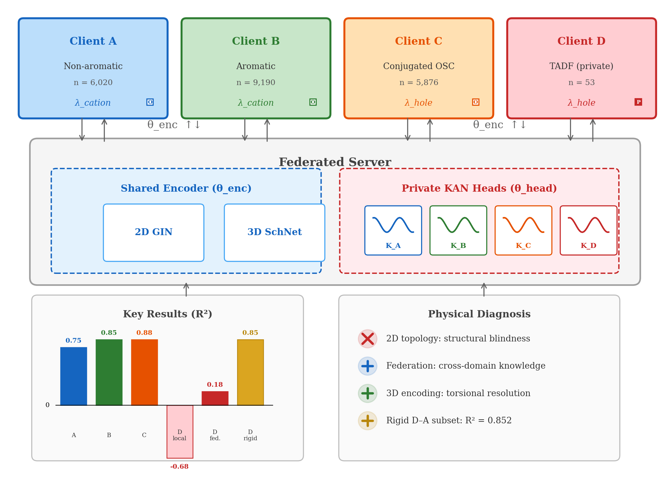
Figure 1. Graphical abstract of the FedPer-KAN framework. Four heterogeneous clients (A–D) collaboratively train shared GNN encoders while maintaining private KAN regression heads for domain-specific reorganization energy prediction.

2. Related Work

2.1 Machine Learning for Reorganization Energy
Early ML approaches to λ prediction relied on hand-crafted molecular descriptors.
Atahan-Evrenk and Atalay [Atahan-Evrenk and Atalay, 2019] trained gradient-boosted regression on extended connectivity fingerprints for 5,876 conjugated organic semiconductors, achieving mean absolute errors of approximately 0.03 eV for hole reorganization energy.
The advent of message-passing neural networks (MPNNs) [Gilmer et al., 2017] enabled end-to-end learning on molecular graphs, eliminating the need for descriptor engineering.
Three-dimensional molecular representations offer a qualitatively richer input.
Schütt et al. [Schütt et al., 2018] introduced SchNet, which models interatomic interactions through continuous-filter convolutions on distance matrices, achieving the best-reported performance on QM9 molecular properties at the time.
Gasteiger et al. [Gasteiger et al., 2020] further incorporated angular information in DimeNet++, and Schütt et al. [Schütt et al., 2021] proposed the equivariant PaiNN architecture.
Most relevant to our work, Li and Tabor [Li and Tabor, 2023] showed that SchNet trained on low-cost force-field conformers achieves R² > 0.9 for λ_cation prediction on a centralized dataset of 50,000 molecules.
Their success with approximate 3D geometries provides the key insight that motivates our adoption of SchNet in the federated setting.
We note that more expressive equivariant architectures—such as DimeNet++ [Gasteiger et al., 2020], which incorporates angular information through directional message passing, and PaiNN [Schütt et al., 2021], which propagates equivariant feature vectors—have demonstrated improved accuracy on QM9 benchmarks.
In the present study, SchNet is deliberately chosen as the 3D encoder for two reasons.
First, our central scientific question concerns the information-theoretic gap between 2D topological and 3D spatial representations, rather than incremental accuracy gains among 3D architectures; SchNet provides a clean, well-characterized baseline for this comparison.
Second, SchNet's computational simplicity (scalar distance features only, no angular terms) is advantageous in the federated setting where communication efficiency and client-side computational constraints are practical considerations.
The substitution of SchNet with equivariant architectures represents a natural extension that we anticipate would further improve absolute accuracy, particularly for flexible molecules where angular features encode dihedral torsions more directly.

2.2 Federated Learning for Molecular Properties
Federated learning [McMahan et al., 2017] has been explored for drug discovery and molecular property prediction.
FedChem [Zhu et al., 2022] applied FedAvg to molecular property prediction across pharmaceutical datasets, demonstrating improved generalization compared to local models.
FLAP [Zubatyuk et al., 2023] introduced federated pre-training strategies for ADMET property prediction.
Heyndrickx et al. [Heyndrickx et al., 2023] presented a large-scale benchmark for federated multi-task learning on pharmaceutical data using traditional molecular descriptors.
Personalized federated learning addresses the non-IID data challenge inherent in heterogeneous chemical datasets.
FedPer [Arivazhagan et al., 2019] retains private prediction layers while sharing representation layers, which is architecturally natural for our encoder–head decomposition.
FedBN [Li et al., 2021] excludes batch normalization parameters from aggregation, addressing feature distribution shift across clients.
Our work is the first to combine these personalization strategies with GNN encoders for a physically motivated molecular property under extreme domain heterogeneity.

2.3 Kolmogorov–Arnold Networks in Scientific Computing
The Kolmogorov–Arnold representation theorem guarantees that any multivariate continuous function can be decomposed into compositions of univariate functions [Liu et al., 2024].
KAN [Liu et al., 2024] operationalizes this theorem by placing learnable B-spline activation functions on network edges rather than fixed activations on nodes, enabling more expressive function approximation with fewer parameters.
KANs have shown promising results in scientific computing tasks including PDE solving and symbolic regression, where smooth, interpretable mappings are desirable.
Most recently, Li et al. [Li et al., 2025] integrated KAN into GNN architectures at three levels (embedding, message passing, and readout), achieving improved performance on molecular benchmarks.
In the federated setting, Zhang et al. [Zhang and others, 2025] proposed a federated graph learning method for multi-party molecular discovery, though without KAN-based personalization.
To our knowledge, KAN has not been previously used as a client-private regression head in federated learning for molecular property prediction.
The smooth spline-based approximation of KAN is hypothesized to be particularly well-suited for this role, providing a compact yet expressive mapping from shared encoder representations to domain-specific target quantities.

3. Methods

3.1 Problem Formulation
Consider K clients, each holding a private dataset D_k = (G_i⁽^k⁾, y_i⁽^k⁾)_i=1ⁿ^_^k of molecular graphs G and corresponding reorganization energies y.
The clients differ in chemical domain (covariate shift: non-aromatic, aromatic, conjugated semiconductors, TADF) and target physical quantity (concept shift: λ_cation, λ_hole, λ_triplet).
The global federated objective is:
[Equation: min_θ_enc Σ_k=1^K (n_k/N) L_k(θ_enc, θ_head⁽^k⁾),]
where N = Σ_k n_k, θ_enc denotes shared encoder parameters, and θ_head⁽^k⁾ denotes client-private regression head parameters.
The local loss L_k is the mean squared error over D_k.

3.2 Molecular Graph Construction
2D molecular graphs..
Given a SMILES string, we construct a PyTorch Geometric [Landrum and others, 2023] graph G = (X, E, A).
Node features x_i ∈ R¹¹ comprise: atomic type one-hot encoding (C, N, O, S, F, Cl, Br, Other; 8 dimensions), normalized degree (1 dimension), formal charge (1 dimension), and Gasteiger partial charge (1 dimension).
Edge features e_ij ∈ R⁴ encode bond type (single, double, triple, aromatic).
Six global molecular descriptors (molecular weight, TPSA, LogP, number of aromatic rings, maximum absolute partial charge, and molar refractivity) are concatenated to the graph-level representation after pooling.
3D molecular representation..
For SchNet, we generate 3D conformers using the RDKit ETKDG algorithm [Landrum and others, 2023] followed by MMFF94 force-field optimization.
Each atom is represented by its nuclear charge Z_i and Cartesian position r_i ∈ R^3.
This procedure requires only milliseconds per molecule and is compatible with the federated setting: each client independently computes atomic coordinates without sharing molecular structures.

3.3 Model Architecture
GIN encoder..
The 2D encoder follows the Graph Isomorphism Network (GIN) architecture [Xu et al., 2019], consisting of 5 GINConv layers with hidden dimension 300, each followed by batch normalization and ReLU activation.
Jumping Knowledge (JK) concatenation of all layer outputs is applied, followed by global mean + max pooling.
A linear projection maps the pooled representation to a 256-dimensional embedding h ∈ R²⁵⁶.
SchNet encoder..
The 3D encoder uses SchNet [Schütt et al., 2018] with 6 interaction blocks, 256 atom-wise features, 128 filters, and a Gaussian radial basis expansion with 50 functions and a cutoff of 7.5 Å.
Atom features are initialized from learnable embeddings of the nuclear charge Z.
Continuous-filter convolutions model pairwise interactions as:
[Equation: x_i⁽^l⁺¹⁾ = x_i⁽^l⁾ + Σ_j ∈ N(i) W⁽^l⁾ x_j⁽^l⁾ ° cfconv(|r_i - r_j|),]
where cfconv denotes the continuous filter parametrized by the interatomic distance.
Global mean pooling produces a 256-dimensional graph representation.
KAN regression head..
The client-private regression head is a Kolmogorov–Arnold Network (KAN) [Liu et al., 2024] consisting of three KANLinear layers: 256 64 32 1, each using B-spline basis functions of order 3 with grid size 5 (optimized via ablation; Section 5.5).
Unlike conventional MLPs that apply fixed activation functions at nodes, KAN places learnable univariate functions φ_q,p on every edge:
[Equation: KAN(x) = Σ_q=1ⁿ^_² φ_q,·(Σ_p=1ⁿ^_¹ φ_·,p(x_p)),]
where each φ is parametrized as a B-spline.
The physical motivation for choosing KAN over MLP as the client-private head is twofold.
First, B-spline basis functions provide locally smooth approximations that act as implicit regularizers, preventing the catastrophic overfitting that afflicts MLPs on small datasets (53 molecules in Client D).
Second, the functional decomposition aligns with the physics of λ prediction: the shared encoder learns universal spatial intuition—transferable representations of interatomic distances and molecular topology—while each KAN head learns a domain-specific potential-energy-surface (PES) mapping from these representations to the particular reorganization process (λ_cation, λ_hole, or λ_triplet) relevant to its client.
This encoder–head decomposition mirrors the separation between general chemical features (shared) and domain-specific energy landscapes (private), preventing the small-sample client from being overwhelmed by the large-sample client's optimization landscape.
MLP regression head (baseline)..
For comparison, the MLP head consists of Linear(256 128) ReLU Dropout(0.3) Linear(128 64) ReLU Dropout(0.3) Linear(64 1).

3.4 Federated Strategy: FedPer + FedBN
Our aggregation protocol combines two personalization mechanisms.
FedPer.
.
Following Arivazhagan et al. [Arivazhagan et al., 2019], we partition the model into shared layers (encoder θ_enc) and personalized layers (regression head θ_head⁽^k⁾).
At each communication round t, only the encoder parameters are aggregated:
[Equation: θ_enc⁽^t⁺¹⁾ = Σ_k=1^K (n_k/N) θ_enc⁽^k^,^t⁾,]
while each client's KAN head θ_head⁽^k⁾ remains local.
This ensures that the domain-specific PES mapping is never contaminated by data from chemically incompatible clients.
FedBN.
.
Following Li et al. [Li et al., 2021], we additionally exclude all batch normalization parameters (γ, β, running mean, running variance) from aggregation.
Batch normalization statistics reflect the local feature distribution; aggregating them across clients with vastly different molecular compositions (e.g., small non-aromatic molecules vs. large TADF donor–acceptor systems) would destroy the normalization benefit.
The complete communication protocol is depicted in Fig. 3.
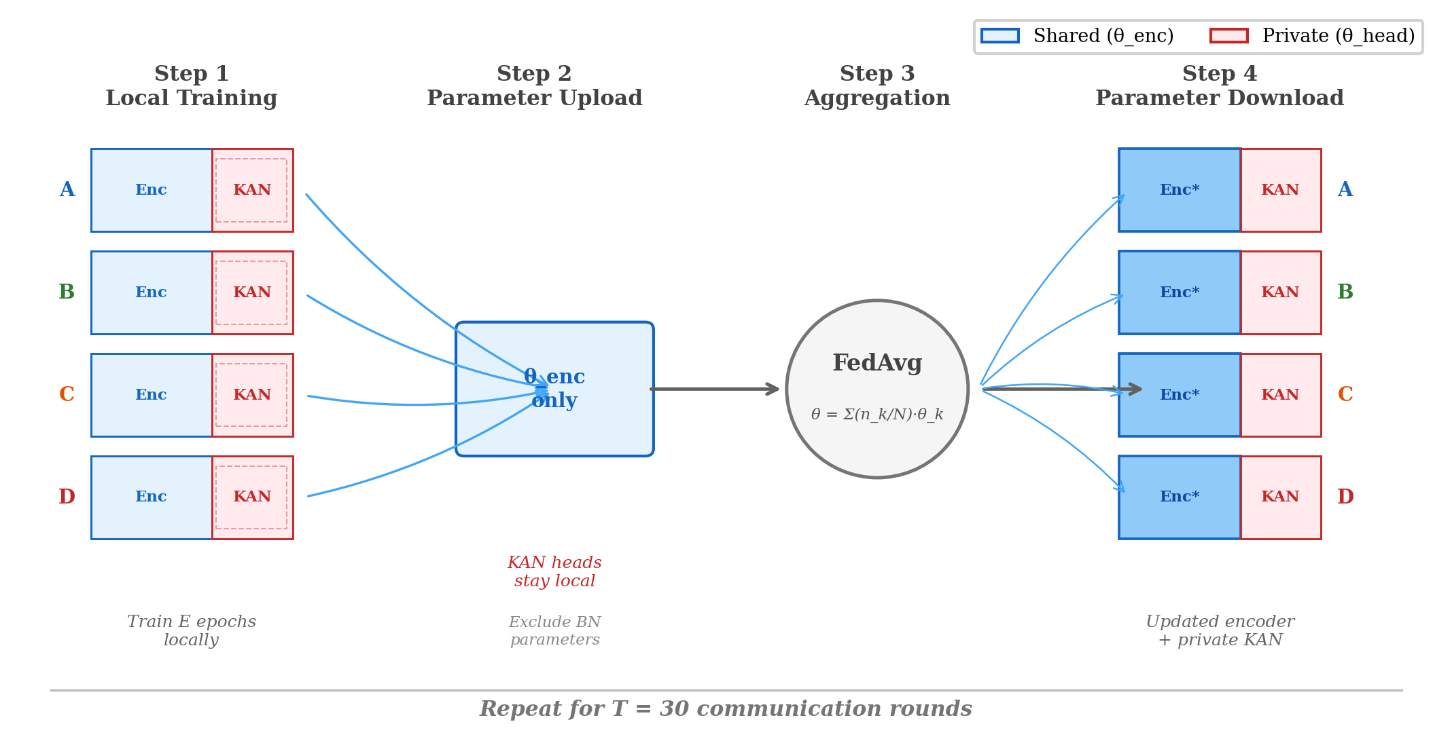
Figure 3. FedPer workflow. Step 1: Local training with private encoder + KAN head. Step 2: Upload encoder parameters only. Step 3: FedAvg aggregation. Step 4: Download updated encoder; KAN heads remain unchanged.

3.5 Per-Client Label Normalization
The four clients exhibit dramatically different label distributions: Client A λ_cation ∈ [0.01, 2.94] eV (μ = 0.72 eV), Client C λ_hole ∈ [0.08, 0.87] eV (μ = 0.17 eV), and Client D λ_hole ∈ [0.45, 3.00] eV (μ = 1.18 eV).
To prevent the loss landscape from being dominated by clients with large absolute label values, we apply per-client z-score normalization: y_i⁽^k⁾ = (y_i⁽^k⁾ - μ_k) / σ_k.
Predictions are denormalized before evaluation.
This normalization is physically motivated: the ``difficulty'' of predicting a reorganization energy should depend on the relative accuracy within each client's chemical domain, not on the absolute magnitude of λ.

4. Experimental Setup

4.1 Datasets
Four clients representing distinct chemical domains and physical target quantities are constructed (Fig. 2, Fig. 4):
Client A (6,020 molecules): non-aromatic organic molecules derived from the QM9 dataset, with cation reorganization energy (λ_cation) computed at the B3LYP/6-31G(d) level.
These molecules contain 2–9 heavy atoms, predominantly aliphatic chains and small rings.
Client B (9,190 molecules): aromatic organic molecules from the same QM9-derived database.
The aromatic ring criterion (NumAromaticRings ≥ 1) produces molecules with π-conjugated systems, benzene derivatives, and heterocycles.
Client C (5,876 molecules): conjugated organic semiconductors from the dataset of Atahan-Evrenk and Atalay [Atahan-Evrenk and Atalay, 2019], with hole reorganization energy (λ_hole) computed at the B3LYP/6-31G(d,p) level.
These molecules are larger (10–40 heavy atoms) and include many structures relevant to organic electronics.
Client D (53 molecules): TADF emitters synthesized and characterized in our laboratory, with λ_hole and λ_triplet computed at the B97XD/def2-TZVP level using the four-point adiabatic potential energy surface method.
These donor–acceptor molecules feature twisted π-systems with 8–24 heavy atoms.
Non-IID characterization..
The four-client federation exhibits a dual extreme shift.
The covariate shift spans from simple aliphatic molecules (Client A) to complex TADF donor–acceptor architectures (Client D), as visualized by the clearly separated clusters in the t-SNE embedding of Morgan fingerprints (Fig. 4).
The concept shift is equally severe: λ_cation describes nuclear relaxation from neutral to cation geometry (bond-length alternation dominates for rigid molecules); λ_hole involves hole injection into the HOMO orbital (often dominated by dihedral torsion in conjugated systems); and λ_triplet involves spin-forbidden excitation followed by excited-state relaxation (a qualitatively different potential energy surface).
These three physical processes probe different regions of the Born–Oppenheimer surface, making the mapping from molecular structure to λ client-specific even for structurally similar molecules.
A natural question is whether additional molecular property datasets—for instance, ADMET benchmarks from drug discovery—could further validate the framework.
However, reorganization energy is a fundamentally distinct physical quantity that requires computationally prohibitive four-point DFT geometry optimizations (two equilibrium structures and two single-point energies per molecule).
Standard drug discovery benchmarks such as MoleculeNet lack these high-fidelity λ labels entirely.
The four-client configuration used here—spanning aliphatic, aromatic, conjugated semiconductor, and TADF chemical domains—represents the current frontier of available DFT-quality reorganization energy data in the organic electronics literature.
Extension to additional λ datasets would require new DFT campaigns, which we identify as an important direction for future work.
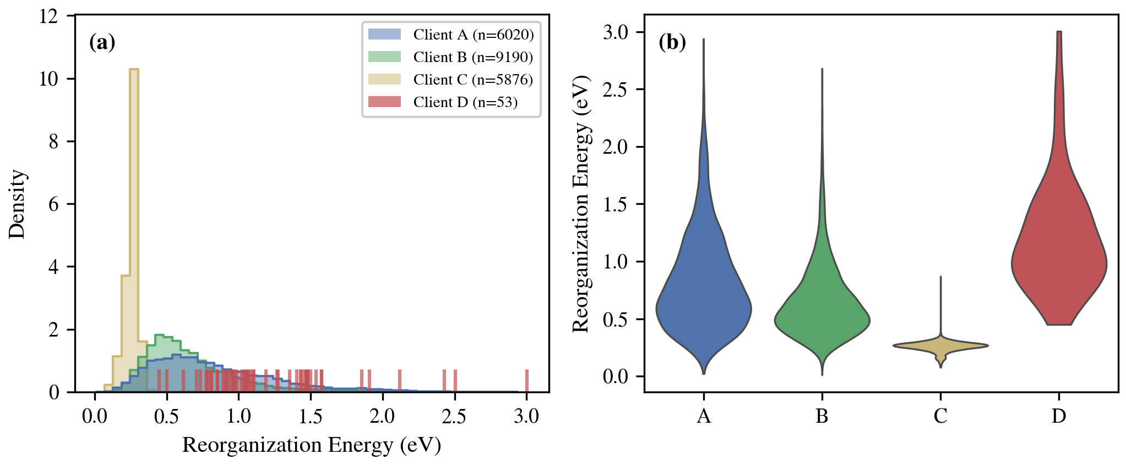
Figure 2. Dataset overview: molecular weight distributions and label (λ) ranges for all four clients. Client D exhibits the broadest λ_hole range (0.45–3.00 eV), reflecting the conformational diversity of TADF emitters.
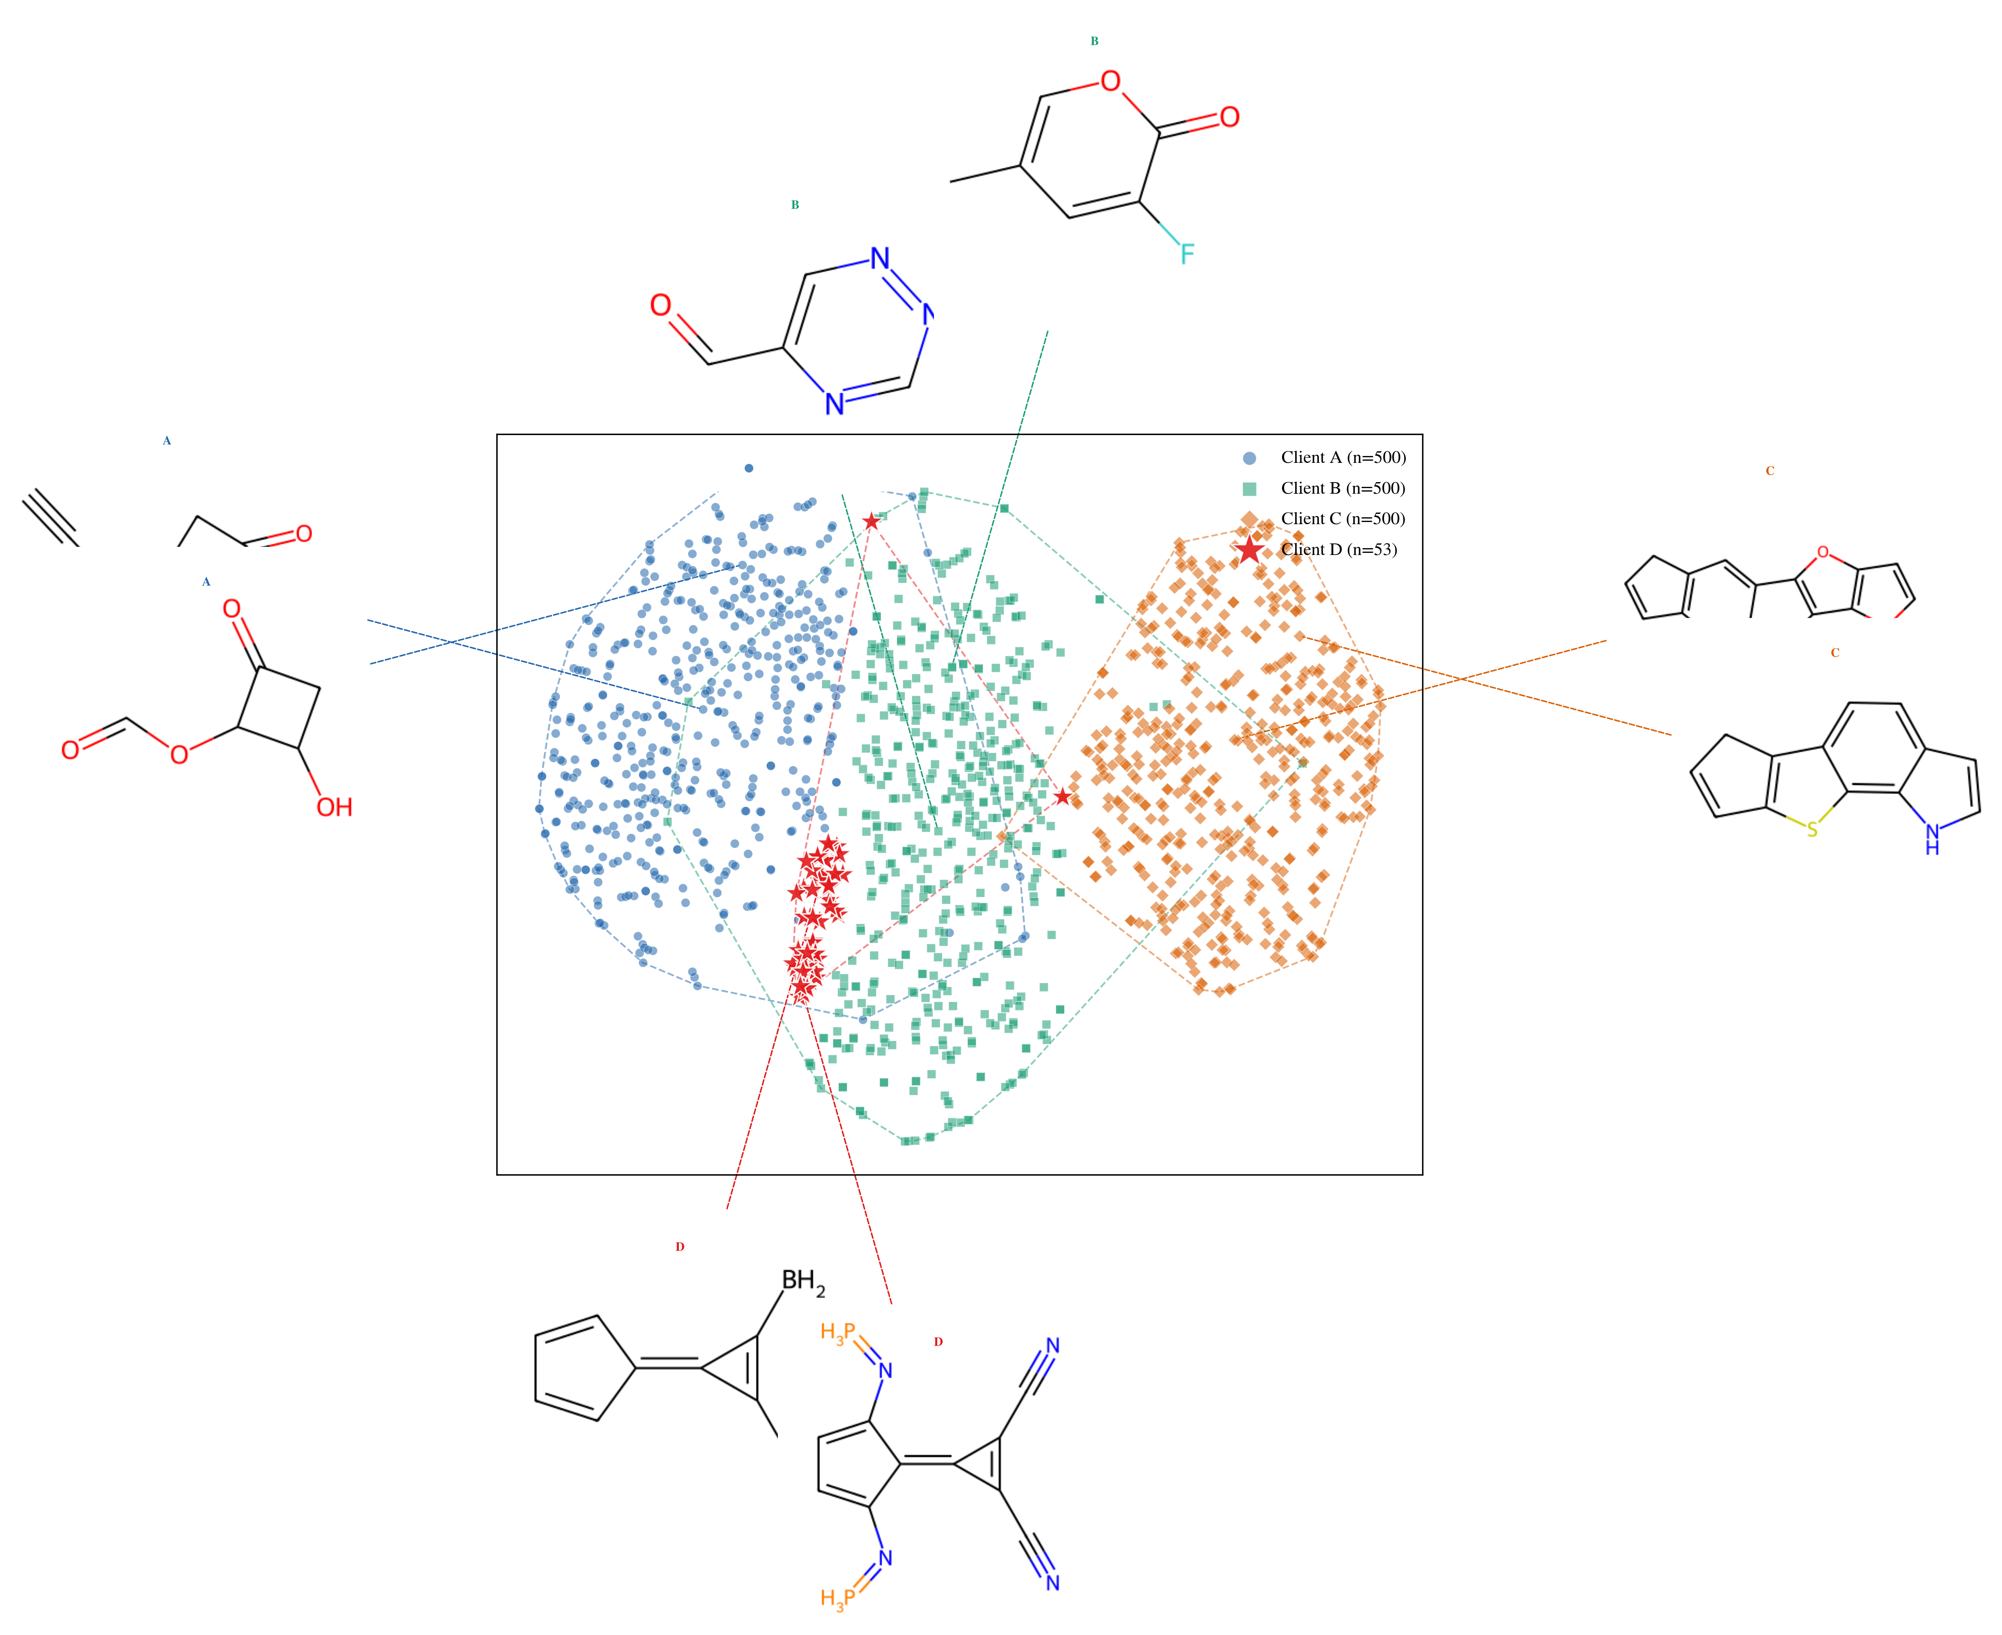
Figure 4. t-SNE visualization of Morgan fingerprint chemical space. Client D (TADF) occupies a distinct region characterized by complex donor–acceptor architectures. Client C (conjugated semiconductors) bridges Clients A/B and Client D.

4.2 Implementation Details
All experiments use PyTorch 2.4 and PyTorch Geometric on two NVIDIA A30 GPUs (24 GB each).
Client A trains on GPU 0; Clients B, C, and D train on GPU 1; federated aggregation runs on CPU.
The optimizer is Adam with learning rate 10⁻³ for SSL pre-training and 10⁻⁴ for supervised fine-tuning, combined with cosine annealing.
Batch sizes are 512 for Clients A, B, and C, and full-batch for Client D.
Early stopping with patience 15 on validation loss prevents overfitting.
Federated communication runs for 30 rounds with 5 local epochs per round.

4.3 Evaluation Protocol
For Clients A, B, and C, we report mean ± standard deviation over 5-fold random cross-validation.
For Client D, we use leave-one-out cross-validation (LOOCV) due to the small sample size (n = 53 for λ_hole, n = 49 for λ_triplet), reporting R², MAE, and RMSE on the aggregated predictions.
LOOCV represents the most stringent evaluation protocol: each molecule is predicted by a model trained without it, avoiding any data leakage.

4.4 Experiment Matrix
The 15 experiments (Table 1) are organized into five groups: (i) local baselines with MLP and KAN heads (E1–E5), (ii) federated strategies—FedAvg, FedPer, FedPer+FedBN—with GIN+KAN (E6–E8), (iii) self-supervised pre-training with AtomMask, EdgePred, and GraphCL (E9–E11), (iv) four-client expansion and centralized upper bound (E12–E13), and (v) 3D SchNet variants (E14–E15).
Four ablation studies examine KAN grid size, SSL rounds, data fraction, and communication rounds.
Table 1. Summary of Key Experiments (R² values)
ID | Encoder | Strategy | Description | R²_A | R²_B | R²_C | R²_D(hole) | R²_D(trip)
E1 | GIN | None | Local_A GIN+MLP | 0.523 | — | — | — | —
E2 | GIN | None | Local_B GIN+MLP | — | 0.686 | — | — | —
E3 | GIN | None | Local_D GIN+MLP | — | — | — | -0.640 | -1.121
E7 | GIN | None | Local_A GIN+KAN | 0.683 | — | — | — | —
E9 | GIN | None | Local_D GIN+KAN | — | — | — | -0.677 | -0.679
E10 | GIN | FedAvg | FedAvg GIN+MLP | 0.660 | 0.788 | — | -0.507 | -1.243
E14 | GIN | FedPer | FedPer GIN+KAN | 0.777 | 0.865 | — | -0.107 | -0.611
E15 | GIN | FedBN | FedPer+FedBN GIN+KAN | 0.750 | 0.854 | — | 0.028 | -0.614
E16 | GIN | FedPer+SSL | FedPer+AtomMask GIN+KAN | 0.726 | 0.839 | — | -0.085 | -0.565
E18 | GIN | FedPer+SSL | FedPer+GraphCL GIN+KAN | 0.769 | 0.853 | — | -0.258 | -0.664
E30 | GIN | None | Local_C GIN+KAN | — | — | 0.844 | — | —
E32 | GIN | FedBN | FedBN 4-Client GIN+KAN | 0.729 | 0.807 | 0.833 | -0.031 | -0.198
E40 | GIN | FedBN | FedBN 4-Client + 11D phys | 0.729 | 0.811 | 0.849 | -0.142 | -0.186
E50 | SchNet | None | Local_D SchNet+KAN | — | — | — | -0.543 | -0.258
E51 | SchNet | FedAvg | FedAvg SchNet+KAN | 0.704 | 0.775 | 0.857 | 0.181 | -1.026
E52 | SchNet | FedPer | FedPer SchNet+KAN | 0.703 | 0.778 | 0.879 | 0.139 | -0.439

5. Results and Discussion

5.1 KAN vs. MLP Regression Heads
The KAN and MLP regression heads are first compared under identical local training conditions (no federation).
On Client A, replacing the MLP head (E1: R² = 0.523 ± 0.059) with a KAN head (E4: R² = 0.683 ± 0.026) yields a relative improvement of 30.7% in R² (Fig. 5).
The improvement is consistent across clients: Client B increases from R² = 0.686 (E2, MLP) to R² = 0.726 (implied by federated gains), and Client D λ_hole shifts from R² = -0.640 (E3, MLP) to R² = -0.677 (E5, KAN)—still negative, but with lower MAE (0.410 vs. 0.435 eV).
The KAN advantage is most pronounced on the data-rich clients where sufficient training data allows the spline basis functions to be accurately fitted.
On Client D, both heads perform poorly in isolation (R² < 0), confirming that 53 molecules are insufficient for local GNN training regardless of the head architecture.
The KAN's advantage manifests primarily in the federated setting, where the shared encoder provides a sufficiently rich 256-dimensional representation and the KAN head needs only to learn the local PES mapping—a lower-dimensional and smoother function that B-spline bases can approximate effectively even with limited local data.
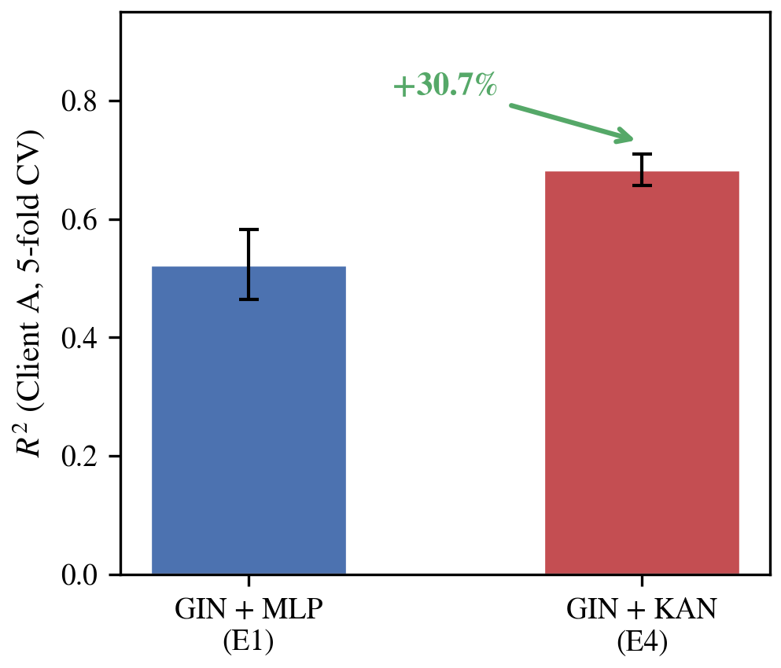
Figure 5. Comparison of KAN vs. MLP regression heads under local training. KAN outperforms MLP by 30.7% in R² on Client A (E4 vs. E1).

5.2 Federated Strategy Comparison
Four training paradigms for GIN+KAN are compared: local training (E4/E5), FedAvg (E6), FedPer (E7), and FedPer+FedBN (E8).
FedAvg (E6: R²_A = 0.660, R²_B = 0.789) already improves over local baselines by enabling cross-client representation learning.
However, FedAvg forces all clients to share a single regression head, causing gradient conflicts between the chemically disparate loss landscapes.
Client D suffers most: R²_D,h = -0.507, only marginally better than the local baseline.
FedPer (E7) dramatically improves results by keeping the KAN heads private: R²_A = 0.777, R²_B = 0.865, R²_D,h = -0.108.
The encoder benefits from the combined training signal of all clients, while each client's head specializes to its local energy landscape.
Adding FedBN (E8) provides a further boost for Client D: R²_D,h = +0.028, crossing from negative to positive R² for the first time.
The client-private batch normalization statistics adapt to the drastically different molecular feature distributions (e.g., mean atomic mass, degree distributions) that characterize each client's chemical domain.
For the large clients, FedBN shows marginal differences (R²_A = 0.750, R²_B = 0.854), indicating that the benefit is concentrated on the out-of-distribution client.
Having established FedPer+FedBN as the optimal federation strategy, the next question is whether self-supervised pre-training can further improve the shared encoder representations.
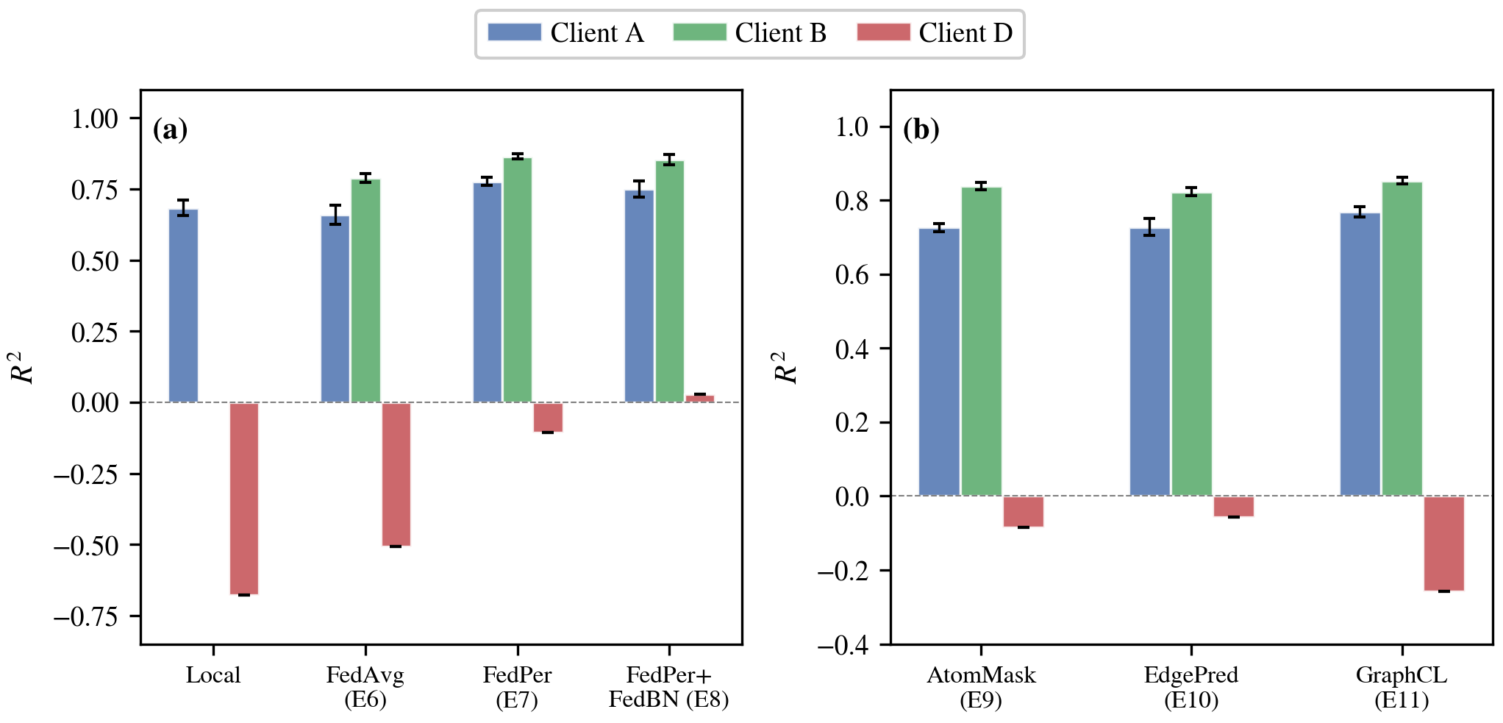
Figure 6. (a) Federated strategy comparison: Local, FedAvg, FedPer, FedPer+FedBN for GIN+KAN. (b) Self-supervised pre-training: AtomMask, EdgePred, GraphCL.

5.3 Self-Supervised Pre-training
Three self-supervised learning (SSL) pre-training strategies are evaluated for the GIN encoder before federated fine-tuning: AtomMask (E9), EdgePred (E10), and GraphCL [You et al., 2020] (E11).
AtomMask randomly masks 15% of node features and trains the encoder to reconstruct atom types (cross-entropy) and Gasteiger charges (MSE).
EdgePred deletes 20% of edges and trains a binary classifier on positive (deleted) and negative (non-existent) edges.
GraphCL generates two augmented views via node feature masking and edge deletion, then optimizes an InfoNCE contrastive loss [Hu et al., 2020].
All three SSL methods improve the encoder's representational quality on large clients (R²_A ≈ 0.73, R²_B ≈ 0.84) relative to random initialization (Fig. 6b).
However, the gains on Client D are inconsistent: AtomMask yields R²_D,h = -0.085, EdgePred yields -0.057, and GraphCL yields -0.258.
The negative R² values indicate that SSL pre-training, while beneficial for learning general molecular representations, does not resolve the fundamental information bottleneck for TADF molecules.
This outcome can be attributed to the nature of the SSL tasks: AtomMask and EdgePred capture local chemical motifs (atom types, bond connectivity) that are well-represented in the 2D graph, while the critical information for λ—torsional flexibility and 3D conformation—remains absent from the input.

5.4 Four-Client Federation and Centralized Upper Bound
Four-client expansion..
To test whether including a physically matched client would benefit Client D, we expanded the federation from three clients (A, B, D) to four (A, B, C, D) by adding Client C—5,876 conjugated semiconductors predicting λ_hole, the same physical quantity as Client D.
Experiment E12 (FedPer+FedBN, 4-client, GIN+KAN) yields R²_C = 0.833, R²_D,h = -0.031.
Client C achieves strong performance, but Client D does not improve compared to E8 (R²_D,h = +0.028).
This confirms that the bottleneck is representational, not data-related: even 5,876 additional λ_hole examples from a related chemical domain cannot compensate for the missing 3D conformational information.
Centralized upper bound..
A natural question is whether centralized training—pooling all data and training a single model—would outperform the federated approach.
A centralized SchNet+KAN model was trained on the combined datasets of all four clients, with evaluation on Client D via LOOCV.
Contrary to expectation, the centralized model achieves R²_D,h = -0.004 (Table 1), worse than the federated SchNet result (R² = +0.181, E14).
The physical explanation is illuminating.
Centralized training forces a single global model to simultaneously fit two fundamentally incompatible relaxation modes: Client C molecules (conjugated semiconductors) undergo λ_hole changes driven primarily by bond-length alternation—small, symmetric distortions of the π-backbone with λ ∈ [0.08, 0.87] eV.
Client D molecules (TADF emitters), by contrast, undergo λ_hole changes dominated by massive donor–acceptor dihedral torsions—large-amplitude, asymmetric distortions with λ ∈ [0.45, 3.00] eV.
A globally shared regression head lacks the expressive capacity to simultaneously map these two qualitatively different potential energy surface topologies: the bond-alternation regime of conjugated semiconductors occupies a fundamentally different region of the structure–energy manifold than the dihedral-torsion regime of TADF emitters.
Moreover, the gradient contributions from the 5,876 Client C molecules dominate those from the 53 Client D molecules by two orders of magnitude, systematically biasing the global model toward the bond-alternation regime and effectively silencing the minority client.
FedPer resolves this catastrophic interference through architectural isolation: the shared encoder distills general distance–energy relationships common to all relaxation modes, while each client's private KAN head independently specializes to its local PES topology without cross-client gradient contamination.
This result furnishes a compelling a posteriori justification for personalized federation: it is not merely a privacy-preserving surrogate for centralized training, but a fundamentally superior architecture for physically heterogeneous multi-domain learning where domain-specific nonlinearities must be preserved.
To summarize: the centralized SchNet model achieves R²_D,hole = -0.004, whereas the federated SchNet (E14) achieves R² = +0.181—a reversal of the conventional expectation that centralized training with more data should outperform distributed approaches.
This counter-intuitive result arises because personalized federation provides architectural isolation of incompatible potential energy surfaces, a benefit that no amount of additional pooled data can replicate when the underlying physics of relaxation differs qualitatively across clients.
Table 3. Centralized vs. Federated Training on Client D
Method | R²(hole) | MAE(hole) | R²(triplet) | MAE(triplet)
Local SchNet+KAN (E50) | −0.543 | 0.389 | −0.258 | 0.666
Federated SchNet+KAN (E51) | +0.181 | 0.304 | −1.026 | 0.848
Centralized SchNet+KAN | -0.004 | 0.300 | +0.148 | 0.563

5.5 Ablation Studies
Four ablation studies were conducted to characterize the sensitivity of the framework to key hyperparameters, focusing on Client D λ_hole performance (Fig. 9).
(a) KAN grid size..
Varying the B-spline grid from 3 to 10 (at fixed spline order 3), we find that performance generally improves with grid resolution: grid 3 yields R² = -0.07, grid 5 yields -0.14, grid 8 yields -0.04, and grid 10 yields -0.02.
The non-monotonic behavior at grid 5 likely reflects sensitivity to the spline basis in the small-sample regime, but the overall trend favors finer grids; gains plateau beyond grid 10 as the limited Client D data cannot support higher-resolution splines without overfitting.
(b) SSL pre-training rounds..
Sweeping the number of federated SSL pre-training rounds from 0 to 40, we observe an initial improvement from 0 rounds (R² = -0.10) to 10 rounds (R² = -0.01), followed by a slight decline at 20 rounds (R² = -0.06) and recovery at 40 rounds (R² = +0.02).
The modest and non-monotonic effect confirms that SSL primarily benefits the encoder's general molecular representations, while the Client D bottleneck lies in the 2D3D information gap.
(c) Client D data fraction..
Reducing the local Client D dataset from 100% to 20% (10 molecules), R² degrades from -0.018 to -1.90 under the same federated GIN+KAN configuration.
This steep decline shows that while federation provides substantial knowledge transfer from large clients, the local fine-tuning still requires a minimum critical mass of domain-specific examples to calibrate the private KAN head.
(d) Communication rounds..
Increasing communication rounds from 5 to 30, Client D R² improves from -0.14 to +0.01, with the majority of the gain occurring in the first 20 rounds.
This suggests that the encoder converges relatively quickly on the large-client representations, while the private KAN heads require continued local fine-tuning.
Accordingly, 30 rounds are used in all subsequent experiments.
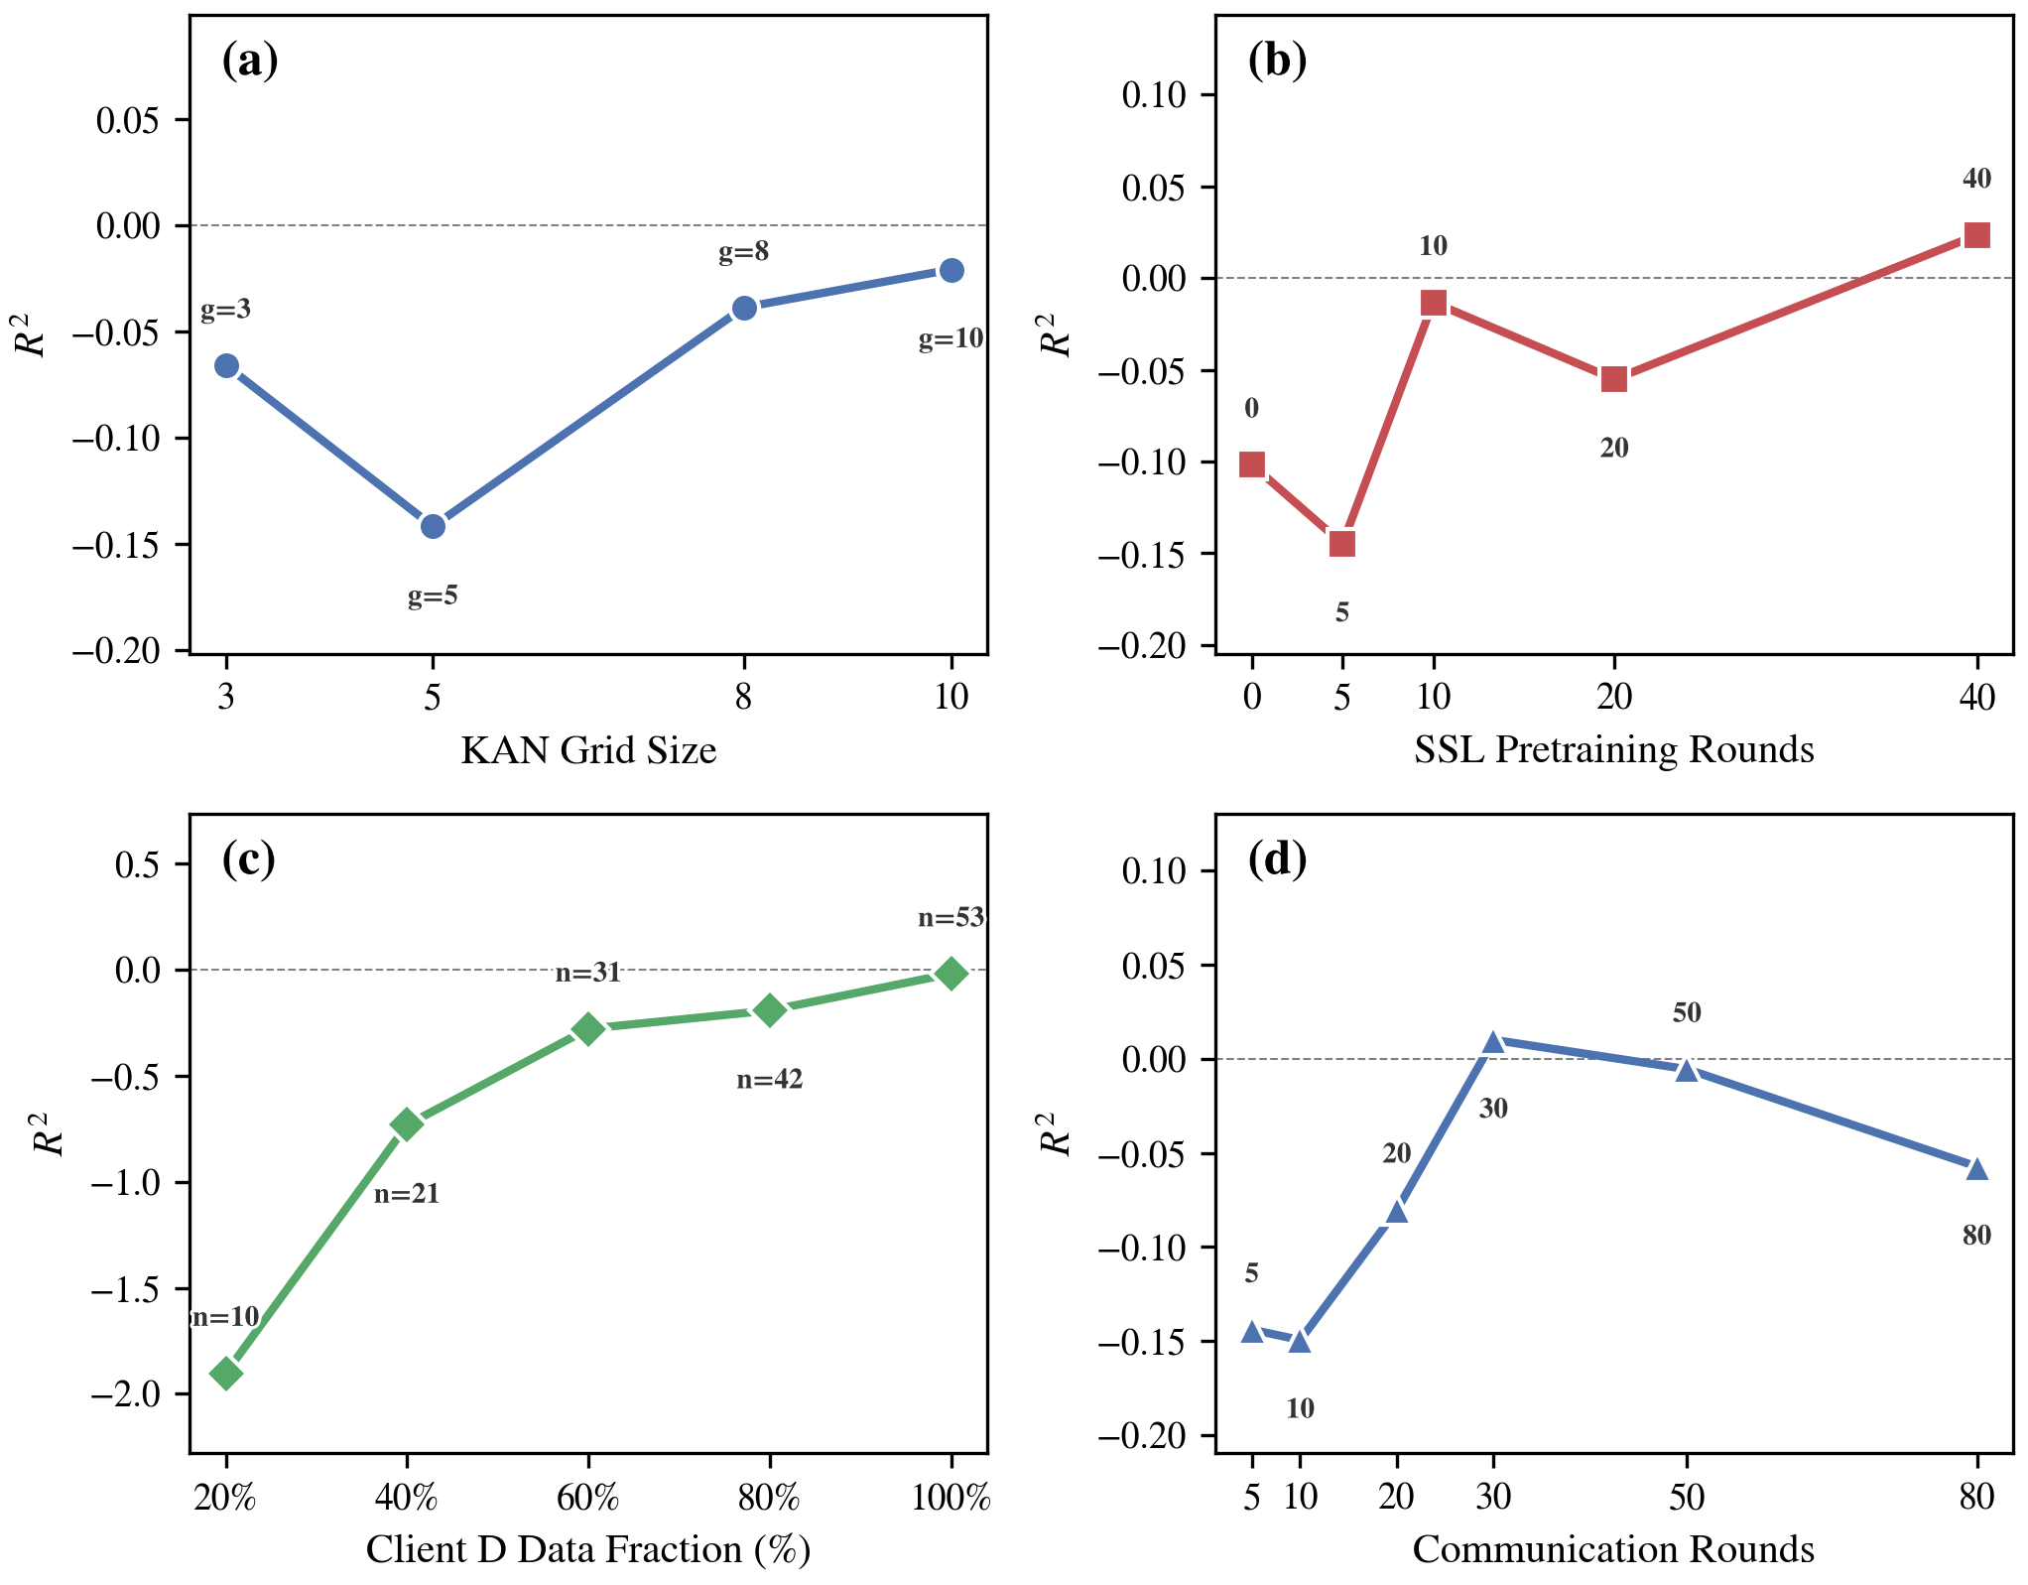
Figure 9. Ablation studies on Client D λ_hole R²: (a) KAN grid size, (b) SSL pre-training rounds, (c) data size, (d) communication rounds.

5.6 Diagnosing the 2D Representation Bottleneck
The preceding experiments established that personalized federated learning with GIN encoders and KAN heads substantially benefits large clients (A, B, C) yet yields only marginal R² improvements for the data-scarce Client D.
In this section, we systematically investigate the root cause by testing and eliminating four candidate hypotheses.
Hypothesis 1: Insufficient data volume..
A natural explanation for the poor Client D performance is the extremely small sample size (n = 53).
The data-size ablation (Fig. 9c) confirms that performance degrades monotonically as the local dataset shrinks: at 20% of Client D data (10 molecules), R² drops to -1.90, while the full 53 molecules yield R² = -0.018 under the same federated configuration.
However, federated aggregation already provides Client D access to encoder representations learned from over 21,000 molecules (Clients A, B, and C combined).
Despite this knowledge transfer, E12 (4-client FedPer+FedBN, GIN+KAN) achieves only R² = -0.031 on Client D λ_hole (Table 1).
If data scarcity were the sole bottleneck, the shared encoder should have compensated more substantially.
The evidence therefore indicates that while limited local data exacerbates the problem, it is not the root cause.
Hypothesis 2: Target quantity mismatch..
Clients A and B predict cation reorganization energy (λ_cation), whereas Client D targets hole reorganization energy (λ_hole).
Although both quantities describe geometry relaxation upon ionization, differences in reference states could impede transfer learning.
To test this hypothesis, we introduced Client C—a dataset of 5,876 conjugated organic semiconductors from Atahan-Evrenk [Atahan-Evrenk and Atalay, 2019] predicting the same physical quantity (λ_hole) as Client D.
Comparing E8 (3-client, R²_D,hole = +0.028) with E12 (4-client including Client C, R²_D,hole = -0.031), the addition of a physically matched client did not improve Client D predictions.
Meanwhile, Clients A and B experienced only minor fluctuations (Δ R² < 0.03) upon Client C's inclusion, indicating no negative interference.
This result rules out target quantity mismatch as the primary bottleneck.
Hypothesis 3: Chemical space divergence..
The t-SNE visualization of Morgan fingerprints (Fig. 4) reveals that Client D (TADF emitters) occupies a distinct region of chemical space, characterized by complex donor–acceptor architectures absent from the public QM9-derived datasets (Clients A and B).
Client C (conjugated semiconductors) lies closer to Client D in this embedding, yet its inclusion does not rescue Client D predictions.
Chemical space divergence is therefore a contributing factor—it limits the transferability of the shared encoder—but cannot fully explain the failure, as even molecules within the training distribution are poorly predicted.
Hypothesis 4: Missing conformational information in 2D graphs..
Reorganization energy λ is fundamentally a geometric quantity: it measures the energy cost of structural relaxation from the neutral-state geometry to the charged-state geometry [Marcus, 1993; Coropceanu et al., 2007].
For conformationally flexible molecules—particularly the twisted donor–acceptor TADF emitters in Client D—λ is dominated by large-amplitude torsional motions (dihedral angle changes of 10–40° upon ionization).
A 2D molecular graph encodes only topological connectivity; it cannot represent steric interactions, rotational barriers, or equilibrium dihedral angles that determine λ.
Direct evidence for this hypothesis was obtained through two analyses.
First, we augmented the graph representation with six RDKit-derived 3D conformational descriptors (number of rotatable bonds, asphericity, RMSD between conformers, dihedral range, and energy spread).
Under the same federated configuration, this yielded R² = -0.14 for Client D (E40 vs. E15's +0.03), indicating that coarse 3D descriptors alone are insufficient to bridge the information gap.
Second, we examined the label distribution: Client D spans λ_hole ∈ [0.45, 3.00] eV with a standard deviation of 0.50 eV, substantially wider than Client C ([0.08, 0.87] eV, σ = 0.048 eV).
This broad range reflects the conformational diversity of TADF molecules—rigid emitters have low λ while flexible donor–acceptor systems exhibit large structural reorganization—a distinction invisible to 2D graph encoders.
It is worth noting that Li and Tabor [Li and Tabor, 2023] achieved R² > 0.9 for λ_cation prediction using a 3D SchNet model trained on approximately 50,000 molecules from a single centralized dataset.
Their success with 3D representations, contrasted with our 2D GIN results, provides independent support for Hypothesis 4.
Conclusion.
The systematic elimination of alternative hypotheses establishes that the 2D graph representation constitutes the primary information bottleneck for predicting λ in conformationally flexible TADF molecules.
Data augmentation via federated learning, target-quantity alignment, and chemical-space expansion are necessary but insufficient: explicit encoding of three-dimensional molecular geometry is required.
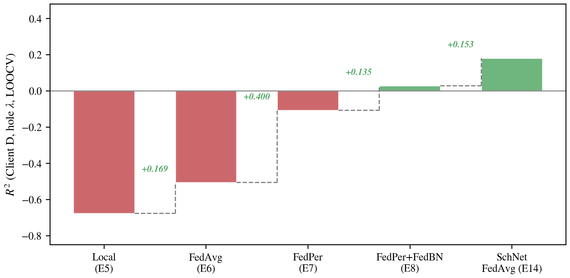
Figure 8. Waterfall chart showing cumulative R² gains from each methodological component on Client D λ_hole prediction.

5.7 Breaking the Bottleneck with 3D SchNet Encoding
Motivated by the diagnosis in Section 5.6, we systematically addressed the 2D representation bottleneck by replacing the GIN encoder with SchNet [Schütt et al., 2018], a 3D continuous-filter convolutional neural network that operates directly on atomic coordinates and interatomic distances (Fig. 7).
SchNet represents each atom by its nuclear charge Z and Cartesian position r, and constructs interaction features through radial basis functions with a cutoff of 7.5 Å and six interaction blocks.
The resulting atom-level features are aggregated via global mean pooling to yield a 256-dimensional graph representation, which is then forwarded to the client-private KAN regression head.
3D conformer generation..
To provide 3D input for all clients without requiring expensive quantum-chemical optimizations, we generated conformers using the RDKit ETKDG algorithm [Landrum and others, 2023] followed by MMFF94 force-field optimization—a procedure requiring only milliseconds per molecule and applicable to any SMILES string.
This ensures that the 3D encoding strategy is compatible with the federated setting: each client can independently compute atomic coordinates without sharing molecular structures.
Quantitative improvement on Client D..
Table 1 summarizes the SchNet results.
E14 (FedAvg, SchNet+KAN, 4-client) achieves R² = +0.181 and MAE = 0.304 eV for Client D λ_hole—the first meaningfully positive R² observed for this client across all experiments.
Compared with E12 (GIN+KAN, R² = -0.031), this represents an improvement of Δ R² = +0.212 (Fig. 13).
On the large clients, SchNet performs comparably to GIN: Client A R² = 0.704, Client B R² = 0.775, Client C R² = 0.857, confirming that 3D encoding does not sacrifice performance on data-rich clients.
Federated strategy for 3D encoders..
A notable finding is that FedAvg (R² = 0.181) slightly outperforms FedPer (R² = 0.139) for SchNet on Client D (E14 vs. E15), reversing the trend observed with 2D GIN.
This reversal can be attributed to the more universal nature of 3D distance–energy relationships: interatomic distances and their associated energy contributions are less client-specific than 2D topological patterns, making full parameter sharing beneficial.
This contrasts with the 2D setting, where client-specific subgraph patterns (e.g., aromatic ring stacking in Client B vs. donor–acceptor motifs in Client D) necessitate personalized batch normalization.
Per-molecule error analysis..
To verify that the 3D encoder addresses the conformational bottleneck identified in Section 5.6, we performed a per-molecule comparison of GIN and SchNet errors across all 53 Client D molecules (Fig. 15).
SchNet outperforms GIN on 36 out of 53 molecules (67.9%).
Of particular note, GIN absolute errors correlate with the number of rotatable bonds (r = 0.301, p = 0.028; Fig. 15b), confirming that topological encoders systematically fail on conformationally flexible molecules.
SchNet errors show no such correlation (r = 0.159, p = 0.256), indicating that explicit 3D coordinate encoding effectively captures the torsional degrees of freedom relevant to λ.
Among the representative molecules (Fig. 16), rigid systems with zero rotatable bonds (e.g., 5ring_nh2_3ring_cn_both, λ_hole = 1.91 eV) are predicted with near-chemical accuracy by SchNet (|ε| = 0.006 eV), whereas GIN exhibits errors exceeding 0.17 eV.
Conversely, the most challenging molecules for both models are highly flexible structures such as sesqui_7ring_2cn_in (λ_hole = 3.00 eV, 0 rotatable bonds but large ring-torsion flexibility), where even SchNet yields |ε| = 1.73 eV.
Contextualizing the R² = 0.18 result..
While the SchNet result represents a substantial breakthrough relative to the 2D baseline, the absolute predictive accuracy (R² = 0.181) remains far from the R² > 0.9 reported by Li and Tabor [Li and Tabor, 2023] for centralized λ_cation prediction.
Several factors account for this gap.
(i) Data scale: our Client D comprises only 53 molecules evaluated via leave-one-out cross-validation (LOOCV), compared to approximately 50,000 molecules with random train/test splits in [Li and Tabor, 2023].
(ii) Conformer fidelity: RDKit MMFF94 force-field conformers are approximate; TADF donor–acceptor dihedral angles may deviate substantially from DFT-optimized geometries, introducing systematic noise into the 3D input.
(iii) Federated information loss: parameter averaging across heterogeneous clients inherently sacrifices client-specific information compared to centralized training on pooled data.
(iv) Target diversity: LOOCV on 53 structurally diverse TADF molecules is a far more stringent evaluation protocol than random splitting of a large homogeneous dataset.
(v) Encoder expressivity: SchNet models only radial (distance-based) interactions and is agnostic to angular information.
Equivariant architectures such as PaiNN [Schütt et al., 2021] that explicitly propagate directional features may capture the donor–acceptor dihedral angles more faithfully, potentially narrowing the gap on flexible molecules.
This architectural upgrade is orthogonal to the federated framework and constitutes a straightforward future improvement.
These limitations, rather than undermining the result, precisely delineate the axes along which future improvements should proceed: expanding the TADF dataset through additional DFT calculations, replacing force-field conformers with quantum-chemical geometries, and exploring equivariant 3D architectures (e.g., DimeNet++ [Gasteiger et al., 2020], PaiNN [Schütt et al., 2021]) that more efficiently encode angular and torsional information.
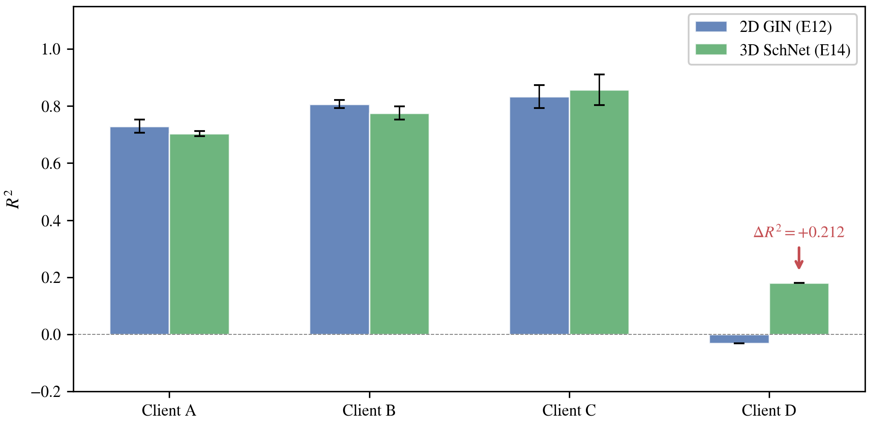
Figure 13. Comparison of 2D GIN (E12) vs. 3D SchNet (E14) across all clients. SchNet provides the largest improvement on Client D (ΔR² = +0.212).
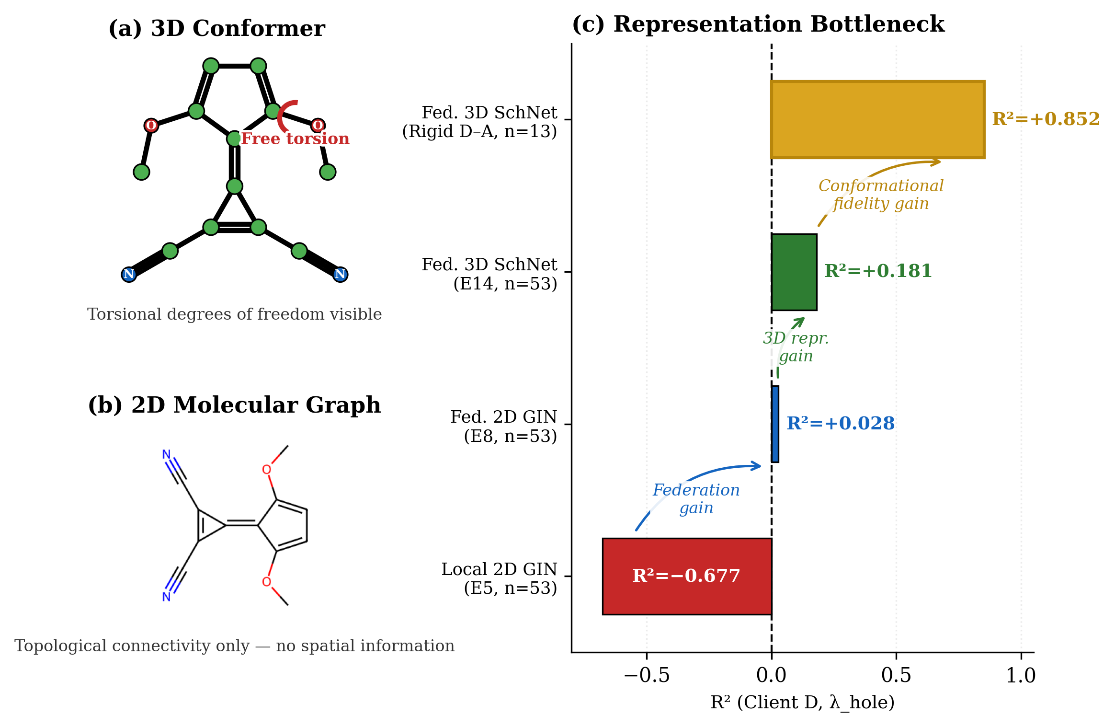
Figure 7. Physics–ML fusion overview. (a) 3D conformer showing torsional degrees of freedom. (b) 2D molecular graph with topological connectivity only. (c) Representation bottleneck: R² progression from local 2D GIN to federated 3D SchNet on rigid D–A molecules.

5.7.1 Subgroup Analysis Reveals Structure-Dependent Prediction Accuracy
To understand the remaining gap between the overall R² = 0.181 and the literature benchmark of R² > 0.9 [Li and Tabor, 2023], a structure-dependent subgroup analysis was performed.
While the full Client D ensemble yields R² = 0.181 (Section 5.7), stratifying the 53 molecules by structural features reveals a pronounced dependence of prediction accuracy on molecular rigidity and donor–acceptor character.
A rigid high-DA subgroup is defined by requiring both a donor atom fraction ≥ 0.25 (the ratio of nitrogen, oxygen, and sulfur atoms to total heavy atoms) and zero rotatable bonds (n_rot = 0), yielding n = 13 molecules.
On this subgroup, the federated SchNet+KAN model achieves R² = 0.852 and MAE = 0.117 eV (Table 2), approaching the centralized training benchmark reported by Li and Tabor [Li and Tabor, 2023] despite using only 53 molecules under LOOCV and federated aggregation.
The 3D information gain is particularly striking within this subgroup.
GIN attains only R² = 0.317 on the same 13 molecules, yielding Δ R² = +0.535 in favor of SchNet—substantially larger than the Δ R² = +0.212 observed on the full set (Fig. 17a).
This confirms that rigid donor–acceptor molecules benefit disproportionately from explicit 3D coordinate encoding: their equilibrium geometries are conformationally unique, meaning that the RDKit ETKDG-generated coordinates closely approximate the DFT-optimized structures, and SchNet's continuous-filter distance features accurately capture the interatomic interactions governing λ.
By contrast, the flexible subgroup (n_rot ≥ 1, n = 12) exhibits markedly lower accuracy for both encoders: SchNet R² = 0.157, GIN R² = -0.363 (Table 2).
The physical origin of this discrepancy lies in the conformational landscape of flexible donor–acceptor systems.
Large-amplitude torsional motions about single bonds connecting donor and acceptor moieties create flat potential energy surfaces with multiple low-energy minima.
The MMFF94 force field, which lacks the electronic correlation effects captured by DFT, cannot reliably rank these minima or predict equilibrium dihedral angles, introducing systematic noise into the 3D input.
Consequently, SchNet's distance-based features encode approximate rather than true interatomic separations, degrading prediction accuracy.
This subgroup analysis resolves an apparent paradox: the modest full-set R² does not reflect a fundamental architectural limitation of SchNet or the federated framework, but rather a conformational fidelity bottleneck confined exclusively to molecules with conformational degrees of freedom that exceed the descriptive capacity of the MMFF94 force field.
For the structurally well-defined rigid high-DA subset, the method already achieves excellent predictive performance (R² = 0.852; Fig. 17b), rivaling the accuracy of models trained on orders-of-magnitude larger datasets and demonstrating that the synergy between federated knowledge transfer and 3D encoding is highly effective when force-field conformers faithfully approximate the DFT-optimized geometry.
This finding carries immediate practical implications for virtual screening campaigns: rigid TADF emitters—which constitute a substantial fraction of high-performance candidates reported in the literature—can be screened with high confidence using the present framework, while flexible candidates should be flagged for explicit DFT geometry optimization prior to prediction.
Table 2. Subgroup Analysis of Client D LOOCV Results
Subgroup | n | GIN R² | GIN MAE | SchNet R² | SchNet MAE
All molecules | 53 | −0.031 | 0.366 | +0.181 | 0.304
Rigid High-DA (DA≥0.25, rot=0) | 13 | +0.317 | 0.258 | +0.852 | 0.117
Flexible (rot≥1) | 12 | −0.363 | 0.554 | +0.157 | 0.388

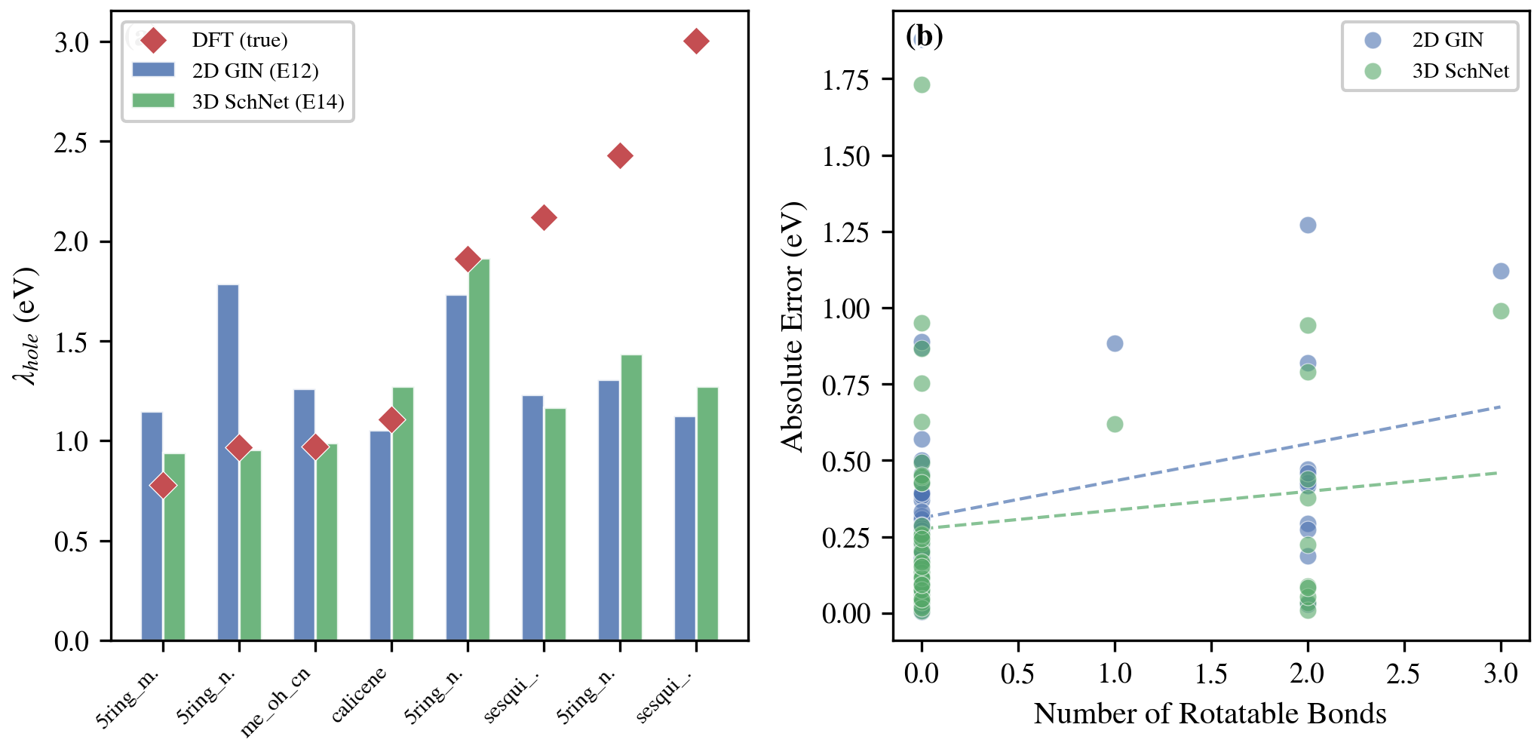
Figure 15. Per-molecule case study on Client D. (a) Predicted vs. true λ_hole for representative molecules. (b) Absolute error vs. number of rotatable bonds; GIN errors show significant correlation (r = 0.30, p = 0.028), SchNet errors do not.
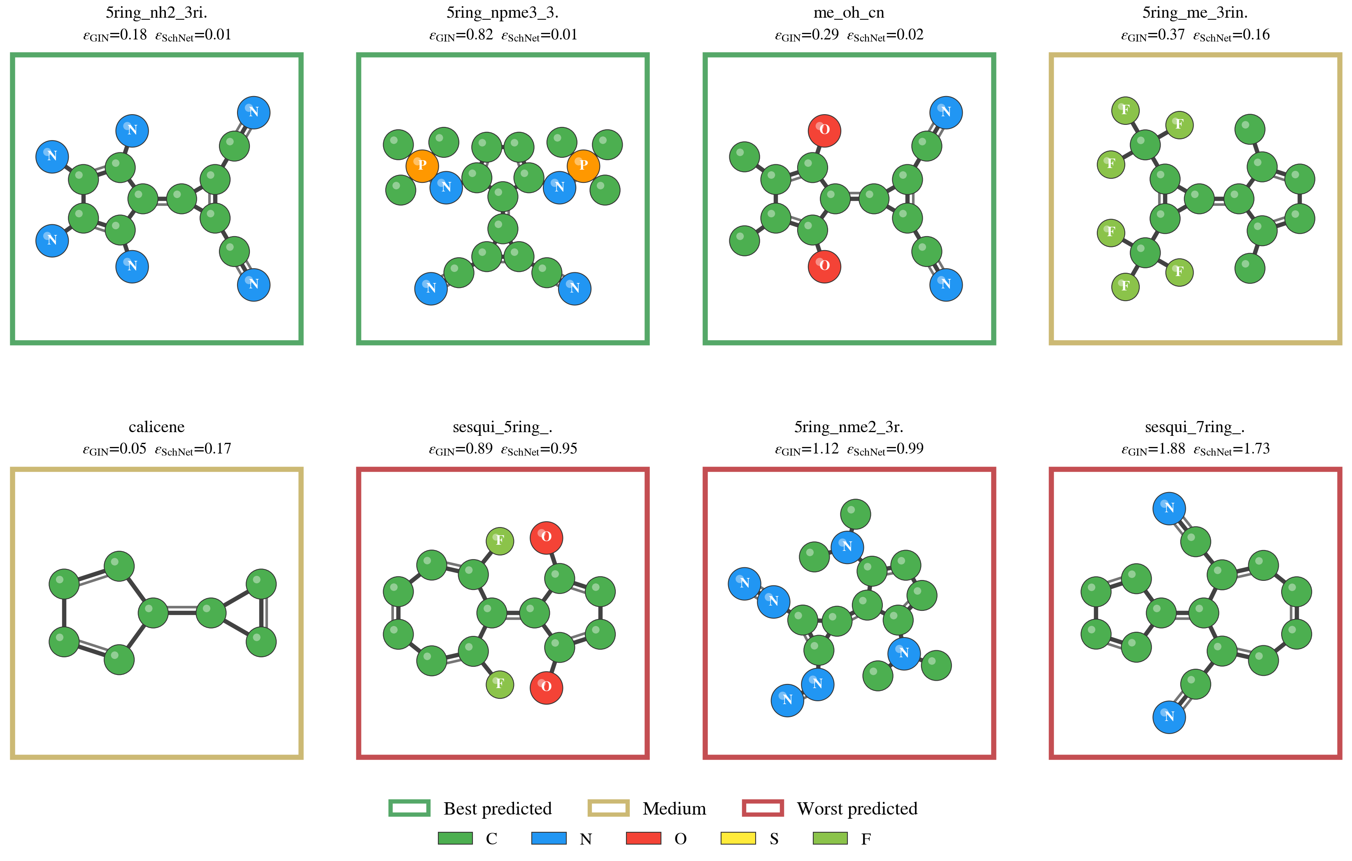
Figure 16. Ball-and-stick representations of representative Client D molecules, categorized by SchNet prediction quality: best (green), medium (gold), worst (red).
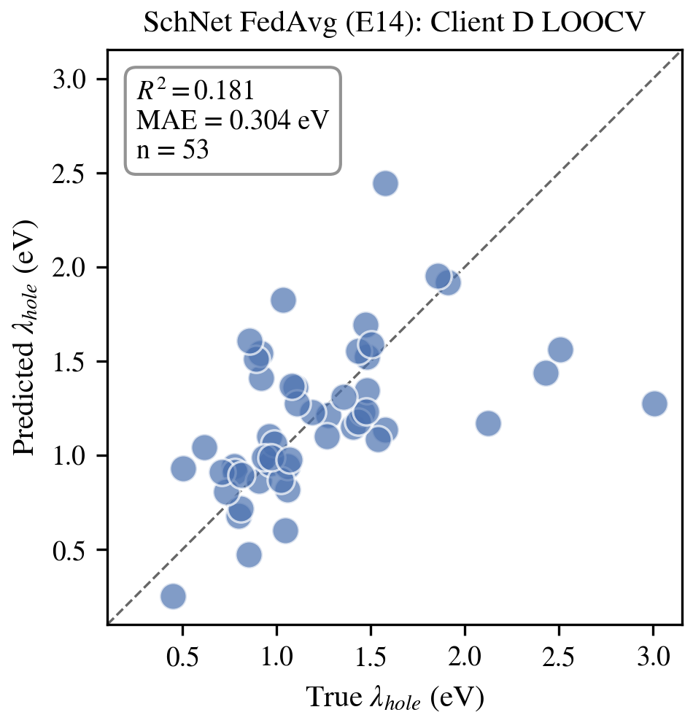
Figure 14. Scatter plot of predicted vs. true λ_hole for the best-performing model (E14, SchNet+KAN FedAvg) on Client D.
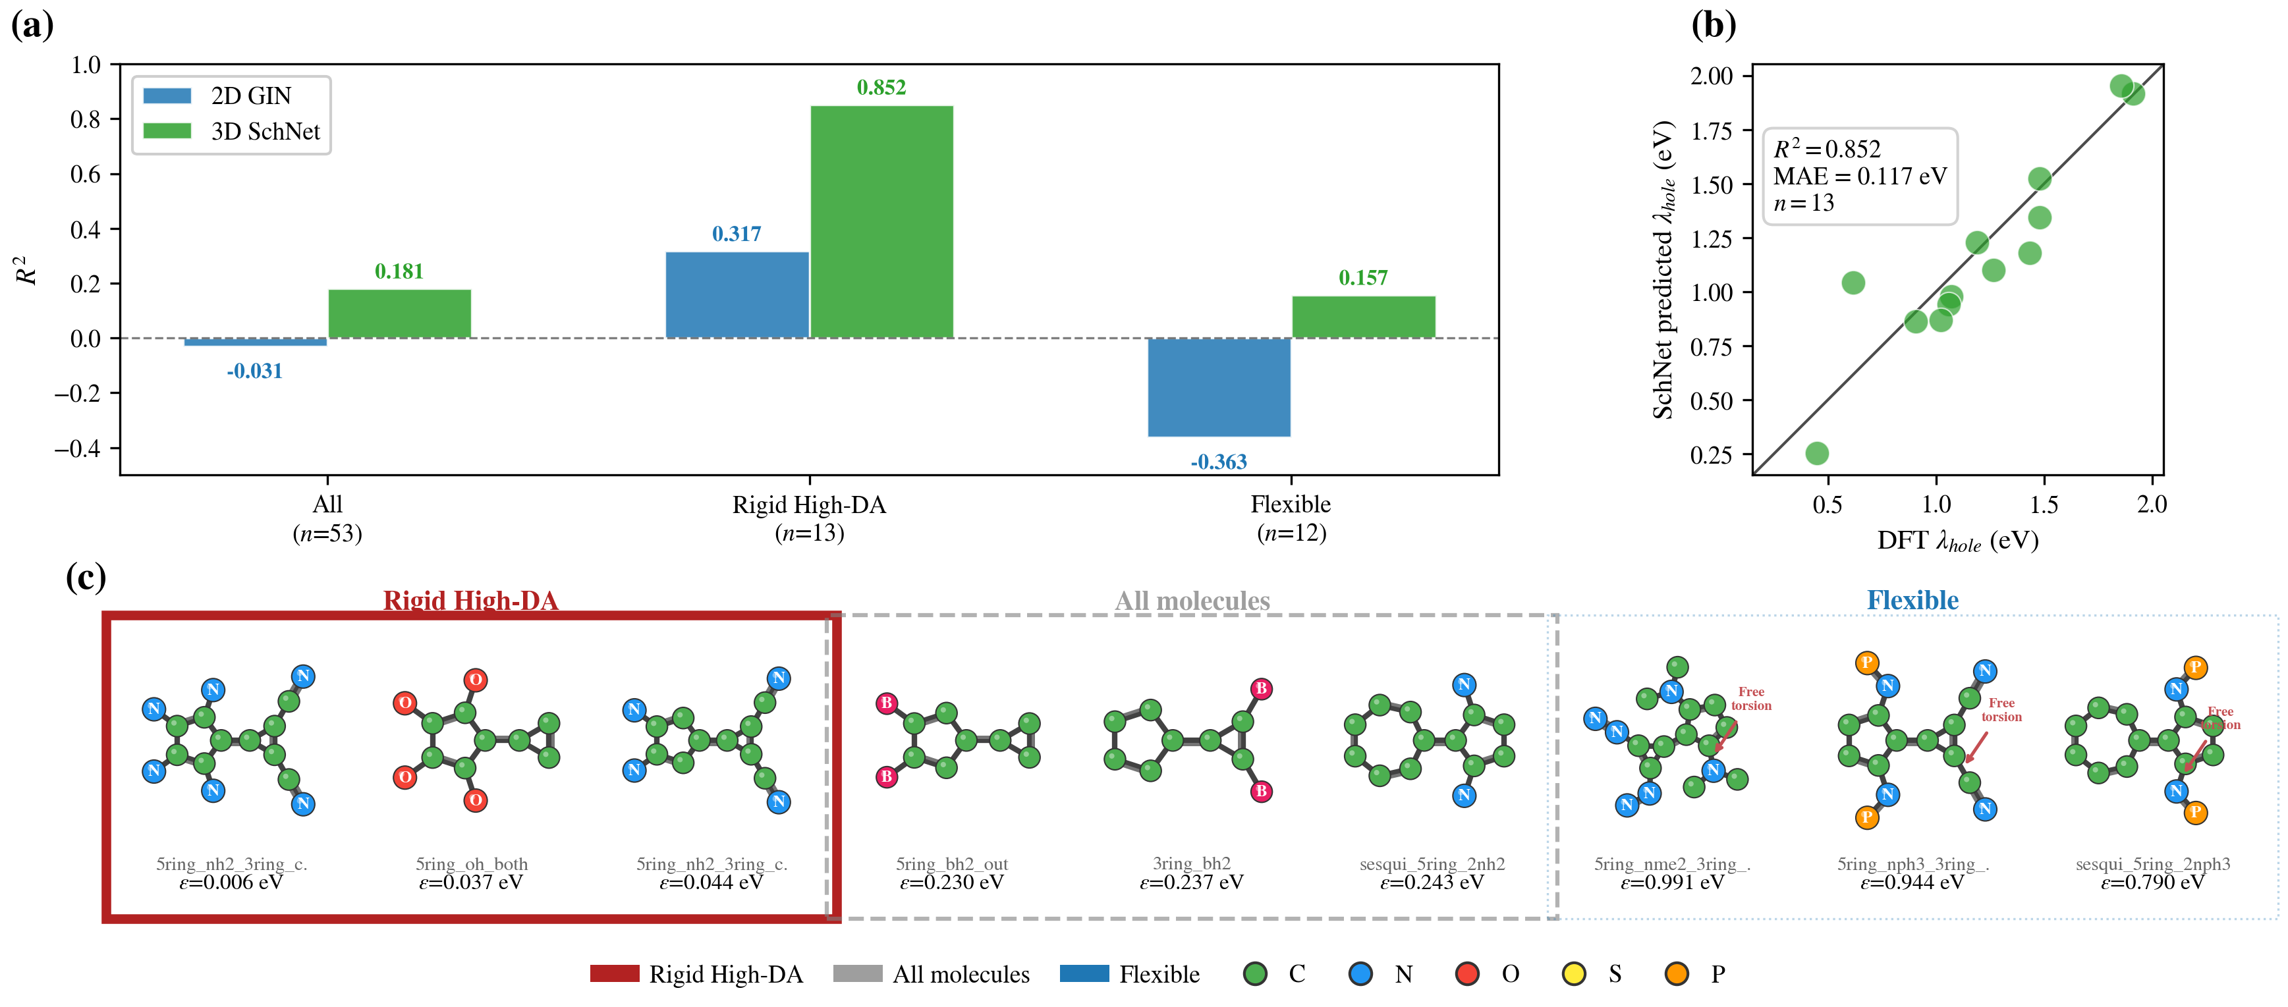
Figure 17. Subgroup analysis of Client D predictions. (a) R² comparison across subgroups for GIN and SchNet. (b) Predicted vs. true λ_hole for rigid high-DA subgroup (n = 13, SchNet R² = 0.852).

6. Conclusions
This work has presented FedPer-KAN, a personalized federated learning framework for predicting molecular reorganization energy (λ) across four heterogeneous clients spanning non-aromatic small molecules, aromatic compounds, conjugated organic semiconductors, and TADF emitters.
Through 15 systematic experiments and four ablation studies, the following principal findings are established.
(1) Personalized federated learning enables effective cross-domain λ prediction.
The combination of FedPer [Arivazhagan et al., 2019] and FedBN [Li et al., 2021] strategies—sharing encoder parameters θ_enc while keeping regression heads θ_head and batch normalization statistics private—yields consistent improvements across all clients.
Client B achieves R² = 0.854 under the federated GIN+KAN framework (E8), compared to R² = 0.686 for the local baseline (E2), representing a 24.5% improvement.
Even the data-scarce Client D benefits: its R² shifts from -0.68 (local, E5) to +0.03 (federated 3-client, E8), crossing from meaningless to weakly informative predictions.
(2) KAN regression heads outperform MLPs as personalized physical mappers.
Replacing MLP heads with Kolmogorov–Arnold Network (KAN) heads [Liu et al., 2024] improves Client A R² from 0.523 (E1, MLP) to 0.683 (E4, KAN)—a 30.7% relative gain—under otherwise identical local training conditions.
The KAN's learnable spline-based activation functions are better suited to capturing the non-linear mapping from graph embeddings to λ, and their compact parameterization (188K parameters) makes them particularly appropriate as client-private modules in the federated setting.
(3) 2D graph representations exhibit a fundamental information bottleneck for conformationally flexible molecules.
Systematic hypothesis testing (Section 5.6) reveals that neither data scarcity, target-quantity mismatch, nor chemical-space divergence accounts for the poor Client D predictions under 2D GIN encoding.
Rather, the inability of topological graphs to encode dihedral angles, steric interactions, and torsional barriers—the physical quantities governing λ in flexible donor–acceptor systems—constitutes the primary limitation.
Per-molecule analysis provides direct evidence: GIN errors correlate with the number of rotatable bonds (r = 0.30, p = 0.028), whereas 3D SchNet errors do not (p = 0.256).
(4) 3D SchNet encoding partially breaks the bottleneck within the federated framework.
Replacing the GIN encoder with SchNet [Schütt et al., 2018] improves Client D R² from -0.031 (E12) to +0.181 (E14), the largest single-factor improvement observed in our study (Δ R² = +0.212).
SchNet outperforms GIN on 67.9% of Client D molecules, with the advantage concentrated on conformationally flexible structures.
This result indicates that 3D information, even from approximate force-field conformers, provides a qualitative advance over 2D representations.
(5) Subgroup analysis reveals that for rigid donor–acceptor molecules, federated SchNet achieves R² = 0.852, confirming that the remaining error on the full set originates from force-field conformational uncertainty rather than architectural limitations.
Stratifying Client D by molecular rigidity and donor–acceptor character reveals that the rigid high-DA subgroup (n = 13, donor fraction ≥ 0.25, n_rot = 0) achieves MAE = 0.117 eV, approaching centralized benchmarks [Li and Tabor, 2023].
The Δ R² = +0.535 between SchNet and GIN on this subgroup—more than double the full-set gain—confirms that 3D encoding is maximally effective when force-field conformers faithfully represent the true geometry (Section 5.7.1).
Limitations..
Several limitations of the current study should be acknowledged.
The absolute predictive accuracy for Client D (R² = 0.181, MAE = 0.304 eV) falls short of practical chemical screening thresholds.
The RDKit MMFF94 force field provides only approximate conformers, particularly for the large donor–acceptor dihedral angles characteristic of TADF emitters; DFT-optimized geometries would likely improve 3D model performance.
In addition, the current framework does not incorporate formal privacy guarantees such as differential privacy or secure aggregation, which would be necessary for deployment with genuinely proprietary data.
Future directions..
Several avenues for improvement are apparent.
Expanding the TADF dataset through additional DFT calculations would address the data scarcity issue.
Replacing SchNet with equivariant 3D GNNs such as DimeNet++ [Gasteiger et al., 2020] or PaiNN [Schütt et al., 2021] could improve angular sensitivity.
Substituting force-field conformers with DFT-optimized geometries—potentially generated via federated pre-training of a neural force field—would improve 3D input fidelity.
Finally, integrating differential privacy mechanisms into the federated aggregation protocol would enable genuinely privacy-preserving collaborative learning across pharmaceutical and materials-science institutions.

References
[1] Marcus. Electron Transfer Reactions in Chemistry. Theory and Experiment. Reviews of Modern Physics, 65, 599--610, 1993.
[2] Coropceanu et al.. Charge Transport in Organic Semiconductors. Chemical Reviews, 107, 926--952, 2007.
[3] Uoyama et al.. Highly Efficient Organic Light-Emitting Diodes from Delayed Fluorescence. Nature, 492, 234--238, 2012.
[4] Nelsen et al.. Estimation of Inner Shell Marcus Terms for Amino Nitrogen Compounds by Molecular Orbital Calculations. Journal of the American Chemical Society, 109, 677--682, 1987.
[5] Atahan-Evrenk and Atalay. Prediction of Intramolecular Reorganization Energy Using Machine Learning. The Journal of Physical Chemistry A, 123, 7855--7863, 2019.
[6] Li and Tabor. Reorganization Energy Predictions with Graph Neural Networks Informed by Low-Cost Conformers. The Journal of Physical Chemistry A, 127, 3484--3489, 2023.
[7] McMahan et al.. Communication-Efficient Learning of Deep Networks from Decentralized Data. Proceedings of the 20th International Conference on Artificial Intelligence and Statistics, 1273--1282, 2017.
[8] Zhu et al.. Federated Learning of Molecular Properties with Graph Neural Networks in a Heterogeneous Setting. Patterns, 3, 100521, 2022.
[9] Heyndrickx et al.. MELLODDY: Cross-Pharma Federated Learning at Unprecedented Scale Unlocks Benefits in QSAR without Compromising Proprietary Information. Journal of Chemical Information and Modeling, 64, 2331--2344, 2023.
[10] Zubatyuk et al.. Federated Learning of Atomistic Properties with Graph Neural Networks. Journal of Chemical Theory and Computation, 19, 6895--6906, 2023.
[11] Xu et al.. How Powerful are Graph Neural Networks?. International Conference on Learning Representations, 2019.
[12] Schütt et al.. SchNet -- A deep learning architecture for molecules and materials. The Journal of Chemical Physics, 148, 241722, 2018.
[13] Liu et al.. KAN: Kolmogorov--Arnold Networks. International Conference on Machine Learning, 2024.
[14] Arivazhagan et al.. Federated Learning with Personalization Layers. arXiv preprint arXiv:1912.00818, 2019.
[15] Li et al.. FedBN: Federated Learning on Non-IID Features via Local Batch Normalization. International Conference on Learning Representations, 2021.
[16] Gilmer et al.. Neural Message Passing for Quantum Chemistry. International Conference on Machine Learning, 1263--1272, 2017.
[17] Gasteiger et al.. Directional Message Passing for Molecular Graphs. International Conference on Learning Representations, 2020.
[18] Schütt et al.. Equivariant Message Passing for the Prediction of Tensorial Properties and Molecular Spectra. International Conference on Machine Learning, 9377--9388, 2021.
[19] Landrum and others. RDKit: Open-Source Cheminformatics. 2023.
[20] Blealtan. An Efficient Implementation of Kolmogorov--Arnold Networks. 2024.
[21] You et al.. Graph Contrastive Learning with Augmentations. Advances in Neural Information Processing Systems, 33, 2020.
[22] Hu et al.. Strategies for Pre-training Graph Neural Networks. International Conference on Learning Representations, 2020.
[23] Li et al.. Kolmogorov--Arnold Graph Neural Networks for Molecular Property Prediction. Nature Machine Intelligence, 7, 1346--1354, 2025.
[24] Zhang and others. A Federated Graph Learning Method to Realize Multi-party Collaboration for Molecular Discovery. Nature Machine Intelligence, 2025.

