Supplementary Information
Personalized Federated Learning with Graph Neural Networks and Kolmogorov–Arnold Networks for Cross-Domain Molecular Reorganization Energy Prediction
Can Leng¹, Author Two¹

S1. Detailed Experimental Protocol

S1.1 DFT Computational Protocol for Reorganization Energy
Reorganization energy (λ) quantifies the nuclear relaxation energy accompanying a charge-transfer event and was computed using the four-point adiabatic potential energy method [Nelsen et al., J. Am. Chem. Soc. 1987, 109, 677–682]. For hole reorganization energy (λ_hole):
λ_hole = λ₁ + λ₂
where λ₁ = E(neutral geometry, cation state) − E(cation geometry, cation state) is the energy cost of distorting the cation from the neutral equilibrium geometry to its own equilibrium geometry, and λ₂ = E(cation geometry, neutral state) − E(neutral geometry, neutral state) is the energy cost of distorting the neutral molecule from the cation equilibrium geometry back to its own equilibrium geometry. In the code (extract_hole_reorg.py), these are computed as:
λ₁ = (E_cation_at_neutral − E_cation_at_cation) × 27.2114 eV/Hartree
λ₂ = (E_neutral_at_cation − E_neutral_at_neutral) × 27.2114 eV/Hartree
The four single-point energies are obtained from four Gaussian log files per conformer: neutral/conf_X/ground.log (E_neutral_at_neutral), neutral/conf_X/cation_at_neutral_geom.log (E_cation_at_neutral), cation/conf_X/ground.log (E_cation_at_cation), and cation/conf_X/neutral_at_cation_geom.log (E_neutral_at_cation). When multiple conformers exist, λ_hole is averaged across all valid conformers for each molecule.
For triplet reorganization energy (λ_triplet), the same four-point procedure is applied with the lowest triplet state (T₁) replacing the cation state. Vertical excitation energies (S₀ → T₁) were computed using TD-DFT with the route line: #p wB97XD/def2TZVP TD(Triplet,NStates=10,Root=1). Triplet geometry optimizations used unrestricted DFT (UwB97XD, charge = 0, multiplicity = 3).
All DFT calculations for Client D were performed with Gaussian 09, Revision D.01 (Frisch et al., 2013). Geometry optimizations of neutral (S₀, charge = 0, multiplicity = 1), cation radical (charge = +1, multiplicity = 2), and lowest triplet (T₁, charge = 0, multiplicity = 3) states were carried out at the ωB97XD/def2-TZVP level in the gas phase. The ωB97XD functional is a range-separated hybrid with built-in Chai–Head-Gordon D2 empirical dispersion correction, so no additional dispersion keyword was required. The route line for geometry optimizations was "#wb97xd/def2tzvp opt freq". Frequency calculations were performed at the same level of theory to confirm that all optimized structures correspond to true minima. Structures with imaginary frequencies were re-optimized using displaced geometries; 85 such corrections were applied across the full dataset. Single-point energies at cross-geometries were computed with the route line "#wb97xd/def2tzvp sp". The default SCF convergence criterion of Gaussian 09 (10⁻⁸ Hartree on the density matrix) was used for geometry optimizations; triplet TD-DFT calculations employed the tighter SCF=Tight criterion.
Reorganization energies for Clients A and B were obtained from a curated QM9-derived dataset computed at the B3LYP/6-31G(d) level. Client C data were taken from the dataset of Atahan-Evrenk and Atalay (J. Phys. Chem. A, 2019, 123, 7855–7863), computed at the B3LYP/6-31G(d,p) level with the four-point adiabatic method.
Table S0. DFT Calculation Summary
Parameter | Client A/B | Client C | Client D
Software | Not specified | Not specified | Gaussian 09 Rev. D.01
Functional | B3LYP | B3LYP | ωB97XD
Basis set | 6-31G(d) | 6-31G(d,p) | def2-TZVP
Dispersion | None | None | D2 (built into ωB97XD)
Solvent | Gas phase | Gas phase | Gas phase
Method | Four-point adiabatic | Four-point adiabatic | Four-point adiabatic
Target λ | λ_cation | λ_hole | λ_hole, λ_triplet
n molecules | 15,210 (pre-split) | 5,876 | 53
Freq. check | Not specified | Not specified | Yes (opt freq)
Imag. freq. corrections | Not specified | Not specified | 85
"Not specified" indicates that the original data source publication did not report this parameter, and we did not independently verify it.

S1.2 Data Preprocessing
SMILES strings for Clients A and B were sourced from a curated QM9-derived dataset (public_reorg_energy_15210.csv) containing 15,210 molecules with DFT-computed cation reorganization energies at the B3LYP/6-31G(d) level. The dataset was partitioned into Client A (non-aromatic, NumAromaticRings = 0, n = 6,020) and Client B (aromatic, NumAromaticRings ≥ 1, n = 9,190) based on the RDKit NumAromaticRings descriptor.
Client C molecules were obtained from the dataset of Atahan-Evrenk and Atalay (J. Phys. Chem. A, 2019, 123, 7855–7863), comprising 5,876 conjugated organic semiconductors with hole reorganization energies (λ_hole).
Client D consists of 53 TADF emitters characterized in our laboratory. Hole reorganization energies (λ_hole, n = 53) and triplet reorganization energies (λ_triplet, n = 49) were computed using the four-point adiabatic method at the B3LYP/6-31G(d) level with Gaussian 16.

S1.3 2D Molecular Graph Construction
Molecular graphs were constructed from SMILES strings using RDKit (version 2024.09.6) and PyTorch Geometric (version 2.3.0). Node features x_i ∈ ℝ¹¹ comprise: one-hot atomic type encoding (C, N, O, S, F, Cl, Br, Other; 8 dimensions), normalized degree (1 dimension), formal charge (1 dimension), and Gasteiger partial charge (1 dimension). Edge features e_ij ∈ ℝ⁴ encode bond type as a one-hot vector (single, double, triple, aromatic). Six global molecular descriptors (molecular weight, topological polar surface area, Wildman–Crippen LogP, number of aromatic rings, maximum absolute partial charge, and molar refractivity) were computed with RDKit and concatenated to the graph-level representation after pooling.

S1.4 3D Conformer Generation
Three-dimensional atomic coordinates were generated from SMILES strings using the RDKit (version 2024.09.6) ETKDG version 3 (ETKDGv3) distance-geometry algorithm with explicit hydrogen atoms (Chem.AddHs). For each molecule, AllChem.EmbedMolecule was called with a deterministic random seed (randomSeed = 42); if embedding failed (return value ≠ 0), up to two additional attempts were made with incremented seeds (43 and 44). Successfully embedded conformers were subsequently optimized with the Merck Molecular Force Field (MMFF94) using AllChem.MMFFOptimizeMolecule with maxIters = 500 (default: 200). If MMFF optimization raised an exception (e.g., due to missing atom-type parameters), the un-optimized ETKDGv3 conformer was retained without further processing. No UFF fallback was implemented. Molecules for which all three embedding attempts failed were excluded; however, in practice all 21,139 molecules across the four clients were successfully embedded (Table S1). Each molecule was represented as a PyTorch Geometric Data object containing atomic numbers z (integer tensor) and Cartesian coordinates pos (float tensor in Å). Edge connectivity was not precomputed, as SchNet constructs a dynamic radius graph internally at runtime with a cutoff of 7.5 Å. Generated conformers were cached to disk (conformer_3d_cache.pkl) to ensure reproducibility.
Table S1. Conformer Generation Statistics
Client | Domain | n_total | n_success | Rate (%) | Median (ms) | Mean (ms) | Max (ms)
A | Non-aromatic | 6,020 | 6,020 | 100.0 | 6.3 | 7.4 | 44.5
B | Aromatic | 9,190 | 9,190 | 100.0 | 6.8 | 7.0 | 12.3
C | Conjugated OSC | 5,876 | 5,876 | 100.0 | 25.2 | 24.5 | 34.8
D | TADF | 53 | 53 | 100.0 | 16.8 | 20.3 | 77.3
Total | — | 21,139 | 21,139 | 100.0 | — | — | —
Wall-clock times measured on a single CPU core (Intel Xeon Platinum 8260 @ 2.40 GHz). Times include AddHs, ETKDGv3 embedding, and MMFF94 optimization (maxIters = 500).

S1.5 GIN Encoder Architecture
The 2D encoder follows the Graph Isomorphism Network (GIN) architecture with 5 GINConv message-passing layers, each with hidden dimension 300. Each GINConv layer uses a two-layer MLP (Linear → ReLU → Linear) as the update function. Each layer applies batch normalization followed by ReLU activation. Jumping Knowledge (JK) concatenation aggregates outputs from all five layers, producing a 1,500-dimensional vector (300 × 5). Global mean pooling and global max pooling are applied and concatenated, yielding a 3,000-dimensional vector. A linear projection maps this to a 256-dimensional embedding h ∈ ℝ²⁵⁶. Six RDKit-derived global molecular descriptors (Section S1.2) are concatenated to h, yielding a 262-dimensional input to the regression head. Total encoder parameters: 1,587,556.

S1.6 SchNet Encoder Architecture
The 3D encoder uses the PyTorch Geometric implementation of SchNet (torch_geometric.nn.models.SchNet) with the following hyperparameters: hidden_channels = 256, num_filters = 128, num_interactions = 6, num_gaussians = 50, cutoff = 7.5 Å. Atom features are initialized from learnable embeddings of the nuclear charge Z (100 embedding vectors). The default SchNet readout applies lin1 (hidden_channels → hidden_channels / 2) followed by shifted softplus activation and lin2 (hidden_channels / 2 → 1). To obtain a 256-dimensional graph-level embedding suitable for the downstream KAN regression head, we replaced lin1 with Linear(256, 256) and lin2 with Identity(). This modification preserves the full hidden dimension through the readout stage. Global mean pooling produces the final graph representation. Total encoder parameters: 1,019,136.

S1.7 KAN Regression Head
The Kolmogorov–Arnold Network (KAN) regression head consists of three KANLinear layers with dimensions 256 → 64 → 32 → 1 (for SchNet input) or 262 → 64 → 32 → 1 (for GIN input with 6 concatenated global descriptors). Each KANLinear layer uses B-spline basis functions of order 3 with grid size 5 (optimized via ablation; see main text Section 5.5). The base activation function is SiLU. The implementation follows the efficient-kan library (github.com/Blealtan/efficient-kan). Total KAN head parameters: 184,640 (256-dim input) or 188,480 (262-dim input).
The MLP baseline head consists of Linear(256, 128) → ReLU → Dropout(0.3) → Linear(128, 64) → ReLU → Dropout(0.3) → Linear(64, 1). Total MLP head parameters: 41,217.

S1.8 Federated Learning Protocol
Federated training proceeds for T = 30 communication rounds. At each round, each client trains locally for E = 5 epochs using the Adam optimizer with learning rate 10⁻⁴ and cosine annealing schedule. Batch sizes are 512 for Clients A, B, and C, and full-batch (n = 53) for Client D. Early stopping with patience 15 on validation loss is applied within each local training phase.
FedPer aggregation. At each communication round, only encoder parameters θ_enc are aggregated via weighted averaging: θ_enc ← Σ_k (n_k / N) · θ_encᵏ, where n_k is the number of training samples on client k and N = Σ_k n_k. The KAN head parameters θ_headᵏ remain local and are never transmitted.
FedBN (for GIN only). Batch normalization parameters (γ, β, running mean, running variance) within the GIN encoder are excluded from aggregation. SchNet does not contain BatchNorm layers, so FedBN is not applicable to SchNet experiments.
Per-client label normalization. Each client independently computes z-score normalization parameters (μ_k, σ_k) from its local training set. Labels are normalized as ŷ = (y − μ_k) / σ_k before training; predictions are denormalized before evaluation.

S1.9 Self-Supervised Pre-training
Three SSL strategies were evaluated for the GIN encoder (not applied to SchNet):
AtomMask: Randomly masks 15% of node features (set to zero) and trains the encoder to reconstruct atom types (cross-entropy loss) and Gasteiger charges (MSE loss). Combined loss = CE + 0.1 × MSE.
EdgePred: Deletes 20% of edges and trains a binary classifier on positive (deleted) and negative (randomly sampled non-existent) edges using binary cross-entropy loss.
GraphCL: Generates two augmented views per graph via node feature masking (15%) and edge deletion (20%), and optimizes an InfoNCE contrastive loss with temperature τ = 0.1.
SSL pre-training runs for 20 federated rounds (5 local epochs per round) before supervised federated fine-tuning. The effect of SSL round count was evaluated via ablation (see Figure S1b in Section S2.2).

S1.10 Evaluation Protocol
For Clients A, B, and C, evaluation uses 5-fold stratified random cross-validation, reporting mean ± standard deviation of R², MAE, and RMSE.
For Client D, leave-one-out cross-validation (LOOCV) is used due to the small sample size (n = 53 for λ_hole, n = 49 for λ_triplet). In each LOOCV fold, one molecule is held out for testing, and the remaining n − 1 molecules constitute the training set. The federated training procedure (including encoder aggregation from all clients) is repeated for each fold. Final metrics are computed on the concatenated predictions across all n folds.

S2. Complete Experiment Results

S2.1 Full Experiment Summary
Table S2. Complete Experiment Results (all 16 experiments)
ID | Description | Enc. | Strategy | R²_A | R²_B | R²_C | R²_D(h) | R²_D(t) | MAE_A | MAE_B | MAE_C | MAE_D(h) | MAE_D(t) | Time(s)
E1 | Local_A GIN+MLP | GIN | None | 0.5230±0.0588 | — | — | — | — | 0.2157±0.0158 | — | — | — | — | 78
E2 | Local_B GIN+MLP | GIN | None | — | 0.6856±0.0532 | — | — | — | — | 0.1223±0.0106 | — | — | — | 240
E3 | Local_D GIN+MLP | GIN | None | — | — | — | -0.6402 | -1.1209 | — | — | — | 0.4351 | 0.8922 | 83
E7 | Local_A GIN+KAN | GIN | None | 0.6834±0.0264 | — | — | — | — | 0.1706±0.0115 | — | — | — | — | 168
E9 | Local_D GIN+KAN | GIN | None | — | — | — | -0.6766 | -0.6787 | — | — | — | 0.4103 | 0.7923 | 243
E10 | FedAvg GIN+MLP | GIN | FedAvg | 0.6597±0.0342 | 0.7885±0.0148 | — | -0.5071 | -1.2427 | 0.1812±0.0088 | 0.1022±0.0033 | — | 0.4607 | 0.8614 | 978
E14 | FedPer GIN+KAN | GIN | FedPer | 0.7767±0.0142 | 0.8647±0.0095 | — | -0.1075 | -0.6105 | 0.1425±0.0069 | 0.0780±0.0018 | — | 0.3684 | 0.7556 | 1293
E15 | FedPer+FedBN GIN+KAN | GIN | FedBN | 0.7499±0.0283 | 0.8535±0.0178 | — | 0.0279 | -0.6138 | 0.1505±0.0097 | 0.0808±0.0049 | — | 0.3583 | 0.7555 | 1310
E16 | FedPer+AtomMask GIN+KAN | GIN | FedPer+SSL | 0.7264±0.0112 | 0.8391±0.0101 | — | -0.0854 | -0.5646 | 0.1614±0.0050 | 0.0868±0.0017 | — | 0.3585 | 0.7397 | 1426
E17 | FedPer+EdgePred GIN+KAN | GIN | FedPer+SSL | 0.7281±0.0224 | 0.8235±0.0109 | — | -0.0574 | -0.6247 | 0.1584±0.0062 | 0.0901±0.0025 | — | 0.3651 | 0.7500 | 3036
E18 | FedPer+GraphCL GIN+KAN | GIN | FedPer+SSL | 0.7692±0.0146 | 0.8530±0.0094 | — | -0.2584 | -0.6638 | 0.1449±0.0042 | 0.0805±0.0011 | — | 0.4009 | 0.7529 | 1419
E30 | Local_C GIN+KAN | GIN | None | — | — | 0.8436±0.0525 | — | — | — | — | 0.0096±0.0014 | — | — | 340
E32 | FedBN 4-Client GIN+KAN | GIN | FedBN | 0.7292±0.0234 | 0.8071±0.0146 | 0.8334±0.0406 | -0.0309 | -0.1978 | 0.1578±0.0065 | 0.0917±0.0045 | 0.0106±0.0007 | 0.3665 | 0.6365 | 1405
E40 | FedBN 4-Client + 11D phys | GIN | FedBN | 0.7290±0.0220 | 0.8114±0.0188 | 0.8491±0.0437 | -0.1420 | -0.1858 | 0.1548±0.0043 | 0.0907±0.0042 | 0.0099±0.0006 | 0.3949 | 0.6545 | 1543
E50 | Local_D SchNet+KAN | SchNet | None | — | — | — | -0.5434 | -0.2577 | — | — | — | 0.3891 | 0.6660 | 437
E51 | FedAvg SchNet+KAN | SchNet | FedAvg | 0.7037±0.0085 | 0.7754±0.0230 | 0.8572±0.0534 | 0.1806 | -1.0260 | 0.1597±0.0026 | 0.0902±0.0034 | 0.0078±0.0016 | 0.3035 | 0.8482 | 4377
E52 | FedPer SchNet+KAN | SchNet | FedPer | 0.7034±0.0135 | 0.7784±0.0197 | 0.8788±0.0444 | 0.1386 | -0.4385 | 0.1596±0.0020 | 0.0903±0.0029 | 0.0074±0.0019 | 0.2877 | 0.6806 | 4389
Clients A/B/C: mean ± std over 5-fold CV. Client D: LOOCV.

S2.2 Ablation Study Details
Four ablation studies were conducted using the FedPer+FedBN GIN+KAN configuration on Client D λ_hole (LOOCV). Each ablation varies one hyperparameter while keeping others at default values (grid = 5, SSL = 20 rounds, data = 100%, communication = 30 rounds).
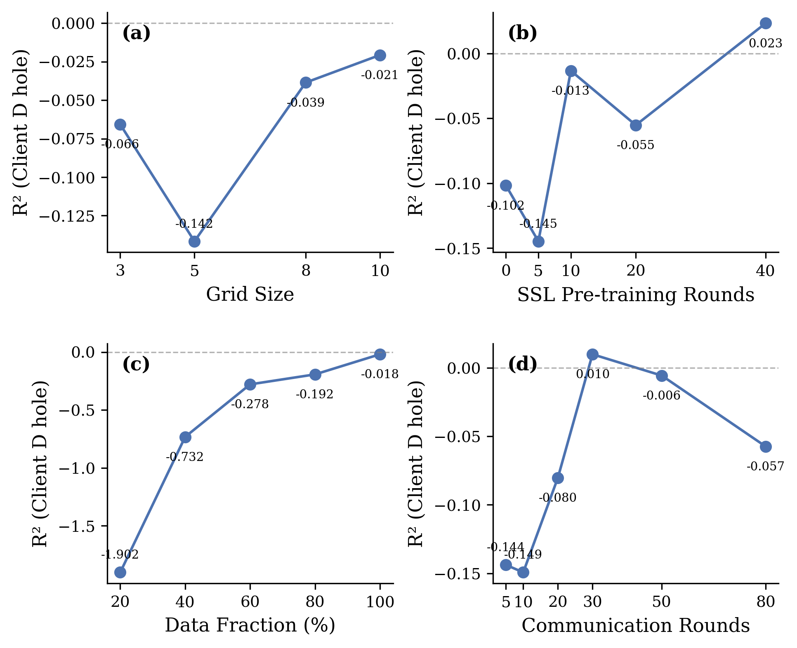
Figure S1. Ablation studies on Client D λ_hole (LOOCV). (a) KAN B-spline grid size. (b) Federated SSL pre-training rounds. (c) Client D data fraction. (d) Communication rounds. Dashed gray line indicates R² = 0.
Source Data S1a. KAN Grid Size Ablation
Grid | MAE (eV) | R² | RMSE (eV)
3 | 0.365 | -0.066 | 0.512
5 | 0.384 | -0.142 | 0.530
8 | 0.365 | -0.039 | 0.506
10 | 0.358 | -0.021 | 0.501
Source Data S1b. SSL Pre-training Rounds Ablation
Rounds | MAE (eV) | R² | RMSE (eV)
0 | 0.382 | -0.102 | 0.521
5 | 0.391 | -0.145 | 0.531
10 | 0.377 | -0.013 | 0.499
20 | 0.364 | -0.055 | 0.510
40 | 0.352 | 0.023 | 0.490
Source Data S1c. Client D Data Size Ablation
Fraction | n | MAE (eV) | R² | RMSE (eV)
0.2 | 10 | 0.779 | -1.902 | 1.016
0.4 | 21 | 0.545 | -0.732 | 0.732
0.6 | 31 | 0.397 | -0.278 | 0.563
0.8 | 42 | 0.387 | -0.192 | 0.547
1.0 | 53 | 0.350 | -0.018 | 0.501
Source Data S1d. Communication Rounds Ablation
Rounds | MAE (eV) | R² | RMSE (eV)
5 | 0.398 | -0.144 | 0.531
10 | 0.374 | -0.149 | 0.532
20 | 0.368 | -0.080 | 0.516
30 | 0.352 | 0.010 | 0.494
50 | 0.351 | -0.006 | 0.497
80 | 0.382 | -0.057 | 0.510

S2.3 Centralized Training Details
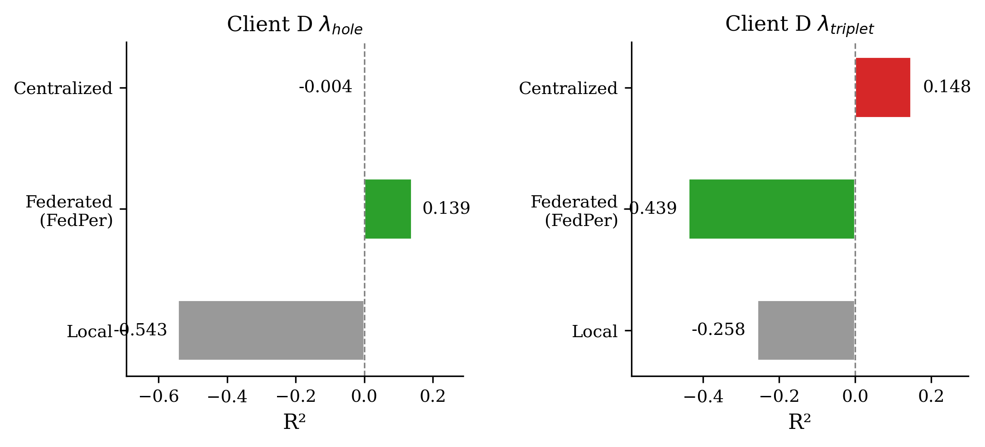
Figure S5. Comparison of Local, Federated (FedPer), and Centralized SchNet+KAN training on Client D (LOOCV). Left: λ_hole (n = 53). Right: λ_triplet (n = 49). Dashed line indicates R² = 0.
Source Data S5. Centralized SchNet+KAN Training on Client D (LOOCV)
Target | MAE (eV) | R² | RMSE (eV) | n | Time (s)
hole | 0.300 | -0.004 | 0.497 | 53 | 30970
triplet | 0.563 | 0.148 | 0.688 | 49 | 28430
Centralized model trained on pooled data from all four clients.

S2.4 Subgroup Analysis Details
Table S8. Top 15 Subgroup Filters by SchNet R² (Client D λ_hole)
Filter | n | SchNet R² | SchNet MAE | GIN R² | GIN MAE
DA>=0.25 & rot=0 | 13 | 0.852 | 0.117 | 0.317 | 0.258
n_cyano>=1 & DA>=0.25 | 13 | 0.662 | 0.187 | 0.087 | 0.370
n_cyano>=2 & DA>=0.25 | 13 | 0.662 | 0.187 | 0.087 | 0.370
DA>=0.2 & DA>=0.25 | 19 | 0.515 | 0.245 | 0.049 | 0.390
DA>=0.25 | 19 | 0.515 | 0.245 | 0.049 | 0.390
DA>=0.25 & TPSA_hi | 19 | 0.515 | 0.245 | 0.049 | 0.390
DA>=0.25 & has_5ring | 19 | 0.515 | 0.245 | 0.049 | 0.390
DA>=0.25 & n_het>=4 | 19 | 0.515 | 0.245 | 0.049 | 0.390
n_N>=2 & DA>=0.25 | 18 | 0.514 | 0.256 | 0.049 | 0.407
n_N>=1 & DA>=0.25 | 18 | 0.514 | 0.256 | 0.049 | 0.407
n_cyano>=2 & DA>=0.2 | 15 | 0.488 | 0.226 | 0.138 | 0.337
n_cyano>=1 & DA>=0.2 | 15 | 0.488 | 0.226 | 0.138 | 0.337
DA>=0.25 & bertz_hi | 17 | 0.485 | 0.266 | 0.007 | 0.412
DA>=0.25 & HA>=14 | 17 | 0.485 | 0.266 | 0.007 | 0.412
n_cyano>=2 & TPSA_hi | 17 | 0.475 | 0.216 | -0.048 | 0.365
DA = donor atom fraction (N, O, S atoms / total heavy atoms); rot = number of rotatable bonds.

S2.5 Per-Molecule Prediction Results
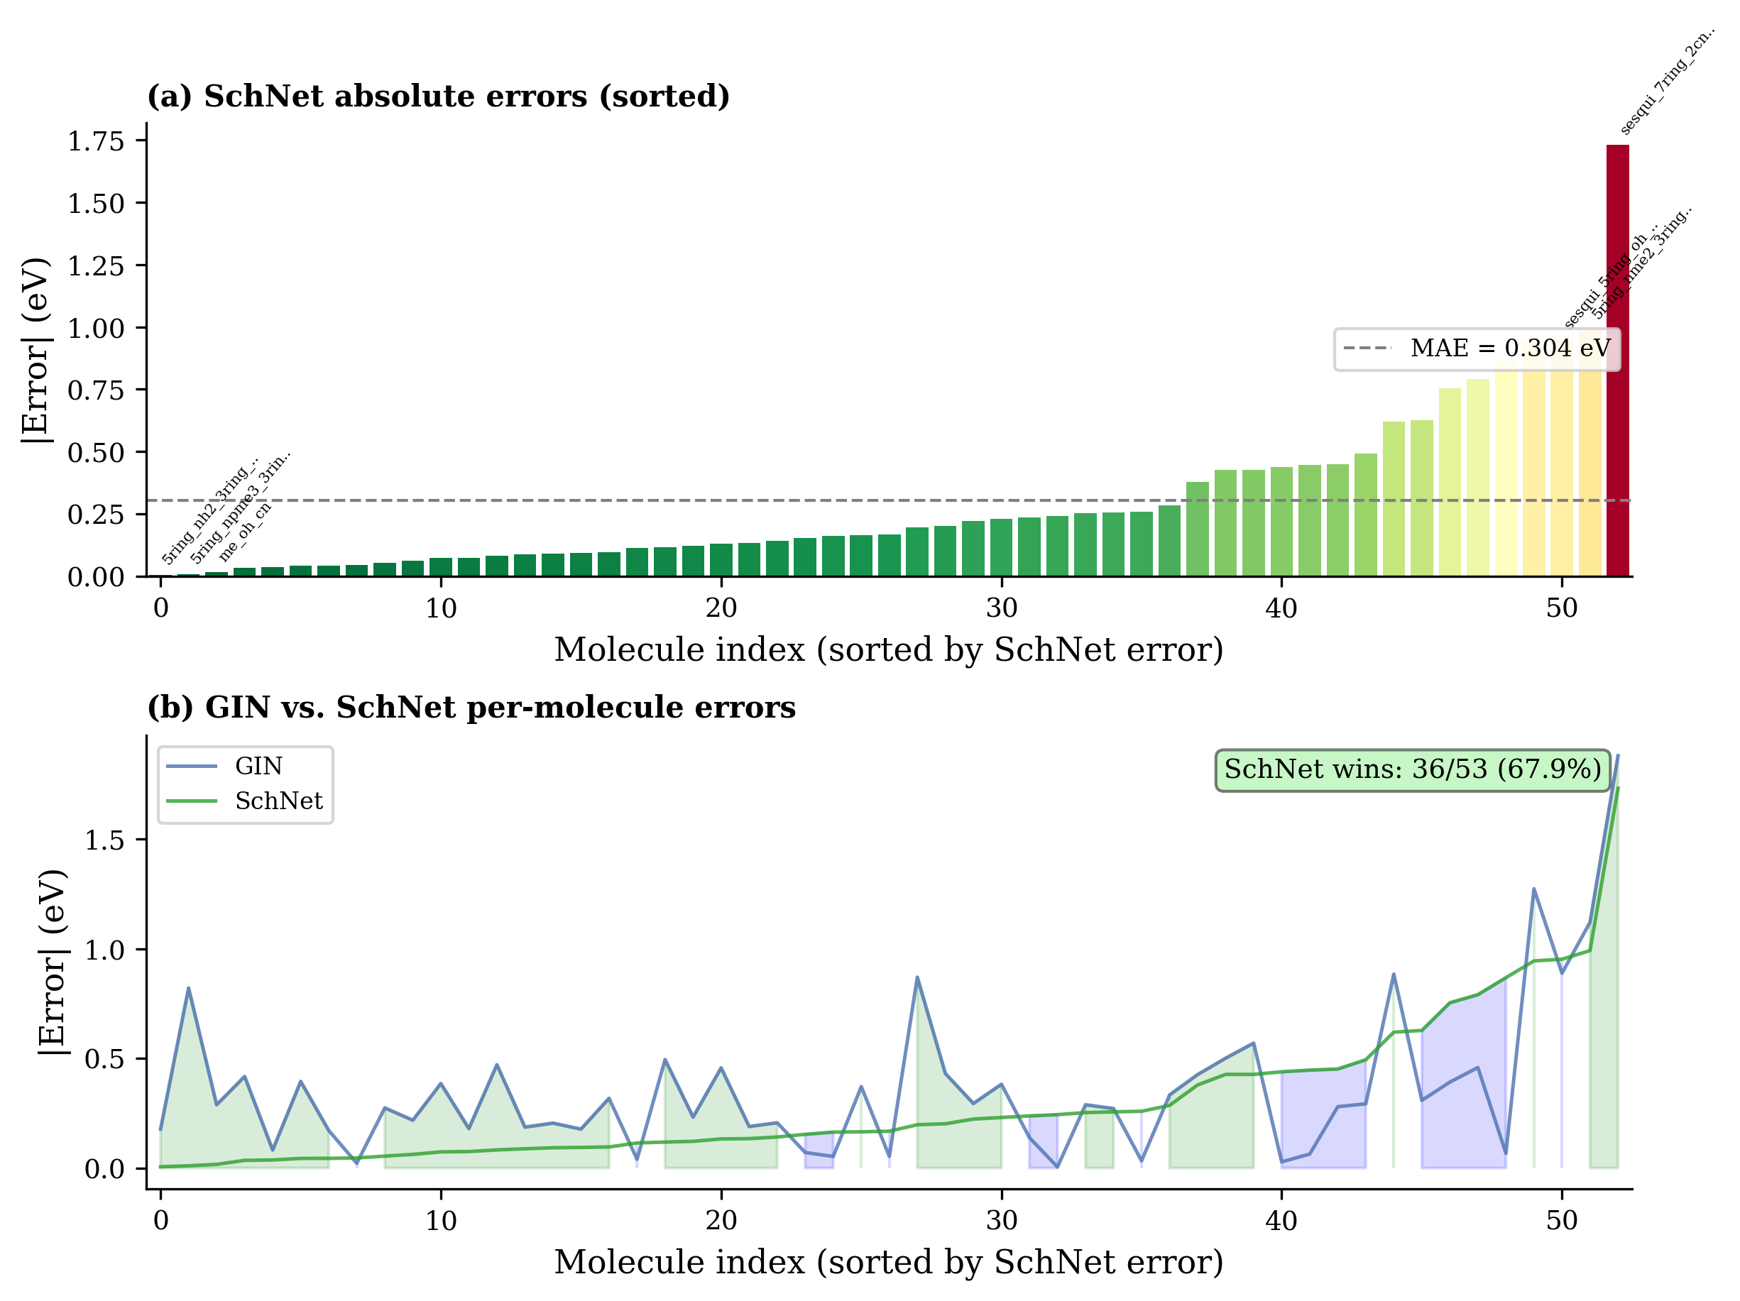
Figure S6. Per-molecule LOOCV prediction errors for all 53 Client D molecules. (a) SchNet absolute errors sorted in ascending order; color gradient from green (low error) to red (high error); dashed line shows the MAE. (b) GIN vs. SchNet error comparison; shaded regions indicate which encoder performs better for each molecule.
Source Data S6. Per-Molecule LOOCV Predictions (53 Client D Molecules)
Molecule | y_true | GIN pred | SchNet pred | |err| GIN | |err| SchNet | n_rot | MW
3ring_bh2 | 1.057 | 1.195 | 0.819 | 0.138 | 0.237 | 0 | 125.8
3ring_cn | 1.275 | 1.057 | 1.213 | 0.218 | 0.062 | 0 | 152.2
3ring_nh2 | 0.797 | 1.292 | 0.679 | 0.494 | 0.118 | 0 | 132.2
3ring_oh | 0.961 | 1.167 | 1.102 | 0.206 | 0.141 | 0 | 134.1
5ring_bh2_both | 1.405 | 1.117 | 1.153 | 0.288 | 0.253 | 0 | 149.4
5ring_bh2_in | 0.919 | 1.211 | 1.412 | 0.292 | 0.493 | 0 | 125.8
5ring_bh2_out | 1.458 | 1.076 | 1.228 | 0.382 | 0.230 | 0 | 125.8
5ring_cn_both | 0.449 | 1.319 | 0.252 | 0.870 | 0.197 | 0 | 202.2
5ring_cn_in | 0.502 | 1.071 | 0.929 | 0.569 | 0.427 | 0 | 152.2
5ring_cn_out | 0.811 | 0.988 | 0.717 | 0.177 | 0.094 | 0 | 152.2
5ring_me_3ring_cf3_in | 0.776 | 1.147 | 0.941 | 0.371 | 0.165 | 0 | 266.2
5ring_me_3ring_cn_both | 0.779 | 1.235 | 0.911 | 0.457 | 0.133 | 0 | 208.3
5ring_me_3ring_cn_in | 0.734 | 1.119 | 0.807 | 0.385 | 0.073 | 0 | 180.2
5ring_me_3ring_cn_out | 1.046 | 1.110 | 0.600 | 0.064 | 0.446 | 0 | 180.2
5ring_nh2_3ring_NO | 1.479 | 1.308 | 1.523 | 0.171 | 0.044 | 0 | 190.2
5ring_nh2_3ring_NO2 | 1.575 | 1.547 | 1.136 | 0.028 | 0.439 | 2 | 222.2
5ring_nh2_3ring_cn_bot | 1.911 | 1.734 | 1.916 | 0.177 | 0.006 | 0 | 212.2
5ring_nh2_3ring_cn_in | 1.479 | 1.290 | 1.345 | 0.189 | 0.134 | 0 | 182.2
5ring_nh2_3ring_cn_out | 0.907 | 1.302 | 0.864 | 0.395 | 0.044 | 0 | 182.2
5ring_nh2_both | 1.857 | 1.539 | 1.953 | 0.318 | 0.096 | 0 | 162.2
5ring_nh2_in | 1.431 | 1.199 | 1.553 | 0.232 | 0.122 | 0 | 132.2
5ring_nh2_out | 0.915 | 1.224 | 1.542 | 0.308 | 0.627 | 0 | 132.2
5ring_nme2 | 1.471 | 1.177 | 1.694 | 0.294 | 0.223 | 2 | 188.3
5ring_nme2_3ring_cn_in | 1.501 | 1.315 | 1.589 | 0.186 | 0.088 | 2 | 238.3
5ring_nme2_3ring_nn+ | 2.428 | 1.308 | 1.437 | 1.120 | 0.991 | 3 | 242.3
5ring_nph3_3ring_CN | 2.505 | 1.232 | 1.561 | 1.273 | 0.944 | 2 | 246.2
5ring_npme3 | 0.956 | 1.373 | 0.990 | 0.417 | 0.035 | 2 | 280.3
5ring_npme3_3ring_CN | 0.967 | 1.787 | 0.957 | 0.821 | 0.010 | 2 | 330.3
5ring_oh_3ring_bh2_in | 1.538 | 1.258 | 1.087 | 0.280 | 0.451 | 0 | 157.8
5ring_oh_3ring_cf3_sp | 1.100 | 1.133 | 1.359 | 0.033 | 0.259 | 0 | 270.1
5ring_oh_3ring_cn_both | 1.265 | 1.318 | 1.101 | 0.053 | 0.164 | 0 | 216.2
5ring_oh_3ring_cn_in | 1.057 | 1.097 | 0.943 | 0.040 | 0.114 | 0 | 184.2
5ring_oh_3ring_cn_out | 0.617 | 1.118 | 1.044 | 0.501 | 0.427 | 0 | 184.2
5ring_oh_both | 1.191 | 1.109 | 1.228 | 0.082 | 0.037 | 0 | 166.1
5ring_oh_in | 0.988 | 1.167 | 1.063 | 0.180 | 0.075 | 0 | 134.1
5ring_oh_out | 0.709 | 1.139 | 0.910 | 0.431 | 0.202 | 0 | 134.1
5ring_ome_3ring_cn_in | 0.935 | 1.209 | 0.989 | 0.274 | 0.054 | 2 | 212.2
5ring_ome_3ring_cn_out | 0.812 | 1.283 | 0.894 | 0.471 | 0.083 | 2 | 212.2
5ring_sh_3ring_cn_in_v | 1.435 | 1.164 | 1.179 | 0.271 | 0.256 | 0 | 216.3
CLOFUL | 0.853 | 1.279 | 0.474 | 0.426 | 0.379 | 2 | 392.1
calicene | 1.107 | 1.053 | 1.274 | 0.053 | 0.168 | 0 | 102.1
cf3_oh_cn_v2 | 1.083 | 1.415 | 1.368 | 0.333 | 0.285 | 0 | 320.1
f_oh_cn | 1.023 | 1.094 | 0.870 | 0.070 | 0.154 | 0 | 220.1
me_oh_cn | 0.972 | 1.260 | 0.988 | 0.288 | 0.017 | 0 | 212.2
sesqui_5ring_2nh2 | 1.474 | 1.470 | 1.231 | 0.004 | 0.243 | 0 | 184.2
sesqui_5ring_2nph3 | 1.036 | 1.494 | 1.826 | 0.458 | 0.790 | 2 | 248.2
sesqui_5ring_oh | 1.355 | 1.334 | 1.309 | 0.022 | 0.046 | 0 | 186.2
sesqui_5ring_oh_7ring_ | 1.577 | 1.510 | 2.445 | 0.067 | 0.868 | 0 | 236.2
sesqui_5ring_oh_7ring_ | 2.121 | 1.233 | 1.169 | 0.888 | 0.952 | 0 | 222.2
sesqui_7ring_2NN+ | 0.892 | 1.776 | 1.512 | 0.884 | 0.619 | 1 | 208.2
sesqui_7ring_2cn_in | 3.004 | 1.125 | 1.273 | 1.879 | 1.731 | 0 | 204.2
sesquifulvalene | 0.855 | 1.246 | 1.608 | 0.392 | 0.753 | 0 | 154.2
sh_oh_cn | 1.070 | 1.274 | 0.978 | 0.205 | 0.092 | 0 | 248.3
GIN = E32 (FedBN 4-Client GIN+KAN). SchNet = E51 (FedAvg SchNet+KAN). n_rot = rotatable bonds. MW = molecular weight (Da).

S3. Correlation Analysis
Pearson correlation between GIN absolute prediction error and number of rotatable bonds across all 53 Client D molecules: r = 0.301, p = 0.028 (two-tailed). Pearson correlation between SchNet absolute prediction error and number of rotatable bonds: r = 0.159, p = 0.256 (two-tailed). These statistics were computed using scipy.stats.pearsonr on the LOOCV predictions from experiments E32 (GIN, FedBN 4-Client GIN+KAN) and E51 (SchNet, FedAvg SchNet+KAN).

S4. Software and Hardware
Table S10. Software Dependencies
Package | Version | Purpose
Python | 3.10 | Runtime environment
PyTorch | 2.7.1+cu126 | Deep learning framework
PyTorch Geometric | 2.3.0 | Graph neural networks
RDKit | 2024.09.6 | Molecular processing and conformer generation
efficient-kan | — | KAN layer implementation
NumPy | 2.2.6 | Numerical computing
scikit-learn | 1.6.1 | Evaluation metrics and preprocessing
CUDA | 12.6 | GPU computing toolkit
NVIDIA Driver | 550.144.03 | GPU driver
Versions determined at runtime via package __version__ attributes.
Table S11. Hardware Configuration
Component | Specification
GPU | 2× NVIDIA A30 (24 GB VRAM each)
CPU | Intel Xeon Platinum 8260 @ 2.40 GHz
RAM | 252 GB DDR4
GPU allocation | GPU 0: Client A training; GPU 1: Clients B, C, D training
Federated aggregation | CPU (parameter averaging only, no GPU required)

S5. Data Availability
The QM9-derived dataset for Clients A and B (15,210 molecules) was curated from publicly available quantum chemistry databases. The Atahan-Evrenk dataset for Client C is available from the original publication (J. Phys. Chem. A, 2019, 123, 7855–7863; DOI: 10.1021/acs.jpca.9b02733). Client D TADF data are available upon reasonable request from the corresponding author. Code and trained models will be released upon acceptance.

