UAV-GAP / CORE RESEARCH EVIDENCE
Two variability spaces • Cross-model interactions • Robustness gaps
01 Validated variability spaces
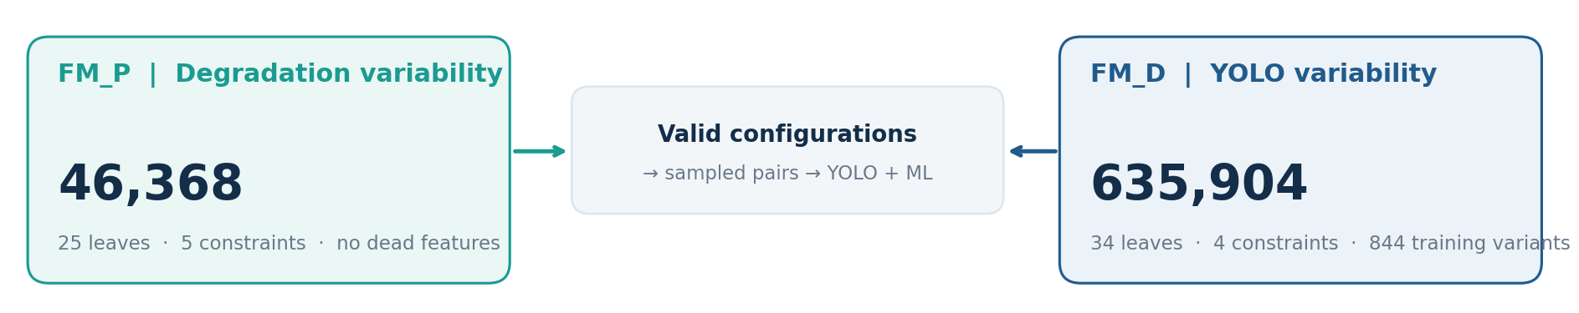
THEORETICAL CROSS-PRODUCT 29,485,596,672 configuration pairs | not an executed evaluation count
02 Interaction: resolution × blur × JPEG | development evidence
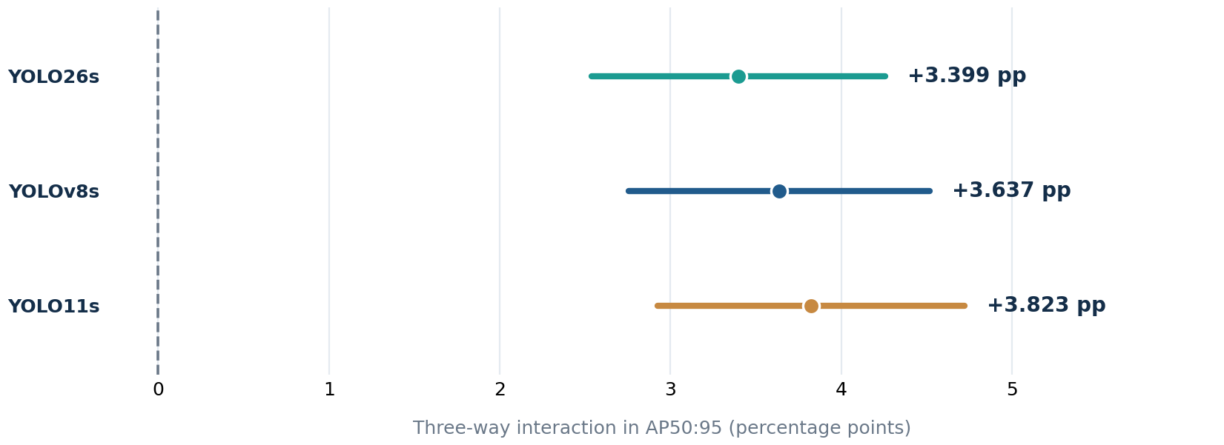 | KEY FINDING  The effect of higher inference resolution changes with blur and JPEG conditions.  All three reported three-way contrasts have positive 95% simultaneous intervals.  DEVELOPMENT ONLY · No independent held-out ML result.
Source: VM26 / CV261207 accepted historical development evidence; 300 VisDrone val images; confidence intervals from the reported joint bootstrap.

UAV-GAP / CORE RESEARCH EVIDENCE
Static coverage sensitivity • Measured severe-blur failures • Supported conclusions
03 Static gap | augmentation coverage assumptions
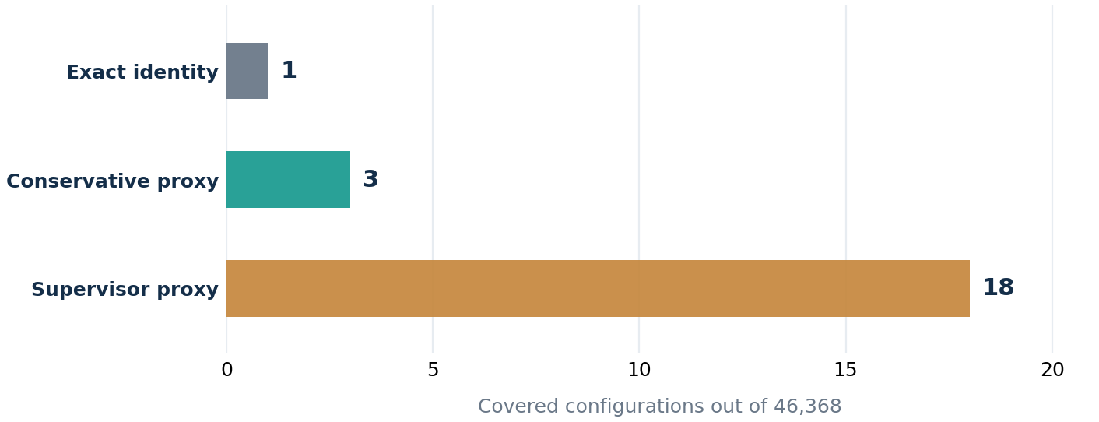 | STATIC UNCOVERED  46,367 · exact identity  46,365 · conservative proxy  46,350 · supervisor proxy  A static gap is NOT a measured detector-failure rate.

04 Measured Tiny-object failure | evaluated detector subset
6  detector settings  3 checkpoints × 2 resolutions | 2  severe-blur conditions  B2 × JPEG None / Q50 | < 0.10  Tiny AP50:95 upper CI  all six settings in both conditions
Conclusion: under the chosen Tiny AP threshold, the six measured settings fail in these two severe-blur conditions; no claim about the full FM_D space.
05 Conclusions and evidence boundary
RQ1 | LOGIC VALIDATED | FM_P and FM_D are satisfiable with no dead features; complete detector deployability is not established.
RQ2 | DEVELOPMENT EVIDENCE | Resolution benefits are jointly conditioned by blur and JPEG; independent predictive validation remains open.
RQ3 | PARTIAL | Static coverage is policy-sensitive; real subset failures are observed, but global empirical gap is unknown.
RQ4 | NOT EVALUATED | No gap-closure effect can be claimed without matched targeted-augmentation training.
Evidence scope: historical development data; formal independent test-dev 0/500. CIs are reported source results, not newly recomputed from raw bootstrap samples.

