# 安装

## 准备yum server源

### 安装服务端yum源

yum install https://dl.fedoraproject.org/pub/epel/epel-release-latest-7.noarch.rpm

### 同步yum源到本地

yum -y install yum-utils createrepo yum-plugin-priorities

yum repolist

cd /work/yum/

yum repolist #获取yum源id

reposync --repoid=epel #时间非常长，考虑使用screen，同步完成之后配置http访问仓库

createrepo --update /work/yum/epel

### 配置nginx

location /yum {

alias /work/yum/docker-ce-stable;

allow 10.10.4.123; #限制访问

deny all;

}

### 客户端配置使用yum源

[root@localhost yum.repos.d]# more server.repo

[base]

name=base

baseurl=http://a3.189young.com/yum

enabled=1

gpgcheck=0

[root@localhost yum.repos.d]#

### 安装docker和docker-compose

yum -y install docker-ce

curl -L "https://github.com/docker/compose/releases/download/1.24.1/docker-compose-$(uname -s)-$(uname -m)" -o /usr/local/bin/docker-compose

chmod +x /usr/local/bin/docker-compose

## 服务

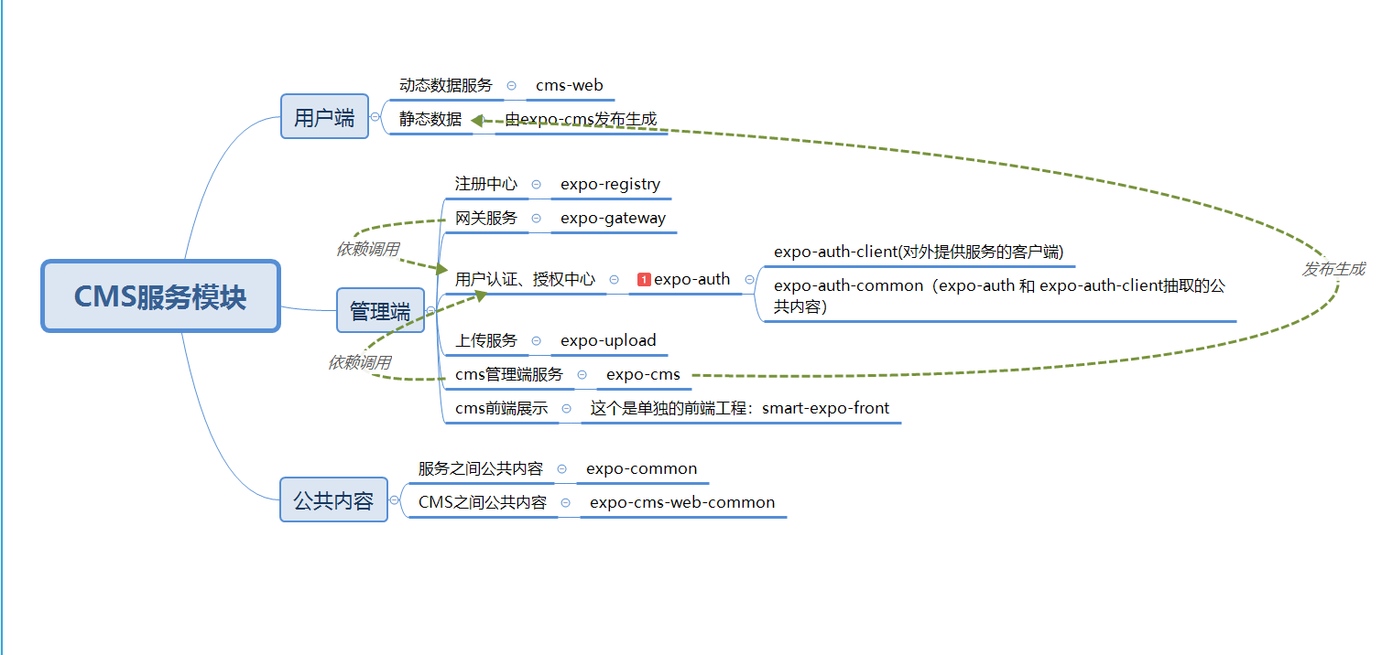

### 服务分类

服务分为三部分组成：

第三方服务：包含Mariadb-server，redis，Elasticsearch

后台服务：

expo-registry

expo-weixin-gataway

expo-gateway

expo-gateway-front

expo-weixin-gateway

expo-activity

expo-sign

expo-questionnaire

expo-auth

expo-cms

expo-cms-web

expo-upload

expo-log

前台服务：

expo-cms

### 启动第三服务

docker-compose -f /smart-expo/smart-expo/deploy/152/docker-compose-thrid-152.yaml up -d

### 启动后台服务

* 启动注册中心

docker-compose -f /smart-expo/smart-expo/deploy/152/docker-compose-registry-152.yaml up -d

* 启动网关

docker-compose -f /smart-expo/smart-expo/deploy/152/docker-compose-gateway-152.yaml up -d

* 启动链路追踪

docker-compose -f /smart-expo/smart-expo/deploy/152/docker-compose-zipkin-152.yaml up -d

* 启动认证、问卷、签到、上传等服务

docker-compose -f /smart-expo/smart-expo/deploy/152/docker-compose-152.yaml up -d