Ho va ten: Le Ngoc Dung
MSSV: 22684211

- docker --version
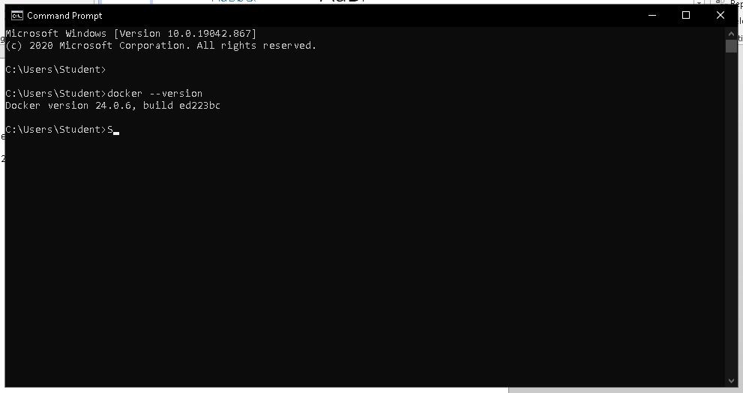
- docker run hello-world
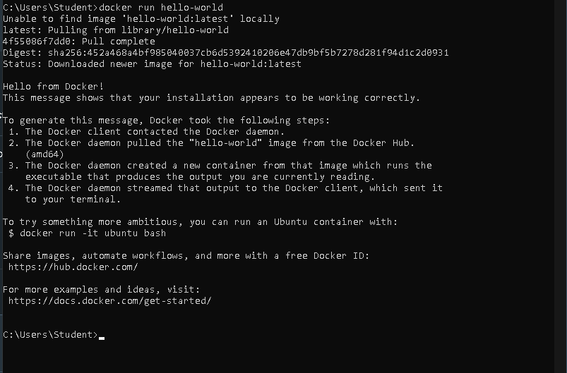
- docker pull nginx

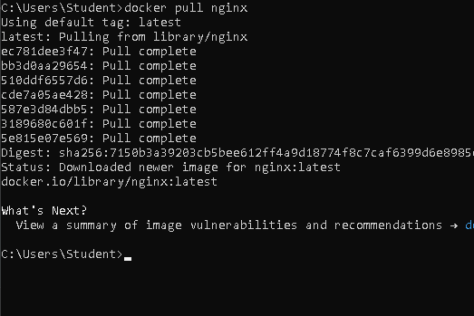
- docker images
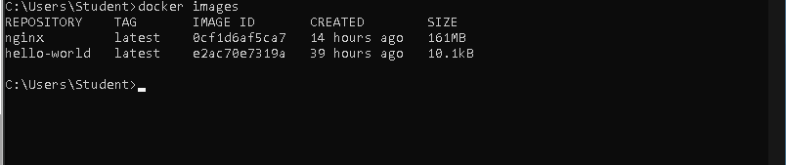
- docker run -d nginx
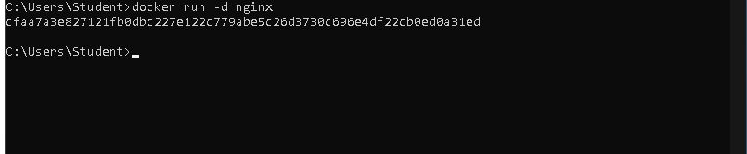

- docker ps
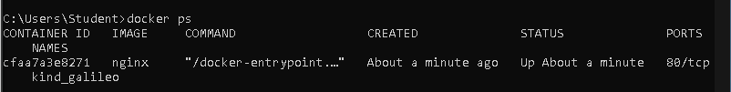
- docker ps –a
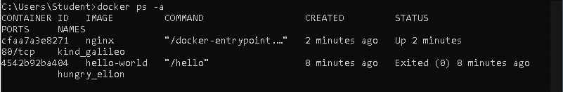

- docker logs <container_id>
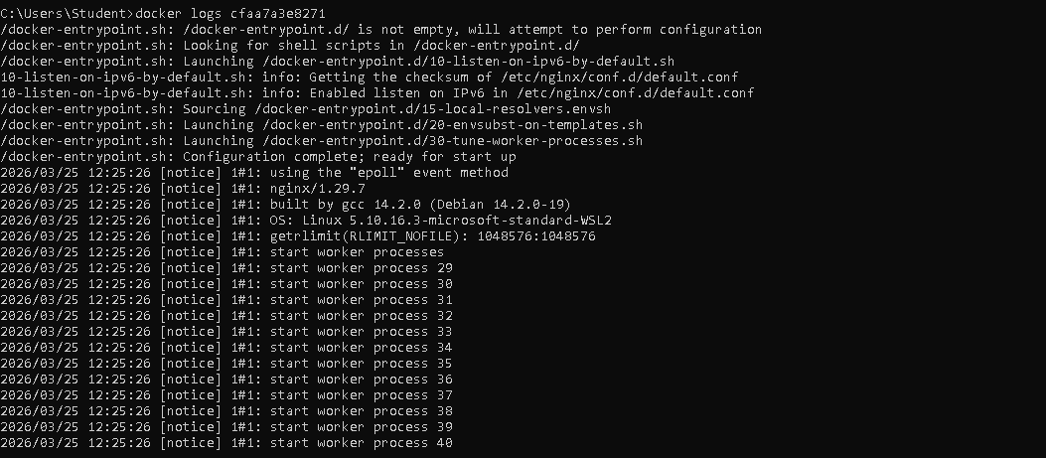
- docker exec -it <container_id> /bin/sh
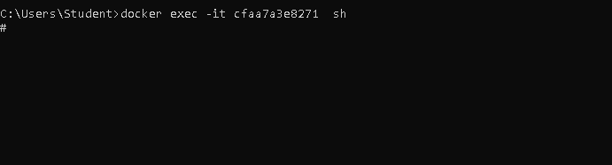

- docker stop <container_id>

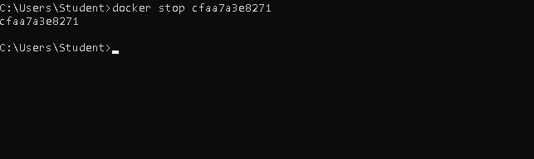

- docker restart <container_id>

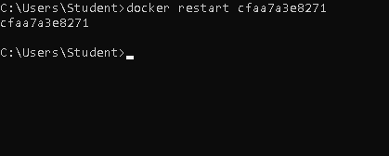
- docker rm <container_id>
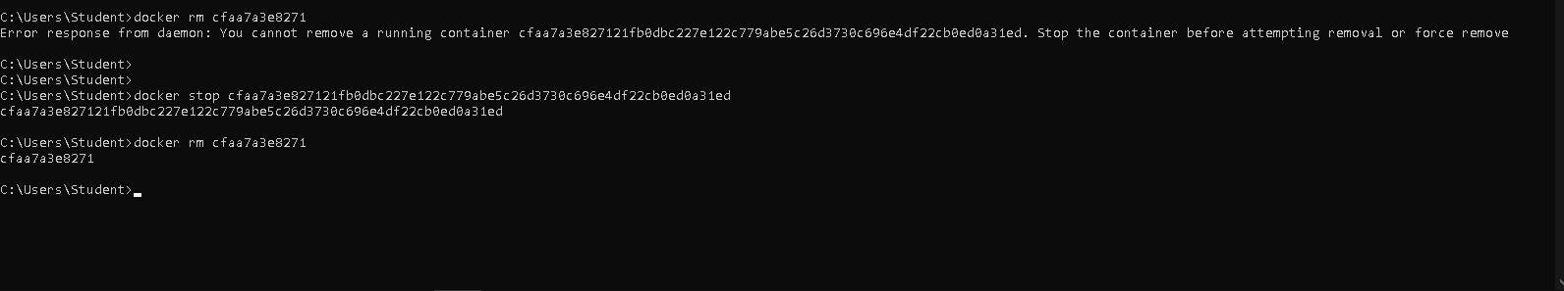
- docker container prune

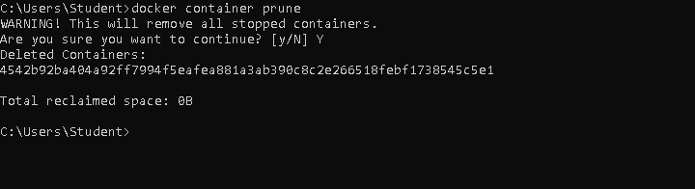

- docker rmi <image_id>
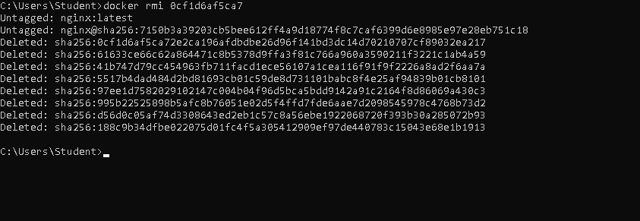

- docker image prune –a

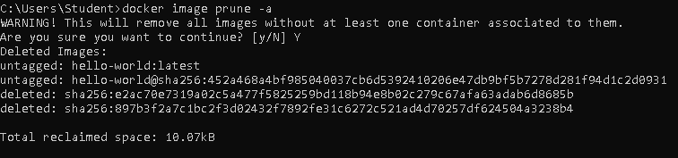

- docker run -d -p 8080:80 nginx
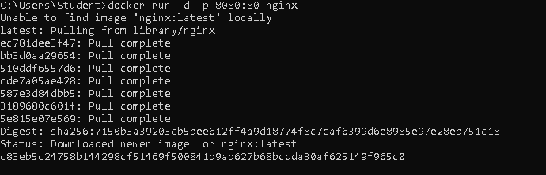
- docker inspect <container_id>
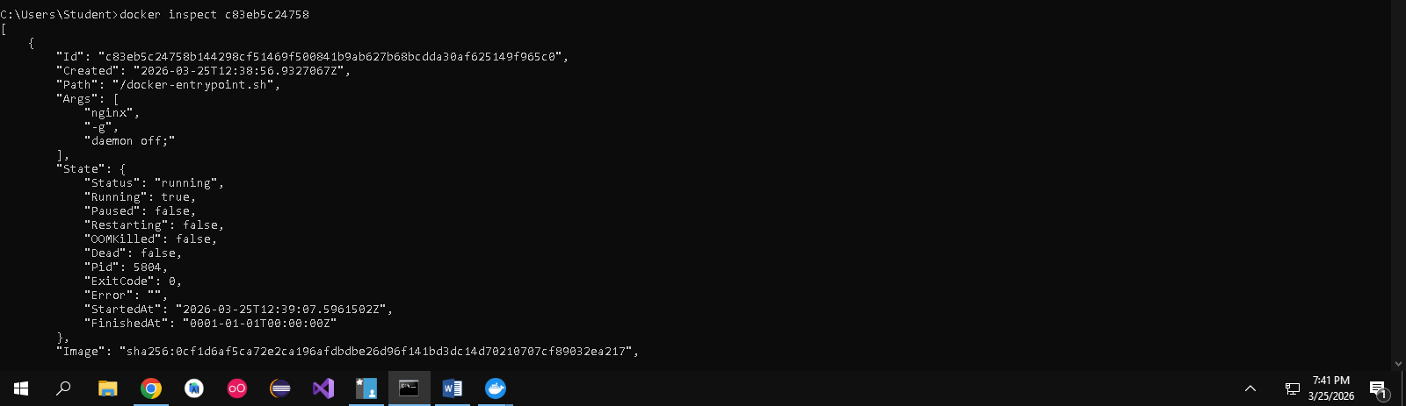
- docker run -d -v mydata:/data nginx
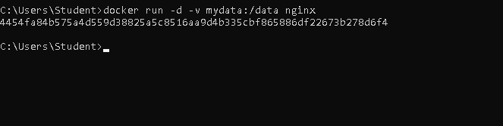

- docker volume ls
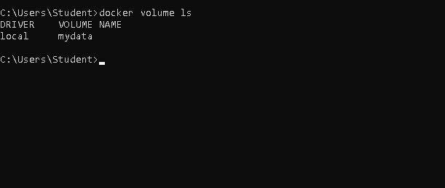

- docker volume prune
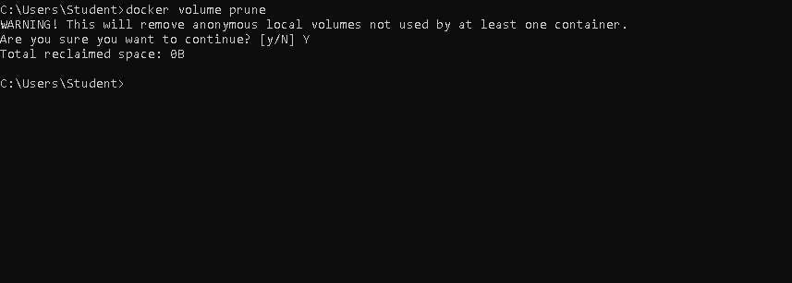

- docker run -d --name my_nginx nginx

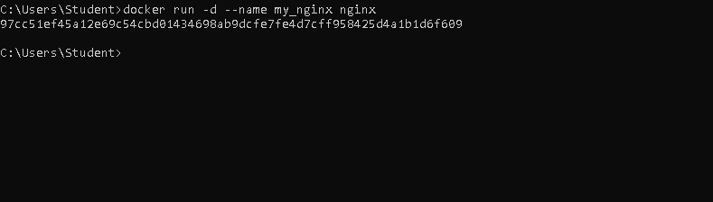

- docker stats
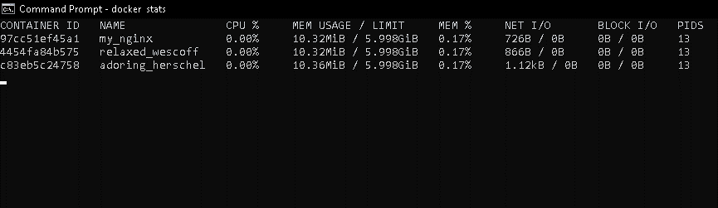

- docker network ls
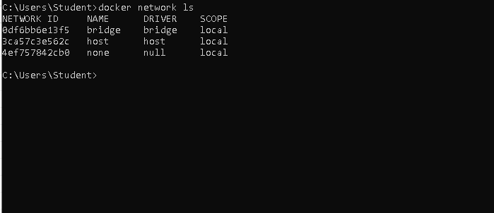

- docker network create my_network
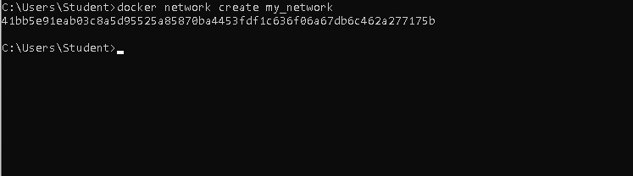

- docker run -d --network my_network --name my_container nginx

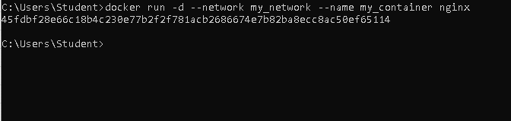

- docker network connect my_network my_nginx

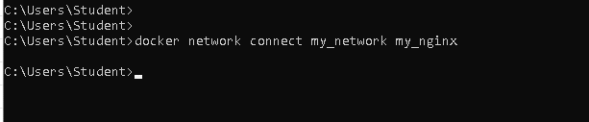

- docker run -d -e MY_ENV=hello_world nginx

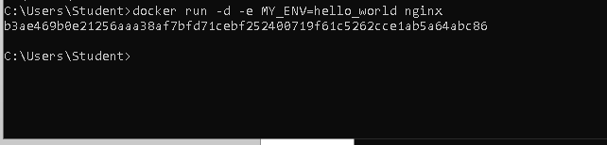
- docker logs -f my_nginx
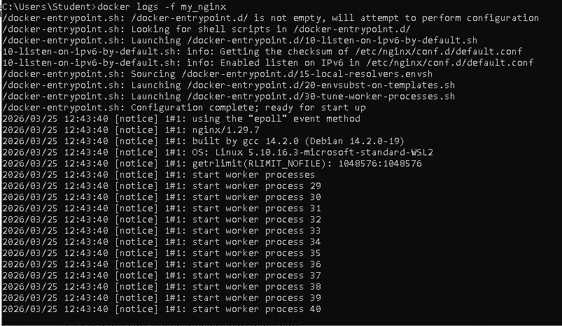

- docker build -t my_nginx_image .
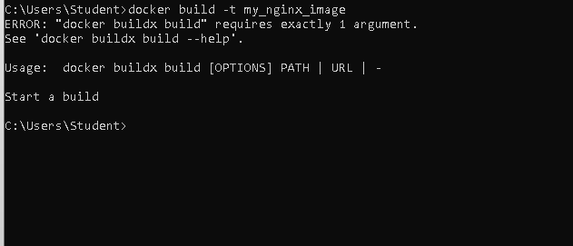

- docker run -d -p 8080:80 my_nginx_image

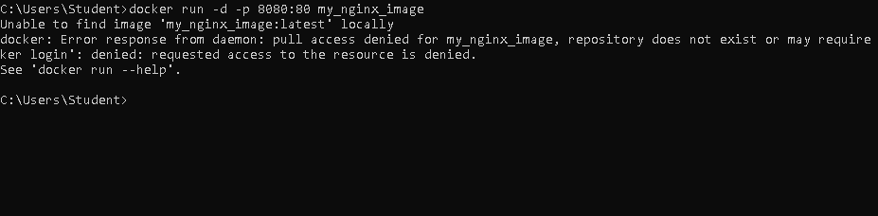

Phan 2:

