**RLC Circuit**

An RLC circuit consists of resistors, inductors and capacitors. It represents a standard example of a harmonic oscillator, namely a device which is able to resonate to a sinusoidal input signal (e.g. voltage or current). The figure below is an RLC circuit with one resistor, one capacitor and one inductor.

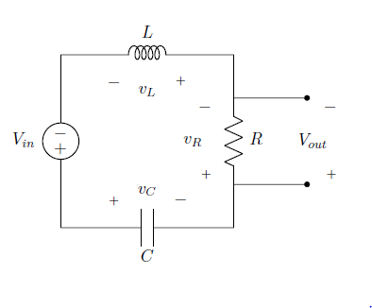

By applying Kirchhoff’s Law, this system could be modelled by three equations as follows:

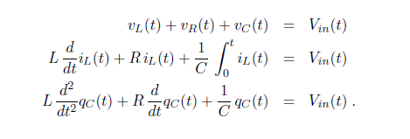

The given conditions are:

* the capacitor is pre-charged at time t = 0 with qc(0) = 500 nC
* no initial current flows through the inductor at time t = 0
* R = 250Ω; C = 3 μF; L = 650mH:

**Runge-Kutta 4th Order Method**

Runge-Kutta Methods are widely used to solve 1st order ODE’s. In this report, the fourth-order Runge-Kutta 3/8 algorithm is implemented in Matlab to solve the RLC system. The 3/8 method is a fourth order Runge-Kutta method for approximating the solution of the initial value problem y'(x) = f(x,y); y(x0) = y0 which evaluates the integrand, f(x,y), four times per step. For step i+1,

yi+1 = yi + 1/8 ( k1 + 3*k2 + 3*k3 + k4 ), where

k1 = h*f(xi, yi),

k2 = h*f(xi + h / 3, yi + k1 / 3 ),

k3 = h*f(xi + 2*h / 3, yi - k1 / 3 + k2 ),

k4 = h*f(xi + h, yi + k1 - k2 + k3 ),

and xi = x0 + i*h.

However, at this point the system is a 2nd order ODE and it 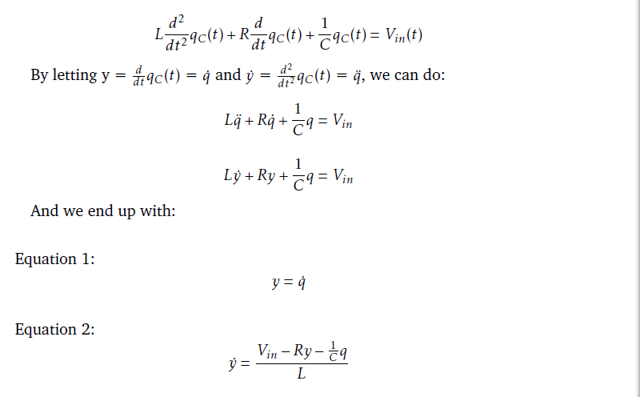needs to be reconstructed to a coupled form.

Using the Runge-Kutta 3/8 algorithm and the coupled equation, the matlab function called **RK4second.m** and a matlab script called **RLC script.m** are established:

The function call includes arguments xi, yi and ti and returns xi+1 and yi+1

% reference from http://www.mymathlib.com/diffeq/runge-kutta/runge_kutta_3_8.html

%

%yi+1 = yi + 1/8 ( k1 + 3 k2 + 3 k3 + k4 ),

%where

%k1 = hf(xi, yi),

%k2 = hf(xi + h / 3, yi + k1 / 3 ),

%k3 = hf(xi + 2 h / 3, yi - k1 / 3 + k2 ),

%k4 = hf(xi + h, yi + k1 - k2 + k3 ),

%and xi = x0 + i h

function [xii,yii] = RK4second(xi,yi,t,h,f1,f2)

k1 = h*f2(xi, yi, t);

k2 = h*f2(xi+h/3, yi+k1/3, t);

k3 = h*f2(xi+2*h/3, yi-k1/3+k2, t);

k4 = h*f2(xi+h, yi+k1-k2+k3, t);

yii = yi + 1/8*(k1 + 3*k2 + 3*k3 + k4);

xii = xi + h*f1(xi, yi, t);

end

The script below is used to simulate the RLC system and test the funtion under different input voltages.

function RLC_Script ()

close all;

clear;

clc;

%initailise parameters

R = 250; %resistance

C = 3e-6; %capacitance

L = 650e-3; %inductance

h = 0.00001; %stepsize

tf = 0.5; %final time

N = round(tf/h); %number of steps

q = zeros(1, N); %charge

i = zeros(1, N); %current dqc/dt

t = zeros(1, N); %x-axis

q(1) = 500e-9; %intial charge

i(1) = 0; %zero initial current

t(1) = 0; %start at time 0

Vout = zeros(1, N); %output voltage

%input

%case 1

%5V dc

% Vin = @(t)5*heaviside(t);

%case 2

% impluse signal with delay

%Vin = @(t)5*exp(-(t^2)/(3e-6));

%case 3

%Square Wave with freq 5Hz, 100Hz, 500Hz

% f=500;

% Vin = @(t)5*square(2*pi*f*t);

%case 4

%%Sine Wave with freq 5Hz, 100Hz, 500Hz

f =500;

Vin = @(t)5*sin(2*pi*f*t);

%coupled first order ODEs from calculation

f1 = @(q, i, t)i;

f2 = @(q, i, t)(Vin(t) - R*i - q/C )/L;

for k = 1 : N - 1

t(k + 1) = t(k) + h;

[q(k + 1), i(k + 1)] = RK4second(q(k), i(k), t(k), h, f1, f2);

Vout(k) = R*i(k);

end

plot(t,Vout);

hold on;

fplot(Vin,'--');

xlim([0,0.1]);

ylim([-6,6]);

xlabel('Time(s)');

ylabel('Vout(V)');

end

**Different Input Voltages**

1. 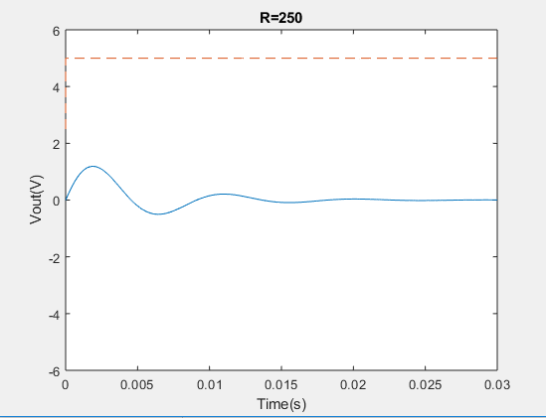Output for Step signal with amplitude of 5V

The output has a transient behaviour due to the capacitor and the inductor. The steady state is zero voltage, which means no current flow in the circuit due to the end of the charge processing for the capacitor. Furthermore, we could determine that the system undergoes an under-damping.

We have the equation

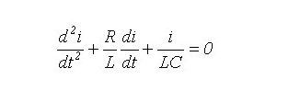

Now let

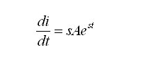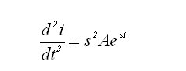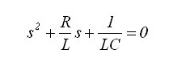

Hence:

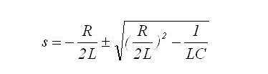The last equation is a quadratic equation in terms of s. The roots of this equation are:

We know that

* If the determinant is greater than zero, there are two real roots and the circuit is said to be over-damped.
* If the determinant is negative, there are two complex roots and the circuit is said to be under-damped.
* If the determinant equals to zero, there is only one root and the circuit is said to be critically damped.

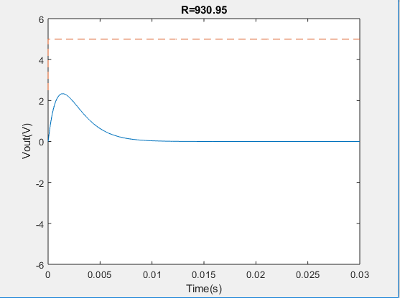In this case the determinant is negative, therefore the output response is under-damped. We change the resistance of the resistor to obtain the other cases. From our calculations, setting R to 930.95 could achieve the critical damping and any value greater than 920.95 would get the result for over-damping. Here is the experiment figure:

It can be easily discerned from the graph that there is no oscillation in this case.

1. Impulsive signal with decay

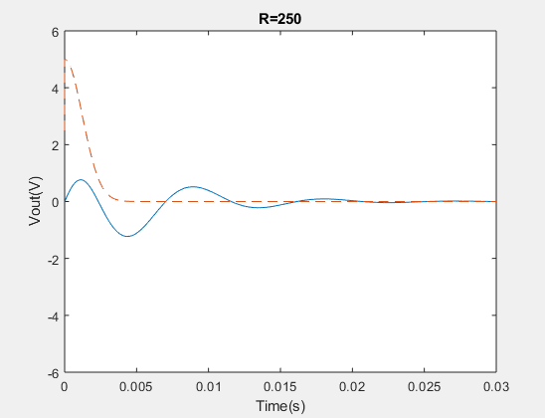

The input voltage can be described as follow

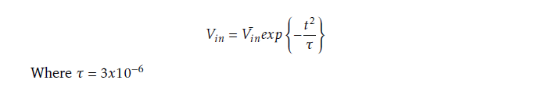

Compared with the step signal, the exponential decay is of the order $e^{{-t}^{2}}$, which leads to a very quick decay for the input signal. Although the impulse is of infinite amplitude, it decays to zero in an infinitesimal period of time and the output only rises for a bit. Besides, as in the previous example, the system is underdamped. Setting R to 930.35 could make a critical damping.

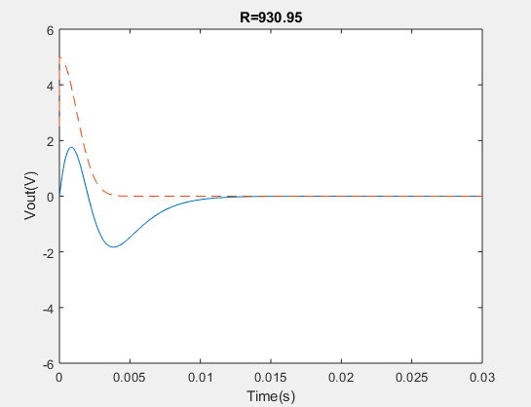

1. Square wave with different frequencies

For this part, three square waves of 5Hz, 100H and 500Hz are tested and the graphs for each output are shown below:

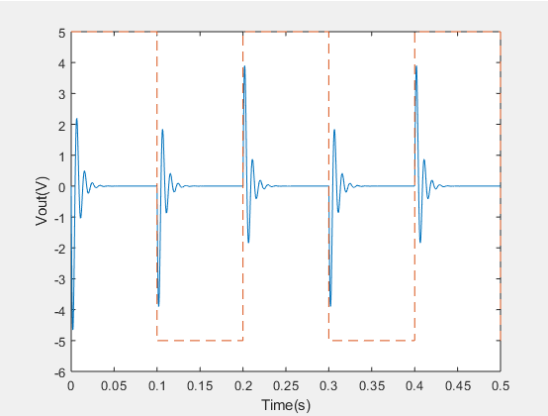

5Hz

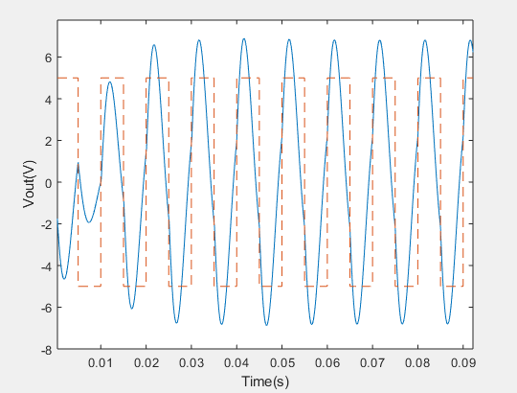

100Hz

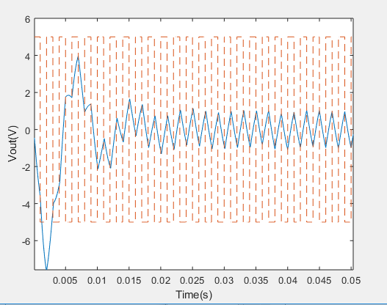

500Hz

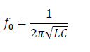When we are discussing periodic inputs, we should always consider the resonant frequency for the RLC circuit.

From the equation

We can get the resonant frequency for this circuit, 113.97Hz. Thus, when the input frequency is 5 Hz, which is much smaller than 113.97Hz, the circuit does not experience a resonance and the output at each square-wave edge has a similar behaviour to the step function. What’s more, the output could reach a steady state similarly.

When the input frequency is 100Hz, which is close to 114Hz, we could easily observe a resonant behaviour. The amplitude of the output voltage is greater than the input amplitude.

When the input frequency is 500Hz, which is much larger than 114Hz, the output is almost a sawtooth function. This is because of the fact that the output does not have enough time to reach steady state when the input square wave switches voltage.

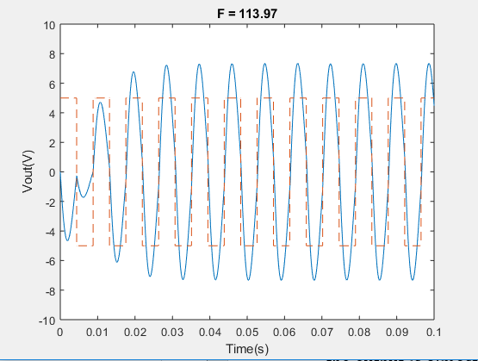The graph below shows the behaviour of the output voltage at resonant frequency. The amplitude of Vout is at maximum value.

1. Sine wave with different frequencies

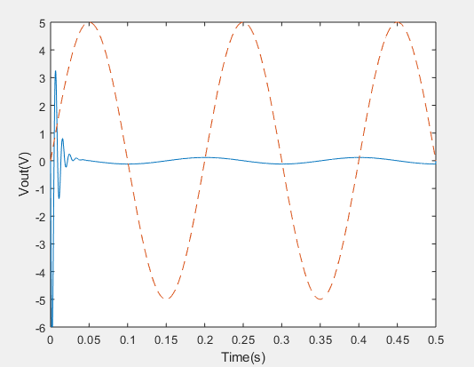For this part, three sine waves of 5Hz, 100H and 500Hz are tested and the pictures of each output are shown below:

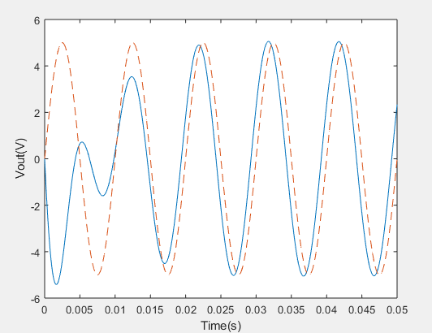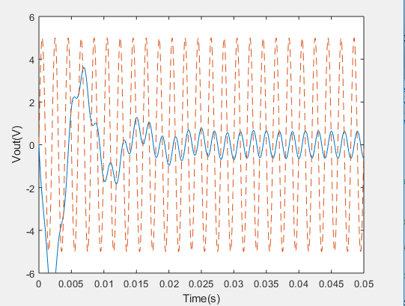

500Hz

100Hz

5Hz

As in the previous section, the resonant frequency is about 114Hz.

The first input is the sinusoid wave with frequency 5Hz which is much less than the resonance frequency. After it reaches a steady state, we observed that the output voltage amplitude is much smaller than the input voltage amplitude. However, the frequencies are the same.

When the input frequency is 100Hz (close to the resonant frequency) the resonance happens, and the output waveform becomes similar to the input signal.

When the input frequency is 500Hz, much larger than 114Hz, we see that the output is similar to a sawtooth function as the input switches voltage quickly. Nonetheless, the output at steady state is still a sinusoid wave with the same frequency of the input wave.