Plantecophys - An R Package for Analysing and Modelling Leaf Gas Exchange Data
Remko A. Duursma
Hawkesbury Institute for the Environment, Western Sydney University, Penrith, NSW, Australia
DOI: 10.1371/journal.pone.0143346
Source and license note: This DOCX is a test manuscript reconstructed from the open-access PLOS ONE article by Duursma (2015), distributed under CC BY. It is intended for Word2JATS conversion testing, not as the original publisher DOCX.

Abstract
Here I present the R package 'plantecophys', a toolkit to analyse and model leaf gas exchange data. Measurements of leaf photosynthesis and transpiration are routinely collected with portable gas exchange instruments, and analysed with a few key models. These models include the Farquhar-von Caemmerer-Berry model of leaf photosynthesis, the Ball-Berry models of stomatal conductance, and the coupled leaf gas exchange model. The package includes functions for fitting these models to measurements and simulating from the fitted models to aid in interpreting experimental data. This open-source package makes technically challenging calculations accessible for many users and is freely available on CRAN.
Keywords: photosynthesis; stomatal conductance; portable gas exchange instrument; process-based model; software

1 Introduction
Since the advent of portable gas exchange instruments, a wealth of data on leaf gas exchange of CO2 and H2O has been collected. These data play a central role in physiological plant ecology, helping researchers understand inter-specific differences in photosynthesis and transpiration.
The photosynthesis model of Farquhar, von Caemmerer and Berry, often called the FvCB model, is widely used in interpreting and modelling leaf gas exchange. The key prediction of the model is the response of photosynthesis to CO2 concentration inside the leaf air space. This model is embedded in many process-based models of vegetation function.
I do not repeat a detailed description of the FvCB model here, as it has been described many times. But generally it is of the form shown in Eq. (1). The variables and model components are discussed in the text and illustrated in Fig. 1.
$$A_n = min(A_c, A_j) - R_d$$
Equation (1). A compact representation of the FvCB model used in the paper.
where An is the net rate of CO2 assimilation, Ac is the gross photosynthesis rate when Rubisco activity is limiting, Aj when RuBP-regeneration is limiting, and Rd the rate of dark respiration.
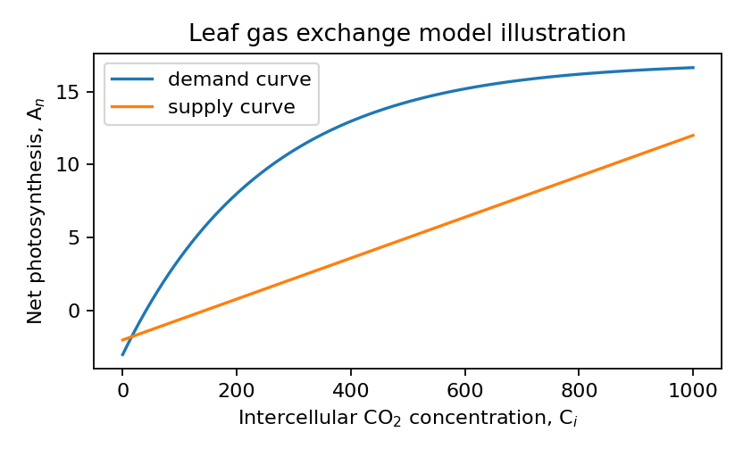
Fig. 1. Leaf photosynthesis and gas-exchange model illustration inspired by the original article.

2 Design and implementation

2.1 The main functions
The main tools included in the plantecophys package are used to fit A-Ci curves, fit Ball-Berry type models, simulate from the coupled leaf gas exchange model, and calculate optimal stomatal conductance. The key functions are summarized in Table 1.
Function | Description
fitaci | Fit, summarize, plot and simulate photosynthesis-CO2 response curves.
fitBB | Fit Ball-Berry type models of stomatal conductance.
FARAO | Estimate optimal stomatal conductance with a numerical implementation.
Photosyn | Simulate C3 photosynthesis and transpiration with the coupled leaf gas exchange model.
PhotosynEB | Estimate leaf temperature from energy balance.
Table 1. Main functions in the plantecophys package.

2.2 Language and availability
The package is implemented in R, has no dependencies on other packages, and does not require compilation. As such it builds easily and is highly portable. The source code is maintained with version control, and the repository includes an issue tracker where users can suggest changes or report bugs.

3 Results and discussion

3.1 Fitting A-Ci curves
The fitaci function fits the FvCB model, yielding estimates of Vcmax, Jmax and Rd and their standard errors. Instead of fitting the minimum function directly, fitaci fits the hyperbolic minimum of Ac and Aj, which avoids a discontinuity; see Eq. (2).
$$A_m = (A_c + A_j - sqrt((A_c + A_j)^2 - 4 θ A_c A_j)) / (2 θ) - R_d$$
Equation (2). Hyperbolic minimum expression for photosynthesis fitting.
The function includes methods to estimate appropriate starting values from the data and attempts the fits along a range of possible starting values. The standard output from the function is illustrated in Fig. 2.
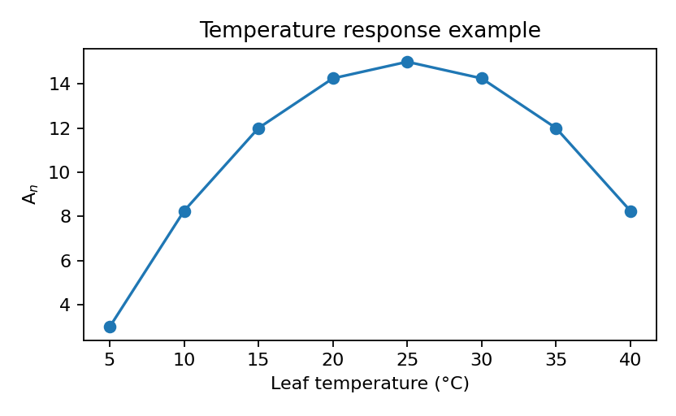
Figure 2. Temperature response example for testing figure-caption extraction.

3.2 Coupled leaf gas exchange model
The intersection of supply and demand curves of photosynthesis gives the steady-state intercellular CO2 concentration. This flexible interface can be used to estimate net photosynthesis when Ci is known or to solve for Ci from the coupled leaf gas exchange model. As shown in Fig. 1 and Table 1, the article combines figures, tables, formula references and bibliographic citations such as [1] and [2].

4 Availability and requirements
1) Project name: plantecophys
2) Project stable release: CRAN package plantecophys
3) Operating systems: platform independent
4) Programming language: R
5) Other requirements: none

Acknowledgments
David Ellsworth, Belinda Medlyn and Martin De Kauwe are acknowledged for discussions on fitting A-Ci curves. Thanks are also due to colleagues who tested and suggested new features.

References
[1] Duursma RA. Plantecophys - An R Package for Analysing and Modelling Leaf Gas Exchange Data. PLoS ONE. 2015;10(11):e0143346. doi:10.1371/journal.pone.0143346.
[2] Farquhar GD, von Caemmerer S, Berry JA. A biochemical model of photosynthetic CO2 assimilation in leaves of C3 species. Planta. 1980;149:78-90.
[3] Ball JT, Woodrow IE, Berry JA. A model predicting stomatal conductance and its contribution to the control of photosynthesis under different environmental conditions. Progress in Photosynthesis Research. 1987.
[4] Medlyn BE, Duursma RA, Eamus D, et al. Reconciling the optimal and empirical approaches to modelling stomatal conductance. Global Change Biology. 2011;17:2134-2144. doi:10.1111/j.1365-2486.2010.02375.x.

