| **Team Number** | 4 | **Section** | 05 |
| --- | --- | --- | --- |
| **Team Members** | 1. Wen Luo 2. Nhat Le 3. Karan Partap Virk 4. honey Singh | | |
| **Software Name** | Passaver | | |

# Introduction

## Objective [5 Points]

This program saves the user's website information(Website address, Email address, User ID, password creation date, Expiration Date, Password). The users of this software are the general public.

## References [5 Points]

Google Chrome Password Saved Feature (Located under Settings, Passwords, Saved Passwords.

## Acronyms, and Abbreviations [5 Points]

Explain all acronyms, abbreviations, and complex concepts used in this document.

| UML Diagram | Unified Modeling Languages Diagram |
| --- | --- |
| MVC | Model-View-Controller |
|  |  |

# Software Overview

## Problem Statement [5 Points]

Computers and the Internet are being used extensively and the security of users' privacy has become a big issue. One of the oldest ways to provide security is using passwords.

Choosing and storing passwords are challenging tasks for many users and cause breaches. Since the number of websites that we use every day is increasing, this causes most users to choose simple memorable passwords, store them improperly, or reuse them for many websites/applications that increase the risk of being cracked.

The existing password managers are not reliable because there is always the risk of leaking our information to the developers of the software!

## Scope [5 Points]

The usage of this software should be the general public who have access to the computer and internet.

# Detailed Design

## UML Class Diagrams (for all classes/interfaces) [30 Points]

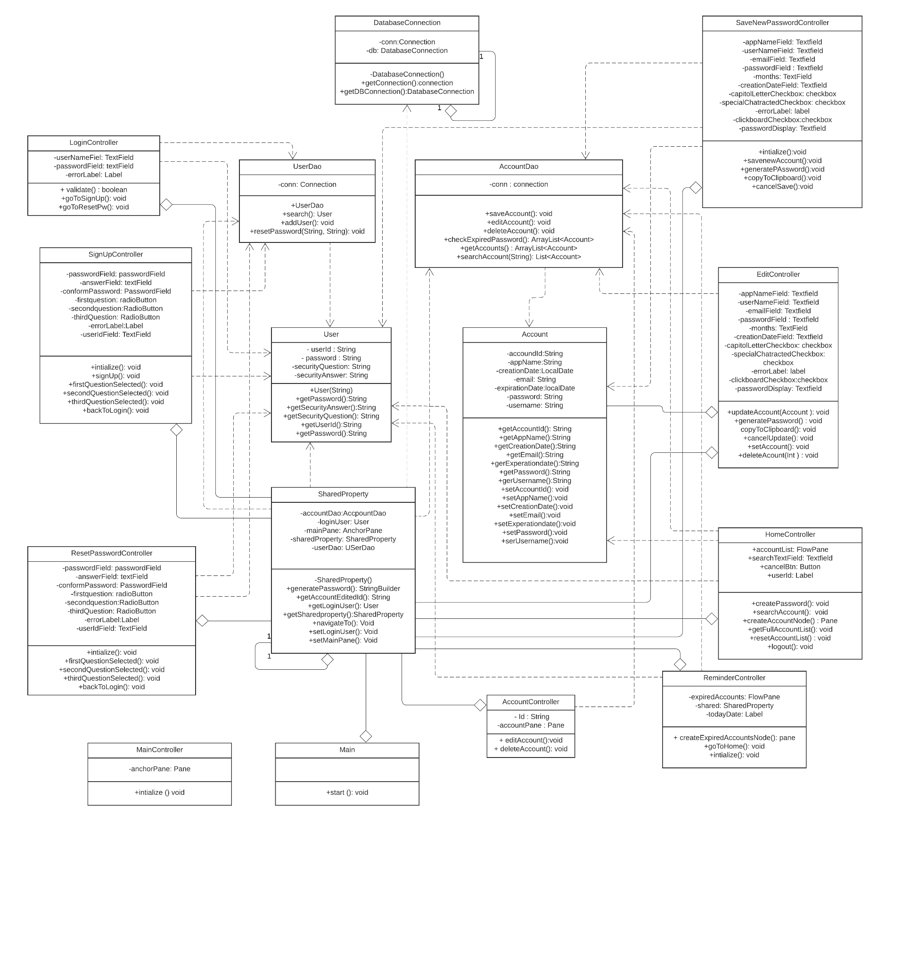

## UML Sequence and/or State Diagrams (at least two) [20 Points]

Create Account State Diagram:

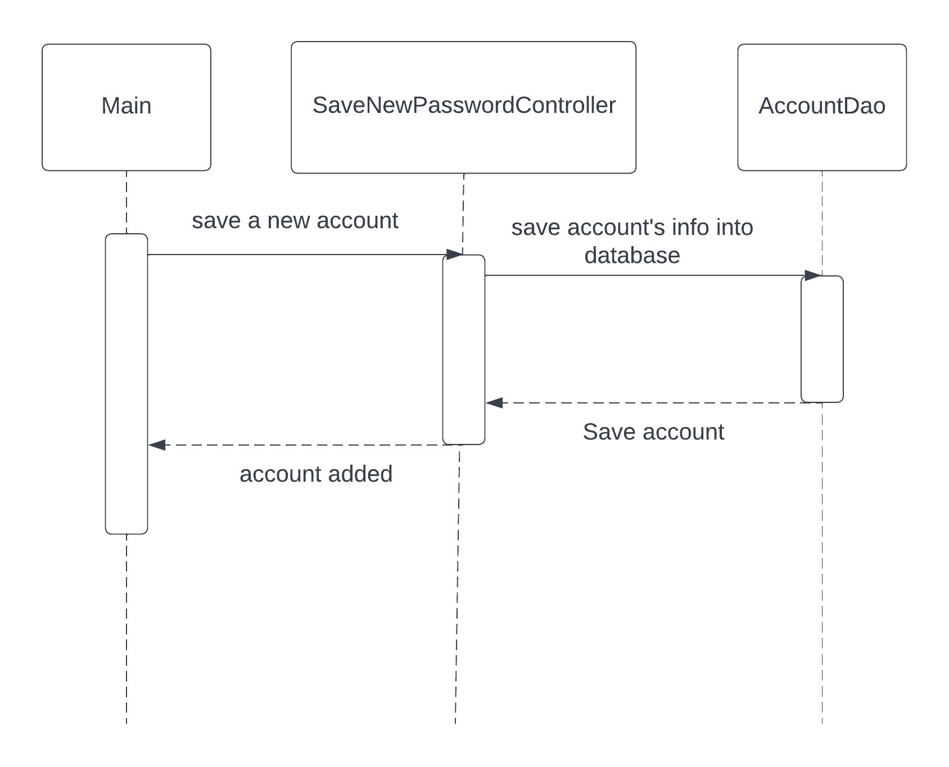

Login State Diagram:

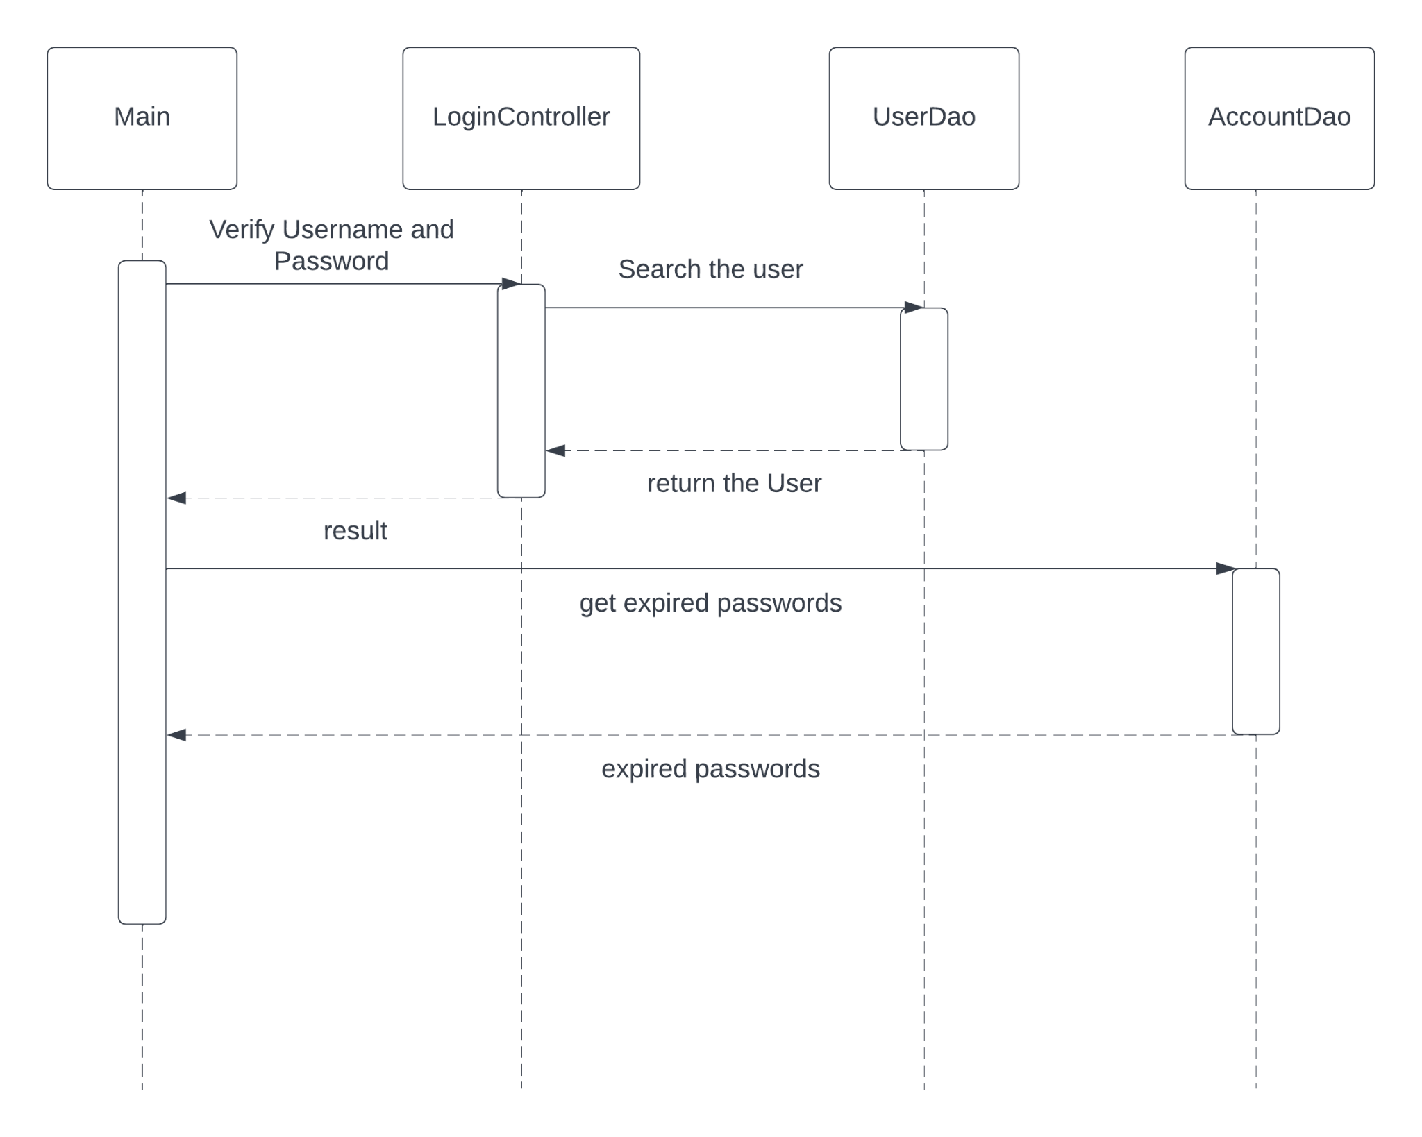

## Mockups [20 Points]