1. Stony Brook 🡪 La Guardia

Train: Stony Brook 🡪 (Jamaica)🡪 Woodside (5:05, 5:54, 6:09, 6:28, 7:07)

Bus: Q70 (Roosevelt Av/61st) -> La Guardia

1. Toronto 🡪 Waterloo

Airport -> Square one: 7 Southbound

Square One to Wilfrid Laurier University: 25

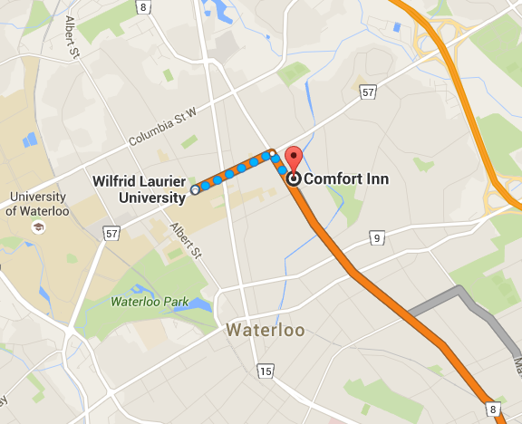 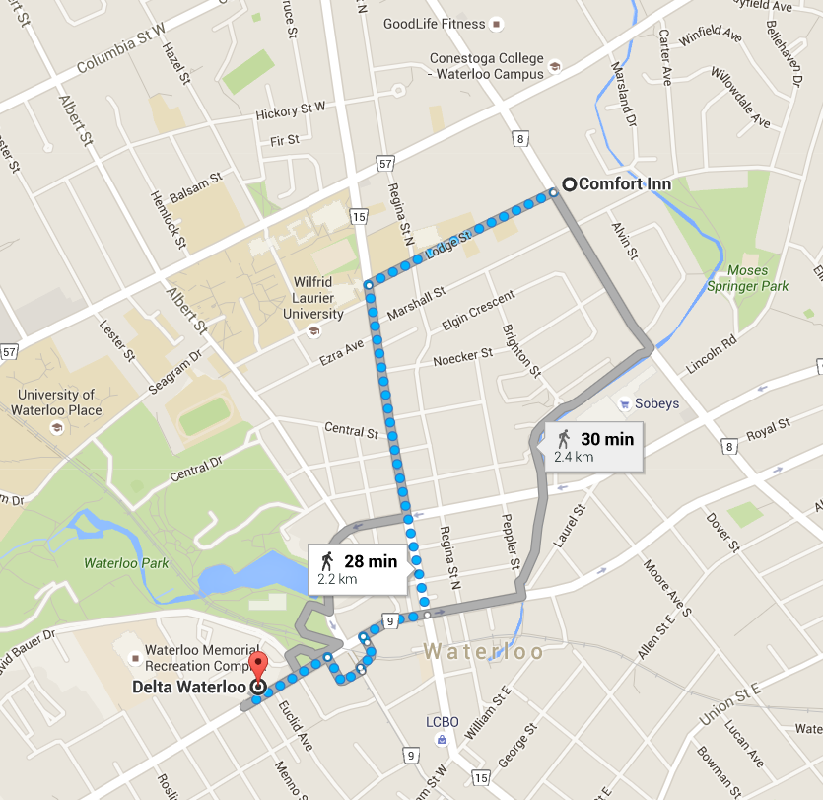

1. Waterloo 🡪 Toronto
2. La Guardia 🡪 Stony Brook

Bus: Q70 🡪 Woodside

Train: Woodside 🡪 Hicksville (Huntington or Jamaica) 🡪 Stony Brook (10:53pm, 11:54pm, 1:54am)