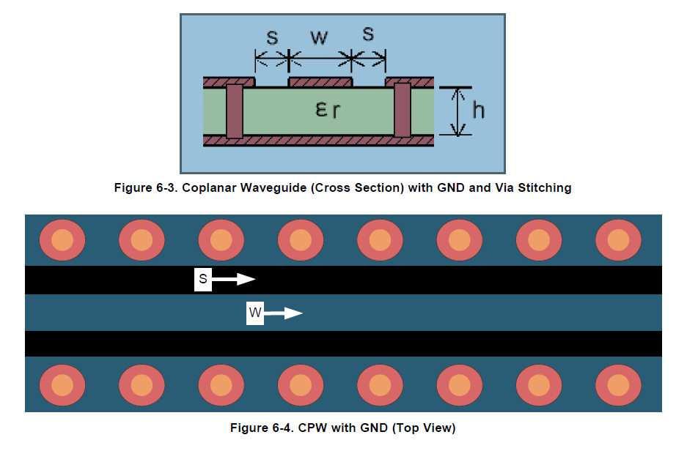

With:

W 35 mils

S 6 mils

H 40 mils

Er (FR-4 substrate)

3.9

RF traces must have 50-Ω impedance (red line)