Imagine I ask you to write a program that manages 100 students in a school. Each student has an ID, a name, a year of birth, and an address.

string[] ids = new string[100];
string[] names = new string[100];
int[] birthYears = new int[100];
string[] addresses = new string[100];
string[] phones = new string[100];

student 47 -> he has new address. What do I do?
Addresses[47] = “new address”

OOP ~ Object-Oriented Programming.
Create new data type -> Student
Student[] students = new Student[100];
students[47].Address = “new address”;
students[47].Phone = “+84…”

"A student has a student ID, a name, a year of birth, and an address. We need to be able to display a student's information and calculate their age."
Class: Student
Fields:
studentId: string
name: string
birthYear: int
address: string
Methods:
Display(): void
CalculateAge(): int

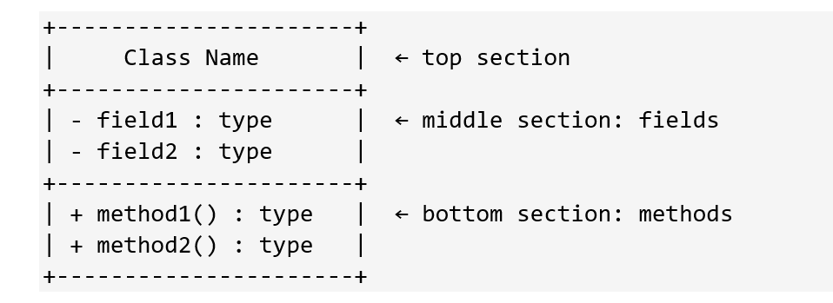
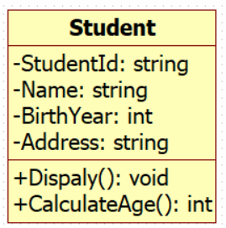
A constructor is a special method whose job is to set up a new object. Three rules:
1. Same name as the class
2. NO return type — not even "void"
3. Runs automatically when "new" is called

Encapsulation: Properties & Validation
HIDE THE FIELD.
EXPOSE A CONTROLLED GATE.

Read the Problem (2 min)

"A bank account has an account number, an owner name, and a current balance. The bank lets the owner deposit money (positive amounts only) and withdraw money (only if the balance is sufficient and the amount is positive). The account number is assigned at creation and never changes. The balance can be read but never directly written from outside."

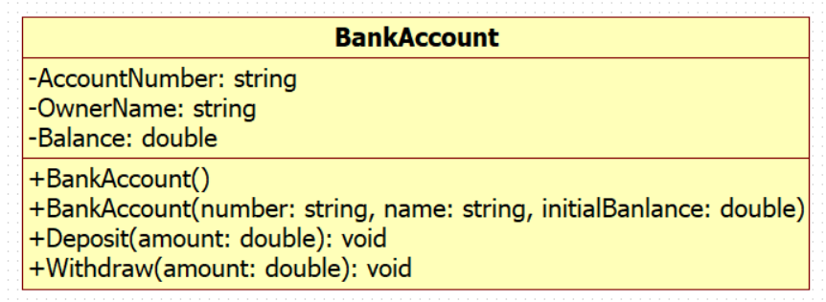
using System;
using System.Collections.Generic;
using System.Text;

public class BankAccount
{
private string accountNumber; // HIDE THE FIELDS
private string ownerName;
private double balance;

// EXPOSE CONTROLLED GATE
// 1. AccountNumber: Never changes after creation.
// Use { get; } only (no set) to make it read-only.
public string AccountNumber { get; }

// 2. OwnerName: Allow changing the owner's name if needed.
public string OwnerName { get; set; }

// 3. Balance: Readable from outside, but modifiable ONLY INSIDE this class.
// Use { get; private set; } -> public to read, private so only this class can assign a value.
public double Balance { get; private set; }

// Default constructor
public BankAccount()
{
AccountNumber = "000000";
OwnerName = "";
Balance = 0;
}

// Parameterized Constructor
public BankAccount(string accountNumber, string ownerName, double initialBalance)
{
// Assign to AccountNumber (can only be assigned once, right here)
AccountNumber = accountNumber;
OwnerName = ownerName;

// Initial balance must also be positive, let's reuse the logic
if (initialBalance > 0)
Balance = initialBalance;
else
Balance = 0;
}

public void Deposit(double amount)
{
// Boundary condition: Check if amount is positive
if (amount > 0)
{
Balance += amount; // Allowed because setter is private, and this code is INSIDE the class
Console.WriteLine($"Deposited {amount}. New balance: {Balance}");
}
else
{
Console.WriteLine("Error: Deposit amount must be positive.");
}
}

public void Withdraw(double amount)
{
// Boundary condition 1: Must be positive
// Boundary condition 2: Must not exceed current balance
if (amount > 0 && amount <= Balance)
{
Balance -= amount;
Console.WriteLine($"Withdrew {amount}. New balance: {Balance}");
}
else if (amount <= 0)
{
Console.WriteLine("Error: Withdrawal amount must be positive.");
}
else // amount > Balance
{
Console.WriteLine("Error: Insufficient funds.");
}
}

}

BankAccount myAccount = new BankAccount("123-456-789", "Le Nhat Tung", 1000);

// Print info
Console.WriteLine($"Account: {myAccount.AccountNumber}");
Console.WriteLine($"Owner: {myAccount.OwnerName}");
Console.WriteLine($"Balance: {myAccount.Balance}\n");

// Try a valid depost
myAccount.Deposit(500);

// Try an invalid deposit (negative amount)
myAccount.Deposit(-50); // Will print Error

// Try a valid withdrawal
myAccount.Withdraw(200);

// Try a withdrawal exceeding balance
myAccount.Withdraw(2000); // Will print Insufficient funds

// 1300
Console.WriteLine($"Balance after deposit and withdraw: {myAccount.Balance}\n");

