LAB 8 Interface
Object-Oriented Programming with C# and StarUML
What it does, not what it is. The ultimate decoupling tool.

1. Overview
In Lab 7, we mastered polymorphism through inheritance (the IS-A relationship). A Dog IS-A(N) Animal. That works beautifully when objects share a common core identity. But what happens when objects share a behavior but have absolutely no shared identity? A Bird can fly. An Airplane can fly. A Superman can fly. But a Bird is not an Airplane. They cannot share a parent class like “FlyingThing” without creating a ridiculous class hierarchy.
Today we learn Interfaces. An interface says: “I don’t care who you are or where you come from. If you want to be used here, you must promise to have these methods.” Interfaces give us polymorphism without inheritance. In C#, a class can only inherit from ONE parent, but it can implement MULTIPLE interfaces. This solves the “multiple inheritance” problem safely.

1.1 Learning Objectives
After completing this lab, students will be able to: * Explain the difference between an inheritance hierarchy (IS-A) and an interface contract (CAN-DO). * Define an interface using the interface keyword and name it with the I prefix (e.g., IFlyable). * Implement an interface in a class using the : InterfaceName syntax. * Store completely unrelated objects in a single List<IInterfaceName> and process them uniformly. * Allow a single class to implement multiple interfaces (e.g., a Duck that both flies and swims). * Recognize when to use an abstract class vs. when to use an interface.

1.2 Prerequisites
- Lab 7 completed: Polymorphism, virtual, override, List<Parent>.
- Understanding that a class can only inherit from one base class.

2. The Big Idea — The USB Port of Programming
Imagine a USB port on your laptop. The laptop doesn’t know if you are plugging in a mouse, a keyboard, a flash drive, or a fan. It doesn’t need to know their brand or their internal structure. It only cares about one thing: Do you have a USB plug? If yes, you can connect.
An interface is a software USB port. It defines a set of methods (the plug shape). Any class that “implements” the interface promises to provide code for those methods. Once a class implements the interface, it can be plugged into any system that expects that interface.

2.1 The naive approach (without interfaces)
Suppose we want a list of things that can fly. Without interfaces, we might try to force an inheritance tree:
// Bad: Forcing unrelated things into a hierarchy
public class FlyingThing { public void Fly(); }
public class Bird : FlyingThing { }
public class Airplane : FlyingThing { }
public class Superman : FlyingThing { } // Superman IS-A FlyingThing? Weird.
This violates object-oriented design. A Superman is a Person, not a “FlyingThing”. If C# allowed multiple inheritance, Superman could inherit from both Person and FlyingThing. But C# doesn’t allow that (to avoid the “Diamond Problem”).

2.2 The interface approach
With interfaces, we decouple behavior from identity:
// Good: Decoupled capability
public interface IFlyable { void Fly(); }
public class Bird : Animal, IFlyable { ... }
public class Airplane : Vehicle, IFlyable { ... }
public class Superman : Person, IFlyable { ... }
Now, Bird IS-A(N) Animal AND CAN-DO Fly. Airplane IS-A Vehicle AND CAN-DO Fly. They keep their proper identities but share the flying capability.

2.3 The three rules of interfaces
- Rule 1: An interface only declares method signatures (no body, no fields, no constructors).
- Rule 2: A class uses : InterfaceName to implement it, and must write the body for every method in the interface.
- Rule 3: You can treat an implementing object as the interface type: IFlyable f = new Bird();. Through f, you can only call methods defined in IFlyable.

Example 1 — The Animal Capabilities (IFlyable & ISwimmable)

3.1 The problem
Description: We have a zoo with Birds, Fish, and Ducks. Birds can fly. Fish can swim. Ducks can do both. We want two separate lists in our program: a list of things we can ask to Fly(), and a list of things we can ask to Swim(). We do not want to use a giant Animal base class with Fly and Swim methods, because forcing a Fish to have a Fly method (even if it does nothing) is bad design.

3.2 Step 1 — UML diagram
Note the notation: <<interface>> above the name, and the dashed line with a hollow triangle arrow pointing UP to the interface (Realization).

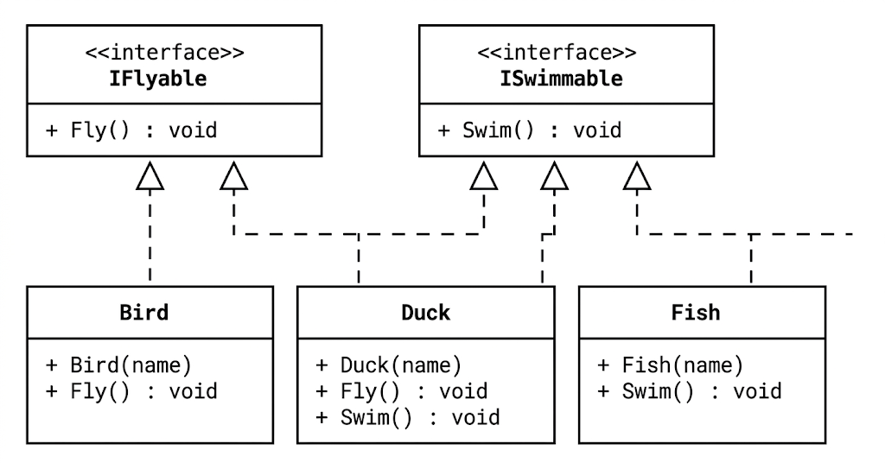

3.3 Step 2 — The interfaces
public interface IFlyable
{
void Fly(); // No access modifier (public is implicit). No body.
}
public interface ISwimmable
{
void Swim();
}

3.4 Step 3 — The classes
Notice how Duck implements both, separated by a comma.
public class Bird : IFlyable
{
private string name;
public Bird(string name) { this.name = name; }
public void Fly()
{
Console.WriteLine($"{name} the bird flaps its wings and flies.");
}
}
public class Fish : ISwimmable
{
private string name;
public Fish(string name) { this.name = name; }
public void Swim()
{
Console.WriteLine($"{name} the fish swims in the water.");
}
}
public class Duck : IFlyable, ISwimmable // Implementing TWO interfaces
{
private string name;
public Duck(string name) { this.name = name; }
public void Fly()
{
Console.WriteLine($"{name} the duck flies awkwardly.");
}
public void Swim()
{
Console.WriteLine($"{name} the duck paddles on the lake.");
}
}

3.5 Step 4 — The Polymorphic Main
class Program
{
static void Main()
{
// A list of things that CAN-DO Fly.
// A Bird and a Duck can go here. A Fish cannot.
List<IFlyable> flyingThings = new List<IFlyable>
{
new Bird("Tweety"),
new Duck("Donald")
};
// A list of things that CAN-DO Swim.
List<ISwimmable> swimmingThings = new List<ISwimmable>
{
new Fish("Nemo"),
new Duck("Donald") // The same Duck object can be in BOTH lists!
};
Console.WriteLine("--- Flying Show ---");
foreach (IFlyable f in flyingThings)
{
f.Fly(); // Polymorphism via interface!
}
Console.WriteLine("\n--- Swimming Show ---");
foreach (ISwimmable s in swimmingThings)
{
s.Swim(); // Polymorphism via interface!
}
}
}
Expected output:
--- Flying Show ---
Tweety the bird flaps its wings and flies.
Donald the duck flies awkwardly.
--- Swimming Show ---
Nemo the fish swims in the water.
Donald the duck paddles on the lake.

3.6 Hands-on Practice 1 — Build the Zoo Capabilities
- In StarUML, draw the diagram from section 3.2. Use the dashed line arrow for interface realization.
- Create Visual Studio project EX1_Capabilities. Add IFlyable.cs, ISwimmable.cs, Bird.cs, Fish.cs, Duck.cs.
- Type the code from sections 3.3-3.5.
- Run and verify the output.
- Try to add new Fish("Nemo") to the flyingThings list. Observe the compile error. This proves the safety of interfaces: you cannot plug a USB drive into a mouse port.

Example 2 — IPayable (Polymorphism without Inheritance)
This is the most common business use case for interfaces. In Lab 7, we calculated payroll for Employees using inheritance. But in real life, a company doesn’t just pay Employees. It also pays Invoices to suppliers. An Invoice is definitely NOT an Employee. They share no base class. But the accounting system wants to process them in the exact same loop.

4.1 The problem
Description: The accounting department needs a single method that takes a list of “things to pay”, calculates the amount, and prints a cheque. The list will contain both Employee objects and Invoice objects.

4.2 Step 1 — UML diagram

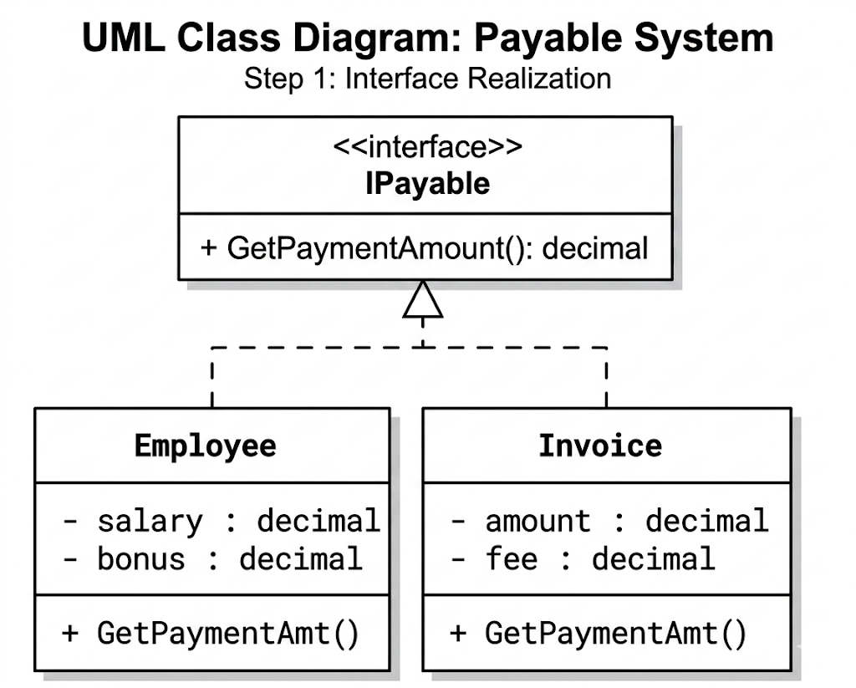

4.3 Step 2 — The Code
public interface IPayable
{
decimal GetPaymentAmount(); // The contract
}
// Unrelated class 1
public class Employee : IPayable
{
private decimal salary;
private decimal bonus;
public Employee(decimal salary, decimal bonus)
{
this.salary = salary; this.bonus = bonus;
}
public decimal GetPaymentAmount() => salary + bonus;
}
// Unrelated class 2
public class Invoice : IPayable
{
private decimal amount;
private decimal fee;
public Invoice(decimal amount, decimal fee)
{
this.amount = amount; this.fee = fee;
}
public decimal GetPaymentAmount() => amount + fee;
}

4.4 Step 3 — The Accounting Loop
class Program
{
static void Main()
{
// Look at this: Employees and Invoices in the SAME list!
// This is impossible with standard inheritance.
List<IPayable> payableList = new List<IPayable>
{
new Employee(3000m, 500m),
new Invoice(1500m, 50m),
new Employee(2500m, 0m),
new Invoice(800m, 20m)
};
decimal totalPayments = 0m;
foreach (IPayable p in payableList)
{
decimal amount = p.GetPaymentAmount();
Console.WriteLine($"Paying: {amount,10:C}");
totalPayments += amount;
}
Console.WriteLine($"--------------------------");
Console.WriteLine($"Total Paid: {totalPayments,10:C}");
}
}

4.5 Why this design wins
- No God Class: We didn’t have to create a horrible base class called EntityThatReceivesMoney.
- Flexibility: Tomorrow, if we need to pay Taxes (which is also not an Employee), Tax just implements IPayable. The foreach loop in accounting never changes.
- Loose Coupling: The accounting system depends on the interface (IPayable), not the concrete classes (Employee, Invoice).

4.6 Hands-on Practice 2 — Build the Accounting System
- Draw the UML in StarUML and export as ex2_payable.png.
- Create project EX2_Payable. Add the interface and two classes.
- Run and verify the total is $7,870.00.
- Add a LandTax class (amount + penalty) that implements IPayable. Add it to the list without changing the loop.

Example 3 — IComparable (The Standard .NET Interfaces)
You don’t always have to write your own interfaces. C# is full of built-in interfaces. One of the most important is IComparable<T>. If your class implements IComparable<T>, you are telling C#: “I know how to sort instances of my class.”

5.1 The problem
Description: We have a list of Product objects. We want to sort them by Price using the built-in List.Sort() method.

5.2 Step 1 — The Code
public class Product : IComparable<Product>
{
public string Name { get; set; }
public decimal Price { get; set; }
public Product(string name, decimal price)
{
Name = name; Price = price;
}
// The contract requires this method.
// Returns negative if this < other, 0 if equal, positive if this > other
public int CompareTo(Product other)
{
// Sorting by price ascending
return this.Price.CompareTo(other.Price);
// Bonus: How to sort descending?
// return other.Price.CompareTo(this.Price);
}
public override string ToString() => $"{Name} ({Price:C})";
}
class Program
{
static void Main()
{
List<Product> cart = new List<Product>
{
new Product("Laptop", 1200m),
new Product("Mouse", 25m),
new Product("Keyboard", 80m)
};
Console.WriteLine("Before sort:");
cart.ForEach(p => Console.WriteLine(p));
// This line calls Product.CompareTo internally for every item!
cart.Sort();
Console.WriteLine("\nAfter sort:");
cart.ForEach(p => Console.WriteLine(p));
}
}

5.3 Hands-on Practice 3 — Sorting Custom Objects
- Create project EX3_Sortable.
- Implement the code above.
- Modify the CompareTo method to sort by Name alphabetically instead of Price. (Hint: string also implements IComparable).

6. Common Errors and How to Fix Them

6.1 Adding access modifiers to interface members
public interface IFlyable
{
public void Fly(); // X COMPILE ERROR
}
Fix: Remove public. Interface members are implicitly public and abstract. Just write void Fly();.

6.2 Forgetting to implement a method
If your class says : IFlyable but you forget to write the Fly() method, C# will refuse to compile. Fix: Hover over the red underline, click “Implement Interface” (or press Ctrl + .), and Visual Studio will write the empty method for you.

6.3 Trying to instantiate an interface
IFlyable f = new IFlyable(); // X COMPILE ERROR
Fix: Interfaces are purely contracts (pure abstract). They have no constructors and no code. You must instantiate a concrete class: IFlyable f = new Bird();.

6.4 Naming conflicts (The need for Explicit Implementation)
Suppose a class implements two interfaces, and both have a method with the exact same name.
public interface IMechanical { void Start(); }
public interface IElectrical { void Start(); }
public class HybridCar : IMechanical, IElectrical { ... }
Fix: You must use Explicit Interface Implementation:
void IMechanical.Start() { Console.WriteLine("Engine turns over."); }
void IElectrical.Start() { Console.WriteLine("Motors engage."); }
To call them, you must cast the object to the specific interface: ((IMechanical)car).Start();

7. Lab Summary
Concept | How it works in C#
Define a contract | public interface IName { void Method(); }
Class promises to fulfill contract | class MyClass : IName { ... }
Multiple capabilities | class Duck : IFlyable, ISwimmable { ... }
Polymorphic list of unrelated objects | List<IPayable> list = new List<IPayable>();
Standard sorting interface | class X : IComparable<X> { public int CompareTo(...) }

8. Homework — Take-home Assignment
Three exercises. Unlike Lab 7 (which used inheritance), you must use interfaces for these. Do NOT use base classes for the polymorphic behavior. Each exercise requires defining at least one interface.
For EVERY exercise you must include: (a) Identification paragraph: The interface(s), the classes implementing them, and why an interface is better than inheritance here. (b) UML class diagram from StarUML (PNG export). Use dashed arrows for interface realization. (c) C# source code for the interface(s) and ALL classes. (d) Main method demonstrating objects of different base types being stored in a List<IInterface> and processed in ONE loop. (e) Screenshot of the program running.
Submission file name: Lab08_Homework_<StudentID>_<FullName>.docx
Homework Exercise 1 — Vehicles and Fuel
Problem: A logistics system tracks fuel consumption. Some vehicles run on Gasoline (IGasolinePowered), some on Electricity (IElectricPowered). A Car is gasoline powered. A Scooter is electric. A HybridBus is BOTH. The system wants a report of all gasoline vehicles and a separate report of all electric vehicles to order fuel/charge. Requirements:
- Interfaces: IGasolinePowered (method: void Refuel()), IElectricPowered (method: void Charge()).
- Classes: Car, Scooter, HybridBus.
- Main: Create ONE Car, ONE Scooter, and ONE HybridBus. Put them in a List<IGasolinePowered> and loop to call Refuel(). Then put the capable ones in a List<IElectricPowered> and loop to call Charge().
Homework Exercise 2 — E-Commerce Discounts
Problem: In an online store, not everything can be discounted. Physical products (Product) can have a discount applied. Digital licenses (SoftwareLicense) usually cannot. Gift cards (GiftCard) can also be discounted. We need a checkout function that processes a list of cart items and applies a 10% discount ONLY if the item implements IDiscountable. Requirements:
- Interface: IDiscountable (method: void ApplyDiscount(decimal percentage)).
- Classes: Product (implements IDiscountable), SoftwareLicense (does NOT implement it), GiftCard (implements IDiscountable). All have a Price property.
- Main: Create a list of mixed objects. Loop through them. Use the is operator: if (item is IDiscountable discountable) { discountable.ApplyDiscount(10m); }. Print the final prices.
Homework Exercise 3 — Cloning Game Characters
Problem: In a game, we need to create copies of characters quickly. We define an ICloneable interface. A Warrior can be cloned. A Dragon can be cloned. When cloned, the new object must have the same stats but be a distinct object in memory (change one, the other doesn't change). Requirements:
- Interface: ICloneable (method: object Clone()).
- Classes: Warrior (fields: Name, HP), Dragon (fields: Name, FirePower).
- Implementation: Inside Clone(), use new Warrior(this.Name, this.HP) to return a fresh copy.
- Main: Create a Warrior. Clone it. Change the original's HP. Print both to prove they are separate objects. Store both in a List<ICloneable> and loop to print them (you will need to cast them back to their types or add a void PrintStats() method to the interface if you wish).

9. Submission & Grading

9.1 Submission
Rename this file to Lab08_Homework_<StudentID>_<FullName>.docx. Fill in every placeholder box. Do not leave any of them empty. Upload to the LMS before the deadline.

9.2 Grading rubric (per exercise — 30% each, plus 10% overall presentation)
Criterion | Weight
Identification paragraph clearly explains WHY an interface was used instead of inheritance. | 5%
UML diagram uses <<interface>> stereotype and dashed realization arrows correctly. | 5%
Interface members have NO access modifiers and NO implementation body. | 5%
Classes correctly implement the interface(s) using : InterfaceName. | 5%
Main uses a List<IInterface> to hold completely different class types. | 6%
Polymorphic loop executes correctly without type-checking (except Exercise 2 where is is required). | 3%
Screenshot shows the program ran and the output is readable. | 1%

9.3 Common reasons points are lost
- Using an abstract base class with virtual methods instead of an interface. (This is Lab 7 material, not Lab 8).
- Adding public to interface method declarations.
- Trying to put a class in a list that does not implement the list’s interface type.
- Forgetting to implement a method from the interface in the class.

— End of Lab 8 —

