[TruQuote]
Function Requirements

Date | [April 03, 2010]
Version | [1.0]
Status | [Approved]
Author | [Le Minh Vuong, Developer]
Reviewed by | [Le Tat Hai, Project Manager]
Approved by | [Nguyen Thi Thanh Thuy, Director]

Revision History

Date | Version | Description | Author
<April 03, 2010> | <1.0> | <Describles Software Requirement Specification > | <Le Minh Vuong>

Table of Contents

1 Introduction 4
1.1 Purpose 4
1.2 Scope 4
1.3 Definitions, Acronyms and Abbreviations 4
1.4 References 5
1.5 Overview 5
2 Requirements 6
2.1 Dealer function 7
2.1.1 REQ101 - Register Account 7
2.1.2 REQ102 - Login 7
2.1.3 REQ103 - Create Order 7
2.1.4 REQ104 - Delete Order 7
2.1.5 REQ103 - Manage Customer Information 8
2.1.6 REQ106 - Search Order 8
2.1.7 REQ107 - Send Mail 8
2.1.8 REQ108 - Backup Order 8
2.2 Design Drawings 8
2.2.1 REQ109 - Re-design template of structure type 8
2.2.2 REQ110 - Render 2D 9
2.2.3 REQ111 - Render 3D 9
2.2.4 REQ112 - Zoom 9
2.3 Admin functions 9
2.3.1 REQ113 -Manage Dealer Information 9
2.3.2 REQ114 - Update Cost 10
2.3.3 REQ115 - Verify Order Information 10
2.4 Generate cost 10
2.4.1 REQ116 - Generate Option Total Costs 10
2.4.2 REQ117 - Generate Total Costs 10
2.5 Output File 11
2.5.1 REQ118 - Save File *.tqu Format 11
2.5.2 REQ119 - Generate *.csv Format 11
2.6 Print fuctions 11
2.6.1 REQ120 - Print Layout 12
2.6.2 REQ121 - Print Elevations 12
2.6.3 REQ122 - Print Total Costs 12

Introduction

Purpose

Scope

<Provide a short description of the software being specified and its purpose, including relevant benefits, objectives, and goals. Relate the software to corporate goals or business strategies. If a separate vision and scope document is available, refer to it rather than duplicating its contents here. An SRS that specifies the next release of an evolving product should contain its own scope statement as a subset of the long-term strategic product vision.>

Definitions, Acronyms and Abbreviations
No | Term | Description
1 | SWT | Smart World Technology Co. ltd
2 | Enduro | Client
3 | UAT | User Acceptance Test
4 | SRS | Software Requirement Specification
5 | SAD | Software Analysis & Design
6 | PM | Project Manager
7 | QC | Quality Control
8 | QA | Quality Assurance

References

<List any other documents or Web addresses to which this SRS refers. These may include user interface style guides, contracts, standards, system requirements specifications, use case documents, or a vision and scope document. Provide enough information so that the reader could access a copy of each reference, including title, author, version number, date, and source or location.>

Overview

Requirements
Audit History
Date/Time: 2010-04-15
Field:name | Formal Requirements | REQs document
 |  | 0

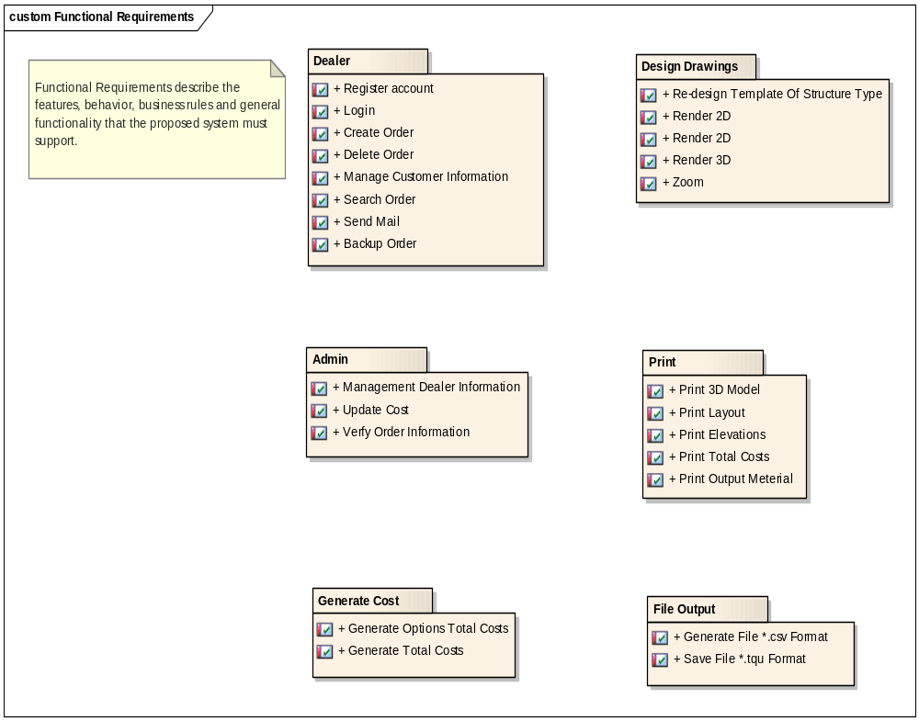

Dealer function

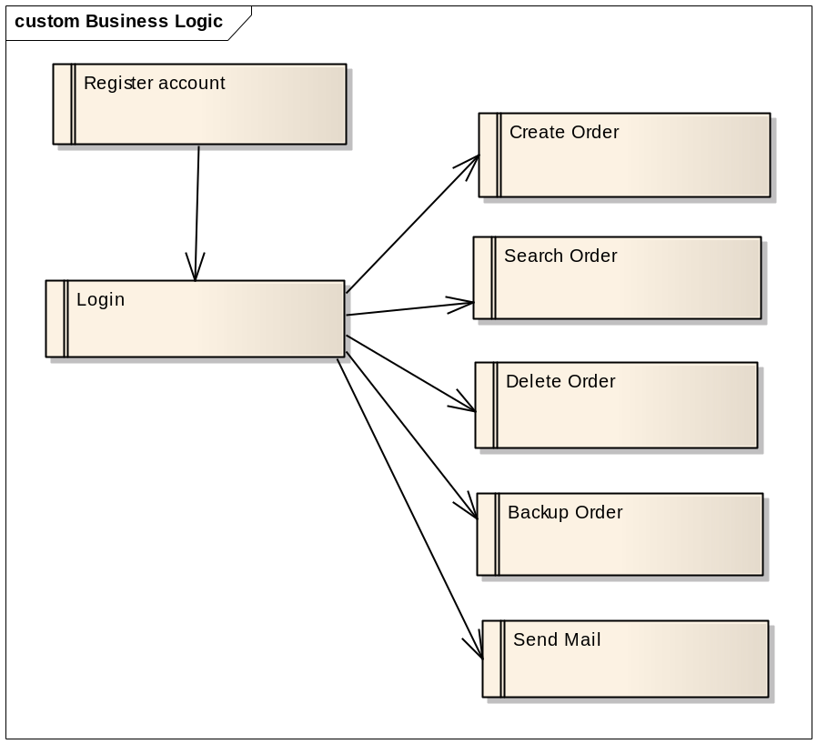

REQ101 - Register Account
«Functional» | Status: Validated | Priority: Low | Difficulty: Low
«Functional» | Dealer registers an account on the company’s server

REQ102 - Login
«Functional» | Status: Validated | Priority: Low | Difficulty: Low
«Functional» | Users must log in with your username and password. If valid, the system will be implemented functions with correspoding user’s rights

