[TruQuote]
Non Function Requirements

Date | [April 10, 2010]
Version | [1.0]
Status | [Approved]
Author | [Le Minh Vuong, Developer]
Reviewed by | [Le Tat Hai, Project Manager]
Approved by | [Nguyen Thi Thanh Thuy, Director]

Revision History

Date | Version | Description | Author
<April 10, 2010> | <1.0> | <Define non-function requirements of TruQuote software> | <Le Minh Vuong>

Table of Contents

1 Introduction 4
1.1 Purpose 4
1.2 Scope 4
1.3 Definitions, Acronyms and Abbreviations 4
1.4 References 5
1.5 Overview 5
2 Non Function Requirements 6
2.1 Security 7
2.1.1 REQ101 - Backup Server 7
2.1.2 REQ102 - Information Security 7
2.1.3 REQ103 - Log Order 7
2.1.4 REQ104 - Synchronize Client - Server 7
2.2 Performance 8
2.2.1 REQ105 - Meet arround 100 users to access concurrently 8
2.2.2 REQ106 - System Fast Calculate 8
2.2.3 REQ107 - System must be flexible 8

Introduction

Purpose

Scope

<Provide a short description of the software being specified and its purpose, including relevant benefits, objectives, and goals. Relate the software to corporate goals or business strategies. If a separate vision and scope document is available, refer to it rather than duplicating its contents here. An SRS that specifies the next release of an evolving product should contain its own scope statement as a subset of the long-term strategic product vision.>

Definitions, Acronyms and Abbreviations

No | Term | Description
1 | SWT | Smart World Technology Co. ltd
2 | Enduro | Client
3 | UAT | User Acceptance Test
4 | SRS | Software Requirement Specification
5 | SAD | Software Analysis & Design
6 | PM | Project Manager
7 | QC | Quality Control
8 | QA | Quality Assurance

References

<List any other documents or Web addresses to which this SRS refers. These may include user interface style guides, contracts, standards, system requirements specifications, use case documents, or a vision and scope document. Provide enough information so that the reader could access a copy of each reference, including title, author, version number, date, and source or location.>

Overview

Non Function Requirements

Audit History
Date/Time: 2010-04-15
Field:name | Formal Requirements | REQs document
 |  | 0

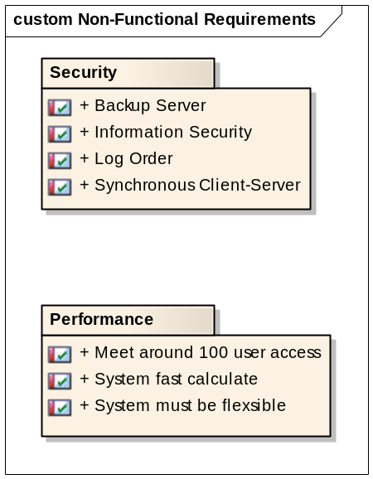

Security

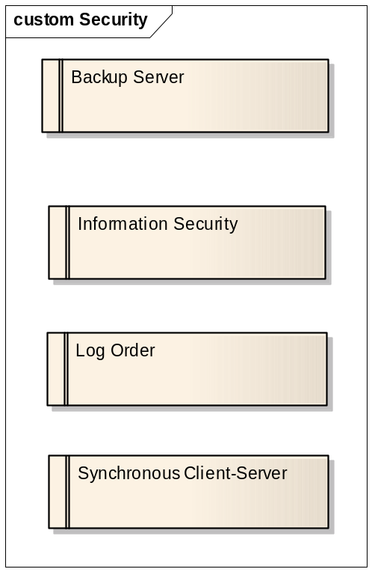

REQ101 - Backup Server
«Functional» | Status: Validated | Priority: Medium | Difficulty: Medium
«Functional» | Admin can backup all orders on server

