[TruQuote]
User Interface Prototype

Date | [April 09, 2010]
Version | [1.0]
Status | [Approved]
Author | [Le Thanh Tung, Developer]
Reviewed by | [Le Tat Hai, Project Manager]
Approved by | [Nguyen Thi Thanh Thuy, Director]

Revision History

Date | Version | Description | Author
<April 09, 2010> | <1.0> | <Design User Interface Prototype > | <Le Thanh Tung>

Table of Contents

1 Introduction 5
1.1 Purpose 5
1.2 Scope 5
1.3 Definitions, Acronyms and Abbreviations 5
1.4 References 6
1.5 Overview 6
2 List screens 7
3 Flow of screens 8
3.1 Main flow of screen 8
3.2 Create order 8
3.3 Output 9
3.4 Admin 11
4 Details User Interface (Prototype) 12
4.1 Login 12
4.2 Create Order 13
4.2.1 Browse Catalogue 13
4.2.2 Customer Information 14
4.2.3 Basic Specs 16
4.2.4 Add Options 18
4.2.5 Installation 20
4.3 Output 22
4.3.1 3D 22
4.3.2 Quotation 23
4.3.3 Print layout 24
4.3.4 Print elevations 25
4.3.5 Output materials 25
4.3.6 Print installation cost 26
4.4 Admin 27
4.4.1 Manage Users 30
4.4.1.1 Edit user information 31
4.4.2 Manage Customer Type 31
4.4.2.1 Edit customer type 32
4.4.3 Manage Equipment Hire Fees 33
4.4.3.1 Edit Equipment Hiring Fees 33
4.4.4 Manage Distributor Misc. Options 34
4.4.5 Manage Valid Specifications 36
4.4.6 Manage Demolition /Site Clearing Fees 37
4.4.6.1 Edit Demolition/Site Clearing Fee 38

Introduction

Purpose

Enduro is consultant company focusing on workshop setting feild.

The project’s product is a software, TruQuote, which is used in consulting, designing and cost calculating in Enduro. Base on information (like length, width, heigth, material, etc) inputed by dealder, software allows user to re-design templates of workshop, render graphic objects in 2D and 3D as well as generate total cost for setting up workshop. These results are significant comments and recommendations for decision making

Scope

<Provide a short description of the software being specified and its purpose, including relevant benefits, objectives, and goals. Relate the software to corporate goals or business strategies. If a separate vision and scope document is available, refer to it rather than duplicating its contents here. An SRS that specifies the next release of an evolving product should contain its own scope statement as a subset of the long-term strategic product vision>

Definitions, Acronyms and Abbreviations

No | Term | Description
1 | PC | Personal Computer
2 | Server | An application that runs on server
3 | Client-Application | A desktop application that runs on pc

References

<List any other documents or Web addresses to which this SRS refers. These may include user interface style guides, contracts, standards, system requirements specifications, use case documents, or a vision and scope document. Provide enough information so that the reader could access a copy of each reference, including title, author, version number, date, and source or location.>

Overview

List screens

No | Screen Name | Description
1 | Error: Reference source not found | The main login page for the software
2 | Error: Reference source not found | This screen shows views on the client application for selection a building model.
3 | Error: Reference source not found | This screen is used to enter customer information.
4 | : Basic Specs | This screen allows the dealers to view and design building for the customer.
5 | Error: Reference source not found | Display and add the options for the building.
6 | Error: Reference source not found | Add costs incurred
7 | Error: Reference source not found | Display 3D of the design
8 | Error: Reference source not found | Reference quotation of the design
9 | Error: Reference source not found | Render 2D drawing with enclosed options
10 | Error: Reference source not found | Render 4 projections of drawing
11 | Error: Reference source not found | Export hiring fee : labour, machine …
12 | Error: Reference source not found | Print form
13 | Error: Reference source not found | Manage system
14 | Error: Reference source not found | Manage users
15 | Error: Reference source not found | Edit user’s information
16 | Error: Reference source not found | Manage customer type
17 | Error: Reference source not found | Edit customer type
18 | Error: Reference source not found | Manage distributor misc. options
19 | Error: Reference source not found | Manage valid specifications
20 | Error: Reference source not found | Manage demolition / site clearing fees
21 | Error: Reference source not found | Edit demolition/site clearing fee
22 | Error: Reference source not found

Flow of screens

Main flow of screen

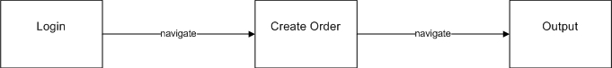

Create order

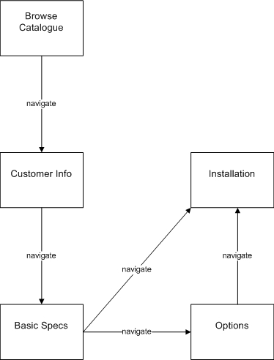

Admin
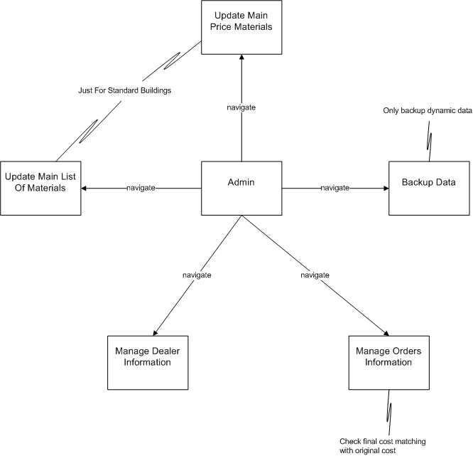

Details User Interface (Prototype)

Create Order

Basic Specs

Figure 1 : Basic Specs
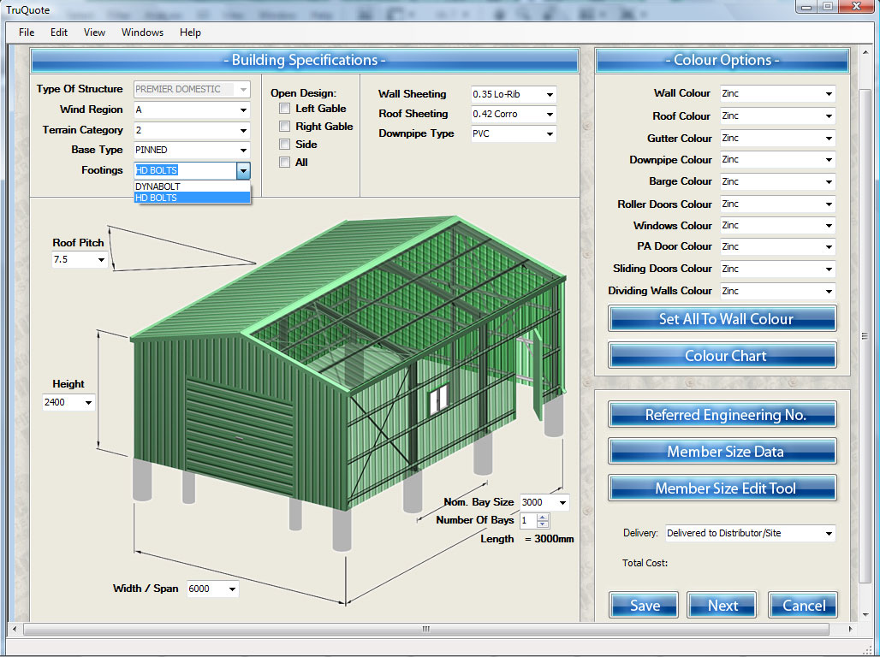

Element | Stereotype | Description
Building Specifications |  | This screen allows the dealers to view and design building for the customer.
Save | «button» | Save the designs original designs of the building
Next | «button» | Move to next step to add options for the building.
Cancel | «button» | Cancel current order, selection and display Browse catalogue screen.
Type of structure | «combo box» | Type of building structure need be built
Wind region | «combo box» | Wind region (weak wind or strong wind. Have 4 wind region : A, B, C, D)
Terrain category | «combo box» | Terrain building
Base type | «combo box» | Base type
Footings | «combo box» | Footings
Left gable | «check box» | Open the model from left direction
Right gable | «check box» | Open the model from right direction
Side | «check box» | Open the model from the side direction
All | «check box» | Open the model from all directions
Wall sheeting | «combo box» | Wall sheeting
Roof sheeting | «combo box» | Roof sheeting
Downpipe type | «combo box» | Downpipe type
Roof pitch | «combo box» | Length of the roof
Nom. Bay size | «combo box» | Size of each bay
Number of bays | «combo box» | Number of bays
Height | «combo box» | Height of the building
Width/Span | «combo box» | Width/Span of the building
Length | «text box» | Total length of the building
Wall color | «combo box» | Wall color
Roof color | «combo box» | Roof color
Gutter color | «combo box» | Gutter color
Downpipe color | «combo box» | Downpipe color
Barge color | «combo box» | Barge color
Roller doors color | «combo box» | Roller doors color
Windows color | «combo box» | Windows color
PA door color | «combo box» | PA door color
Sliding doors color | «combo box» | Sliding doors color
Dividing walls color | «combo box» | Dividing walls color
Set all to wall color | «button» | Set all to wall color
Color chart | «button» | Table of color
Referred engineering no. | «button» | License number reference
Member size data | «button» | Output reference materials table originaly
Member size edit tool | «button» | Allow dealers customize their interface
Delivery | «combo box» | Shipping cost
Total cost | «text» | The cost reference to build the building

