[TruQuote]
Domain Model

Date | [April 03, 2010]
Version | [1.0]
Status | [Approved]
Author | [Le Minh Vuong, Developer]
Reviewed by | [Le Tat Hai, Project Manager]
Approved by | [Nguyen Thi Thanh Thuy, Director]

Revision History

Date | Version | Description | Author
<May 21, 2010> | <1.0> | <Describles Domain Model > | <Le Minh Vuong>

Table of Contents

1 Introduction 4
1.1 Purpose 4
1.2 Scope 4
1.3 Definitions, Acronyms and Abbreviations 4
1.4 References 4
1.5 Overview 4
1.5 5
2 Domain model 5
2.1 Structure 5
2.2 BasicSpec 6
2.3 Options 7
2.4 Frame 7
2.5 ColumnRafter 7
2.6 Purlin 8
2.7 Girt 8
2.8 Column 8
2.9 Rafter 8
2.10 Screws 9
2.11 Plate 9
2.12 Apex 9
2.13 Haunch 10
2.14 Bolt 10
2.15 Sheeting 10
2.16 Roof 11
2.17 Wall 11
2.18 Gutter 11

Introduction

Purpose

<Identify the product whose software requirements are specified in this document, including the revision or release number. Describe the scope of the product that is covered by this SRS, particularly if this SRS describes only part of the system or a single subsystem.>

Scope

<Provide a short description of the software being specified and its purpose, including relevant benefits, objectives, and goals. Relate the software to corporate goals or business strategies. If a separate vision and scope document is available, refer to it rather than duplicating its contents here. An SRS that specifies the next release of an evolving product should contain its own scope statement as a subset of the long-term strategic product vision.>

Definitions, Acronyms and Abbreviations
No | Term | Description
1
2
3
4
5
6
7
8

References

<List any other documents or Web addresses to which this SRS refers. These may include user interface style guides, contracts, standards, system requirements specifications, use case documents, or a vision and scope document. Provide enough information so that the reader could access a copy of each reference, including title, author, version number, date, and source or location.>

Overview

Domain model

Package: Design Model
Detail: Created on 5/19/2010. Last modified on 5/21/2010.
Notes:

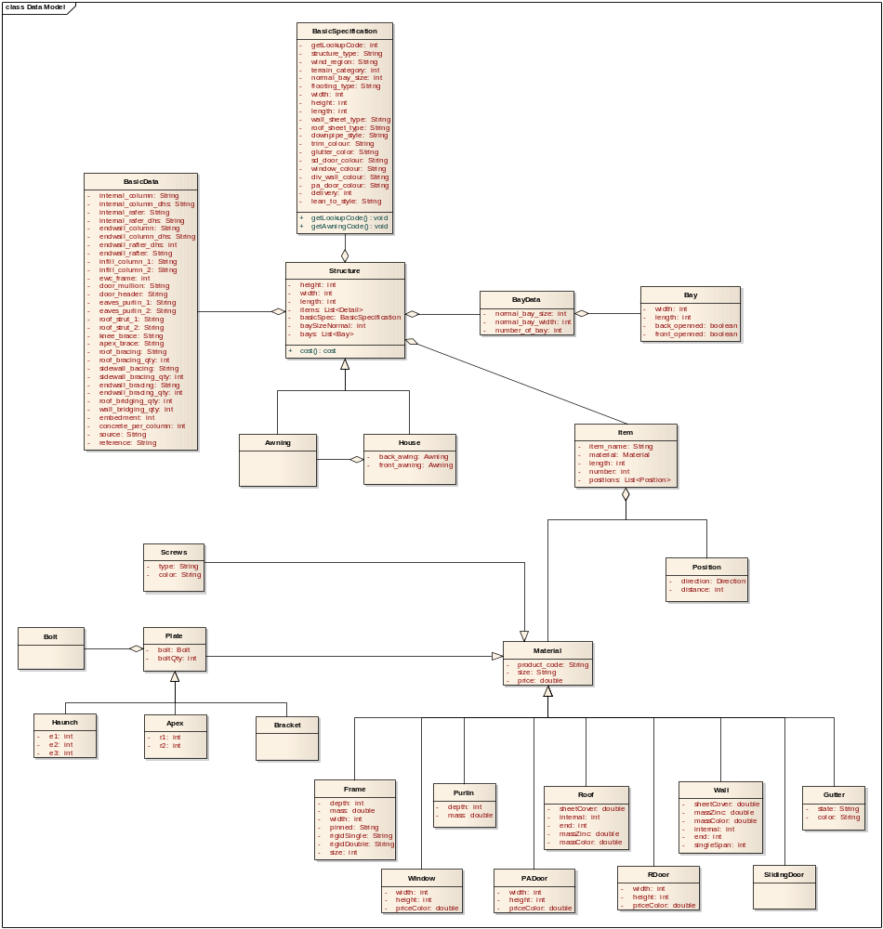

Structure

Detail: Created on 5/19/2010. Last modified on 5/21/2010.
Notes:

Columns

Name | Type | Not Null | Len | Init | Notes
structure_type | String |  |  |  | defined structure type
wind_region | String |  |  |  | the wind region
terrain_category | double |  |  |  | terrain
base_type | int |  |  |  | base type of structure
roof_pitch | int |  |  |  | type of terrain where build structure
Span | int |  |  |  | width of structure
bay_space | int |  |  |  | width of bay
Height | int |  |  |  | height of structure
DOS | int |  |  |  | double or single frame
basic_spec | BasicSpec |  |  |  | contain component to lookup
Options | List<Option> |  |  |  | options
sheeting | List<Sheeting> |  |  |  | roof sheeting and wall sheeting

BasicSpec

Detail: Created on 5/19/2010. Last modified on 5/21/2010.Notes:

Columns

Name | Type | Not Null | Len | Init | Notes
lookupcode | long |  |  |  | id
Column | List<Frame>
Rafter | List<Frame>
door_mullion | List<Frame> |  |  |  | used for door frame
roof_strut | List<Frame> |  |  |  | used for roof frame
knee_brace | Frame
bracing | List<WindBracing>

Options

Detail: Created on 3/17/2005. Last modified on 4/24/2009.
Notes:

Columns

Name | Type | Not Null | Len | Init | Notes
Name | String
Code | String
Type | String
pricing_zinc | double
pricing_color | double

Frame

Detail: Created on 5/19/2010. Last modified on 5/21/2010.
Notes:

Columns

Name | Type | Not Null | Len | Init | Notes
frame_name | String
frame_code | String
Depth | int
Mass | double
frame_pricing | double

ColumnRafter

Detail: Created on 5/19/2010. Last modified on 5/21/2010.
Notes:

Columns
Name | Type | Not Null | Len | Init | Notes
Width | int
Pinned | String
rigidSingle | String
rigidDouble | String
Size | int
plainProduct | String

Purlin

Detail: Created on 5/19/2010. Last modified on 5/21/2010.
Notes:

Columns

Name | Type | Not Null | Len | Init | Notes

Girt

Detail: Created on 3/17/2005. Last modified on 4/24/2009.
Notes:

Columns

Name | Type | Not Null | Len | Init | Notes

Column

Detail: Created on 5/19/2010. Last modified on 5/21/2010.
Notes:

Columns

Name | Type | Not Null | Len | Init | Notes

Rafter

Detail: Created on 5/19/2010. Last modified on 5/21/2010.
Notes:

Columns

Name | Type | Not Null | Len | Init | Notes

Screws

Detail: Created on 5/19/2010. Last modified on 5/21/2010.
Notes:

Columns

Name | Type | Not Null | Len | Init | Notes
screws_name | String
screws_code | String
screws_type | String
screws_pricing | double

Plate

Detail: Created on 5/19/2010. Last modified on 5/21/2010.
Notes:

Columns

Name | Type | Not Null | Len | Init | Notes
plate_name | String
plate_code | String
bolt | Bolt |  |  |  | bolt type used
bolt_number | int
plate_pricing | int
on_google | boolean |  |  |  | check product has not yet been update

Apex

Detail: Created on 5/19/2010. Last modified on 5/21/2010.
Notes:

Columns

Name | Type | Not Null | Len | Init | Notes

Haunch

Detail: Created on 5/19/2010. Last modified on 5/21/2010.
Notes:

Columns

Name | Type | Not Null | Len | Init | Notes

Bolt

Detail: Created on 5/19/2010. Last modified on 5/21/2010.
Notes:

Columns

Name | Type | Not Null | Len | Init | Notes
bolt_name | String
bolt_code | String
bolt_pricing | double

Sheeting

Detail: Created on 5/19/2010. Last modified on 5/21/2010.
Notes:

Columns

Name | Type | Not Null | Len | Init | Notes
Name | String
Code | String
Bmt | String
Type | String
mass | double
color | String
pricing | double

Roof

Detail: Created on 5/19/2010. Last modified on 5/21/2010.
Notes:

Columns

Name | Type | Not Null | Len | Init | Notes

Wall

Detail: Created on 5/19/2010. Last modified on 5/21/2010.
Notes:

Columns

Name | Type | Not Null | Len | Init | Notes

Gutter

Detail: Created on 5/19/2010. Last modified on 5/21/2010.
Notes:

Columns

Name | Type | Not Null | Len | Init | Notes
gutter_name | String
gutter_code | String
state | String
gutter_bracket | String |  |  |  | used to support gutter
gutter_pricing | double

