Author 1 (one author only)

|  |  |  |  |  |  |  |
| --- | --- | --- | --- | --- | --- | --- |
| First Name  (or initial) | Middle Name (or initial) | Surname | Suffix  (Jr., III, etc.) | Optional http://orcid.orgORCID | Email | Contact author? yes or no |
| James | Charles | Slosson |  |  | [jcs6630@psu.edu](mailto:jcs6630@psu.edu) | Yes |

ASABE use

|  |
| --- |
|  |

Author 2 (one author only)

|  |  |  |  |  |  |  |
| --- | --- | --- | --- | --- | --- | --- |
| First Name  (or initial) | Middle Name (or initial) | Surname | Suffix  (Jr., III, etc.) | Optional http://orcid.orgORCID | Email | Contact author? yes or no |
| Yiming |  | Li |  |  | [ybl5069@psu.edu](mailto:ybl5069@psu.edu) | no |

ASABE use

|  |
| --- |
|  |

Author 3

|  |  |  |  |  |  |  |
| --- | --- | --- | --- | --- | --- | --- |
| First Name  (or initial) | Middle Name (or initial) | Surname | Suffix  (Jr., III, etc.) | Optional http://orcid.orgORCID | Email | Contact author? yes or no |
| Hojae |  | Yi |  | 0000-0002-6337-7417 | [huy1@psu.edu](mailto:huy1@psu.edu) | no |

ASABE use

|  |
| --- |
|  |

Author 4

|  |  |  |  |  |  |  |
| --- | --- | --- | --- | --- | --- | --- |
| First Name  (or initial) | Middle Name (or initial) | Surname | Suffix  (Jr., III, etc.) | Optional http://orcid.orgORCID | Email | Contact author? yes or no |
|  |  |  |  |  |  |  |

ASABE use

|  |
| --- |
|  |

Author 5

|  |  |  |  |  |  |  |
| --- | --- | --- | --- | --- | --- | --- |
| First Name  (or initial) | Middle Name (or initial) | Surname | Suffix  (Jr., III, etc.) | Optional http://orcid.orgORCID | Email | Contact author? yes or no |
|  |  |  |  |  |  |  |

ASABE use

|  |
| --- |
|  |

Author 6—repeat the two "Author" and "ASABE use" tables for each additional author

|  |  |  |  |  |  |  |
| --- | --- | --- | --- | --- | --- | --- |
| First Name  (or initial) | Middle Name (or initial) | Surname | Suffix  (Jr., III, etc.) | Optional http://orcid.orgORCID | Email | Contact author? yes or no |
|  |  |  |  |  |  |  |

ASABE use

|  |
| --- |
|  |

Paper number and page range

|  |
| --- |
| Paper number on the line below |
| **2200583** |
| Pages 1-**7** |

|  |  |
| --- | --- |
| ASABE_all_blue | An ASABE Meeting Presentation  DOI: https://doi.org/10.13031/aim.202200583  Paper Number: 2200583 |

**IDENTIFYING SOURCES OF HIGH FRICTION IN ANATOMICAL FRACTIONS OF CORN STOVER**

James C. Slosson, Yiming Li and Hojae Yi

The Pennsylvania State University, University Park, PA 16802

Written for presentation at the  
2022 ASABE Annual International Meeting  
Sponsored by ASABE  
Houston, Texas  
July 17–20, 2022

**Abstract.** Corn stover interactions involving cob fractions were found to contain the largest peaks and variance in friction coefficients (Table 3). Cob particles with woody-ring sub-fractions on the contacting surface were observed to be significantly harder and 'claw-like' in nature. Whereas the pith region of the cob was very similar to the exposed pith in stalk particles. Particles of stalk and husk both showed moderate friction coefficients.

From the observation that particles of corn cob show a larger standard deviation in the determined coefficient of friction, it can be hypothesized that particles of corn cob will have a high contribution to an erratic feedstock flow behavior. It can also be hypothesized that the cob will generate high frictional forces considering the high cohesive forces and moderate friction coefficients observed in a corn cob. The experimental data suggest that high-stress feedstock handling applications may be more stable with the removal of corn cob.

The anatomical fractions discussed in this paper were categorized using macro-observations for the purpose of potential mechanical separation. Under further review, it appears each corn stover fraction contained an associated set of sub-fractions that could be found in at least one other fraction. Sub-fractions could be generally characterized as woody, pithy, or leafy. Additional steps in comminuting particles to expose 'sub-fractions' may allow fluid separation techniques to create more uniform and, therefore, desirable products. It is recommended to repeat this experiment using two additional comminution methods (i.e., knife mill and hammer mill) practiced in the industry to study varying effects of size reduction equipment on friction coefficients.

**Keywords**. Biomass, corn stover, anatomical fraction, coefficient of friction (COF), adhesion force, sub-fractions.

|  |
| --- |
| The authors are solely responsible for the content of this meeting presentation. The presentation does not necessarily reflect the official position of the American Society of Agricultural and Biological Engineers (ASABE), and its printing and distribution does not constitute an endorsement of views which may be expressed. Meeting presentations are not subject to the formal peer review process by ASABE editorial committees; therefore, they are not to be presented as refereed publications. Publish your paper in our journal after successfully completing the peer review process. See [www.asabe.org/JournalSubmission](http://www.asabe.org/JournalSubmission) for details. Citation of this work should state that it is from an ASABE meeting paper. EXAMPLE: Author's Last Name, Initials. 2022. Title of presentation. ASABE Paper No. ---. St. Joseph, MI.: ASABE. For information about securing permission to reprint or reproduce a meeting presentation, please contact ASABE at [www.asabe.org/copyright](http://www.asabe.org/copyright) (2950 Niles Road, St. Joseph, MI 49085-9659 USA). |

# Introduction

Department of Energy's Bioenergy Technology Office (BETO) considers corn stover a key candidate as a biomass source for its abundance and current use in integrated biorefineries (IBR) (Bioenergy Technologies Office, 2017). Corn stover refers to the remaining corn plant fractions (i.e., stalk, husk, and cob) after the lower stalk is cut away and the grain has been harvested. While many want to bring the advantages of new biofuel technologies to industrial production, there is a significant financial risk due to frequent misrepresentation of physical and chemical variabilities in effective lignocellulosic biomass handling and feeding (Crawford et al., 2016; Ray et al., 2020). In the most recent 2016 evaluation, total biofuel production only reached 7% of the expected 58 billion gallons per year design capacity ("Feedstock-Conversion Interface Consortium (FCIC)," n.d.; Westover and Hartley, 2018). The challenges in the handling of biomass are one of the crucial impediments to adopting biomass as feedstocks for biofuel production.

DOE Bioenergy Technology Office (2016) reports that flowability challenges are mainly associated with biomass density, particle size distribution, moisture content, angle of repose, shear stress, bridging tendency, cohesive strength, and friction of equipment surfaces. The variations in biomass factors such as shape, size, moisture content, and low bulk density are considered to make it challenging to handle and transport in its original form (N Kaliyan and R V Morey, 2007). However, the majority of the metrics used for the mentioned flow challenges are focused on bulk behavior and do not address the inter-particle mechanics leading to bulk observation.

Understanding interparticle mechanics associated with each corn stover fraction will provide valuable information for understanding the overall poor flow behavior of milled corn stover. More specifically, such quantitative information will help identify certain fractions that may be significantly responsible for the poor flowability behavior of comingled corn stover fractions.

This research aims to gain quantitative knowledge of the interparticle mechanics of fractionated corn stover through the development of an interparticle mechanics tester capable of accommodating biomass particles and a test protocol to determine friction and adhesion properties. With the novel data on interparticle mechanical properties of corn stover particles from different anatomical origins, this study aims to examine the significance of the difference in friction coefficients between corn stover particles from different anatomical fractions. The knowledge gained by this study will contribute to reducing operational challenges by removing fractions with high friction and traction adhesion contributions.

# Materials and Methods

This section details the method used to determine friction coefficients between anatomical fractions of corn stover.

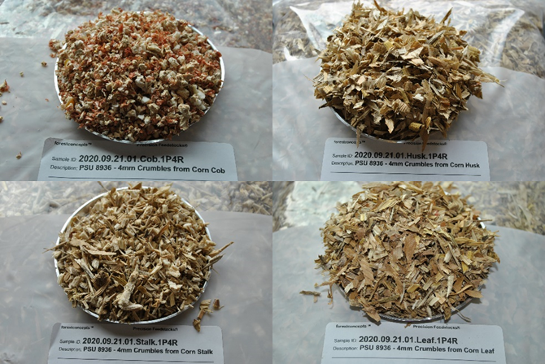

Figure : Sample images of individual corn stover fractions used in the present study. 4mm cob Crumbles® (top left), 4mm husk Crumbles® (top right), 4mm stalk Crumbles® (bottom left), and 4mm leaf Crumbles® (bottom right).

## Material Preprocessing History

A square bale of field-dried corn stover from Antares Corn Stover (Hardin, IO) was processed by Forest Concepts, LLC (Auburn, WA). The bale was hand separated and placed into labeled bins designated for each anatomical fraction. Individual fractions were then comminuted to Crumbles® using Forest Concepts' Crumbler® Rotary Shear technology and conveyed into a final screening process. The screening was performed using a 3-deck orbital screen to filter out fractions with geometric mean diameter outside the 4mm target.

Lab characterization for anatomical fractions of corn stover was provided by Forest Concepts, LLC analytics laboratory in Auburn, WA. Final products were analyzed for size, moisture content, and loose and bulk density (Table 1). Individual corn stover fractions were packaged and shipped to Pennsylvania State University's Food and Biomaterials Lab for inter-particle mechanics testing.

Table : Lab characterization for anatomical fractions of corn stover. Provided by Forest Concepts, LLC analytics laboratory in Auburn, WA.

|  |  |  |  |  |  |
| --- | --- | --- | --- | --- | --- |
| **Anatomical Fraction** | **Moisture Content** | **Geometric Mean Diameter (mm)** | | **Bulk Density (odkg/m^3)** | |
| ***%MCwb*** | ***Xgm*** | ***Sgm*** | ***Loose*** | ***Tapped*** |
| Cob | 9.7 | 6.6 | 1.6 | 179 | 217 |
| Husk | 9.7 | 4.6 | 1.6 | 48 | 66 |
| Stalk | 9.7 | 4.5 | 1.8 | 76 | 98 |

## Inter-particle Mechanics Tester (IPMT)

The development of a new Inter-particle Mechanics Tester (IPMT) was needed (Figure 2) to measure the traction force between a stationary and moving particle under a varying magnitude of normal load. This arrangement allows for one test run to produce multiple normal force and lateral force measurements and alleviates the requirement to conduct separate tests with different normal forces in a conventional friction test (Pitenis et al., 2014). The development of the new design was essential for simulating any possible orientation of two interacting particles. This design allows collecting friction coefficients over multiple untested regions without resampling surfaces or replacing test particles between each repetition. With this design, it is also possible to prepare and condition multiple test samples, e.g., conduct friction experiments in an environment-controlled chamber at a different environmental relative humidity.

Figure : Inter-particle mechanics tester (right) with a detailed view of sample mounting (left).

## Specifications and Operational Parameters of IPMT

An IPMT was developed to perform friction tests on fully supported particles, unsupported (over-hanging), or combinations of both. Sample holders and component position/capacity are easily adjustable to handle any particles of any size and shape. The specifications for the IPMT are limited to the following conditions.

* Minimum incremental push/pull motion is 0.05 μm.
* Maximum push/pull travel ranges up to 25 mm to accommodate a typical biomass particle size.
* Push/pull velocity is set to 1.2 mm/s.
* Maximum displacement of the normal force actuator is 14mm to accommodate a typical biomass particle size.
* Minimum normal displacement of the particle is as small as 6 nm.
* Three-dimensional control of the initial particle contact location is possible.
* Maximum allowed normal force is approximately 3 N.
* The accuracy of loadcell is ±0.02% of FS.
* Maximum sample rate is 1 kHz.

## Experimental Design and Setup

An experimental procedure was developed to perform friction tests with minimal experimental error, as detailed below.

### Experimental Design

A sample size of 12 was selected for each possible combination of anatomical fractions to obtain a minimum of three data points and to ensure the experiment could be completed as planned. Once all the data had been collected and analyzed, an analysis of variance (ANOVA) (alpha=0.05) was used to determine the source of variance. The Wilcoxon signed-rank (signed-rank) test was selected to test the null hypothesis (i.e., friction coefficients between corn stover particles from different anatomical fractions are not statistically different) for a population of unknown statistical distribution. The signed-rank test is a useful alternative to a paired student t-test when the normality of the observed data set is not ensured.

### Sample Preparation

Approximately 50 g samples were collected from each anatomical fraction of corn stover. Each sample was held in a controlled environment for 72 hours to allow for particles to reach equilibrium moisture content (~10% MCwb). Once particle moisture was equalized, particles were randomly selected and adhered to removable particle mounts (Figure 3) using Permatex *Ultra Bond™ Super Glue*. Mounting methods (fully vs. singly supported) and grain orientations were performed randomly with every particle. Conservative volumes of adhesives were applied to reduce absorption into particles as well as to ensure proper curing. A curing period of 24 hours (±2 hours) was established for experimental consistency.

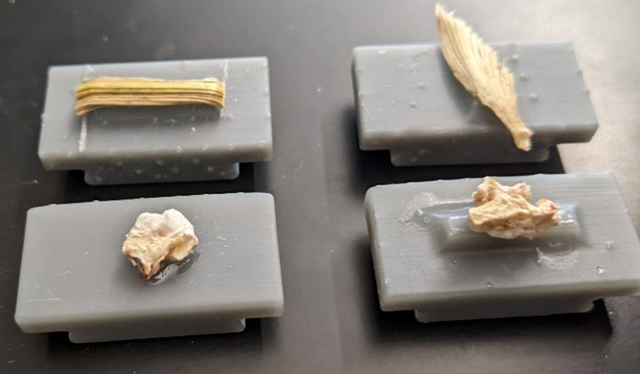

Figure : Image of corn stover particles adhered to plastic particle mount for conditioning and testing. The upper and lower half of the image contains 4mm husk and cob fractions, respectively.

Once the adhesive had cured for 24 hours, particle pairs were randomly selected for testing. Table 2 contains the experimental plan for each possible particle pair and the required number of repetitions to be completed to test the null hypothesis.

Table : Experimental plan for the required number of corn fraction test pairs and associated repetitions.

|  |  |  |  |
| --- | --- | --- | --- |
| **Pair ID#** | **Base Particle** | **Interacting Particle** | **Req. Test Repetitions** |
| 1 | Stalk | Stalk | 12 |
| 2 | Cob | 12 |
| 3 | Husk | 12 |
| 4 | Cob | Cob | 12 |
| 5 | Husk | 12 |
| 6 | Husk | Husk | 12 |

### IPMT Settings and Operating Procedures

Each experiment was performed at a sliding speed of 0.5 mm/min with a randomized initial normal loading force between 30 and 200g. Prior to each test, test operators must determine the required positioning of the normal force applicator (See Figure 2) to produce the target initial normal loading. This procedure was performed in less than 0.1mm increments to prevent overloading of the normal force sensor past the selected design capacity. Once the target initial normal force was applied, the traction force applicator and data collection were initiated. Data collection is terminated once particles are no longer in contact or upon sensor capacity concerns.

### Data collection and analysis methods

Normal and traction force data were collected at 80Hz, using National Instruments™ LabVIEW and two 24-bit Di-1000U signal digitizers (Loadstar Sensors - Freemont, CA). The middle two quartiles were selected and extracted as steady-state data for further analysis for each data collection experiment performed.

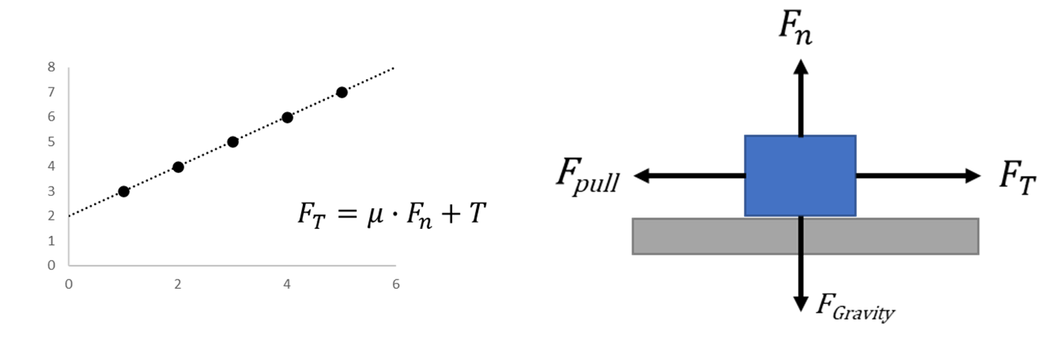

Figure : Theoretical plot of traction force versus normal force (Left). Force diagram of two particles (grey and blue) under applied normal and pulling force (Right).

Similar to as shown in Figure 4, the coefficient of friction (μ) will be determined using the average ratio of traction force to the applied normal force during steady-state conditions.

# Results and Discussion

Corn stover interactions involving cob fractions were found to contain the largest peaks and variance in friction coefficients (Table 3). Cob particles with woody-ring sub-fractions on the contacting surface were observed to be significantly harder and 'claw-like' in nature. Whereas the pith region of the cob was very similar to the exposed pith in stalk particles. Particles of stalk and husk both showed moderate friction coefficients.

Table : Average and standard deviations for each combination of interacting corn stover fractions.

|  |  |  |
| --- | --- | --- |
| **Paired Fractions** | **Average**  **Friction Coefficient** | **Standard Deviation** |
| stalk-stalk | 0.28 | 0.09 |
| cob-cob | 0.86 | 0.26 |
| husk-husk | 0.23 | 0.06 |
| stalk-cob | 0.53 | 0.25 |
| cob-husk | 0.32 | 0.16 |
| stalk-husk | 0.21 | 0.07 |

Table : Wilcoxon Signed Rank Test Critical Values Table

|  |  |  |  |
| --- | --- | --- | --- |
| **Particle Pair** | **Comparison Pair** | **Sum<Cr?** | **Result** |
| stalk-stalk | cob-cob | TRUE | reject null |
| husk-husk | FALSE | fail to reject |
| stalk-cob | TRUE | reject null |
| cob-husk | FALSE | fail to reject |
| stalk-husk | FALSE | fail to reject |
| cob-cob | husk-husk | TRUE | reject null |
| stalk-cob | TRUE | reject null |
| cob-husk | TRUE | reject null |
| stalk-husk | TRUE | reject null |
| husk-husk | stalk-cob | TRUE | reject null |
| cob-husk | FALSE | fail to reject |
| stalk-husk | FALSE | fail to reject |
| stalk-cob | cob-husk | FALSE | fail to reject |
| stalk-husk | TRUE | reject null |
| cob-husk | stalk-husk | TRUE | reject null |

An ANOVA test (α=0.05) showed the key source of variance in friction coefficients was found to be between different combinations of fractions. Leading to further investigation of key sources of variances. Without an understanding of the population distribution, a Wilcoxon signed-rank test was conducted to determine the significance across the variance with each corn stover fraction combination. As shown in Table 4, the results suggest that cob fractions had a significantly different friction coefficient.

# Conclusions

From the observation that particles of corn cob show a larger standard deviation in the determined coefficient of friction, it can be hypothesized that particles of corn cob will have a high contribution to an erratic feedstock flow behavior. It can also be hypothesized that the cob will generate high frictional forces considering the high cohesive forces and moderate friction coefficients observed in a corn cob. The experimental data suggest that high-stress feedstock handling applications may be more stable with the removal of corn cob.

It is planned to repeat tests with variations in moisture content. High adhesive forces in cob particles containing 'woody-ring' subfractions may be reduced as moisture levels increase towards the fiber saturation point, but further studies are required to understand any adverse effects on friction coefficients.

The anatomical fractions discussed in this paper were categorized using macro-observations for the purpose of potential mechanical separation. Under further review, it appears each corn stover fraction contained an associated set of sub-fractions that could be found in at least one other fraction. Sub-fractions could be generally characterized as woody, pithy, or leafy. Additional steps in comminuting particles to expose 'sub-fractions' may allow fluid separation techniques to create more uniform and, therefore, desirable products. It is recommended to repeat this experiment using two additional comminution methods (i.e., knife mill and hammer mill) practiced in the industry to study varying effects of size reduction equipment on friction coefficients.

# Acknowledgment

This material is based upon work supported by the US Department of Energy's Office of Energy Efficiency and Renewable Energy (EERE) under the Bioenergy Technologies Office, Integrated Biorefinery Optimization award number DE-EE0008936. This work was partially supported by USDA NIFA Agricultural Experiment Station project PEN-4671.

# References

Bioenergy Technologies Office. (2016). *Biorefinery Optimization Workshop Summary Report* (p. 72). Chicago, IL: Department of Energy.

Bioenergy Technologies Office. (2017). *2017 Project Peer Review—Feedstock Supply and Logistics*. Denver, Colorado: Department of Energy. Retrieved from https://www.energy.gov/eere/bioenergy/downloads/2017-project-peer-review-feedstock-supply-and-logistics

Crawford, N. C., Nagle, N., Sievers, D. A., Stickel, J. J. (2016). The effects of physical and chemical preprocessing on the flowability of corn stover. *Biomass and Bioenergy*, *85*, 126–134. https://doi.org/10.1016/j.biombioe.2015.12.015

Feedstock-Conversion Interface Consortium (FCIC). (n.d.), 24.

N Kaliyan, R V Morey. (2007). Roll Press Briquetting of Corn Stover and Switchgrass: A Pilot Scale Continuous Briquetting Study. In *2007 Minneapolis, Minnesota, June 17-20, 2007*. American Society of Agricultural and Biological Engineers. https://doi.org/10.13031/2013.24034

Pitenis, A. A., Dowson, D., Gregory Sawyer, W. (2014). Leonardo da Vinci's Friction Experiments: An Old Story Acknowledged and Repeated. *Tribology Letters*, *56*(3), 509–515. https://doi.org/10.1007/s11249-014-0428-7

Ray, A. E., Williams, C. L., Hoover, A. N., Li, C., Sale, K. L., Emerson, R. M., … Donohoe, B. S. (2020). Multiscale Characterization of Lignocellulosic Biomass Variability and Its Implications to Preprocessing and Conversion: a Case Study for Corn Stover. *ACS Sustainable Chemistry & Engineering*, *8*(8), 3218–3230. https://doi.org/10.1021/acssuschemeng.9b06763

Westover, T. L., Hartley, D. S. (2018). Biomass Handling and Feeding. In M. Nageswara-Rao & J. R. Soneji (Eds.), *Advances in Biofuels and Bioenergy*. InTech. https://doi.org/10.5772/intechopen.74606