Friction and adhesion between corn stover particles

James C. Slosson, Yiming Li, Sena Atsyo, Heather Burkholder, and Hojae Yi

2024-10-22

Abstract

Corn stover interactions involving cob fractions were found to contain the largest peaks and variance in friction coefficients (Table 3). Cob particles with woody-ring sub-fractions on the contacting surface were observed to be significantly harder and ’claw-like’ in nature. Whereas the pith region of the cob was very similar to the exposed pith in stalk particles. Particles of stalk and husk both showed moderate friction coefficients.

From the observation that particles of corn cob show a larger standard deviation in the determined coefficient of friction, it can be hypothesized that particles of corn cob will have a high contribution to an erratic feedstock flow behavior. It can also be hypothesized that the cob will generate high frictional forces considering the high cohesive forces and moderate friction coefficients observed in a corn cob. The experimental data suggest that high-stress feedstock handling applications may be more stable with the removal of corn cob.

The anatomical fractions discussed in this paper were categorized using macro-observations for the purpose of potential mechanical separation. Under further review, it appears each corn stover fraction contained an associated set of sub-fractions that could be found in at least one other fraction. Sub-fractions could be generally characterized as woody, pithy, or leafy. Additional steps in comminuting particles to expose ’sub-fractions’ may allow fluid separation techniques to create more uniform and, therefore, desirable products. It is recommended to repeat this experiment using two additional comminution methods (i.e., knife mill and hammer mill) practiced in the industry to study varying effects of size reduction equipment on friction coefficients.

# Introduction

Department of Energy’s Bioenergy Technology Office (BETO) considers corn stover a key candidate as a biomass source for its abundance and current use in integrated biorefineries (IBR) (Doyle 2014; USDOE 2011; Langholtz, Stokes, and Eaton 2016; Perlack et al. 2011). Corn stover refers to the remaining corn plant fractions (i.e., stalk, husk, and cob) after the lower stalk is cut away and the grain has been harvested. While many want to bring the advantages of new biofuel technologies to industrial production, there is a significant financial risk due to frequent misrepresentation of physical and chemical variabilities in effective lignocellulosic biomass handling and feeding (Crawford et al. 2016; Ray et al. 2020; Ray et al. 2017). In the most recent 2016 evaluation, total biofuel production only reached 7% of the expected 58 billion gallons per year design capacity (Westover and Hartley 2018). The challenges in the handling of biomass are one of the crucial impediments to adopting biomass as feedstocks for biofuel production.

BETO (2016) reports that flowability challenges are mainly associated with biomass density, particle size distribution, moisture content, angle of repose, shear stress, bridging tendency, cohesive strength, and friction of equipment surfaces (Westover and Hartley 2018). The variations in biomass factors such as shape, size, moisture content, and low bulk density are considered to make it challenging to handle and transport in its original form (Kaliyan et al. 2009).

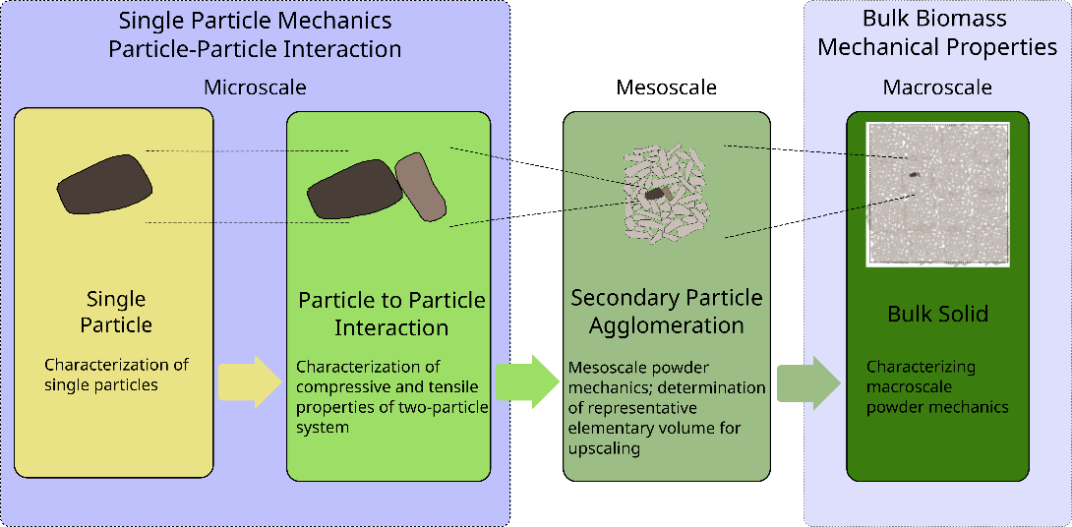The root cause of such variations in bulk behavior of milled biomass originates from the multiscale-nature as depicted in the Figure 1. This means in order to develop a first-principle based understanding of bulk biomass behavior, quantitative knowledge of interactions between particles is necessary. ~~With such knowledge, one can investigate and develop a predictive model of the mechanical behavior of bulk biomass.~~ One of earlier mention on the friction coefficient between particle and bulk behavior was from Raynolds [1], where he mentioned that “we cannot assume that tan*φ* has any relation to the actual friction between the molecules,” where *φ* is the angle of repose. In later development of the bulk mechanism of particulate system, this concept was further developed into the Mohr-Coulomb’s law, where the two material properties are named as ‘coefficient of cohesion’ and ‘internal angle of friction.’ While it is widely accepted that the angle of repose coincides with the angle of repose, it is difficult to find an experimental study corroborating this concept. One clear concept is that mechanical interactions between particles will give rise to the frictional resistance to the failure of bulk materials. This study aims to taking a step toward to bridging this knowledge gap between bulk mechanical behavior and inter-particle mechanical behavior at the underlying scale.

Figure Schematic of the emerging bulk mechanical properties from the mechanical interactions between biomass particles to the bulk mechanical behavior of milled biomass

.

* Janssen’s equation (Janssen 1895) and stresses on silo wall(Schulze and Schwedes 1994)
* Still not quantified Reynolds’ question on the relationship between the angle of repose and friction between particles (Reynolds 1885)
* Recent studies with DEM still relying on fitted parameters that are not determined with particles (Xia et al. 2023; F. Chen et al. 2023, 2022)

Understanding interparticle mechanics associated with each corn stover fraction will provide valuable information for understanding the overall poor flow behavior of milled corn stover. More specifically, such quantitative information will help identify certain fractions that may be significantly responsible for the poor flowability behavior of comingled corn stover fractions.

There exists a ASTM standards concerning the measuring friction coefficient including ASTM G115-10 (2018). However, listed methods in ASTM G115-10 (2018) assumes a specific geometry, e.g., flat surface or sphere, and not feasible to implement for testing milled biomass particles, which are much smaller in size and irregular in shape. Also test protocols reflect repeated sliding in cyclic motion or rotation, which is implemented in a typical tribometer. This also reflects specific industrial applications such as ball bearing or sliding frames, which are not applicable to the interactions of biomass particles relevant to the bulk biomass flow.

* In other words, the current friction measurements focus on interactions between sliding surfaces, e.g., bearing. This focus is also reflected in the DEM framework, requiring sliding and rolling friction coefficient. From the perspective of the handling bulk biomass, or any other cohesive particulate materials, the friction coefficient of incipient relative motion between particles is of interest.

Therefore, we developed an in-house instrument and protocol that can determine mechanical interaction between biomass particles following the Derjaguin’s adhesive friction model (Gao et al. 2004; Derjaguin 1934; Derjaguin, Muller, and Toporov 1975).

This study aims to gain quantitative knowledge of the interparticle mechanics of fractionated corn stover through the development of an interparticle mechanics tester capable of accommodating biomass particles and a test protocol to determine friction and adhesion properties. With the novel data on interparticle mechanical properties of corn stover particles from different anatomical origins, this study aims to examine the significance of the difference in friction coefficients between corn stover particles from different anatomical fractions. The knowledge gained by this study will contribute to reducing operational challenges by removing fractions with high friction and traction adhesion contributions.

## Other notable quotes

page 121: Variability of biomass exceeds handling machinery design specification: This paper also mentions the start-up or continuous running efficiency

# Materials and Methods

This section details the method used to determine friction coefficients between anatomical fractions of corn stover.

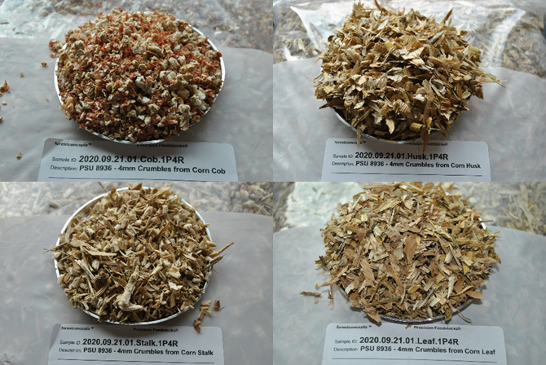

Figure Sample images of individual corn stover fractions used in the present study. 4mm cob Crumbles® (top left), 4mm husk Crumbles® (top right), 4mm stalk Crumbles® (bottom left), and 4mm leaf Crumbles® (bottom right)

## Material Preprocessing History

A square bale of field-dried corn stover from Antares Corn Stover (Hardin, IO) was processed by Forest Concepts, LLC (Auburn, WA). The bale was hand separated and placed into labeled bins designated for each anatomical fraction. Individual fractions were then comminuted to Crumbles® using Forest Concepts’ Crumbler® Rotary Shear technology and conveyed into a final screening process. The screening was performed using a 3-deck orbital screen to filter out fractions with geometric mean diameter outside the 4mm target.

The physical properties of particles of different tissue types of corn stover indicate that the crumbled particles are in consistent size (Table 1). However, the bulk density values are significantly different from each other (Kruskal-Wallis test, p = 5e-13 < 0.05).

Table Physical properties of corn stover particles of different tissue type (Forest Concepts, LLC analytics laboratory in Auburn, WA) following [2].

|  |  |  |  |  |  |
| --- | --- | --- | --- | --- | --- |
| Anatomical Fraction | Moisture Content | Geometric Mean  Particle Size D50 | Standard Deviation of Particle Size | Loose Bulk Density  (oven-dried) | Tapped Bulk Density  (oven-dried) |
|  | (% w.b.) | (mm) | (mm) | (kg/m3) | (kg/m3) |
| Cob | 9.7 | 6.6 | 1.6 | 179 | 217 |
| Husk | 9.7 | 4.6 | 1.6 | 48 | 66 |
| Leaf |  |  |  |  |  |
| Stalk | 9.7 | 4.5 | 1.8 | 76 | 98 |

## Inter-particle Mechanics (IPM) Tester

Existing tribometer, similar to the instrument used in Chen et al.[3], can be used in determining friction coefficient. However, because of the dimension of typical milled biomass particles, an additional attachment is needed. In addition, the cyclic reciprocating movement is not simulating the frictional interaction between biomass particles during handling. Furthermore, this arrangement is not adequate to determine adhesive friction following Derjaguin’s law [4,5].

The development of a new Inter-particle Mechanics (IPM) was needed (Figure 2) to measure the traction force between a stationary and moving particle under a varying magnitude of normal load. This arrangement allows for one test run to produce multiple normal force and lateral force measurements and alleviates the requirement to conduct separate tests with different normal forces in a conventional friction tester (Pitenis, Dowson, and Gregory Sawyer 2014; ASTM G115-10 2018). The development of the new design was essential for simulating any possible orientation of two interacting particles. This design allows collecting friction coefficients over multiple untested regions without resampling surfaces or replacing test particles between each repetition. With this design, it is also possible to prepare and condition multiple test samples, e.g., conduct friction experiments in an environment-controlled chamber at a different environmental relative humidity.

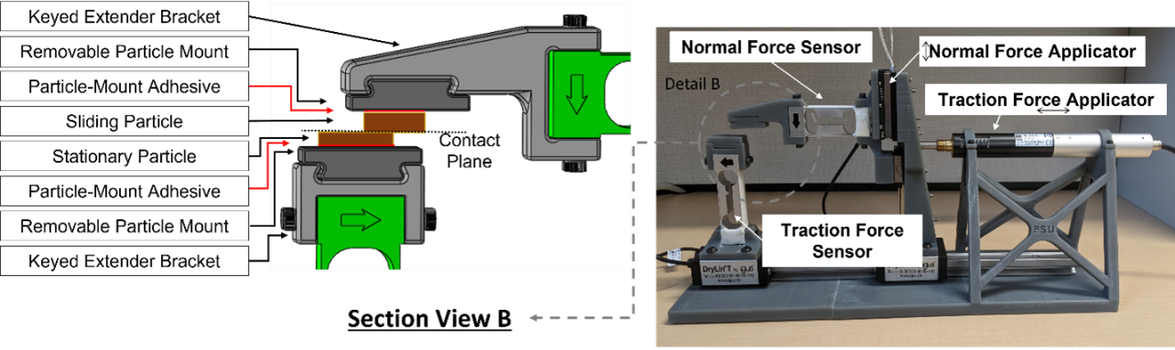

Figure Inter-particle mechanics tester (right) with a detailed view of sample mounting (left)

## Specifications and Operational Parameters of IPMT

An IPMT was developed to perform friction tests on fully supported particles, unsupported (over-hanging), or combinations of both. Sample holders and component position/capacity are easily adjustable to handle any particles of any size and shape. Considering the need to characterize the frictional contact with the perspective of storage and incipient flow, IPMT was designed to have minimum incremental push and pull motion is 0.05 μm and a typical push and pull velocity is set to 1.2 mm/s. To accommodate a typical biomass particle size, the maximum push and pull travel ranges up to 25 mm to accommodate a typical biomass particle size. For vertical direction movement, the maximum displacement of the normal force actuator is designed to be 14mm to accommodate a typical biomass particle size. The resolution of the actuator is 6 nm. Combined vertical and lateral displacement actuators make it possible to control the initial particle contact location if there exists a specific region of interest. The maximum forces of vertical and normal force censors are 20.02 N and 2.94 N, respectfully, whereas the accuracy of both force sensors is ±0.02% of the full scale. Sampling rates of displacement and force sensors are equal to or higher than 1 kHz. Normal and traction force data were collected at 80Hz, using National Instruments™ LabVIEW (Version 2022, Austin TX) and two 24-bit Di-1000U signal digitizers (Loadstar Sensors - Freemont, CA).

## Experimental Design and Setup

An experimental procedure was developed to perform friction tests with minimal experimental error. A sample size of 15 was selected for each possible combination of anatomical fractions to ensure the quality of a subsequent analysis of variance (Kruskal-Wallis test with ) that examined the magnitude and source of variance. The Wilcoxon signed-rank (signed-rank) test was conducted to test the null hypotheses, i.e., friction coefficients and adhesion forces between corn stover particles from different anatomical fractions are not statistically different, without assuming a statistical distribution of determined friction coefficient and adhesion forces.

To prepare inter-particle mechanics test, approximately 50 g samples were collected from each anatomical fraction of milled corn stover. Each sample was held in a controlled environment for 72 hours to allow for particles to reach equilibrium moisture content at approximately 23 °C and 40 % RH. Resulting moisture contents of cob, husk, leaf, and stalk are 8.9 ± 1.0 %, 7.0 ± 1.4 %, 7.0 ± 1.2 %, and 8.9 ± 1.12 %, respectively (values after ± represent the standard error with n = 11).

Once particle moisture was equalized, particles were randomly selected and adhered to removable particle mounts (Figure 4) using Permatex *Ultra Bond™ Super Glue*. Conservative volumes of adhesives were applied to minimize the absorption into particles as well as to ensure proper curing. A curing period of longer than 24 hours was established for experimental consistency. The curing environment is identical to the moisture equilibrating environment. Finally, the grain orientations were randomly chosen with every particle.

* 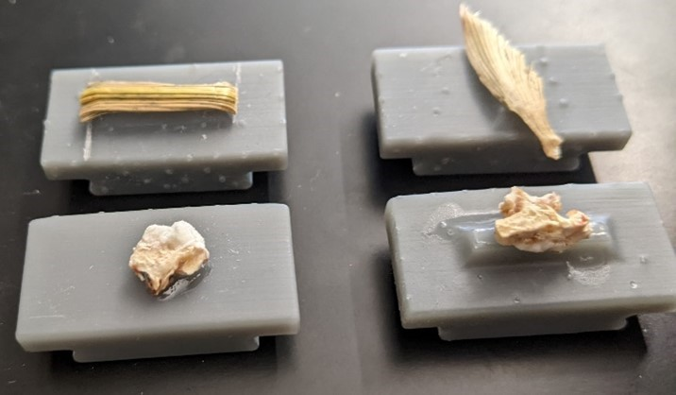

Figure Image of corn stover particles adhered to plastic particle mount for conditioning and testing. The upper and lower half of the image contains 4mm husk and cob fractions, respectively

Once the adhesive had cured for 24 hours, particle pairs were randomly selected for testing. Table 2 lists the combinations of milled corn particles of different tissue type and conducted number of repetitions for appropriate statistical analysis.

Table Experimental plan for the required number of corn fraction test pairs and associated repetitions

|  |  |  |
| --- | --- | --- |
| Base Particle | Interacting Particle | Minimum Repetitions |
| Cob | Cob | 15 |
| Cob | Husk | 15 |
| Cob | Leaf | 15 |
| Cob | Stalk | 15 |
| Husk | Husk | 15 |
| Husk | Leaf | 15 |
| Husk | Stalk | 15 |
| Leaf | Leaf | 15 |
| Leaf | Stalk | 15 |
| Stalk | Stalk | 15 |

An inter-particle mechanics test started with establishing a contact between a base particle and interacting particle with positive normal force ranging between 3 N and 2 N. Then lateral sliding was initiated at a speed of 0.5 mm/min. The normal and lateral forces are tracked and recorded until the contact between two particles is lost, which results in sudden change in force measurement. The middle two quartiles were selected and extracted as steady-state data for further analysis and determination of friction coefficient and adhesion force.

* 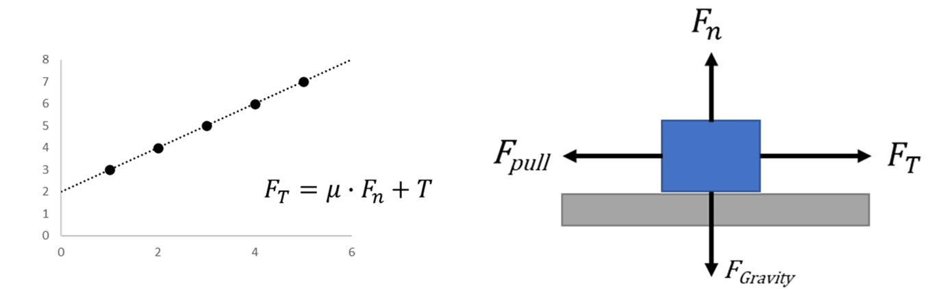

Figure Theoretical plot of traction force versus normal force (Left). Force diagram of two particles (grey and blue) under applied normal and pulling force (Right)



As shown in Figure 5, the coefficient of friction (μ) is defined as the slope of the best fit line and the adhesion force is defined as the y-axis intercept of the bet-fit line, assuming the normal and traction forces are in a linear relationship as proposed by Derjaguin [6]. Therefore, a linear regression analysis was conducted to determine the friction coefficient and adhesion force from experimental data.

# Results and Discussion

## Validation of the IPM

* reference material test: paper
* reference material test: polypropylene

Table 3 lists the results of the validation experiment.

Table Validation test results of polypropylene

| Variable |  | Min |  |  |  |  | Max |  | IQR | #NA |
| --- | --- | --- | --- | --- | --- | --- | --- | --- | --- | --- |
| mu | 20 | 0.194 | 0.221 | 0.250 | 0.258 | 0.288 | 0.394 | 0.051 | 0.067 | 0 |
| c | 20 | -8.472 | 2.048 | 3.790 | 3.309 | 5.488 | 8.931 | 3.657 | 3.441 | 0 |

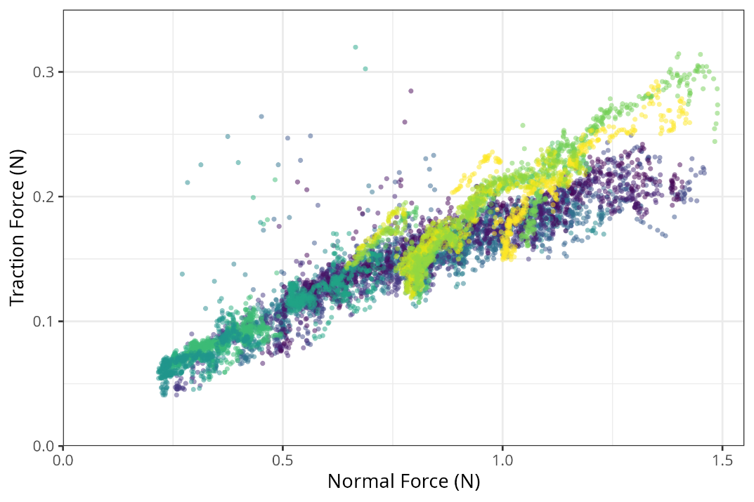

Figure Validation test results of polypropylene

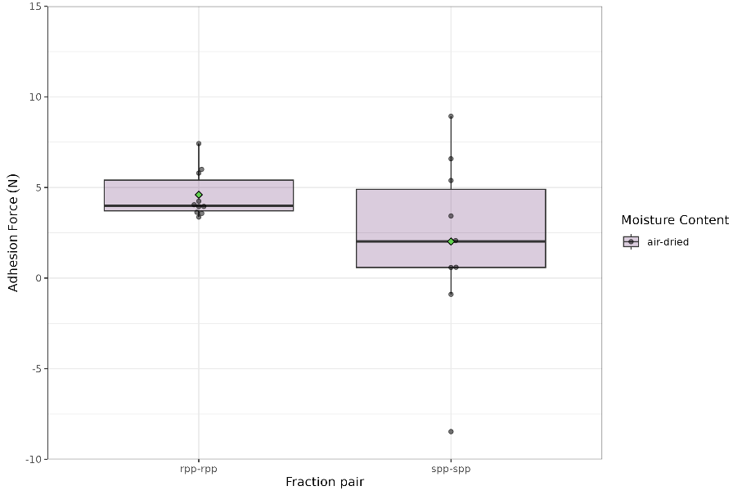

Figure Validation test results of polypropylene; adhesion force

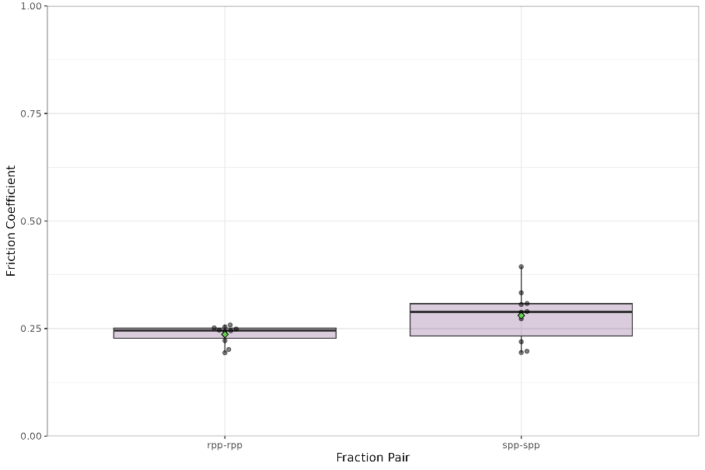Figure Validation test results of polypropylene; friction coefficient

Figure Polypropylene friction coefficient and adhesion force determined using the Interparticle Mechanics Tester

To validate the developed Inter-Particle Mechanics tester, a polypropylene sheet was used as a reference material. The raw data of 20 tests are shown in Figure 9. It is clear that the normal force and traction force follows a linear relationship. Also, following Derjaguin’s cohesive friction law [5–7], the friction coefficient and adhesion force can be determined using the intercept and slope of a linear regression using a linear polynomial. Derjaguin’s cohesive friction law can be described as the equation below:

, where is the traction force, is the normal force, is the friction coefficient, and is the adhesion force.

The summary of the determined friction coefficient () and adhesion force () are listed in Table 4 and Figure 10. The specification listed in by the vendor (McMaster-Carr) ranges between 0.25 and 0.28. The determined friction coefficient is smaller than the listed range. This is expected trend because the friction coefficient is reported to be smaller with the smaller normal force and initial sliding friction segment for polypropylene [8]. This observation supports that the Interparticle Mechanics Tester accurately measures the frictional characteristics.

Figure Interparticle Mechanics Tester Results of polypropylene sheet. Each color represents different run of the experiments (n=20)

Table Summary statistics of Polypropylene friction coefficient and adhesion force determined using the Interparticle Mechanics Tester

|  |  |  |  |  |  |  |  |  |
| --- | --- | --- | --- | --- | --- | --- | --- | --- |
| Interparticle Mechanics  Properties | Sample Size | Min | Q1 | Median | Mean | Q3 | Max | Interquartile Range |
| friction coefficient  () | 20 | 0.10 | 0.12 | 0.14 | 0.16 | 0.20 | 0.26 | 0.07 |
| adhesion force  (, N) | 20 | -0.07 | 0.00 | 0.04 | 0.02 | 0.05 | 0.08 | 0.05 |

## Corn stover particles from different tissue types

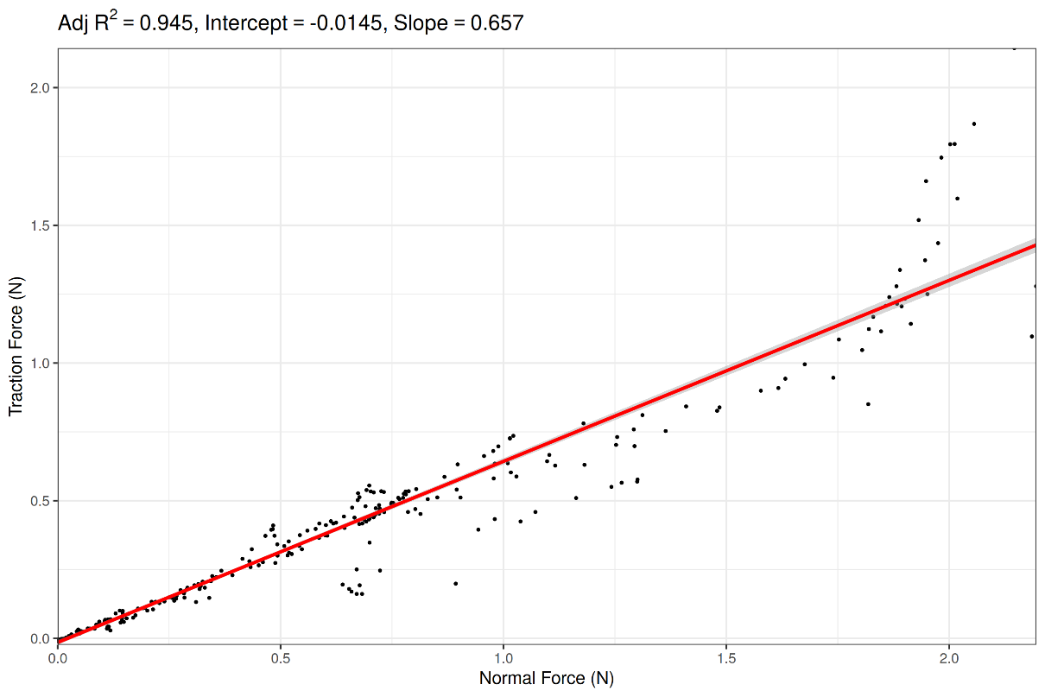

Figure Typical corn stover particle result (cob particle vs. stalk particle shown)

Corn stover interactions involving cob fractions were found to contain the largest peaks and variance in friction coefficients (Table 4). Cob particles with woody-ring sub-fractions on the contacting surface were observed to be significantly harder and ’claw-like’ in nature. Whereas the pith region of the cob was very similar to the exposed pith in stalk particles. Particles of stalk and husk both showed moderate friction coefficients.

Table Wilcox Signed Rank Test Critical Values Table

|  |  |  |
| --- | --- | --- |
| Paired Fractions | Average Friction Coefficient | Standard Deviation |
| stalk-stalk | 0.28 | 0.09 |
| cob-cob | 0.86 | 0.26 |
| husk-husk | 0.23 | 0.06 |
| stalk-cob | 0.53 | 0.25 |
| cob-husk | 0.32 | 0.16 |
| stalk-husk | 0.21 | 0.07 |

Table Anova test result

| Particle Pair | Comparison Pair | Sum<Cr? | Result |
| --- | --- | --- | --- |
| stalk-stalk | cob-cob | TRUE | reject null |
|  | husk-husk | FALSE | fail to reject |
|  | stalk-cob | TRUE | reject null |
|  | cob-husk | FALSE | fail to reject |
|  | stalk-husk | FALSE | fail to reject |
| cob-cob | husk-husk | TRUE | reject null |
|  | stalk-cob | TRUE | reject null |
|  | cob-husk | TRUE | reject null |
|  | stalk-husk | TRUE | reject null |
| husk-husk | stalk-cob | TRUE | reject null |
|  | cob-husk | FALSE | fail to reject |
|  | stalk-husk | FALSE | fail to reject |
| stalk-cob | cob-husk | FALSE | fail to reject |
|  | stalk-husk | TRUE | reject null |
| cob-husk | stalk-husk | TRUE | reject null |

An ANOVA test () showed the key source of variance in friction coefficients was found to be between different combinations of fractions. Leading to further investigation of key sources of variances. Without an understanding of the population distribution, a Wilcoxon signed-rank test was conducted to determine the significance across the variance with each corn stover fraction combination. As shown in Table 5, the results suggest that cob fractions had a significantly different friction coefficient.

# Conclusions

From the observation that particles of corn cob show a larger standard deviation in the determined coefficient of friction, it can be hypothesized that particles of corn cob will have a high contribution to an erratic feedstock flow behavior. It can also be hypothesized that the cob will generate high frictional forces, considering the high cohesive forces and moderate friction coefficients observed in a corn cob. The experimental data suggest that high-stress feedstock handling applications may be more stable with the removal of corn cob.

It is planned to repeat tests with variations in moisture content. High adhesive forces in cob particles containing ’woody-ring’ subfractions may be reduced as moisture levels increase towards the fiber saturation point, but further studies are required to understand any adverse effects on friction coefficients.

The anatomical fractions discussed in this paper were categorized using macro-observations for the purpose of potential mechanical separation. Under further review, it appears each corn stover fraction contained an associated set of sub-fractions that could be found in at least one other fraction. Sub-fractions could be generally characterized as woody, pithy, or leafy. Additional steps in cminuting particles to expose ’sub-fractions’ may allow fluid separation techniques to create more uniform and, therefore, desirable products. It is recommended to repeat this experiment using two additional comminution methods (i.e., knife mill and hammer mill) practiced in the industry to study varying effects of size reduction equipment on friction coefficients.

## Future studies

Using DEM in biomass flow studies

# Acknowledgment

This material is based upon work supported by the US Department of Energy’s Office of Energy Efficiency and Renewable Energy (EERE) under the Bioenergy Technologies Office, Integrated Biorefinery Optimization award number DE-EE0008936.

This work was partially supported by USDA NIFA Agricultural Experiment Station project PEN-4671.

# References

ASTM G115-10. 2018. *Guide for Measuring and Reporting Friction Coefficients*. Standard. West Conshohocken, PA: ASTM International. <https://doi.org/10.1520/G0115-10R18>.

BETO. 2016. “Biorefinery Optimization Workshop Summary Report.” Chicago, IL: Department of Energy.

Chen, Feiyang, Yidong Xia, Jordan L. Klinger, and Qiushi Chen. 2022. “A Set of Hysteretic Nonlinear Contact Models for DEM: Theory, Formulation, and Application for Lignocellulosic Biomass.” *Powder Technology* 399 (February): 117100. <https://doi.org/10.1016/j.powtec.2021.117100>.

Chen, Feiyang, Yidong Xia, Jordan Klinger, and Qiushi Chen. 2023. “Hopper Discharge Flow Dynamics of Milled Pine and Prediction of Process Upsets Using the Discrete Element Method.” *Powder Technology* 415 (February): 118165. <https://doi.org/10.1016/j.powtec.2022.118165>.

Chen, Zhengpu, Carl Wassgren, and Kingsly Ambrose. 2020. “Measurements of Grain Kernel Friction Coefficients Using a Reciprocating-Pin Tribometer.” *Transactions of the ASABE* 63 (3): 675–85. <https://doi.org/10.13031/trans.13748>.

Crawford, Nathan C., Nick Nagle, David A. Sievers, and Jonathan J. Stickel. 2016. “The Effects of Physical and Chemical Preprocessing on the Flowability of Corn Stover.” *Biomass and Bioenergy* 85 (February): 126–34. <https://doi.org/10.1016/j.biombioe.2015.12.015>.

Derjaguin, B. V. 1934. “Molekulartheorie Der Äußeren Reibung.” *Zeitschrift Für Physik* 88 (9-10): 661–75.

Derjaguin, B. V., V. M Muller, and Yu. P Toporov. 1975. “Effect of Contact Deformations on the Adhesion of Particles.” *Journal of Colloid and Interface Science* 53 (2): 314–26. <https://doi.org/10.1016/0021-9797(75)90018-1>.

Derjaguin, B. V., and Y. P. Toporov. 1994. “Influence of Adhesion on the Sliding and Rolling Friction.” *Progress in Surface Science* 45 (1): 317–27. <https://doi.org/10.1016/0079-6816(94)90064-7>.

Doyle, Glenn. 2014. “Integrated Biorefinery Lessons Learned and Best Practices.” In, 13. Washington, DC: U.S. Department of Energy. <https://www.energy.gov/eere/bioenergy/biomass-2014-growing-future-bioeconomy>.

Gao, Jianping, W. D. Luedtke, D. Gourdon, M. Ruths, J. N. Israelachvili, and Uzi Landman. 2004. “Frictional Forces and Amontons’ Law:  From the Molecular to the Macroscopic Scale.” *The Journal of Physical Chemistry B* 108 (11): 3410–25. <https://doi.org/10.1021/jp036362l>.

Janssen, HA. 1895. “Versuche Uber Getreidedruck in Silozellen.” *Z. Ver. Deut. Ing.* 39: 1045.

Kaliyan, N., R. V. Morey, M. D. White, and A. Doering. 2009. “Roll Press Briquetting and Pelleting of Corn Stover and Switchgrass.” *Transactions of the ASABE* 52 (2): 543–55. <http://elibrary.asabe.org/abstract.asp?aid=26812>.

Langholtz, M. H., B. J. Stokes, and L. M. Eaton. 2016. “2016 Billion-Ton Report: Advancing Domestic Resources for a Thriving Bioeconomy.” DOE/EE-1440, ORNL/TM-2016/160, 1271651. <https://doi.org/10.2172/1271651>.

Perlack, Robert D., Laurence M. Eaton, Anthony F. Turhollow Jr, Matt H. Langholtz, Craig C. Brandt, Mark E. Downing, Robin L. Graham, et al. 2011. “US Billion-Ton Update: Biomass Supply for a Bioenergy and Bioproducts Industry.” <https://works.bepress.com/douglas_karlen/47/>.

Pitenis, Angela A., Duncan Dowson, and W. Gregory Sawyer. 2014. “Leonardo Da Vinci’s Friction Experiments: An Old Story Acknowledged and Repeated.” *Tribology Letters* 56 (3): 509–15. <https://doi.org/10.1007/s11249-014-0428-7>.

Ray, Allison E., Chenlin Li, Vicki S. Thompson, Dayna L. Daubaras, Nicholas J. Nagle, and Damon S. Hartley. 2017. “Biomass Blending and Densification: Impacts on Feedstock Supply and Biochemical Conversion Performance.” Technical Report INL/MIS-16-38547-Revision-1. Idaho Falls, ID: Idaho National Laboratory (INL). <https://doi.org/10.5772/67207>.

Ray, Allison E., C. Luke Williams, Amber N. Hoover, Chenlin Li, Kenneth L. Sale, Rachel M. Emerson, Jordan Klinger, et al. 2020. “Multiscale Characterization of Lignocellulosic Biomass Variability and Its Implications to Preprocessing and Conversion: A Case Study for Corn Stover.” *ACS Sustainable Chemistry & Engineering* 8 (8): 3218–30. <https://doi.org/10.1021/acssuschemeng.9b06763>.

Reynolds, Osborne. 1885. “LVII. On the Dilatancy of Media Composed of Rigid Particles in Contact. With Experimental Illustrations,” December. <https://doi.org/10.1080/14786448508627791>.

Schulze, Dietmar, and Jörg Schwedes. 1994. “An Examination of Initial Stresses in Hoppers.” *Chemical Engineering Science* 49 (13): 2047–58. <https://doi.org/10.1016/0009-2509(94)E0023-J>.

USDOE. 2011. “U.S. Billion-Ton Update: Crop Residues and Agricultural Wastes.” Department of Energy. <https://www1.eere.energy.gov/bioenergy/pdfs/btu_crop_residues.pdf>.

Westover, Tyler L., and Damon S. Hartley. 2018. “Biomass Handling and Feeding.” In *Advances in Biofuels and Bioenergy*, edited by Madhugiri Nageswara-Rao and Jaya R. Soneji. InTech. <https://doi.org/10.5772/intechopen.74606>.

Xia, Yidong, Tiasha Bhattacharjee, Jordan Klinger, Eric Fillerup, John Aston, and Vicki Thompson. 2023. “Defining Particle Size Distribution of Milled Biomass: Sieve Diameter Versus Surface Area.” In, 12. Omaha, Nebraska: ASABE.

[1] O. Reynolds, LVII. On the dilatancy of media composed of rigid particles in contact. With experimental illustrations, (1885). https://doi.org/10.1080/14786448508627791.

[2] ANSI/ASAE S424.1, Method of Determining and Expressing Particle Size of Chopped Forage Materials by Screening, American Society of Agricultural and Biological Engineers, Saint Joseph, MI, 1992. https://elibrary.asabe.org/azdez.asp?JID=2&AID=23583&CID=s2000&T=2 (accessed May 1, 2015).

[3] Z. Chen, C. Wassgren, K. Ambrose, Measurements of Grain Kernel Friction Coefficients Using a Reciprocating-Pin Tribometer, Transactions of the ASABE 63 (2020) 675–685. https://doi.org/10.13031/trans.13748.

[4] B.V. Derjaguin, Molekulartheorie der äußeren reibung, Zeitschrift Für Physik 88 (1934) 661–675.

[5] B.V. Derjaguin, Y.P. Toporov, Influence of adhesion on the sliding and rolling friction, Progress in Surface Science 45 (1994) 317–327. https://doi.org/10.1016/0079-6816(94)90064-7.

[6] B.V. Derjaguin, V.M. Muller, Yu.P. Toporov, Effect of contact deformations on the adhesion of particles, Journal of Colloid and Interface Science 53 (1975) 314–326. https://doi.org/10.1016/0021-9797(75)90018-1.

[7] J. Gao, W.D. Luedtke, D. Gourdon, M. Ruths, J.N. Israelachvili, U. Landman, Frictional Forces and Amontons’ Law:  From the Molecular to the Macroscopic Scale, J. Phys. Chem. B 108 (2004) 3410–3425. https://doi.org/10.1021/jp036362l.

[8] P. Sędłak, B. Białobrzeska, T. Stawicki, P. Kostencki, Effect of Polypropylene Modification by Impregnation with Oil on Its Wear and Friction Coefficient at Variable Load and Various Friction Rates, International Journal of Polymer Science 2017 (2017) 9123586. https://doi.org/10.1155/2017/9123586.