Friction and adhesion between corn stover particles

James C. Slosson, Yiming Li, Sena Atsyo, Heather Burkholder, and Hojae Yi

Abstract

Corn stover interactions involving cob fractions were found to contain the largest peaks and variance in friction coefficients (Table 3). Cob particles with woody-ring sub-fractions on the contacting surface were observed to be significantly harder and ’claw-like’ in nature. Whereas the pith region of the cob was very similar to the exposed pith in stalk particles. Particles of stalk and husk both showed moderate friction coefficients.

From the observation that particles of corn cob show a larger standard deviation in the determined coefficient of friction, it can be hypothesized that particles of corn cob will have a high contribution to erratic feedstock flow behavior. It can also be hypothesized that the cob will generate high frictional forces considering the high cohesive forces and moderate friction coefficients observed in a corn cob. The experimental data suggests that high-stress feedstock handling applications may be more stable with the removal of corn cob.

The anatomical fractions discussed in this paper were categorized using macro-observations for the purpose of potential mechanical separation. Under further review, it appears each corn stover fraction contained an associated set of sub-fractions that could be found in at least one other fraction. Sub-fractions could be generally characterized as woody, pithy, or leafy. Additional steps in comminuting particles to expose ’sub-fractions’ may allow fluid separation techniques to create more uniform and, therefore, desirable products. It is recommended to repeat this experiment using two additional comminution methods (i.e., knife mill and hammer mill) practiced in the industry to study varying effects of size reduction equipment on friction coefficients.

# Introduction

Department of Energy’s Bioenergy Technology Office (BETO) considers corn stover a key candidate as a biomass source for its abundance and current use in integrated biorefineries (IBR) (Doyle 2014; USDOE 2011; Langholtz, Stokes, and Eaton 2016; Perlack et al. 2011). Corn stover refers to the remaining corn plant fractions (i.e., stalk, husk, and cob) after the lower stalk is cut away and the grain has been harvested. While many want to bring the advantages of new biofuel technologies to industrial production, there is a significant financial risk due to frequent misrepresentation of physical and chemical variabilities in effective lignocellulosic biomass handling and feeding (Crawford et al. 2016; Ray et al. 2020; Ray et al. 2017). In the most recent 2016 evaluation, total biofuel production only reached 7% of the expected 58 billion gallons per year design capacity (Westover and Hartley 2018). The challenges in the handling of biomass are one of the crucial impediments to adopting biomass as feedstocks for biofuel production.

BETO (2016) reports that flowability challenges are mainly associated with biomass density, particle size distribution, moisture content, angle of repose, shear stress, bridging tendency, cohesive strength, and friction of equipment surfaces (Westover and Hartley 2018). The variations in biomass factors such as shape, size, moisture content, and low bulk density are considered to make it challenging to handle and transport in its original form (Kaliyan et al. 2009). It is widely recognized that the variability of biomass exceeds handling machinery design specification and hampers the start-up and continuous running efficiency of unit processed involving milled biomass (Kenney et al. 2013). This is a consistent issue in handling particulate materials (Fayed and Otten 1984; Alderborn and Nystrom 1996)

The root cause of such variations in bulk behavior of milled biomass originates from the multiscale nature as depicted in the Figure 1. This means in order to develop a first-principle based understanding of bulk biomass behavior, quantitative knowledge of interactions between particles is necessary. One of earlier mention on the friction coefficient between particle and bulk behavior was from Raynolds (1885), where he mentioned that “we cannot assume that tan*φ* has any relation to the actual friction between the molecules,” where *φ* is the angle of repose. In later development of the bulk mechanism of particulate system, this concept was further developed into the Mohr-Coulomb’s law, where the two material properties are named as ‘coefficient of cohesion’ and ‘angle of internal friction.’ While it is widely accepted that the angle of repose coincides with the angle of internal friction, it is difficult to find an experimental study corroborating this concept(Metcalf 1966; Ghazavi, Hosseini, and Mollanouri 2008; Liu 2011; Al-Hashemi and Al-Amoudi 2018; Rackl, Grötsch, and Günthner 2017; Zegzulka et al. 2022; Rao 2018; Mohsenin 1986). Recent development in DEM allows quantitative investigation of the relationship between the internal angle of friction and the angle of repose(Elekes and Parteli 2021; Hamed et al. 2022), yet the experimental study is still sparse.

In the framework of granular material, the flow of bulk material is described as the material failure, which is analogous to the Coulomb’s strength theory -> connected to the angle of internal friction.

One clear concept is that mechanical interactions between particles will give rise to the frictional resistance to the failure of bulk materials. This study aims to taking a step toward to bridging this knowledge gap between bulk mechanical behavior and inter-particle mechanical behavior at the underlying scale.

In biomass handling, the prediction of the conditions of the incipient flow is critical. When a continuum constitutive model is employed, it is largely based on the failure criteria of elasto-perfect plastic models, e.g., Mohr-Coulomb failure criterion. In the discrete element model, we hope to predict such failure emerging from underlying inter-particle mechanics, where it has been assumed that the friction between particles is related to the bulk friction. However, as Reynolds noted (Reynolds 1885), such a physical relationship is yet to be experimentally substantiated. There still exists a need to experimentally examine the relationship between frictional behavior at the particle scale and continuum scale. Such a knowledge potentially will explain the origin of lateral to vertical load ratio in Janssen’s equation (Janssen 1895) and stresses on silo wall (Schulze and Schwedes 1994).

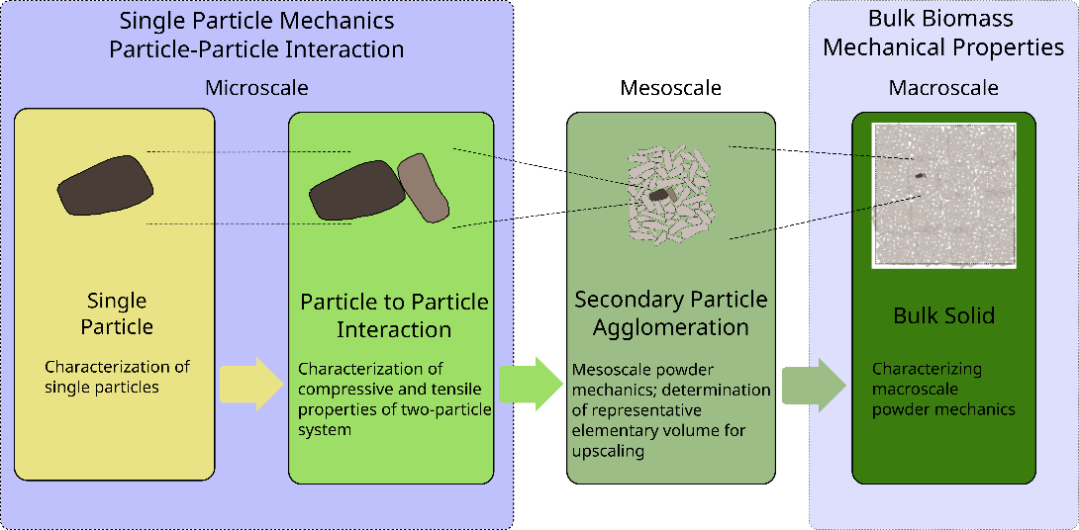Understanding interparticle mechanics associated with each corn stover fraction will provide valuable information for understanding the overall poor flow behavior of milled corn stover. More specifically, such quantitative information will help identify certain fractions that may be significantly responsible for the poor flowability behavior of comingled corn stover fractions. Such knowledge will complement the recent efforts in using DEM to predict flow behavior of milled biomass relying on fitted parameters that are not determined with particles (Xia et al. 2023; F. Chen et al. 2023, 2022)

Figure Schematic of the emerging bulk mechanical properties from the mechanical interactions between biomass particles to the bulk mechanical behavior of milled biomass

There exists a ASTM standards concerning the measuring friction coefficient including ASTM G115-10 (2018). However, listed methods in ASTM G115-10 (2018) assumes a specific geometry, e.g., flat surface or sphere, and not feasible to implement for testing milled biomass particles, which are much smaller in size and irregular in shape. Also test protocols reflect repeated sliding in cyclic motion or rotation, which is implemented in a typical tribometer. This also reflects specific industrial applications such as ball bearing or sliding frames, which are not applicable to the interactions of biomass particles relevant to the bulk biomass flow.

In other words, the current friction measurements focus on interactions between sliding surfaces, e.g., bearing. This focus is also reflected in the DEM framework, requiring sliding and rolling friction coefficient. From the perspective of handling bulk biomass, or any other cohesive particulate materials, the friction coefficient of incipient relative motion between particles is of interest.

Therefore, we developed an in-house instrument and protocol that can determine mechanical interaction between biomass particles following Derjaguin’s adhesive friction model (Gao et al. 2004; Derjaguin 1934; Derjaguin, Muller, and Toporov 1975).

This study aims to gain quantitative knowledge of the interparticle mechanics of fractionated corn stover through the development of an interparticle mechanics tester capable of accommodating biomass particles and a test protocol to determine friction and adhesion properties. With the novel data on interparticle mechanical properties of corn stover particles from different anatomical origins, this study aims to examine the significance of the difference in friction coefficients between corn stover particles from different anatomical fractions. The knowledge gained by this study will contribute to reducing operational challenges by removing fractions with high friction and traction adhesion contributions.

# Materials and Methods

This section details the method used to determine friction coefficients between anatomical fractions of corn stover.

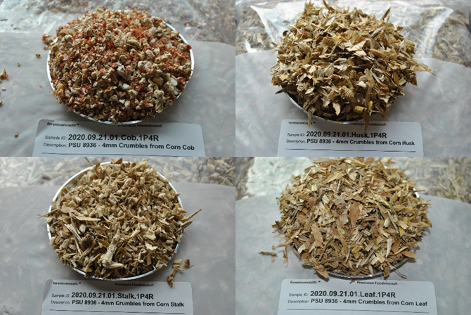

Figure Sample images of individual corn stover fractions used in the present study. 4mm cob Crumbles® (top left), 4mm husk Crumbles® (top right), 4mm stalk Crumbles® (bottom left), and 4mm leaf Crumbles® (bottom right)

## Material Preprocessing History

A square bale of field-dried corn stover from Antares Corn Stover (Hardin, IO) was processed by Forest Concepts, LLC (Auburn, WA). The bale was hand separated and placed into labeled bins designated for each anatomical fraction. Individual fractions were then comminuted to Crumbles® using Forest Concepts’ Crumbler® Rotary Shear technology and conveyed into a final screening process. The screening was performed using a 3-deck orbital screen to filter out fractions with geometric mean diameter outside the 4mm target.

The physical properties of particles of different tissue types of corn stover indicate that the crumbled particles are in consistent size (Table 1). However, the bulk density values are significantly different from each other (Kruskal-Wallis test, p = 5e-13 < 0.05).

Table Physical properties of corn stover particles of different tissue type (Forest Concepts, LLC analytics laboratory in Auburn, WA) following (ANSI/ASAE S424.1 1992).

|  |  |  |  |  |  |
| --- | --- | --- | --- | --- | --- |
| Anatomical Fraction | Moisture Content | Geometric Mean  Particle Size D50 | Standard Deviation of Particle Size | Loose Bulk Density  (oven-dried) | Tapped Bulk Density  (oven-dried) |
|  | (% w.b.) | (mm) | (mm) | (kg/m3) | (kg/m3) |
| Cob | 9.7 | 6.6 | 1.6 | 179 | 217 |
| Husk | 9.7 | 4.6 | 1.6 | 48 | 66 |
| Leaf |  |  |  |  |  |
| Stalk | 9.7 | 4.5 | 1.8 | 76 | 98 |

## Inter-particle Mechanics (IPM) Tester

The existing tribometer, similar to the instrument used by Chen et al.(Chen, Wassgren, and Ambrose 2020), can be used in determining friction coefficient. However, an additional attachment is needed because of the dimension of typical milled biomass particles. In addition, the cyclic reciprocating movement does not simulate the frictional interaction between biomass particles during handling. Furthermore, this arrangement is not adequate to determine adhesive friction following Derjaguin’s law (Derjaguin 1934; Derjaguin and Toporov 1994).

The development of a new Inter-particle Mechanics (IPM) tester was needed (Figure 3) to measure the traction force between a stationary and moving particle under a varying magnitude of normal load. This arrangement allows for one test run to produce multiple normal force and lateral force measurements and alleviates the requirement to conduct separate tests with different normal forces in a conventional friction tester (Pitenis, Dowson, and Gregory Sawyer 2014; ASTM G115-10 2018). The development of the new design was essential for simulating any possible orientation of two interacting particles. This design allows friction coefficients to be determined over multiple untested regions without resampling surfaces or replacing test particles between each repetition. With this design, it is also possible to prepare and condition multiple test samples, e.g., conduct experiments in an environment-controlled chamber at a different environmental relative humidity.

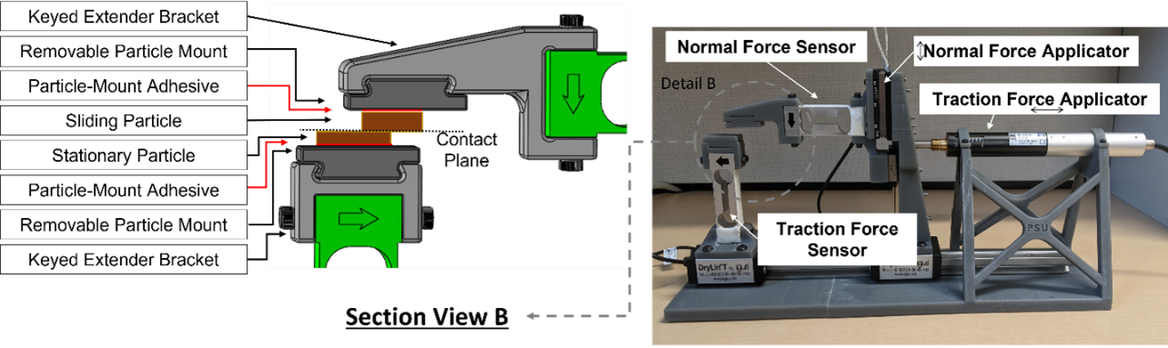

Figure Inter-particle mechanics tester (right) with a detailed view of sample mounting (left)

## Specifications and Operational Parameters of IPMT

An IPM tester was developed to perform friction tests on fully supported particles, unsupported (over-hanging), or combinations of both. Sample holders and component position/capacity are easily adjustable to handle particles of any size and shape. Considering the need to characterize the frictional contact with the perspective of storage and incipient flow, IPMT was designed to have a minimum incremental push and pull motion of 0.05 μm, and a typical push and pull velocity is set to 1.2 mm/s. To accommodate a typical biomass particle dimension, the maximum push and pull travel ranges up to 25 mm to accommodate a typical biomass particle size. For vertical direction movement, the normal force actuator's maximum displacement is 14mm to accommodate a typical biomass particle size. The resolution of the actuator is 6 nm. Combined vertical and lateral displacement actuators make it possible to control the initial particle contact location if there exists a specific region of interest. The maximum forces of vertical and normal force censors are 20.02 N and 2.94 N, respectively, whereas the accuracy of both force sensors is ±0.02% of the full scale. Sampling rates of displacement and force sensors are equal to or higher than 1 kHz. Normal and traction force data were collected at 80Hz, using National Instruments™ LabVIEW (Version 2022, Austin TX) and two 24-bit Di-1000U signal digitizers (Loadstar Sensors - Freemont, CA).

## Experimental Design and Setup

An experimental procedure was developed to perform friction tests with minimal experimental error. A sample size of 15 was selected for each possible combination of anatomical fractions to ensure the quality of a subsequent analysis of variance (Kruskal-Wallis test with ) that examined the magnitude and source of variance. The Wilcoxon signed-rank (signed-rank) test was conducted to test the null hypotheses, i.e., friction coefficients and adhesion forces between corn stover particles from different anatomical fractions are not statistically different, without assuming a statistical distribution of determined friction coefficient and adhesion forces.

To prepare an inter-particle mechanics test, approximately 50 g samples were collected from each anatomical fraction of milled corn stover. Each sample was held in a controlled environment for 72 hours to allow for particles to reach an equilibrium moisture content at approximately 23 °C and 40 % RH. The resulting moisture contents of cob, husk, leaf, and stalk are 8.9 ± 1.0 %, 7.0 ± 1.4 %, 7.0 ± 1.2 %, and 8.9 ± 1.12 %, respectively (values after ± represent the standard error with n = 11).

Once particle moisture was equalized, particles were randomly selected and adhered to removable particle mounts (Figure 4) using Permatex *Ultra Bond™ Super Glue*. Conservative volumes of adhesives were applied to minimize the absorption into particles and ensure proper curing. From the visual inspection, it appeared that no glue simps into the particle samples, which is attributed to the high viscosity of the chosen glue and quick initial curing time. A curing period of longer than 24 hours was established for experimental consistency. The curing environment is identical to the moisture-equilibrating environment. Finally, the grain orientations were randomly chosen with every particle.

* 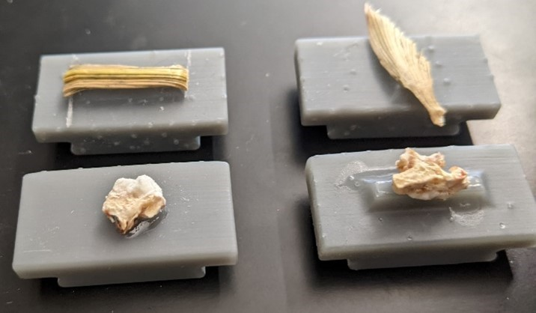

Figure Photograph of corn stover particles adhered to plastic particle mount for conditioning and testing. Samples shown in the picture are 4mm husk (top) and cob (bottom) fractions, respectively.

Once the adhesive had cured, particle pairs were randomly selected for testing. Table 2 lists the combinations of milled corn particles of different tissue types and conducted a number of repetitions for statistical analysis with an appropriate level of confidence.

Table Experimental plan for the required number of corn fraction test pairs and associated repetitions

|  |  |  |
| --- | --- | --- |
| Base Particle | Interacting Particle | Minimum Repetitions |
| Cob | Cob | 15 |
| Cob | Husk | 15 |
| Cob | Leaf | 15 |
| Cob | Stalk | 15 |
| Husk | Husk | 15 |
| Husk | Leaf | 15 |
| Husk | Stalk | 15 |
| Leaf | Leaf | 15 |
| Leaf | Stalk | 15 |
| Stalk | Stalk | 15 |

An inter-particle mechanics test started with establishing contact between particle samples indicated by a positive normal force reading typically ranging between 3 N and 2 N. Then, lateral sliding was initiated at a speed of 0.5 mm/min. The normal and lateral forces were tracked and recorded simultaneously until the contact between two particles was lost, which resulted in a sudden change in force measurement. The middle two quartiles were selected and extracted as steady-state data for further analysis and determination of friction coefficient and adhesion force.

To determine the cohesive frictional contact, a modified Amonton’s equation by Derjaguin (Derjaguin 1934; Gao et al. 2004; Derjaguin, Muller, and Toporov 1975)

Where is tractional force in the lateral direction, is the adhesion force, is the coefficient of friction, and is the normal force representing the contact force. From this linear relationship, the coefficient of friction (*μ*) was determined from the slope of the best-fit line, and the adhesion force () was determined from the y-axis, i.e., the traction force axis, the intercept of the best-fit line. Therefore, linear regression analyses were conducted to determine the coefficient of friction (*μ*) and adhesion force () from experimental data.

# Results and Discussion

## Validation of the IPM

To validate the developed Inter-Particle Mechanics tester, a polypropylene sheet was used as a reference material. A polypropylene sheet with 1/16 inch thickness was obtained from McMaster-Carr, which lists the friction coefficient to range from 0.25 to 0.28 based on the specification of the manufacturer. 20 samples were prepared and subjected to the IPM test. The obtained 20 test results of frictional interaction between two polypropylene sheet samples are shown in Figure 5, which clearly shows a linear relationship between normal force and traction force with detectable traction force.

Using Derjaguin’s adhesive contact model, the coefficient of friction and adhesion force were determined from the slope and intercept of the obtained linear relationship through the linear regression analysis. The summary of the determined friction coefficient () and adhesion force () are listed in Table 3 and shown in Figure 6 .

The specification listed in by the vendor (McMaster-Carr) ranges between 0.25 and 0.28. The determined friction coefficient is smaller than the listed range. This is an expected trend because the friction coefficient is reported to be smaller with the smaller normal force and initial sliding friction segment for polypropylene (Sędłak et al. 2017). This observation supports the accuracy of the Interparticle Mechanics Tester in determining frictional characteristics.

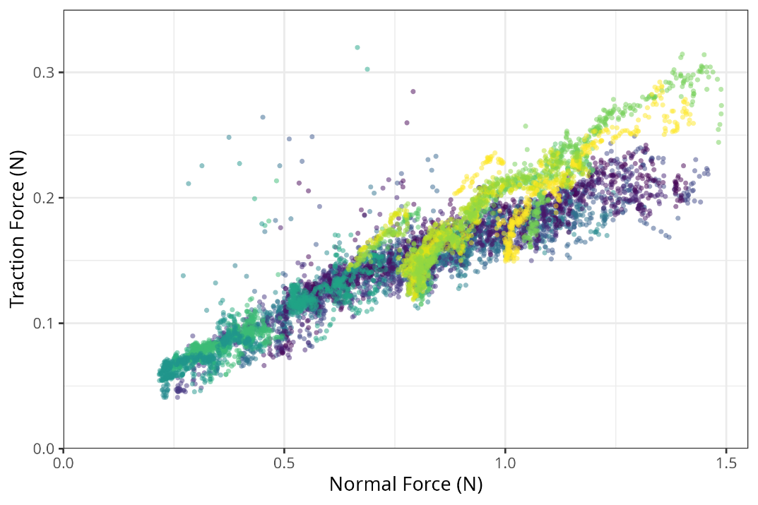Figure Validation test results of polypropylene

Table Summary statistics of Polypropylene friction coefficient and adhesion force determined using the Interparticle Mechanics Tester

|  |  |  |  |  |  |  |  |  |
| --- | --- | --- | --- | --- | --- | --- | --- | --- |
| Interparticle Mechanics  Properties | Sample Size | Min | Q1 | Median | Mean | Q3 | Max | Interquartile Range |
| friction coefficient  () | 20 | 0.10 | 0.12 | 0.14 | 0.16 | 0.20 | 0.26 | 0.07 |
| adhesion force  (, N) | 20 | -0.07 | 0.00 | 0.04 | 0.02 | 0.05 | 0.08 | 0.05 |

Figure Interparticle Mechanics Test results of polypropylene sheet samples. Each color represents a different run of the experiments (n=20)

## Friction Coefficient and Adhesion Force of Corn stover particles from different types

To examine the variability in frictional contact mechanics between corn stover particles from different tissue types, corn stover samples were manually fractionated into the cob, husk, leaf, and stalk, then Crumbled® using a 4 mm screen by Forest Concepts, LLC. Twenty particle sample pairs for each tissue type were prepared, and the interparticle mechanics tests were conducted. A typical experimental data and regression analysis result 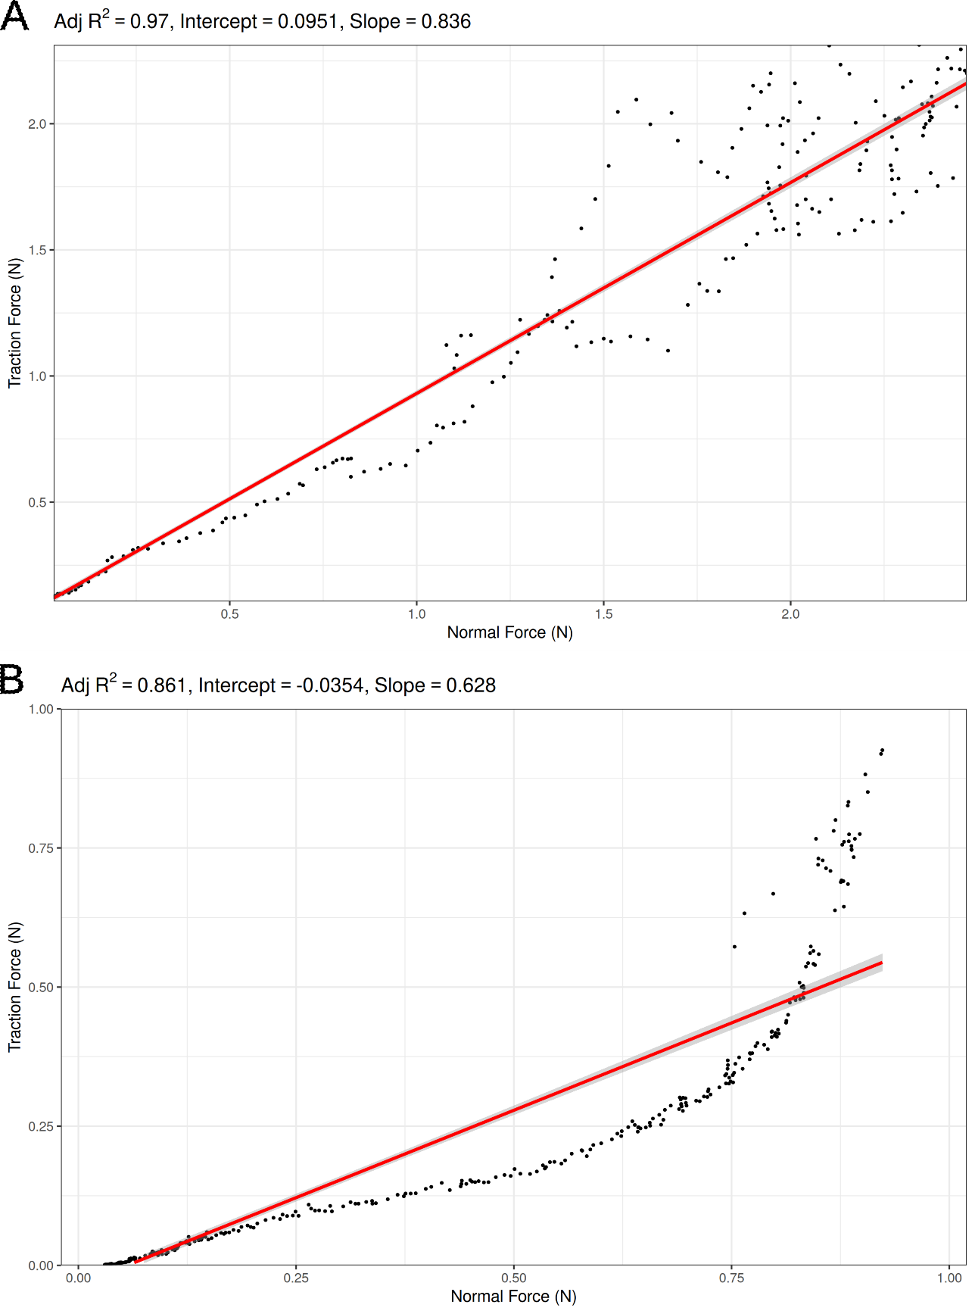is shown in Figure 7.

Figure Typical corn stover particle result (A is from cob particle vs. cob particle and B is from cob particle vs stalk particle)

Derjaguin’s linear model and other polynomial models reflecting the observation of Sędłak (Sędłak et al. 2017) hinting that friction coefficient values can be smaller when the applied normal force is smaller.

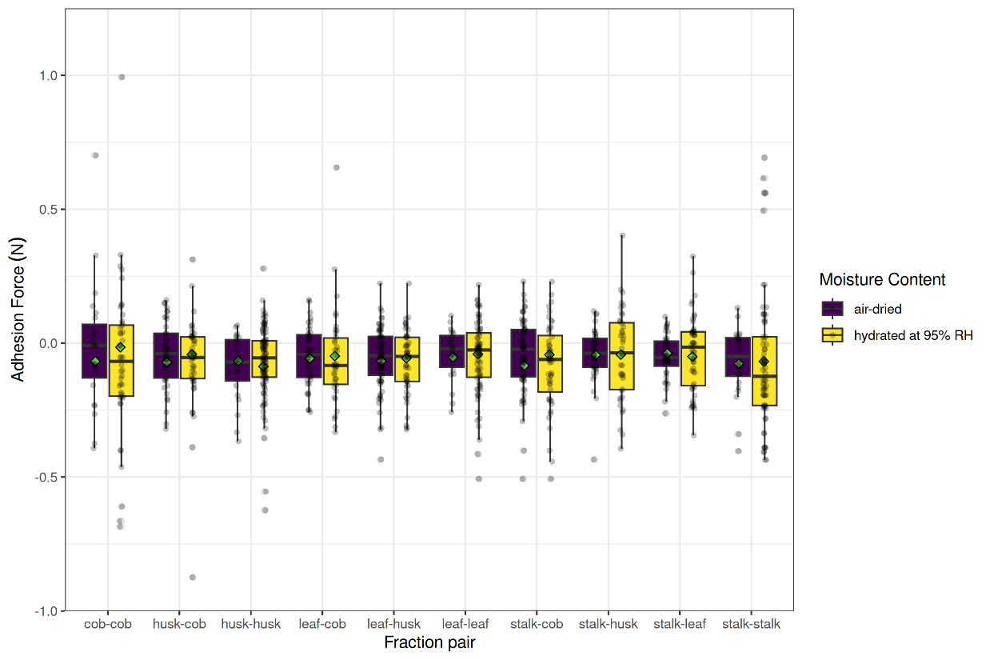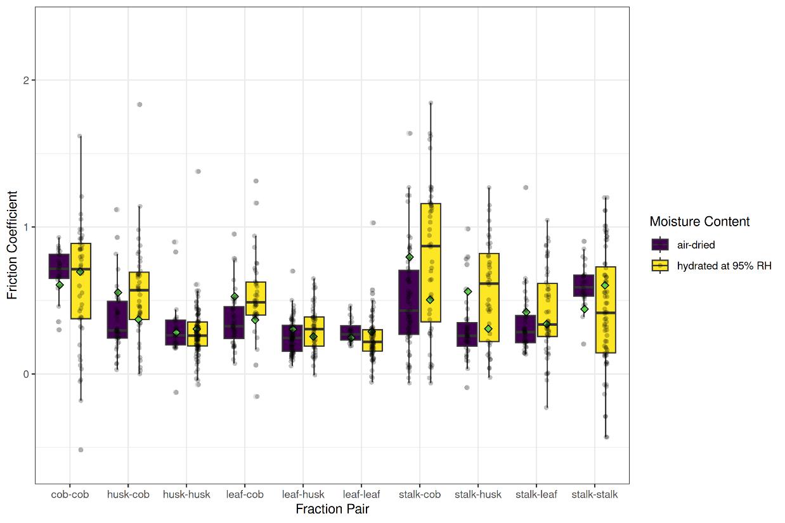Figure  *Friction coefficient between corn particles of different tissue types and moisture contents*

Figure Adhesion forces between corn particles of different tissue types and moisture contents

The determined friction coefficient and adhesion forces of corn stover particles are shown in Figure 8 and Figure 9. The analysis of corn stover particle interactions reveals distinct patterns in both friction coefficients and adhesion forces across different fraction pairs. Among the friction coefficients, cob-cob and stalk-cob interactions demonstrate the highest values at 0.636 and 0.629 respectively, indicating substantial frictional resistance between these particle types. The moderate friction range includes husk-cob and stalk-husk combinations, showing coefficients of 0.464 and 0.437, while stalk-stalk interactions exhibit intermediate friction behavior with a coefficient of 0.483.

Leaf-based interactions consistently display lower friction coefficients, with leaf-leaf pairs showing 0.255, leaf-husk pairs at 0.275, and leaf-cob combinations reaching 0.445. This pattern suggests that leaf material generally creates less frictional resistance compared to other corn stover components.

Regarding adhesion forces, all fraction pairs exhibit negative values, indicating attractive forces between particles. Stalk-stalk pairs demonstrate the strongest adhesion with a value of -0.074, closely followed by husk-husk interactions at -0.071. Stalk-cob and leaf-husk pairs show moderate adhesion forces around -0.060, with husk-cob interactions similarly positioned at -0.057.

An interesting inverse relationship emerges between friction and adhesion properties. Notably, cob-cob interactions show the lowest adhesion force at -0.027 despite having high friction, while stalk-leaf and stalk-husk pairs demonstrate relatively lower adhesion forces around -0.043. This pattern suggests that materials with high friction coefficients tend to exhibit lower adhesion forces, while those with strong adhesion generally show moderate friction coefficients. Leaf-based interactions maintain their unique character by consistently showing lower friction coefficients paired with moderate to high adhesion forces.

Corn stover interactions involving cob fractions were found to contain the largest peaks and variance in friction coefficients (Table 4). Cob particles with woody-ring sub-fractions on the contacting surface were observed to be significantly harder and ’claw-like’ in nature. Whereas the pith region of the cob was very similar to the exposed pith in stalk particles. Particles of stalk and husk both showed moderate friction coefficients.

Table Determined Coefficient of friction and adhesion force values of corn stover particles from different tissue types

|  |  |  |  |  |
| --- | --- | --- | --- | --- |
| Paired Fractions | Average Friction Coefficient | Standard Deviation | Mean Adhesion Force  (N) | Standard Deviation  (N) |
| cob-cob | 0.70 | 0.16 | -0.02 | 0.23 |
| husk-husk | 0.31 | 0.21 | -0.09 | 0.12 |
| leaf-leaf | 0.29 | 0.08 | -0.05 | 0.09 |
| stalk-stalk | 0.60 | 0.15 | -0.07 | 0.13 |

Table Analysis of variation (Dunn test) in the coefficient of friction and adhesion force between corn stover particles

| Particle Pair | Comparison Pair | p values for  Coefficient of Friction | p values for Adhesion Force |
| --- | --- | --- | --- |
| cob-cob | husk-husk | 3.33e-13 | 0.53 |
|  | leaf-leaf | 1.92e-15 | 0.75 |
|  | stalk-stalk | 5.59e-3 | 0.12 |
| husk-husk | leaf-leaf | 2.6e-1 | 0.28 |
|  | stalk-stalk | 1.88e-6 | 0.26 |
| leaf-leaf | stalk-stalk | 2.32e-8 | 0.04 |

Without an understanding of the population distribution, Kruskal-Wallis test was conducted to determine the significance across the variance with each corn stover fraction combination with Dunn test as the post-hoc test. It is found that the tissue type can be a source of variance in friction coefficients (χ2 = 86, df = 3, p < 2e-16). Post-hoc Dunn test results (, Table 5) show that particles of different tissue types exhibit significantly different friction coefficients except husk and leaf particles. On the other hand, the adhesion forces are not found to be significantly different (Kruska-Wallis test, χ2 = 4.8, df = 3, p = 0.2).

### Relationship with Mohr-Coulomb parameters

If the friction coefficient and adhesion force between particles are related to the internal angle of friction and cohesion coefficient of the Mohr-Coulomb model, we should observe the correlation between these. Also, for materials with significantly different friction or adhesion forces at the particle scale should exhibit different bulk behavior.

There exist two different challenges in substantiating this. First, what is an appropriate bulk mechanical test. For Mohr-Coulomb model calibration, sliding or rotating shear cell are most widely used. In their respective test protocols, the angle of internal friction is determined by the common tangent angle of Mohr circles produced with different consolidation stress. In this process, the zero-consolidation pressure corresponds to the determination of unconfined yield stress of the subject bulk material. But, is it really so?

The shear cell uses a metal wall as a sample holder, and the reactive lateral stress applied to the test specimen is not known yet it is expected to be non-zero. Therefore, the response of bulk material sample includes the combination of active and passive lateral pressure development during shearing. A rotational shear cell is thought to have less of such effect. However, it still includes the frictional resistance between metal wall material and sample specimen. While it is reasonable to assume that such die-wall effect diminishes rapidly following St Venant’s principle, the overall torque measurement includes such effect at the largest diameter, which is expected to be larger because of the distance from the rotation axis.

This also leads to the second challenge, which is the nature of existing plasticity models. Almost all of these constitutive models assume that the bulk material behavior is isotropic and homogeneous. While the latter is generally true, the isotropy assumption should be closely validated. The adoption of plasticity models in soil mechanics is also contested from this perspective. It is understandable that anisotropic constitutive models become too complex to be practical. However, it can be argued that the sophisticated constitutive models, e.g., hypoplasticity (von Wolffersdorff, 1996), and variants of critical state models (Yin et al. 2017; Massoudi 2023; Roscoe and Burland 1968; Schofield and Wroth 1968)., developed to overcome the gap between model prediction and observations of the real world are quite complex and there exist scarce or less clear experimental calibration procedure.

Considering these limitations, it is necessary to consider experimental methods that minimize the influences from interaction between test specimen and the instrument. We plan to investigate such experimental calibration of the widely considered elasto-plasticity constitutive model. Then, we will be able to investigate the hypothesized relationship between the bulk mechanical properties of milled biomass and experimental measurements of particle-to-particle mechanical interactions.

In addition to the relationship between friction coefficient and adhesion force between particles and the corresponding mechanical properties of bulk biomass, we should be able to examine the origin of Reynolds dilatancy (Reynolds 1885; Rowe 1969) during shearing. While strength can arise from interparticle friction, dilatancy concerns volumetric deformation, which is related to the morphology of particles. Therefore, particle size and shape should be considered at the same time. By decoupling the contact behavior between particles, particle size, and particle shape from the cohort of parameters of a discrete element model. In other words, the core parameters of DEM contact model can now be quantified with the experimental observation reported in this paper. We envision that this approach will make it possible to investigate how the bulk flow behavior emerges from mechanical interactions between particles at the underlying scale.

# Conclusions

From the observation that particles of corn cob show a larger standard deviation in the determined coefficient of friction, it can be hypothesized that particles of corn cob will have a high contribution to an erratic feedstock flow behavior. It can also be hypothesized that the cob will generate high frictional forces, considering the high cohesive forces and moderate friction coefficients observed in a corn cob. The experimental data suggest that high-stress feedstock handling applications may be more stable with the removal of corn cob.

It is planned to repeat tests with variations in moisture content. High adhesive forces in cob particles containing ’woody-ring’ subfractions may be reduced as moisture levels increase towards the fiber saturation point, but further studies are required to understand any adverse effects on friction coefficients.

The anatomical fractions discussed in this paper were categorized using macro-observations for the purpose of potential mechanical separation. Under further review, it appears each corn stover fraction contained an associated set of sub-fractions that could be found in at least one other fraction. Sub-fractions could be generally characterized as woody, pithy, or leafy. Additional steps in cminuting particles to expose ’sub-fractions’ may allow fluid separation techniques to create more uniform and, therefore, desirable products. It is recommended to repeat this experiment using two additional comminution methods (i.e., knife mill and hammer mill) practiced in the industry to study varying effects of size reduction equipment on friction coefficients.

## Future studies

Using DEM in biomass flow studies

# Acknowledgment

This material is based upon work supported by the US Department of Energy’s Office of Energy Efficiency and Renewable Energy (EERE) under the Bioenergy Technologies Office, Integrated Biorefinery Optimization award number DE-EE0008936.

This work was partially supported by USDA NIFA Agricultural Experiment Station project PEN-4671.

# References

Alderborn, Göran, and Christer Nystrom. 1996. *Pharmaceutical Powder Compaction Technology*. Marcel Dekker, Inc. http://www.diva-portal.org/smash/record.jsf?pid=diva2:87597.

Al-Hashemi, Hamzah M. Beakawi, and Omar S.Baghabra Al-Amoudi. 2018. “A Review on the Angle of Repose of Granular Materials.” *Powder Technology* 330 (May):397–417. https://doi.org/10.1016/j.powtec.2018.02.003.

ANSI/ASAE S424.1. 1992. “Method of Determining and Expressing Particle Size of Chopped Forage Materials by Screening.” Standard ANSI/ASAE S424.1 MAR1992 (R2012). ASABE Standard. Saint Joseph, MI: American Society of Agricultural and Biological Engineers. https://elibrary.asabe.org/azdez.asp?JID=2&AID=23583&CID=s2000&T=2.

ASTM G115-10. 2018. “Guide for Measuring and Reporting Friction Coefficients.” Standard. West Conshohocken, PA: ASTM International. https://doi.org/10.1520/G0115-10R18.

Chen, Zhengpu, Carl Wassgren, and Kingsly Ambrose. 2020. “Measurements of Grain Kernel Friction Coefficients Using a Reciprocating-Pin Tribometer.” *Transactions of the ASABE* 63 (3): 675–85. https://doi.org/10.13031/trans.13748.

Derjaguin, B. V. 1934. “Molekulartheorie Der Äußeren Reibung.” *Zeitschrift Für Physik* 88 (9–10): 661–75.

Derjaguin, B. V, V. M Muller, and Yu. P Toporov. 1975. “Effect of Contact Deformations on the Adhesion of Particles.” *Journal of Colloid and Interface Science* 53 (2): 314–26. https://doi.org/10.1016/0021-9797(75)90018-1.

Derjaguin, B. V., and Y. P. Toporov. 1994. “Influence of Adhesion on the Sliding and Rolling Friction.” *Progress in Surface Science* 45 (1): 317–27. https://doi.org/10.1016/0079-6816(94)90064-7.

Elekes, Filip, and Eric J. R. Parteli. 2021. “An Expression for the Angle of Repose of Dry Cohesive Granular Materials on Earth and in Planetary Environments.” *Proceedings of the National Academy of Sciences* 118 (38): e2107965118. https://doi.org/10.1073/pnas.2107965118.

Fayed, M E, and Lambert Otten. 1984. *Handbook of Powder Science and Technology*. Van Nostrand Reinhold Company Inc, New York, NY 10020.

Gao, Jianping, W. D. Luedtke, D. Gourdon, M. Ruths, J. N. Israelachvili, and Uzi Landman. 2004. “Frictional Forces and Amontons’ Law:  From the Molecular to the Macroscopic Scale.” *The Journal of Physical Chemistry B* 108 (11): 3410–25. https://doi.org/10.1021/jp036362l.

Ghazavi, M, M Hosseini, and M Mollanouri. 2008. “A Comparison between Angle of Repose and Friction Angle of Sand.” In *The 12th International Conference of International Association for Computer Methods and Advances in Geomechanics (IACMAG)*, 1–6.

Hamed, Ahmed, Yidong Xia, Nepu Saha, Jordan Klinger, David N. Lanning, and Jim Dooley. 2022. “Flowability of Crumbler Rotary Shear Size-Reduced Granular Biomass: An Experiment-Informed Modeling Study on the Angle of Repose.” *Frontiers in Energy Research* 10. https://www.frontiersin.org/article/10.3389/fenrg.2022.859248.

Kenney, Kevin L, William A Smith, Garold L Gresham, and Tyler L Westover. 2013. “Understanding Biomass Feedstock Variability.” *Biofuels* 4 (1): 111–27. https://doi.org/10.4155/bfs.12.83.

Liu, Zhichao. 2011. “Measuring the Angle of Repose of Granular Systems Using Hollow Cylinders.” University of Pittsburgh ETD, Pittsburgh, PA: University of Pittsburgh. https://d-scholarship.pitt.edu/6401/.

Massoudi, Mehrdad. 2023. “Remarks on Constitutive Modeling of Granular Materials.” *Eng* 4 (4): 2856–78. https://doi.org/10.3390/eng4040161.

Metcalf, J. R. 1966. “Angle of Repose and Internal Friction.” *International Journal of Rock Mechanics and Mining Sciences & Geomechanics Abstracts* 3 (2): 155–61. https://doi.org/10.1016/0148-9062(66)90005-2.

Mohsenin, Nuri N. 1986. *Physical Properties of Plant and Animal Materials: Structure, Physical Characteristics, and Mechanical Properties*. 2nd rev. and Updated ed. New York, NY: Gordon and Breach Science Publishers.

Pitenis, Angela A., Duncan Dowson, and W. Gregory Sawyer. 2014. “Leonardo Da Vinci’s Friction Experiments: An Old Story Acknowledged and Repeated.” *Tribology Letters* 56 (3): 509–15. https://doi.org/10.1007/s11249-014-0428-7.

Rackl, Michael, Florian E. Grötsch, and Willibald A. Günthner. 2017. “Angle of Repose Revisited: When Is a Heap a Cone?” Edited by F. Radjai, S. Nezamabadi, S. Luding, and J.Y. Delenne. *EPJ Web of Conferences* 140:02002. https://doi.org/10.1051/epjconf/201714002002.

Rao, M. A. 2018. “Transport and Storage of Food Products.” In *Handbook of Food Engineering*, by Dennis R. Heldman, Daryl B. Lund, and Cristina Sabliov. CRC Press.

Reynolds, Osborne. 1885. “LVII. On the Dilatancy of Media Composed of Rigid Particles in Contact. With Experimental Illustrations,” December. https://doi.org/10.1080/14786448508627791.

Roscoe, K. H., and J. B. Burland. 1968. “On the Generalized Stress-Strain Behavior of Wet Clay.” In *Engineering Plasticity*, 535–609. Cambridge, UK. https://trid.trb.org/view/124868.

Rowe, P. W. 1969. “Osborne Reynolds and Dilatancy.” *Géotechnique* 19 (1): 1–5. https://doi.org/10.1680/geot.1969.19.1.1.

Schofield, Andrew, and Peter Wroth. 1968. *Critical State Soil Mechanics*. London, New York etc.: McGraw-Hill.

Sędłak, Paweł, Beata Białobrzeska, Tomasz Stawicki, and Piotr Kostencki. 2017. “Effect of Polypropylene Modification by Impregnation with Oil on Its Wear and Friction Coefficient at Variable Load and Various Friction Rates.” *International Journal of Polymer Science* 2017 (1): 9123586. https://doi.org/10.1155/2017/9123586.

Yin, Zhen-Yu, Pierre-Yves Hicher, Christophe Dano, and Yin-Fu Jin. 2017. “Modeling Mechanical Behavior of Very Coarse Granular Materials.” *Journal of Engineering Mechanics* 143 (1): C4016006. https://doi.org/10.1061/(ASCE)EM.1943-7889.0001059.

Zegzulka, Jiri, Jan Necas, Jiri Rozbroj, Daniel Gelnar, Álvaro Ramírez-Gómez, and Lucie Jezerska. 2022. “Internal Friction Angle Model of Particles.” *Scientific Reports* 12 (1): 2036. https://doi.org/10.1038/s41598-022-05891-8.