**String & multidimensional Array &Functions**

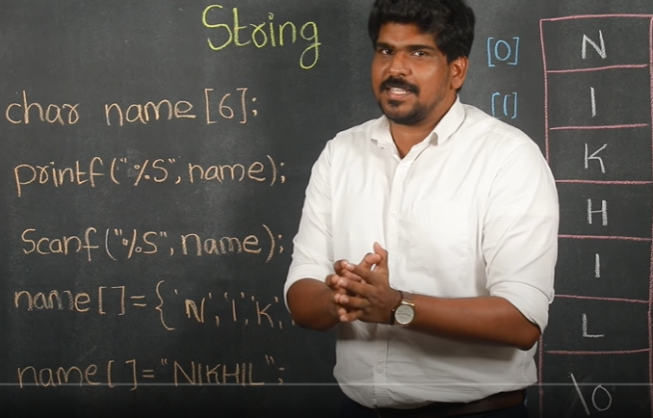

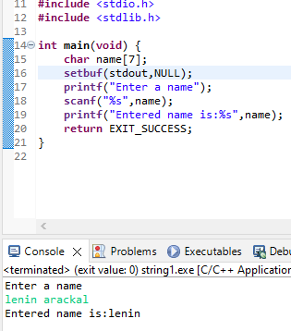

**Character Array=String**

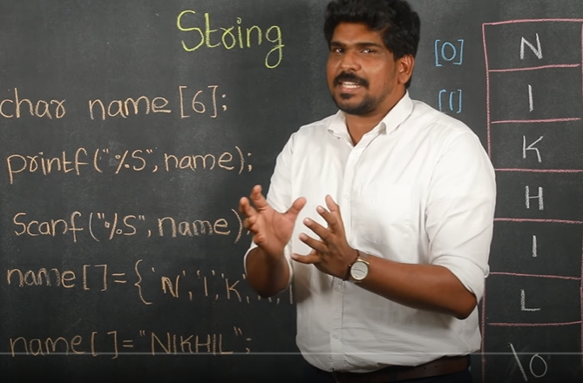

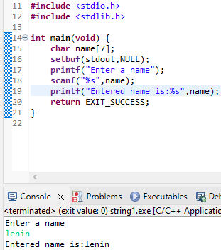

**Multi-dimensional Array**

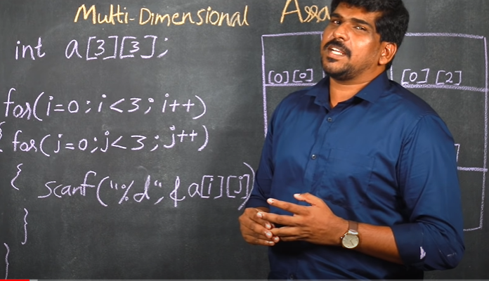

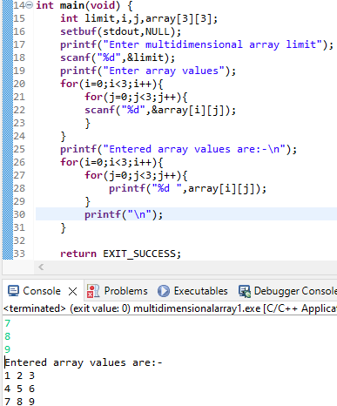

**2 Multidimensional Array Multiplication**

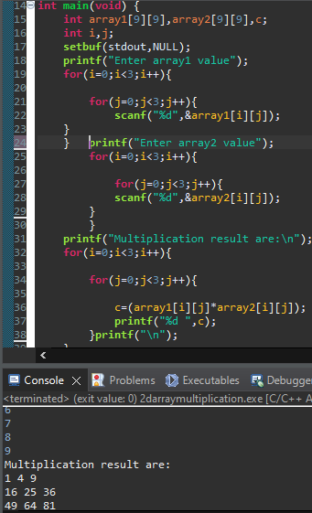

**Functions**

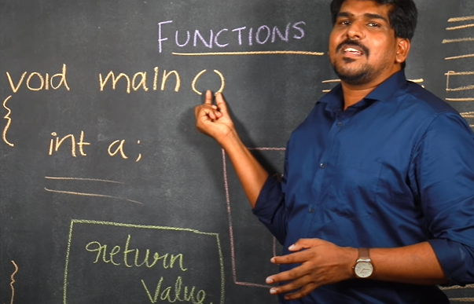

**=======================================================**

**4 type Functions**

1. **Functions without Argument and without Return Value**
2. **Functions with Argument and without Return Value**
3. **Functions with Argument and with Return Value**
4. **Functions without Argument with return Value**

**================================================**

**Functions without Argument and without Return Value**

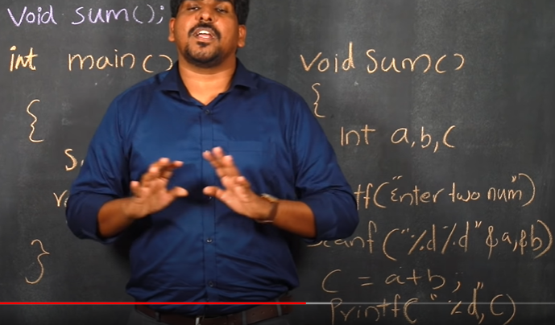

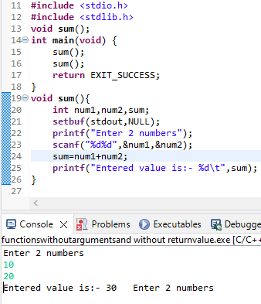

**Functions with Argument and without Return Value**

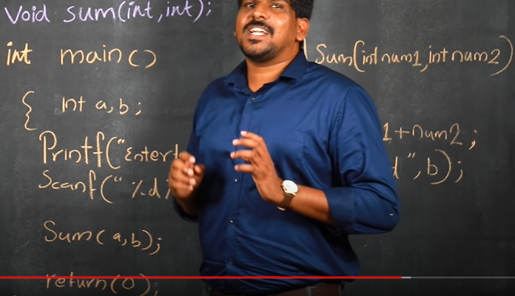

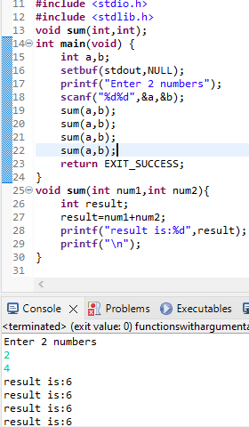

**Functions with Argument and with Return Value**

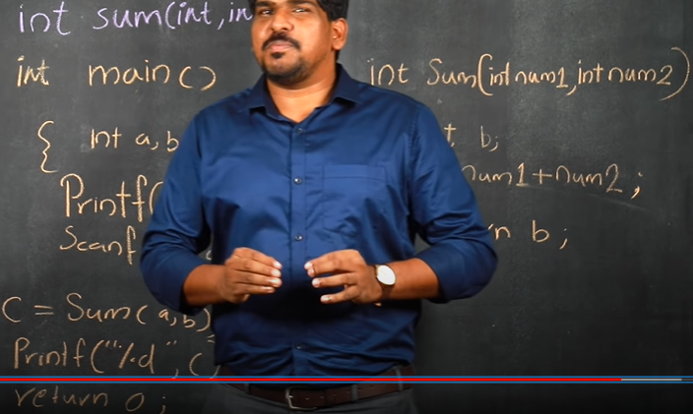

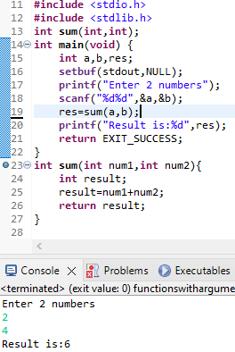

**Functions without Argument with return Value**

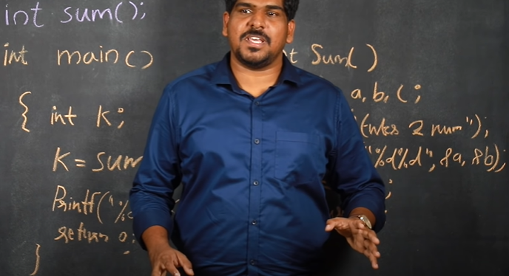

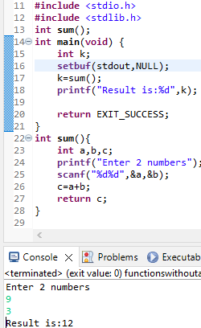

**Array multidimensional sum assignment2part6**

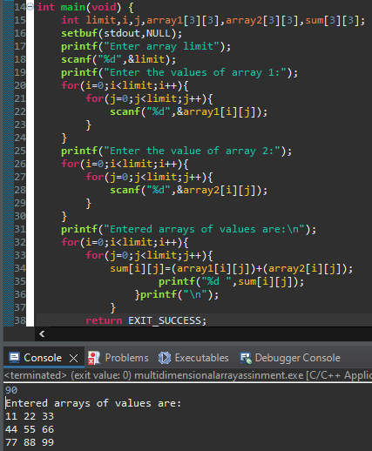

**No argument no return value assignment3part6**

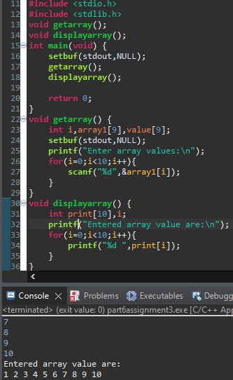

**Palindrome number**

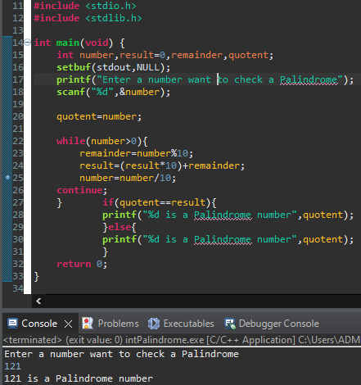

**Palindrome character and Number**

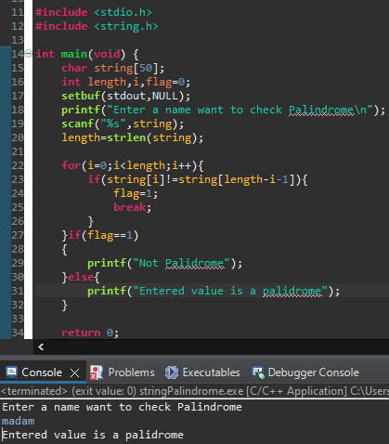

[#include](https://www.youtube.com/hashtag/include) <stdio.h>

[#include](https://www.youtube.com/hashtag/include) <string.h>

int main() {

char str[44];

int i,len,flag=0;

printf(" Enter your string\n");

scanf("%s",str);

len = strlen(str);

for(i=0;i<len/2;i++){

if(str[i] != str[(len-1)-i]){

flag=1;

break;

}

}

if(flag==1){

printf("Not palindrome");

}else{

printf("Palindrome");

}

return 0;

}