**FIT3179 Data Visualization Week 9 Homework**

Name: Pin Hen Song Student ID: 32648308

Studio: 6 Tutor: Clair Pan

<https://ph-song.github.io/FIT3179/H3/>

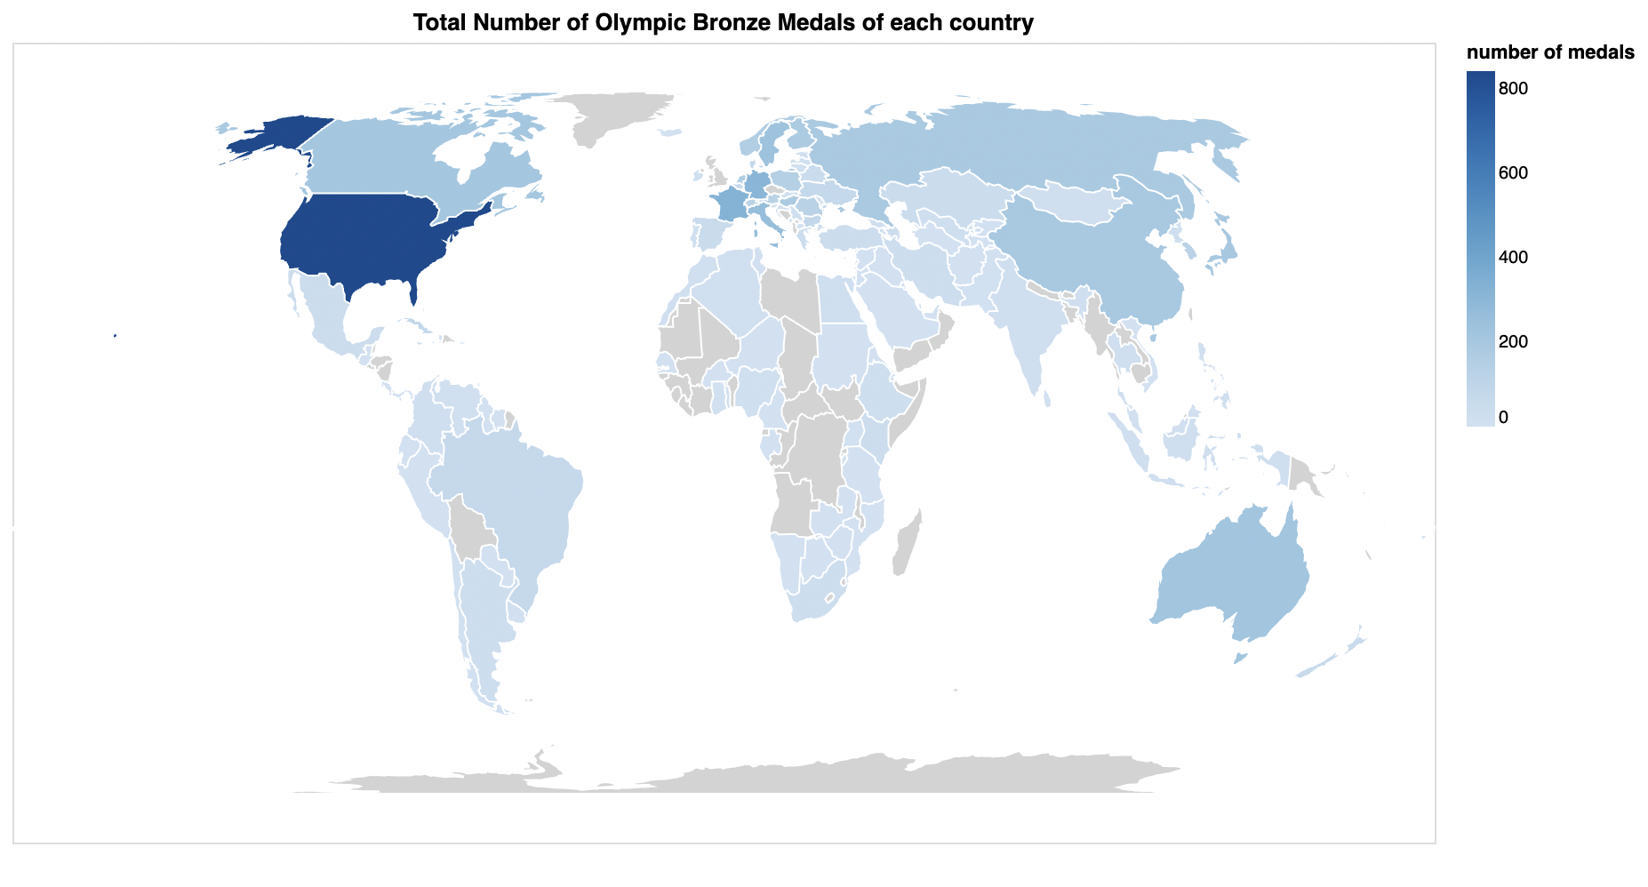

Domain : Olympic bronze medal

Source : <https://worldpopulationreview.com/country-rankings/olympic-medals-by-country>

Data type : table

Data attribute : country (categorical), number of medal (ordered, quantitative)

Map Idiom : Choropleth map, to compare number of bronze medals between countries. It is preferred over proportional symbol map because proportional symbol map is more suitable to show quantitative value of specific geographic location such as city or state, while the unit of data is country.