**Cleaning outliers/dust**

Course_over_ground = 999

|  |  |  |  |  |  |  |  |
| --- | --- | --- | --- | --- | --- | --- | --- |
| 8236743231 | 29564 | 2014-10-30 11:42:25.000000 | 170.789.567 | -45.247.216 | 999 | 103 | 370053844 |

Speed_gps_kph = 999

|  |  |  |  |  |  |  |  |
| --- | --- | --- | --- | --- | --- | --- | --- |
| 8235832303 | 25347 | 2014-10-30 08:49:39.000000 | 170.795.254 | -45.250.447 | 153 | 999 | 370053844 |
| 8236263484 | 11237 | 2014-10-30 10:09:48.000000 | 17.079.663 | -45.255.164 | 169 | 999 | 370053844 |
| 8236664269 | 3763 | 2014-10-30 11:27:06.000000 | 170.794.591 | -45.249.733 | 145 | 999 | 370053844 |
| 8236747777 | 39033 | 2014-10-30 11:43:12.000000 | 170.796.995 | -45.256.788 | 169 | 999 | 370156551 |

**Questions**

Which drivers should she be most concerned about in regards to speeding? Think about the number of events and the average speed reached.

***Road-Segment 370248900***

*Avg. speed_gps_kph 95,714522363*

*Number of Records 1.811*

***Road-Segment 370161648***

*Avg. speed_gps_kph 97,333787466*

*Number of Records 3.670*

***Road-Segment 370053844***

*Avg. speed_gps_kph 96,973100587*

*Number of Records 6.989*

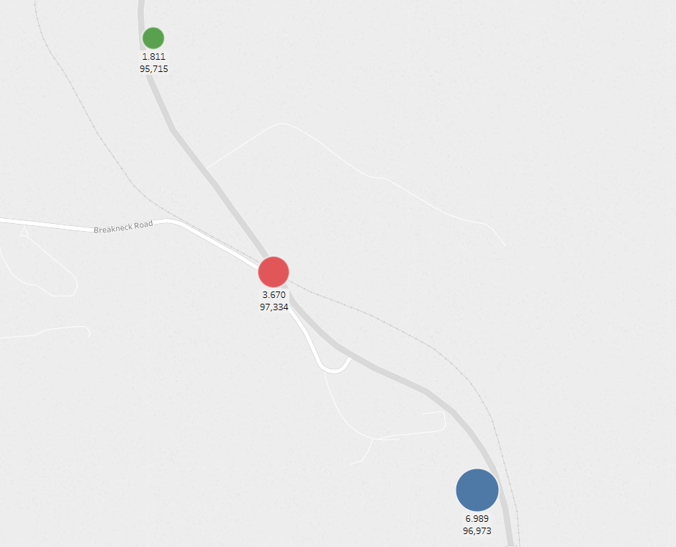

Are there times or days where speeding is worse?

*On Saturday and Sunday we have above average speed and allowed between 106kph and 109kph.*

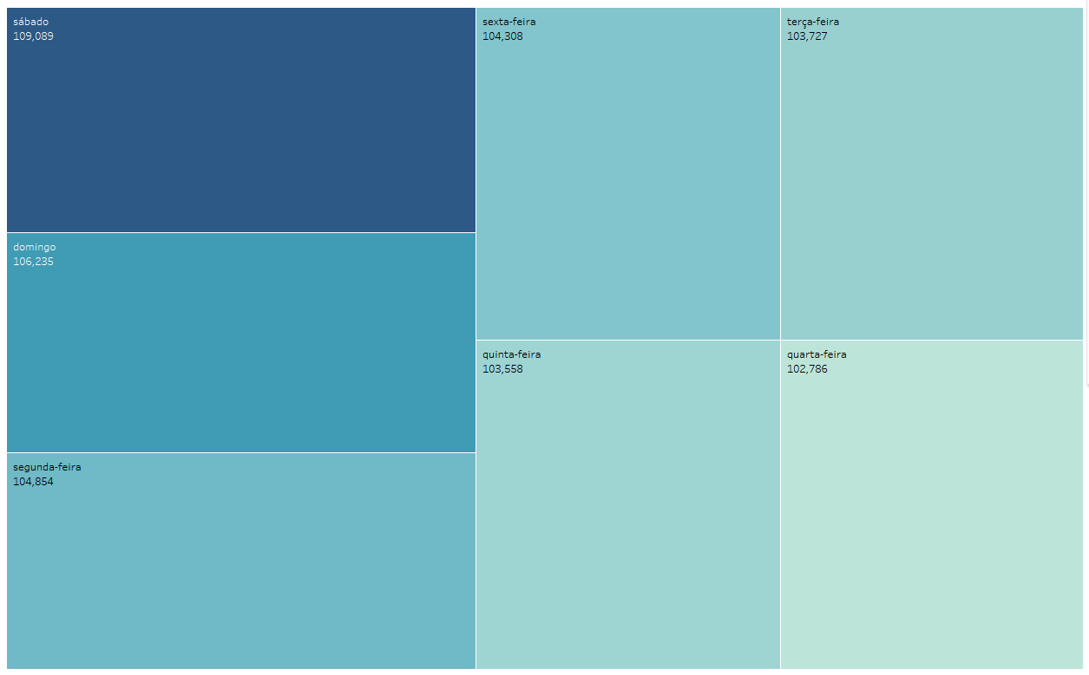

Do vehicle drive faster going Northbound or Southbound?

*From north to south the average speed increases from 96.36kph to 96.97kph.*

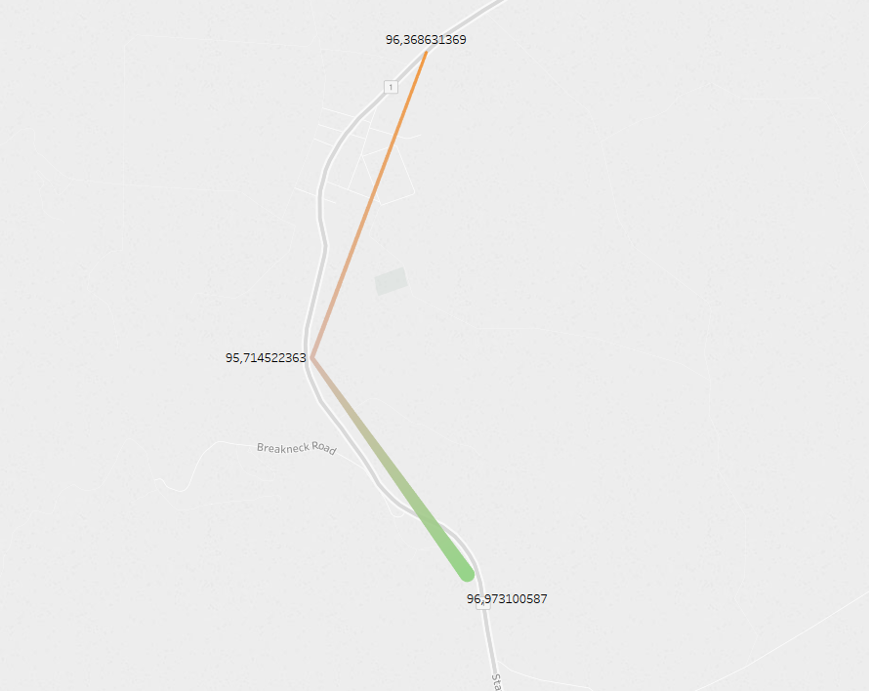

Does speeding improve/worsen over time?

*Between 7am and 2pm we have retention for acceleration.*

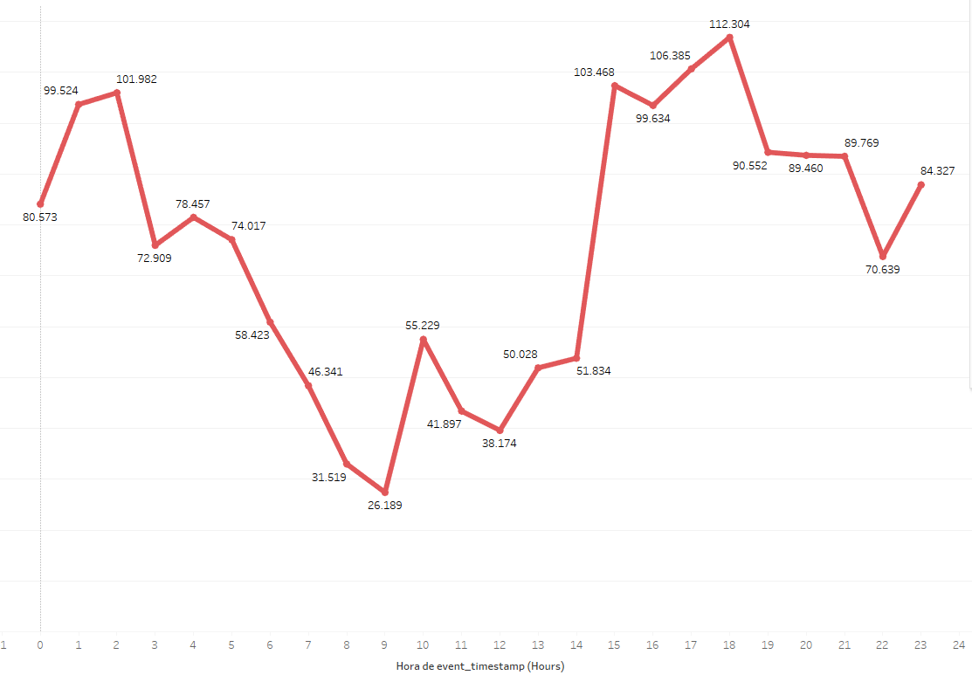

Which vehicles have the highest average speed through the Virtual Speed Camera?

*Below we have the machine_id and the average speed.*

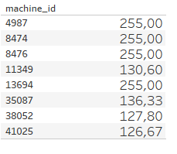

Any other insights you obtain from the data….

*a) Weekly traffic flow influences the speed at these hourly intervals:*

*- 4am until 10am*

*- 1pm until 3pm*

*b) And using font data from metservice*

*Most records when the weather is quite cold, visibility 20km and speed between 76 and 100kph*

