

**OCTOPUS ORGANIZER**

**Quick Start**

*With Octopus Organizer we aim to provide you with an innovative and intuitive way of organizing your files. Get more out of your data and stay organized by tagging and stacking your files.*

**#GetOrganized**

L. Scheffler

# The Main Components

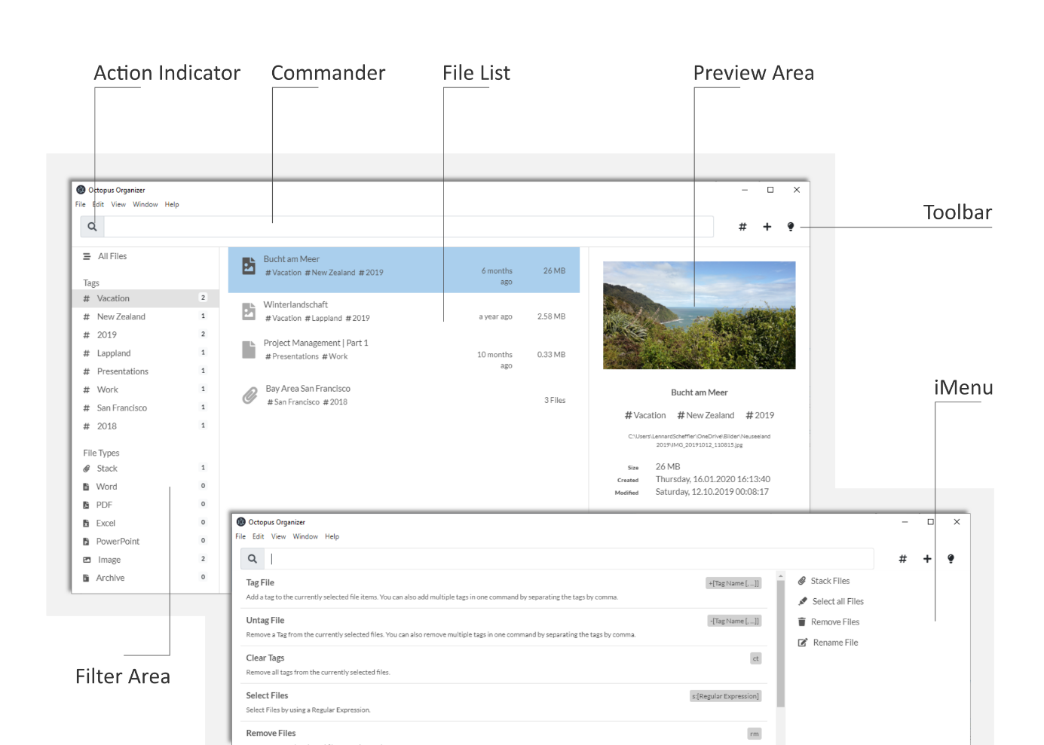

The main components of the application will help you to keep track of your files:

|  |  |
| --- | --- |
| Action Indicator | When using the Commander, the Action indicator will show you, weather the text is a valid command or if your text will otherwise be used to perform a global search in your files. |
| Commander | The commander is the heart of Octopus. With the Commander you can prompt a variety of commands in order to organize and find your files. See a list of available commands in the iMenu. |
| File List | The File List shows you all files and stacks that you would like to get organized. |
| Preview Area | In the Preview Area, you can take a closer look to the selected File or Stack. |
| Toolbar | The Toolbar gives you access to some commonly used features of Octopus, e.g. adding and filtering tags. |
| iMenu | The iMenu helps you controlling the Commander. Click the Light Bulb in the top right corner or hit [CTRL]+[SPACE] on your keyboard to access the iMenu. Depending on the context, the iMenu will help you finding commands, tags, actions and much more. |
| Filter Area | In the Filter Area you can see all tags and file types of your organized files. Click on of the items to filter your files according to tags or file types. |

# Organize your first File

Organizing your first File in Octopus is easy. Just Drag and Drop a File from your File System into the Application Window.

Select the file by clicking and add your first Tags. For example, if you would like to tag your file with the Tag *Vacation*, use the *+* or *TAG* Command:

|  |
| --- |
| +Vacation |

Maybe, you would like to provide the File with a proper name? Just use the *RENAME* or *=* Command int the Commander:

|  |
| --- |
| =Picture of a Beach |

# Create a Stack

Stacks are a useful feature if you would like to bundle similar files into one single element. Just mark a set of files by holding the [SHIFT] key on your keyboard and click to the files you would like to add to a stack. Then use the *STACK* command:

|  |
| --- |
| stack:My First Stack |