# Interface Design 1

Gestalt Principle: Principle of grouping;

Explanation:

The Moodle homepage provides a visually intuitive representation of the hierarchical organization of courses, employing principles such as similarity, proximity, connection, and enclosure to convey relative strength in grouping. Courses are effectively grouped within distinct categories, facilitating an immediate understanding of their alignment with specific semesters. The design ensures that users can effortlessly discern the semester affiliation of each listed course at a glance. Moreover, for enhanced clarity and streamlined navigation, the platform allows users to dynamically collapse or expand different semesters. This feature empowers users to focus selectively on the current semester or revisit past semesters, thereby tailoring the user experience to individual preferences and optimizing the accessibility of relevant course information.

# Interface Design 2



Gestalt Principle: Law of Past Experience;

Explanation: We understand that notifications are commonly represented by a bell icon. This visual cue immediately informs us that, upon glancing at it, we can access our pivotal notifications, activities, and more. Additionally, the chat symbol is depicted as a speech bubble, a familiar visual element often associated with conversations, as seen in comics. This particular visualization serves as a clear indicator that clicking on this symbol will lead us to engage in a conversation with others. The intuitive design thus allows users to effortlessly navigate and comprehend the functions associated with these icons, enhancing the overall user experience.

# Interface Design 3

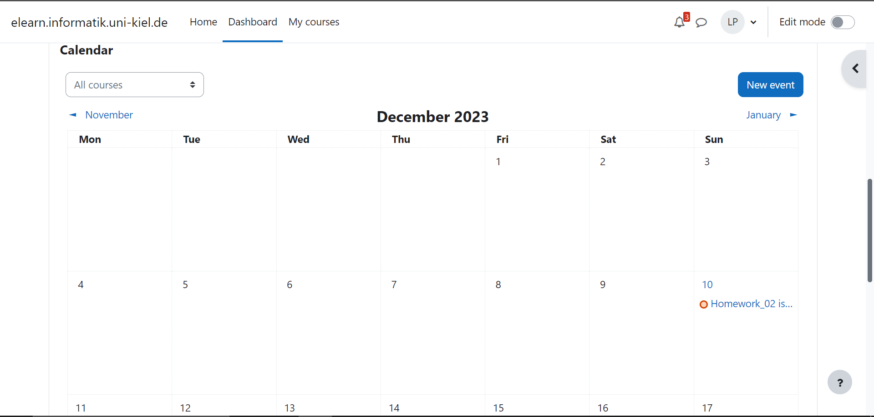

Gestalt Principle: Law of Continuation

Explanation: The elements are arranged in a line and are perceived to have a continuous connection and are more likely to be perceived as a single unit. It utilizes visuale elements to portray events that span multiple days or weeks or highlight submission dues. This creates a perceptual continuity, helping users understand that these events are part of a cohesive time period. It al maintains a consistent visual style for days within the same month.