BUSRADAR-MS — A Real-Time Bus Tracking Pipeline
A self-directed learning project building an end-to-end streaming data pipeline from scratch.


🔗 Live dashboard: busradar-ms.live

Project Overview
Busradar is a real-time data pipeline that ingests live public transit positions from all buses in Münster, Germany (my hometown). A single Kafka topic acts as the central event backbone, feeding two independent downstream consumers that each serve a different purpose:
- Batch branch: Kafka → Spark Structured Streaming → Delta Lake → dbt , building a structured analytical layer for historical analysis.
- Streaming branch: Kafka → Flask (background consumer) → Server-Sent Events → Leaflet.js, powering a live map dashboard that visualizes every active bus in real time.
The data source is the real-time WebSocket feed from Stadtwerke Münster (the city’s public transit operator), which pushes GeoJSON-encoded bus positions every few seconds. This dataset reflects actual vehicle movements across 40+ bus lines, with operational metadata including delays, stop sequences, and route assignments.
The project serves as a hands-on learning path through the modern data stack. Every component — from the async WebSocket consumer to the dbt serving layer to the EC2 deployment — was built incrementally to develop practical fluency with production-grade tools. The live deployment at busradar-ms.live provides a tangible, running proof of the full system.

Architecture
The pipeline uses a streaming-first architecture with a shared Kafka backbone. Both branches consume independently from the same topic, but they serve fundamentally different purposes — the batch branch builds a durable analytical store (~220k rows/day, 2.6M+ rows accumulated), while the streaming branch powers a live operational dashboard. This is not a lambda architecture (where both branches compute the same result and a serving layer merges them), but rather two independent consumers each solving a different problem from the same event stream.
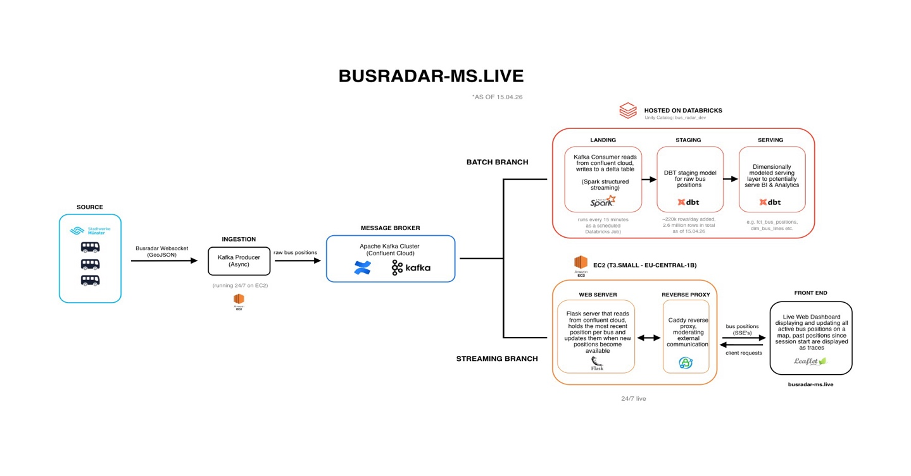Data flow:
- Ingestion — A Python WebSocket client connects to Stadtwerke Münster’s live feed, flattens GeoJSON features into individual bus position events, and produces them to Kafka using fahrtbezeichner (trip identifier) as the message key.
- Batch branch — Spark Structured Streaming on Databricks consumes from Kafka using an AvailableNow trigger on a 15-minute schedule (configured as a Databricks Job). Raw positions land in a Delta Lake bronze table under Unity Catalog. dbt then transforms bronze into a staging view and serving-layer materialized views (fct_bus_positions, dim_bus_lines, dim_dates) for analytical queries via Databricks SQL.
- Streaming branch — A Flask web server runs a background Kafka consumer thread that maintains an in-memory dictionary of the latest position per bus. An SSE endpoint (/stream) snapshots this state every second, evicts stale buses, and pushes JSON to all connected browser clients. The frontend renders positions on a Leaflet.js map with direction arrows, movement trails, and color-coding.

Tech Stack

Layer | Technology | Purpose
Data Source | Stadtwerke Münster WebSocket | Real-time GeoJSON bus positions
Ingestion | Python, websockets, confluent-kafka | Async WebSocket consumer, Kafka producer
Message Broker | Apache Kafka (Confluent Cloud) | Central event backbone, 6 partitions
Batch Processing | Spark Structured Streaming (Databricks) | Kafka → Delta Lake micro-batch ingestion
Storage | Delta Lake, Unity Catalog | Bronze table, schema enforcement, checkpoints
Transformation | dbt (dbt-databricks) | Staging views, serving materialized views, tests
Analytics | Databricks SQL | Query layer on dbt serving models
Web Server | Flask, Server-Sent Events | Real-time API with background Kafka consumer
Frontend | Leaflet.js, HTML/CSS/JS | Live map with trails, popups, line filtering
Infrastructure | AWS EC2 (t3.small), Caddy, systemd | Hosting, reverse proxy (auto-HTTPS), process management
Domain | Strato | busradar-ms.live

Repository Structure
busradar/
├── kafka/ # Ingestion layer
│ ├── producer.py # WebSocket → Kafka producer (async)
│ ├── consumer.py # Standalone test consumer (debugging)
│ ├── config.py # Confluent Cloud connection config
│ ├── databricks_consumer.ipynb # Spark Structured Streaming consumer
│ ├── requirements.txt
│ └── .env.example # Required environment variables
│
├── web/ # Streaming branch — live dashboard
│ ├── app.py # Flask SSE server + background Kafka consumer
│ ├── templates/
│ │ └── index.html # Leaflet.js map with full UI
│ └── requirements.txt
│
├── dbt_bus_radar_ms/ # Transformation layer (dbt project)
│ ├── dbt_project.yml # Project config, schema routing
│ ├── models/
│ │ ├── staging/
│ │ │ ├── stg_raw_bus_positions.sql # View on bronze table
│ │ │ └── _src_bus_positions.yml # Source definition
│ │ └── serving/
│ │ ├── fct_bus_positions.sql # Fact table (materialized view)
│ │ ├── dim_bus_lines.sql # Line dimension (materialized view)
│ │ └── dim_dates.sql # Date dimension (table, dbt_date)
│ ├── macros/
│ │ └── generate_schema_name.sql # Schema routing override
│ ├── packages.yml # dbt_utils, dbt_date
│ └── seeds/ # Planned: dim_stations
│
├── docs/ # Documentation assets
│ └── busradar-ms-architecture.svg # Pipeline architecture diagram
│
├── .gitignore
└── README.md

Pipeline Deep-Dive

Ingestion: WebSocket → Kafka
The producer (kafka/producer.py) establishes a persistent WebSocket connection to wss://websocket.busradar.conterra.de. Each incoming message is a GeoJSON FeatureCollection containing the current state of all active buses.
The producer flattens each feature into an individual bus position event, handling two operation types:
- MODIFY — A bus has moved. The event includes coordinates, line information, delay, stop sequence, and operational timestamps. Latitude and longitude are extracted from GeoJSON geometry coordinates.
- REMOVE — A bus has gone out of service. The event carries only identifiers, no coordinates.
Each event is produced to the bus_locations_ms_raw topic with fahrtbezeichner (the unique trip identifier) as the Kafka message key. This ensures all events for a given trip land on the same partition, preserving ordering per bus. The producer handles BufferError with backpressure (poll-and-retry) and uses asynchronous delivery callbacks for error tracking.
On WebSocket disconnection, the websockets library’s built-in reconnection (async for websocket in websockets.connect(uri)) automatically re-establishes the connection.

Batch Branch: Kafka → Delta Lake → dbt
Spark Structured Streaming (kafka/databricks_consumer.ipynb) reads from the Kafka topic on Databricks. It uses the AvailableNow trigger — processing all available messages in a single micro-batch, then terminating. A Databricks Job runs this notebook on a 15-minute cron schedule, giving near-real-time analytical freshness without the cost of a continuously running cluster.
The raw JSON payloads are parsed against a defined StructType schema, enriched with kafka_timestamp and a _loaded_at audit column, and appended to the bus_radar_dev.bronze.raw_positions Delta table. Checkpoints are stored in a Unity Catalog Volume to ensure exactly-once processing semantics across job runs.

dbt (dbt_bus_radar_ms/) then transforms the bronze layer into analytics-ready models:
Model | Type | Schema | Description
stg_raw_bus_positions | View | bronze | Pass-through staging view on the raw Delta table
fct_bus_positions | Materialized View | analytics | Fact table with parsed timestamps, delay, hour/minute extraction, bus line key
dim_bus_lines | Materialized View | analytics | Distinct bus lines with route direction (deduped from raw)
dim_dates | Table | analytics | Standard date dimension (1990–2050, via dbt_date)
The project uses a generate_schema_name macro override to route models directly to their target schemas (bronze, analytics) rather than prepending the dbt target schema — a deliberate design choice for cleaner Unity Catalog organization.
Materialized views auto-refresh on query in Databricks SQL, so the serving layer stays current without manual orchestration.

Streaming Branch: Kafka → Flask SSE → Live Map
The Flask application (web/app.py) runs a background daemon thread with a dedicated Kafka consumer. This consumer polls the same bus_locations_ms_raw topic and maintains a shared in-memory dictionary (bus_positions) keyed by fahrtbezeichner:
- MODIFY events upsert the dictionary entry with the latest position and a _last_seen timestamp.
- REMOVE events delete the entry.
The /stream SSE endpoint snapshots this dictionary every second, evicts entries older than the staleness threshold (currently 10 minutes), serializes to JSON, and pushes to all connected browser clients via Server-Sent Events.
The frontend (web/templates/index.html) connects to /stream using the browser’s native EventSource API and renders each bus as a color-coded marker on a Leaflet.js map. Features include direction-of-travel arrows (calculated from successive positions), fading movement trails, delay color-coding, per-line filtering, and a searchable sidebar with live statistics.
Transparency note: The frontend (HTML/CSS/JavaScript) was built with AI assistance. The backend pipeline — from WebSocket ingestion through Kafka, Spark, Delta Lake, dbt, Flask, and EC2 deployment — is the author’s own work.

Infrastructure & Deployment
The streaming branch runs on an AWS EC2 t3.small instance (eu-central-1b). The deployment uses:
- systemd — Process management for the Kafka producer and Flask web server. Unit files ensure automatic restart on failure and structured logging via journald.
- Caddy — Reverse proxy with automatic HTTPS certificate provisioning via Let’s Encrypt. Serves the Flask app on port 443 and handles TLS termination.
- Domain — busradar-ms.live registered via Strato (€0.25/month), DNS A-record pointed to the EC2 Elastic IP.
The Databricks-side batch processing runs on serverless compute, triggered by a Databricks Job on a 15-minute cron schedule.

Roadmap
This project is under active development. Planned improvements include:
Near-term - [ ] Prod / dev EC2 instance split — dedicated production instance with DNS repointing, current instance becomes dev - [ ] GTFS-based route snapping — project GPS positions onto official Stadtwerke Münster route shapes using GTFS static feed data - [ ] dim_stations seed — enrich the dbt layer with a station/stop dimension from GTFS stops data - [ ] Staleness threshold tuning — optimize the eviction window based on observed bus reporting intervals - [ ] Cron overnight shutdown (1–5am) — reduce EC2 costs during no-service hours
Medium-term - [ ] Self-hosted Kafka (KRaft) — single-broker setup on a second EC2 instance as a learning exercise, replacing Confluent Cloud - [ ] Producer heartbeat logging — periodic health-check log lines for monitoring producer liveness
Future - [ ] Frontend event tracking → Kafka → Databricks — a second source system feeding the same analytical pipeline, demonstrating multi-source ingestion - [ ] Log offloading to CloudWatch — structured log pipeline for operational visibility - [ ] Silver snapped-positions table — store GTFS-matched positions as a curated analytical layer

Getting Started

Prerequisites
- Python 3.11+
- A Confluent Cloud account (or self-hosted Kafka cluster)
- Databricks workspace with Unity Catalog enabled
- AWS EC2 instance (for deployment) or local machine (for development)

Setup
- Clone the repository
- git clone https://github.com/<your-username>/busradar.git
cd busradar
- Configure environment variables
- cp kafka/.env.example kafka/.env
# Edit kafka/.env with your Confluent Cloud credentials
- Required variables:
- CONFLUENT_BOOTSTRAP_SERVERS=<your-cluster-url>
CONFLUENT_SASL_SSL=SASL_SSL
CONFLUENT_CONNECTION_METHOD=PLAIN
CONFLUENT_USERNAME=<your-api-key>
CONFLUENT_API_KEY=<your-api-secret>
- Install dependencies
- # Kafka producer
cd kafka && pip install -r requirements.txt
# Web dashboard
cd ../web && pip install -r requirements.txt
- Start the producer (ingests live bus data into Kafka)
- cd kafka
python producer.py
- Start the web dashboard (consumes from Kafka, serves live map)
- cd web
python app.py
# Open http://localhost:8050 in your browser
- Run dbt models (requires Databricks connection configured in ~/.dbt/profiles.yml)
- cd dbt_bus_radar_ms
dbt deps
dbt run

License
This project is for educational and portfolio purposes.

Built by Lennart Rosenthal as a self-directed data engineering learning project. busradar-ms.live

