Bayesian Approach to Analysing Citizens’ Trust in the Finnish Government

1 Introduction
Foster & Frieden (2017) claim, that Europeans’ confidence in political institutions has dropped significantly since the Euro-crisis in 2009. Their article also claims that the trust is tied to citizens’ income and occupational and educational backgrounds. The study finds out that people with higher education and skills are more likely to trust the government.
In this project, we investigate the Finland’s citizens’ trust in Finnish political institutions. We are particularly interested about the socioeconomical factors that cause lower trust in the Finnish government.
The study is conducted using the FSD3991 Citizen’s Pulse (Kansalaispulssi) of 1/2025 [lähde]. The Citizen’s Pulse is a survey dedicated for Finnish citizens aged between 15–74. The survey aims to find out Finnish people’s opinions about relevant topics and confidence towards public institutions.
2 Problem Formulation
The research question of the project is the following: What share of Finns aged 15–74 have very low trust in the government, how does it vary by region and household economic situation, and how precisely can each of these shares be estimated? We approach the problem as a regressioon problem with an ordinal outcome. The target variable is continous, $y_{i}∈\left[1, 10\right]$.
The goal of the project is to infer the posterior distribution of model parameters given the survey data using the Bayesian framework. The project focuses on the uncertainty of the low-trust tail.
3 Data Analysis
The raw dataset contains N=2182 observations. For each observation, there are 72 independent variables, one of which is the outcome variable. The variables are either categorical or on a scale 1–10. The explanatory variables used in the models will be treated as continous, assuming equally spaced, interval-level responses.
Categorical variables are gender, age group, household status, minor children in household status, region and municipality, highest education and household financial status. The continous covariates are opinions related to confidence in various public institutions, including the government, police, defence forces, education system and European Union. The covariates also contain a weight (paino) in the range [726, 4657]. The weights sum up to 4 126 603, which is the size of the population between ages 15–74. This is due to the respondents not being random, which is corrected by scaling with the weight.
3 Missing Data

4 Categorial Data

4 Numeric Data
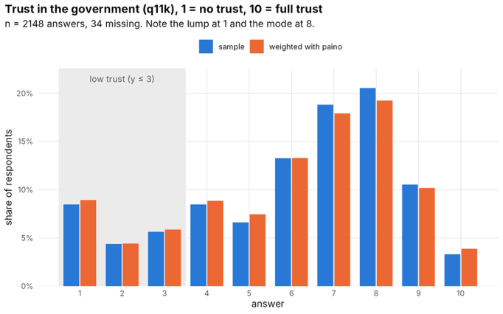
- lump at 1

