Autonomous Robotic Car Challenge — Project Report
Embedded Systems Project · Raspberry Pi Pico W + Cytron Robo Pico · µT-Kernel 3.0
Group 5: Kent (2500343) · Levia (2503109) · Max (2501660) · Lennon (2503438) · Raees (2501955)
10 November 2026

Contents
1. Introduction
1.1 Mission requirements and where they are met
2. System Architecture
2.1 Real-time design on µT-Kernel
2.2 Working within the template
2.3 Resource usage
3. Hardware and Wiring
4. Subsystem Design
4.1 Buddy 1 — WiFi Communication, Command and Telemetry
4.2 Buddy 2 — Motion Control System
4.3 Buddy 3 — Barcode Decoding and IR Line Following
4.4 Buddy 4 — IMU-Based Motion and Terrain Monitoring
4.5 Buddy 5 — Adaptive Ultrasonic Scanning and Obstacle Profiling
5. Integration — Vehicle Controller
6. Verification and Evidence
7. Robustness
8. Software Quality — BARR-C:2018 Conformance
8.1 How conformance is checked
8.2 Deviations
8.3 Latent defects found by the conformance pass
9. Limitations and Future Work
10. Demonstration Plan
Appendix A — Build and Flash
Appendix B — Template Changes

1. Introduction
This report documents the design, implementation, integration and verification of an autonomous robotic car that follows a line track, decodes directional barcodes, measures the highest speed hump on the route, profiles and bypasses static obstacles, and reports telemetry over WiFi. It follows the project write-up and the student briefing: the car runs µT-Kernel 3.0 on a Raspberry Pi Pico W mounted on a Cytron Robo Pico, is written in C with the Pico C SDK, is built on the course template repository (sirfonzie/mtk3smp-rp2040) and is written to the BARR-C:2018 Embedded C Coding Standard. Section 8 shows how conformance is checked with tools that anyone can re-run, and lists the few deviations that the kernel, the template and the Pico SDK force on us.
The briefing's guidance — "Start with interfaces, then build evidence" — shaped the whole project. Every subsystem exposes a small C API, has its own standalone test program (APP_MODE=TEST_xxx), and every hardware-independent algorithm is unit-tested on a PC before it ever runs on the car.

1.1 Mission requirements and where they are met
# | Requirement (write-up) | Implementation | Owner
1 | Follow a line track autonomously | line_follow.c edge-tracking PID + motion.c wheel PID | B3, B2
2 | Detect and decode barcodes | ir_sensor.c 1 kHz edge capture + barcode_decode.c Code 39 | B3
3 | Execute Left / Right / Straight / U-turn | vehicle.c::execute_nav() using encoder turns | B3, B2
4 | Detect humps | terrain_hump_update() pitch state machine in terrain.c | B4
5 | Measure and report highest hump peak | height = Σ ds·sin(pitch); max_peak_mm in telemetry | B4, B1
6 | Detect obstacles on or near the line | background sonar monitor task, two readings under 200 mm | B5
7 | Profile obstacle shape and position | 17-point servo scan (50°–130°) + avoidance_profile() | B5
8 | Navigate around obstacles without collision | avoidance_plan() + diagonal (45°) bypass | B5, B2
9 | Reacquire the original line | seek_line() + reacquire_line() | B5, B3
10 | Report telemetry over WiFi | lwIP's MQTT 3.1.1 client, 5 Hz telemetry, heartbeat | B1

2. System Architecture
The software follows the suggested three-layer architecture (sensor, control, communication). A hardware-abstraction layer (HAL) sits underneath, and a vehicle controller coordinates the five subsystems.
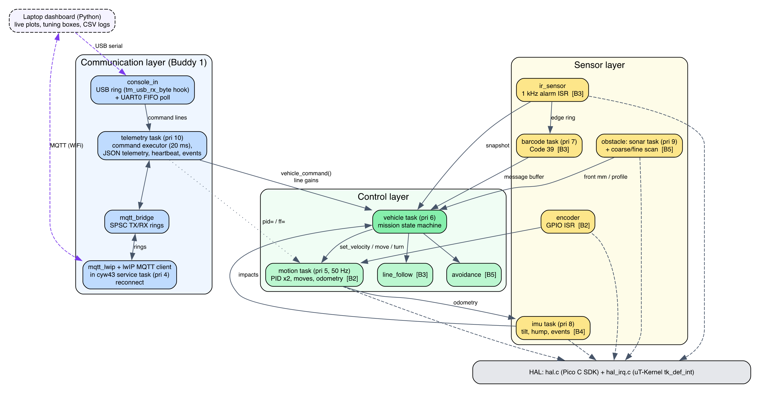
Software architecture and data flow

2.1 Real-time design on µT-Kernel
Priority | Task / handler | Rate | Role
ISR | IO_BANK0 GPIO | on edge | wheel encoders, ultrasonic echo (µs timestamps)
ISR | TIMER alarm 3 | 1 kHz | samples 3 IR channels, barcode edge detection
4 | cyw43 (template) | 2 ms poll | WiFi radio, lwIP, MQTT client via hook
5 | motion | 50 Hz (cyclic handler) | two speed PIDs, distance/turn moves, odometry
6 | vehicle | 50 Hz | mission state machine, line-following loop
7 | barcode | 100 Hz | frames + decodes barcode edge stream
8 | imu | 50 Hz | tilt, hump, impact, turn-rate, motion events
9 | sonar | ~14 Hz | front-distance monitor
10 | telemetry | 20 ms loop | commands (USB, UART, MQTT), binary telemetry frames (off–20 Hz), 1 Hz heartbeat, events
10 | blink (template) | 2 Hz | liveness LED on GP16

The motion loop is woken by a µT-Kernel cyclic handler (tk_cre_cyc) calling tk_wup_tsk, so its period is drift-free. Timing-critical capture (encoders, echo width, barcode bars) happens in interrupt handlers registered with tk_def_int; heavier processing is deferred to tasks.
Inter-task communication uses µT-Kernel objects where blocking semantics are needed and lock-free structures where interrupt context is involved:
Channel | Mechanism | Why
barcode → vehicle | message buffer (tk_snd_mbf) | queued commands, never lost
MQTT/telemetry → vehicle | message buffer | thread-safe commands from any task
motion move completion | event flag (tk_wai_flg) | tasks block until a move finishes
echo ISR → sonar | event flag set from ISR | measurement without busy-waiting
ultrasonic sharing | semaphore | monitor task and scans never ping together
IR ISR → barcode task | SPSC ring buffer | ISR must never block
tasks ↔ lwIP context | two SPSC rings with dmb barriers | the two worlds cannot share headers
status snapshots | DI()/EI() struct copy | microsecond critical sections

2.2 Working within the template
Studying the template revealed constraints that drove several design decisions:
- Pico SDK version. The template is qualified against Pico SDK 2.2.0; newer SDKs fail to build it (fixed_bitset.h). We pin 2.2.0.
- No SDK runtime. The template links only selected SDK sources. hal.c therefore uses the SDK's header-only APIs (hardware/pwm.h, adc.h, gpio.h, hardware_structs), and implements I2C at register level, mirroring the SDK's i2c_write_blocking logic, because SDK i2c.c needs clocks_init and pico_time.
- Header separation. <tk/tkernel.h> and SDK/lwIP headers cannot share a translation unit because their size_t typedefs collide (we reproduced this compiler error). Every SDK-facing file (hal.c, mqtt_lwip.c) exposes a plain stdint API instead.
- Single-owner peripherals. The template's safety rules require each peripheral to have one owner. We disabled the kernel's sample ADC/I2C drivers (config_device.h) so the application owns ADC and I2C0 exclusively.
- Reserved pins. GP0/GP1 (console UART), GP16 (liveness LED) and GP23/24/25/29 (radio) are left untouched.
- 10 ms kernel tick. This is too coarse for barcode sampling, so the 1 kHz sampler uses RP2040 hardware alarm 3 (unused by the kernel) with drift-free re-arming.
- No MQTT in the template. The CYW43 service task owns lwIP in NO_SYS mode and has no application hook. We added a weak cyw43_utk_app_poll() hook (5 lines) and a WIFI_MQTT build knob that enables lwIP TCP and compiles lwIP's own MQTT client (apps/mqtt/mqtt.c), which is in the SDK's lwIP tree but not in the template's build.
- No usable console input. The template's tm_getchar() spins with interrupts disabled until a byte arrives, which would freeze every task, and on the USB console received bytes are simply discarded. We read the UART0 receive FIFO without blocking (hal_uart0_getc()), and added a weak tm_usb_rx_byte() hook where the USB glue used to discard input. The USB service task, which owns TinyUSB, calls the hook and the bytes go into a lock-free ring.

2.3 Resource usage
Build | Flash (text) | RAM (data+bss)
Mission, UART console | ≈ 70 KB | ≈ 16 KB
Mission, USB console + WiFi + MQTT | 363 KB | 58 KB
Application code only (linked, WiFi build) | 27.4 KB | 8.2 KB (+ 17.4 KB task stacks)

The RP2040 has 264 KB of SRAM and 2 MB of flash, so all builds fit comfortably.
Change Requirement 1 (minimum-bit data representation) cut the mission build's static RAM by 4.1 KB and the application's own RAM from 6.1 KB to 2.0 KB; the measurements, the field table and the message sizes are in docs/DATA_REPRESENTATION.md.
Efficiency choices:
- Integer fixed-point filtering in the 1 kHz ISR.
- Telemetry in integer units (no printf float support is needed).
- Custom soft-float sqrt/atan2/sin. The M0+ has no FPU, and newlib's libm is no shortcut: its sqrtf() and atan2f() set errno, which pulls newlib's stdio and system calls into an image that has none (we tried it: the builds without WiFi then fail to link).
- Event-driven echo and encoder capture instead of polling.
- Telemetry rate chosen so MQTT never saturates the TCP send buffer.
CPU cost measured on the car with the timing command over a full 72 s lap (INT-06, 4 Nov, WiFi on):
Item | Longest time measured | Period
IR sampler ISR | 66 µs | 1 ms
Motion loop | 725 µs | 20 ms
Vehicle loop | 667 µs | 20 ms
IMU step (polled I2C) | 1372 µs | 20 ms
Network (MQTT) | 991 µs | 200 ms telemetry
Whole lap | CPU load 12 %, control jitter at most 1779 µs (limit 2000 µs)

3. Hardware and Wiring
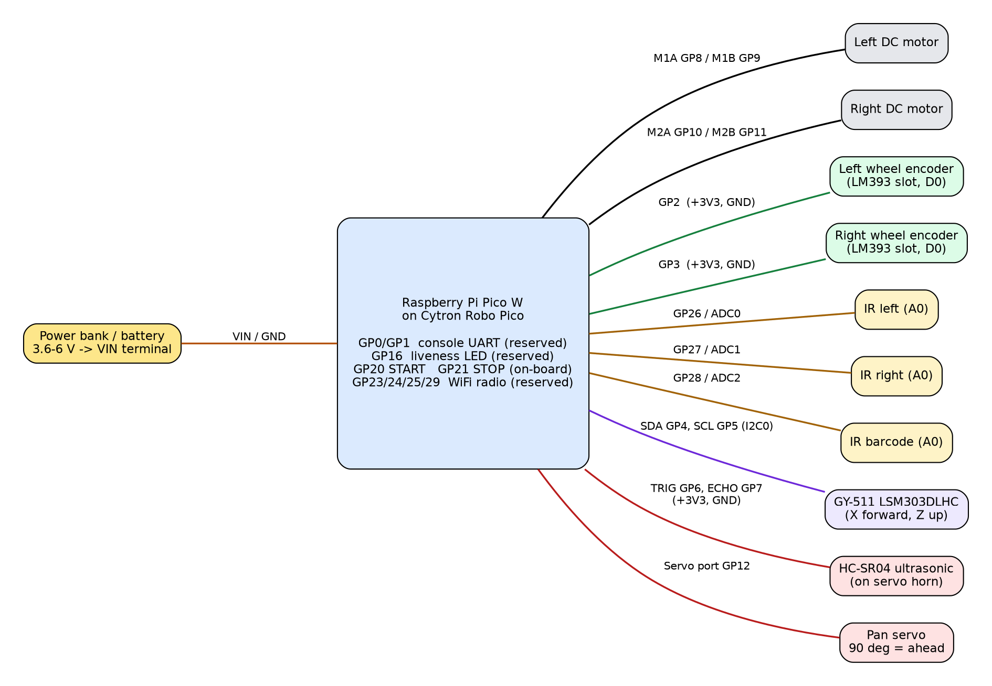
Wiring diagram
Device | Device pin | Pico / Robo Pico | Notes
Left motor | + / − | M1 terminals (GP8 / GP9) | MxA=PWM, MxB=0 → forward; swap wires or set MOTOR_L_INVERT if reversed
Right motor | + / − | M2 terminals (GP10 / GP11) | MOTOR_R_INVERT likewise
Left encoder | VCC / GND / D0 | 3V3 / GND / GP2 | Grove 2
Right encoder | VCC / GND / D0 | 3V3 / GND / GP3 | Grove 2
IR left | VCC / GND / A0 | 3V3 / GND / GP26 (ADC0) | use analog output, D0 unused
IR right | VCC / GND / A0 | 3V3 / GND / GP27 (ADC1)
IR barcode | VCC / GND / A0 | 3V3 / GND / GP28 (ADC2)
LSM303D IMU | VIN / GND / SDA / SCL | 3V3 / GND / GP4 / GP5 | I2C0 at 400 kHz; chip X axis forward, Z up
HC-SR04 | VCC / GND / TRIG / ECHO | 3V3 / GND / GP6 / GP7 | per course slide; a 5 V module needs a divider on ECHO
Servo | signal / V+ / GND | Servo port GP12 | 90° = straight ahead
Buttons | — | GP20 START, GP21 STOP | on-board
Power | — | VIN terminal 3.6–6 V | common ground for everything

Mounting notes.
- Line sensors. Place the two sensors so each IR spot sits on one edge of the 18 mm line (≈18 mm apart). Centred, each reads ≈0.5, which gives the steepest, most linear error signal.
- Barcode sensor. Offset it to the barcode side, ≈45–50 mm from the line centre. The barcode lies 20 mm beyond the line edge (see the course barcode specification).
- Grove port 5 and 6 share GP26. Wire only the listed pins.

4. Subsystem Design

4.1 Buddy 1 — WiFi Communication, Command and Telemetry
Communication API (mqtt_bridge.h): mqtt_bridge_publish(topic, frame, len), mqtt_bridge_get_command(buf, size, &len), mqtt_bridge_get_stats(&stats). Application tasks never touch lwIP. Two single-producer/single-consumer rings carry messages into and out of the lwIP context, using memory barriers so they are also correct under the template's dual-core SMP profile.
MQTT client (mqtt_lwip.c on lwIP's apps/mqtt). lwIP's own MQTT 3.1.1 client does the protocol work: CONNECT with last will, PUBLISH, SUBSCRIBE, keep-alive pings and the broker watchdog. mqtt_lwip.c manages the connection and moves messages between that client and the bridge. It runs inside the template's CYW43 task through the new hook, so all lwIP calls stay in one context as NO_SYS requires. An earlier version carried its own MQTT encoder and decoder; a simplification review replaced them with the client lwIP already ships.
Connection recovery:
- The client connects only once the link is up and DHCP has an address.
- Each attempt (TCP connect and CONNACK) gets 2 s, then 4 s, then 8 s; an attempt not accepted by then is abandoned and the next one starts. A session that drops reconnects at once.
- lwIP's client sends PINGREQ after keepalive seconds without sending, and closes the session if nothing (data or a TCP acknowledgement) arrives for 1.5 × keepalive, so steady telemetry cannot cause a false disconnect.
- The last-will message marks the car offline if it disappears.

MQTT documentation
All topics start with picocar/<id>/, where <id> is MQTT_CAR_ID in mqtt_config.h (default car1). Since Change Requirement 1 every payload is a compact binary frame: byte 0 holds the frame type and the format version, then the fields follow with explicit masks and shifts, least significant bit first (frames.c). The field list of every frame, with ranges, units and bit widths, is in docs/DATA_REPRESENTATION.md; tools/dashboard/frames.py decodes them into the field names below.
Topic | Dir | QoS / retain | Rate | Frame
picocar/<id>/telemetry | car → laptop | 0 / no | 5 Hz (rate=: off, or 50–5000 ms) | telemetry, 43 B
picocar/<id>/heartbeat | car → laptop | 0 / no | 1 Hz | heartbeat, 26 B
picocar/<id>/event | car → laptop | 0 / no | when something happens | state, barcode, hump, obstacle, impact, reply, gains, timing (2–24 B)
picocar/<id>/status | car → laptop | 0 / retained | on connect; last will | status, 2 B: online / offline
picocar/<id>/cmd | laptop → car | 0 / no | on demand | command, 4–11 B

Telemetry (decoded names): t run time ms, st vehicle state, ls line state, nav / pend last and pending barcode command, spd / tgt wheel speed and target mm/s, pwm duty %, enc encoder ticks (low 16 bits), odo mm, hdg heading 0.1°, ir normalised IR ‰ (left, right, barcode), le line error ‰, nbc barcodes and bc the last symbol, pitch / roll / yaw 0.1°, rate turn rate 0.1°/s, hump {h, pk, max mm, n}, ev motion event, front mm (−1 = no echo), act / nobs avoidance action and obstacles passed, faults the active fault bits.
Heartbeat: up s, seq, st, link, pub / drop / rx (16-bit, wrapping), recon, rejoin, wreset, tries (8-bit, saturating), wifi and why (sent as 3- and 4-bit codes of the texts listed in the README), ip, imu, i2cerr, faults and fcount (how often each fault was raised).
Events: state (st, why: a 5-bit code of the reason), barcode (code, cmd), hump (n, peak_mm, max_mm), obstacle (found, dist, ang, width, centre, cl, cr, act), impact (n), cmd (the reply: id, cmd, ok, err), gains (pid, ff, line, speed, rate) and timing (window, load, jitter, periods and each section's maximum; the averages are printed on the console).

Commands and live tuning
The same commands are accepted on the MQTT cmd topic, as binary command frames, and typed as text on the USB or UART serial console. So gains can be tuned without reflashing in every build, including the test builds that have no WiFi. command.c parses them (pure C, 28 unit tests) and the telemetry task executes them within 20 ms.
Command | Effect | Applied by
start, stop, calibrate | run control, as the GP20/GP21 buttons | vehicle task (message buffer)
speed=<mm/s> | cruise speed, 60–300 (NFR2: barcode sampling) | vehicle task
pid=<kp>,<ki>,<kd> | wheel-speed PID, both wheels | motion_set_speed_gains()
ff=<kf>,<offset> | feed-forward (%/(mm/s)) and static-friction offset (%) | motion_set_feedforward()
line=<kp>,<ki>,<kd> | line-following PID, applied without resetting the controller | vehicle task, which owns the follower
rate=<ms> | telemetry period: 0 = off, 50–5000 | telemetry task
gains, help | report the gains in use / list commands | telemetry task
timing | task times, control jitter and CPU load since the last timing (a timing event) | telemetry task

The tuning commands (speed=, pid=, ff=, line=) are accepted only while the car is IDLE or STOPPED, so the controllers never change mid-run; while driving they are answered with a reply frame whose error is "only while IDLE or STOPPED". start, stop, rate=, gains, help and timing work in every state.
- Keywords are case-insensitive and spaces are ignored.
- Every command is answered with a reply frame (request id, command, error code), and on the console with a readable # cmd line giving the reason (for example wrong number of values, gain out of range 0..1000, or not available in this build).
- Every change is followed by a gains frame (and a # gains console line) with the values now in use; gains travel in 0.001 steps, the same precision as the text commands. It is sent 60 ms later so the vehicle task has applied line gains first; review caught that an immediate reply would have reported the old values.
- Gains live in RAM and reset on reboot. The final values are copied into car_config.h, because the template forbids flash writes without parking the second core.
- Serial input is limited to 64-character lines. On the UART, commands are paced in 16-byte chunks so the 32-byte receive FIFO (polled every 20 ms) never overflows; the dashboard does this automatically.

Laptop dashboard and telemetry demonstration
tools/dashboard/picocar_dashboard.py (Python: paho-mqtt, pyserial; the web server is the standard library) connects over MQTT (--mqtt <broker>) or over the USB cable (--serial auto finds the Pico by its USB vendor ID 0x2E8A) and serves one web page at http://127.0.0.1:8050. The page gets at most five updates a second (Server-Sent Events) and redraws a chart only when new data arrived, so it stays smooth at 20 Hz telemetry.
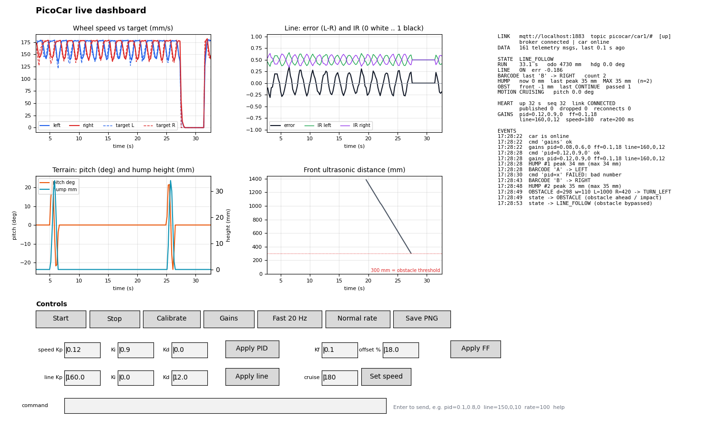
Dashboard with the car simulator
- Live charts of the last 30 s: wheel speed against target, and line error with the left and right IR sensors; live values for pitch, hump height and peak, and front distance.
- Status panel: state, barcode, run-maximum hump peak, obstacles, and link health (heartbeat, reconnects, dropped messages).
- Controls: Start, Stop, Calibrate, 20 Hz / 5 Hz telemetry buttons, turn buttons (nav=1..4, as if a barcode was read), and tuning boxes pre-filled from the car's gains event, each with an Apply button.
- Logging: every session is saved to logs/<date_time>/: telemetry.csv (33 columns in engineering units), events.csv, heartbeat.csv, commands.log and console.log. These files are the raw evidence for the tables in this report, and Save PNG stores the plots alongside them.
tools/dashboard/sim_car.py publishes the firmware's exact message formats and obeys the same commands. Its wheel model uses the firmware's PID law, so a pid= change visibly alters the response. It was used to verify the dashboard end to end against a Mosquitto broker: commands, acks, rejected commands, rate changes and logging. The serial path was verified against an emulated console on a pseudo-terminal.
Recovery demonstration. Stop and restart the broker: the heartbeat's reconnect counter increments and publishing resumes. Without WIFI_MQTT, the same frames are printed on the USB console (as @ + hex) at 1 Hz, so the dashboard's serial mode demonstrates the telemetry framework without a network.

4.2 Buddy 2 — Motion Control System
Motor driver (motor.c). 10 kHz PWM (the Robo Pico maximum is 20 kHz) drives MxA while MxB is held low, which gives drive-brake operation and a near-linear speed-to-duty curve.
Encoders (encoder.c). Both edges are counted for distance resolution: π·65/40 = 5.1 mm per tick. Speed uses rising-to-rising periods, which are immune to uneven slot and bar widths. A moving average of 4 periods is used, and the estimate decays towards zero when the wheel slows (the elapsed time since the last edge bounds the period). A 300 µs glitch filter rejects comparator chatter.
Speed control (pid.c, motion.c). One PID controller per wheel runs at 50 Hz: output = kf·setpoint + kp·e + I − kd·d(measurement)/dt, plus a static-friction offset.
- Taking the derivative on the measurement avoids set-point kick.
- Conditional integration with clamping prevents integral wind-up.
- The single-channel encoders cannot sense direction, so the controller works on speed magnitude and applies the commanded sign.
Straight-line correction. During moves, the wheel that is ahead is slowed and the one lagging is sped up, by STRAIGHT_KP × (dL − dR).
Encoder turns. Each wheel travels π·W·θ/360 in opposite directions. Moves slow down over the last 80 mm and have a stall timeout of 3× the ideal time + 1 s.
Required APIs:
- motion_move_forward(mm, speed), motion_move_backward(mm, speed)
- motion_turn_left(deg), motion_turn_right(deg), motion_stop()
- motion_set_velocity(vl, vr) for line following
- motion_wait() returns OK / BUSY / FAIL, so callers can abort
- motion_get_status() provides odometry, heading and turn rate

PID tuning report
Method. Use APP_MODE=TEST_MOTOR with the dashboard in serial mode.
- Press START. The first run makes an open-loop duty sweep (0–100 % in 10 % steps) through the motion task's open-loop mode. Plot speed against duty: the slope gives the feed-forward gain (%/(mm/s)) and the x-intercept gives the static-friction offset (the dead-band). Send both with ff=<kf>,<offset>.
- The test then logs closed-loop steps (0 → 100 → 180 → 0 mm/s) as CSV at 25 Hz, headed by the gains in use (# step test with pid=… ff=…). Fast 20 Hz also shows the response live.
- Change pid= and press START again. Only the step test repeats, so each iteration takes about 10 s instead of a rebuild and reflash. Tune in the order kf → kp (until slight overshoot, then back off 30 %) → ki (removes steady-state error) → kd (only if oscillation remains).
- Copy the final values into car_config.h. console.log keeps every step run for the table below.
While adding live tuning we found and fixed a defect in the original motor test. Every re-run called motion_init() again, which created a second control task and cyclic handler. The duty sweep also drove the motors directly while the control task braked them every 20 ms. motion_init() is now idempotent, and the sweep runs through the new motion_set_open_loop() mode.
Simulation baseline. A first-order motor model (5 mm/s per % duty, τ = 0.15 s) with the default gains reaches 180 mm/s with 0 % overshoot and under 5 % error within 2 s (host test test_pid).
Result on the car (S2-U02, 28 Oct, TEST_MOTOR). The open-loop sweep put the dead band between 10 % and 20 % duty, giving ff=0.12,2.3. The final gains, copied into car_config.h, are kp 0.104, ki 0.60, kd 0, kf 0.12, offset 2.3 %:
Step | Peak | Overshoot | Settled | Steady value
0 → 160 mm/s | 258–261 mm/s at 120 ms | 61 % | ≈ 400 ms | 171–180 mm/s (≈ +10 %)
160 → 50 mm/s | 49–51 mm/s at 120 ms | none | ≈ 120 ms | 52–55 mm/s (+5 %)
→ 0 |  |  | 200 ms | 0

No step oscillated. The overshoot on the first step comes from the feed-forward and offset acting together from standstill. The mission drives at 75 mm/s, where the response settles well within one line-following correction.

Motion accuracy evaluation
APP_MODE=TEST_MOTION runs: forward 500 mm, left 90°, right 90°, backward 500 mm, U-turn 180°. It prints the encoder distance and heading for each move. Measure the real result with a tape and protractor over 5 runs, then calibrate WHEEL_DIAMETER_MM from the distance error and TRACK_WIDTH_MM from the turn error.
With the first values (wheel 65.0 mm, track 138 mm) the car drove about 450 mm for 500 mm (−10 %). After calibration (WHEEL_DIAMETER_MM 58.9, TRACK_WIDTH_MM 132), 28 Oct, S2-U03 and S2-U04:
Move | Commanded | Measured (n=5, tape / protractor) | Error
Forward | 500 mm | 500 mm (encoders 496–497) | ≈ 0 %
Left turn | 90° | ≈ 91° | +1°
Right turn | 90° | ≈ 91° | +1°
Backward | 500 mm | 500 mm (encoders 495–496) | ≈ 0 %
U-turn | 180° | ≈ 183° | +3°

4.3 Buddy 3 — Barcode Decoding and IR Line Following
Calibration (ir_sensor.c). Each channel tracks its minimum and maximum while the car spins 360° over the line (calibrate command, or START held for 2 s while idle). Readings are normalised to 0 = white and 1 = black, per channel. This makes the algorithm robust to lighting changes and to differences between sensors. Calibration is rejected if the contrast is below 200 counts.
Line position and following (line_follow.c). The error is L − R, in the range [−1, 1]. A PID controller turns it into a differential wheel speed (mm/s per unit of error), and the base speed drops by up to 50 % on large errors for stability at varying speeds.
- LOST is declared only after 150 ms with both sensors on white.
- JUNCTION is declared only after 10 mm of travel with both sensors on black.
- These confirmations mean a single noisy sample cannot trigger an action.
Line PID tuning. Build MISSION, press Start on the dashboard and watch the line-error plot; press Stop, set line=<kp>,<ki>,<kd> (tuning is accepted only while IDLE or STOPPED), and press Start again to compare runs. A good result is a line error that settles close to 0 on straights without sustained oscillation.
Line gains (kp / ki / kd) | Speed | Result on the course
45 / 0 / 0 | 50 mm/s | held the bends (27 Oct), but wove on straights
35 / 0 / 0 | 75 mm/s | visible weaving on straights
18 / 0 / 0 (final) | 75 mm/s | smooth; full laps without leaving the line (SYS-01, 4 and 9 Nov)

The two line sensors sit close together, so a small offset already gives a large error; a lower gain was needed than the first estimate. For the first 150 mm (at most 1.5 s) after a start, a turn or a line search, a separate settle gain (LINE_SETTLE_KP) applies. It was 40 and shook the car at every start; it is now 18, the same as the running gain, and the shake is gone (10 Nov).
Barcode (barcode_decode.c). The course barcode is Code 39. We decoded the provided specification photo by hand as *A* (start, A, stop) and used the photo's bar widths as a test vector. Bars and spaces are timed by the 1 kHz sampler, using hysteresis on the normalised reading (black above 0.08, white below 0.05; the sensor sits high, so the contrast is small). A frame ends after 500 ms of white.
Decoding classifies the 3 widest of each 9 elements as wide. Code 39 guarantees exactly three wide elements per character, so this works regardless of speed and only assumes the speed is steady over one ≈40 mm character. A frame that fails forwards is reversed and decoded again, because the car may read the code from either end. Frames must start and end with *, which rejects line crossings and noise.
Navigation command interface. Decoded characters map A→LEFT, B→RIGHT, C→STRAIGHT and D→U-TURN by default; the map= command changes the mapping at run time, so the course's own letters can be used without reflashing. Commands reach the vehicle task through a message buffer.
The vehicle executes a command at the next junction:
- Advance by the sensor-to-axle offset.
- Make an encoder turn.
- Sweep to re-centre on the line.
A U-turn is executed immediately. If no junction appears within 400 mm, the command is executed anyway.
Verification.
- The photo vector decodes to A forwards and backwards.
- 1000/1000 synthetic frames of A–D decode correctly with ±20 % width noise, ±1 % per-element speed drift, in both directions.
- Uniform widths and truncated frames are rejected.
On the car.
- S3-U03 (30 Oct, line following over the barcodes): 16 of 20 read at 100 mm/s and 25 of 27 at 180 mm/s. Closed by team decision; broken frames could still give a wrong letter at that time.
- SYS-02 (10 Nov, final build, 75 mm/s): LEFT, RIGHT, STRAIGHT and U-TURN 4 of 4, each barcode read on the first pass and executed at the next junction (videos).
- At running height the narrow bars barely move the sensor, so frames depend on the wide bars standing out. Lowering the thresholds to 0.08 / 0.05 and lengthening the quiet gap to 500 ms made reads reliable at 75 mm/s; a decoder that guessed letters from the wide bars alone was tried and dropped, because several letters share the same wide bars.

4.4 Buddy 4 — IMU-Based Motion and Terrain Monitoring
IMU processing (imu.c). The LSM303D (I2C address 0x1D, WHO_AM_I 0x49) is configured as follows (values from its datasheet):
- Accelerometer: 100 Hz, ±2 g, block data update, 0.061 mg/LSB.
- Magnetometer: 50 Hz, high resolution, ±4 gauss, continuous conversion.
At start-up, 100 samples taken while the car is still give the accelerometer biases. The magnetometer's hard-iron offsets come from the min/max recorded during the 360° calibration spin.
No gyroscope. The LSM303D has no gyro, so:
- Pitch = atan2(ax, √(ay²+az²)), with the car's own acceleration (d(speed)/dt from the encoders) removed from ax first, so that braking is not mistaken for a slope.
- Turn rate is reported from the encoders ((vR − vL)/track) and from the magnetometer heading derivative.
- An impact is a jerk (sample-to-sample change of the acceleration vector) above 700 mg, with a 500 ms hold-off. An impact during line following triggers an obstacle scan.
Hump-detection algorithm (terrain.c). Double-integrating acceleration drifts quadratically, so height is instead the path integral h = Σ ds·sin(pitch), with ds from the encoders (arc length). Integration only runs during a hump, which bounds drift.
- A hump starts when |pitch| exceeds 6°.
- A pre-roll accumulator adds the height already gained while the slope was gentle. Without it the estimate was 14 % low on a 60 mm hump; adding it came from a host-test failure.
- The hump ends after 30 mm of level travel with the height back below 35 % of the peak.
- Humps must be at least 5 mm high, and the tracker abandons a "hump" longer than 1.5 m (a ramp or drift).
- The run maximum max_peak_mm is reported in telemetry and as a hump event.
Motion classification. Events are STATIONARY, CRUISING, ACCELERATING, DECELERATING, TURNING, CLIMBING, DESCENDING and IMPACT, in that priority order.

Terrain analysis report
Simulation: a raised-cosine hump 250 mm long, crossed at 150 mm/s and 50 Hz, with ±1° random pitch noise.
True height | Estimated peak | Error
20 mm | 20.1 mm | +0.6 %
30 mm | 30.4 mm | +1.3 %
40 mm | 40.1 mm | +0.3 %
60 mm | 60.0 mm | +0.0 %
flat floor | no hump | correct

On the course the track leaves room for only one wheel on the hump, so the car rolls rather than pitches. terrain.c therefore also measures height from roll, with a lever of HUMP_ROLL_LEVER_MM (100 mm). Results against a ruler:
Hump | Ruler height | Estimates | Within ±5 mm
1 cm, pushed by hand (S4-U03, 23 Oct) | 10 mm | 11, 11, 10, 12, 11 mm | 5 of 5
2 cm, pushed by hand (S4-U03, 23 Oct) | 20 mm | 17, 18, 16, 15, 19 mm | 5 of 5
1 cm, line following (SYS-03, 30–31 Oct) | 10 mm | 14.4, 12.3, 12.4 mm | 3 of 3
1 cm, final build (SYS-03, 10 Nov) | 10 mm | 9.8 mm (log), 12.2 mm (filmed run) | 2 of 2

4.5 Buddy 5 — Adaptive Ultrasonic Scanning and Obstacle Profiling
Scanning subsystem (ultrasonic.c, servo.c, obstacle.c).
- The HC-SR04 echo width is timestamped by GPIO interrupts (no busy-waiting), with distance = µs × 0.1715 mm.
- The datasheet's 60 ms minimum cycle is enforced, and each scan point takes the median of 3 readings.
- A background task monitors the front distance about every 70 ms. Two readings in a row under 200 mm (OBST_DETECT_MM) are needed to stop the car, so one spurious echo is ignored. Front and impact triggers are ignored while the IMU reports the car on a hump: the sonar sees the floor when the nose dips, and the landing jolt can look like an impact.
- Floor echoes. The sensor is mounted low and cannot tilt up, so the floor echoes at about 300–380 mm. Echoes at 280 mm (OBST_FLOOR_MM) or further count as no echo in a profile.
- Sensor health (Week 6 obstacle statechart, NFR9). Each ping is VALID, OUT_OF_RANGE, FAULT or BUSY. ECHO must be low before a trigger, so a line stuck high is a FAULT rather than free space. A task waits at most 100 ms for the sensor (US_SEM_TIMEOUT_MS; BUSY, no ping sent). Four FAULT pings in a row (about 0.3 s; two stopped the car on short dropouts while pivoting), or no front reading for 300 ms, stop the car (fault: sonar no echo / sonar stale). The monitor and the scans hand the sensor over through a busy flag, so a front reading is never taken while the servo is moving.
- Servo range. The first mount let the sensor turn only about ±25°; it was rebuilt on 3 Nov to turn ±45°. servo.c never commands past SERVO_MIN_DEG/SERVO_MAX_DEG (50°/130°, ±40°), so the servo cannot push the sensor against the car.
- Scan. Stage 1 is the front monitor itself. A separate coarse pass at 65/90/115° missed an 8 cm box between those angles on 25 Oct and was dropped. Stage 2 is a full sweep from 130° to 50° in 5° steps (17 points). Stage 3 is avoidance_profile() on those points. The write-up's 30°–150° are an example of "a small number of scan angles"; they cannot be reached on this car.
Obstacle profile generator (avoidance.c). Each reading is placed sideways at lateral = d·cos(a), positive to the right of the car.
- The obstacle is the closest echo inside the car's corridor, grown into a cluster of neighbouring echoes within 150 mm of it.
- An early version chose the closest echo anywhere, so a nearby side wall hid the real obstacle. The unit test caught this.
- An edge counts as seen only with a clear scan point past it. A box whose edges are not both seen, or that reads narrower than 100 mm (part of it missed), is passed "blind": wide enough for the widest expected box (200 mm), on the left.
- Outputs: closest point and angle, left and right edges, width (and a beam-corrected estimate), lateral centre, and left/right clearance.
Avoidance algorithm. Possible actions are CONTINUE, STOP, TURN_LEFT, TURN_RIGHT and REVERSE.
- CONTINUE if the obstacle lies entirely outside the corridor.
- REVERSE and re-scan if it is closer than 90 mm (at most 2 attempts, then STOP).
- Otherwise pass on the side away from where the box reads, by the smaller sideways offset that clears it (at least 150 mm, since a seen edge can be 60–80 mm off). This keeps the deviation from the original route small, as the write-up requires.
Bypass and recovery (vehicle.c). The bypass is diagonal, which needs half the turning of a box-shaped one:
- Turn 45° towards the chosen side and drive until the car is offset by the planned amount. If the box is too close for this leg to clear its near corner, back off first.
- Turn back to parallel and drive past the obstacle, for the closest echo + the deepest expected box (OBST_DEPTH_MAX_MM, 150 mm) + clearance for the car's corner + 50 mm. The front sonar watches ahead during the pass; an obstacle confirmed there stops the car (path blocked).
- Turn 45° back towards the line and drive until either IR sensor sees it, then turn to the original heading and sweep until centred.
- Hand control back to line following.
Every move runs at 75 mm/s. Every step is abortable, including the scan (STOP is checked every 20 ms while the servo settles and after every ping, so it acts within about one ping, 0.1 s), and failures fall back to LINE_SEARCH. After an IMU impact the car first reverses, because the HC-SR04 gets no echo closer than 20 mm and the scan would otherwise report a clear path.
Worst-case obstacle time. Worked out from the constants; the 17-point scan took about 4.7 s on the car (INT-04, 30 Oct).
Step | How it is worked out | Worst | Typical
Stop and settle | STOP_SETTLE_MS | 0.2 s | 0.2 s
Scan | 17 points: servo move + 120 ms settle + 3 pings × 60 ms; recentre | 5 s | 4.7 s
Too close: reverse and re-scan | at most 2 attempts, then STOP | 2 × 7 s | 0
Out and back legs | 2 × 45° turns + diagonal legs of offset × 1.41 at 75 mm/s | 9 s | 6 s
Pass | closest + 150 mm depth + corner clearance + 50 mm at 75 mm/s | 7 s | 5 s
Re-acquire | turn to heading + sweeps | 5 s | 1 s
Total |  | ≈ 40 s | ≈ 17 s

Each move also has a 10 s timeout (MOVE_TIMEOUT_MS), so a stuck leg ends in STOP rather than hanging, and the 250 ms watchdog is fed throughout the scan.
Servo direction. The code assumes 0° points to the car's right; SERVO_INVERT corrects a mirrored mount. On 3 Nov the side was settled on video with the box placed from behind the car: SERVO_INVERT 0 is correct.
Results on the car.
Test | Result
S5-U03, bypass with the box left- and right-aligned on the line (4 Nov) | side correct 6 of 6, line rejoined 6 of 6
SYS-04, final build (9 Nov): box right of, centred on and left of the line | all three bypassed without touching, line picked up again (videos)
S5-U07, profile accuracy (6 Nov) | centre within 2 mm on the 100 mm box; width over-read (≥ 218 mm for 100 mm, ≥ 199–219 mm for 185 mm)
S5-U08, STOP during a scan | stops within one servo step
S5-U10, humps | no obstacle stop from the sonar or the IMU over 1 cm and 2 cm humps (5 runs)
S5-U11, watchdog | 3 scans, bypasses and calibration spins with no watchdog reset
S5-U12, sonar wire pulled | the car stopped every time; see section 9

The width over-read is the sonar's beam: at about 200 mm the cone still echoes off a box from well past its edges, so a small box looks 100–120 mm wider. The bypass treats this as margin; the centre, which sets the side, is accurate.

5. Integration — Vehicle Controller
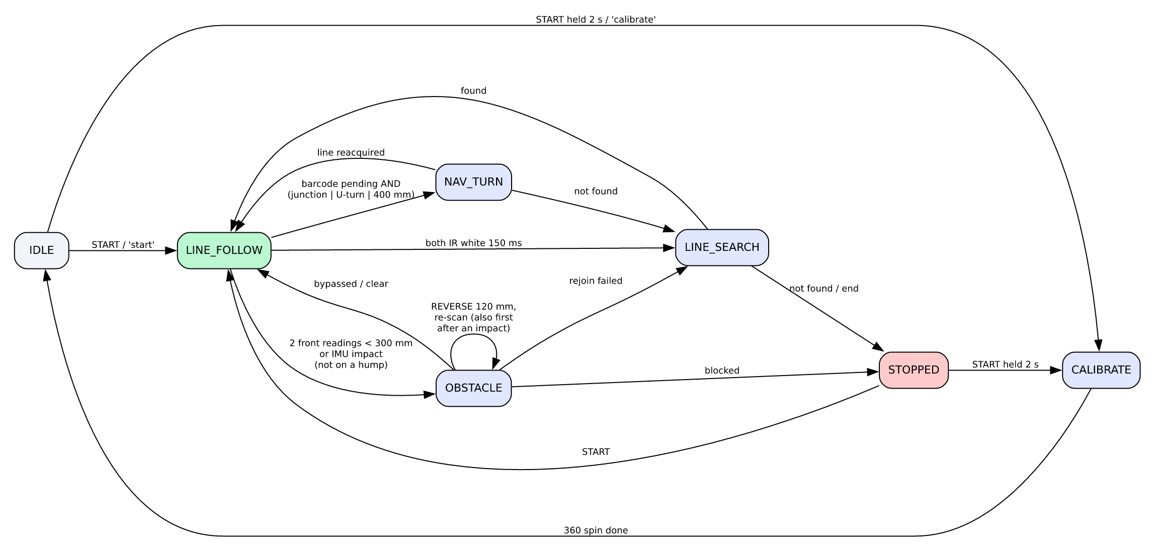
Mission state machine
The vehicle task owns mission state and is the only caller of motion commands during a run, which avoids conflicting commands. Subsystems communicate only through their public APIs. Manoeuvres are sequences of blocking moves, but every wait, and every step of an obstacle scan, polls the STOP button and MQTT stop, so the car can always be halted.
Controls:
- GP20 (START) acts on release, so the car never moves under the user's hand: a short press starts a run; held for 2 s while idle, it runs calibration.
- GP21 (STOP) stops the car and never moves it. Presses are latched by an interrupt, so a short press during a scan is not missed.
- MQTT commands can do the same remotely.
A new run discards barcodes decoded while the car stood still (pushed by hand, or seen during the calibration spin), so they cannot become its first turn.

6. Verification and Evidence
Build verification. All eleven application modes (MISSION, TEST_MOTOR, TEST_MOTION, TEST_WHEELS, TEST_IR, TEST_BARCODE, TEST_IMU, TEST_CRASH, TEST_ULTRASONIC, TEST_OBSTACLE, TEST_TELEMETRY), the UART-console build and the WiFi+MQTT build compile against the template and Pico SDK 2.2.0 with zero warnings (last checked with arm-none-eabi-gcc 15.3.1). Application files are compiled as strict C99 (-std=c99 -Wpedantic) with -Wall -Wextra -Wsign-conversion -Wfloat-equal -Wdouble-promotion -Wshadow (section 8). We also checked in the linked image that both template hooks (cyw43_utk_app_poll, tm_usb_rx_byte) resolve to the application's strong symbols. The disassembly shows the USB service loop calling our tm_usb_rx_byte.
Host unit tests (make -C tests/host): 325/325 pass, including 64 checks of the packed data and binary frames (tests/host/test_data.c). The host build uses the same C99 and warning flags as the firmware, plus -Werror.
Module | What is proven
car_math | sqrt rel. error 1.2e-7, atan2 0.0007°, sin 3.6e-6; whole-turn reduction; a non-finite or huge input gives 0
pid | settles within 5 %, no overshoot on the motor model, integral clamped, a non-finite input gives 0
line_follow | steering sign, LOST/JUNCTION confirmation
barcode_decode | course photo = *A* both directions; 1000/1000 noisy frames
terrain | hump height within 1.3 % (table in §4.4), no false humps
avoidance | width/centre estimates, side choice with a wall, reverse/stop/continue
mqtt_lwip | against a fake lwIP (tests/host/lwip/): no attempt without a network, a 2 s window before a new attempt, online (retained) and the cmd subscription on connect, a message kept while the client is full, commands only from the cmd topic, reconnects counted
mqtt_bridge | ring capacity, drop-when-offline, command path
vehicle + obstacle | the real vehicle.c, obstacle.c and servo.c in a simulation on a fake µT-Kernel (tests/host/sim/, tk/, tm/) with simulated time, buttons, motion, IR, IMU and sonar: START on release and 2 s hold to calibrate, STOP never moves the car, a 6 ms STOP press between polls is latched, speed limited to 300 mm/s; one close echo ignored and two stop the car; the full scan and the diagonal bypass back to the line; reverse before the scan after an impact; triggers ignored on a hump; a STOP or stop ends a scan at the next servo step; a STOP in a line search, U-turn or bypass gives one STOPPED (stop command); stale barcodes discarded at START; the watchdog armed only while the car can move, and the longest time without a feed while armed 101 ms (one ping); four FAULT pings in a row, or 300 ms without a front reading, stop the car; a STOP during a scan ends it while the servo moves or after the current ping, with no further move; the servo never goes past the mount's limits; the pass distance is closest + deepest box + car length + margin, and an obstacle ahead during the pass gives STOPPED (path blocked). Each of these fixes was broken on purpose once to confirm a check fails
command | every command and its limits, spaces and case, rejection of bad counts, negative gains and trailing text; serial line assembly (CRLF, backspace, control bytes, overflow recovery); 3-decimal formatter (including NaN); live line gains surviving re-initialisation

Dashboard. Tested end to end against a Mosquitto broker with sim_car.py, which checked commands, acks, rejected commands, rate changes and CSV logs. The serial path was tested against an emulated USB console on a pseudo-terminal. That test also confirmed the 16-byte write pacing and that the dashboard requests the gains when the port opens.
Hardware tests. Each buddy's APP_MODE test program prints CSV for the tables in section 4. Run them in this order: motor → motion → IR → barcode → IMU → ultrasonic → telemetry → mission. That order matches the briefing's "repeatable subsystem tests, then integrate early". Every run is recorded in testing/*/TEST_LOG.md with its commit, tester, log folder and result.
System and integration results on the final hardware:
Test | What | Result
SYS-01 | full lap of the course | PASS: 4 and 9 Nov, no line left; 72 s lap (video)
SYS-02 | barcode turns LEFT, RIGHT, STRAIGHT, U-TURN at junctions | PASS: 4 of 4, each read on the first pass (10 Nov, videos)
SYS-03 | hump detected and its height reported | PASS: 10 mm hump read 9.8 / 12.2 mm (10 Nov, video)
SYS-04 | obstacle bypassed and line reacquired | PASS: box right, centred and left (9 Nov, videos)
SYS-05 | telemetry over WiFi during runs | PASS: 4 sessions of 9–23 min, connected throughout
INT-02 | STOP from the dashboard | PASS: 9–12 ms on the car to the motors stopped
INT-06 / INT-11 | timing over a full lap | PASS: jitter 1779 µs (limit 2000), load 12 %
INT-07 | encoder counts under full load, 5 min | PASS: no torn or lost counts
INT-09 | Change Requirement 1 RAM saving | PASS: application RAM 6128 → 2359 B (−62 %)
INT-10 | faults (encoder, motor stall, IMU, sonar, WiFi loss) | PASS: each stops the car or, for WiFi, keeps it driving and reports the loss
S1-U03 to U06 | WiFi link 10 min, broker and hotspot outages, no cable | PASS: 4.75 Hz telemetry, recovery 43–62 s

The review-and-test cycle found and fixed eight defects before any hardware run:
- MQTT keepalive starvation.
- Wall-masked obstacle.
- Hump under-estimation.
- The size_t header clash.
- A stale START request restarting the car.
- A test-vector error.
- TEST_MOTOR starting a second motion task on every re-run.
- A gains report after line= that could show the previous values.
The BARR-C conformance pass and the independent review of it found seven more; they are listed in section 8.3.

7. Robustness
- Sensor faults. Missing echoes, I2C timeouts (2 ms per transfer, counted in the heartbeat as i2cerr) and low-contrast calibration are all detected and reported. They never hang a task.
- Motion safety. Every move has a stall timeout and every manoeuvre can be aborted.
- Watchdog. The RP2040 watchdog (WATCHDOG_TIMEOUT_MS, 250 ms, the Week 6 value) guards motion: set_state() arms it in every state that can move the car and stops it in IDLE and STOPPED, the only states in which the WiFi chip may be restarted (that restart stalls the cyw43 task, which runs above the vehicle task). The vehicle task feeds it in every wait, about every 0.1 s at most (the longest gap is one sonar ping, 101 ms in the host simulation), so a stalled task stops the car within 250 ms (A14 asks for 500 ms). The motor outputs go off with the reset, and the first state after boot reports watchdog reset as its reason. usermain() stops the watchdog first thing at start-up.
- Line recovery. A lost line gets an expanding sweep search before the car gives up with a reason.
- Collision. An IMU impact triggers a stop, a reverse, a scan and avoidance.
- Communication. Reconnection uses back-off, the last-will marks the car offline, a heartbeat sequence number reveals lost messages, and telemetry is simply dropped (and counted) when offline, so control is never delayed by the network.
- Real-time. Control runs at higher priority than communication, and interrupt handlers are short.

8. Software Quality — BARR-C:2018 Conformance
All application code (app_program/, 52 files) and the host tests (tests/host/, 5 files) are written to BARR-C:2018. An earlier draft of this report claimed conformance after a style review only. A rule-by-rule audit against the standard showed that the claim did not hold: the checker below reports 1,570 mechanical findings in that earlier code. The code was therefore brought into conformance, and the claim is now backed by tools that anyone can re-run.

8.1 How conformance is checked
Check | What it enforces | BARR-C rules
Compiler: -std=c99 -Wpedantic -Wall -Wextra -Wsign-conversion -Wfloat-equal -Wdouble-promotion -Wshadow (subdir.mk; host tests also -Werror) | C99 only, no signed/unsigned mixing, no float equality, no silent float-to-double promotion, no shadowed names, no unused parameters | 1.1.a, 5.3.c, 5.4.b.iv
app_program/.clang-format (clang-format 18) | 80 columns, braces on their own lines, spacing, type * p_name pointers, aligned declarations and assignments, 4-space indentation, no tabs, return type on its own line with name ( in definitions | 1.2, 1.3, 3.1, 3.2, 3.4, 3.5, Appendix C
tools/barr_layout.py (run by tools/barr_format.sh after clang-format) | break aligned with its case, blank lines around natural blocks, end-of-file comment | 8.3.a, 3.3.b, 3.3.c
tools/barr_check.py (token-based heuristic checker) | every cast commented; operands of logical AND and OR parenthesised; one exit per function; functions ≤ 100 lines; if nesting ≤ 2; else if chains end with else; switch has default; no magic numbers or assignments in loop control; constant on the left of ==; f on float constants; naming (g, p, pp, b, h, ≥ 3 characters, lower case, module prefix, _task); Doxygen @file and @brief; section order; own header included; no /*, // or \ inside comments | 1.4.b, 1.6.a, 1.7, 2.1.b, 2.2.h, 3.3.c, 4.3.b, 4.3.c, 5.2.b, 5.4.b, 6.1, 6.2, 6.4.a, 7.1, 7.2.d, 8.1–8.6
Manual review | comment quality, volatile on every variable shared with an ISR or another task, const parameters, isfinite() after floating-point calculations, header contents, single-owner kernel objects | 1.8, 2.2, 4.2, 5.4.b.v
Project documents | abbreviations table docs/ABBREVIATIONS.md; file templates docs/templates/module.c and module.h | 1.5.b, 4.4.a

To reproduce, from the repository root: sh tools/barr_format.sh --check (clang-format plus barr_layout.py; reports any file whose layout would change), python3 tools/barr_check.py app_program/*.[ch] app_program/*/*.[ch] tests/host/*.[ch] (skips the template-owned files) and make -C tests/host. sh tools/barr_format.sh reformats in place.
Result. tools/barr_check.py on the earlier code and on the delivered code:
Rule | Finding | Before | After
1.6.a | cast without a comment explaining its range | 327 | 0
5.4.b.i | float instead of float32_t | 370 | 0
3.1.j / App. C | definition not written type / name (params) | 229 | 0
7.1.e | name shorter than 3 characters | 185 | 0
2.2.h | file without a Doxygen @file block / function without @brief | 50 / 83 | 0 / 0
4.3.b | public function body after a private one | 90 | 0
6.1.i | public function without the module prefix | 56 | 0 (+3 deviations)
6.2.c | more than one exit, or return not last | 53 | 0
3.3.c | no end-of-file comment | 50 | 0
1.4.b | operand of a logical AND or OR not parenthesised | 45 | 0
7.1.n | kernel handle not named h_ | 8 | 0
8.4.a / 8.4.b | magic number or assignment in loop control | 7 / 1 | 0 / 0
4.3.c | source does not include its own header | 4 | 0
2.1.b, 1.7.d, 7.2.d, 8.2.b, 1.2.a, 5.4.b.iv | other | 12 | 0
 | Total | 1,570 | 0

Beyond these mechanical rules, the pass also marked every variable shared between tasks, or between a task and an interrupt, volatile (1.8.c); gave every lock-free ring a memory barrier on both sides; made every task's private working state explicit (initialised inside the task); added isfinite() checks wherever a floating-point result reaches an actuator, a loop or an integer conversion (5.4.b.v); and split long functions into small single-exit ones. Behaviour is unchanged: all host tests pass and all builds are warning-free.

8.2 Deviations
Rule | Where | Why | Mitigation
1.1.a (C99) | hal.c is compiled as GNU C11 | it includes the Pico SDK hardware headers, which use static_assert and anonymous unions | hal.c is the only file that includes SDK headers, and its own code is C99; every other file is compiled with -std=c99 -Wpedantic
6.1.i (module prefix) | usermain(), tm_usb_rx_byte(), cyw43_utk_app_poll() | the kernel's entry point and the template's two weak hooks fix these names | a NOTE in each header; the checker reports them separately
5.2.a, 7.1 (types and names in kernel signatures) | task entries (INT stacd, void * p_exinf), interrupt handlers (UINT intno), kernel types ID, ER, UB, UINT | the µT-Kernel API defines these | kernel types appear only at kernel calls; application data uses stdint.h types
6.5.a (interrupt keyword) | handlers registered with tk_def_int() | on the Cortex-M0+ the hardware stacks the caller-saved registers, so an ordinary AAPCS function is a valid handler, and the kernel's TA_HLNG wrapper calls it | handlers are named *_isr, are static and sit at the end of their module (6.5.b, 6.5.c)
5.4.a (avoid floating point) | motion, line following, IMU, terrain and obstacle geometry use float32_t | trigonometry, PID and filter maths are clearer and less error-prone in floating point, and the soft-float work runs only in the 50 Hz tasks, well within the CPU budget (section 2.3) | float32_t only, f suffixes, no equality tests, isfinite() checks; the 1 kHz sampler ISR is integer-only
1.6.a (cast comment) | (void) casts that discard a return value | they convert no value; the deliberate discard is the documentation | every value-converting cast in the application (167, found with the checker's cast detector) has a comment
2.2.a (complete sentences) | end-of-line comments on #defines and structure members | they label units and ranges (/* mm/s per percent duty */), which a sentence would not make clearer | block comments are full sentences
scope | template files: kernel, libraries, demo_tasks.c/.h, usb_console_compat.h and the six patched template files | not our code; reformatting them would bury the real changes in the template patch | our hunks in the patched files follow the template's own style
scope | tests/host/lwip/, the fake lwIP for the host test of mqtt_lwip.c | it must copy lwIP's own names and types | the test that drives it (test_main.c) is checked
scope | tests/host/tk/, tm/ and sim/, the fake µT-Kernel and the vehicle simulation | they copy the kernel's names and types, and sim/vehicle_sim.c includes vehicle.c to run its loop | the tests that drive them (test_main.c) are checked

8.3 Latent defects found by the conformance pass
- hal_alarm_ack_rearm() decided whether the next alarm time was already in the past by casting a uint32_t difference to int32_t, which is implementation-defined for large values (Rules 1.6, 5.3). It now uses a wrap-safe unsigned comparison.
- The motion task converted the stall-timeout to uint32_t from a float; a non-finite or huge move distance made that conversion undefined. The value is now checked with isfinite() and clamped, and a move with a non-finite goal or speed becomes a stop.
- car_math_sin() and wrap180() in imu.c reduced the angle by repeated subtraction of a full turn. That never ends for an infinite angle, or for a very large one, where subtracting 2π no longer changes a float. Both now check isfinite() and a range limit, and remove whole turns in one step (new host tests).
- The motion status was written field by field while other tasks copied it. On the template's dual-core profile, a reader on the other core could see half of one control cycle and half of the next. The control task now works on a private copy, publishes it in one short DI/EI section, and publishes b_last_ok before waking a task waiting for the move.
- The IR sampler's barcode ring had no memory barriers, which the template's dual-core profile needs; both sides now have them.
A separate reviewer then compared every rewritten module with the earlier code, function by function. It found no change in behaviour beyond the fixes above and integer rounding (instead of truncation) in printed values, and it found two more defects, which are now fixed:
- Spurious obstacle stop at the start of a run. imu_reset_run() clears the IMU's impact counter one IMU cycle later, but the vehicle task treated any change of the counter as a new impact. On a second run, or after a bump while idle, the car stopped and scanned as soon as it started. Only an increase now counts as an impact, and a decrease is taken as the reset; the telemetry impact event uses the same rule.
- Failure paths. A move with a non-finite distance now reports MOTION_WAIT_FAIL instead of the previous move's result, and hal_irq_gpio_attach() enables a registered pin's edge interrupt even if defining the shared bank handler failed on the first attempt (a later attach retries it).
Pure algorithm modules contain no RTOS calls, which is why they can be unit-tested on a PC.

9. Limitations and Future Work
- Barcode at running height. The barcode sensor sits high enough that narrow bars barely change its reading. Reads at 75 mm/s are reliable on the course (SYS-02 4 of 4), but faster runs and worn codes miss more frames.
- Obstacle width. The sonar beam makes small boxes read 100–120 mm too wide (S5-U07). The bypass uses this as margin and the centre is accurate, so the side choice is unaffected.
- Sonar fault shown as an IMU fault. The IMU (GP4/5) and the sonar (GP6/7) share a connector area; pulling a sonar wire at the board also disturbs the IMU's I2C link, so the car stops on fault: IMU first (S5-U12, 10 Nov). It always stops; the sonar's own fault was shown on 30 Oct and 4 Nov. A rerun unplugging at the sensor end is planned.
- Encoders have no direction channel, so direction is inferred from the commanded sign. A wheel pushed backwards by an external force is counted as forward.
- - The scan covers ±40°. Free space beyond it is assumed (A10), and the obstacle's depth is not measured: the pass assumes at most OBST_DEPTH_MAX_MM (150 mm, the course's boxes). A deeper obstacle would be clipped when the car turns back to the line.
- A low-mounted sonar can still see a hump's face before the car tilts (assumption A12). Log the front range while approaching the course hump; on the course it stayed above the 200 mm trigger (S5-U10).
- Tuned gains are held in RAM only and must be copied into car_config.h. Saving them to flash would need the template's core-parking protocol, which it does not provide.
- MQTT commands are not authenticated beyond the broker login. Anyone who can publish to the broker can stop or start the car, so use a private network or set MQTT_USERNAME/MQTT_PASSWORD with a Mosquitto password file.
- The firmware needs the qualified single-core kernel profile. Status snapshots are copied with interrupts disabled, which is atomic only on one core (assumption A13), so app_main.c stops an SMP=1 build with a compile error. Dual-core operation would need spinlock-protected copies.

10. Demonstration Plan
- Show the boot log: each subsystem prints [init] … OK.
- Run calibration and show the IR contrast.
- Open the dashboard (--mqtt <broker>). Show the status turning online, the heartbeat, and a live speed= change acknowledged by the car.
- Run the full course while the dashboard shows barcode events, the hump peak and the obstacle profile. Save PNG at the end and show the logged CSV.
- Demonstrate recovery: restart the broker (the car reconnects) and lift the car off the line (the car searches).
- Present the evidence tables and unit-test output.

Appendix A — Build and Flash
Our repository holds only our side of the project. setup.sh fetches the course template at the commit our changes were made against (2e8e6ad), applies docs/template_changes.patch, links app_program/ into it, and fetches Pico SDK 2.2.0; both land in git-ignored folders (template/, sdk/).
sh setup.sh # once
gmake -C template/build_make -j8 APP_MODE=TEST_IMU CONSOLE=usb_cdc # one subsystem
cd template/config
cp wifi_credentials.example.h wifi_credentials.h # edit
cp mqtt_config.example.h mqtt_config.h # edit
cd ../..
gmake -C template/build_make -j8 CONSOLE=uart WIFI=cyw43 WIFI_JOIN=1 \
WIFI_NETIF=1 WIFI_DHCP=1 WIFI_DNS=1 WIFI_MQTT=1 # full mission
gmake is GNU make 4; on Linux plain make is the same. macOS's own make (3.81) picks the wrong build rule for the USB console, so install GNU make there.
To flash, hold BOOTSEL, plug in the USB cable, and copy the .uf2 file (built in template/build_make/, firmware is built locally and is not kept in the repository) to the RPI-RP2 drive. The console runs at 115200 baud on the USB port (CONSOLE=usb_cdc) or on GP0/GP1. Type help on it for the command list.
Dashboard (see tools/dashboard/README.md):
pip install -r tools/dashboard/requirements.txt
python tools/dashboard/picocar_dashboard.py --serial auto # USB cable
python tools/dashboard/picocar_dashboard.py --mqtt 192.168.1.100 # WiFi build
python tools/dashboard/sim_car.py --mqtt localhost --autostart # no car

Appendix B — Template Changes
Template files are named by their path inside the template (template/ after setup.sh); the others are in our repository.
File | Change
app_program/* | PicoCar application (replaces the demo app_main.c; demo_tasks.c blink kept)
build_make/mtkernel_3/app_program/subdir.mk | Pico SDK include paths, APP_MODE, WIFI_MQTT (also compiles lwIP's apps/mqtt/mqtt.c), strict C99 and extra warnings for application files (section 8), stale-object guard
config/config_device.h | DEVCNF_USE_ADC 0, DEVCNF_USE_IIC 0 (application owns ADC and I2C0)
lib/libnet/lwip/include/lwipopts.h | LWIP_TCP also enabled by TM_WIFI_MQTT; for lwIP's MQTT client, one more timer (MEMP_NUM_SYS_TIMEOUT) and a 1 KB output buffer (MQTT_OUTPUT_RINGBUF_SIZE)
lib/libwifi/sysdepend/pico_rp2040/cyw43_utk.c | weak cyw43_utk_app_poll() hook called in the service loop
lib/libtm/sysdepend/pico_rp2040/usb/usb_tinyusb_glue.c | received USB bytes go to a weak tm_usb_rx_byte() hook instead of being discarded (the default still discards)
.gitignore | also ignores config/mqtt_config.h
tools/dashboard/* | laptop dashboard, car simulator (new, not part of the firmware)
app_program/.clang-format, tests/host/.clang-format, tools/barr_format.sh, tools/barr_layout.py, tools/barr_check.py | BARR-C layout and checks (new)
docs/ABBREVIATIONS.md, docs/templates/ | BARR-C abbreviations table and file templates (new)
config/mqtt_config.example.h | broker address, car ID, keepalive

