Design Review

Submission Detail | Student Entry
GROUP ID

Purpose
Document the system requirements, hardware connections, RTOS task structure, behavioural models, assumptions, and AI-supported design reasoning before major implementation. Treat this Week 6 submission as an architecture freeze before full integration and Tribunal 1. The design may change later, but major changes must be justified with engineering evidence.

How to use this template
- This is an architecture-freeze document. The team may improve the design later, but major changes must be justified during Tribunal 1.
- Use AI assistants for ideation, critique, and gap checking. Do not paste AI output directly as the final design.
- Summarise, challenge, correct, and justify AI suggestions using engineering reasoning.
- Keep all artefacts consistent: requirements, pin layout, RTOS task table, task interaction diagram, statecharts, assumptions, and AI evidence.

Team Role and Subsystem Ownership
Identify each buddy’s primary subsystem responsibility. The role does not need to match the examples exactly, but every major hardware and software responsibility should have a clear owner.
Buddy | Student ID | Primary subsystem / responsibility
Buddy 1 |  | Communications and telemetry. Wi-Fi join and our MQTT 3.1.1 client over lwIP (mqtt_lwip.c, mqtt_codec.c, mqtt_bridge.c), telemetry / event / heartbeat publishing, command parser and live tuning (command.c, telemetry.c, console_in.c), laptop dashboard.
Buddy 2 |  | Motion and timing-critical outputs. Motor PWM driver, wheel encoders (edge ISR), per-wheel speed PID with feed-forward, distance and turn moves on a 20 ms cyclic control loop (motor.c, encoder.c, pid.c, motion.c).
Buddy 3 |  | Perception: line and barcode. Three IR sensors on the ADC, 1 kHz sampler ISR and calibration (ir_sensor.c), line-following PID and line classifier (line_follow.c), Code 39 barcode capture and decoding (barcode.c, barcode_decode.c).
Buddy 4 |  | Environmental sensing and safety. LSM303DLHC accelerometer / magnetometer over I2C (imu.c): pitch, heading, turn rate, hump detection with peak height (terrain.c), impact (collision) detection and motion events.
Buddy 5 |  | Obstacle handling and system integration. HC-SR04 on a servo (ultrasonic.c, servo.c, obstacle.c), obstacle profiling and avoidance planning (avoidance.c), the mission state machine (vehicle.c) and integration of all subsystems.

Submission Instructions
- Complete every required section.
- Diagrams may be produced using any suitable tool, but labels must remain readable when inserted into this document.
- AI assistants may support drafting. The team remains responsible for technical correctness, consistency, and the ability to explain every decision.
- Use consistent names across the requirements, hardware sketch, task table, task interaction diagram, and statecharts.

1. Requirements
State what the system must do and the important quality or timing constraints. Requirements should be specific, testable, and traceable to the proposed design (you may add more FR and/or NFR as needed).

1.1 Functional Requirements
ID | Requirement
FR1 | The car shall follow an 18 mm black line using two analog IR sensors and a PID steering controller (Buddy 3, vehicle state LINE_FOLLOW).
FR2 | The car shall detect loss of the line (both sensors on white for ≥ 150 ms), search for it with up to 5 growing sweeps towards the side it was last seen, and stop with a reason if it is not found.
FR3 | The car shall read Code 39 barcodes (*A* to *D*) placed beside the line in either direction of travel and execute A = left, B = right, C = straight, D = U-turn at the next junction (U-turn at once; after 400 mm if no junction appears).
FR4 | The car shall drive a set distance and turn a set angle using the wheel encoders and closed-loop wheel-speed control (move forward / backward, turn left / right, stop).
FR5 | The car shall detect humps from the IMU pitch and report the number of humps and the peak height of each hump and of the whole run.
FR6 | The car shall detect impacts (collisions) from the accelerometer and classify its motion as stationary, cruising, accelerating, decelerating, turning, climbing, descending or impact.
FR7 | The car shall detect an obstacle ahead (closer than 300 mm), stop, scan it with the servo-mounted ultrasonic sensor (coarse 30–150°, then fine ±20° in 5° steps) and estimate its edges and the free space on each side.
FR8 | The car shall handle the obstacle by reversing and re-scanning, bypassing it on the side that needs the smaller sideways offset, or stopping if both sides are blocked, and shall then rejoin the line.
FR9 | The car shall publish telemetry over Wi-Fi / MQTT at 5 Hz (state, wheel speeds, IR levels, pitch, heading, hump, obstacle, barcode), events when they happen, and a 1 Hz heartbeat with link statistics.
FR10 | The car shall accept start, stop, calibrate and tuning commands (speed=, pid=, ff=, line=, rate=) from MQTT, USB or UART, and acknowledge every command.
FR11 | The car shall reconnect to the Wi-Fi broker automatically after a TCP or MQTT failure, without interrupting driving.
FR12 | The car shall provide START (GP20) and STOP (GP21) buttons; STOP shall brake the motors from any running state.
FR13 | The car shall provide a calibration routine (a 360° spin) that records the IR white / black levels and the magnetometer offsets.

1.2 Non-Functional Requirements
ID | Requirement
NFR1 | Wheel-speed control shall run every 20 ms (50 Hz), woken by a kernel cyclic handler; cycle-to-cycle jitter shall stay below 2 ms (to be measured, see A2).
NFR2 | The IR sensors shall be sampled at 1 kHz by a hardware-timer ISR, so a 3 mm narrow bar at cruise speed (180 mm/s, about 17 ms) gives at least 10 samples.
NFR3 | A STOP from a button, the console or MQTT shall brake the motors within 100 ms of reaching the car while driving (budget: 20 ms command poll + 20 ms vehicle loop + 20 ms control period = 60 ms).
NFR4 | Line loss shall be confirmed only after 150 ms and a junction only after 10 mm of travel, so one noisy sample or a short gap cannot trigger an action.
NFR5 | An obstacle shall be detected at 300 mm or more; the front range is measured every 70 ms (the HC-SR04 needs at least 60 ms between pings) and each ping times out after 40 ms.
NFR6 | The IMU shall be read every 20 ms over I2C0 at 400 kHz; hump peak height shall be within ±5 mm of a ruler measurement.
NFR7 | Motion accuracy: straight moves within ±2 % of the distance (±10 mm over 500 mm) and 90° turns within ±5° on the course surface.
NFR8 | Only the cyw43 task shall call lwIP. The MQTT client shall time out CONNECT and CONNACK after 5 s, retry with 1, 2, 4, 8 s back-off, send PINGREQ every 15 s and drop a link silent for 45 s. A network stall shall never block a driving task.
NFR9 | No task shall wait forever on hardware: encoder timeout 200 ms (wheel stopped), echo timeout 40 ms, motion moves fail after 3 × the ideal time + 1 s, and the vehicle task gives up on a move after 10 s.
NFR10 | All application code shall be C99 and conform to BARR-C:2018 (tools/barr_check.py reports 0 findings; deviations are documented) and build with zero warnings under -Wall -Wextra -Wpedantic -Wsign-conversion -Wshadow.
NFR11 | The firmware shall fit the RP2040 with static allocation only (no malloc in application code): the Wi-Fi build uses about 357 KB of flash and 58 KB of RAM (arm-none-eabi-size).

2. Hardware Integration Pin Layout
Sketch how sensors, actuators, displays, communication modules, and power connections interface with the Robo Pico. Label pins and interfaces such as GPIO, ADC, PWM, I2C, SPI, and UART.

Device / Module | Type | Signal Name | Sensor label | Pico GPIO Pin | Interface | Notes / RTOS Task Owner
Left motor (M1) | Actuator | MOTOR_L_A / MOTOR_L_B | M1A / M1B | GP8 / GP9 | PWM (10 kHz) | Owned only by the motion task (priority 5). A = PWM, B = 0 drives forward; both low brakes.
Right motor (M2) | Actuator | MOTOR_R_A / MOTOR_R_B | M2A / M2B | GP10 / GP11 | PWM (10 kHz) | Owned only by the motion task. MOTOR_x_INVERT in car_config.h fixes a reversed wire.
Left wheel encoder | Sensor | ENCODER_L | D0 | GP2 | GPIO interrupt | encoder_edge_isr counts edges (300 µs glitch filter) and time-stamps them; the motion task reads the counts.
Right wheel encoder | Sensor | ENCODER_R | D0 | GP3 | GPIO interrupt | As above. Single channel: direction comes from the commanded motor direction.
IR sensor, left | Sensor | IR_LEFT | A0 | GP26 | ADC0 | Sampled at 1 kHz by ir_sample_isr (TIMER3 alarm); the vehicle task reads the snapshot for the line PID.
IR sensor, right | Sensor | IR_RIGHT | A0 | GP27 | ADC1 | As above. The two sensors straddle the 18 mm line edges.
IR sensor, barcode | Sensor | IR_BARCODE | A0 | GP28 | ADC2 | Mounted about 45–50 mm to the barcode side; the ISR times bar / space widths into a ring for the barcode task (priority 7).
GY-511 IMU (LSM303DLHC) | Sensor | IMU_SDA | SDA | GP4 | I2C0 (400 kHz) | The imu task (priority 8) is the only I2C0 user; the kernel's own I2C driver is disabled. Accel 0x19, mag 0x1E.
GY-511 IMU (LSM303DLHC) | Sensor | IMU_SCL | SCL | GP5 | I2C0 | Clock line of the same bus.
HC-SR04 ultrasonic | Sensor | US_TRIG | TRIG | GP6 | GPIO output | 10 µs trigger pulse. A semaphore lets only one task ping at a time (obstacle monitor or vehicle scans).
HC-SR04 ultrasonic | Sensor | US_ECHO | ECHO | GP7 | GPIO interrupt | echo_edge_isr times the pulse and sets an event flag. Powered from 3.3 V as in the course slide (a 5 V module would need a divider).
Servo (sonar mount) | Actuator | SERVO | SIG | GP12 | PWM (50 Hz) | 90° = straight ahead. Moved by obstacle.c functions running in the vehicle task during scans and bypasses.
START / STOP buttons | User input | BTN_START / BTN_STOP | On-board | GP20 / GP21 | GPIO input, pull-up | Polled by the vehicle task every 20 ms (press = low).
Liveness LED | Indicator | BOARD_LED | On-board | GP16 | GPIO output | Template blink task (priority 10).
Console UART0 | Comms | UART0_TX / UART0_RX | TX / RX | GP0 / GP1 | UART | Template console (tm_printf); the telemetry task polls the RX FIFO for commands.
USB console | Comms | USB CDC | Micro-USB | USB | USB CDC | Template usb task (priority 3); received bytes go through a ring to the telemetry task.
CYW43439 Wi-Fi (on Pico W) | Comms | WL_ON, WL_D, WL_CS, WL_CLK | Internal | GP23 / 24 / 25 / 29 | SPI (PIO) | Template cyw43 task (priority 4) runs lwIP and our MQTT client. These pins are reserved.
Battery | Power | VIN | + / − | VIN terminal | Power | 3.6–6 V into the Robo Pico; all modules share one ground; sensors on 3V3.

3. RTOS Task Table
List the proposed RTOS tasks. Priorities are preliminary at Week 6 and must be justified.
Task | Purpose | Inputs | Outputs | Trigger | Priority
control cyclic handler (kernel) | Wake the motion task on time | Kernel tick (10 ms) | tk_wup_tsk(motion) | Every 20 ms | Handler (above all tasks)
ir_sample_isr (TIMER3 alarm) | Sample the 3 IR channels; time barcode bars and spaces | ADC GP26–28 | IR snapshot; width ring (64 entries) | Hardware alarm, 1 kHz | ISR (level 2)
encoder_edge_isr (IO_BANK0) | Count wheel edges and time-stamp them | GP2 / GP3 edges | Edge counts and periods | Each encoder edge | ISR (level 2)
echo_edge_isr (IO_BANK0) | Time the ultrasonic echo pulse | GP7 edges | Echo width; echo event flag | Each echo edge | ISR (level 2)
usb (template) | TinyUSB device and USB console | USB bus | Console bytes (ring) | Event / periodic | 3
cyw43 (template) | Wi-Fi driver, lwIP and our MQTT client | TX ring, radio | MQTT packets; command ring; link state | Polls every 2 ms | 4
motion | Wheel-speed PID, distance and turn moves | Encoder counts; motion requests | Motor PWM; motion status; done flag | Woken every 20 ms | 5
vehicle | Mission state machine, line PID, navigation, obstacle handling | IR snapshot; barcode messages; IMU and obstacle status; buttons; vehicle commands | Motion requests; servo; vehicle status | Periodic, 20 ms | 6
barcode | Assemble frames and decode Code 39 | Width ring | Navigation command (message buffer); stats | Periodic, 10 ms | 7
imu | Pitch, heading, humps, impacts, motion events | I2C0 accel / mag; motion status | IMU status snapshot | Periodic, 20 ms | 8
obstacle (monitor) | Measure the front range while the servo is centred | HC-SR04 (via semaphore) | Front distance snapshot | Periodic, 70 ms | 9
telemetry | Command executor; telemetry, events, heartbeat | Console ring; command ring; all status snapshots | Vehicle commands; gains; TX ring; console text | Periodic, 20 ms | 10
blink (template) | Liveness LED | – | GP16 | Periodic | 10
app_tests (test builds only) | Per-buddy test programs (TEST_MOTOR … TEST_TELEMETRY) | Console | Console logs | Once at start | 11

Priority and ownership justification:
Priorities follow deadlines and consequences (lower number = higher priority in µT-Kernel):
- ISRs and the cyclic handler run above every task but only record data (counts, time stamps, ring entries) or signal a task; they never block, so their cost is a few microseconds.
- motion (5) has the hardest deadline: a late 20 ms PID cycle makes the wheels surge, and it is the only task that drives the motors, so every stop ends here.
- vehicle (6) makes the 20 ms driving decisions (line PID, line loss, junctions, obstacles) and issues motion requests, so it sits directly below motion.
- barcode (7) runs every 10 ms but is below vehicle: the time-critical edge timing is already done in the ISR, and the 64-entry ring holds more than two whole barcodes (29 elements each), so the task can be late by over 100 ms without losing data.
- imu (8) is soft real-time: hump integration uses the actual distance travelled between samples, so a late sample costs accuracy only slightly.
- obstacle (9) is limited by the sensor (≥ 60 ms between pings); a 70 ms period is enough to see a box at 300 mm at 180 mm/s (about 1.7 s away).
- telemetry (10) is human-facing and has the loosest deadline; its queues drop and count messages rather than block anything.
- usb (3) and cyw43 (4) keep the template's priorities because the template's USB and Wi-Fi drivers depend on them. cyw43 above motion is a known risk that must be measured (A2, gap check).
Ownership rule: each peripheral has one owner — motors: motion; IR ADC: ir_sample_isr; I2C0: imu; network: cyw43. The ultrasonic sensor is the only shared device (obstacle monitor and vehicle scans) and is protected by a semaphore; the monitor only pings while the servo is centred.

4. Task Interaction Diagram
Show RTOS tasks, queues, semaphores, mutexes, event groups, notifications, and data flow. Clearly distinguish software tasks from hardware devices and interrupt service routines.
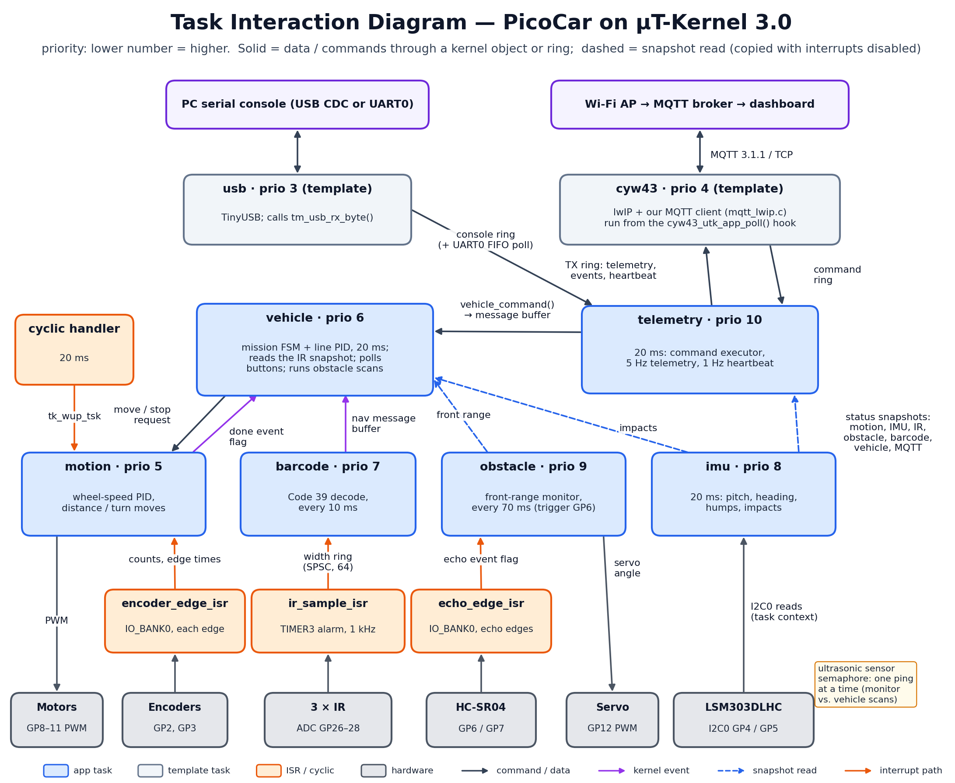

Brief explanation of the main communication paths:
- Sensor → ISR → task. Hardware interrupts only record data: ir_sample_isr writes the latest IR levels (snapshot) and pushes bar / space widths into a 64-entry single-producer / single-consumer ring (with memory barriers) for the barcode task; encoder_edge_isr updates counts read by motion; echo_edge_isr sets an event flag the pinging task waits on with a 40 ms timeout.
- Control loop. A 20 ms kernel cyclic handler wakes the motion task with tk_wup_tsk. The vehicle task posts move / velocity / stop requests (copied with interrupts disabled; the newest request wins) and waits for completion on the motion “done” event flag with a timeout (motion_wait).
- Barcode to navigation. The barcode task decodes a frame and sends the command (LEFT / RIGHT / STRAIGHT / U-TURN) through a 4-message message buffer; the vehicle task polls it without blocking and executes it at the next junction.
- Status snapshots (dashed lines). Each producer (motion, imu, obstacle monitor, ir_sample_isr, vehicle, MQTT bridge) keeps its status in a struct that readers copy with interrupts briefly disabled, so readers always get a consistent copy and no task blocks on another.
- Commands in. Console bytes (USB ring filled by the template's usb task, or the UART0 FIFO) and MQTT commands (command ring filled by the cyw43 task) are parsed by the telemetry task, which forwards start / stop / calibrate / speed to the vehicle task through a message buffer (non-blocking send) and applies tuning gains.
- Telemetry out. The telemetry task formats JSON and puts it in a 6-slot TX ring; the cyw43 task publishes it. If the ring is full or the link is down the message is dropped and counted in the heartbeat, so a network problem never delays driving.
- Shared sensor. A counting semaphore makes the ultrasonic sensor single-user and enforces the 60 ms gap between pings for the obstacle monitor and the vehicle task's scans.

5. System-Level Statechart
Model the operating states of the entire system. Label transition events or conditions. Include relevant fault, stop, or recovery behaviour.
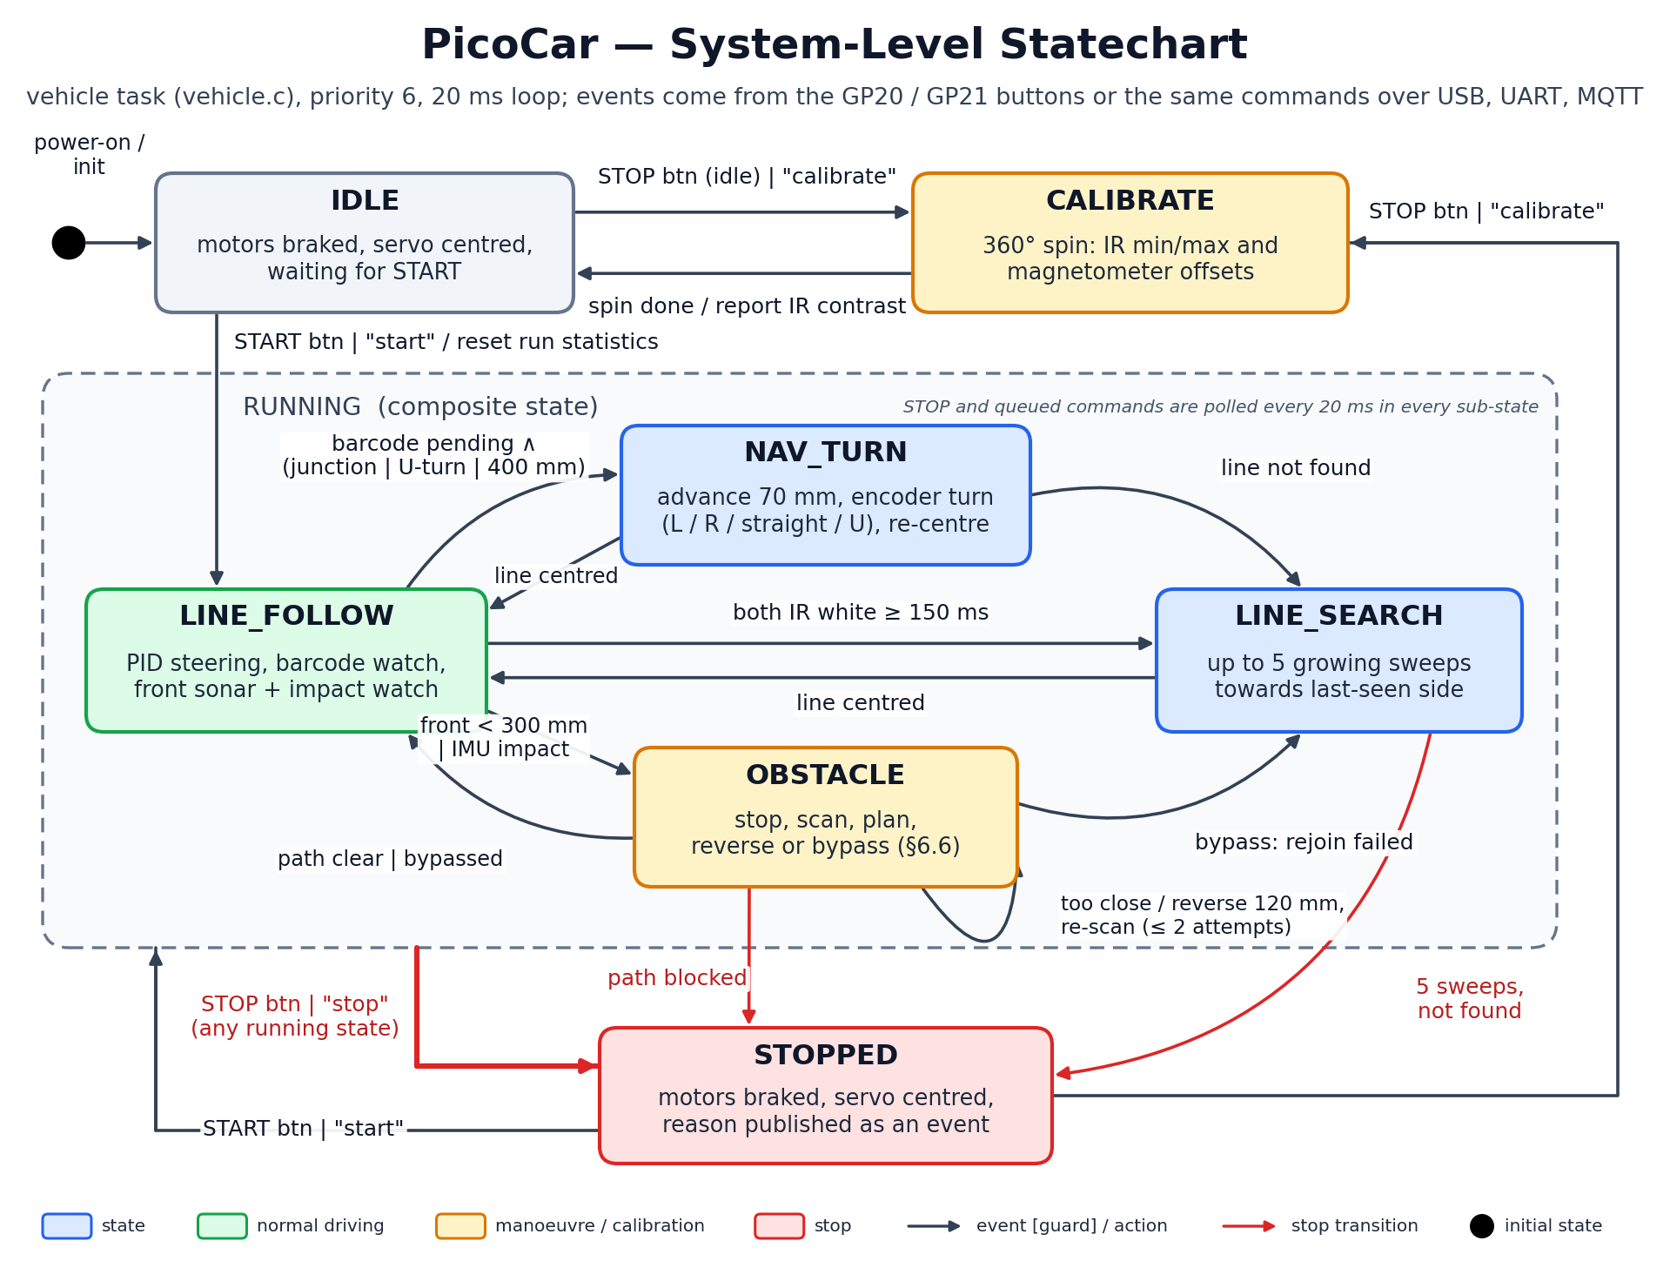

Explain the main states and any important assumptions:
The system states belong to the vehicle task (vehicle.c), which runs every 20 ms and checks the buttons and queued commands in every state.
- IDLE — after power-on: motors braked, servo centred. START (button or “start”) resets the run statistics (humps, obstacles, impacts) and enters RUNNING at LINE_FOLLOW. STOP while idle, or “calibrate”, enters CALIBRATE.
- CALIBRATE — a slow 360° spin that records the IR minimum / maximum and the magnetometer offsets, then returns to IDLE and reports the IR contrast.
- RUNNING (composite):
- LINE_FOLLOW — PID steering on the two IR sensors while watching for barcodes, the front range (< 300 mm) and IMU impacts.
- NAV_TURN — entered when a barcode command is pending and a junction is reached (or at once for a U-turn, or after 400 mm with no junction): advance 70 mm so the wheels are on the junction, turn by encoder, then re-centre on the line.
- LINE_SEARCH — both sensors white for 150 ms: up to 5 growing sweeps towards the side the line was last seen.
- OBSTACLE — stop, scan, plan, then reverse and re-scan (at most 2 times), bypass, or give up (detailed in 6.6).
- STOPPED — the fault / stop state: motors braked, servo centred, and the reason (“stop command”, “path blocked”, “line not found”, a failed move) published as an event. START resumes at LINE_FOLLOW; “calibrate” goes to CALIBRATE.
Assumptions: the car starts on the line; a junction is a place where both IR sensors see black for ≥ 10 mm; barcodes are read while line following; every move has a timeout, so no state can hang waiting for the motors. STOP is honoured within one loop in every state except during an obstacle scan, when the motors are already braked (see gap check).

6. Subsystem Statecharts

Add more sub-systems if needed.

6.1 Subsystem Statechart 1 — MQTT Connection (Buddy 1)
Field | Student Entry
Subsystem name | MQTT connection manager (mqtt_lwip.c)
Related RTOS task(s) | cyw43 template task (priority 4) through the cyw43_utk_app_poll() hook; telemetry task (priority 10) through the TX / command rings
Purpose | Keep one MQTT 3.1.1 session to the laptop broker alive, publish queued telemetry, and deliver commands, recovering by itself from Wi-Fi, TCP or broker failures (FR9–FR11, NFR8).
Reason a statechart is needed | The client is event-driven (lwIP callbacks) and has timeouts and retries; a statechart makes each failure path and its recovery explicit so no state can hang and the dashboard can show the link state.

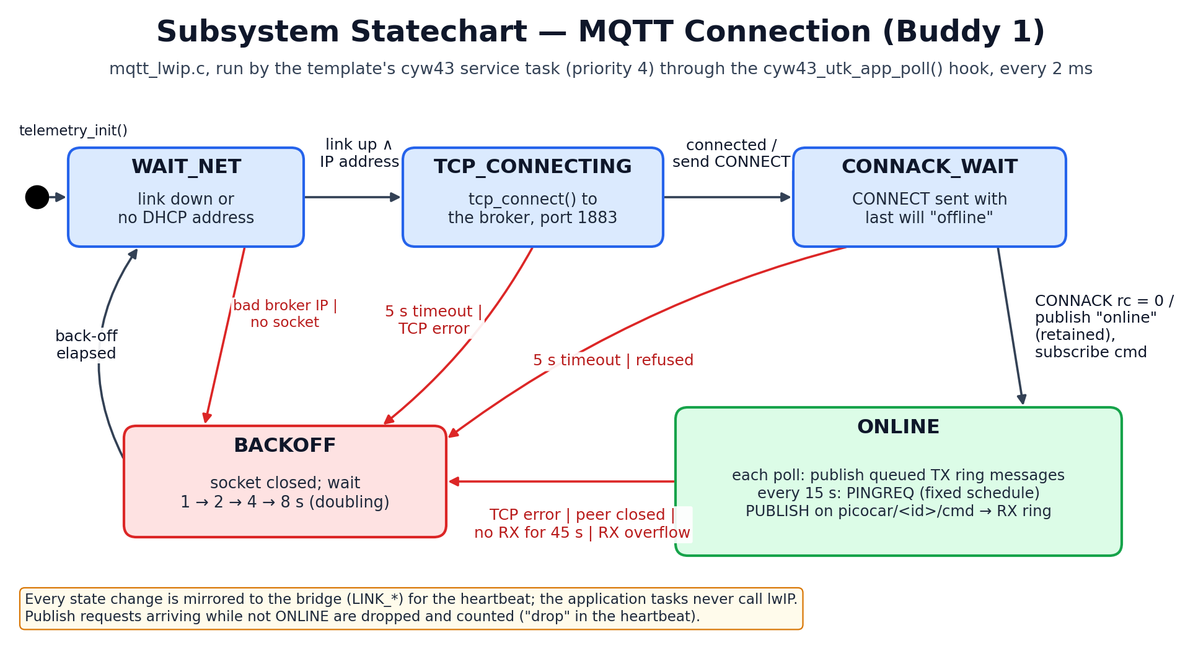
Brief explanation of states, events, and fault handling:
- WAIT_NET — no link or no DHCP address; nothing is sent. When the link is up with an address the client opens a TCP connection (TCP_CONNECTING).
- CONNACK_WAIT — CONNECT has been sent with the last will “offline” (retained). CONNACK rc = 0 leads to ONLINE: publish “online” (retained) and subscribe to picocar/<id>/cmd.
- ONLINE — each poll (every 2 ms) publishes what is waiting in the TX ring; a PINGREQ goes out every 15 s on a fixed schedule; incoming PUBLISH on the command topic goes into the command ring for the telemetry task.
- Faults — a bad broker address, a 5 s TCP or CONNACK timeout, a refused CONNACK, a TCP error, the peer closing, no data received for 45 s, or a receive overflow all close the socket and go to BACKOFF, which waits 1, 2, 4, then 8 s before trying again.
Every state change is mirrored into the bridge (LINK_*), so the heartbeat reports the link state and reconnect count. Messages published while not ONLINE are dropped and counted; driving never waits for the network.

6.2 Subsystem Statechart 2 — Motion Controller (Buddy 2)
Field | Student Entry
Subsystem name | Motion controller (motion.c with pid.c, motor.c, encoder.c)
Related RTOS task(s) | motion task (priority 5), woken every 20 ms by a kernel cyclic handler; requests come from the vehicle task (and the test programs)
Purpose | Turn distance, angle and speed requests into wheel PWM using per-wheel speed PID with feed-forward, and report when a move is done or has failed (FR4, NFR1, NFR7, NFR9).
Reason a statechart is needed | The controller behaves differently by mode (idle, velocity, open loop, moving with ramp-down) and must end every move in a defined way (done, stopped or failed); a statechart shows each mode, the completion rules and the stall timeout.

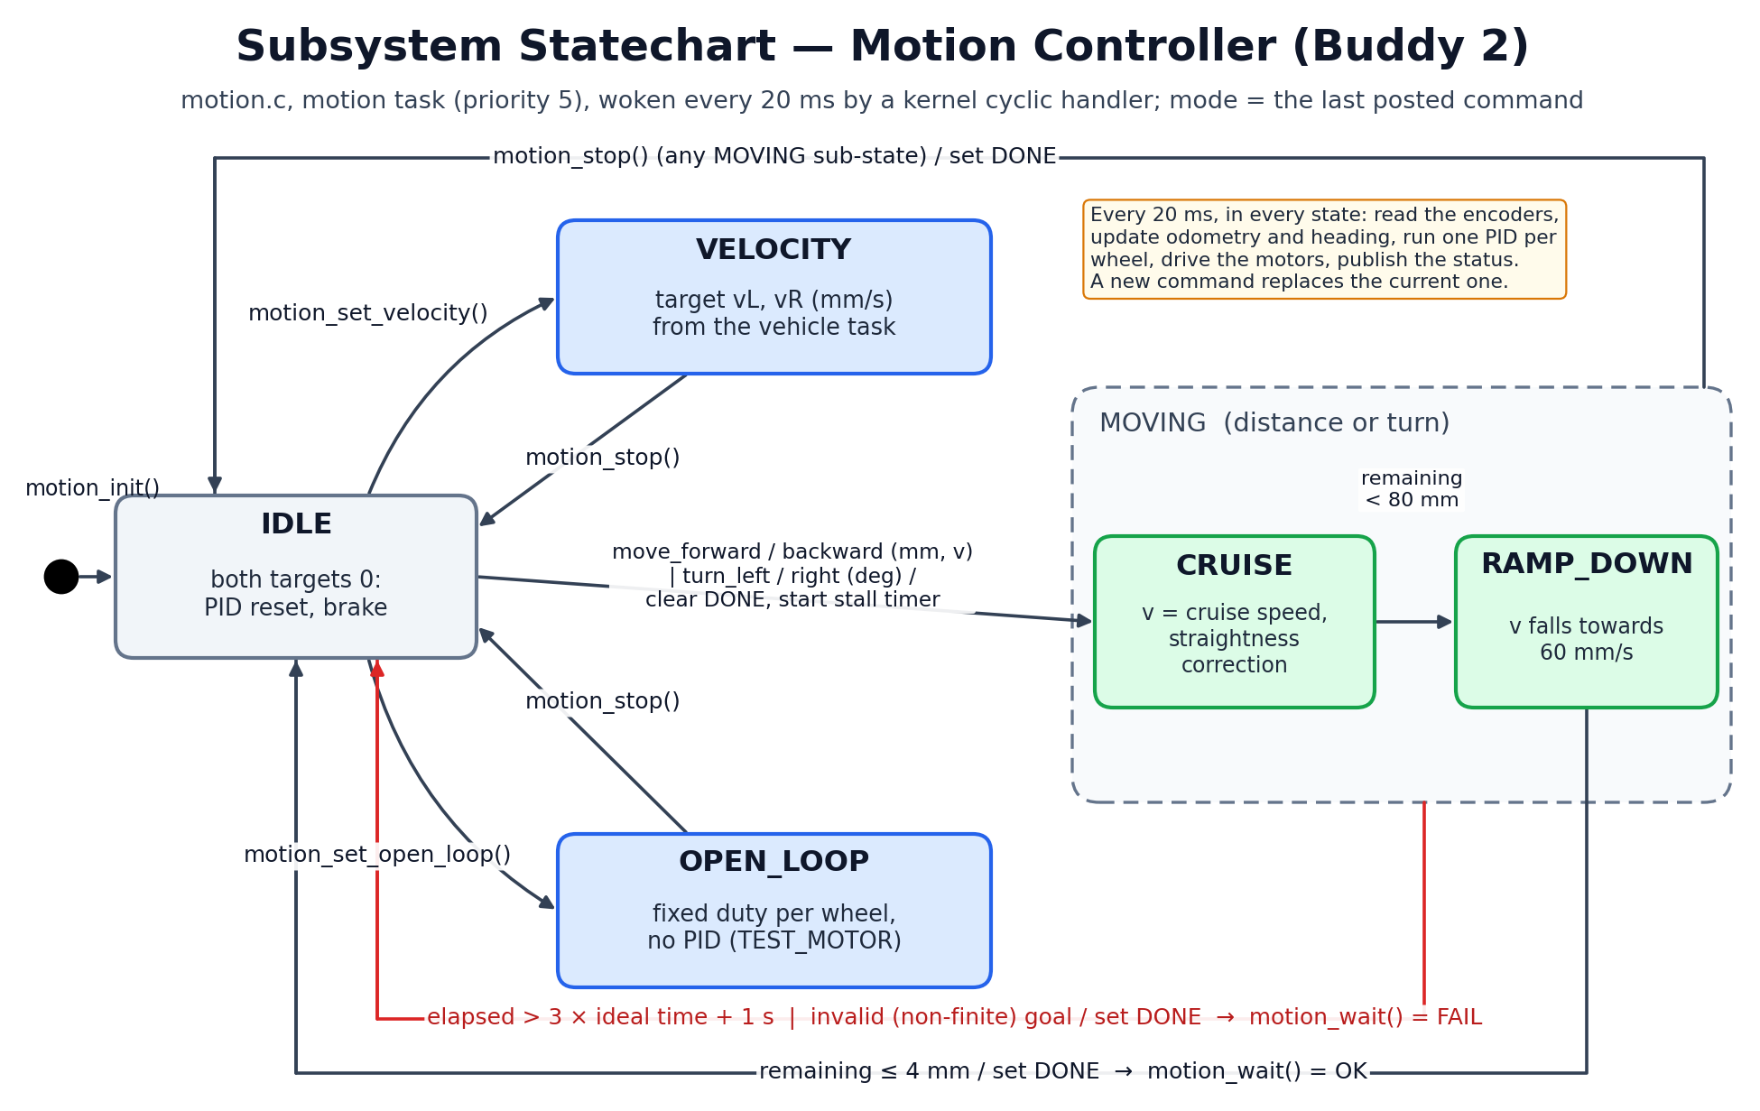
Brief explanation of states, events, and fault handling:
- IDLE — both targets 0, PID state reset, motors braked. motion_stop() from any state returns here and sets the DONE flag so a waiting task is released at once.
- VELOCITY — continuous wheel speeds from the vehicle task (line following, line search). OPEN_LOOP — fixed duty per wheel without PID, used only by TEST_MOTOR to measure the motor response.
- MOVING (distance or turn) — CRUISE at the requested speed with a straightness correction from the left / right distance mismatch; RAMP_DOWN once less than 80 mm (or equivalent arc) remains, slowing towards 60 mm/s so the car stops on target.
- Completion — remaining ≤ 4 mm sets DONE, so motion_wait() returns OK. Fault — a move taking longer than 3 × its ideal time + 1 s (stall, wheel slip, disconnected encoder) or a non-finite goal also sets DONE but motion_wait() returns FAIL; the vehicle task then goes to LINE_SEARCH or STOPPED.
In every state the task reads the encoders, updates odometry and heading, runs one PID step per wheel, drives the motors and publishes its status atomically.

6.3 Subsystem Statechart 3 — Line Tracking Classifier (Buddy 3)
Field | Student Entry
Subsystem name | Line tracking classifier (line_follow.c)
Related RTOS task(s) | vehicle task (priority 6), every 20 ms; IR data from ir_sample_isr (1 kHz)
Purpose | Classify the two normalised IR readings as on the line, line lost or junction, and compute the PID steering and speed while on the line (FR1, FR2, NFR4).
Reason a statechart is needed | Line loss and junctions must be confirmed over time or distance, not from one sample; the statechart makes these confirmation rules and the recovery back to LINE_ON explicit.

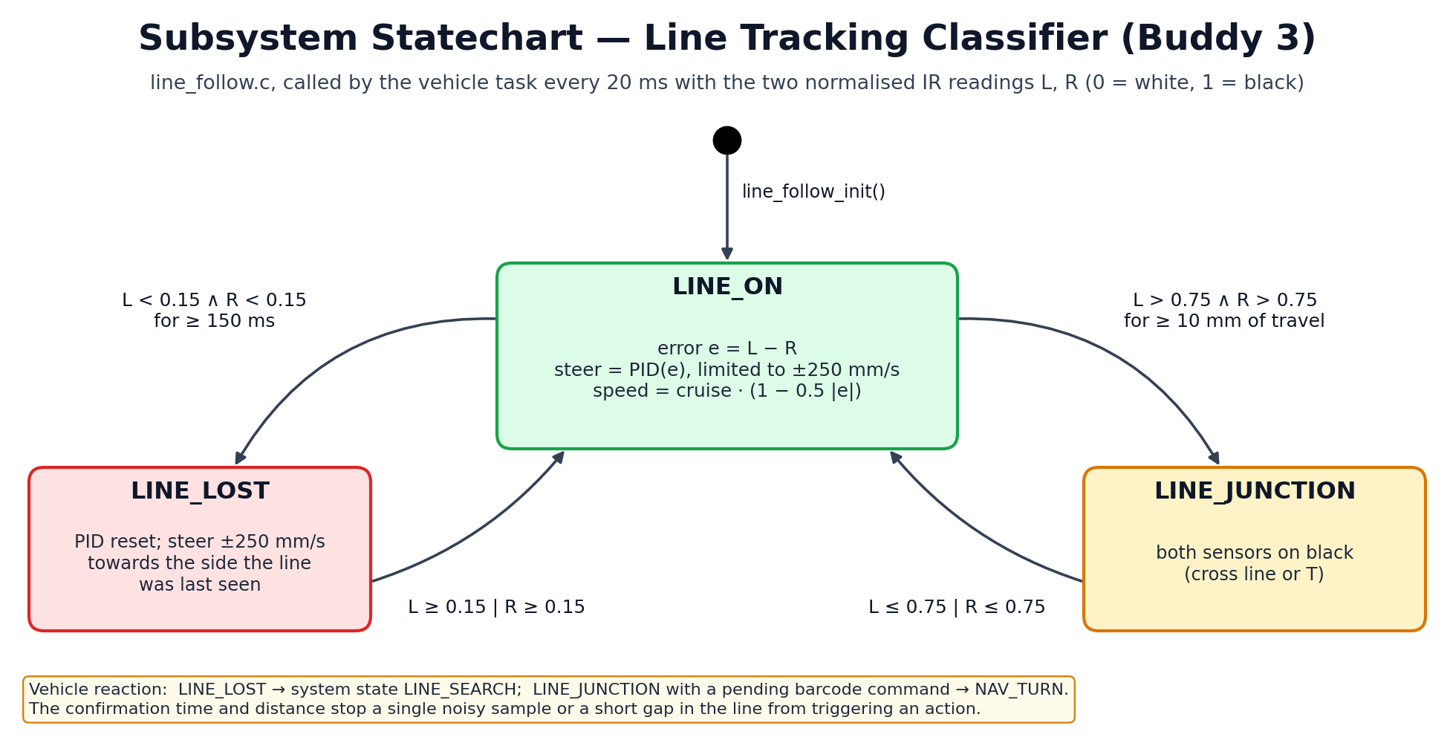
Brief explanation of states, events, and fault handling:
- LINE_ON — normal tracking: error e = L − R (0 = white, 1 = black), steering = PID(e) limited to ±250 mm/s, forward speed = cruise × (1 − 0.5 |e|) so the car slows in bends.
- LINE_LOST — both readings below 0.15 for at least 150 ms. The PID is reset and the car steers towards the side the line was last seen. Any reading of 0.15 or more returns to LINE_ON.
- LINE_JUNCTION — both readings above 0.75 for at least 10 mm of travel (a cross line or T). Either reading dropping to 0.75 or below returns to LINE_ON.
The vehicle task reacts to the classifier: LINE_LOST → system state LINE_SEARCH; LINE_JUNCTION with a pending barcode command → NAV_TURN. The time and distance thresholds stop a noisy sample or a short gap in the tape from causing an action. Calibration (CALIBRATE state) sets the white / black levels used for normalising.

6.4 Subsystem Statechart 4 — Barcode Capture and Decoding (Buddy 3)
Field | Student Entry
Subsystem name | Barcode capture and decoding (ir_sensor.c edge detector, barcode.c, barcode_decode.c)
Related RTOS task(s) | ir_sample_isr (1 kHz, region A); barcode task (priority 7, every 10 ms, region B); result to the vehicle task through a message buffer
Purpose | Measure bar and space widths from the barcode IR sensor, assemble a frame, decode *X* in either reading direction and send the navigation command (FR3, NFR2).
Reason a statechart is needed | The work is split between an ISR and a task that run concurrently; the statechart shows both regions, the frame start / end rules (first bar, 250 ms quiet zone) and every rejection path.

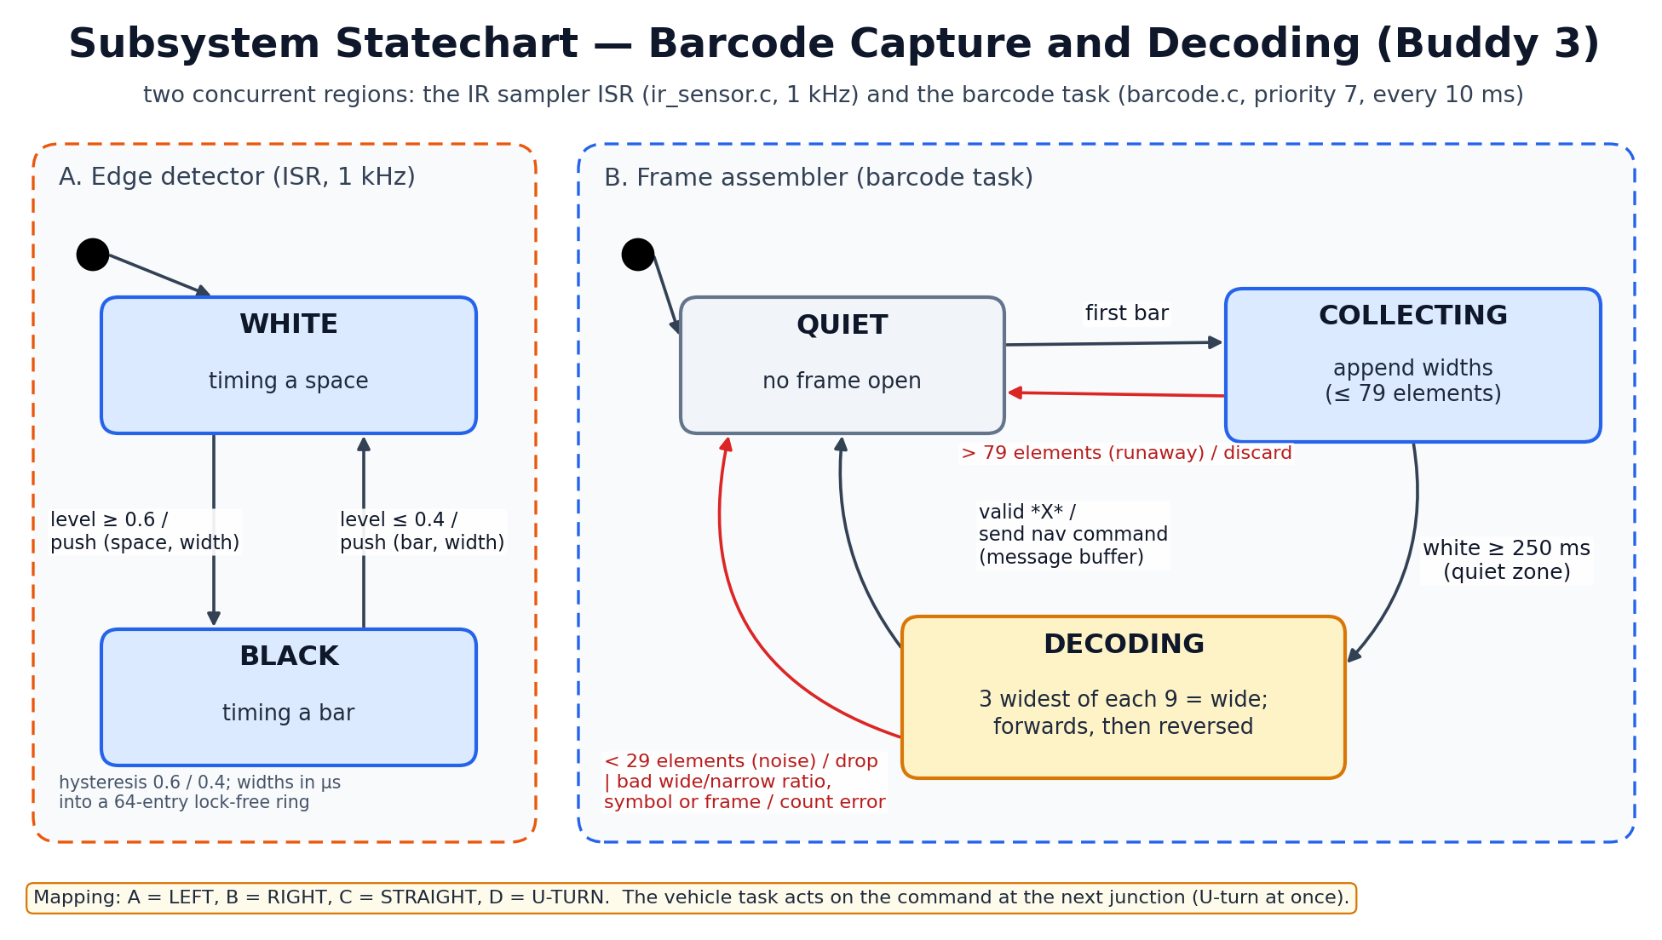
Brief explanation of states, events, and fault handling:
- Region A (ISR) — two states, WHITE (timing a space) and BLACK (timing a bar), with hysteresis: black at ≥ 0.6, white at ≤ 0.4. Each change pushes the finished element and its width in µs into the 64-entry lock-free ring.
- Region B (task) — QUIET until the first bar arrives, then COLLECTING widths (at most 79 elements; more is a runaway and is discarded). White for ≥ 250 ms (quiet zone) ends the frame and starts DECODING.
- DECODING — in each 9-element character the 3 widest elements are wide; the pattern is looked up in the Code 39 table, first forwards and then reversed (the car may cross the code in either direction). A valid *X* frame sends the command (A = LEFT, B = RIGHT, C = STRAIGHT, D = U-TURN) to the vehicle task.
- Rejections — fewer than 29 elements (noise, a junction or a line edge) are dropped silently; a bad wide / narrow ratio (< 1.6), an unknown symbol or a missing * frame is counted as an error in the telemetry, and the task returns to QUIET.

6.5 Subsystem Statechart 5 — Hump Tracker (Buddy 4)
Field | Student Entry
Subsystem name | Hump tracker (terrain.c)
Related RTOS task(s) | imu task (priority 8), every 20 ms; distance from the motion status (encoders); hump events published by the telemetry task
Purpose | Detect each hump, integrate its height from pitch and distance travelled, and report the number of humps and the peak height (FR5, NFR6).
Reason a statechart is needed | Start, peak and end of a hump are decided from noisy pitch over time; the statechart fixes the trigger and end conditions, the minimum height, and the abandon rule for ramps or drift.

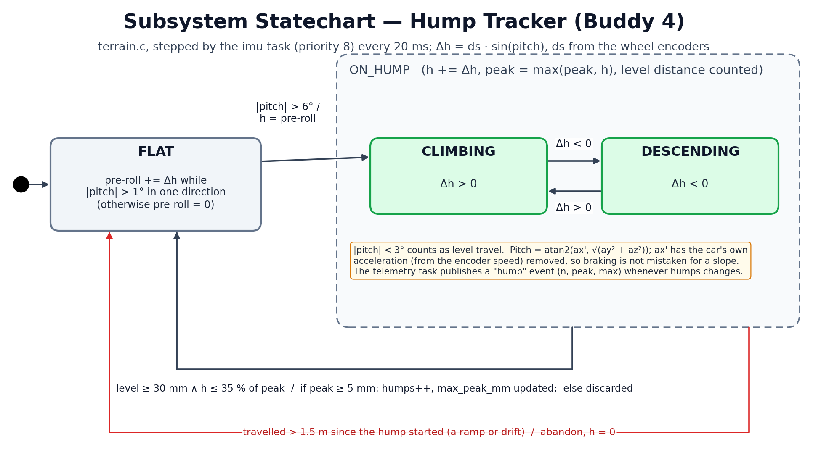
Brief explanation of states, events, and fault handling:
- FLAT — the tracker keeps a small “pre-roll” height while the pitch stays above 1° in one direction, so the part of the climb below the 6° trigger is not lost (without it the first host simulation read humps about 14 % low).
- ON_HUMP — entered when |pitch| > 6°, starting with h = pre-roll. Each sample adds Δh = ds · sin(pitch), where ds is the encoder distance, and updates the peak; the sub-state is CLIMBING when Δh > 0 and DESCENDING when Δh < 0.
- End — after ≥ 30 mm of level travel (|pitch| < 3°) with h back below 35 % of the peak. If the peak is at least 5 mm the hump is counted and the run's maximum peak is updated; smaller bumps are discarded. The telemetry task publishes a “hump” event whenever the count changes.
- Abandon — more than 1.5 m on a “hump” means a ramp or drift, so it is abandoned. Pitch comes from the accelerometer with the car's own acceleration (from the encoder speed) removed, so braking is not mistaken for a slope.

6.6 Subsystem Statechart 6 — Obstacle Handling (Buddy 5, with Buddy 2)
Field | Student Entry
Subsystem name | Obstacle handling (vehicle.c handle_obstacle, obstacle.c, avoidance.c, ultrasonic.c, servo.c)
Related RTOS task(s) | vehicle task (priority 6) runs the sequence; obstacle task (priority 9) monitors the front range; motion task (priority 5) executes the moves
Purpose | Stop before an obstacle, profile it, choose continue / reverse / bypass / stop, bypass it with the smallest sideways offset, and rejoin the line (FR7, FR8, NFR5).
Reason a statechart is needed | Obstacle handling is a multi-step sequence with guards, a retry counter and several ways to fail; the statechart shows every decision and where each failure leads (LINE_SEARCH or STOPPED).

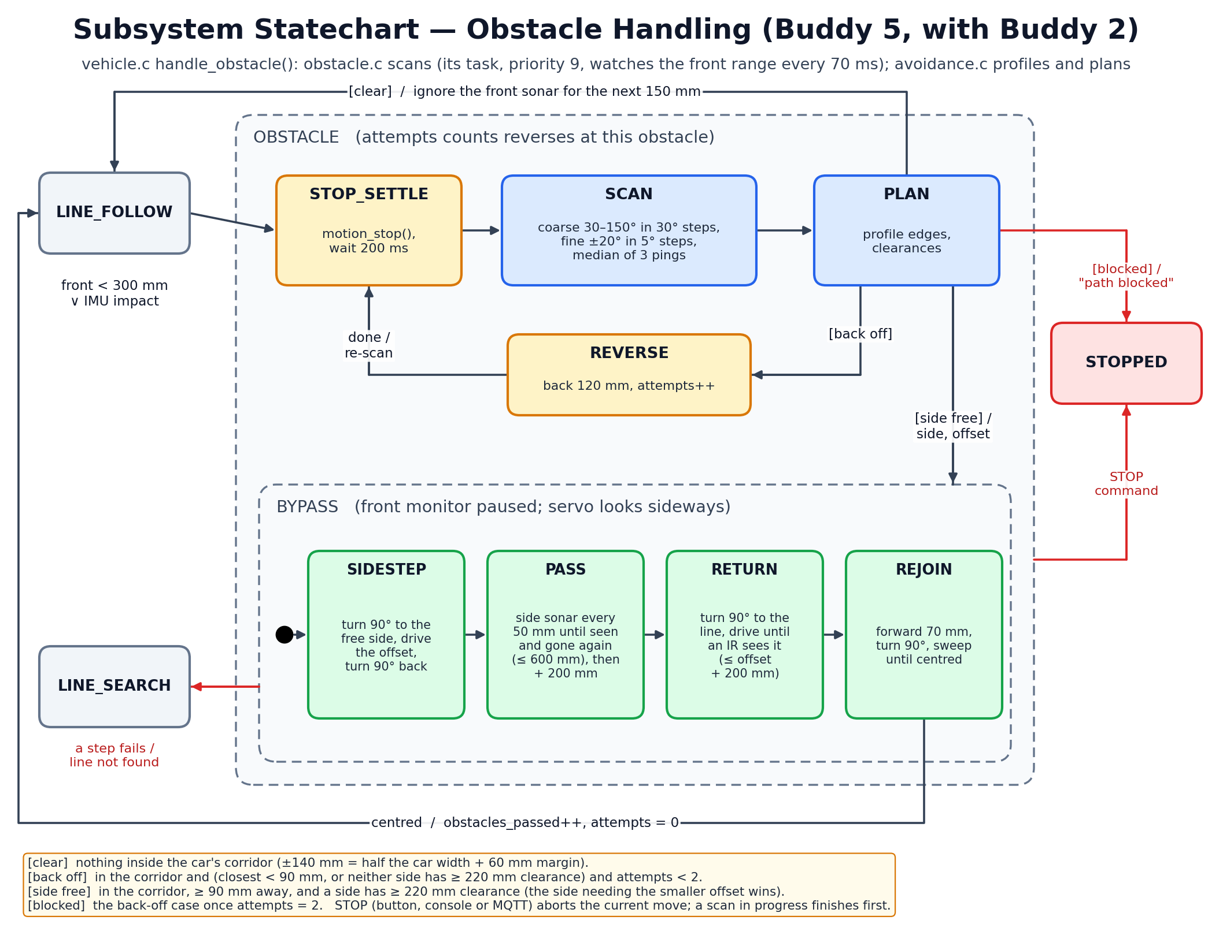
Brief explanation of states, events, and fault handling:
- STOP_SETTLE → SCAN → PLAN — brake and wait 200 ms, then scan: coarse at 30, 60, 90, 120, 150° and fine ±20° around the object in 5° steps, taking the median of 3 pings at each angle. avoidance.c turns the points into the obstacle's edges and the free space on each side.
- [clear] — nothing in the car's corridor (±140 mm): continue line following and ignore the front sonar for 150 mm.
- [back off] — too close (< 90 mm) or no side with 220 mm of space: REVERSE 120 mm and re-scan, at most twice; after that the path is [blocked] and the car goes to STOPPED with the reason “path blocked”.
- [side free] → BYPASS — SIDESTEP (turn 90° to the free side, drive the offset, turn back), PASS (side-looking sonar every 50 mm until the obstacle has been seen and has gone, at most 600 mm, then one car length), RETURN (turn towards the line and drive until an IR sensor sees it, at most offset + 200 mm) and REJOIN (forward 70 mm, turn 90°, sweep until centred) → LINE_FOLLOW.
- Faults — any failed move or line not found during the bypass → LINE_SEARCH. A STOP command aborts the current move and goes to STOPPED; a scan already in progress finishes first (recorded in the gap check).

7. Assumptions
List assumptions that the design depends on. Each assumption must state the risk if it is wrong and how the team will validate it before full integration. Have at least 1 assumption per buddy.
ID | Assumption | Risk if wrong | Validation method | Owner | Status
A1 | The lab Wi-Fi access point and a laptop broker (mosquitto, port 1883) are reachable from the car, with no client isolation and a round trip under 100 ms. | No telemetry or remote commands during the demo; the dashboard shows the car as offline. | Run the TEST_TELEMETRY build with the dashboard for 10 minutes in the lab; check the heartbeat for reconnects and dropped messages. So far tested only against a local broker with sim_car.py. | Buddy 1 | Partially validated (host simulation)
A2 | The template cyw43 task (priority 4, above motion) never delays the 20 ms control loop by more than about 2 ms. | Speed PID jitter makes the car wobble or overshoot distances while Wi-Fi is busy. | Time-stamp every control cycle and log the maximum jitter with 5 Hz telemetry streaming, with Wi-Fi on and off. If above 2 ms, lower the cyw43 priority below motion and re-test the link. | Buddy 1 | Open
A3 | The 20-slot encoders give clean, single edges (≥ 300 µs apart) up to cruise speed, about 10 mm of travel per slot, and wheel slip is small on the course surface. | Distance and turn errors (NFR7), noisy speed feedback, false stall timeouts. | TEST_MOTION: 5 × 500 mm straight runs and 5 × 90° turns each way, measured with a tape and protractor; check the encoder signal on a scope at cruise speed. | Buddy 2 | Open
A4 | The motors respond roughly linearly to PWM above an 18 % dead-band, and battery sag during one run is small enough for PID + feed-forward to absorb. | Stalls at low speed, overshoot, or different behaviour at the end of the battery. | TEST_MOTOR: open-loop PWM sweep and PID step response logged with the dashboard, with a full and a low battery; tune kF and the offset with the live-tuning commands. | Buddy 2 | Open
A5 | After calibration the IR analog output gives a white / black contrast of more than 50 % of the ADC range at the mounting height, and lab lighting does not shift it. | Line lost too often, junctions or barcode bars missed. | TEST_IR: record calibrated min / max on the course under normal lighting and next to a window; check the contrast reported at the end of CALIBRATE. | Buddy 3 | Open
A6 | The car's speed stays roughly constant (±20 %) over one 141 mm barcode, so relative bar widths are preserved, and a 3 mm bar lasts at least 10 samples. | Wrong or missed barcode, so the car turns the wrong way. | TEST_BARCODE: 20 passes each at 100 and 180 mm/s, in both directions; target ≥ 90 % correct and 0 wrong commands. The decoder is so far tested with synthetic width vectors on the host. | Buddy 3 | Partially validated (host simulation)
A7 | The accelerometer pitch, after removing the car's own acceleration, is accurate to about ±1° at 20 ms, and vibration on flat ground never exceeds the 6° trigger. | False humps, or hump heights outside ±5 mm (NFR6). | TEST_IMU: 5 m on flat floor must give 0 humps; drive over a hump whose height is measured with a ruler, 5 times, and compare. The integrator is so far tested with a simulated hump profile. | Buddy 4 | Partially validated (host simulation)
A8 | A real impact produces a sample-to-sample change above 700 mg, which normal driving (bumps, braking, the hump) does not. | Missed collisions, or false OBSTACLE stops during normal driving. | Log the largest jerk during normal laps and the hump, then during gentle pushes into a box; adjust IMPACT_JERK_MG between the two. | Buddy 4 | Open
A9 | Obstacles are box-like, at least 50 mm wide and reflect sound; the HC-SR04 on 3.3 V gives stable readings from 20 to 1000 mm, and the beam widens objects predictably. | Missed obstacles, oversized profiles, or the wrong bypass side. | TEST_ULTRASONIC: scan known boxes at 150 mm and 250 mm, straight and offset; compare the profiled edges with tape measurements; check readings at 3.3 V. | Buddy 5 | Open
A10 | There is at least 220 mm of free space beside the obstacle and the line continues roughly straight past it, so the box-shaped bypass can rejoin within offset + 200 mm. | The car loses the line (LINE_SEARCH) or stops with “path blocked”. | Run the full bypass on the course with the obstacle in each allowed position, 5 times each; count clean rejoins and note where the line was found. | Buddy 5 | Open

8. AI-Supported Design Evidence
Document how AI was used to support the design. The aim is not to show that AI produced perfect answers, but to show that the team used AI critically, corrected weak suggestions, and made final engineering decisions.

8.1 Pre-Submission AI Ideation
Buddy | AI prompt or discussion used | Useful AI ideas | Weak or unrealistic AI ideas | Team decision
Buddy 1 | “The µT-Kernel template's cyw43 task owns lwIP (NO_SYS). Design an MQTT client so the other tasks can publish telemetry and receive commands without calling lwIP.” | Run the client inside the cyw43 task through a weak poll hook; exchange data through single-producer / single-consumer rings; last will “offline” plus a retained “online”; exponential back-off. | The first version sent PINGREQ only when the link was idle. With 5 Hz telemetry it never pinged, so a dead broker was never noticed. It also reported new gains before the vehicle task had applied them. | PINGREQ on a fixed 15 s schedule plus a 45 s receive-silence limit (NFR8). The gains report is sent 60 ms after the command, once it has been applied.
Buddy 2 | “Structure a 50 Hz per-wheel speed PID and distance / turn moves on µT-Kernel 3.0. How should the loop be timed and how does a caller wait for a move?” | A kernel cyclic handler that only wakes the task; feed-forward + static-friction offset; ramp-down before the target; a stall timeout; an event flag for “done”. | The TEST_MOTOR program created a second motion task every time it was re-run, and its open-loop PWM sweep fought the PID. | Initialisation made idempotent; an OPEN_LOOP mode added for measuring the motors; moves fail after 3 × ideal time + 1 s so no caller waits forever.
Buddy 3 | “How can one analog IR sensor read Code 39 barcodes at an unknown speed and in either direction?” | Time bar / space widths instead of sampling positions; call the 3 widest of each 9 elements wide; try the frame forwards, then reversed. | Sampling in a 10 ms task would give about one sample per 3 mm bar at cruise speed. One AI-written test vector did not match the Code 39 table. | Sampling moved to a 1 kHz hardware-alarm ISR (NFR2) with 0.6 / 0.4 hysteresis; every table entry and test vector checked against the course barcode specification and the sample photo (*A*).
Buddy 4 | “The GY-511 has no gyroscope. How can we estimate hump height and detect collisions with only an accelerometer, a magnetometer and wheel encoders?” | Integrate sin(pitch) × encoder distance instead of double-integrating acceleration; subtract the car's own acceleration (from encoder speed) before computing pitch; impact from sample-to-sample jerk. | Double integration of acceleration was also suggested (it drifts within seconds). The first hump tracker read about 14 % low in host simulation because the climb below the 6° trigger was lost. | Path integral kept; a pre-roll height added below the trigger; minimum height 5 mm and an abandon rule at 1.5 m for ramps.
Buddy 5 | “Plan obstacle avoidance with an ultrasonic sensor on a servo, then review the whole design for consistency and coding-standard compliance.” | Coarse-then-fine scan; a corridor test for “in the way”; pick the side needing the smaller offset; a box-shaped bypass that watches the obstacle with a side-looking sonar. | The profile merged an obstacle with a wall beside it, so both sides looked blocked. The AI also stated the code “follows Barr-C” when our checker found 1,570 violations. | Points clustered by depth so neighbours are separated from the obstacle. We wrote tools/barr_check.py and fixed the code to 0 findings, with documented deviations (NFR10).

8.2 Team-Reviewed Architecture Freeze
AI or initial idea | Team decision | Engineering reason | Affected artefact
One RTOS task per subsystem, priorities by deadline (motion 5, vehicle 6, barcode 7, imu 8, obstacle 9, telemetry 10). | Accepted | Matches buddy ownership, so each buddy can test a task alone (TEST_* builds). Deadline-ordered priorities give the 20 ms control loop precedence over everything that can wait. | RTOS task table, task interaction diagram, team roles
Create our own network task for MQTT. | Modified | lwIP runs in NO_SYS mode and is not thread-safe, and the template's cyw43 task already owns it. The client runs inside that task through a weak hook; other tasks use rings only. | Task table, task interaction diagram, MQTT statechart, NFR8
Use the kernel's ADC and I2C device drivers. | Rejected with reason | They use blocking device-manager calls that cannot run in a 1 kHz ISR. Disabled in config_device.h; each peripheral has one owner (IR ADC: ISR, I2C0: imu task). | Pin layout, task table, assumptions A5 / A7
Sample the IR sensors from a 10 ms task or the kernel tick. | Rejected with reason | A 3 mm bar lasts about 17 ms at cruise speed; 10 ms sampling gives one or two samples. A TIMER3 alarm ISR at 1 kHz gives about 17. | NFR2, barcode statechart, task table
Use the newest Pico SDK. | Rejected with reason | The template fails to build with newer SDKs (fixed_bitset.h). SDK pinned at 2.2.0 and recorded in the build notes. | Build set-up, integration plan
Hump height by double integration of acceleration. | Rejected with reason | Integration drift grows with time squared. The path integral of sin(pitch) × encoder distance only drifts with pitch error and resets at the end of each hump. | Hump statechart, FR5, NFR6, A7
Read console commands with the template's tm_getchar(). | Rejected with reason | It spins with interrupts disabled, which would stall the control loop. A non-blocking ring filled by a USB receive hook, plus a UART FIFO poll, is used instead. | Task interaction diagram, FR10
Use floating point in the control code (BARR-C 5.4.a prefers fixed width types). | Accepted with deviation | PID and geometry are far clearer in float; a float32_t typedef and isfinite() guards are used, and the deviation is documented. The CPU load (RP2040 has no FPU) must be measured with A2. | NFR10, coding-standard deviation list

8.3 Final AI-Vetted Gap Check
After completing the design, ask AI to act as a strict embedded systems reviewer. The review should identify missing requirements, unclear interfaces, untested assumptions, weak mitigations, timing concerns, task conflicts, or resource contention.
Use one of these Team Response options: Fixed, Partially fixed, Accepted as risk, Deferred, Rejected with reason, or Needs validation. The action and evidence columns must justify the selected response.  AI reviewer prompt used | Act as a strict embedded systems reviewer for an autonomous line-following robot car (Raspberry Pi Pico W on a Cytron Robo Pico, µT-Kernel 3.0, C99 / BARR-C:2018) with line following, barcode navigation, hump detection, obstacle avoidance and MQTT telemetry. Check the requirements, pin layout, RTOS task table, task interaction diagram, statecharts, assumptions, and AI evidence. Identify missing requirements, unclear interfaces, untested assumptions, weak safety mitigations, timing risks, task conflicts, and shared-resource problems. Do not rewrite the design; list only gaps that the team must review and justify.

AI-identified gap | Team response | Action taken | Evidence or reason
STOP is not acted on while an obstacle scan is running: the vehicle task is busy inside obstacle_scan() for up to about 2 s. | Accepted as risk | Documented in the obstacle statechart. The motors are braked before the scan starts, so the car is stationary. Plan: check the abort flag between servo steps after Week 6. | handle_obstacle() calls motion_stop() before obstacle_scan(); NFR3 applies while driving.
The template cyw43 task (priority 4) is above motion (5); a long Wi-Fi or lwIP burst could delay the control loop. | Needs validation | Measure control-loop jitter with telemetry streaming (A2). If it exceeds 2 ms, lower the cyw43 priority below motion. | NFR1, assumption A2.
Encoders are single-channel, so the car cannot sense direction; a pushed or rolling-back car miscounts. | Accepted as risk | Direction is taken from the commanded motor direction; the car only reverses under command (obstacle reverse). Accuracy checked in TEST_MOTION. | A3, NFR7; the car_config.h notes.
There is no watchdog: a hung task could leave the motors running. | Deferred | Every wait has a timeout (NFR9) and the motion task brakes when idle. An RP2040 watchdog fed by the vehicle task will be added after integration, once the kernel start-up time is known. | NFR9; integration plan after Week 6.
Battery voltage is not monitored; motor response changes as the battery drains. | Needs validation | The PID integral term absorbs slow changes. Test with a full and a low battery (A4). VSYS cannot be read because GP29 is used by the Wi-Fi chip on the Pico W. | A4; pin layout (GP29 reserved).
MQTT has no authentication or TLS; anyone on the network could send start / stop. | Accepted as risk | Closed lab network; commands limited to a small parsed set; username / password available in mqtt_config.h if the lab broker needs them. | FR10; mqtt_config.example.h.
The ultrasonic sensor is used by two tasks (obstacle monitor and vehicle scans); pings could overlap or come too close together. | Fixed | A semaphore makes it single-user and enforces ≥ 60 ms between pings; the monitor only pings while the servo is centred. | ultrasonic.c (sensor semaphore), obstacle.c monitor_task; task interaction diagram.
Barcode decoding assumes near-constant speed across the barcode; PID speed changes or a bend could distort the widths. | Needs validation | Wide / narrow is decided per character (relative widths), and the car slows in bends. Success rate to be measured at two speeds and both directions (A6). | A6, FR3, NFR2.
Hump detection could trigger on braking, acceleration or vibration. | Partially fixed | The car's own acceleration is removed before computing pitch; 6° / 3° hysteresis, 5 mm minimum height and a 1.5 m abandon rule. Still to be checked on the real hump and flat floor (A7). | Hump statechart, A7, NFR6.
Several requirements had no measurable target (motion accuracy, hump accuracy, STOP latency). | Fixed | Added NFR3 (STOP ≤ 100 ms), NFR6 (±5 mm hump), NFR7 (±2 % distance, ±5° turn) and pass criteria in the assumption validations. | Section 1.2, section 7.
A spurious OBSTACLE could be raised at the start of a run, because the IMU impact counter is reset when a run starts. | Fixed | Only an increase of the impact count is treated as an impact; a smaller count is recognised as the reset. | vehicle.c obstacle_due(); found in an independent code review.

9. Design Consistency
Use this section to demonstrate that the design artefacts describe one coherent system rather than independent diagrams.
Check | Student Response
Which task owns each hardware device? | Motors (GP8–11): motion task only. Encoders (GP2 / GP3): encoder_edge_isr, read by motion. IR sensors (GP26–28, ADC): ir_sample_isr, read by the vehicle and barcode tasks. IMU (I2C0, GP4 / GP5): imu task only. HC-SR04 (GP6 / GP7): shared by the obstacle monitor task and the vehicle task's scans under a semaphore, with echo_edge_isr timing the echo. Servo (GP12): obstacle.c functions running in the vehicle task. Buttons (GP20 / GP21): vehicle task. Wi-Fi (CYW43): template cyw43 task. USB / UART0 consoles: template usb task and the telemetry task. LED (GP16): blink task.
Which task has the highest priority, and why? | Among our tasks, motion (priority 5) is highest: it runs the 20 ms wheel-speed loop, a late cycle directly disturbs the car, and it is the only task that drives the motors, so every stop ends there. The ISRs and the 20 ms cyclic handler run above all tasks but only record data or wake a task. The template's usb (3) and cyw43 (4) tasks keep their template priorities; their effect on the control loop is assumption A2.
Which subsystem statechart corresponds to which RTOS task or subsystem? | 6.1 MQTT connection: cyw43 task (hook) with the telemetry task. 6.2 Motion controller: motion task. 6.3 Line classifier: vehicle task (line_follow.c). 6.4 Barcode: ir_sample_isr and the barcode task. 6.5 Hump tracker: imu task (terrain.c). 6.6 Obstacle handling: vehicle task with the obstacle and motion tasks. The system statechart (section 5) is the vehicle task's state machine, and its OBSTACLE and LINE_SEARCH states are expanded in 6.6 and 6.3.
How are functional requirements reflected in the task and statechart design? | FR1–FR2: vehicle task, LINE_FOLLOW / LINE_SEARCH, line classifier (6.3). FR3: ir_sample_isr + barcode task (6.4) and NAV_TURN. FR4: motion task (6.2). FR5–FR6: imu task and hump tracker (6.5). FR7–FR8: OBSTACLE state (6.6) with the obstacle and motion tasks. FR9–FR11: telemetry and cyw43 tasks, MQTT statechart (6.1). FR12: buttons polled by the vehicle task; STOPPED state. FR13: CALIBRATE state.
What changes are still expected after the Week 6 review? | Calibrate car_config.h values on the real car (IR levels, PID gains, servo pulse range, motor direction). Measure control-loop jitter and CPU load, and move the cyw43 priority if needed (A2). Validate A1–A10 and fill the test tables with dashboard logs. Make obstacle scans abortable by STOP and add a watchdog. Update the task interaction diagram and statecharts if any queue, priority or state changes during integration.

